AN OVERVIEW OF THE METAL-ORGANIC FRAMEWORK
N. Ganeshwari¹, M.Karunakaran^{*1}, S.Usha¹, S.Prabakaran¹ and K.Kasirajan²
1. Thin Film & Nano Science Research Lab, PG & Research Department of Physics, Alagappa Government Arts College, Karaikudi – 630 003, Tamilnadu,
2. Division of Advanced Materials Engineering, Kongi National University, Budaedong 275, Seobuk-gu, Cheonan-si, Chungnam 31080, Republic of Korea
India.
tvdkaruna@gmail.com
ABSTRACT
Metal-Organic Frameworks(MOFs) have a unique class of porous hybrid organic-inorganic materials that have fascinating attention over the fast decennium. Due to their benefits, including their high porosity, structure, and flexibility, MOFs and their imitations have been widely used to enhance catalysis and energy storage efficiency. They have also been used to solve water and electromagnetic pollution. This present article discusses structural exposure; types (MOF-5, HKUST-1, UiO, Zeolitic imidazolate framework(ZIF), MOF-76), methods of synthesis, and applications have been discussed. To increase the stability linking metal ions/clusters and ligands and prevent the generation of harmful by-products, MOFs are made by substituting biomolecules for traditional organic linkers. Additionally, they have special benefits such as optimal reusability and stability, mechanical strength, and biocompatibility. Finally, the provocation and perspectives are discussed to provide the future development of MOFs as methodical tribunes for disease diagnosis and drug delivery systems.
Keywords: MOFs, ZIF, drug delivery, biocompatibility, diseases diagnosis.
1. INTRODUCTION
Metal-organic frameworks (MOFs), a specific class of coordination polymers, have captivated attention in different areas of science. Metal-organic frameworks (MOFs) are composed of chemical bonds between inorganic metal clusters and organic ligands as linkers [1]. In terms of their potential for diversity, this puts them ahead of other manmade materials like zeolites [2]. which benefits from their well-defined structure, high porosity, modularity, high surface area, a wide range of pore shapes, relatively low toxicity, and easy chemical functionalization [3]. MOFs can be fastly converted into metal oxides, metal sulfides, and porous carbon (PC) electroactive materials for energy storage devices. and that have potential applications in various fields such as ultra-strong applicability in adsorption, gas storage, catalysis, and electrochemical energy conservation [4]. For the hydrogenation of CO2 with the saturated electrolyte of KHCO3, the metal-organic porous materials based on copper, such as HKUST-1 and CuAdeAce, are MOFs and metal-organic aerogels of CuDTA and CuZnDTA [5]. MOF is one of the most promising areas of human health care in developing safer and more effective drug carriers, a constantly developing area of biomedical material sciences [6]. Biological metal-organic frameworks (bio-MOFs) with excellent biocompatibility and diverse functionality have garnered a lot of attention in recent years. [7]. It is possible to know the four basic abilities of MOFs to be used in pursuing applications. These attributes are composition, pore diameter, pore morphology, and combination with different nanomaterials [8].
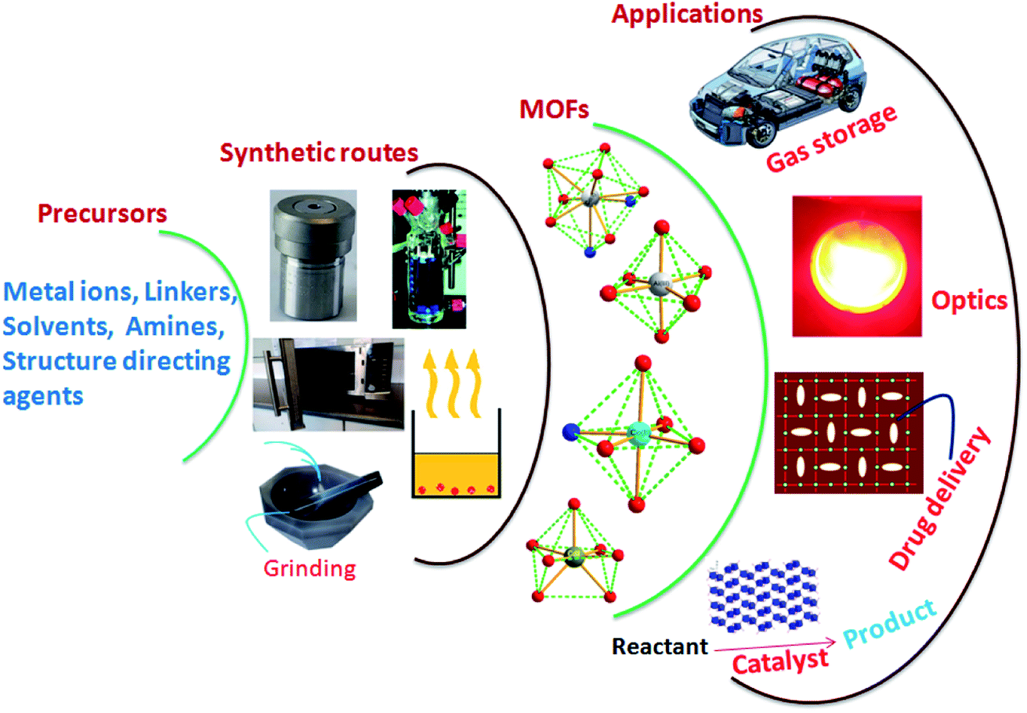

Fig. 1 Schematic representation of MOF synthetic routes and probable application
2. TYPE OF METAL-ORGANIC FRAMEWORKS
We might mention the following MOF-5, HKUST-1, UiO, Zeolitic imidazolate framework (ZIF), and MOF-76 as examples of the most popular types of MOFs alternatively used in sensing.
2.1 MOF-5
A Cubic metal-organic framework substance MOF-5 or IRMOF-1 has the formula Zn4O (BDC)³, Where BDC2=1,4 azodicarboxylate (MOF-5) with a surface area to volume ratio of 2200m²/cm³. MOF-5 Stands out among metal-organic frameworks as having one of the highest surface area to volume ratios [9]. It was also the first metal-organic framework that was investigated for hydrogen gas storage. Due to its massive and secondary construction unit and benzene linkages, MOFs' structure has a very high porosity and thermal stability. [10]. The major methods used to synthesize MOF-5 were hydrothermal, solvothermal, microwave-based, and sonochemical processes. The solvothermal approach, which may produce a large amount of product in a single batch, is the most straightforward and effective of the procedures discussed. A MOFs derivative produced by replacing Zn²+ with Mn²+ revealed selective catalytic epoxidation of olefins in which the SBU of MOF-5 played a significant catalytic role [11].

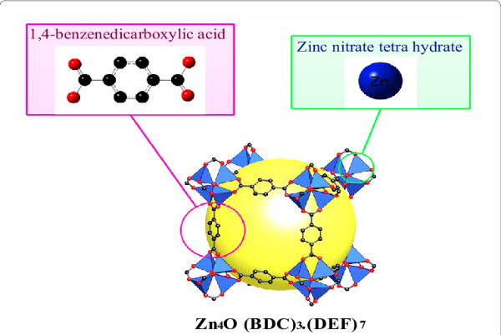

Fig2: The Schematic illustration of the construction of metal-organic framework material (MOF-5)
2.2 HKUST-1
A cubic lattice (fm-3m) of benzene dicarboxylate (BTC) ligands that coordinate copper ions. Cu (II) ions from dimers in the HKUST-1 Framework, with each copper atom being coordinated by four oxygen atoms from BTC linkers as well as a water molecule[12]. the creation of composites based on HKUST-1 is a popular and active research and as a result, fresh and noteworthy instances have demonstrated intriguing applications (e.g. H₂ Storage, catalysis, chromatography, CO₂ capture, and lithium–sulfur batteries)[13]. The creation of composites (hybrid functionalized materials) employing MOF materials and other crystalline structures, like graphene or multi-walled carbon nanotubes, is another form of functionalization[14]. When HKUST-1 and GO are combined the former’s ability to decompose in water is prevented and the ladle's adsorptive, photochemical, and electrical capabilities are enhanced [15]. HKUST-1 is a copper-based metal-organic framework (MOF) that exhibits high electrical conductivity as a result of the copper ions it contains. It can be used as an antimicrobial agent in hydrogels [16].
2.3 UIO
The UiOs MOF family consists of three primary classes: UiO-66, UiO-67, and UiO-68. Particularly boring versions of these MOFs have been made by attaching functional groups to the linkers, including amines, halogens, hydroxyls, or nitrous. Two commonly used Zr-based frameworks are UiO-66 and UiO-67. [17]. Especially, UiO-67 is a MOF procured by coordinating the theZR6O4(OH)4 metal unit with the 4,40-biphenyl dicarboxylate organic linker. On the other side, UiO-66 and UiO-68 prevailed by coordinating the same metal building block but with different linkers such as 1,4-benzene-dicarboxylate and 4,40,40-triphenyl dicarboxylate, respectively [18]. We show that UiO-66 NPs display excellent biocompatibility and little cytotoxicity both in vitro and in vivo in relevant lung studies. Our research demonstrates that UiO-66 presents an innovative way to regulate lung penetration and particle deposition with potential applications in inhaled immunotherapies, nano vaccines, drug delivery, and COVID-19 [19].
2.4 ZIF-8 and ZIF-67
A subfamily of MOFs with a cage resembling sodalite is known as zeolitic imidazolate frameworks (ZIFs), which are based on imidazole bridging with metallic nodes (such as Zn and Co). and Using a pyrolysis-oxidation-phosphorization method, a CoP/NCNHP nanostructure can be created using the ZIF-8@ZIF-67 framework as a precursor. Li et al. developed Zn/Co-ZIF with a regulated hollow structure using a template that was similar to ZIF-8@ZIF-67. This structure-based Pd@H-Zn/Co-ZIF exhibits better activity and selectivity in the semi-hydrogenation of acetylene [20]. Due to the high porosity of the framework, ZIF-8 and ZIF-67 have a relatively large surface area (1970 m2 g). These compounds also have stable chemical and thermal characteristics. ZIF-8/ZIF-67 is made up of two MIM or Zn/Co ions and has a sodalite-like structure. They have an opening with a diameter of 3.4 nm in the center, which leads to a micropore with a diameter of 11.6 nm [21].
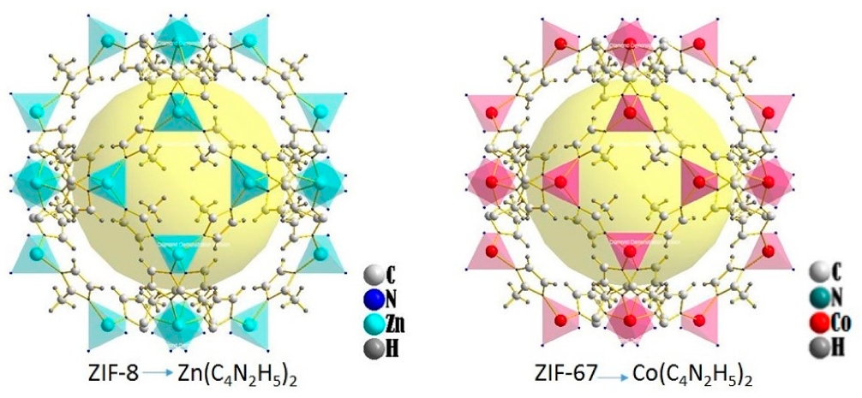

Fig3: Representative crystal structures of ZIFs under study.

2.5 MOF-76
The gadolinium(III) version of the MOF-76 family was selected because it is simple to make, has a high reaction yield, and works well in our investigations as a magnetic refrigerator, a humidity sensor, and an adsorbent of carbon dioxide, methane, and hydrogen [22]. The crystal structure of MOF-76(Tb) consists of terbium(III) and benzene-1,3,5-tricarboxylate(-III) ions, one coordinated aqua ligand, and one crystallization N, N'-dimethylformamide molecule. MOF-76 can be used in sensing studies as well as biological imaging and light interactive devices.
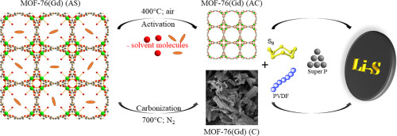

Fig4: structures of MOF -76
3. SYNTHESIS OF METHODS OF METAL-ORGANIC FRAMEWORK
Numerous variables, including reaction time, temperature, solvent, type of organic ligands and metal ions, size of nodes, structural characteristics, presence of counter ion, and crystallization kinetics, which should result in nucleation and crystal growth, affect the synthesis of MOFs [23]. Oxalatotitanates and titanophosphates were first made using hydrothermal processes.
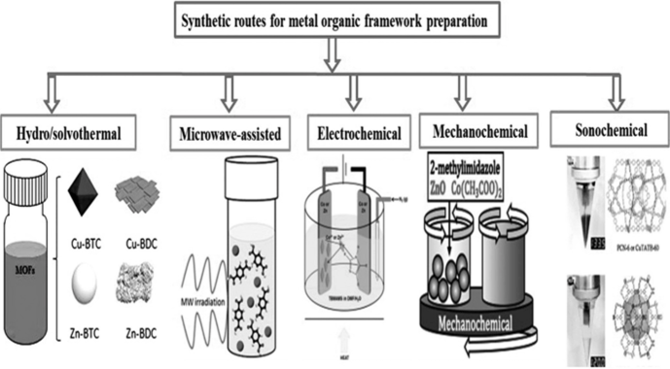
Fig 5: Overview of synthesis methods for the preparation of MOFs
Metal extraction has historically been done using the hydrothermal method. It has also been mentioned that enormous crystals may be made using this technology. It depends on the temperature in an experiment with a controlled environment. The synthesis medium must be under extremely high pressure and temperature conditions. MW radiation has been developed for the production of inorganic or organic solid-state molecules and has the benefits of controlling phase and microstructure, particle size distribution, and shortening crystallization times [24].
The electrochemical approach can be used in batch mode or continuous flow operation.Compared to traditional microwave and hydrothermal synthesis, this one has the advantage of functioning under more favorable conditions. The sonochemical method stimulates homogenous nucleation and rapid kinetics, which is enabled by the acoustic cavitation of the ultrasound waves, leading to a significant reduction in particle size. This synthesis has the benefit of operating under more hospitable settings than conventional microwave and hydrothermal synthesis. A notable reduction in particle size results from the sonochemical strategy's stimulation of homogenous nucleation and quick kinetics, which is made possible by the ultrasound waves' acoustic cavitation[25].
4. APPLICATIONS
The applications of altered MOFs are mainly distinct in medicine-related fields such as disease diagnosis and drug delivery (e.g., diabetes, cancer, anti-diabetic agents, wound healing, neurological diseases, ocular diseases, and factorial infections). then energy-related fields like hydrogen production, overall water splittings, and environmental-related fields that dye degradation and water pollution[26].
The most potential alternative energy source to combat the current issue of fossil fuel use is hydrogen energyMOFs can also play a significant part in the generation of hydrogen. In photocatalytic and electrocatalytic production methods, MOFs are used to produce hydrogen[27].
4.1 DRUG DELIVERY
Due to their huge surface area, highly customizable pore size, and tailoring of the metal ion or organic linker, MOFs are a potential prospect for drug delivery. Nano-MOFs, which were made by shrinking the size of MOF particles, work well as drug delivery vectors. [28]. The cavity of MOF and/or the framework structures might be filled with a range of hydrophobic, hydrophilic, and amphiphilic therapeutic compounds[29]. The MOF nanocarriers provide targeted drug delivery, higher cellular uptake, and regulated drug release, making MOFs a viable family of DDSs for drug delivery. These medications include hormones, antiglaucoma therapies, anticancer treatments, and antibacterial compounds [30]. The continuous drug release capability of the external stimuli-responsive devices is increased, and they have a greater potential for biological use.

4.2 DISEASE DIAGNOSIS
There are several examples, including gold-incorporated MOFs for MRI and PTT for the treatment of breast cancer, target-specific anticancer ZIF-8/enzyme hybrid MOFs with little harm to healthy cells, Fe3O4@bio-MOF-folic-acid-chitosan combine (FC) hybrid structures as theranostic in the treatment of breast cancer, Zr-MOF@glucose-6-phosphate appeal in the treatment of kidney cancer, highly selective and sensitive [31].
Acetone was detected using MOFs made from ZnO@MoS2 nanosheet core/shell heterojunctions. Making highly luminous frameworks from non-luminescent MOFs with a strong selectivity to acetone will enable the creation of fluorometric sensors for the detection and monitoring of diabetes [32].
4. CONCLUSION
We have examined the various MOF families and probable synthesis methods in this chapter. MOFs are characterized by large surface areas, high porosity, and flexible pore diameters. Therefore, we conclude that the discovery of MOF has shown to be beneficial to every aspect of our lives today and that it continues to attract the interest of researchers. There has to be a lot more research done in this area to make MOFs more relevant across a range of sectors.
REFERENCES
[1] .Vedia Foziya Yusuf, Naved I, Malek and Suresh Kumar Kailasa. Review on Metal-Organic Framework Classification, Synthetic Approaches, and Influencing Factors: Application in Energy, Drug Delivery, and Waste Water Treatment ACS Omega 20227,49 44507-44531 DOI:10.1021/acs omega.2c05310.
[2] Miral Al Sharabati,Rana Sabouni, and Ghaleb A. Husseini. Biomedical Applications of Metal-Organic Frameworks for Disease Diagnosis and Drug Delivery: A Review Nanomaterials 2022 doi:10.330/nan012020277
[3]. Jie Liu, Yanjun L, and Zhichao Lou. Recent Advancement in MOF/Biomass and Bio-Mof Multifunctional Materials: A Review Sustainability 2022,14,5768 https://doi.orgl 103390/ Su 14105768
[4] Lakshmanan Gurusamy1, Sambandam Anandan2 and Jerry J. Wu1Metal-Organic Frameworks for Chemical Reactions. DOI: https://doi.org/10.1016/B978-0-12-822099-3.00018-6
[5] Rajasekaran Elakkiya and Govindhan Maduraiveeran. Metal-Organic Frameworks for Chemical Reactions. DOI: https://doi.org/10.1016/B978-0-12-822099-3.00013-7
[6]. Parth Malik1, Rachna Gupta1,2, and Rakesh Kumar Ameta1. Metal-Organic Frameworks for Chemical Reactions. DOI: https://doi.org/10.1016/B978-0-12-822099-3.00016-2
[7]. Huai-Song Wang, Yi-Hui Wang Ya Ding Development of biological metal-organic frameworks designed for biomedical applications; and from bio-sensing/bio-imaging to disease treatment.rsc.li/nanoscale-advances.
[8]. Metal-Organic Frameworks for Chemical Reactions. DOI: https://doi.org/10.1016/B978-0-12-822099-3.00016-2
[9].Rosi, Nathaniel L.; Eckert, Juergen; Eddaoudi, Mohamed; Vodak, David T.; Kim, Jaheon; O'Keefe, Michael; Yaghi, Omar M. (2003). "Hydrogen storage in microporous metal-organic frameworks". Science. 300 (5622):

[10].Engin Burgaz, Ayse Erciyes, Muberra Andac, Omer Andac.Synthesis and characterization of nano-sized metal-organic framework-5 (MOF-5) by using a consecutive combination of ultrasound and microwave irradiation methods https://doi.org/10.1016/j.ica 2018.10.014

[11] Abdul Malik P. Peedikakkal Isam H. Aljund Upgrading the Hydrogen Storage of MOF-5 by Post-Synthetic Exchange with Divalent Metal ions. Appl. Sci. 2021, 11, 11687. https://doi.org/10.3390/app112411687

[12]. Kuen-Song Lin, Abhijit Krishna Adhikari, Chi-Nan Ku, Chao-Lung Chiang, Hua Kuo. Synthesis characterization of porous HKUST-1 Metal-Organic Frameworks for Hydrogen Storage.https://doi.org/10.1016/j.ijhydene 2012.04.105
[13]. Jonathan Cortes-Suarez, Vanessa Celis-Arias, Hiram I Beltran, Adriana Tejeda-Cruz lich A Ibarra, Josue E Romero-Iberra El, Sanchez-Gonzalez, Sandra Loera-Serna. Synthesis and Characterization of a SWCNT@HKUST-1 Composite: Enhancing the CO₂ Adsorption Properties of HKUST-1 ACS Omega 2019, 4, 3, 5275–5282 https://doi.org/10.1021/acsomega.9b00330
[14]. Paulina Jogodka, Krzysz tof Matus and Agata Lamaca .On the HKUST-1 1/Go and HKUST-1/Rgo composites: The impact of Synthesis method on physicochemical properties. Molecules 2022,27(20), 7082; https://doi.org/10.3390/molecules27207082

[16].Wanli Zhao, Yuanhui Long, Yunging He, Jiabing Cai, Mingxian Liu. HNTS@HKUUST-1 Strengthened PAAM hydrogel for Strain Sensing and antibacterial application. https://doi.org/10.1016/j.micromeso.2022.112207

[17]. Michel J. Katz, Zachary J. Colon, Paul W. Siu, Karl A. Scheidt, Randall Q. Snurr, Joseph T. Hupp and Omer K. Farha. A facile synthesis of UiO-66, UiO-67, and their derivatives. Chem Common.,2013,49, 9449 DOI:10.1039/c3cc46105j

[18] Tolga Zorlu1, Luca Guerrini1, and Ramon A. Alvarez-Puebla1,2 The sensing applications of metal-organic frameworks and their basic features affecting the fate of detection. Metal-Organic Frameworks for Chemical Reactions DOI: https://doi.org/10.1016/B978-0-12-822099-3.00011

[19]. Bader M. Jarai, Zachary Stillman, Lucas Attia, Gerald E. Decker, Eric D. Bloch, and Catherine A. Fromen. Evaluating UiO-66 Metal-Organic Framework(MOF) Nanoparticles as Acid-Sensitive Carriers for Pulmonary Drug Delivery Applications: ACS Appl Mater interfaces.2020 sep2; 12(35):38989-39004 doi:10.1021/acsami.0c10900

[20].Aotian Gu, Jiuyu Chen, Qianhong Gao, MuhammadMusaa Khan, Peng Wang, Yan Jiao, Zongxiang Zhang, Ying Liu, Yi Yang: The preparation of Ag/ZIF-8@ZIF-67 core-shell composites as an excellent catalyst for degradation of the nitroaromatic compounds https://doi.org/10.1016/j.apsusc.2020.146160,

[21].Zahra Pouramini, Seyyed Moitaba Mousari, Aziz Bubapoor, Seyyed Alireza Hashemi Chin Wei Lai, Yousef Mazaheri, and Wai-Hung Chiang. Effect of Metal Atom in Zeolitic Imidazolate Frameworks (ZIF-8 & 67) for Removal of Dyes and Antibiotics from Wastewater: A Review, Catalysts 2023, 13(1), 155; https://doi.org/10.3390/catal13010155

[22].D. Capková, T. Kazda, O. Čech, N. Király, T. Zelenka ^{e}, P. Čudek, A. Sharma, V. Hornebecq, A. Straková Fedorková, M. Almáši Influence of metal-organic framework MOF-https://doi.org/10.1016/j.est.2022.1044197
[23] A. Ratnamala1, G. Deepthi Reddy2, M. Noorjahaan2, H. Manjunatha1, S. Janardan1, N. Suresh Kumar3, K. Chandra Babu Naidu4, Anish Khan5,6 and Abdullah M. Asiri5, Titanium-based metal-organic frameworks for photocatalytic applications. Metal-Organic Frameworks for Chemical Reactions. DOI: https://doi.org/10.1016/B978-0-12-822099-3.00003

[24]. Mohammad, Ramezanzadeh, and Bahram Ramezanzadeh Thermomechanical and anticorrosion characteristics of metal-organic frameworksMetal-Organic Frameworks for Chemical Reactions. DOI: https://doi.org/10.1016/B978-0-12-822099-3.00012-5

[25]. Rajasekaran Elakkiya and Govindhan Maduraiveeran. Metal-organic frameworks: preparation and application in electrocatalytic CO2 reduction reaction, Metal-Organic Frameworks for Chemical Reactions. DOI: https://doi.org/10.1016/B978-0-12-822099-3.00013-7
[26] Miral Al Sharabati, Rana Sabouni, GhalebA.Husseini. Biomedical applications of metal-organic frameworks for disc diagnosis and Drug Delivery: A Review Nanomaterials 2022 doi:10.330/nan012020277
[27] Jiao, L., Seow, J. Y. R., Skinner, W. S., Wang, Z. U., & Jiang, H. L. (2019). Metal–organic frameworks: Structures and functional applications. Materials Today, 27, 43-68.

[28] Gaurav Awasthi, Sahil Shivgotra, Shibyendu Nikhar, Subramanian Sundarrajan Seeram Ramakrishna, Pawan Kumar. Progressive Trends on the Biomedical Applications of Metal-Organic Frameworks Polymers 2022, 14(21), 4710; https://doi.org/10.3390/polym14214710
[29] Biomedical Applications of Metal-Organic Frameworks 10.3390/polym14214710
[30] Yujia Liwei Zheng Yu Yang, Xu Qian, Ting Fu, He Yan, Cheng Cui, Weihong Tan Metal-Organic Framework Nanocarriers for Drug Delivery in Biomedical Application103 (2020)

[31] Mohammad Reza Saeb Mohammad Reza, Metal–Organic Frameworks (MOFs) for Cancer Therapy,2021 Dec; 14(23): 7277. doi: 10.3390/ma14237277
[32] Gutierrez.m, Moslein A.F., Tan J.C., Facile and fast transformation of non-luminescent to highly luminescent metal-organic frameworks: Acetone sensing for diabetes diagnosis lead capturefrompollutendwater.ACSapplmater.interface.2021;13;7811.doi;10.1021/acsami.0c22307

