SOLAR TREE
Aayush Chauhan¹
Rishabh Kumar^{2*}
46.rishabhkumar@gmail.com
Aditya Saini³
Drashti Anand⁴
Neha Sharma⁵
Preksha Chordia⁶
Sagar Seekhwal⁷
Shrikant Burman⁸
Sumedha Narula⁹
Electrical and Electronics Engineering Department
Uttarakhand Technical University, Dehradun Uttarakhand
INDIA
ABSTRACT
Solar energy is widely regarded as the most plentiful and vital energy source that is necessary for our modern lives. It can be harnessed in the form of electricity through the use of solar panels. But solar power panels need a large area to be established (in civic areas it’s not possible find such a large area), and has issues with prisoner effectiveness and public perception. In these situation, Solar tree is the new conception, being able of dealing with these problems effectively. A solar tree is an innovative structure that incorporates photovoltaic technology onto a single pillar resembling a tree. To maximize the conversion of power from solar panels, maximum power point tracking (MPPT) is employed, which adjusts the panels' angle in response to variations in falling irradiance angle. In this research 50 watt 10 solar PV panels are used to create a tree like structure with keeping in mind to minimize the shadowing effect and each panel is inclined at an angle of 22.5º towards south-east direction and a MPPT solar hybrid inverter is used which helps in yielding the maximum solar energy which will be stored in the fast-charging solar battery. Internet of Things (IoT) is implemented in the research which help in recording the data of panels for research purpose. Solar panels may reach a temperature of 65 degrees Celsius, causing a decrease in the efficiency of solar cell functionality. In the research we will be using Sprinkler system as a coolant for our solar panels which will be controlled using IOT to improve the efficiency of the solar panels as we know that temperature effect the efficiency of the panels. As we have known that due to high temperature the efficiency of the solar panel decreases, so using IoT we will measure the temperature of the solar PV panels. There is limited work been reported on improving the design of solar tree and making them convenient in use and more efficient keeping that in mind we have built this research as these solar tree power plants could be the part of the smart cities plan.
- INTRODUCTION
Renewable energy comes from constantly replenishing sources or processes. These energy sources include solar energy, wind energy, geothermal energy and hydropower. Renewable energy sources are often associated with green and clean energies, but there are subtle differences between these three types of energies. If renewable energy sources are recyclable, clean energy is energy that does not emit pollutants such as carbon dioxide, and green energy comes from renewable energy sources. There is often overlap between these types of energies, but not all types of renewable energies are actually completely clean or green.
- Solar energy
Solar energy is that energy which is gets by the radiation of the sun. Solar energy is present on the earth continuously and in abundant manner. Solar energy is freely available. It does not produce any feasts that mean it's pollution free. It's affordable in cost. It has low conservation cost. Only problem with solar system it cannot produce energy in bad rainfall condition. But it has lesser effectiveness than other energy sources. It only needs original investment. It has long life span and has lower emigration. Free from pollution.
- Advantages of Solar Energy
The nature has never been cruelled to mankind. In fact, it is fetching him different types of materials and resources to fulfil the different needs of mankind. Solar energy belongs to the same category. The sun is a huge nuclear reactor where hydrogen gas is continuously burning at high temperature and generating energy.
They are mentioned below:
- Solar energy is a powerful alternative to fossils and nuclear fuels.
- The sun offers an ideal energy source, unlimited in supply and inexpensive, which does not produce air and water pollutants.
- Increasingly competitive energy source.
- Reduces the need to rely on the electricity grid or natural gas.
- Subsidies for self-supply.
- Key measure against climate change.
- Generates wealth and local employment.
- Ability to generate enough electricity to run a home/building.
- A Sight on Solar Geometry:
When designing any type of system that relies on solar radiation, it is important to take into consideration the seasonal and hourly changes in position of the sun. This has a direct influence on the incident angle of sunlight, so it is valuable to incorporate a system that can adjust to the position of the sun. It is also helpful to consider the position of the sun when deciding the placement of a structure’s windows.
The position of the sun can be described by two different angles. The first angle is the solar azimuth (denoted by α, alpha), which is defined as the clockwise angle between the sun and the cardinal direction of true north. It is measured up to the horizontal projection of the sun’s position onto the Earth’s surface. The second angle is the solar altitude or elevation (denoted by Φ, phi), indicating the angle of the sun’s position from the horizontal (See Figure 1). The angle of incidence is not a measure of the sun’s position, but rather a measure of the amount of radiation incident on a vertical surface. The angle of incidence is related to the solar altitude as follows:
θ = 90° – Φ
Together, the two angles provide useful information about the orientation of incoming sunlight on an object or structure. Knowing this, solar collectors and other devices should be installed so they are within 20° of either side of perpendicular to the sun. By incorporating a system that adjusts to the incident angle of the sun, we can further control the angle incident on the surface of the collector [3].
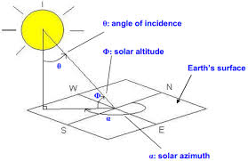
Figure 1 Solar Geometry
The Earth is tilted about 23.5°on its pole-to-pole axis, relative to the horizontal plane of its orbit. This results in a 47° peak solar altitude angle difference, causing the hemisphere-specific difference between summer and winter. In the northern hemisphere, the sun remains on the south-facing (equator-facing) side of the house all day long, and varies in its incident angle.
- SOLAR PV TREE
The concept of a “Solar PV Tree” is a unique blend of art and technology to form a solar PV sculpture. This novel idea was considered as an attempt to use the new technology of solar power and artistic aesthetics. A solar tree is basically a decorative means of producing renewable electricity. It has a tree like an edifice and panels are arranged as leaves on the branches of the energy tree. It’s just like a natural tree but with solar panels instead of leaves [1].
Solar tree is a self-contained photovoltaic installation. It is equipped with a series of solar panels that produce voltage at their respective ends as long as they are illuminated by sunlight. After that, the voltage can be utilized to charge batteries. The energy stored in the batteries is subsequently used for a variety of reasons. Unless the batteries need to be replaced every few years, the electric energy supplied by this device is absolutely free. Additional automatic control of the charging and discharging processes of the batteries can ensure that the batteries last as long as possible.
‘TREE’ stands for
T = Tree generating
R = Renewable
E = Energy and
E = Electricity
Solar tree embodies a steel structure, on top of which solar panels collect Sun’s radiant energy to charge mobile phones, laptops and small electronic gadgets. It can also be used for charging street lights. Since panels are arranged at different angles, a solar PV tree is able to capture incident Sunlight throughout the day irrespective of the position of the Sun. The three-dimensional structure of solar tree can enhance the total surface area for Sunlight capture.
- Objective of building solar tree:
- There was a huge economical barrier in building solar tree but we built a cost-efficient solar tree.
- There were only some standard solar trees structural design, we tried making a better structure for the solar tree plant.
- We tested it with a sprinkler system in order to improve the efficiency of the power plant.
Some more advantages of solar tree are:
In the field of golf courses and resorts; In urban and rural areas; Applicable in recreational parks, city parks; In penthouses, balconies, verandas, private gardens; Applicable on highways. In deforested areas; It is used for street lighting; It is also used for domestic supply; It is applicable for industrial power supply; It can also useful for continuous power supply; It is used in batteries charging of mobile phones, laptops, tablets; Wireless data transmission.
- Basic components of a solar tree
- Solar PV Panels
- Cables for connecting modules
- Inverter
- Batteries
- Structure
- MPPT Energy Charge Controller

These are the basic components of solar tree but for its advancement we can also use Solar Trackers and other similar devices such as Solar Concentrator.
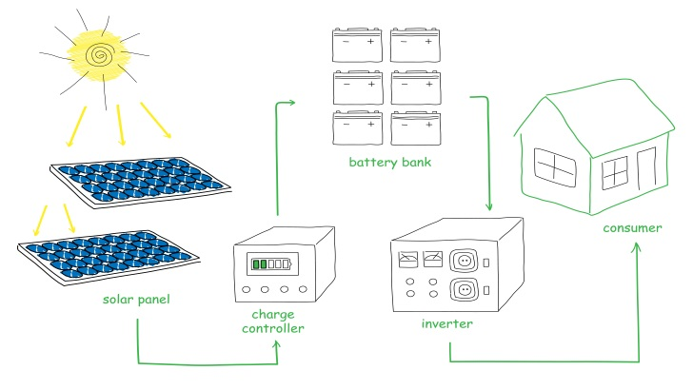

Figure 2. Solar PV System
- Designing of Solar Tree
Solar energy, is considered as the most abundant and important indispensable source of energy, can be used in the form of electrical energy using solar panels. But solar power panels need a large area to be established (in civic areas it’s not possible find such a large area), and has issues with prisoner effectiveness and public perception. In similar situation, Solar tree is the stylish conception, being able of dealing with these problems effectively. A solar tree is structure or artwork digging photovoltaic technology on a single pillar, like a tree structure. Ideal conversion of power from solar panels can be attained by using maximum power point tracking (MPPT), which involves the adaptation of panels’ angle in agreement to the change in the angle of falling irradiance. In the project 50 watt 10 solar PV panels are used to create a tree like structure with keeping in mind to minimize the shadowing effect and also giving each panel an inclination angle of 22.5º towards south-east direction then a MPPT solar hybrid inverter is used to yield the maximum solar energy which will be stored in the fast-charging solar battery. Further, Internet of Things (IoT) will be implemented in the project which will help in two things firstly for recording the data of panels for research purpose and secondly for monitoring purpose that will be used in sprinkler system which would be installed on the solar tree to improve the efficiency of the solar panels as we know that temperature effect the efficiency of the panels. At high temperature the efficiency of the panel is compromised and to overcome this an Automated Sprinkler System will be used.
The solar tree is designed in a way that each panel works with maximum efficiency for maximum time period. For which the main task was to eliminate the shadow effect. So, the task was fulfilled with the help of tinker cad.
The basic points we kept in mind were
- The branches should be at 120º separated from each other and the branch above it should be in conjugate with it. So, the shadow of above panel doesn’t stop the rays of panels below it.
- The branches were inclined at an angle of 22.5º with respect to the pole(structure).
- Further the panel should be kept South-East direction (as per Indian standards).
3-D design of solar tree, prepared by Tinkercad software is shown in fig.2

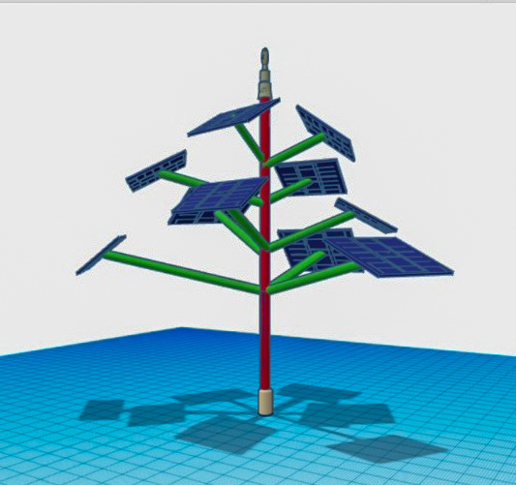
Figure 2 Design by Tinkercad
- Schematic and Circuit Diagram of the Solar tree: Schematic and circuit diagrams are shown in fig.3 and 4 respectively

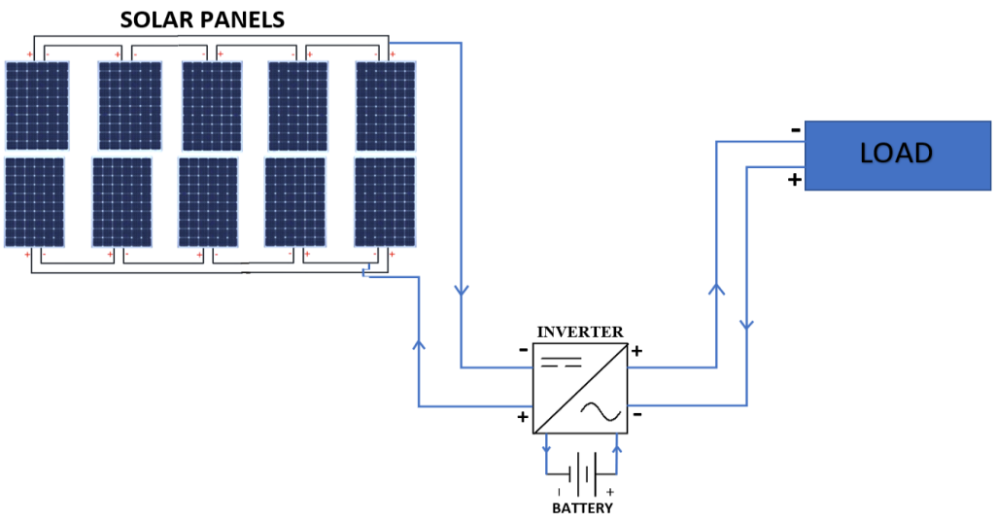
Figure 3 Schematic Diagram

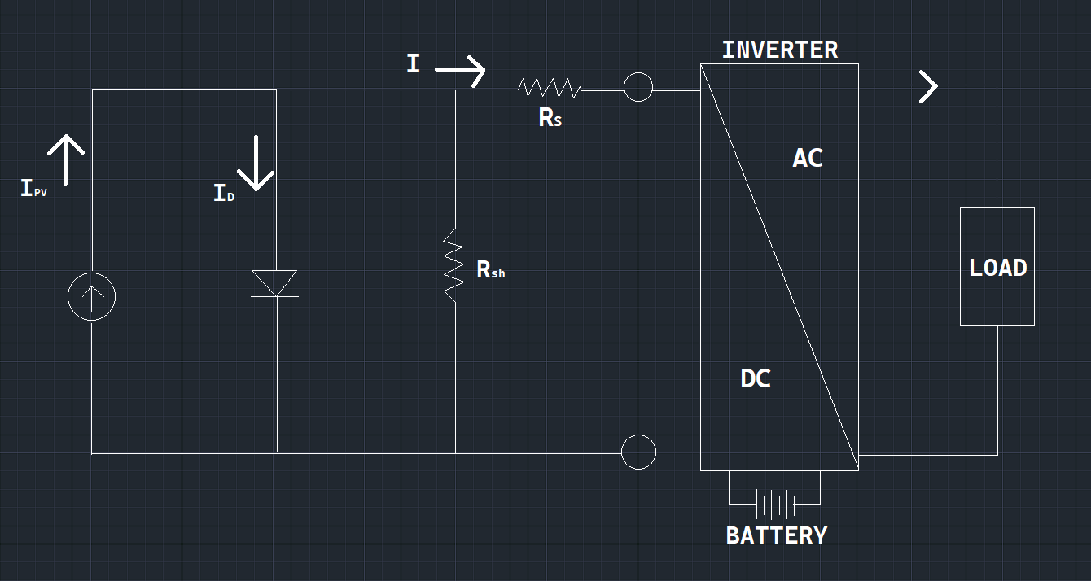
Figure 4 Circuit Diagram

- Block Diagram of the Project:

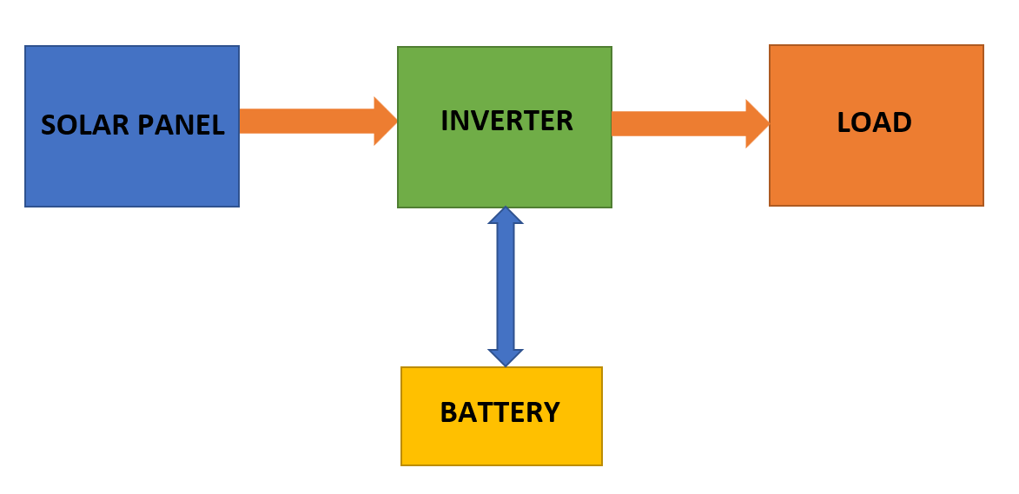
Figure 5 Block Diagram

- CONSTRUCTION OF SOLAR TREE

An objective of many solar tree installations is to promote awareness, understanding, and adoption of renewable energy. They are not typically used as a primary source of energy for a property—that role is accomplished by rooftop solar systems. Solar trees are complementary to rooftop solar systems, or other green building measures, symbolizing these larger investments and their environmental benefit. Solar trees may build awareness and interest in solar technology and also provide shade and meeting places. There are many objectives that a solar tree hold beneath some of them are listed below.
Some of the general objectives of the solar tree are:
1. Agricultural field
- They are also used to power tillers, pumps, etc.
2. Commercial Buildings
- In various companies, factories, offices, schools, etc; Solar trees can be installed with proper land management.
3. Residential Sites
- Residential areas like colonies can be benefitted from the solar trees.
- They are also used in green or net-zero energy buildings.
- They can also be easily installed/placed at verandahs, private gardens (see Figure 8).
4. Highways
- Solar trees can be installed across highways to power lighting systems and surveillance cameras.
5. Coastlines
- They can be used on coastlines as on highways.
6. Public Places
- They can be installed at public places like parks, gardens, tourist spots, etc to power lightings as well as to increase aesthetic appearance..
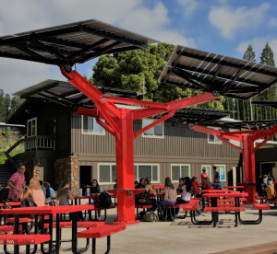
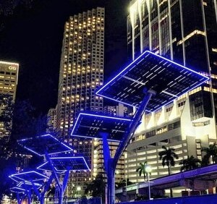

- CONCLUSION
In conclusion, the concept of a solar tree represents a innovative and sustainable solution in the field of renewable energy generation and urban design. By mimicking the form and function of a tree, these structures integrate solar panels into their design, harnessing solar energy efficiently while also adding aesthetic value to urban environments.

Solar trees offer several key advantages. Firstly, they optimize space utilization, making them particularly suitable for urban areas with limited available land. Secondly, their design allows for better solar panel orientation, maximizing energy capture throughout the day. Additionally, solar trees can serve as charging stations, providing convenient access to clean energy for electric vehicles and devices.

The implementation of solar trees can contribute significantly to reducing carbon emissions, decreasing reliance on fossil fuels, and promoting sustainable energy practices. However, challenges such as initial setup costs, maintenance, and ensuring compatibility with local infrastructure need to be addressed for widespread adoption.

As technology continues to advance, solar trees may become even more efficient and cost-effective, making them an increasingly viable option for mainstream energy generation. Their ability to combine functionality with aesthetics and environmental benefits makes them a promising innovation in the journey towards a greener and more sustainable future.
REFERANCE
[1] Mr. A P R Srinivas, “Design and Development of a SOLAR TREE”, International Journal of Scientific & Engineering Research, Volume 7, Issue 10, October-2016 ISSN 2229-5518.
[2] https://www1.eere.energy.gov › solar_timeline.
[3] Holck, O. and Rosenfeld, J.L.J. (2005). Estimation of Exposure to Sunlight of the Liner Under a Tiled Roof Solar Energy. Vol 78 No. 2. pp. 199–209.

[4] Jenny Nelson, The Physics of Solar Cells, Imperial College Press, 2003.

[5] Mr. A P R Srinivas, “Design and Development of a SOLAR TREE”, International Journal of Scientific & Engineering Research, Volume 7, Issue 10, October-2016 ISSN 2229-5518.

[6] Notton. G, Cristofari. C, Mattei. M. and Poggi. P. (2005). Modelling of a double-glass photovoltaic module using finite differences, Appl. Therm.Eng, 25, 2854–2877.
[7] Kumar, S., Tiwari, P. & Zymbler, M. Internet of Things is a revolutionary approach for future technology enhancement: a review. J Big Data 6, 111 (2019).
[8] Manish Dhone, Kishor Sonwane, Denis Farkase, Jayantsingh Baghel “A Review on Solar Tree” International Journal of Scientific and Research Publications, Volume 4, Issue 2, December 2018 IJARIIE-ISSN(O)-2395-4396
[9] G. S. Karlekar Asst. Professor, Department of Electrical Engineering. Ballarpur Institute of Tech., Ballarpur, India. International Journal of Engineering Applied Sciences and Technology, 2020 Vol. 4, Issue 10, ISSN No. 2455-2143

