RADIOPHARMACEUTICAL SCIENCE
Rajni Dubey, Surendra Dangi, Satyabhavna Sakre

Associate Professor, School of Pharmacy and Research People’s University Bhopal, Madhya Pradesh.
Associate Professor, School of Pharmacy and Research People’s University Bhopal, Madhya Pradesh.
Assistant Professor, School of Pharmacy and Research People’s University Bhopal, Madhya Pradesh.

Introduction: - A intriguing area of scientific study focused on the investigation of radioactive compounds used as therapeutic agents is known as radiopharmaceuticals. These compounds have the ability to release radiation continuously on their own, which causes them to gradually break down into stable nuclei. It's interesting to note that outside factors like temperature, pressure, concentration, or the presence of a catalyst still have an impact on radiation emissions.
There are different types of radiopharmaceuticals:
A radiopharmaceutical preparation: - is a medication in a ready-to-use form that is safe for human consumption and includes a radionuclide. The radionuclide is essential to the preparation's medical use, making it suitable for one or more diagnostic or therapeutic uses.
A radionuclide generator: - is a device that separates a daughter radionuclide with a short half-life from a parent radionuclide with a long half-life in order to produce a radiopharmaceutical preparation.
A radionuclide generated:-for radio labelling with the end product being a radiopharmaceutical preparation is referred to as a radiopharmaceutical precursor.
A radiopharmaceutical preparation kit: - is a vial containing the non-radionuclide components of a radiopharmaceutical preparation, typically in the form of a sterilized, validated product to which the appropriate radionuclide is added or diluted before medical use. The kit is frequently a multidose vial, and the radiopharmaceutical preparation may include additional steps such boiling, heating, filtration, and buffering. Radiopharmaceutical formulations made from kits are normally advised to be used within 12 hours after production.
Radioactivity:- is a natural and spontaneous occurrence in which unstable atoms of particular materials release or radiate excess energy as particles or waves. Following emission, the daughter atom might be a lower-energy variation of the same element or a totally other element. Because of their propensity to remove electrons from the atoms of whatever object they contact, these released particles or waves are referred to as ionizing radiations.
The most frequent type of radiation released has typically been classed as:

- α rays
- β rays
- γ rays

Radioactive rays
Alpha rays:
- The alpha particles are the heaviest as they are produced when the heaviest element decay.
- They are not waves but high energy particles which are expelled from unstable nuclei.
- These are similar to Helium atom and contain two protons and two neutrons, having a mass of 4 amu.
He or α-particle
4. These particles are large and heavy in nature, so cannot penetrate but easily get absorbed.
5. Due to less penetration of alpha particles, because they cannot permeate tissues, the elements that release them are useless in biological applications. 6. When a radioactive element produces alpha particles, the resultant nucleus has an atomic number that is less than two units and a mass number that is less than four units less than the original.
Ra ⎯→ Rn + He (α)
7. In an electric or magnetic field, they are deflected.
8. They cause fluorescence and phosphorescence in certain materials, such as zinc sulphide.
9. They can penetrate matter by ionizing the gas through which they move.
10. Their energy is around 6 meV.

Beta rays:
1. They are much lighter energy particles and have less ionizing power than alpha particles.
2. Beta particles are 8000 times smaller than the alpha particles.
3. The emission of beta particles from element does not alter the atomic mass and is converted to element with next higher atomic number
C ⎯→ N + β⁻
4. Beta particles have negligible masses, about 1/1836 than of hydrogen ion and are high speed electrons. (e or β-particle).
5. They are deflected in an electric and magnetic field.
6. They can penetrate matter by ionizing the gas through which they move. Their penetrating power is 100 times that of -particles, yet their ionizing strength is 1/100th that of -particles.
7. Fluorescence and phosphorescence are produced in some materials, such as zinc sulphide.
8. They have an energy range of 2 to 3 meV.

Beta particles can be classified into two types:
Electron emission or negatrons: These are emitted by unstable nuclei in which neutrons are transformed into protons with beta emission.
n → p + β
Here the released proton particle has the same mass as that of original atom while the
β-particle has charge as an electron.
Positrons:
1. A positron is a beta particle formed when a proton within a radionuclide nucleus is transformed into a neutron. It is uncommon, and because they are short-lived, they have no biological application.
2. Positron emission reduces the quantity of proton relative to neutrons, and this kind of decay is common in big "proton-rich" radionuclides.
3. Carbon-11, Nitrogen-13, Oxygen-15, Aluminium-26, Sodium-22, Fluorine-18, and Iodine-121 are among the isotopes that undergo this decay and so emit positrons.
C ⎯→ B + $\begin{matrix}0 \\ 1\end{matrix}$β
Gamma rays:
- They are having completely different character. They do not have any charge or mass on them. It travels with the same velocity of light.
- Gamma rays are like X-rays, have shorter wavelength than the visible light.
- Penetrating power of gamma rays was found to be more than alpha and beta rays.
- When gamma rays are emitted from a radioactive element, no change or loss of atomic mass or number takes place, only there is lowering of nuclear energy.
5. They cause fluorescence in some materials.
6. They generate heat on the surface they hit and knock electrons out of it.
7. They are capable of causing a nuclear reaction.
Characteristics of Gamma, Beta, and Alpha Radiations
Property | Type of Radiation
 | α | β | γ
Charge | + 1 | − 1 | 0
Mass | 6.64 × 10⁻²⁴ g | 9.11 × 10⁻²⁸ g | 0
Relative penetrating power | − | 100 | 10,000
Nature of radiation | He nuclei | Electron | High-energy photons

Isotopes:
Isotopes are atoms of the same element with the same atomic number but differing mass values. Nuclides are another name for isotopes. Nuclides contain the same amount of protons but differ in their neutron count. They are chemically identical, but their physical qualities differ because to the variable amount of neutrons. e.g. There are three isotopes of hydrogen:

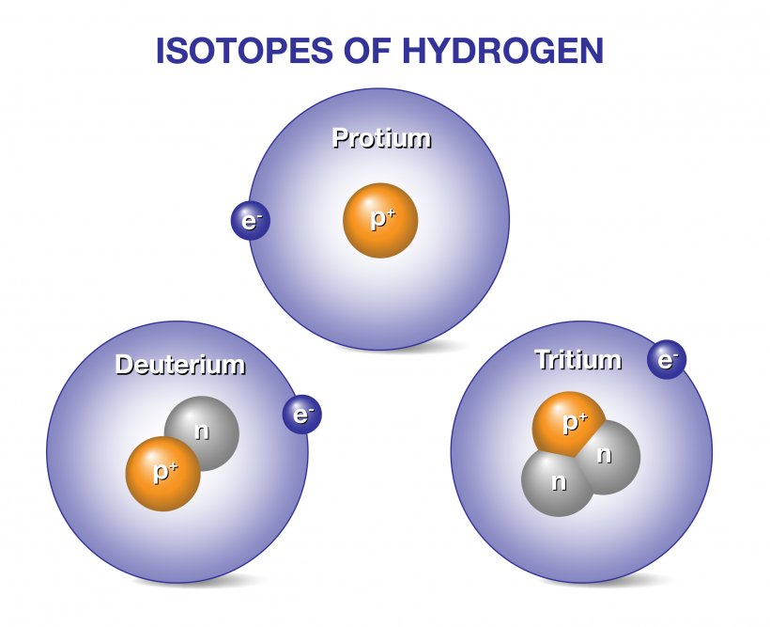

Isotopes are classified into two types:
1. Stable Isotopes
2. Radioactive Isotopes
Stable Isotopes: These isotopes are stable in nature and do not emit any kind of radiation. e.g. ¹³C, ³⁵Cl, ¹H (protium), ²H (deuterium)
Radioactive Isotopes: Radioactive isotopes are also referred to as radioisotopes. These are naturally or chemically generated isotopes of a chemical element with an unstable nucleus that decays, producing alpha, beta, and gamma rays until stability is achieved. A non-radioactive isotope of another element is the stable end result. The parent nuclide is the initial nuclide, while the result is the daughter nuclide. This nuclear alteration is known as disintegration or radioactive decay. e.g.
X ⎯⎯⎯⎯⎯⎯⎯→ X + α-rays
Parent nuclei Daughter nuclei (Stable or unstable)
Radioactive Isotopes are of two types:
1. Naturally occurring: e.g. U²³⁵(Uranium), Ra²²⁶(Radium), Rb⁸⁷(Rubidium),
K⁴⁰ (Potassium)
2. Artificial radionuclides: They are created during nuclear processes. It is formed by hitting atoms of a given element with radiation particles, resulting in the formation of new atoms from another type of element. e.g. By hitting aluminium with alpha particles, a radioactive isotope of phosphorus is created.

Al + He ⎯→ P + n
Stability of Isotopes:
The naturally occurring nuclides have a particular ratio of protons and neutrons in most of the elements. Any deviation in this ratio alters the atomic number and cause unstability of nucleus. e.g. Stable ratio of potassium is 1:1.115.
If more neutrons are added to the nucleus, this ratio will get disturbed and nuclide becomes unstable.
- Most isotopes of element with Z number 83 or less are stable and are called as stable isotopes.
- However, some naturally occurring isotopes with Z number less than 83 are unstable.
- All the nuclides with Z number above 83 whether naturally occurring or artificially prepared are unstable.
Radioactive decay
Radioactivity involves release of radiation from the nuclei of radioactive isotopes. The quantity of radioactivity contained in given sample does not remain same and keep on decaying continuously. Each radionuclide, whether natural or artificial get disintegrated by the emission of energy.
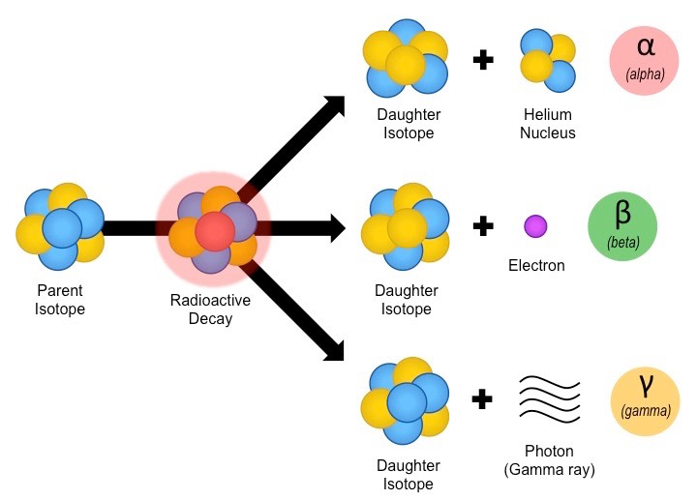
Identification of radioactive element depends upon:
- Disintegration rate
- Decay constant
- Half life
- Type of radiation emitted
Half-Life (t_{1/2}):
It is the time required for a radioactive isotope to decay to one half of its original value at any given point of time.
Each radioactive element has its own characteristic half-life (t_{1/2}), irrespective of quantity present.
t_{1/2} = λ where λ = Disintegration constant
The half-life period for any given radioelement remains unchanged under varying conditions of temperature, pressure and chemical environment. This is because radioactivity is a nuclear property and remains unaffected by changes in the outer electron arrangement.
e.g. Initially 64 micro curies of radioactivity occur in a given sample of ferric citrate (⁵⁹Fe) solution on a particular date.
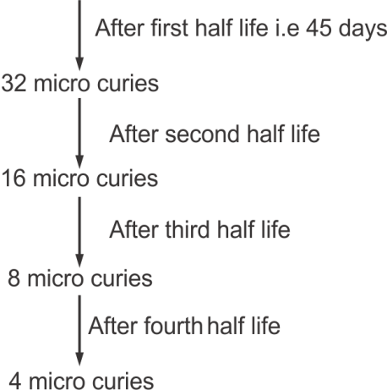

After the fourth half-life, radioactivity is decreased to one-sixth of its initial value. When estimating the dosage of any radiopharmaceutical, the t1/2 calculation must be taken into account.

Name | Half-life | Application
Ferric citrate (⁵⁹Fe) solution | 45 days | Study of iron metabolism and RBC formation
Sodium iodide (¹³¹I) | 8.06 days | Thyroid scanning and study of thyroid uptake
Sodium phosphate (³²P) injection | 14.2 days | Treatment of polycythemia (overproduction of RBCs)
Calcium chloride (⁴⁵Ca) | 160 days | Study of calcium metabolism disorder, bone cancer
Ammonium Bromide Injection (⁸²Br) | 36 hrs. | Extracellular water measurement

Units of Radioactivity:

Curie: It is represented by the letter "C" and is defined as the amount of any radioactive material that disintegrates at a rate of 3.7 1010 per second, or the same rate as 1 g of radium..
1 gm of radioactive element = 3.7 × 10¹⁰ disintegrations/sec

Roentgen: It is a unit of measurement for the exposure of X-rays and Gamma rays.
1R = 2.58 × 10⁻⁴ C kg⁻¹ (C = Couloumb)

RAD (Radiation Absorbed Dose): It measures the radiation dosage that was absorbed. 1 RAD = 10⁻² J/kg
Each 1R absorption in the air has been equivalent to 0.87 RAD and for water it has been 0.97 RAD.

RBE (Relative Biological Effectiveness): Relative Biological efficacy, or RBE, is a measurement system that has been developed because the biological efficacy of a particular radiation varies on the radiation's kind. The relative effects of radiations (alpha, beta, and gamma) on the biological system are expressed in this.
Becquerel: One disintegration per second
1 Bq = 2.7 × 10⁻¹¹ Ci (Ci = Curie)
Radioactive Dosimetry:
Dosimetry is the measurement of radiation dose. Radiation dose can be calculated only if bio-distribution and clearance rate are known. Bio-distribution is the amount of activity within the organ, while the clearance rate is the rate at which the drug is eliminated from the body with respect to time.
The SI unit of dosimetry is Gray (Gy) or rad.
1 Gy or rad = One gray of radiation is equal to one joule of energy in the form of ionizing radiation, divided by one kilogram of matter.
Radiopharmaceuticals used in majority of diagnostic studies in adults ordinary result in organ dose of less than 5 rads, within dose to the whole body of less than 0.2 rads. Radiation dose below 1.0 rad are considered to be in ‘low dose’ range.
Radiation dose level is estimated using average activities administered to adults like:
Radiation dose | Diagnostic use
High doses (>5 rads) | - ¹³¹I- Sodium iodide for thyroid imaging  - ^{m}I-iodocholesterol for adrenal imaging  - ^{n}Se-Selenomethionine for pancreas imaging  - ^{99m}Tc-DMSA (dimercaptosuccinic acid) for renal imaging
Medium dose (1-5 rads) | - ^{99m}Tc-pertechnetate for brain imaging  - ^{99m}Tc-(DTPA Diethylenetriamine-pentaacetic acid) for brain imaging  - ^{99m}Tc-Sulphur colloid for liver imaging  - ^{99m}Tc-diphosphates for bone imaging  - ⁶⁷Ga-citrate for tumour and abscess imaging  - ²⁰¹Tl-chloride for heart imaging  - ⁵¹Cr-Sodium chromate for red cell studies  - ^{99m}Tc-gluceptate for brain and kidney imaging
Low dose (< 1 rad) | ^{99m}Tc (Technetium)-red blood cells for blood pool imaging  ^{99m}Tc-MAA (Macro aggregated albumin) for lung imaging  ¹³¹I-hippuran for kidney function studies  ¹²⁷Xe and ¹³⁰Xe for lung ventilation imaging

Mode of Decay:
Radionuclide can undergo disintegration by different modes until a stable nucleus does not form. If the daughter element is unstable it becomes a parent element and starts decaying, until it becomes stable. This series is called as radioactive series.
Daughter nucleus thus formed from the parent nucleus will have different number of neutrons or atomic number.
Measurement of Radioactivity
The measurement of nuclear radiation and detection is an important aspect in the identification of type of radiations (α, β, γ) and to assay the radionuclide emitting the radiation, suitable detectors are required. The radiations are identified on the basis of their properties.
e.g. Ionization chambers, proportional counters, and geiger-Muller counters are used to measure ionization effect.
The scintillation effect of radiation is measured using scintillation detector and the photographic effect is measured by Autoradiography.
Principle: All detectors work on the idea that radiation deposits its energy in the detector through the generation of charge carriers, either directly or indirectly, resulting in the flow of current or a voltage pulse. Applying an electric field within the detector allows for the collection of the ions produced there, and an electrometer may be used to monitor the current moving through the detector.

Gas Filled Detectors:
1. Ionization Chamber:
It is the most basic gas-filled detector, based on the collection of all charges produced by direct ionization of gas molecules using an electric field.
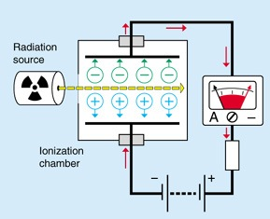
It comprises of a chamber filled with gas such as Argon, Helium, or Air, among others. The ionization chamber is outfitted with two electrodes maintained at varying electric potentials (50-100V for each cm of distance between two electrodes) and a measurement device to detect current flow. Radiation causes the ionization of gas molecules or ions, which results in the release of electrons, which displays changes in electric current.
2.Proportional Counters:
It is a modified type of an ionization chamber in which an applied potential produces ionization of the main electron, which results in thunderous bursting/production of more free electrons, which are transferred to the anode and amplified by an electric circuit. The voltage range across which ionization occurs is known as the proportional region, and counters that operate in this region are known as proportional counters. When the electric field gradient between the cathode and anode is raised by raising the applied voltage, the electron created in primary ionization ionizes the gas molecule further, increasing the number of ion pairs. Larger numbers of extra electrons are freed for each main electron liberated, and the current pulse is amplified.
The overall charge collected becomes proportional to the number of ion pairs originally present. It operates at a pulse ratio and is used as a gas filled or gas flow counter for, and fission fragment counting.
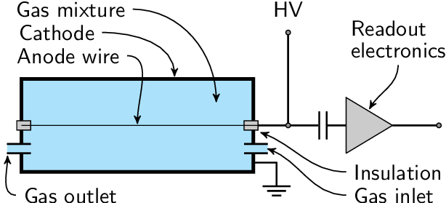

3. Geiger-Muller Counter:
Geiger and Muller invented the GM counter in Germany in 1928. It is the oldest radiation detector because of its inexpensive cost, simplicity, and superior performance in operation.It does not require the use of a high gain amplifier and can quickly detect,, radiations.
Principle:
A GM counter is made up of a GM tube, a sensor element that detects radiation, and processing circuits that show the results. The GM tube is filled with a low-pressure inert gas such as Helium, Neon, or Argon and subjected to a high voltage (450-500 V). When a particle or photon of incoming radiation ionizes the gas, the tube transmits electrical charge. The ionization is greatly amplified within the tube, resulting in an easily quantified detection pulse that is supplied to processing circuitry, which displays the result.
Construction:
- It consists of a cylinder 1-2 cm in diameter of stainless steel or glass coated with silver on inner side which acts as cathode.
- Internally a tungsten wire is suspended which is mounted at one end with a glass bead, act as anode.
- Cylinder is filled mixture of gas (argon and helium generally used) which also contain a small amount of quenching vapours.
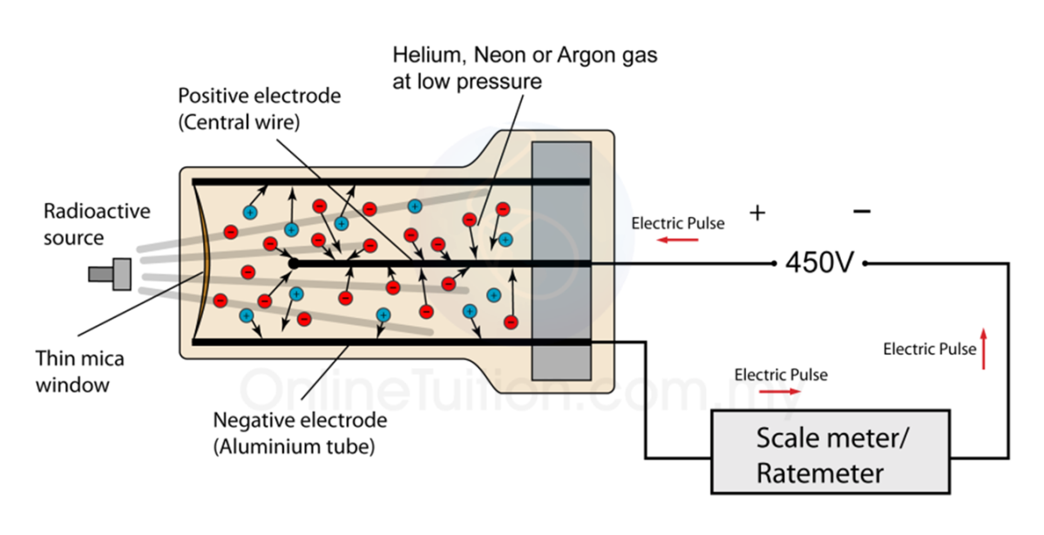
Quenching vapours are used:
(a) to avoid the potential false pulse that would be created if a positive ion reached the cathode.
(b) To take in photons that are released when excited atoms and molecules go back to their ground state.
Note: Chlorine, Bromine, Ethanol are commonly used as quenching agents.
Working:
- Radiations when enter the tube through a thin section also called as window causes the ionization of gas molecules. From these ionized atoms or molecules, an electron is knocked out of the atom and the remaining atom is positively charged.
- When the high voltage is applied across the electrode (300-1300), the electrons and positively charged ions are attracted towards anode and cathode respectively.
- Hence, each particle of radiation produces a brief flow or pulse of current which can be transmitted to radioactive sensor via an interface, which is finally recorded in computer.
- All pulses from a GM counter are of same amplitude for any incident radiations.

Disadvantages:
A GM counter cannot distinguish between types of different radiation and their energy. However, the multiplication factor is a big advantage in simple radioactive counting.

Scintillation Detector:
When high energy radiation or photons is incident on certain substance, a flash of light is emitted by the phenomenon called fluorescence or phosphorescence.

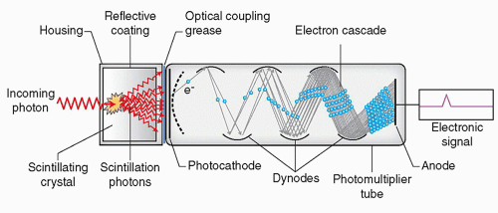
Scintillation Detector
This output light can be used as a measure of adsorbed radiation on scintillation detector. This emitted light when enters into photo-multiplier tube; it multiplies and amplifies even a small signal. So it becomes possible to measure alpha, beta or gamma radiation by scintillation detector.

Important properties of good scintillation detector are:
- High scintillation efficiency.
- The light produced should be proportional to the light incident on detectors.
- Detector material should be transparent to the wavelength range and must not produce any interference in the resultant spectra.
- Short decay time of the induced fluorescence can be increased by dynodes which are made up of phosphor or fluor which multiplies the electrons when strike to them. Hence various inorganic and organic scintillation detectors can be used to measure the incident radiation.
- Inorganic scintillation detectors like alkyl halides are most common compounds.
e.g. Sodium iodide, Cesium iodide, Lithium iodide.
- Organic Scintillators like plastic scintillators have good scintillation property but stilbene have low scintillation property.
Semiconductor Detector:
It is an electron-rich (n) and electron-poor (p) semiconductor diode. Since the band gap in a semiconductor is relatively tiny (on the order of 2-3 eV), many electron hole pairs are created, which results in very excellent resolution for these detectors. When a reverse bias is applied across a diode, electrons move toward the n-end while "holes" move toward the p-end. The production of electron and hole pairs, which move under the influence of the applied electric field, occurs as a result of the absorption of incoming radiations. A voltage pulse that is proportionate to the strength of the incident radiation is created by the collection of electrons at the electrode.

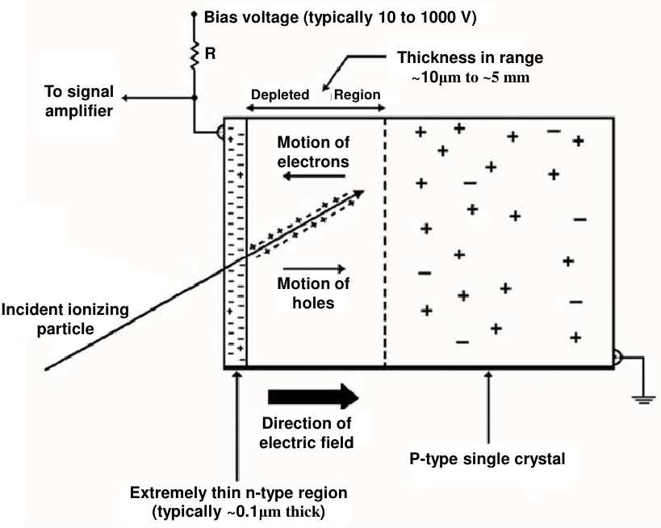
Solid State Detectors:
They have high resolution, compactness and easy interpretation of output signal.
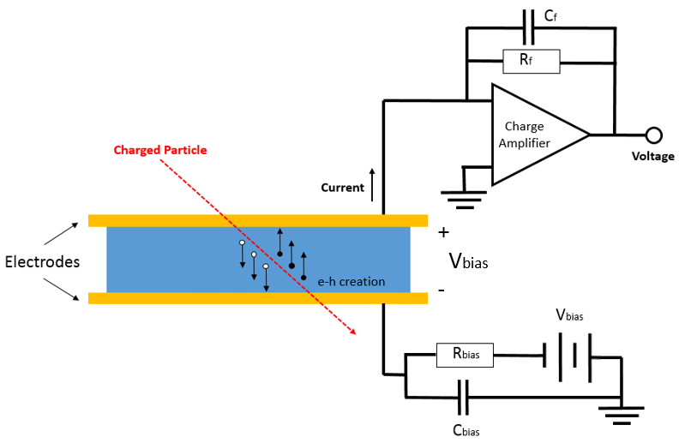

(a) Cerenkov Detector: These are based on light that is produced by rapidly charged particles passing through an optically transparent material with a refractive index greater than one. The Cherenkov detector's schematic arrangement is shown in the experiment that found the antiproton. The unusual configuration of the cylindrical and flat mirrors (a) enables the choice of a narrow range of Cherenkov angles and the positioning of the three PMTs outside of the particle's path. The counter's forward portion is seen in (b).

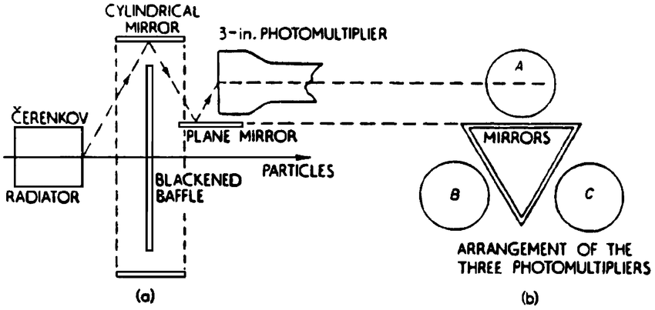

(b) Thermoluminescence dosimeters: These are composed of those inorganic crystals where electron hole pairs have generated as a result of radiations that may trap these pairs and cause light to be emitted when heated. LiF, CaF2, CaSO4:Mn, etc.
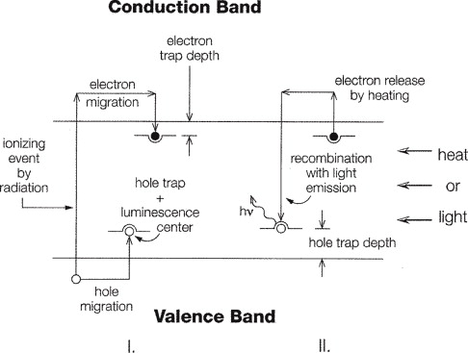
(c) Track-etch Detector: Ionizing radiations with a greater linear energy transfer (LET) generate a trail of damaged molecules as they travel through a dielectric substance. When etched in a strong acid or alkali solution, the tract can be seen in various materials. The damaged molecular pathways etch quicker than the bulk and appear as surface pits. By looking through a microscope, these tracks may be counted. Quartz, mica, silica glass, flint glass, polyethylene terephthalate, cellulose triacetate, and cellulose nitrate are typical track-etch materials.
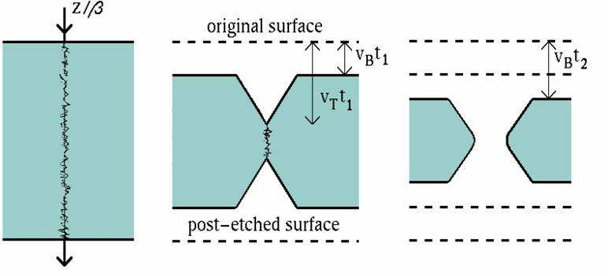
(d) Autoradiography (Photographic Emulsion : A glass or cellulose acetate film supports silver halide grains (AgBr) suspended in a gelatin matrix in ordinary photographic film. The silver halide grain is ionized or sensitized by incident radiation, and it remains intact until it is developed for an eternity. In physiological investigations of plants and animals, they are more helpful in detecting and identifying gamma radiations. First, give an animal a radioactive material. After allowing enough time for localization, remove the tissue and embed it in paraffin. Now, divide into pieces and store in a dark room with photographic emulsion. Radiation-emitting radioactive particles also darken, develop, and fix the photographic emulsion.

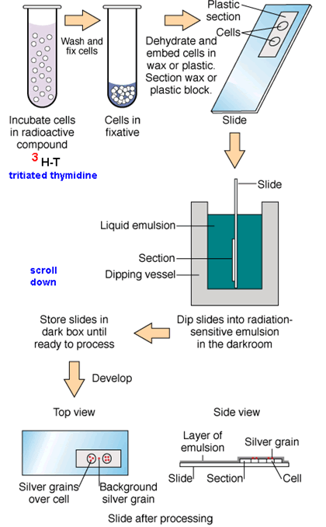

Handling and Storage of Radioactive Material:
Radioactive material must be handled and stored with extreme caution in order to safeguard humans from its negative consequences.
- The radioactive materials are stored in remote areas such that it should be away from exposure to human beings.
- α and β-emitters are stored in thick glass such that shielding effect is provided,
while γ-emitters are stored in lead containers.
- The area of radioactive material should be tested for intensity of radioactivity.
- Exposure to radioactive radiation can cause blood cancer to persons.
- Lead shielding is required while handling with radioactive substances.
- Shielding effect can also be achieved by water layer and concrete blocks. Water layer blocks only radiation which allows visible light to pass while concrete blocks all the radiations.
Certain precautions must be taken:
(i) Radioactive material should never be touched with hands but handled by means of forceps.
(ii) Food contaminated with radioactive material can cause serious damage to internal organs, so avoid any food intake, drinking and smoking within the lab.
(iii) While handling the substance, appropriate shielding or protective clothes must be used.
(iv) Radioactive material needs to be insulated and stored in clearly marked containers.
(v) Area of storage must be under proper supervision.
(vi) Disposal of radioactive material is done with great care.
Packaging and Storage Condition:
The solution has to be prepared in single dose or multiple dose containers that have been previously treated to prevent absorption. So as to avoid absorption of radionuclides on the wall of the container including laboratory vessels, it has been recommended that containers used to handle sodium iodide I-131 solution, should be first of all rinsed with a solution having approximately 0.8% of sodium bisulphate and 0.25% of sodium iodide and then water until the last rinsing has been neutral to litmus.
Uses:
- Radioactive iodine is mainly used for the diagnosis of disorders of thyroid function.
- It is also used in the treatment of hyperthyroidism.
- Radioactive iodine is also used in the treatment of Grave’s disease (toxic diffused goiter).
- It is also used in radiotherapy of thyroid cancer.
- It is also used in the treatment of thyrotoxicosis.

Applications of Radioisotopes
Radioisotopes have their uses in medicines in four different ways:
(i) Radioactive tracers for diagnostic purpose.
(ii) Radiation source in therapy.
(iii) Research.
(iv) Sterilization.

(i) Radioisotopes in Diagnosis:
- Chromium in the form of sodium chromate attaches strongly to the haemoglobin of red blood cells. This makes radioactive chromium-151 an excellent isotope for determining the flow of blood through the heart. This isotope is also useful for determining the lifetime of RBC, which can be of great importance in the diagnosis of anaemia.
- Cyanocobalamin (⁵⁷Co) is used for measuring glomerular filteration rate.
- Ferric citrate (⁵⁹Fe) injection finds the use in hematological disorders.
- Colloidal gold (¹⁹⁸Au ) has been used in studying the blood circulation in Liver.
- Sodium iodide (¹³¹I) injection is used to study the functioning of Thyroid gland.
- Iodinated (¹³¹I) human serum albumin injection finds the use to investigate cardiovascular functions.
- Radioactive cobalt (Cobalt-59 or Cobalt-60) is used to study defects in Vitamin B₁₂ absorption.
- Sodium iodohippurate I-131 injection finds the diagnostic use in the study of renal functions.
- Sodium rose Bengal I-131 injection finds use as a diagnostic agent to test liver functions.
(ii) Radioisotopes in Therapy:
The therapeutic use of radioisotopes depends on the ability of their ionization. These are useful to destroy or weaken malfunctioning cells. It is β-radiation that causes the destruction of damaged cells. The radionuclide therapy (RNT) or short range radiotherapy is known as brachytherapy and this is becoming the main means of treatment. Radiotherapy is less commonly used in the diagnosis of radioactive material present in medicines. An ideal therapeutic radioisotope should be a strong β-emitter with just enough γ to enable imaging. e.g.
- Yttrium-90 is used for the treatment of cancer particularly liver cancer and it is being used more widely including for arthritis.
- Iodine-131 is used to treat the thyroid for cancers and abnormal conditions such as hyperthyroidism.
- Phosphorus-32 is used to control the excess of RBC production in bone marrow
i.e. Polycythemia.
- Boron-10 is used in the treatment of tumor. Boron-10 gets concentrated in tumor and on irradiation with neutrons, it produces high energy α-particle which kills the cancer.
- Lead-212 can be attached to monoclonal antibodies for cancer treatment.
- The alpha decays of Bismuth-213 and Polonium-210 are the active ones destroying cancer cells over a couple of hours.
- Gold-198 finds use in carcinoma of uterus and urinary bladder.
- Cyanocobalamin finds use in diagnosis of pernicious anemia.
- Iodine-131 preparation finds use in the treatment of thyroid gland.
(iii) In Research:
Excellent biological and medicinal study can be carried out with radioactive isotopes as tracers. Generally Carbon-14 and Tritium are most commonly used.
(iv) Sterilization:
Thermolabile substances like vitamins, hormones, antibiotics can be safely sterilized by strong radiation sources. e.g. Cobalt-60 or Cesium-137 may be used for sterilizing surgical instrument.
1. Agricultural Use: Gamma rays are used to kill pests. These are used to induce genetic mutations in a plant in order to produce a better strain which has higher resistance against pest and diseases. Radioisotopes used as tracers in the effectiveness of fertilizers are N-15 and P-32.
2. Industrial Uses: Americium-241 is used in many smoke detectors for homes and business in thickness gauges designed to measure and control thickness during manufacturing processes. Californium-252 is used for neutron activation analysis,
to inspect airline luggage for hidden explosives.
3. Analytical Applications:
(a) Analytical procedures (b) Radioisotope dilution analysis
(c) Recovery indication in analysis (d) Radioimmuno Assay (RIA)
(e) Solubility determination (f) Activation analysis
(g) Enzyme assays (h) Receptor assays
4. Reaction Mechanism: Several instances have been reported of information concerning reaction mechanisms obtained with the aid of artificial radio elements.

Various therapeutic and diagnostic applications of radio-isotopes:

Sr. No. | Radio-isotope | Applications/Uses
1. | Calcium-44, 45 (Ca-44,45) | Study of bone structure and bone cancer
2. | Carbon-14(C-14) | Emit β-radiations, used in medical and pharmaceutical research
3. | Strontium-90(Sr-90) | Pure β-emitter, used in radiotherapy of superficial carcinoma.
4. | Cobalt-60(Co-60) | γ-emitter, radiotherapy , sterilization of heat labile substances, study of vitamin B₁₂
5. | Cobalt-57(Co-57) | Used in diagnosis of pernicious anemia

Sr. No. | Radio-isotope | Applications/Uses
6. | Hydrogen- ²H, ³H (β-emitter) | Used to determine total body water content
7. | Iron-59 (Fe-59) | Emit beta and gamma rays, used to study iron absorption, life span of red blood cells
8. | Nitrogen-13,15(N-13, N-15) | Used in investigation of amino acid and protein metabolism
9. | Oxygen-17,18(O-17, O-18) | To study organic reactions and photosynthesis
10. | Oxygen-15(O-15) | Cerebral blood flow imaging and myocardial blood flow imaging.
11. | Sodium-22,24(Na-22, Na-24) | Used in estimation of extracellular fluid, body circulation rate, excretion and distribution of water
12. | Sodium chromate  (Cr-51) solution | It finds use in measuring red cell volume and its survival time
13. | Cr-51 EDTA | For glomerular filtration rate estimation.
14. | Fluorine-18 (Positron emitter) | Used in investigation of tumor imaging, bone imaging, myocardial imaging.
15. | Gallium-67 (γ-emitter) | Tumor imaging and inflammation/infections imaging
16. | Gallium-68 (positron emitter) | Prostate cancer imaging
17. | Iodine-123 (γ-emitter) | Thyroid uptake and thyroid imaging, renal imaging
18. | Iodine-125 | Used in diagnosis of clotting by fibrinogen scan
19. | Iodine-131 | Used in thyroid uptake study, also used to treat thyroid carcinoma and non-toxic goiter.
20. | Krypton-81m (γ-emitter) | Lung ventilation and lung perfusion imaging
21. | Nitrogen-13 (positron emitter) | Myocardial blood flow imaging
22. | Phosphorus-32 | In the treatment of polycythemia and related disorders
23. | Radium-223 (α-emitter) | In the treatment of metastatic cancer in bone
24. | Selenium-75 (γ-emitter) | Investigation of adrenal gland imaging and bile salt absorption
25. | Technetium-99m (γ-emitter) | Investigation of stomach and salivary gland imaging, first pass blood flow imaging, bone marrow imaging, lacrimal imaging, gastric emptying imaging etc.

Hazards associated with Radiopharmaceuticals - The effects of radiation that might be harmful are only those brought on by changed individual cells (damaged either individually or in tiny numbers), which can lead to cancer induction, genetic changes, or impacts on an embryo. Diagnostic radiopharmaceuticals are linked to side effects such cell depletion in the bone marrow and reduced fertility or infertility.
The following hazards of radiation exposure and relative risk of such effects are observed:
1. Induction of Cancer: Humans exposed to low amounts of radiation are most likely at danger of cancer induction. Human malignancies caused by radiation include breast, thyroid, lung, leukemia, and gastrointestinal cancer.
2. Genetic Defects: The stimulation of genetic risk in humans is based on animal research, as there has been no major proof of radiation-induced gene mutation in people. Thus, the chance of a genetic problem in a kid of a patient who had a radionuclide diagnostic test is negligible.

3. Effect on the Embryo: The main impacts of high radiation doses on the embryo include mortality, deformity, and decreased growth. With larger dosages, these consequences become more likely. The stage of pregnancy at which the mother is irradiated is critical in determining consequences since the differentiating organ system is most sensitive at that time. Congenital deformity and retarded development are the most likely effects of radiation damage during organogenesis (approximately 11 to 50 days after conception), while growth retardation is the main impact of large doses following organogenesis.
4. Lactation: The use of radiopharmaceuticals during breastfeeding is dangerous because the radiation travels into breast milk. As a result, a safe delay between radiopharmaceutical delivery and resumption of breast feeding should be observed.
When Tc-99 is delivered, for example, breast feeding should be ceased for 24 hours.
Reference:

1. Nadugopal B, Swain SS, Ojha SK, Meher CP. Impact of radiopharmaceuticals in the healthcare system. PharmaTutor 2017;5:23–31.
2. Heske SM, Hladik WB, Laven DL, Kavula MP. Status of radiologic pharmacy education in colleges of pharmacy. Am J Pharm Educ 1996;60:152–61.
5. Paes FM, Serafini AN. Systemic metabolic radiopharmaceutical therapy in the treatment of metastatic bone pain. In: Seminars in nuclear medicine. Elsevier; 2010. p. 89–104.
6. Paes FM, Ernani V, Hosein P, Serafini AN. Radiopharmaceuticals: when and how to use them to treat metastatic bone pain. J Support Oncol 2011;9:197–205.
7. Taylor AT. Radionuclides in nephrourology, part 1: radiopharmaceuticals, quality control, and quantitative indices. J Nucl Med 2014;55:608–15.
8. A.H. Beckett & J.B. Stenlake's, Practical Pharmaceutical Chemistry Vol I & II, Stahlone Press of University of London, 4th edition.
9. Anand & Chatwal, Inorganic Pharmaceutical Chemistry
10. P. Gundu Rao, Inorganic Pharmaceutical Chemistry, 3rd Edition
11. https://www.ncbi.nlm.nih.gov/books/NBK554440/ ❖ https://www.sciencedirect.com/topics/chemistry/radiopharmaceutical
12. A.I. Vogel, Text Book of Quantitative Inorganic analysis ❖ https://www.cpp.edu/~pbsiegel/bio431/texnotes/chapter4.pdf

