Synthetic DNA delivery system – A brief overview
Kuldeep Vinchurkar¹, Praveen Sharma², Pritesh Paliwal², Nadeem Farooqui²
Laxmi Narain College of Pharmacy, Indore, M.P.
Indore Institute of Pharmacy, Indore, M.P.

Highlights:
- Introduction: Explain what synthetic DNA is, why it is important, and what are the main goals and challenges of synthetic DNA research and development.
- History: Provide a brief overview of the history of synthetic DNA, from the first synthesis of oligonucleotides in the 1950s to the recent achievements of creating artificial genomes and cells.
- Methods: Describe the main methods and techniques for synthesizing and manipulating synthetic DNA, such as chemical synthesis, enzymatic synthesis, gene editing, and DNA assembly.
- Applications: Discuss the various applications and potential uses of synthetic DNA in different fields, such as biotechnology, medicine, data storage, security, and bioengineering.
- Ethical and social implications: Address the ethical and social issues and concerns that arise from synthetic DNA, such as biosafety, biosecurity, intellectual property, regulation, and public perception.
- Conclusion: Summarize the main points of the chapter, highlight the current state and future prospects of synthetic DNA, and suggest some directions for further research.

- Introduction
The rapid progress in the field of synthetic biology has opened up exciting possibilities for applications in various domains, ranging from medical therapeutics and gene editing to agriculture and biotechnology. At the heart of these advancements lies the crucial challenge of delivering synthetic DNA constructs into target cells, tissues, and organisms effectively. Synthetic DNA delivery systems play a pivotal role in facilitating the integration of engineered genetic material into living systems, thereby enabling the realization of these groundbreaking applications.
The concept of synthetic DNA delivery revolves around the idea of introducing artificial genetic material, such as plasmids, oligonucleotides, or gene-editing tools like CRISPR/Cas9, into a recipient cell or organism. These synthetic DNA constructs hold the potential to modify or add specific genetic information, thereby altering cellular behavior or providing therapeutic benefits. Synthetic DNA delivery systems are essential tools that empower scientists to engineer and control genetic information at a level never before possible. At the core of these systems lies the artful design of carrier vehicles, meticulously engineered to safeguard the stability of synthetic DNA and navigate the intricate barriers that separate the external environment from the inner workings of living cells. The ability to transfer and precisely express foreign DNA sequences grants researchers unprecedented opportunities to explore gene function, correct genetic defects, and create novel genetic traits, all with profound implications for human health, disease treatment, and sustainable agriculture.
Synthetic DNA is the artificial creation of DNA molecules that can be used for various purposes, such as research, engineering, or data storage. Synthetic DNA can be made by assembling nucleotides (the building blocks of DNA) in a specific sequence, or by modifying natural DNA to alter its properties. Synthetic DNA can offer more flexibility and functionality than natural DNA, as it can be designed to have novel features or behaviors.
Synthetic DNA is important because it can enable new discoveries and innovations in various fields of biology, medicine, engineering, and data storage. Synthetic DNA can help scientists study genes and how they affect our traits, health, and evolution. Synthetic DNA can also help scientists create new organisms or modify existing ones for various purposes, such as producing drugs, vaccines, biofuels, or bioplastics. Synthetic DNA can also be used as a novel medium for storing information, as it can store more data in less space and for a longer time than conventional methods.
Some of the main goals of synthetic DNA research and development are
- To create new biological systems with novel functions and properties,
One of the main goals of synthetic DNA research and development is to create new biological systems with novel functions and properties. Synthetic biology aims to engineer and design biological components, pathways, and organisms to perform specific tasks or functions that do not exist in nature. This field goes beyond traditional genetic engineering by designing and constructing biological systems from scratch, rather than simply modifying existing organisms.
Some of the key goals in synthetic DNA research and development to achieve this objective include:
Engineering Novel Pathways: Synthetic DNA research aims to create new metabolic pathways and cellular processes that enable the production of valuable compounds, biofuels, pharmaceuticals, and other useful products. By introducing synthetic DNA constructs into host cells, researchers can reprogram cellular metabolism to produce desired molecules efficiently.
Designing Synthetic Genetic Circuits: Synthetic DNA research seeks to construct genetic circuits with precise control over gene expression and regulation. These circuits can be designed to perform complex computational operations or respond to specific environmental cues, enabling new levels of control over cellular behavior.
Creating Artificial Life Forms: Scientists are exploring the possibility of creating synthetic organisms with unique properties and functionalities. These artificial life forms, often referred to as xenobiology or xenobots, could serve as bioengineered tools for environmental cleanup, drug delivery, or other applications.
Expanding the Genetic Alphabet: Synthetic DNA research aims to expand the genetic alphabet beyond the four canonical nucleotides (A, C, G, and T). By incorporating novel nucleotides, researchers can develop synthetic DNA with increased information storage capacity and improved stability.
Gene Therapy and Precision Medicine: Synthetic DNA is a key component in gene therapy, where it can be used to deliver therapeutic genes into target cells to treat genetic disorders and other diseases. Synthetic DNA research aims to optimize the delivery and expression of therapeutic genes for safe and effective treatments.
DNA Data Storage: Synthetic DNA is being explored as a potential medium for long-term data storage due to its high information density and stability. Researchers are working on developing methods to encode and retrieve digital information using synthetic DNA.
Environmental and Agricultural Applications: Synthetic DNA research has implications for environmental sustainability and agriculture. Engineered microorganisms can be designed to break down pollutants or enhance crop yield and resilience.
Biosensors and Diagnostics: Synthetic DNA research aims to develop DNA-based biosensors and diagnostic tools that can detect specific molecules or pathogens with high sensitivity and specificity.

- To understand the principles of life and its evolution, and
Understanding the principles of life and its evolution is one of the fundamental goals of synthetic DNA research and development. Synthetic biology provides a powerful toolkit to investigate the basic building blocks of life and explore the mechanisms underlying biological processes. By constructing and manipulating DNA sequences in a controlled manner, researchers can gain profound insights into the complexities of life and its evolution. Some of the key goals in this regard include:

Origin of Life: Synthetic DNA research contributes to our understanding of how life may have originated on Earth. By recreating early life-like systems and protocells using synthetic DNA, scientists can simulate conditions that might have existed in the prebiotic environment, shedding light on the possible emergence of self-replicating and evolving entities.
Minimal Genome Studies: Researchers aim to identify the minimal set of genes necessary for a living organism's viability. Constructing and studying organisms with streamlined genomes can help decipher essential biological functions and offer insights into the common features shared by all living systems.
Evolutionary Studies: Synthetic DNA research allows scientists to recreate and study ancient DNA sequences from extinct organisms, providing valuable information about the evolutionary history of life on Earth. By comparing synthetic DNA constructs with natural DNA from different species, researchers can uncover key evolutionary relationships and trace the emergence of specific traits and adaptations.
Directed Evolution: By introducing random mutations or genetic variations into DNA sequences and selecting desired traits, synthetic DNA research enables directed evolution. This process mimics natural selection and accelerates the development of useful proteins, enzymes, and other biological molecules for various applications, including drug development and biotechnology.
Understanding Genetic Regulatory Networks: Synthetic DNA constructs help researchers investigate how genes are regulated and how they interact with one another in complex genetic networks. Understanding these interactions is essential for deciphering cellular behavior and developing new therapeutic strategies.
Synthetic Ecology: Synthetic DNA research explores the dynamics of ecological systems through the creation of synthetic ecosystems. These artificial communities of microorganisms can help study ecological interactions, nutrient cycling, and ecosystem stability under controlled conditions.
Systematic Biological Studies: By engineering genetic circuits and networks in a modular and systematic manner, synthetic DNA research allows for the precise investigation of cellular functions and behaviors. This approach provides critical insights into the principles governing cellular processes and can reveal novel mechanisms that may have practical applications.
Predictive Biology: Synthetic DNA research contributes to predictive biology, where models and simulations of biological systems can be constructed and validated experimentally. This approach enhances our ability to predict the behavior of biological systems and design more effective therapies and interventions.

- To address various challenges in health, environment, energy, and data storage.
One of the primary goals of synthetic DNA research and development is to address various challenges in health, environment, energy, and data storage. Synthetic biology and synthetic DNA technologies offer promising solutions to complex problems in these crucial areas. Some of the key goals include:
Health:
a. Gene Therapy: Synthetic DNA is utilized in gene therapy to treat genetic disorders by delivering therapeutic genes to correct or replace faulty genes in patients.
b. Personalized Medicine: Synthetic DNA allows for the development of personalized medicine, where treatments can be tailored to an individual's unique genetic makeup.
c. Vaccines: Synthetic DNA-based vaccines have the potential to revolutionize vaccination strategies, offering improved efficacy and rapid development against infectious diseases and emerging pathogens.
d. Drug Development: Synthetic DNA enables the creation of synthetic libraries for drug discovery, accelerating the identification of new compounds and potential pharmaceutical targets.
Environment:
a. Bioremediation: Synthetic DNA can be used to engineer microorganisms capable of breaking down pollutants and contaminants, contributing to environmental cleanup efforts.
b. Bioenergy: Synthetic DNA research aids in developing biofuels and renewable energy sources by engineering microorganisms with enhanced capabilities for biomass conversion and fuel production.
Energy:
a. Synthetic Photosynthesis: Researchers aim to design synthetic biological systems that mimic photosynthesis to harness solar energy and produce biofuels or other valuable products sustainably.
b. Microbial Electrosynthesis: Synthetic DNA research explores the use of microorganisms to convert carbon dioxide and electricity into valuable chemicals and fuels, offering a potential carbon-neutral energy solution.
Data Storage:
a. DNA Data Storage: Synthetic DNA has the potential to store vast amounts of digital information in a stable and compact form. Research in this area aims to develop cost-effective and reliable DNA-based data storage systems.
By harnessing the power of synthetic DNA, researchers and scientists envision solving some of the world's most pressing challenges in health, environment, energy, and data storage. As synthetic DNA technologies continue to advance and become more accessible, these goals are becoming closer to reality, offering the potential for transformative impacts on human health, sustainability, and technological progress.
Some of the main challenges of synthetic DNA research and development are
- To reduce the cost and increase the speed and accuracy of DNA synthesis,
Indeed, reducing the cost and increasing the speed and accuracy of DNA synthesis are crucial challenges in synthetic DNA research and development. The field of synthetic biology has seen significant advancements in recent years, but there are still some obstacles that need to be addressed to unlock its full potential. Here are some of the main challenges related to cost, speed, and accuracy in synthetic DNA research and development:
Cost of DNA Synthesis: DNA synthesis can be expensive, particularly for long or complex sequences. The cost of chemicals, reagents, and equipment required for DNA synthesis can pose a barrier to conducting large-scale or high-throughput experiments. Reducing the cost of DNA synthesis is essential to making synthetic biology more accessible to researchers and facilitating broader applications.
Speed of DNA Synthesis: Traditional methods of DNA synthesis can be time-consuming, especially for long DNA sequences. The time required for synthesis can limit the pace of research and slow down the development of new applications. Faster DNA synthesis methods are needed to accelerate scientific discoveries and technological advancements.
Accuracy and Error Rates: DNA synthesis can introduce errors or mutations, leading to inaccuracies in the final synthesized DNA sequences. High error rates can hinder the reliability and reproducibility of experimental results and may lead to false conclusions. Improving the accuracy of DNA synthesis is critical to ensure the integrity of synthetic biology applications.
Scalability: As the field of synthetic biology continues to expand, there is a growing need for scalable DNA synthesis methods. Being able to synthesize DNA at larger scales efficiently is essential for industrial applications, such as biomanufacturing and large-scale genetic engineering projects.
Sequence Length Limitations: Some DNA synthesis methods have limitations on the length of DNA sequences that can be synthesized in a single step. Overcoming these limitations is crucial for synthesizing longer DNA fragments, such as entire genes or gene clusters.
Complexity of DNA Assembly: Assembling complex DNA constructs, such as multi-gene pathways or large genetic circuits, can be challenging and time-consuming. Streamlining the assembly process and developing more efficient DNA assembly methods will facilitate the construction of intricate synthetic genetic systems.
Standardization and Quality Control: Establishing standardized protocols and quality control measures for DNA synthesis is essential to ensure reproducibility and consistency across different laboratories and synthetic biology projects.
Addressing these challenges requires ongoing research and development in the field of synthetic DNA synthesis. Advancements in DNA synthesis technologies, automation, and bioinformatics tools are likely to play a significant role in overcoming these obstacles and driving progress in synthetic biology applications. As researchers continue to innovate and collaborate, we can expect to see significant improvements in the cost, speed, and accuracy of DNA synthesis, unlocking new possibilities for synthetic biology and its diverse applications.

- To improve the design and assembly of complex DNA nanostructures,
Improving the design and assembly of complex DNA nanostructures is a significant challenge in synthetic DNA research and development. DNA nanotechnology has emerged as a powerful tool for constructing precise and programmable nanostructures with a wide range of potential applications in various fields, including medicine, electronics, and materials science. However, there are several challenges that researchers face when designing and assembling complex DNA nanostructures:
Design Complexity: Designing complex DNA nanostructures involves specifying the sequence of nucleotides in a way that allows the formation of the desired three-dimensional shapes and functionalities. As the complexity of the design increases, it becomes more challenging to predict and control the behavior of the DNA strands, leading to potential design errors or unintended structures.
Structural Stability: Ensuring the stability of complex DNA nanostructures is crucial for their functionality and practical applications. The interactions between DNA strands, such as base pairing and stacking, must be carefully balanced to prevent the structure from falling apart due to thermal fluctuations or other destabilizing factors.
Scalability: As the size and complexity of DNA nanostructures increase, the assembly process becomes more intricate and time-consuming. Developing scalable assembly methods that can efficiently handle large and complex nanostructures is essential for the practical implementation of DNA nanotechnology.
Error Correction: The assembly process of DNA nanostructures is not immune to errors, which can lead to misfolded or incomplete structures. Implementing error-correction mechanisms to detect and fix assembly errors is vital to improving the yield and reliability of complex DNA nanostructures.
Biocompatibility: When considering applications in biomedicine or nanomedicine, ensuring the biocompatibility of DNA nanostructures is critical. DNA nanomaterials must be designed in a way that minimizes potential immune responses or cytotoxic effects.
Integration with Other Technologies: Integrating DNA nanostructures with other nanotechnologies, such as nanoparticles or proteins, can present challenges due to differences in materials, scales, and assembly methods. Bridging these technologies effectively can unlock new possibilities for advanced applications.
Predictive Modeling: Developing accurate predictive models for the behavior of complex DNA nanostructures is essential for guiding the design process and understanding the thermodynamics and kinetics of assembly. Improving predictive modeling capabilities will facilitate more efficient and rational design strategies.
Biocompatibility: When considering applications in biomedicine or nanomedicine, ensuring the biocompatibility of DNA nanostructures is critical. DNA nanomaterials must be designed in a way that minimizes potential immune responses or cytotoxic effects.
Addressing these challenges requires a multidisciplinary approach, bringing together expertise from fields such as structural biology, bioinformatics, materials science, and computer science. By advancing the design and assembly of complex DNA nanostructures, researchers can unlock new possibilities for nanotechnology and pave the way for innovative applications in diverse fields. Continued research and collaboration in this area will undoubtedly lead to exciting breakthroughs and advancements in synthetic DNA research and development
- To ensure the safety and ethical use of synthetic DNA, and
Indeed, ensuring the safety and ethical use of synthetic DNA is a paramount challenge in research and development. Synthetic biology holds immense potential for transformative advancements in medicine, biotechnology, and other fields. However, the powerful capabilities of synthetic DNA also raise important safety and ethical considerations that must be addressed to prevent potential risks and misuse. Some of the main challenges in this area include:
Biosecurity and Dual-Use Concerns: Synthetic DNA sequences can be designed to encode harmful pathogens or toxins. The risk of intentional or unintentional misuse of synthetic DNA for bioterrorism or other harmful purposes is a significant concern. Implementing robust biosecurity measures and responsible oversight is essential to prevent the misuse of synthetic DNA technologies.

Environmental Impact: The release of synthetic organisms or DNA constructs into the environment raises concerns about unintended ecological consequences. Researchers must assess and mitigate potential risks to ecosystems and biodiversity when working with genetically modified organisms (GMOs) and engineered DNA constructs.
Off-Target Effects and Unintended Consequences: The introduction of synthetic DNA into living organisms can have unintended effects on the host's genome and cellular processes. Ensuring accurate and precise targeting, as well as comprehensive safety testing, is crucial to minimize off-target effects and unintended consequences.
Long-Term Safety and Stability: In therapeutic applications, such as gene therapy, long-term safety and stability of the introduced synthetic DNA are critical factors. Understanding the potential for insertional mutagenesis or other long-term effects is essential for the safe and effective use of synthetic DNA in medical treatments.
Ethical Considerations: The ethical use of synthetic DNA involves thoughtful consideration of issues such as informed consent for research participants in genetic studies, the protection of individual privacy, and the equitable distribution of benefits and risks associated with synthetic DNA technologies.
Intellectual Property and Access: The patenting and commercialization of synthetic DNA technologies can impact access to these innovations for research and public benefit. Balancing intellectual property rights with the need for open access to essential technologies is a complex challenge.
Public Perception and Engagement: Public perception and understanding of synthetic DNA research are crucial. Addressing concerns and promoting transparency through public engagement and communication can foster trust and informed decision-making.
Regulatory Frameworks: The development of robust and adaptive regulatory frameworks is essential to oversee the safe and ethical use of synthetic DNA technologies. These frameworks must strike a balance between promoting innovation and ensuring adequate safety and ethical considerations.
Addressing these challenges requires collaboration among scientists, policymakers, ethicists, and the public. International cooperation and clear guidelines are needed to navigate the complex landscape of synthetic DNA research and development responsibly. By proactively addressing safety and ethical considerations, researchers can unlock the full potential of synthetic DNA while minimizing risks and ensuring responsible applications of this transformative technology.
- To overcome the limitations of natural DNA in terms of stability, diversity, and compatibility.
Overcoming the limitations of natural DNA is a significant challenge in synthetic DNA research and development. While natural DNA serves as the blueprint of life and has been the foundation of genetics and molecular biology, it also presents certain constraints that synthetic DNA seeks to address. Some of the main challenges in this context include:
Stability: Natural DNA can be susceptible to degradation by various environmental factors, such as nucleases and UV radiation. Ensuring the stability of synthetic DNA under a wide range of conditions is crucial for its practical applications, especially in harsh environments or for long-term storage.
Diversity: Natural DNA is limited to the four canonical nucleotides: adenine (A), cytosine (C), guanine (G), and thymine (T). Expanding the genetic alphabet by incorporating novel nucleotides or synthetic bases could unlock new possibilities for synthetic DNA, including enhanced functionality and the development of unique biopolymers.
Compatibility: Natural DNA interactions, such as base pairing and DNA-protein interactions, need to be compatible with synthetic DNA to ensure its seamless integration with existing biological systems and cellular processes. Synthetic DNA should be designed in a way that allows it to interact effectively with natural DNA and biomolecules.
Replication and Transcription: Synthetic DNA should be compatible with cellular machinery to undergo replication and transcription accurately. Overcoming potential obstacles related to replication fidelity and transcriptional efficiency is essential for the reliable propagation and expression of synthetic DNA constructs.
Stability of Large Constructs: Assembling large DNA constructs, such as whole genomes or gene clusters, can pose challenges related to structural stability and replication fidelity. Developing methods to optimize the stability and accuracy of large synthetic DNA constructs is crucial for their successful implementation.
Delivery Systems: Efficient and reliable delivery systems are essential for introducing synthetic DNA into target cells or organisms. Overcoming delivery challenges, such as cell-specific targeting and avoiding immune responses, is critical for successful gene therapy and genetic engineering applications.
Ethical and Safety Considerations: The introduction of synthetic DNA with expanded genetic alphabets or novel functions raises important ethical and safety considerations. Ensuring responsible research and development, as well as comprehensive safety assessments, is crucial to mitigate potential risks.
Standardization and Compatibility: Developing standardized protocols and best practices for the design and synthesis of synthetic DNA will facilitate its broader adoption and compatibility across different research groups and applications.
Addressing these challenges requires multidisciplinary collaboration and continuous innovation in the fields of synthetic biology, genetics, chemistry, and bioinformatics. As researchers push the boundaries of synthetic DNA, novel solutions will emerge to overcome the limitations of natural DNA, enabling transformative applications with far-reaching implications for medicine, biotechnology, and beyond.
- History:
Synthetic DNA is the artificial creation of DNA molecules, which can be used for various purposes in medicine, molecular biology, and biotechnology. Here is a brief overview of the history of synthetic DNA:
- The first synthesis of a short DNA fragment was reported by Har Gobind Khorana and his colleagues in 1970, using chemical methods.
- The first synthesis of a peptide-coding gene was achieved by Herbert Boyer and his colleagues in 1974, using enzymatic methods.
- The first synthesis of a protein-coding gene was accomplished by Alexander Markham and his colleagues in 1976, using a combination of chemical and enzymatic methods.
- The phosphoramidite method, which is the most widely used technique for DNA synthesis today, was developed by Marvin Caruthers and his colleagues in the late 1970s and early 1980s.
- The first synthesis of an entire viral genome was reported by Craig Venter and his colleagues in 2002, using a combination of PCR and assembly methods.
- The first synthesis of an entire bacterial genome was reported by Craig Venter and his colleagues in 2008, using a combination of cloning and assembly methods.
- The first synthesis of an entire eukaryotic chromosome was reported by Jef Boeke and his colleagues in 2014, using a combination of yeast recombination and assembly methods.
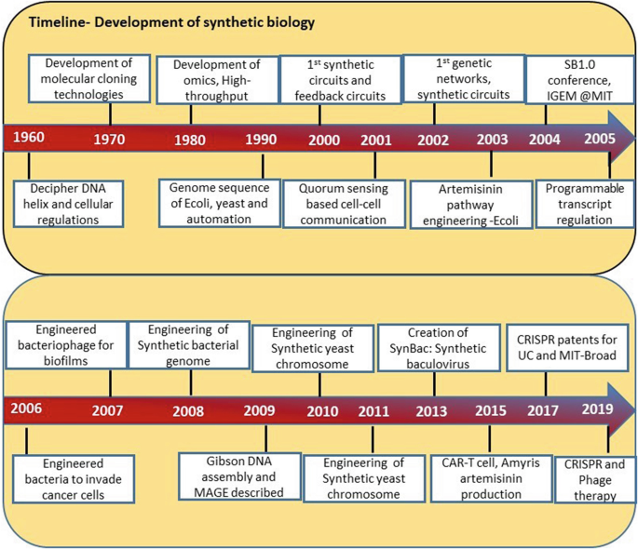
Figure 1: Timeline – Development of synthetic biology
(Source: Nxumalo, Z., Thimiri Govinda Raj, D.B. (2020). Application and Challenges of Synthetic Biology. In: Singh, V. (eds) Advances in Synthetic Biology. Springer, Singapore.)
- Oligonucleotides
Oligonucleotides are short fragments of DNA or RNA that can be synthesized chemically for various applications in molecular biology and biotechnology. Here is a brief overview of the history of oligonucleotide synthesis:
- The first published account of the directed chemical synthesis of an oligonucleotide occurred in 1955 when Michelson and Todd reported the preparation of a dithymidinyl nucleotide using chemical methods.
- The first synthesis of a longer oligonucleotide was reported by Khorana and his colleagues in 1960, using enzymatic methods.
- The phosphotriester method, which was developed by Todd's group in the 1950s, was improved by Letsinger and his colleagues in the 1960s and 1970s, allowing the synthesis of longer and more complex oligonucleotides.
- The phosphoramidite method, which is the most widely used technique for oligonucleotide synthesis today, was developed by Caruthers and his colleagues in the late 1970s and early 1980s, using solid-phase synthesis and automated systems.
- The first synthesis of an entire gene using oligonucleotides was reported by Itakura and his colleagues in 1977, using a combination of chemical and enzymatic methods.
- The first synthesis of an entire viral genome using oligonucleotides was reported by Venter and his colleagues in 2002, using a combination of PCR and assembly methods.
- The first synthesis of an entire bacterial genome using oligonucleotides was reported by Venter and his colleagues in 2008, using a combination of cloning and assembly methods.
- The first creation of a synthetic cell with a minimal genome using oligonucleotides was reported by Venter and his colleagues in 2016, using a combination of genome design, synthesis, and transplantation methods.
Oligonucleotide synthesis has enabled many advances in genetic engineering, synthetic biology, gene therapy, DNA computing, and data storage. It is expected to have more applications and impacts in the future.
Some of the recent achievements in creating artificial genomes and cells are:
- The first creation of a synthetic cell with a minimal genome was reported by Craig Venter and his colleagues in 2016, using a combination of genome design, synthesis, and transplantation methods. They designed and synthesized a genome of 473 genes, which is the smallest genome known to support life, and transplanted it into a recipient cell, creating a new bacterial species called JCVI-syn3.0.
- The first bacterium with a synthetic genome was reported by Craig Venter and his colleagues in 2010, using a similar approach as above. They synthesized the genome of Mycoplasma mycoides and transplanted it into a Mycoplasma capricolum cell, creating a new bacterial strain called JCVI-syn1.0.
- The first recoded organism with an expanded genetic code was reported by George Church and his colleagues in 2013, using a combination of genome editing and synthesis methods. They recoded the genome of Escherichia coli to remove all instances of the stop codon UAG and replace it with UAA, freeing up UAG for encoding novel amino acids. They also introduced an orthogonal tRNA-synthetase pair that can incorporate unnatural amino acids into proteins in response to UAG.
- The first synthesis of an entire eukaryotic chromosome was reported by Jef Boeke and his colleagues in 2014, using a combination of yeast recombination and assembly methods. They synthesized chromosome III of Saccharomyces cerevisiae, which is about 272 kb long, and replaced the native chromosome with the synthetic one, creating a new yeast strain called synIII.
- The first synthesis of an entire viral genome was reported by Craig Venter and his colleagues in 2002, using a combination of PCR and assembly methods. They synthesized the genome of bacteriophage phi X174, which is about 5.4 kb long, and used it to infect E. coli cells, producing infectious viral particles.
These achievements demonstrate the feasibility and potential of creating artificial genomes and cells for various purposes, such as understanding the origin and evolution of life, engineering novel biological functions, and developing new therapeutics and biotechnologies.
Synthetic DNA has enabled many advances in genetic engineering, synthetic biology, gene therapy, DNA computing, and data storage. It is expected to have more applications and impacts in the future.
- Methods:
Synthetic DNA is the artificial creation of DNA molecules with defined sequences, which can be used for various purposes in molecular biology and biotechnology. Some of the main methods and techniques for synthesizing and manipulating synthetic DNA are:
- The phosphoramidite method is the most widely used technique for synthesizing short DNA fragments (oligonucleotides) up to 200 nucleotides long. This method involves the sequential coupling of nucleoside monomers with phosphoramidite groups on a solid support, followed by deprotection and cleavage from the support.
- The gene synthesis method is the assembly of longer DNA fragments (genes) from oligonucleotides using various strategies, such as PCR, ligation, recombination, or Gibson assembly. This method allows the synthesis of genes with desired sequences and modifications, such as codon optimization, restriction sites, or mutations.
- The genome synthesis method is the construction of entire genomes or chromosomes from genes or larger DNA fragments using various strategies, such as cloning, yeast recombination, or transplantation. This method allows the creation of synthetic genomes or chromosomes with desired features, such as minimal genomes, recoded genomes, or novel functions.
- The DNA manipulation method is the modification of synthetic or natural DNA using various techniques, such as restriction enzymes, nucleases, polymerases, ligases, recombinases, or genome editing tools. This method allows the manipulation of DNA for various purposes, such as cloning, mutagenesis, integration, or deletion.
These methods and techniques enable the synthesis and manipulation of synthetic DNA for various applications, such as understanding and engineering biological systems, developing new therapeutics and biotechnologies, and exploring the origin and evolution of life.
- Phosphoramidite method
The phosphoramidite method is the most widely used technique for synthesizing DNA oligonucleotides, which are short DNA fragments with defined sequences. Here is a brief introduction, principle, procedure, advantages, and disadvantages of the phosphoramidite method:
Introduction:
The phosphoramidite method was developed by Marvin Caruthers and his colleagues in the late 1970s and early 1980s, based on the earlier work by Alexander Todd and his colleagues on the phosphotriester method. The phosphoramidite method involves the sequential coupling of nucleoside monomers with phosphoramidite groups on a solid support, followed by deprotection and cleavage from the support.
Principle:
The phosphoramidite method relies on the formation of a phosphite triester linkage between the 5'-hydroxyl group of a nucleoside monomer and the 3'-hydroxyl group of a growing oligonucleotide chain, catalyzed by an acidic activator. The phosphite triester linkage is then oxidized to form a more stable phosphate triester linkage, which is the natural internucleotide linkage in DNA.
Procedure:
The phosphoramidite method consists of four main steps that are repeated for each nucleotide addition: deprotection (or detritylation), coupling, capping, and oxidation. The procedure is as follows:
- Deprotection: The 5'-dimethoxytrityl (DMT) protecting group is removed from the first nucleoside monomer that is attached to a solid support (such as controlled pore glass or polystyrene beads) using an acid solution (such as trichloroacetic acid or dichloroacetic acid). This exposes a free 5'-hydroxyl group that can react with the next nucleoside monomer.
- Coupling: A solution of the next nucleoside monomer with a phosphoramidite group at the 3'-position and various protecting groups at other positions (such as benzoyl for adenine and cytosine, isobutyryl for guanine, and dimethylformamidine for thymine) is added to the reaction vessel along with an acidic activator (such as tetrazole or pyridinium salt). The activator protonates the diisopropylamino group of the phosphoramidite, making it more electrophilic and susceptible to nucleophilic attack by the 5'-hydroxyl group of the first nucleoside monomer. This results in the formation of a phosphite triester linkage and the release of diisopropylamine as a byproduct.
- Capping: A solution of acetic anhydride and N-methylimidazole is added to the reaction vessel to acetylate any unreacted 5'-hydroxyl groups on the solid support. This prevents them from participating in further coupling reactions and generating truncated sequences.
- Oxidation: A solution of iodine, water, and pyridine or lutidine is added to the reaction vessel to oxidize the phosphite triester linkage to a phosphate triester linkage, which is more stable and resistant to hydrolysis.
Advantages:
The phosphoramidite method has several advantages over other methods of oligonucleotide synthesis, such as:
- High coupling efficiency: The phosphoramidite coupling reaction is fast and efficient, with an average yield of over 98% per cycle. This allows the synthesis of longer and more complex oligonucleotides with fewer errors.
- High purity: The DMT protecting group serves as a chromophore that can be monitored by UV detection to determine the coupling efficiency and purity of each cycle. The DMT group can also be used for the purification of oligonucleotides by reverse-phase chromatography.
- Versatility: The phosphoramidite method can accommodate various modifications and labels on the nucleoside monomers, such as fluorescent dyes, biotin, amino groups, thiol groups, etc. These modifications can enhance the functionality and applications of oligonucleotides.
Disadvantages: The phosphoramidite method also has some disadvantages, such as:
- High cost: The phosphoramidite method requires expensive reagents and equipment, such as nucleoside phosphoramidites, activators, oxidizers, solid supports, synthesizers, etc. The cost increases with the length and complexity of the oligonucleotide.
- Environmental impact: The phosphoramidite method generates large amounts of hazardous waste, such as organic solvents, acids, bases, iodine, etc. These waste materials need to be properly disposed of or recycled to minimize the environmental impact.
- Limitations: The phosphoramidite method has some limitations in terms of the length and quality of the oligonucleotide. The coupling efficiency decreases with the length of the oligonucleotide, resulting in more errors and lower yields. The phosphoramidite method also introduces some unwanted modifications, such as depurination, oxidation, and chain scission, which can affect the performance and stability of the oligonucleotide.
- Gene synthesis method
Gene synthesis is the assembly of longer DNA fragments (genes) from shorter DNA fragments (oligonucleotides) with defined sequences. Here is a brief introduction, principle, procedure, advantages, and disadvantages of the gene synthesis method:
Introduction:
Gene synthesis was first demonstrated by Herbert Boyer and his colleagues in 1974, who synthesized a peptide-coding gene using enzymatic methods. Later, Alexander Markham and his colleagues synthesized a protein-coding gene using a combination of chemical and enzymatic methods in 1976. Since then, various strategies and technologies have been developed to improve the efficiency and accuracy of gene synthesis, such as PCR, ligation, recombination, or Gibson assembly.
Principle:
Gene synthesis relies on the design and synthesis of oligonucleotides that overlap with each other and cover the entire sequence of the target gene. These oligonucleotides are then assembled into larger DNA fragments by annealing and joining methods, such as PCR, ligation, recombination, or Gibson assembly. The assembled DNA fragments are then cloned into a suitable vector and transformed into a host cell for verification and amplification.
Procedure:
Gene synthesis consists of four main steps: design, synthesis, assembly, and cloning. The procedure is as follows:
- Design: The sequence of the target gene is designed using various software tools that optimize codon usage, GC content, restriction sites, secondary structures, etc. The designed gene sequence is then divided into smaller segments that can be synthesized as oligonucleotides. The oligonucleotides are designed to have overlapping regions with each other and with the vector for assembly and cloning purposes.
- Synthesis: The oligonucleotides are synthesized using the phosphoramidite method on a solid support, such as controlled pore glass or polystyrene beads. The oligonucleotides are then deprotected and cleaved from the support using an acid solution. The oligonucleotides are then purified by various methods, such as HPLC, PAGE, or cartridge purification.
- Assembly: The oligonucleotides are assembled into larger DNA fragments by annealing and joining methods, such as PCR, ligation, recombination, or Gibson assembly. PCR involves the use of primers and polymerases to amplify and join the oligonucleotides by repeated cycles of denaturation, annealing, and extension. Ligation involves the use of ligases to join the oligonucleotides by forming phosphodiester bonds between their ends. Recombination involves the use of recombinases to join the oligonucleotides by exchanging homologous regions between them. Gibson assembly involves the use of a mixture of enzymes that perform exonuclease digestion, annealing, and polymerase filling to join the oligonucleotides in a single reaction.
- Cloning: The assembled DNA fragments are cloned into a suitable vector by various methods, such as restriction digestion and ligation, homologous recombination, or Gibson assembly. The vector contains features such as the origin of replication, antibiotic resistance gene, promoter, terminator, etc. that facilitate the propagation and expression of the target gene in a host cell. The vector is then transformed into a host cell, such as E. coli or yeast, by various methods, such as electroporation or heat shock. The transformed cells are then screened for the presence and correctness of the target gene by various methods, such as colony PCR, restriction analysis, sequencing, etc.
Advantages:
Gene synthesis has several advantages over other methods of obtaining genes, such as:
- Customization: Gene synthesis allows the creation of genes with desired sequences and modifications that may not exist in nature or may be difficult to obtain by other methods. Gene synthesis can also introduce features such as codon optimization, restriction sites, mutations, etc. that enhance the functionality and applications of genes.
- Speed: Gene synthesis can produce genes faster than other methods that rely on natural sources or mutagenesis. Gene synthesis can also avoid the limitations and uncertainties associated with natural sources or mutagenesis.
- Scalability: Gene synthesis can produce genes in large quantities and at low cost by using automated systems and parallel processes. Gene synthesis can also produce multiple genes simultaneously by using multiplexing techniques.
Disadvantages: Gene synthesis also has some disadvantages, such as:
- Errors: Gene synthesis can introduce errors in the sequence or structure of genes due to various factors such as imperfect oligonucleotide synthesis, assembly, or cloning. Gene synthesis requires various quality control measures to detect and correct errors and ensure the accuracy and fidelity of genes.
- Complexity: Gene synthesis can be challenging for genes that are very long, have high GC content, have repetitive regions, or have secondary structures. Gene synthesis requires various optimization and modification strategies to overcome these challenges and improve the efficiency and success of gene synthesis.
- Safety: Gene synthesis can pose potential risks to the environment and human health if the genes are harmful or hazardous. Gene synthesis requires various biosafety and biosecurity measures to prevent the misuse or abuse of genes and ensure the safety and responsibility of gene synthesis.
- Genome synthesis
Genome synthesis is the construction of entire genomes or chromosomes from smaller DNA fragments with defined sequences. Here is a brief introduction, principle, procedure, advantages, and disadvantages of the genome synthesis method:
Introduction:
Genome synthesis was first demonstrated by Craig Venter and his colleagues in 2002, who synthesized the entire genome of bacteriophage phi X174 using PCR and assembly methods. Later, they synthesized the entire genome of Mycoplasma mycoides and transplanted it into a Mycoplasma capricolum cell, creating the first bacterium with a synthetic genome in 2010. They also created the first synthetic cell with a minimal genome in 2016, using genome design, synthesis, and transplantation methods. More recently, Jef Boeke and his colleagues synthesized the entire chromosome III of Saccharomyces cerevisiae, creating the first synthetic eukaryotic chromosome in 2014.
Principle:
Genome synthesis relies on the design and synthesis of smaller DNA fragments that cover the entire sequence of the target genome or chromosome. These DNA fragments are then assembled into larger DNA fragments by various methods, such as cloning, yeast recombination, or transplantation. The assembled DNA fragments are then verified and integrated into a suitable host cell for expression and function.
Procedure:
Genome synthesis consists of four main steps: design, synthesis, assembly, and integration. The procedure is as follows:
- Design: The sequence of the target genome or chromosome is designed using various software tools that optimize the features, such as codon usage, GC content, restriction sites, secondary structures, etc. The designed genome or chromosome sequence is then divided into smaller segments that can be synthesized as oligonucleotides or genes. The oligonucleotides or genes are designed to have overlapping regions with each other and with the vector for assembly and integration purposes.
- Synthesis: The oligonucleotides or genes are synthesized using the phosphoramidite method on a solid support or by gene synthesis methods using various strategies, such as PCR, ligation, recombination, or Gibson assembly. The oligonucleotides or genes are then deprotected and cleaved from the support or cloned into a suitable vector using various methods, such as restriction digestion and ligation, homologous recombination, or Gibson assembly. The oligonucleotides or genes are then purified by various methods, such as HPLC, PAGE, or cartridge purification.
- Assembly: The oligonucleotides or genes are assembled into larger DNA fragments by various methods, such as cloning, yeast recombination, or transplantation. Cloning involves the use of restriction enzymes and ligases to insert the oligonucleotides or genes into a vector that can replicate in a host cell, such as E. coli or yeast. Yeast recombination involves the use of yeast cells as a natural chassis for assembling the oligonucleotides or genes by homologous recombination. Transplantation involves the use of donor cells to provide a membrane envelope for assembling the oligonucleotides or genes by electroporation.
- Integration: The assembled DNA fragments are integrated into a suitable host cell for expression and function by various methods, such as transformation, transfection, electroporation, microinjection, etc. The host cell can be a bacterial cell, a yeast cell, a mammalian cell, etc. depending on the origin and purpose of the target genome or chromosome. The integrated DNA fragments are then screened for the presence and correctness by various methods, such as PCR, restriction analysis, sequencing, etc.
Advantages: Genome synthesis has several advantages over other methods of obtaining genomes or chromosomes, such as.
- Customization: Genome synthesis allows the creation of genomes or chromosomes with desired sequences and modifications that may not exist in nature or may be difficult to obtain by other methods. Genome synthesis can also introduce features such as minimal genomes, recoded genomes, novel functions, etc. that enhance the functionality and applications of genomes or chromosomes.
- Speed: Genome synthesis can produce genomes or chromosomes faster than other methods that rely on natural sources or mutagenesis. Genome synthesis can also avoid the limitations and uncertainties associated with natural sources or mutagenesis.
- Scalability: Genome synthesis can produce genomes or chromosomes in large quantities and at low cost by using automated systems and parallel processes. Genome synthesis can also produce multiple genomes or chromosomes simultaneously by using multiplexing techniques.
Disadvantages: Genome synthesis also has some disadvantages, such as:
- Errors: Genome synthesis can introduce errors in the sequence or structure of genomes or chromosomes due to various factors such as imperfect oligonucleotide or gene synthesis, assembly, or integration. Genome synthesis requires various quality control measures to detect and correct errors and ensure the accuracy and fidelity of genomes or chromosomes.
- Complexity: Genome synthesis can be challenging for genomes or chromosomes that are very long, have high GC content, have repetitive regions, or have secondary structures. Genome synthesis requires various optimization and modification strategies to overcome these challenges and improve the efficiency and success of genome synthesis.
- Safety: Genome synthesis can pose potential risks to the environment and human health if the genomes or chromosomes are harmful or hazardous. Genome synthesis requires various biosafety and biosecurity measures to prevent the misuse or abuse of genomes or chromosomes and ensure the safety and responsibility of genome synthesis.
- DNA manipulation
DNA manipulation is the modification of synthetic or natural DNA using various techniques, such as restriction enzymes, nucleases, polymerases, ligases, recombinases, or genome editing tools. Here is a brief introduction, principle, procedure, advantages and disadvantages of the DNA manipulation method:
Introduction:
DNA manipulation was first demonstrated by Paul Berg and his colleagues in 1972, who created the first recombinant DNA molecule by joining DNA fragments from two different sources using restriction enzymes and ligases¹. Later, Herbert Boyer and Stanley Cohen developed the first recombinant DNA cloning method by inserting foreign DNA into a bacterial plasmid and transforming it into E. coli cells in 1973. Since then, various techniques and tools have been developed to improve the efficiency and accuracy of DNA manipulation, such as nucleases, polymerases, recombinases, or genome editing tools¹².
Principle:
DNA manipulation relies on the recognition and cleavage of specific sequences or sites on DNA molecules by various enzymes or tools, such as restriction enzymes, nucleases, polymerases, ligases, recombinases, or genome editing tools. These enzymes or tools can modify DNA molecules by adding, deleting, replacing, or rearranging nucleotides or fragments.
Procedure: DNA manipulation consists of four main steps: digestion, modification, ligation, and transformation. The procedure is as follows:
- Digestion: The DNA molecules are cut into smaller fragments by restriction enzymes or nucleases that recognize and cleave specific sequences or sites on the DNA. The restriction enzymes can generate blunt ends or sticky ends on the DNA fragments depending on their cleavage pattern. The nucleases can generate single-stranded nicks or double-stranded breaks on the DNA depending on their activity.
- Modification: The DNA fragments are modified by various methods, such as polymerase chain reaction (PCR), mutagenesis, recombination, or genome editing. PCR involves the use of primers and polymerases to amplify and modify the DNA fragments by repeated cycles of denaturation, annealing, and extension. Mutagenesis involves the use of mutagens or mutator strains to introduce random or specific mutations on the DNA fragments. Recombination involves the use of recombinases to exchange homologous regions between the DNA fragments. Genome editing involves the use of tools such as CRISPR-Cas9 or TALENs to introduce targeted modifications on the DNA fragments by creating double-stranded breaks and inducing repair mechanisms.
- Ligation: The modified DNA fragments are joined together by ligases that form phosphodiester bonds between their ends. The ligases can join blunt ends or sticky ends depending on their specificity. The ligation can create circular or linear DNA molecules depending on the configuration of the ends.
- Transformation: The ligated DNA molecules are introduced into a host cell by various methods, such as electroporation, heat shock, microinjection, etc. The host cell can be a bacterial cell, a yeast cell, a mammalian cell, etc. depending on the origin and purpose of the DNA molecules. The transformed cells are then screened for the presence and expression of the DNA molecules by various methods, such as colony PCR, restriction analysis, sequencing, etc.
Advantages: DNA manipulation has several advantages over other methods of obtaining or modifying DNA molecules, such as:
- Customization: DNA manipulation allows the creation of novel DNA molecules with desired sequences and modifications that may not exist in nature or may be difficult to obtain by other methods. DNA manipulation can also introduce features such as restriction sites, mutations, tags, etc. that enhance the functionality and applications of DNA molecules.
- Speed: DNA manipulation can produce novel DNA molecules faster than other methods that rely on natural sources or synthesis. DNA manipulation can also avoid the limitations and uncertainties associated with natural sources or synthesis.
- Versatility: DNA manipulation can produce various types of DNA molecules with different sizes and shapes by using different enzymes or tools. DNA manipulation can also produce multiple DNA molecules simultaneously by using multiplexing techniques.
Disadvantages: DNA manipulation also has some disadvantages, such as:
- Errors: DNA manipulation can introduce errors in the sequence or structure of DNA molecules due to various factors such as imperfect digestion, modification, ligation, or transformation. DNA manipulation requires various quality control measures to detect and correct errors and ensure the accuracy and fidelity of DNA molecules.
- Complexity: DNA manipulation can be challenging for DNA molecules that are very long, have high GC content, have repetitive regions, or have secondary structures. DNA manipulation requires various optimization and modification strategies to overcome these challenges and improve the efficiency and success of DNA manipulation.
- Safety: DNA manipulation can pose potential risks to the environment and human health if the DNA molecules are harmful or hazardous. DNA manipulation requires various biosafety and biosecurity measures to prevent the misuse or abuse of DNA molecules and ensure the safety and responsibility of DNA manipulation.

- Computational tool for design and assembly of synthetic DNA:
There are several computational tools available for the design and assembly of synthetic DNA. These tools help researchers and scientists in the design, optimization, and analysis of DNA sequences for various applications, such as gene synthesis, genetic engineering, and synthetic biology. Here are some commonly used computational tools in this field:
DNA Sequence Design Tools:
- Gene Designer: A tool for designing synthetic genes and DNA sequences. It offers features like codon optimization, restriction enzyme analysis, and primer design.
- Benchling: A comprehensive platform that includes tools for designing DNA sequences, cloning, and DNA assembly. It also offers collaboration and data management features.
DNA Assembly Tools:
- GeneArt® Gene Synthesis: A tool provided by Thermo Fisher Scientific for gene synthesis and DNA assembly. It supports seamless assembly of DNA fragments and provides customization options.
- Geneious: A bioinformatics software suite that includes DNA assembly tools, allowing users to design and assemble DNA fragments using various methods like Gibson Assembly and Golden Gate Assembly.
DNA Editing and Design Tools:
- CRISPR Design Tools: Several online tools are available for designing guide RNA sequences for CRISPR-mediated genome editing. Examples include CRISPOR, CHOPCHOP, and Benchling's CRISPR tool.
- SnapGene: A molecular biology software that enables visualization, simulation, and annotation of DNA sequences. It also provides tools for designing primers, cloning, and DNA assembly.
DNA Sequence Analysis Tools:
- BLAST (Basic Local Alignment Search Tool): A widely used tool for comparing DNA sequences against a database to find similar sequences.
- Geneious: Apart from assembly, Geneious also provides tools for sequence alignment, motif search, and restriction enzyme analysis.
Genome Engineering Tools:
- CRISPResso: A computational tool for analyzing CRISPR/Cas9 genome editing outcomes. It can quantify insertion, deletion, and substitution mutations introduced by CRISPR.
These are just a few examples of the many computational tools available for DNA design and assembly. The choice of tools depends on the specific requirements of the project and the preferences of the researcher. It's always a good idea to explore different tools and choose the ones that best fit your needs.
- Applications:
Synthetic DNA is the artificial creation of DNA molecules with defined sequences, which can be used for various purposes in molecular biology and biotechnology. Some of the various applications and potential uses of synthetic DNA in different fields are:
- Biotechnology: Synthetic DNA can be used to create novel biological systems or functions by engineering genes, pathways, or genomes. For example, synthetic DNA can be used to create synthetic biology circuits that can sense and respond to environmental signals, such as light, temperature, or chemicals. Synthetic DNA can also be used to create metabolic pathways that can produce valuable compounds, such as biofuels, drugs, or materials. Synthetic DNA can also be used to create synthetic genomes that can encode minimal or novel life forms, such as bacteria or viruses.
- Bioengineering and Synthetic Biology: Synthetic DNA is a fundamental tool in the field of synthetic biology. Scientists can design and synthesize DNA sequences to create artificial organisms with novel functions or to modify existing organisms to perform specific tasks. This has applications in bioengineering, biofuel production, environmental remediation, and the creation of biosensors and bioremediation systems.
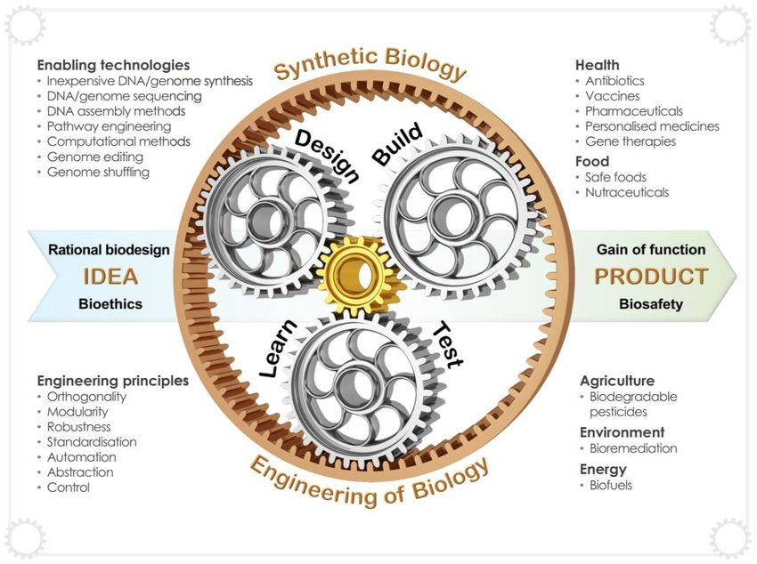

Figure1: Synthetic biology entails the engineering of biology, incorporating enabling technologies and enabling
approaches framed around rational engineering principles.
(Source: Cameron, D., Bashor, C. & Collins, J. A brief history of synthetic biology. Nat Rev Microbiol 12, 381–390 (2014).
.
- Medicine: Synthetic DNA can be used to develop new therapeutics or diagnostics for various diseases or conditions. For example, synthetic DNA can be used to create vaccines that can elicit immune responses against pathogens, such as hepatitis B virus or malaria parasite. Synthetic DNA can also be used to create gene therapies that can deliver functional genes or correct defective genes in target cells, such as cancer cells or blood cells. Synthetic DNA can also be used to create molecular probes that can detect specific biomarkers or pathogens in biological samples, such as blood or saliva.
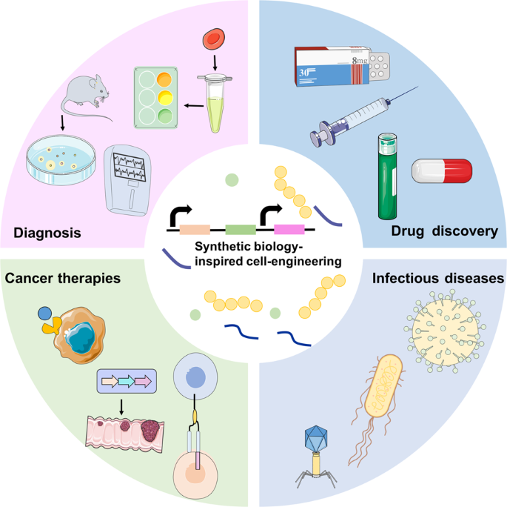
Figure 2: Synthetic biology-inspired cell engineering can be employed for various medical applications.
(Source: Zhao, N., Song, Y., Xie, X. et al. Synthetic biology-inspired cell engineering in diagnosis, treatment, and drug development. Sig Transduct Target Ther 8, 112 (2023).
- Data storage: Synthetic DNA can be used to store large amounts of digital information in a compact and durable format. For example, synthetic DNA can be used to encode binary data into nucleotide sequences and store them in synthetic DNA molecules that can be preserved for long periods of time. Synthetic DNA can also be used to retrieve the stored data by sequencing the synthetic DNA molecules and decoding the nucleotide sequences back into binary data. Synthetic DNA can offer advantages over conventional data storage media, such as high density, low energy consumption, and long-term stability.
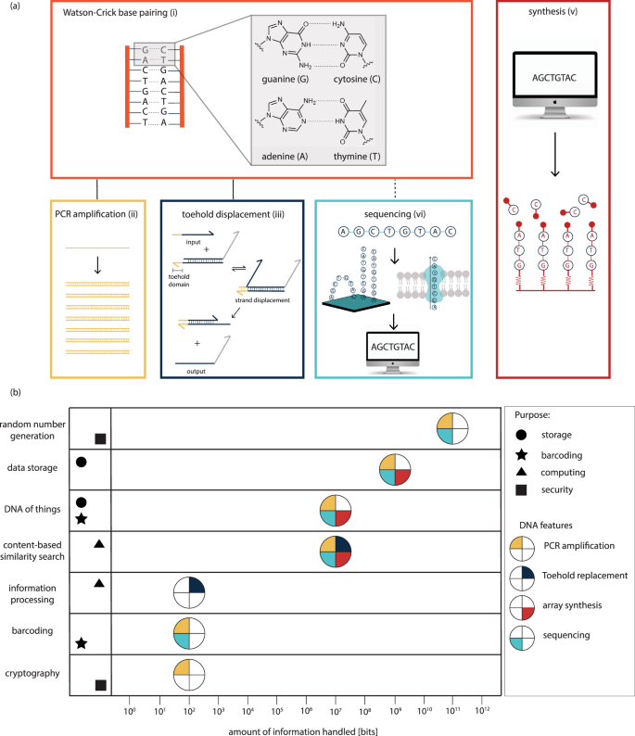
Figure 3: Synthetic DNA applications in information technology
(Source: Meiser, L.C., Nguyen, B.H., Chen, YJ. et al. Synthetic DNA applications in information technology. Nat Commun 13, 352 (2022).
- Security: Synthetic DNA can be used to enhance the security of various products or systems by providing unique and verifiable identifiers or codes. For example, synthetic DNA can be used to create barcodes that can label products or documents with specific information, such as origin, date, or authenticity. Synthetic DNA can also be used to create encryption keys that can protect data or communication from unauthorized access or tampering. Synthetic DNA can offer advantages over conventional security methods, such as high diversity, low visibility, and high resistance to counterfeiting.
- Bioengineering: Synthetic DNA can be used to manipulate the properties or functions of various biological materials or systems by introducing specific modifications or features. For example, synthetic DNA can be used to create nanomaterials that can self-assemble into desired shapes or structures, such as wires, tubes, or cages. Synthetic DNA can also be used to create biosensors that can detect and measure various physical or chemical stimuli, such as pH, temperature, or glucose. Synthetic DNA can also be used to create biocomputers that can perform logical operations or computations using biochemical reactions.
It's important to note that while synthetic DNA holds immense potential, there are also ethical considerations surrounding its use, such as ensuring responsible and safe practices, addressing potential environmental impacts, and considering the potential misuse of synthetic DNA for harmful purposes. Ongoing research and discussions are aimed at developing guidelines and regulations to govern the use of synthetic DNA technologies.
Please keep in mind that the field of synthetic DNA is rapidly evolving, and new applications and uses may continue to emerge as research progresses.
- Conclusion
Synthetic DNA is the artificial creation of DNA molecules with defined sequences, which can be used for various purposes in molecular biology and biotechnology. Synthetic DNA can be synthesized and manipulated by various methods, such as phosphoramidite method, gene synthesis method, genome synthesis method, and DNA manipulation method. Synthetic DNA has various applications and potential uses in different fields, such as biotechnology, medicine, data storage, security, and bioengineering. Synthetic DNA offers advantages over natural DNA or conventional methods, such as customization, speed, scalability, diversity, and stability. However, synthetic DNA also has some disadvantages and challenges, such as errors, complexity, cost, safety, and ethics. Synthetic DNA is a rapidly developing and expanding field that has great potential to revolutionize science and technology. Some directions for further research include:
- Improving the efficiency and accuracy of synthetic DNA synthesis and manipulation methods
- Exploring the feasibility and functionality of novel synthetic DNA sequences and modifications
- Developing new applications and products based on synthetic DNA for various sectors and domains
- Evaluating the environmental and social impacts and implications of synthetic DNA use and production
- Establishing the ethical and legal frameworks and guidelines for synthetic DNA research and innovation.
- References:
- Meiser, L.C., Nguyen, B.H., Chen, YJ. et al. Synthetic DNA applications in information technology. Nat Commun 13, 352 (2022).
- Zhao, N., Song, Y., Xie, X. et al. Synthetic biology-inspired cell engineering in diagnosis, treatment, and drug development. Sig Transduct Target Ther 8, 112 (2023).
- Cameron, D., Bashor, C. & Collins, J. A brief history of synthetic biology. Nat Rev Microbiol 12, 381–390 (2014).
- Nxumalo, Z., Thimiri Govinda Raj, D.B. (2020). Application and Challenges of Synthetic Biology. In: Singh, V. (eds) Advances in Synthetic Biology. Springer, Singapore.
- Benner, S. A. Synthetic biology: act natural. Nature 421, 118 (2003).
- Shapira, P., Kwon, S. & Youtie, J. Tracking the emergence of synthetic biology. Scientometrics 112, 1439–1469 (2017).
- Singh, V. Recent advancements in synthetic biology: current status and challenges. Gene 535, 1–11 (2014).
- Westerhoff, H. V. & Palsson, B. O. The evolution of molecular biology into systems biology. Nature Biotech. 22, 1249–1252 (2004).
- Breitling R, Takano E. Synthetic biology advances for pharmaceutical production. Current Opinion in Biotechnology. 35:46–51 (2015).
- Calvert J. The commodification of emergence: Systems biology, synthetic biology and intellectual property. BioSocieties. 3:383–398 (2008).
- Chen G-Q, Feng Y. Synthetic biology in China, UK and US. Synthetic and Systems Biotechnology. 4:215 (2016).
- Church G, Regis E. Regensis: How synthetic biology will reinvent nature and ourselves. New York: Basic Books; 2012.
- Clarke LJ, Kitney RI. Synthetic biology in the UK – An outline of plans and progress. Synthetic and Systems Biotechnology. 1(4):243–257 (2016).
- Convention on Biological Diversity . Synthetic biology. Technical series no. 82. Montreal: Secretariat of the Convention on Biological Diversity; 2015.
- Douglas CMW, Stemerding D. Governing synthetic biology for global health through responsible research and innovation. Systems and Synthetic Biology. 7:139 (2013).
- Engelhard, M. (Ed.). (2016). Synthetic biology analysed: Tools for discussion and evaluation. Ethics of science and technology assessment (Vol. 44). Cham: Springer.
- ETC Group. (2010). Synthetic biology: Creating artificial life forms. Briefing and recommendations for CBD delegates to COP 10.
- Jungmann R, Renner S, Simmel FC. From DNA nanotechnology to synthetic biology. HFSP Journal. 2(2):99–109 (2008).
- Lienert F, Lohmueller JJ, Garg A, Silver PA. Synthetic biology in mammalian cells: Next generation research tools and therapeutics. Nature Reviews Molecular Cell Biology.15:95–107 (2014).
- Minssen T, Wested JB. Standardization, IPRs and open innovation in synthetic biology. In: Beldiman D, editor. Innovation, competition and collaboration. Cheltenham: Edward Elgar; 34–66 (2015).
- MIT. (2004). The first international meeting on synthetic biology. synthetic biology 1.0. June 10–12, 2004. Cambridge, MA: Massachusetts Institute of Technology.
- Mogoutov A, Kahane B. Data search strategy for science and technology emergence: A scalable and evolutionary query for nanotechnology tracking. Research Policy. 2007;36(6):893–903.
- National Academies of Science. (2010). Synthetic biology: Building on nature’s inspiration. Interdisciplinary research team summaries. The National Academies Keck Futures Initiative. Washington, DC: National Academies Press.
- NSF. (2006). Synthetic Biology Engineering Research Center (SynBERC). Award Abstract #0540879. Arlington, VA: National Science Foundation.
- Pei L, Schmidt M, Wei W. Synthetic biology: An emerging research field in China. Biotechnology Advances. 2011;29(6):804–814.
- Raimbault B, Cointet J-P, Joly P-B. Mapping the emergence of synthetic biology. PLoS ONE.11(9):e0161522 (2016).
- Shih SCC, Moraes C. Next generation tools to accelerate the synthetic biology process. Integrative Biology.8:585–588 (2016).
- Si T, Zhao H. A brief overview of synthetic biology research programs and roadmap studies in the United States. Synthetic and Systems Biotechnology. 2016.
- Tucker JB, Zilinskas RA. The promise and perils of synthetic biology. The New Atlantis Spring.12:25–45 (2006).
- van Doren D, Koenigstein S, Reiss T. The development of synthetic biology: A patent analysis. Systems and Synthetic Biology.7:209–220 (2013).

