COMPARATIVE ANALYSIS OF METHYLENE BLUE AND GIEMSA STAINS TO STUDY THE BARR BODY FROM BUCCAL EPITHELIAL CELLS IN FORENSIC FACET
Vaishnavi Katakwar ¹, Archana Mahakalkar ² , Virendra Shende ³
1,2,3 Department of Forensic Biology ,Government Institute of Forensic Science, Nagpur, Maharashtra, India.
Correspondence Author and Address: Dr. Archana Mahakalkar, archanasap79@gmail.com

ABSTRACT:
In Forensic Science, determining sexual identity is critical. There are various methods for determining sex or gender identification. This can be accomplished by identifying "Barr Body" in various body tissues and cells that are only seen in females. Along with Barr Body identification, there are various other ways of sex determination that are costly and time intensive, such as PCR, Karyotyping, AMEL identification, and so on. Barr Body Identification is a simple, quick, and low-cost procedure that produces better results. The Present study's objectives are to examine the effective stain for determining Barr Bodies from buccal epithelial cells; to determine the existence of Barr Bodies in Males and Females; and to determine the significance of Barr Bodies in the identification of sex of an individual in Forensic Science. In this study, two Buccal smears were obtained from each of 120 college students (60 males and 60 females) and stained with Giemsa and Methylene Blue and observed under a digital compound microscope. T-test was used for statistical analysis to compare the existence of Barr bodies in two stains. P0.05 was the statistical significance. Giemsa stain was shown to be more efficient than Methylene Blue in determining Barr Bodies from buccal epithelial cells. Barr bodies in buccal epithelial smears were shown to be the easiest way for determining sex, with an accuracy of 93.33-95.88%.
Keywords: Barr Body, Sex determination, buccal epithelial, Sex chromatin, Giemsa stain, Methylene Blue stain, Forensic Significance, etc.
INTRODUCTION:
Barr Body, an inactive X-chromosome found in the nuclei of the majority of female somatic cells, is frequently utilized in forensic science sex determination tests to help identify a person. [1]. The phenomenon of Barr Body was first described in nerve cells of female cats by Dr. Murray Barr and Ewart Bertram in 1949 [2]. Small, well-defined structures called Barr bodies strongly stain with nuclear dyes such haematoxylin and eosin (H and E), Feulgen, Cresyl-violet,thionine, Papanicolaou,Giemsa, and aceto-orcein as well as fluorescence stains like acridine orange. [3]. However, male nuclei do not contain Barr Body; they are devoid of it. The diameter of a Barr body is about one micron. In buccal mucosa nuclei and sections of a variety of human tissues, the average size has been calculated to be between 0.7 and 1.2. Barr bodies are most commonly found on the nucleus periphery. However, a small number of Barr bodies are found in other parts of the nucleus, and many of these are located near a nucleolus [4].
A British geneticist named Mary F. Lyon developed the X-inactivation technique. According to the Lyon hypothesis, during early embryonic life one of the X chromosome is inactivated and other remains activated in each somatic cell of female. X-inactivation results in clumped chromatin known as Barr bodies, which are generally thought to be inactive. Lyonization describes the formation of Barr bodies [5]. The key principles of the hypothesis were as follows: first, that there was a single active X chromosome in each female mammal cell, and that the heteropyknotic X that was seen was the inactive one; second, that this inactivation happened early in embryonic life; and third, that the inactivated X of a particular cell might have been either of maternal or paternal origin, and that this was decided at random. All offspring of a particular cell line would exhibit the inactivation of the parent cell, resulting in mosaic females with respect to the makeup of the X chromosome, which would correlate to the observed variable phenotype. [6]. By examining the X and Y chromosomes in cells that are not actively dividing, one can determine a person's gender. To confirm the existence or absence of Barr bodies, buccal smears, skin biopsies, blood, ligament, hair root sheath, and tooth pulp can be used. [7]
Forensic Significance of Barr Bodies:
The determination of a person's gender is an important aspect in forensic science. DNA analysis, tooth measurements, and craniofacial appearance have all been used as gender identification tools. Gender can also be determined using sperm, blood, hair, pulp fibroblasts, buccal epithelial cells, cervical cells, skin, and saliva stains discovered in various body parts or on dangerous weapons at crime scenes and disaster sites. Cytological methods such as Davidson body in polymorphonuclear leukocytes, AMEL identification, and Barr bodies (X chromatin) and polymerase chain reaction (PCR), karyotyping can be used to confirm gender. Barr body demonstration is therefore regarded as one of the most straightforward procedures for determining gender using exfoliative cytology [3].

Barr body is a facultative heterochromatic structure that only manifests in normal females during interphase as a dark-staining, outlying nuclear structure in the somatic cell nucleus. The Lyon inactivation theory can be used to explain the distribution of Barr bodies in a single cell when the chromosomal structure contains several X chromosomes. The use of amniotic fluid assists in a prenatal sex diagnosis, while the analysis of Barr bodies in cell nuclei from readily accessible tissues like buccal mucosa, hair roots, and blood cells enables a preliminary description of an individual's sex chromosome status, hermaphroditism, gonadal, and some complicated anomalies. [3].

MATERIALS AND METHODOLOGY:
An experiment-based study was conducted in the month of March, 2022 after getting approval from Institute’s Ethical Committee. Oral Buccal Smear samples were collected from 120 college students of age range between 18-25. Among them 60 were males and 60 were females.
Sample Collection:
Following a mouthwash rinse, the subjects were instructed to rinse their mouths with regular water. Following mouth-washing, two oral buccal smear samples were obtained by scraping the subject's buccal mucosa with a sterile toothpick on a glass slide containing one drop of distilled water. (Figure 1). These samples were allowed to air-dried at room temperature for 1-2 minutes. All the samples were collected from the subjects with their written consent.
Sample Preparation:
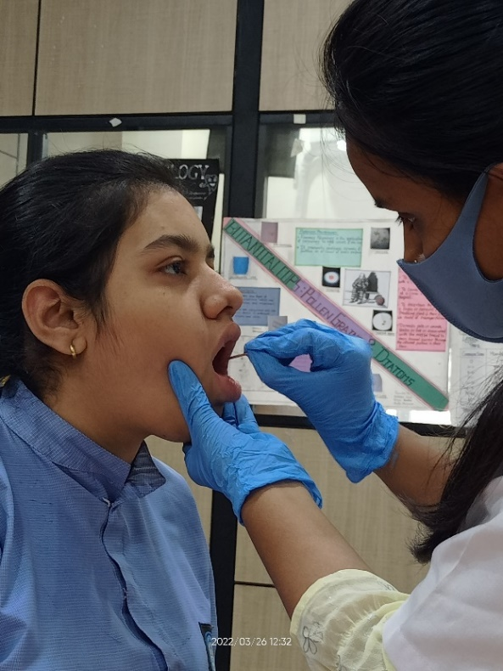
One of the samples from 2 samples, was stained with working solution of Giemsa Stain and other stained with Methylene Blue. Both the stained samples were allowed to air-dried at room temperature for 10-15 minutes. After drying, sample stained with Giemsa was directly observed unde
Figure 1: Sample collection

compound microscope. While sample stained with Methylene blue was washed under running water and then covered with coverslip and observed under compound microscope. All the 240 samples slide was observed under Cilika BT-E Benchtop Biological Digital Microscope.
Inclusion Criteria: The research included cells where a chromatin thread close to the nuclear membrane served as the connection between the Barr body and a nucleolus. At the nuclear membrane, the Barr body can have many configurations, such as flattened, convex.
Exclusion Criteria: The study excluded degenerating, folded, and overlapping nuclei. Barr bodies can also be seen near the nucleus's centre; however, they cannot be separated from nucleoli were eliminated. Folded cells with the cell membrane covering the nucleus and Extruded nuclei from the cell were not taken into consideration.
Statistical Analysis: The calculated mean and standard deviation were used in a statistical t-test to compare the existence of Barr bodies in two stains. P0.0001 was used as the statistical significance threshold.
RESULT:
Both the Giemsa and Methylene Blue stains were used to analyze the prepared sample slides. Barr body positive cells were not present in the male samples when stained with Methylene Blue or Giemsa (Table 1). Barr body positive cells were observed in females, as seen in Figures 2 and 3 using the Methylene Blue and Giemsa stains, respectively. Barr body positive cells were discovered to be present in 0% of the male population while being present in 91.66% and 86.66% of the female population, respectively, in both the Giemsa and Methylene Blue stain (Graph 1). The mean and standard deviation for the Barr body positive cells on the female sample slides stained with Giemsa and Methylene Blue were determined for the statistical analysis. Giemsa and Methylene Blue stain variance was compared using a T-test. Less than 0.0001 was discovered to be the p-value. This difference was deemed statistically significant (Table 2) by conventional standards. The Giemsa stain's sensitivity was 100%, specificity was 92.30%, and total accuracy was reported to be 95.83%. Sensitivity, specificity, and accuracy for methylene blue were determined to be 100%, 88.24%, and 93.33%, respectively. Giemsa was discovered to have a significantly higher sex determination efficacy than Methylene Blue. (Table 3).

Table 1: Total no. of Barr bodies observed in both stains
Groups | No. of Individuals | Total no. of Barr Bodies in two stains
 |  | Giemsa Stain | Methylene Blue Stain
Females | 60 | 55 | 52
Males | 60 | 0 | 0

Table 2: Result of t-test statistics
Stains | Group | Mean | Standard Deviation | Standard error of mean. | P – Value
Giemsa | Female | 5.42 | 3.82 | 0.35 | P<0.0001
Methylene Blue | Female | 2.72 | 2.53 | 0.20
P value <0.0001 which is statistically significant

Table 3: Sensitivity, Specificity and Accuracy of Giemsa and Methylene Blue for Sex determination
 | Giemsa | Methylene Blue
Sensitivity | 100% | 100%
Specificity | 92.3% | 88.24%
Accuracy | 95.83% | 93.33%

Graph 1: Percentage of Barr Bodies in Males & Females
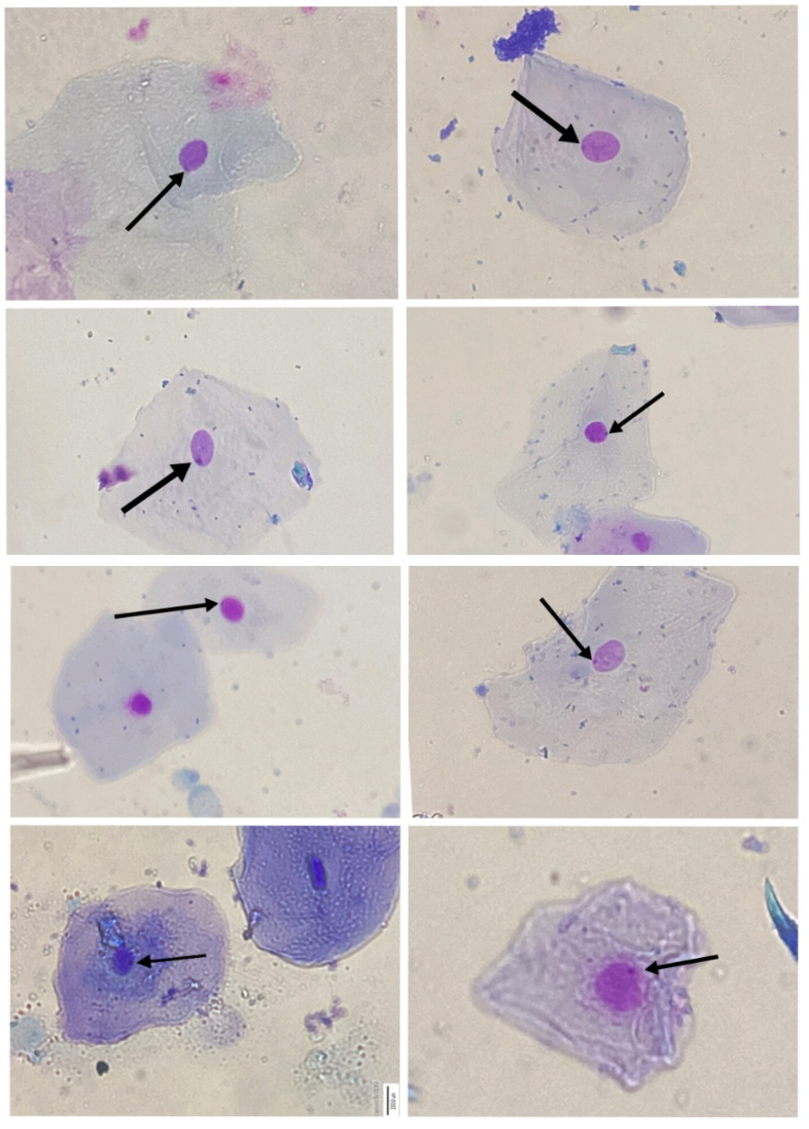
Figure 2: Barr bodies in Giemsa staining
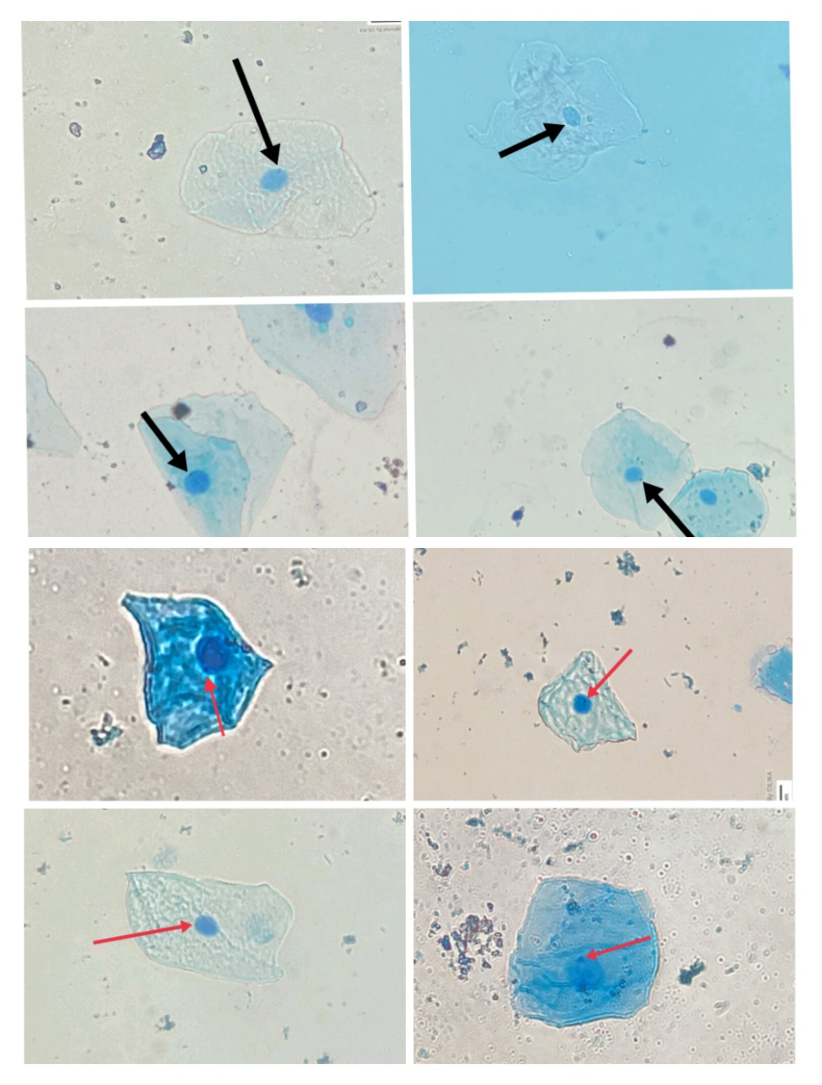
Figure 3: Barr bodies in Methylene Blue staining
DISCUSSION:
In Forensic Science personal identification of both living and dead plays an important role. Sex or gender determination is an important aspect in individualization. There are various biological materials such as blood, semen, saliva, buccal epithelial cells, etc. that can serve as a means of sex determination. Sex determination from buccal epithelial cells is one the easiest and quick method. In this method, presence of Barr body is used to identify the sex of an individual.
The idea of Barr Bodies was initially discovered by Barr and Bertram in 1949. They discovered Barr bodies, which were separate from the nucleoli in the nuclei of the female cat's neuron cells. According to their research, mature female cat nerve cells had a well-developed nucleolar satellite that was situated next to the nucleolus and had a significantly deeper stain than the nucleolus. While a weakly formed nucleolar satellite was sporadic in mature male cats' nerve cells [2]
Barr body detection was launched for the 1968 Olympics and was largely welcomed as the solution to gender misrepresentation in sports. The cytological assessment of buccal smear was reported as easiest, rapid and dignified test [8].
Methylene Blue and Giemsa Buccal smears were stained quickly and easily, and preparations could be produced in a matter of minutes. The appearance of Barr body's dark-stained supports the sex determination. Giemsa's sensitivity and specificity in the current study were 100% and 92.30%, respectively. Giemsa stain was found to have an overall accuracy of 95.83%. Sensitivity, specificity, and accuracy for methylene blue were determined to be 100%, 88.24%, and 93.33%, respectively. In our study, Giemsa performed more effectively than Methylene Blue. The similar outcome was observed in the study conducted by Htun et al. in 2017, where the sensitivity for Giemsa was 96% and the specificity was 100%. The overall accuracy of Giemsa was 98%. Methylene Blue has sensitivity, specificity, and accuracy of 92%, 96%, and 94%, respectively. Giemsa greatly increased the effectiveness of both male and female gender identification compared to Methylene Blue [9].
Present study shows, the identification of Barr bodies in males was negative whereas in females the identification of Barr bodies was positive, which was found to be similar with the study of Talari et al. 2017 [3].
Disorders like Klinefelter's syndrome are characterized by chromosomal alterations. The limitations of the approach are triple-X (XXXXY) in females and 47, 48, and 49 chromosomes (XXY), XXXY, and XXXY, respectively, in males. Barr bodies can be seen in different numbers in the nucleus of males with Klinefelter's syndrome, leading to a false-positive result. While there is only one Barr body in the nuclei of normal females, there are two Barr bodies in the nuclei of triple-X females. It could be challenging to distinguish between a triple-X female and a Klinefelter's disease variant XXXY when two Barr bodies are present. [10].
In present study, absence of Barr body was observed in males with both the Giemsa and Methylene Blue stain. Whereas, in Females presence of Barr bodies were observed in both the Giemsa and Methylene Blue stain with 91.66% and 86.66% respectively. The efficacy and accuracy with Giemsa stain was found to be better than Methylene Blue stain in sex determination using Barr body.
CONCLUSION:
Sex determination is an integral part of individualisation in the Forensic Science. DNA analysis is the most accurate and time-consuming method for sex determination. But Barr bodies analysis for sex determination is the simplest, cheapest and rapid method one can employ. The simplest way for determining gender is to use Barr bodies in buccal epithelial smears, which has an accuracy range of 93.33–95.88%.
Present study shows that Giemsa and Methylene blue can also be used in analysis of Barr bodies in sex determination. The study found that the efficacy of Giemsa stain is better than Methylene Blue in sex determination. For future research it is recommended that the study should be carried out on large scales using some other stains along with Giemsa and Methylene blue for better assessment of sex determination using Barr body.

[1] | Biswas G. Review of Forensic Medicine and Forensic Toxicology: 2015; 3:59.
[2] | Bertram E., Barr M. A Morphological Distinction between Neurones of the Male and Female, and the Behaviour of the Nucleolar Satellite during Accelerated Nucleoprotein Synthesis. Nature:1949;163:676-677.
[3] | Talari A. Bashamalla R. Rao V. G.Taneeru S.Yeluri S.Madala J. K. Cytological assessment of Barr body in buccal scrapes: A comparative study," Pierre Fauchard Academy: 2017; 31: 9-13.
[4] | Mittwoch U. SEX CHROMATIN, Medical Genetics :1967;1: 50-76.
[5] | Lyon M. Lyon hypothesis. Nature 1961;190: 372-373.
[6] | Harper P. S. Mary Lyon and the hypothesis of random X chromosome inactivation. Human Genetics; 2011: 130: 169-174.
[7] | Bhoyar L.Z. Mahakalkar A. L. A forensic review on sex determination methods for teeth, Int. J. of Life Sciencess; 2021: 45-54.
[8] | Ritchie R., Reynard J. Lewis T. Intersex and the Olympic Games, Royal Society of Medicine. 2008;101: 395-399.
[9] | Htun K. S., Naing T.Ye L. A.Thein Z. Gender Determination from Barr bodies using Giemsa and Methylene Blue Stains in buccal mucosal smears. 2017
[10] | Sahana A.Ashok K. P.(): Aceto-Orcein Squash technique for Barr bodies detection. RGUHS; 2017; 9:15-22.

References:

