Dosage forms are important for delivering drugs to specific sites within the body. They serve a variety of purposes, including:
- Ensuring safe and convenient delivery of an accurate dose. Dosage forms can be designed to control the release of medication, ensuring that the correct amount is delivered to the body at the right time. This is important for both efficacy and safety. For example, tablets and capsules are designed to break down in the stomach or intestines, releasing the medication into the bloodstream. This prevents the medication from being absorbed too quickly, which could lead to side effects.
- Protecting drug substances from atmospheric oxygen or moisture. Many drugs are sensitive to oxygen or moisture, and can degrade over time if not properly protected. Dosage forms can help to protect drugs from these elements, extending their shelf life. For example, capsules and tablets are often coated with a protective layer.
- Providing protection from gastric juice after oral administration. Some drugs are inactivated by gastric juice, the acidic fluid that is produced in the stomach. Dosage forms can be designed to protect drugs from gastric juice, allowing them to reach the intestines where they can be absorbed into the bloodstream. For example, enteric-coated tablets are designed to dissolve in the intestines, but not in the stomach.
- Masking the bitter taste and odor of drug substances. Many drugs have a bitter taste or odor that can be unpleasant to take. Dosage forms can be used to mask the taste and odor of drugs, making them more palatable. For example, capsules and coated tablets can be filled with a flavored liquid or powder.
- Offering liquid preparations for drugs that are insoluble or unstable in the desired vehicle. Some drugs are insoluble in water, the most common solvent used in liquid dosage forms. Dosage forms can be designed to use a different solvent that the drug is soluble in, such as alcohol or glycerin. For example, suspensions are liquid dosage forms that contain insoluble particles of drug that are suspended in a liquid.
- Providing liquid dosage forms for substances soluble in the desired vehicle. Some drugs are soluble in water, and can be easily formulated into liquid dosage forms such as solutions. Solutions are liquid dosage forms that contain dissolved drug particles.
- Facilitating optimal drug action by controlling the release mechanisms. Some drugs need to be released slowly into the body in order to be effective. Dosage forms can be designed to control the release of drugs, ensuring that they are released at the right rate. For example, controlled-release tablets release medication over a period of time, rather than all at once.
- Allowing for insertion of drugs into body cavities (e.g., rectal and vaginal) and utilizing the desired vehicle for insoluble drugs. Some drugs can be administered directly into body cavities, such as the rectum or vagina. Dosage forms can be designed to be inserted into these cavities, and to dissolve or melt there, releasing the medication into the body. For example, suppositories are solid dosage forms that are designed to melt at body temperature and release medication into the rectum.
- Enabling optional drug action through topical administration sites, exemplified by ointments, creams, and ear and nasal preparations. Some drugs can be applied to the skin or mucous membranes, where they can have a local effect. Dosage forms can be designed for topical administration, such as ointments, creams, and nasal sprays.
- Ensuring controlled release mechanisms and proper placement of drugs within body tissues. Some drugs need to be placed in specific tissues in the body in order to be effective. Dosage forms can be designed to ensure that drugs are released in the correct tissues and at the correct rate. For example, implants are solid dosage forms that are surgically inserted into the body, where they slowly release medication over time.
Dosage forms are an essential part of the delivery of drugs to the body. They play a vital role in ensuring the safety, efficacy, and convenience of drug therapy.
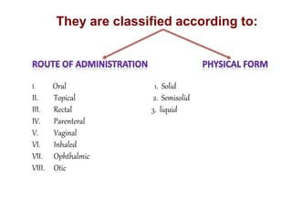
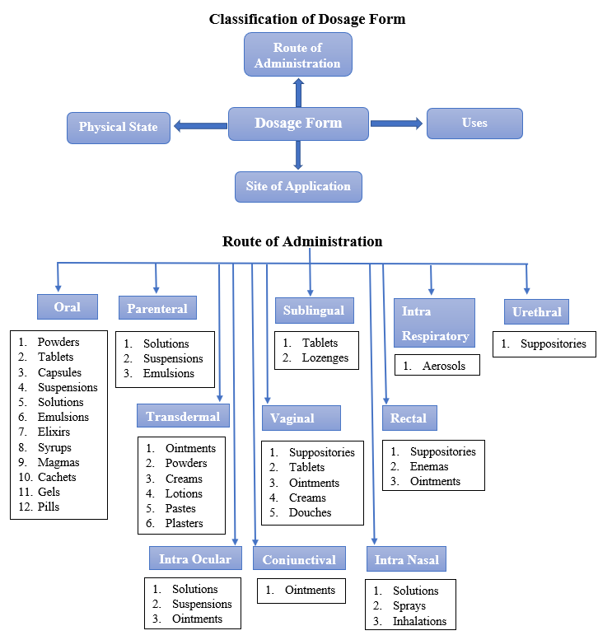
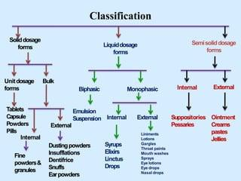
CHAPTER -1
Solid dosage forms are an important part of the pharmaceutical industry. They are used to deliver drugs to the body in a safe and effective manner. Solid dosage forms offer several advantages over liquid dosage forms, including:
- Physical and chemical stability: Solid dosage forms are more stable than liquid dosage forms, and are less likely to degrade over time. This is important for ensuring the safety and efficacy of the drug.
- Cost-effectiveness: Solid dosage forms are typically more cost-effective to manufacture than liquid dosage forms. This is because they require less equipment and labor to produce.
- Ease of consumption and portability: Solid dosage forms are easier to consume and transport than liquid dosage forms. This makes them a more convenient option for patients.
- Uniform mixing and accurate dosage: Solid dosage forms undergo the same unit operation during the preparation process, ensuring uniform mixing and accurate drug dosage. This is important for ensuring the safety and efficacy of the drug.
The most commonly used solid dosage forms are powders, granules, tablets, and capsules. Powders are solid particles that are not compressed or bound together. Granules are small, solid particles that are bound together by a binder. Tablets are solid dosage forms that are made by compressing powders or granules. Capsules are solid dosage forms that are made by filling a shell with powder or granules.
The development of solid dosage forms is a complex process that involves a number of steps, including:
- Preformulation: This step involves studying the physical and chemical properties of the drug and excipients to determine the best formulation for the dosage form.
- Formulation: This step involves selecting the appropriate excipients and blending them with the drug to create a stable and consistent formulation.
- Processing: This step involves manufacturing the dosage form, which may involve compression, encapsulation, or other methods.
- Characterization: This step involves testing the dosage form to ensure that it meets the desired specifications.
- Scale-up: This step involves scaling up the manufacturing process to produce the dosage form in commercial quantities.
The development of solid dosage forms is a critical step in the pharmaceutical development process. It is important to ensure that the dosage form is safe, effective, and convenient for patients.
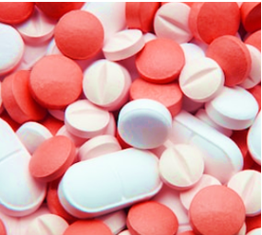
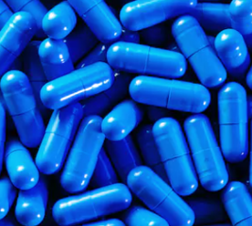 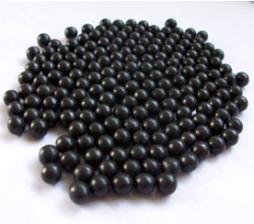
Tablet Capsule Granules Pellets
A pharmaceutical tablet is a solid oral dosage form that contains active substances and pharmaceutical excipients. Excipients are substances other than the active ingredient that are added to the tablet to improve its performance or make it easier to manufacture. Common excipients used in tablets include:
- Diluents: These are substances that increase the volume of the tablet without adding any active ingredient. They are used to make the tablet easier to swallow and to ensure that the tablet has a consistent weight.
- Binders: These are substances that hold the tablet together. They are essential for preventing the tablet from crumbling or breaking apart.
- Glidants: These are substances that help the tablet slide down the throat. They are especially important for large or high-dose tablets.
- Lubricants: These are substances that prevent the tablet from sticking to the manufacturing equipment. They also help to prevent the tablet from sticking to the patient's mouth or throat.
Tablets are typically compressed to their final form using a tablet press. The pressure applied during compression determines the hardness of the tablet. Hard tablets are more difficult to break and swallow, but they are also more resistant to degradation. Soft tablets are easier to break and swallow, but they are also more likely to degrade.
Tablets can be administered orally, buccally, intravaginally, or rectally. The method of administration is determined by the drug and the desired effect. For example, oral tablets are the most common type of tablet and are swallowed with water. Buccal tablets are placed between the cheek and gum and are absorbed through the lining of the mouth. Intravaginal tablets are inserted into the vagina and are absorbed through the vaginal walls. Rectal tablets are inserted into the rectum and are absorbed through the rectal walls.
Tablets can vary in size, shape, weight, thickness, dissolution, and hardness based on their intended use and manufacturing process. For example, large tablets are often used for high-dose medications, while small tablets are easier to swallow. Shaped tablets are often used for branding or to make the tablet easier to break into smaller doses. Weight and thickness are important for ensuring that the tablet is consistent and that it has the correct amount of active ingredient. Dissolution is the rate at which the tablet dissolves in the body. Tablets with a fast dissolution rate are often used for medications that need to be absorbed quickly, while tablets with a slow dissolution rate are often used for medications that need to be released slowly into the body. Hardness is important for preventing the tablet from crumbling or breaking apart.
Tablets are a versatile and effective way to deliver medication to the body. They are easy to manufacture, store, and transport. They can also be designed to deliver medication at a specific rate or to a specific location in the body. As a result, tablets are one of the most common types of dosage forms used in the pharmaceutical industry.
Tablets are an important dosage form in the pharmaceutical industry. They offer a number of advantages, including:
- Accuracy: Tablets can be accurately dosed, ensuring that patients receive the correct amount of medication.
- Convenience: Tablets are easy to swallow and transport, making them a convenient option for patients.
- Stability: Tablets are relatively stable, and can be stored for long periods of time without losing their potency.
- Cost-effectiveness: Tablets are typically less expensive to manufacture than other dosage forms, such as capsules or injections.
The pharmaceutical properties of tablets are important for ensuring their quality and effectiveness. Tablets should be:
- Hard and strong: This is to ensure that they can withstand the mechanical stresses of manufacturing, packing, and shipping.
- Physically and chemically stable: This is to ensure that they do not degrade over time or when exposed to environmental factors.
- Bioavailable: This means that they release their contents in a predictable and reproducible manner, so that the patient receives the correct dose of medication.
- Free from defects: This includes cracks, chips, and contamination.
- Uniform in weight and drug content: This is to ensure that each tablet contains the same amount of medication.
In addition to these pharmaceutical properties, tablets should also be easy to swallow and have an appealing appearance. This can help to improve patient compliance and make taking medication more enjoyable.
The pharmaceutical uses of tablets are wide-ranging. They can be used to treat a variety of conditions, including:
- Pain: Tablets are a common way to deliver pain medication.
- Infection: Tablets can be used to deliver antibiotics and other medications to treat infections.
- Allergies: Tablets can be used to deliver antihistamines and other medications to treat allergies.
- Mental health conditions: Tablets can be used to deliver antidepressants, anti-anxiety medications, and other medications to treat mental health conditions.
- Chronic diseases: Tablets can be used to deliver medications to treat chronic conditions, such as diabetes, high blood pressure, and heart disease.
Tablets are an important part of the pharmaceutical armamentarium. They are a versatile and effective dosage form that can be used to treat a wide range of conditions.
Types of Tablets
Pharmaceutical tablets are solid dosage forms that are widely used for oral ingestion. They can be categorized based on their characteristics and intended use.
Standard Compressed Tablets
These uncoated tablets are made through compression using wet granulation, direct compression, or double compression. They provide rapid disintegration and drug release and are often used for local actions in the gastrointestinal tract.
Multiple Compressed Tablets
Prepared through more than one compression cycle, these tablets are suitable when separation of active ingredients is necessary for stability or uniform distribution. They include compression coated tablets (such as sugar-coated, film-coated, gelatin-coated, and enteric-coated), layered tablets, and inlay tablets.
Targeted Tablets
This category comprises floating tablets, designed to prolong residence time in the GI tract, and colon targeting tablets, which deliver drugs specifically to the colon.
- Floating Tablets: These tablets are designed to prolong the residence time of the dosage form within the gastrointestinal tract. They can expand in the gastric environment and are beneficial for drugs requiring controlled delivery, minimizing mucosal irritation by releasing the drug slowly.
- Colon Targeting Tablets: These tablets deliver drugs accurately to the lower gastrointestinal tract, specifically the colon, by avoiding drug release in the upper gastrointestinal tract. They are suitable for drugs with specific requirements like instability, low solubility, and short half-life.
Chewable Tablets
Intended to be broken and chewed, these tablets are helpful for children or adults who have difficulty swallowing.
Dispersible Tablets
These tablets are designed to be dispersed in water before administration, offering a homogeneous solution for easy ingestion.
Other Types of Tablets
- Lozenges and Troches: These tablets are designed to be placed in the mouth and dissolved or chewed. They are often used for local treatments, such as pain relief or sore throat relief.
- Sublingual Tablets: These tablets are placed under the tongue and dissolve quickly. They are used for drugs that need to be absorbed into the bloodstream quickly, such as nitroglycerin for heart pain.
- Buccally Tablets: These tablets are placed between the cheek and gum and dissolve slowly. They are used for drugs that need to be absorbed into the bloodstream slowly, such as nicotine gum for smoking cessation.
- Dental Cones: These tablets are placed in the gum and dissolve slowly. They are used for local anesthetics or to deliver fluoride to the teeth.
- Mouth Dissolved or Rapidly Dissolving Tablets: These tablets dissolve quickly in the mouth. They are often used for children or adults who have difficulty swallowing.
- Vaginal Tablets: These tablets are inserted into the vagina and dissolve slowly. They are used to deliver drugs locally to the vagina, such as antifungals or hormones.
- Rectal Tablets: These tablets are inserted into the rectum and dissolve slowly. They are used to deliver drugs locally to the rectum, such as pain relievers or laxatives.
- Implants: These tablets are surgically inserted under the skin. They are used to deliver drugs over a long period of time, such as hormones or pain relievers.
Modified Release Tablets
These tablets release the medicament slowly over an extended period after administration, often targeting specific sites for controlled drug delivery. They are used to achieve constant drug concentration and may include various adjuvants to alter water uptake, swelling, and gelling characteristics to modify drug release.
Conclusion
Tablets are a versatile and effective dosage form that can be used to deliver medications for a variety of conditions. The different types of tablets available offer healthcare professionals with a wide range of options to choose from, depending on the specific needs of the patient.
ORAL TABLETS FOR INGESTION
Oral tablets are the most common type of dosage form used for medication delivery. They are swallowed whole and dissolve in the stomach or intestines, releasing the drug into the bloodstream. Oral tablets come in a variety of types and formulations, each with its own unique properties and intended use.
- Standard Compressed Tablets are the most basic type of oral tablet. They are made by compressing a mixture of drug powder and excipients (inactive ingredients) into a solid form. Standard compressed tablets typically dissolve quickly in the stomach, providing a rapid onset of drug action.
- Multiple Compressed Tablets are made by compressing multiple layers of drug and excipients together. This can be done to create tablets with different release profiles, such as immediate-release and sustained-release tablets. Multiple compressed tablets can also be used to combine two or more drugs in a single tablet.
- Targeted Tablets are designed to release the drug in a specific location in the gastrointestinal tract. For example, floating tablets are designed to remain in the stomach for a longer period of time, while colon-targeting tablets are designed to release the drug in the colon.
- Chewable Tablets are designed to be chewed before swallowing. This makes them easier to swallow for children and people who have difficulty swallowing pills. Chewable tablets also allow the drug to be absorbed more quickly into the bloodstream.
- Dispersible Tablets are designed to be dispersed in water before swallowing. This creates a homogeneous solution that is easier to swallow and allows the drug to be absorbed more quickly into the bloodstream.
In addition to these common types of oral tablets, there are also a variety of other specialized tablets that are used for specific purposes. For example, lozenges and troches are designed to dissolve in the mouth, releasing the drug locally for treating conditions such as sore throat and mouth ulcers. Sublingual tablets are designed to dissolve under the tongue, delivering the drug directly into the bloodstream for rapid onset of action. Buccal tablets are designed to be placed between the cheek and gum, where they slowly release the drug into the bloodstream.
The type of oral tablet that is used will depend on the specific medication and the desired therapeutic effect. For example, a standard compressed tablet may be used for a drug that needs to be absorbed quickly, while a sustained-release tablet may be used for a drug that needs to be released over a longer period of time. The formulation of the tablet will also be important to consider, as different formulations can have different effects on the release of the drug.
By understanding the different types and formulations of oral tablets, healthcare professionals can select the most appropriate tablet for each patient. This can help to ensure that patients receive the correct dose of medication at the right time, leading to improved patient outcomes.
CAPSULES
Capsules are solid dosage forms that consist of a medicinal agent enclosed in a gelatin shell. They are typically swallowed whole and dissolve in the stomach or intestines, releasing the drug into the bloodstream. Capsules come in two main types: hard gelatin capsules and soft gelatin capsules.
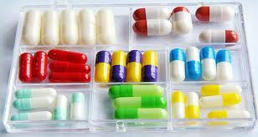
Fig.capsules
- Hard Gelatin Capsules (HGC) are made up of two parts: a body and a cap. The body and cap are made from gelatin, which is a protein derived from collagen. HGCs are typically clear, colorless, and tasteless. However, they can be colored using FD&C and D&C dyes and made opaque with agents like titanium dioxide. Medicated capsules often contain combinations of colorants and opaquants, giving them distinct appearances with different colors for the caps and bodies.
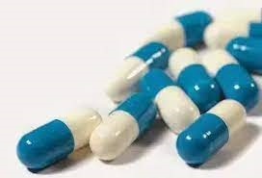
Fig. hard gelatin capsule
- Soft Gelatin Capsules are made up of a single piece of gelatin. They are typically more flexible than HGCs and have a higher moisture content. Soft gelatin capsules can be filled with a variety of liquids, including suspensions, solutions, and semisolids. They are also often used to encapsulate drugs that are sensitive to moisture or heat.
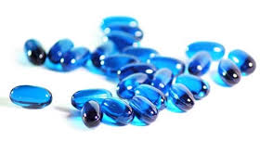
Fig. Soft gelatin capsules
In addition to hard and soft gelatin capsules, there are also other types of capsules, such as:
- Enteric-coated capsules are designed to resist stomach acid and dissolve in the small intestine. This is useful for drugs that are destroyed by stomach acid or that should not be absorbed in the stomach.
- Time-release capsules are designed to release the drug over a period of time. This is useful for drugs that need to be administered in a controlled manner.
- Molded capsules are made by compressing a mixture of drug powder and excipients into a solid form. Molded capsules are typically more complex than HGCs or soft gelatin capsules and can be used to create a variety of shapes and sizes.
Capsules are a versatile dosage form that can be used to deliver a wide range of drugs. They are easy to swallow and can be customized to meet the specific needs of each patient.
Granules
Granules are a type of solid dosage form that is made up of small, solid particles. They are typically made by mixing a drug with a carrier, such as sugar or starch. Granules can be swallowed whole or dissolved in water before administration.
Granules have a number of advantages over other dosage forms, such as tablets and capsules. They are easier to swallow, especially for children and the elderly. They also have a larger surface area than tablets or capsules, which allows for faster drug absorption. Granules can also be formulated to release the drug over a period of time, which can be useful for certain medications.
Fig.1 Granules.
There are a number of different types of granules, including:
- Soluble granules dissolve quickly in water, making them easy to take.
- Suspension granules do not dissolve completely in water, but form a suspension that can be easily swallowed.
- Effervescent granules release carbon dioxide when they come into contact with water, creating a fizzy drink that can mask the taste of the medication.
Granules are a versatile dosage form that can be used to deliver a wide range of drugs. They are easy to swallow, have a large surface area for drug absorption, and can be formulated to release the drug over a period of time.
Pellets
Pellets are small, spherical units that are made by agglomerating fine powders. They are typically used in oral and injectable drug delivery systems. Pellets offer a number of advantages over other dosage forms, including:
- Taste masking: Pellets can be coated with a variety of materials to mask the taste of unpleasant drugs. This is especially useful for children and patients who have difficulty swallowing pills.
- Increased surface area: Pellets have a larger surface area than tablets or capsules, which allows for faster drug absorption. This is important for drugs that need to be absorbed quickly, such as pain relievers or antibiotics.
- Sustained-release dosage forms: Pellets can be formulated to release the drug over a period of time. This is useful for drugs that need to be administered in a controlled manner, such as hormones or blood pressure medications.
Pellets are a versatile dosage form that can be used to deliver a wide range of drugs. They are easy to swallow and can be customized to meet the specific needs of each patient.
Here are some additional benefits of using pellets in drug delivery:
- Improved patient compliance: Pellets are often easier to swallow than tablets or capsules, which can improve patient compliance.
- Reduced dosage frequency: Pellets that are designed for sustained release can allow for reduced dosage frequency, which can be convenient for patients and save money.
- Extended day and night time drug activity: Pellets can be designed to release the drug over a 24-hour period, which can provide extended drug activity and reduce the number of doses that need to be taken each day.
Pellets are a promising dosage form for the delivery of a wide range of drugs. They offer a number of advantages over other dosage forms, including taste masking, increased surface area, and sustained-release capabilities. As a result, pellets have the potential to improve patient compliance, reduce dosage frequency, and extend day and night time drug activity.
Chapter 2: Pharmaceutical Liquid Dosage Forms
Pharmaceutical liquid dosage forms are a versatile and effective means of delivering medicinal compounds to patients. These liquid formulations are characterized by their ability to be poured and encompass a diverse array of formulations designed for various routes of administration, including oral and parenteral pathways.
Composition of liquid dosage forms
Liquid dosage forms are composed of both active pharmaceutical ingredients (APIs) and non-pharmaceutical components, commonly referred to as excipients. APIs are the medicinal substances that are responsible for the therapeutic effects of the dosage form. Excipients are added to liquid dosage forms to improve their stability, solubility, palatability, and overall therapeutic efficacy.
Some common excipients used in liquid dosage forms include:
- Emulsifiers: These substances help to disperse two immiscible liquids (such as oil and water) in a single formulation.
- Dispersants: These substances help to prevent the aggregation of solid particles in a liquid formulation.
- Solubilizers: These substances help to dissolve APIs that are not soluble in water.
- Stabilizers: These substances help to prevent the degradation of APIs over time.
- Suspending agents: These substances help to keep solid particles in suspension in a liquid formulation.
- Wetting agents: These substances help to wet solid particles, making them easier to disperse in a liquid formulation.
- Thickeners: These substances help to increase the viscosity of a liquid formulation, making it easier to administer.
- Preservatives: These substances help to prevent the growth of microorganisms in a liquid formulation.
- Sweeteners: These substances add sweetness to a liquid formulation.
- Flavorings: These substances add flavor to a liquid formulation.
- Coloring agents: These substances add color to a liquid formulation.
Administration routes for liquid dosage forms
Liquid dosage forms can be administered via a variety of routes, including:
- Oral: Liquid dosage forms can be swallowed or taken as a mouthwash or gargle.
- Parenteral: Liquid dosage forms can be injected into the body.
- Ophthalmic: Liquid dosage forms can be applied to the eyes.
- Nasal: Liquid dosage forms can be applied to the nose.
- Otic: Liquid dosage forms can be applied to the ears.
- Topical: Liquid dosage forms can be applied to the skin.
Types of liquid dosage forms
There are many different types of liquid dosage forms, each with its own unique characteristics and applications. Some common types of liquid dosage forms include:
- Solutions: Solutions are homogeneous mixtures of APIs and solvents. They are clear and transparent, and they are absorbed quickly by the body.
- Suspensions: Suspensions are heterogeneous mixtures of APIs and solvents. They contain solid particles that are suspended in a liquid medium. Suspensions are typically cloudy, and they may have to be shaken before use.
- Emulsions: Emulsions are two immiscible liquids (such as oil and water) that are stabilized by an emulsifier. Emulsions are typically white or off-white, and they may have to be shaken before use.
- Syrups: Syrups are concentrated solutions of sugars or other sweeteners in water. They are thick and syrupy, and they are often used to mask the taste of bitter APIs.
- Elixirs: Elixirs are sweet, aromatic liquid mixtures of APIs and solvents. They are typically used for oral administration.
- Tinctures: Tinctures are alcoholic solutions of APIs. They are typically used for topical application.
- Drops: Drops are small volumes of liquid that are typically administered to the eyes, nose, or ears.
Advantages and disadvantages of liquid dosage forms
Liquid dosage forms offer a number of advantages over other types of dosage forms, including:
- They are easy to swallow, making them a good option for patients who have difficulty swallowing tablets or capsules.
- They are absorbed quickly by the body, providing a rapid onset of action.
- They can be administered to patients of all ages, including infants and young children.
- They can be flavored to mask the taste of bitter APIs.
- They are relatively inexpensive to produce.
However, liquid dosage forms also have some disadvantages, including:
- They may be unstable and require refrigeration.
- They may be contaminated with microorganisms.
- They may be difficult to measure accurately.
- They may be messy to administer.
Conclusion
Pharmaceutical liquid dosage forms are a versatile and effective means of delivering medicinal compounds to patients. They offer a number of advantages over other types of dosage forms, but they also have some disadvantages. Liquid dosage forms should be chosen carefully based on the specific needs of the patient.
Chapter 3: Semi-solid Dosage Forms
Semi-solid dosage forms are a versatile and important class of pharmaceutical products. They are typically used for topical or transdermal drug delivery, but they can also be administered rectally, vaginally, or nasally. Semi-solid dosage forms offer a number of advantages over other dosage forms, including:
- Ease of use: Semi-solid dosage forms are typically easy to apply and remove. They are also relatively mess-free, making them a good option for patients who have difficulty handling other dosage forms.
- Targeted delivery: Semi-solid dosage forms can be designed to deliver drugs to specific areas of the body. This is particularly useful for treating skin conditions, as well as conditions of the rectum, vagina, and nose.
- Sustained release: Semi-solid dosage forms can be designed to release drugs over a prolonged period of time. This can be useful for providing long-lasting relief from pain or other symptoms.
There are a variety of different semi-solid dosage forms, including:
- Ointments: Ointments are thick, greasy preparations that are typically used for skin conditions. They are made by suspending or dissolving active ingredients in a base of oil, wax, and other excipients.
- Gels: Gels are semi-solid preparations that are more watery than ointments. They are made by suspending active ingredients in a gelling agent, such as gelatin or pectin. Gels are often used for topical medications, as they can provide a cooling and soothing effect.
- Creams: Creams are semi-solid preparations that are similar to gels, but they contain more oil. They are often used for topical medications, as they can provide a protective barrier for the skin.
- Suppositories: Suppositories are solid dosage forms that are designed to melt or dissolve at body temperature. They are typically inserted into the rectum, vagina, or urethra to deliver drugs to the bloodstream.
- Pessaries: Pessaries are similar to suppositories, but they are designed to be inserted into the vagina. They are typically used to deliver drugs to the reproductive system.
Semi-solid dosage forms are an important part of the pharmaceutical toolkit. They offer a number of advantages over other dosage forms, making them a good choice for a variety of medical conditions.
Novel Drug Delivery Systems
In addition to traditional semi-solid dosage forms, there are a number of novel drug delivery systems that are being developed. These systems offer new ways to deliver drugs to the body, with the goal of improving efficacy and safety.
One promising novel drug delivery system is inhalation therapy. Inhalation therapy allows drugs to be delivered directly to the lungs, bypassing the digestive system and the liver. This can lead to faster onset of action and reduced side effects.
Another novel drug delivery system is transdermal therapy. Transdermal therapy involves applying drugs to the skin, where they are absorbed into the bloodstream. Transdermal therapy is a convenient and discreet way to deliver drugs, and it can be used for long-term treatment.
Parenteral drug delivery is another novel drug delivery system. Parenteral drug delivery involves injecting drugs directly into the bloodstream. Parenteral drug delivery is typically used for emergency medications or for drugs that cannot be absorbed through the digestive system.
Oral strips and films are another novel drug delivery system. Oral strips and films are placed on the tongue, where they dissolve and deliver drugs to the bloodstream. Oral strips and films are a convenient and discreet way to deliver drugs, and they are well-suited for patients who have difficulty swallowing tablets or capsules.
Novel drug delivery systems offer new ways to improve the efficacy and safety of drug treatment. These systems are still under development, but they have the potential to revolutionize the way drugs are delivered to patients.

