Review: Nanoparticle-Based Modulation Of Immune Reactions And Reduction Of Their Immunotoxicity
Richa Das, Shreni Agrawal, Esha Rami, Dinky Patel, Ebenezer Andoh
Department of Life Sciences, Parul Institute of Applied Science Parul University, Vadodara-391760, Gujarat, India

Abstract
In the past few years, the emergence of novel variants of pathogenic microorganisms has posed a great challenge in the immunization and treatment of infectious diseases. Over the years, astonishing efforts have been made in vaccine development and to improve the efficaciousness of the existing vaccines against specific diseases. There are different types of vaccines available, which include live-attenuated vaccines, toxoids, subunit vaccinations, and inactivated vaccines. However, there are some risks associated with them like, regaining pathogenicity in immunocompromised patients. To tackle this issue, there is a need to develop more effective and risk-free vaccines in association with suitable systems which can elicit a cell-mediated and humoral immune response. Overthe past few years, particles with a size ranging from 1-100 nm are gaining a lot of attention. They are called nanoparticles (NPs). In various fields of life sciences and almost all types of technology, applications using nanoparticles are considered to be numerous. Asthe nanotechnology field has developed its applications,researchers are trying to determine the effects of nanoparticles on the immunological system of the body by the use of nanoparticle-based vaccines. Surface modifications of nanoparticles with ligands can help in strengthening the immunogenic response and open new possibilities for manipulating immune responses with reduced immune toxicity. Nanoparticles can be designed in a way that can influence cytokine secretion and immunogenicity. This article discusses different practical implications and theories made so far using nanoparticles in vaccine delivery, few unfavorable immunotoxicity of nanoparticles and how to reduce them.
Keywords: Nanoparticles, vaccine delivery, ligands, immunogenic response, immunogenicity, immunostimulation

*Corresponding author: Dr. Esha Rami,
Department of Life Science,
Parul Institute of Applied Science,
Parul University, Vadodara-391760, Gujarat, India
(e-mail: esha.rami82036@paruluniversity.ac.in)
Contact No: +91 9428551505

Introduction
A nanoparticle which is also known as ultrafine particle is a small particle that ranges between 1 to 100 nanometres in diameter which is Undetectable by the human eye. Now a days, nanotechnology has numerous applications in various fields that is information technology, homeland security,transportation, biomedical researches, medicine, energy, food safety, and environmental science, among many others [1].Nanoparticles (NPs) have shown their potential in a wide variety of biological procedures designed to control the immune system. They function as the carriers of drugs and genes. [2], vaccines, adjuvants, biomedical imaging [3], photodynamic therapy [4], wound healing [6,7], tissue engineering [5] and are used therapeutically to treat a number of disorders. Due to their smaller size, NPs either assist immune system escape from them or boost the immunological response to a specific infection [8]. The control of immune system reaction by NPs develops more interest in biomedical research for the treatment of different types of cancer and immune disorders [9]. So, the regulation and modification of immunity, either by boosting or suppressing the immune response, is referred to as immunomodulation. Agents that activate or suppress the immune system's function cause immunomodulation, which alters the immune system in humans. [10]. NPs provide two types of immune response which are immunostimulation and immunosuppression.Immunostimulation is the term for an immune system modulation that elevates an immune response..Immunostimulators have devided into two categories, which are specific immunostimulators and non-specific immunostimulators. The immunostimulators that give rise to the immune response due to specific antigen is known as specific immunostimulators which include vaccines or antigens of any kind. Non-specific immunostimulators, like adjuvants, can enhance the immune response to other antigens or stimulate immune system components without antigenic specificities regardless of the antigenic specificity [11].Generally speaking, vaccines are the most frequently used immunostimulators in the human population.
Antigens from particular pathogens are used in vaccines to trigger a potent immune response that is protective.An adjuvant which is no-specific immunostimulator is often used in conjugation with vaccines. Adjuvants are administered along with vaccines to help the immune system respond to the vaccine antigen in a stronger and more protective way, increasing the body's level of defence against the pathogen. The human body also produces a variety of immunostimulants, such as cytokines, to improve immune function. [12]. Other synthetic adjuvants and immunostimulants include levamisole and thalidomide, but they have a number of negative side effects, including kidney damage, liver damage, digestive problems, sexual dysfunction, bone marrow depression, myalgia, and hypertension. [12]. Many times immunostimulation goes out of control that may lead to thrombosis, anaphylaxis, and allergic reactions. [13]. Similarly, Immunosuppression is the deliberate prevention or reduction of an immune response. Immunosuppression is preferred for the treatment of inflammatory diseases, autoimmune disorders, and to prevent allergic reactions. [14]. Sometimes, Incorrect immunosuppression can weaken the immune system's response to harmed, infected, and cancerous cells as well as bone marrow and thymus malfunctions. [15].The study of NP-mediated immunomodulation (immunostimulation and immunosuppression) is incredibly new. Additionally, it is unclear how the immune system interacts with NPs and how NPs affect the body's immunological system. Here, in this review paper, we have mostly discussed specific immunostimulation which involves vaccines and some part of immunosuppression. To describe the impact of immunostimulation on the body’s immune system, we have taken an example of the hepatitis-B vaccine by using NPs. In addition, we have also talked about how to lessen the immunotoxicity of NPs.
Nanoparticles interaction with immune system
Our immune system is made up of two components: the innate immune system and the adaptive immune system based on how they function [16 ,17, 18].The human body's initial line of defence against foreign substances is the innate immunity, which eliminates contaminated cells or foreign particles when they come in contact with it. It is also called as a non-specific immune response [19]. It is regulated by effector cells, like, macrophages, mast cells (MCs), dendritic cells (DCs) and neutrophils [18,20]. The adaptive immune system is the second line of defence against pathogens or foreign particles. T-cells and B-cells are specialized cells that function as a component of the adaptive immunity [21]. When NPs enter the mammalian body, they trigger an inflammatory response. They communicate with innate effector cells, which stimulates the immune system. This interaction leads to a cascade of signals upon activation of pattern recognition receptors (PRRs) [22,23]. To recognise pathogen-associated molecular patterns (PAMPs) connected to microbial pathogens or cellular stress, innate effector cells express PRRs[23,24]. Signalling molecules such as chemokines and cytokines are secreted in response to inflammation, aiding in molecular coordination and communication between immune cells [25]. Typically, positively charged nanoparticles are more likely to cause inflammation than negatively or neutrally charged ones[26].For instance, macrophages that have cationic substances readily interact with the surface's negatively charged sialic acid.
The toll-like receptors (TLRs) on macrophages identify foreign antigens, bind to them, and trigger the signal transduction cascade and inflammatory response[27]. This is has been observed in an experiment conducted by Lucarelli et al., where he exposed human macrophages to low doses of various nanoparticles, including ZrO2, SiO2, TiO2, and Co nanoparticles, and noticed increased TLR receptor expression and inflammatory cytokine production.The experiment interpreted that inflammatory responses are activated by different nanoparticles in distinguishing ways [28]. The immune system interaction with NPs also depends on the physicochemical properties like, charge, size, hydrophobicity and shape [29]. This can be seen in a study by Chuang et al., who found that the surface area of various-sized carbon black nanoparticles associated with the degree of the inflammatory reaction they caused[30]. In comparison, adaptive immunity takes several days to produce a complete antipathogen response. MHC complexes, T cell receptors, and antibodies are three types of highly variable receptors that the adaptive immunity rests on [31]. Nanoparticles can trigger both cellular and humoral immune responses, which make up the immune system[25]. This was shown in a study by Liu et al., who discovered that polyhydroxylated fullerenes [C60(OH)20] boosted Th1 cytokine production while inhibiting Th2 cytokine production[32]. There are few NPs having epitope structures that binds with specific antibodies.When joined to a larger carrier molecule, the majority of NPs function as haptens and are immunogenic. The immune system can generate specific antibodies when NPs are introduced. This has been demonstrated by Chen et al., who observed the production of IgG antibodies specific to fullerenes when a mouse was immunised with a bovine thyroglobulin–conjugated C60 fullerene derivate [33]. Another factor to consider is the non-specific adsorption of proteins on the NP surface, which results in the development of a protein corona [34, 35]. When NPs enter the host, it comes in contact with biological fluids and becomes coated with biomolecules like, sugars, proteins and nucleic acids, thus, forming a corona [36]. This corona includes a series of proteins called opsonins like, C3b and C1q. Their function is to tag foreign entities for their rapid elimination [34,35]. When these proteins bind with the charged NPs, they activate the complement system and initiate a cascade of immune responses [37].
Systemforidentifyingnanoparticles as foreign B
Different sets of mechanisms have been developed to comprehend how immune cells respond to foreign objects or infectious agents. There are mainly two cells which are dendritic cells (DCs) and macrophages present in our immune system play an important role as antigen-presenting cells (APCs). Normally, both cells play a role in the initial identification of possible antigens (innate immunity) and the subsequent activation of B and T lymphocytes to begin adaptive immunity[38,39]. Pattern recognition receptors (PRRs), membrane receptors found on the surface of APCs, are one of their action mechanisms. [40].These PRRs are categorised into four families: Toll-like receptors (TLR), C-type lectin receptors (CLR), RIG-1 like receptors (RLR), nucleotide-binding oligomerization domain-like receptors (NLR). These PRRs are the key elements of the innate immunity which have the capability to recognizes conserved molecular structures of foreign bodies Such as damage-associated molecular patterns (DAMPs) and pathogen-associated molecular patterns (PAMPs)[41]. These DAMPs and PAMPs are typically unique to microbes like bacteria, viruses, parasites, or fungi and are necessary for their survival. PAMPs are typically glycans (like bacterial lipopolysaccharide (LPS)), nucleic acids (like viral ssRNA), or proteins (like bacterial flagellin). This PRRs recognizes and binds with PAMPs to eliminate them with the use of different mechanism like phagocytosis, opsonisation, complement activation, action of host-derived antimicrobial substances and acute inflammation. The immune system involves certain receptors-ligand interactions (NLRs-NOD like receptors), which stimulate immune-competent cells and cause the release of alarmins and other danger-sensing signals in addition to cell adhesion receptors' recognition of foreign bodies. [43,44].Alarmins perform similarly to PAMPs, which include reactive oxygen species (ROS), heparan sulphate, ATP, uric acid, DNA, and a structurally varied set of antimicrobial peptides (also known as antibacterial host-defense peptides), as well as heat shock proteins and proteins like the high-mobility group box-1 (HMGB1) [45,46]. Damaged or dying cells produce or exude normal cell components known as alarmins.These molecules help the body quickly identify foreign objects and microorganisms in order to protect it from their harmful effects. PRRs involves the another set of mechanism which is TOLL like receptors (TLRs). In all the different types of PRRs, TLRs are the earliest discovered and most researched receptors. In mice, the TLR family has 12 members (TLR1-TLR9, TLR11-TLR13) whereas in humans, it has 10 members (TLR1-TLR10). TLRs are confined on the surface of cells or in internal organelles like the ER, endosome, lysosome, and endolysosome [47]. For either its endogenous or exogenous ligand, each TLR is extremely specific [48]. Many researchers are studying whether TLRs that interact with NPs identify them as foreign particles or help them avoid being identified as such by the immune system [49]. TLRs recognised polyglutine acid NPs as foreign substances, according to researchers. This harmless and biodegradable material, Polyglutine acid NPs, induces an inflammatory response by activating macrophages and cytokines [50]. Additionally, recent results showed that TLRs can be activated by metal oxide NPs [51]. Particularly, TiO₂, ZnO, ZrO₂, and silver NPs activated the immune response by TLRs [52,53]. Toll like receptors 4 identifies bacterial lipopolysaccharide (LPS). Toll like receptors 2 identifies a different types of PAMPs which includes zymosan, lipotechoic acids, mannan, peptidoglycans, lipoproteins and tGPI-mucin along with TLR6 or TLR1 [54]. Bacterial flagellin is recognised by TLR5 [55]. TLR10 identifies influenza A viral infection [56]. TLR7 and TLR8 recognizes the lipidoid NPs which stimulates the release of cytokines [57]. Therefore, understanding the immune response to nanoparticles is crucial for improving their efficacy in immunology and therapeutic applications.

.
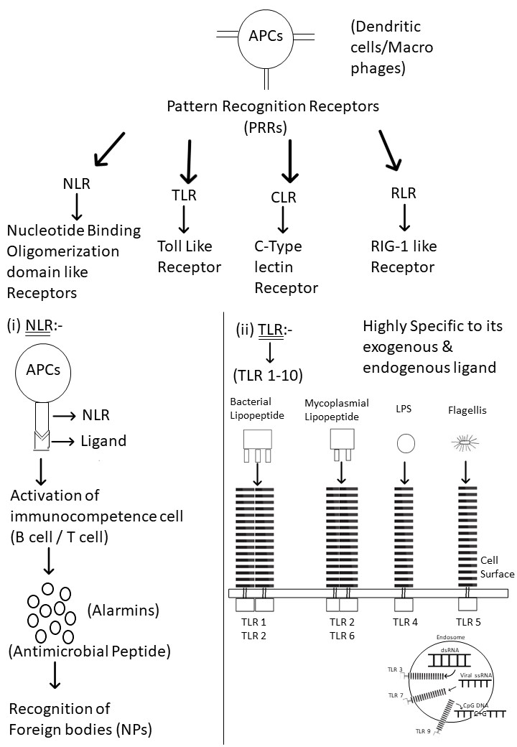
Fig. 1 representing the sysem for the recognition of nanoparticles as foreign B

Developing vaccines by directing Nps at immune system

The live attenuated or inactivated whole organism-based vaccinations have wiped out or almost eliminated many great killers of mankind, like, polio, measles, smallpox [58]. However, the efficiency of these vaccines has posed a challenge towards the new emerging disease like, Ebola, H1N1 and the recent,SARS‐CoV‐2 [59,60]. The delivery of vaccinations to target areas for error-free antigen presentation by MHC class I and cross-presentation of exogenously delivered vaccines are two more serious issues with conventional vaccines [16,61]. Medical scientists experimented with NPs in various ways to create new, effective vaccine and vaccinations administration methods. Due to their immunogenic properties, which help to improve the antigenic characteristics of weak conjugated antigens, NPs are frequently utilised as adjuvants [18,62]. For example, When polymethylmethacrylate (PMMA) nanoparticles were utilised as adjuvants in the HIV-2 virus vaccination in mice, it elicited a 100 times greater antibody response than the traditional adjuvant aluminium hydroxide [Al (OH)3] [63]. To induce a strong immune response, effective vaccination strategies focus on the production of cytotoxic (CD8+) T lymphocytes (CTL), which are introduced to foreign antigens by both MHC class II and MHC class I molecules [64]. In an experiment conducted by Hunsawong et al., A possible dengue vaccine was developed using the UV-inactivated DENV-2 strain packaged into chitosan core-shell nanoparticles (NPs). When a mouse was immunized, there was a significant increase in CD4+ and CD8+ T cell frequency and cytokine production was observed [65]. The immunogenic properties of NPs vary depending on their size and surface charge, making them intriguing for application in healthcare and as vaccine delivery systems [66]. For instance, there are several advantages of using VLP nanoparticles in vaccines because of their unique nano-dimensional size, uniformity, symmetrical shape and stable structure, which resemble native viruses. These NPs are utilised to direct vaccine antigens to antigen-presenting cells (APCs), which aids in the uptake of the vaccination. In contrast to larger nanoparticles (greater than 100 nm in size), which are typically held by cells at the injection site and must be absorbed and transported by dendritic cells (DCs) to reach the lymph nodes, smaller nanoparticles (25–40 nm in size) more quickly pass through tissue barriers and reach draining lymph nodes [67,68]. Immune responses can be modulated very effectively by targeting DCs [69]. DCs function as important APCs and encode their innate immune receptors as well. DCs therefore function as a link between innate and adaptive immunity, interacting with T and B cells to generate adaptive immune responses [70-72]. As a result, vaccination and DC targeting must both be employed to modify broad immune responses [49]. Multiple immune responses are elicited by targeting DCs to boost DC maturation or their absorption effectiveness. Yeste et al. used gold NPs to co-formulate Aryl hydrocarbon receptor ligands and proinsulin, which was then given to diabetic mice. It was noted that NPs were immediately absorbed by the splenic DCs and caused a tolerogenic reaction, as shown by an increase in the number of FoxP3+ T cells produced. Consequently, causing a delay in the beginning of diabetes [73].

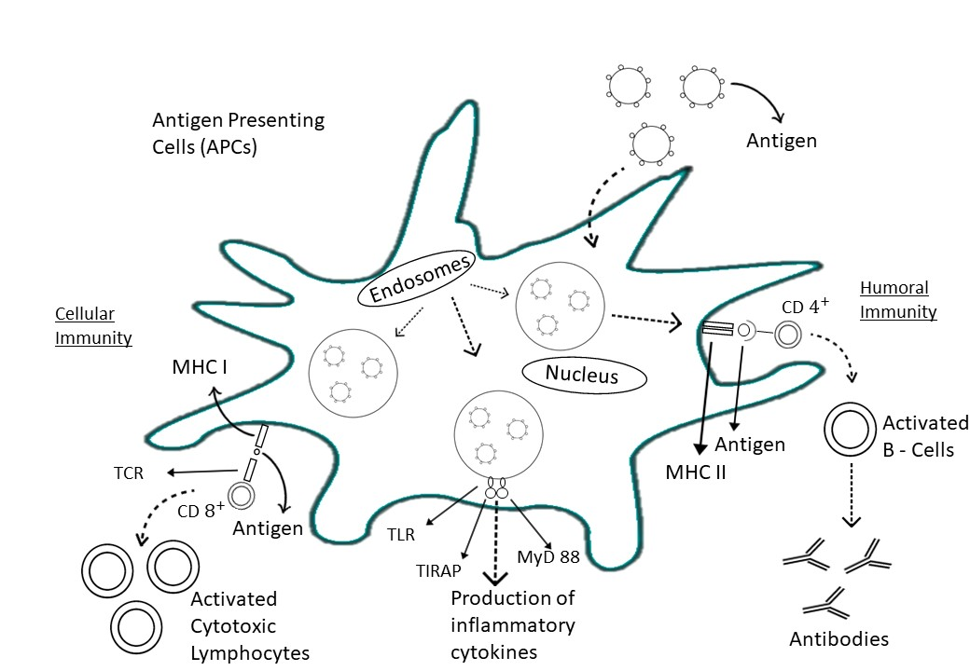

Fig.2 depicting targeting of Nanoparticles towards immune system

Nanoemulsion based hepatitis B mucosal vaccine

Hepatitis is still a serious public health concern due to its high incidence and fatality rates. Although the fact that a hepatitis B vaccination has been available on the market for more than 30 years, Hepatitis B virus (HBV) is a chronic infection that affects about 240 million individuals globally[74]. HBV causes over half of the global occurrences of hepatocellular carcinoma (HCC) and around one-third of all cases of liver cirrhosis [75]. With a diameter of 42nm, the infectious HBV has a spherical, double-shelled structure. It consists of a lipid sheath encasing HBsAg. It protects an inner nucleocapsid that contains HBcAg and is complexed with the viral DNA genome and polymerase that is encoded by the virus.HBV's genome is approximately 3.2 kb long and is partly double-stranded circular DNA. The viral polymerase is covalently attached to the minus strand's 5′ end [76]. The hepatotropic DNA virus family Hepadnaviridae, which reproduces through reverse transcription of an RNA pregenome, includes HBV as its model member[77].

Hepatitis B vaccines history

Plasma was obtained from an HBV-infected man in 1970 and inactivated by heat. The plasma was then diluted and injected into healthy people. However, plasma lost its infective capabilities but retained its immunogenic qualities, resulting in no illness in the recipients. Furthermore, these vaccinated receptors were proven to be safe against future HBV assaults. The development of a vaccine derived from plasmapheresis of human HBV carriers was sparked by these pure indigenous forms of the hepatitis B surface antigen (HBsAg), which is the major target of HBV-neutralizing antibodies. Recombinant vaccines made through genetic engineering have been recognised as reliable and secure defences against hepatitis B since about 1986. HBsAg is used as an immunogen in both plasma-derived and recombinant vaccines, and it successfully induces the formation of anti-HBs antibodies, giving recipients a protective humoral immunity [78].

Hepatitis B vaccine drawbacks

The current hepatitis B vaccines have certain drawbacks. One issue is the relatively high rate of non-responders, affecting about 10-15% of recipients [79]. Additionally, a sequence of three intramuscular injections is necessary for vaccinations, which, along with the necessity for a guaranteed cold chain from the manufacturing point to the usage point and access to sterile needles, increases the price greatly and makes immunisation efforts more difficult in many low-income countries [80]. Moreover, the existing preventive hepatitis B vaccines mainly trigger a systemic immune response, with a limited mucosal immune response. Despite the fact that HBV is a mucosal virus and spreads by parenteral or permucosal exposure[81].

Nano-delivery systems for hepatitis B vaccines

Parenteral immunizations do not give optimum or long-term defence against diseases brought on by ingested, bred, or sexually transmitted microorganisms,as is commonly acknowledged. Mucosal vaccination is a viable alternative to parenteral vaccination. It also removes the need for sterile needles while enhancing mucosal and systemic immune responses. [81].Because of the particle size, nanocarrier-based delivery devices can stimulate both [82]. Nanoparticles with droplet sizes ranging from 20 to 200 nm are used in nano-emulsions.Emulsions are soft materials created by emulsifying droplets of one liquid distributed in another immiscible liquid [83]. They function as solid sphere carriers with alipophilic, amorphous, and negatively charged surfaces [84]. They are isotropic, heterogeneous formations with a transparent or translucent appearance that are kinetically stable (no visible flocculation or coalescence over extended durations) [85]. Low-energy emulsification techniques, in contrast to high-energy techniques, which control droplet size by the amount of external energy input, result in smaller, more uniform droplets because of the system's intrinsic physicochemical characteristics. [86-91]. Nanoemulsions are made from soybean oil, water, ethanol, emulsifying agents, and surfactants [92,93].Captex 8000, Captex 355, Capryol 90, Myritol 318, Witepsol, Sefsol-218, triacetin, isopropyl myristate, olive oil, and castor oil are among the oils utilized in nanoemulsionformulations[94]. The emulsifying agent is the chemical that causes the lipid and aqueous phase combination to stay stable [95]. Because of the tiny droplet size and wide oil/water contact, nanoemulsion stability is seldom accomplished with just a surfactant, therefore a cosurfactant may be required [96]. They offer several benefits, including toxicological safety, vaccination protection, and excellent permeability and absorption of water-soluble medicines or proteins/peptides [97-99]. Nanoemulsions can also help antigen-presenting cells (APCs) display antigens and passively target the lymphatic system [100-103].

Characterization of Hepatitis B vaccine formulation

Makidon et al. developed a unique Nanoemulsion-Based Hepatitis B Mucosal Vaccinebased on the mixture of nanoemulsion adjuvant and recombinant HBsAg. Two components make up the hepatitis B vaccine candidate: recombinant HBsAg and NE (NE and W805EC formulation).The nanoemulsion was made by emulsifying water with soybean oil (64%), cetyl pyridinium chloride (CPC, 1%), Tween 80 (5%), and ethanol (8%) to produce mean droplet sizes of less than 400 nm. NE additives are positively charged due to the inclusion of quaternary ammonium chloride.Antigens that are negatively charged, such HBsAg, are combined with NE, the HBsAg-NE combination remains positively charged, but the size of the positive charge is decreased [104]. To verify NE stability, the emulsion's droplet size was measured alone and in combination either with low (0.5 mg/ml) or high (2.5 mg/ml) doses of HBsAg in a broad spectrum of concentrations (1 percent to 40%)[104]. The occurrence of destabilization processes such as creaming, coalescence, flocculation, and sedimentation can also be used to estimate stability with the naked eye. Similarly, due of the interaction of NEs with biological tissues, pH analysis is an important measurement that may be conducted using a pH pen or a pH [105]. By incubating each formulation for 72 hours at 4ºC, 25ºC, or 40ºC, it is investigated how temperature affects the interaction between NE and the antigen.[104]. Thermostability of antigen in NE is particularly beneficial since it enables for fast vaccine administration without the requirement for refrigeration or pauses in the cold chain during vaccine distribution. This is especially beneficial in the case of a pandemic. NE adjuvants are manufactured from GRAS materials that are easy to make and perform effectively with a wide range of antigens. When used alone, NE adjuvants are thermostable to 40°C for many years, and when coupled with antigen, they are thermostable to 40°C for weeks to months [106].The average lipid droplet size for both antigen concentrations was around 349 nm, and it was uniform and steady, and neither temperature nor NE concentration affected the droplet size of the combination [104]. Dynamic light scattering is now the most often used particle size analysis method, and it may be paired with a Z-potential analyzer to acquire surface charge information [105]. SDS-PAGE and Western blot were used to determine the HBsAg in the emulsion's purity. The zeta potential was used to determine the vaccine formulation's surface charge. The positive zeta potential decreased when NE was mixed with HBsAg. This implies that the negatively charged HBsAg particles and the NE are electrostatically attracted to one another. Using isothermal titration calorimetry (ITC) and laser diffraction particle size, the interaction of HBsAg with NE was further investigated.Prior to mixing, two separate and different-sized NE and HBsAg peaks were seen. However following formulation, just one edge with a dynamic diameter of 300 nm was discovered. A link among the lipid phase and the HBsAg protein in the water stage of NE was implied by the absence of two separate peaks, indicating that no major part of the antigen was still independent of the lipid. Using ITC, a thermodynamic analysis of the HBsAg-NE contact revealed a spontaneous exothermic mechanism with a calculated change in binding heat capacity 21.44,indicating that the interaction is energetically favourable[104].

Challenges and future prospects
Escape of nanoparticles from immune system
Recent Advances in bioactive science and nanoscience have enabled nanocrystals to evade the immune system.The surface charge, sizes, hydrophilicity/hydrophobicity [107] and steric effects of particle coating [108,109] of NPs can be modulated to influence their interactions with the immune system. The body defence absorbs foreign particles into the vascular systemduring opsonization by employing the mononuclear phagocyte system (MPS). To avoid opsonization, researchers proposed covering nanoparticles with polymers to conceal their surfaces. Scientists have demonstrated that when particles are coated with polyethylene glycol (PEG) [108] or other hydrophilic polymers, they can become invisible in the presence of opsonins and macrophages[110]. The PEG coating on the surface of NPs was also shown to enhance their halflife in the bloodstream from minutes to hours [111]. These results urge mainstream medical experts to look for novel ways to replicate natural compounds like medications. Hu et al. [112] implement the drug-delivery concept in which polymeric NPs were created by combining poly(lactic-co-glycolic acid) (PLGA) with blood vessel membrane-derived vesicles. The final NP product is encased in an RBC-membrane shell and has a core-shell structure. These RBC-based polymeric NPs provide the same extended blood circulation half-life as PEG-coated NPs, enabling medical researchers to maintain medicine in vivo.[112].Furthermore, In a rat model of rheumatoid arthritis, type II collagen-encapsulated PLGA NPs reduced the immune system's response to inflammation [113]. Additionally, it has been demonstrated that delivering IL-10-encoding DNA through NP prevents mice from developing autoimmune diabetes.114]. Further research revealed the utilization of betamethasonepoly(lactic acid) NPs and cytotoxic T lymphocyte-associated antigen-4Ig-silica NPs for the treatment of autoimmune thyroiditis and autoimmune uveoretinitis[115,116]. Furthermore, additional NPs with non-immunomodulatory and non-inflammogenic features have been found for the treatment of autoimmune illnesses [117]. Ferumoxtran-10 (a minuscule, superparamagnetic oxide of iron particle covered in dextran) NPs have been introduced, which have impacts on macrophage survival, cytokinin production, and oxidative burst[118].Furthermore, these NPs are not harmful to monocytes, have no influence oncytokines that are aggravating, and lack chemotactic signals. Metallic nanoparticles have also been linked to immune system evasion. Ag NPs, for example, the production of inflammatory cytokines is suppressed. Metallic nanoparticles, on the other hand, depend on their concentration to determine whether the immune system is stimulated or inhibited. Ag NP concentrations larger than 15 ppm have an impact on the cytokine release and activation of mononuclear cells from the peripheral bloodstream (PBMCs).[119]. It has been demonstrated that Ag NPs with a size of 22 nm inhibit the replication of Malt1 and Sema7a, which are in charge of streamlining immune cell activity[118]. Metal NPs can thus be utilized to control cytokine production by varying their quantities. In order to evade the immune system, another form of NP, polymeric NPs, is added. Solid lipid NPs with cholesteryl butyrate conjugation, for example, were employed to block neutrophil infiltration and adherence to endothelial cells [120,121].a bacterial endotoxin-induced, glucosamine-conjugated polyamidoamine (PAMAM) NPs were shown to inhibit the commencement of translation within human monocyte-derived macrophages and DCs of IL-1, IL-6, IL-12, TNF-, and MIP-1[122,123].G4 amine and hydroxyl-terminated dendrimers were found to be effective in inhibiting microglial inflammation in subsequent experiments [124]. More research has shown that NPs can be used to lessen NP toxicity. The recombinant Tumour Necrosis Factor-alpha (TNF-) vaccination, which is used in cancer treatments, has been restricted due to systemic toxicity caused by its protein component [125]. This vaccine is being used after being conjugated onto the outermost layer of colloidal gold nanoparticles (NPs) connected to polyethylene glycol (PEG)[126]. As previously stated, nanoparticles can be developed or changed to activate or inhibit the immune system for a variety of uses.
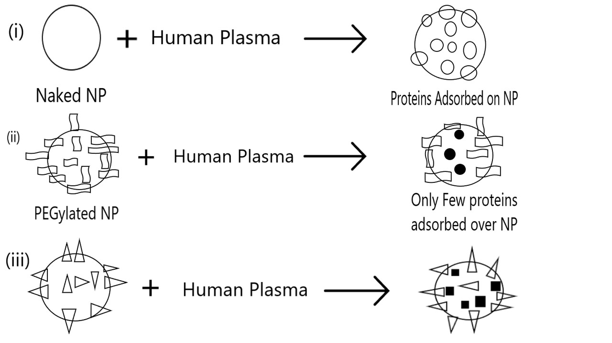
Fig3. Representing escape of NPs from immune system

Toxic effects of nanoparticles

As previously stated, NPs can be employed to influence immune responses. This modulation, however, can become uncontrolled at times, resulting in detrimental repercussions. The activation of phagocytic cells, which leads to NP engulfment, is also connected to the redundancy of immunostimulation and cytotoxicity generated by NPs. High NP concentrations have a detrimental impact on bodily tissues. NPs at concentrations of 1 mg mL1 or higher have been shown to induce tissue damage [127]. When the NP concentration reaches a hazardous threshold, Reactive oxygen species (ROS), which are released by phagocytic cells and can lead to cancer or cell death[128]. The size of NPs are critical in deciding whether they are cytotoxic or not. Researchers must analyze the charge, size, surface area, physicochemical characteristics, shape, distribution, composition, surface chemistry, surface area, mechanism, and nature of the action to assess if NPs are immunotoxic in the presence of biological molecules [129].Similar to the dissemination of intravascular coagulation (DIC), the injection of cationic polyamide amine (PAMAM) dendrimers induced vascular clotting and irregular hemorrhage. The generation of DIC in mice as a result of PAMAM dendrimers further revealed that toxicity is size and charge dependant [130]. As shown in a study of the hemolytic ability of colloidal silver with an identical surface charge as red blood cells, the physicochemical properties of NPs also influence their interactions with red blood cells. Colloidal silver's hemolytic ability was shown to depend more on the surface area of the particle than its mass[131].
Methods for reducing NPs toxicity
Many parameters, including light, NP size, temperature, surface coating, chemical composition, NP concentration in the immune system, salt concentration, and their interaction with cells, have been studied to lessen NP toxicity [126,132-133]. Light is one of the most important elements influencing NP cytotoxicity. While working with NPs, researchers discovered that Ag NPs aggregated due to the peculiar exposure of UV component of the sunlight, which promotes the dipole-dipole interaction. Additionally, they discovered that after being exposed to sunshine, Ag NPs wrapped with polyvinylpyrrolidone (PVP) and gum arabic (GA) were less dangerous[134]. Another research found that the size of the NPs in respect to light impacts their cytotoxicity.Under both dark and light circumstances, Tetrahymena pyriformis (T. pyriformis) was tested against small- and large-sized Ag nanoparticles (5–10 nm and 15–25 nm, respectively). They discovered that Smaller NPs pose less riskswhen exposed to light than big NPs [135]. In addition to size and light exposure, the form of the NPs influences their cytotoxicity. It has been found that Ag NPs in a cube form are less dangerous to plant and bacterial cells than rod-shaped Ag NPs [136]. Scientists have shown that the majority of NPs induce cytotoxicity by producing reactive oxygen species (ROS). However, by covering the NPs with PEG and dextran, ROS generation can be decreased. Since PEG and dextran coating avoids the Fenton reaction, by limiting the conversion of ROS into hydroxyl radicals, cells can strengthen their antioxidant defense system and get rid of ROS. [137]. As a result, several variables influence NP cytotoxicity, and it remains difficult to totally minimize NP toxicity in the immune system.
Coclusion
In this review paper, we have discussed how nanoparticles interact with the immune system. The use of nanoparticles in biological sciences and immunology is a promising treatment approach for a variety of immune-related disorders. The use of NPs to modulate immune response has opened the possibility to treating major illnesses such as cancer and autoimmune disorders. They function as a one-of-a-kind instrument with various physical, chemical, and mechanical qualities that may be altered to interact with certain target items. Different chemical treatments can be used to tailor the surface of NPs. They can be utilized to treat specific medical ailments by designing and controlling the size, shape, elasticity, and surface qualities of the NPs.We saw an example of a hepatitis B vaccine that was changed using the nano emulsion approach. Furthermore, we have shown that the body's immune system identifying NPs through the usage of various receptors is a very complicated process. However, there is still a lot to learn about nanoparticles and their applications in biological research and immunology.

References
- Vert, M.; Doi, Y.; Hellwich, K. H.; Hess, M.; Hodge, P.; Kubisa, P.; Rinaudo, M.; Schué, F. O. (2012). "Terminology for biorelated polymers and applications (IUPAC Recommendations 2012)". Pure and Applied Chemistry. 84 (2): 377 410
- Y. Zhou, G. Quan, Q. Wu, X. Zhang, B. Niu, B. Wu, Y. Huang, X. Pan and C. Wu, Acta Pharm. Sin. B, 2018, 8, 165–177.
- D. Kim, J. Kim, Y. I. Park, N. Lee and T. Hyeon, ACS Cent. Sci., 2018, 4, 324–336.
- Z. Dong, L. Feng, Y. Hao, M. Chen, M. Gao, Y. Chao, H. Zhao, W. Zhu, J. Liu, C. Liang, Q. Zhang and Z. Liu, J. Am. Chem. Soc., 2018, 140, 2165–2178.
- C. Boyer, L. Figueiredo, R. Pace, J. Lesoeur, T. Rouillon, C. L. Visage, J. F. Tassin, P. Weiss, J. Guicheux and G. Rethore, Acta Biomater., 2018, 65, 112–122.
- S. Silver, L. T. Phung and G. Silver, J. Ind. Microbiol. Biotechnol., 2006, 33, 627–634.
- E. A. Kamoun, X. Chen, M. S. M. Eldin and E.-R. S. Kenawy, Arabian J. Chem., 2015, 8, 1–14.
- B. S. Zolnik, A. Gonzalez-Fernandez, N. Sadrieh and M. A. Dobrovolskaia, Endocrinology, 2010, 151, 458–465.
- M. M. Markiewski, R. A. DeAngelis, F. Benencia, S. K. Ricklin-Lichtsteiner, A. Koutoulaki, C. Gerard, G. Coukos and J. D. Lambris, Nat. Immunol., 2008, 9, 1225.
- Shivaprasad HN, Kharya MD, Rana AC, Mohan S. preliminary immunomodulatory activities of the aqueous extract of terminalia chebula. Pharmaceut boil. 2006; 449(1): 32-34.
- Fenichet RL, chirigos MA. Immunemodulation agents and their mechanisms. New York: marcel dekker. 1984.
- Diasio RB, Lobuglio AF. Immunomodulators: immunosuppressive agents and immunostimulants. In: Hardman JG, limberd LE. Goodman and gilman’s: the pharmacological basis of therapeutics. 9th ed. New York: Mc grow hill companies Inc.1996: 1291-1307.
- U. C. Nygaard, J. S. Hansen, M. Samuelsen, T. Alberg, C. D. Marioara and M. Løvik, Toxicol. Sci., 2009, 109, 113– 123.
- J. J. Ryan, H. R. Bateman, A. Stover, G. Gomez, S. K. Norton, W. Zhao, L. B. Schwartz, R. Lenk and C. L. Kepley, J. Immunol., 2007, 179, 665–672.
- R. Brayner, Nano Today, 2008, 3, 48–55.
16. I. Pantic.Sci. Prog, 2011; 94:97–107.
17. L. M. Sompayrac. How the immune system works: Wiley-Blackwell Publisher; 2019.
18. Muhammad, Q., Jang, Y., Kang, S. H., Moon, J., Kim, W. J., & Park, H. Biomater. Sci., 2020; 8: 1490-1501
19. S. Franz, S. Rammelt, D. Scharnweber, J. C. Simon. Biomaterials, 2011; 32:6692–6709.
20. B. J. Nickoloff. Dermal immune system: CRC Press; 2019.
21. D. Landesman-Milo, D. Peer J. Controlled Release, 2012; 161:600–608.
22. T. Maekawa, T. A. Kufer, P. Schulze-Lefert. Nat. Immunol, 2011;12:817.
23. Moyano D. F, Liu Y, Peer D, Rotello V. Small, 2015;12(1):76–82.
24. Boraschi D. Nanoparticles and Innate Immunity: Academic Press; 2014.p. 9–31.
25. Kononenko V, MojcaNarat, DamjanaDrobne. Arh Hig Rada Toksikol, 2015;66:97-108
26. Dobrovolskaia MA, McNeil SE. Nat Nanotechnol, 2007;2:469-78.
27. Dwivedi PD, Misra A, Shanker R, Das M. Nanotoxicology, 2009;3:19-26.
28. Lucarelli M, Gatti AM, Savarino G, Quattroni P, Martinelli L, Monari E et al. Eur Cytokine Netw, 2004;15:339-46.
29. Luo YH, Chang LW, Lin P. Biomed Res Int. 2015;2015
30. Chuang HC, Chenc LC, Leic YC, Wuc KY, Fengb PH, Chengc TJ. Atmos Environ, 2015;106:329-34.
31. Duschl A. (2014). Nanoparticles and Adaptive Immunity. Academic Press; 2014.p.33–53.
32.Liu Y, Jiao F, Qiu Y, Li W, Qu Y, Tian C et al. Nanotechnology, 2009;20:415102.

33. Chen BX, Wilson SR, Das N, Coughlin DJ, Erlanger BF. Proc Natl Acad Sci USA, 1998;95:10809-13.

34. M. P. Monopoli, D. Walczyk, A. Campbell, G. Elia, I. Lynch, F. B. Bombelli et al. J. Am. Chem. Soc, 2011;133:2525.
35. J. Szebeni, L. Baranyi, S. Savay, H. U. Lutz, E. Jelezarova, R. Bunger et al. J. Liposome Res, 2000;10:467.
36. Monopoli MP, Aberg C, Salvati A, Dawson KA. Nat Nanotechnol, 2012;7(12):779–86.

37. S. M. Moghimi, P. P. Wibroe, S. Y. Helvig, Z. S. Farhangrazi, A. C. Hunter. Adv. Drug Deliv. Rev, 2012;64:1385.
- J. E. Babensee, Semin. Immunol., 2012, 20, 101–108.
- Z. Xia and J. T. Triffitt, Biomed. Mater., 2006, 1, R1.
- D. F. Moyano, M. Goldsmith, D. J. Solfiell, D. LandesmanMilo, O. R. Miranda, D. Peer and V. M. Rotello, J. Am. Chem. Soc., 2012, 134, 3965–3967.
- S. Chadwick, C. Kriegel and M. Amiji, Adv. Drug Delivery Rev., 2010, 62, 394–407.
- T. Nürnberger and B. Kemmerling, Annual Plant Reviews online, 2018, 16–47.
- A. Friedman, J. Drugs Dermatol., 2011, 10, 427–433.
- J. E. Babensee, J. M. Anderson, L. V. McIntire and A. G. Mikos, Adv. Drug Delivery Rev., 1998, 33, 111– 139.
- M. Escamilla-Tilch, G. Filio-Rodríguez, R. García-Rocha, I. Mancilla-Herrera, N. A. Mitchison, J. A. Ruiz-Pacheco, F. J. Sánchez-García, D. Sandoval-Borrego and E. A. Vázquez-Sánchez, Immunol. Cell Biol., 2013, 91, 601– 610.
- M. Lamkanfi, Nat. Rev. Immunol., 2011, 11, 213.
- Botos I, Segal DM, Davies DR. The structural biology of toll-like receptors. Structure (2011) 19:447–59. doi:10.1016/j.str.2011.02.004
- W.-J. Hu, J. W. Eaton, T. P. Ugarova and L. Tang, Blood, 2001, 98, 1231–1238.
- 52 E. T. Mohammed and G. M. Safwat, Biol. Trace Elem. Res., 2019, 1–11.
- 53 T. Uto, T. Akagi, K. Yoshinaga, M. Toyama, M. Akashi and M. Baba, Biomaterials, 2011, 32, 5206–5212.
- Smith U.M., Simon J.K., Baker J.R., Jr. Applications of nanotechnology for immunology. Nat. Rev. Immunol. 2013;13:592–605. doi: 10.1038/nri3488.
- Lucarelli M., Gatti A.M., Savarino G., Quattroni P., Martinelli L., Monari E., Boraschi D. Innate defence functions of macrophages can be biased by nano-sized ceramic and metallic particles. Eur. Cytokine Netw. 2004;15:339–346.
- Cui Y., Liu H., Zhou M., Duan Y., Li N., Gong X., Hu R., Hong M., Hong F. Signaling pathway of inflammatory responses in the mouse liver caused by TiO₂ nanoparticles. J. Biomed. Mater. Res. Part A. 2011;96:221–229. doi: 10.1002/jbm.a.32976.
- Kawai T, Akira S. The role of pattern-recognition receptors in innate immunity: update on toll-like receptors. Nat Immunol (2010) 11:373–84. doi:10.1038/ni.1863
- Akira S, Uematsu S, Takeuchi O. Pathogen recognition and innate immunity. Cell (2006) 124:783–801. doi:10.1016/j.cell.2006.02.015
- Lee SM, Kok KH, Jaume M, Cheung TK, Yip TF, Lai JC, et al. Toll-like receptor 10 is involved in induction of innate immune responses to influenza virus infection. Proc Natl Acad Sci USA (2014) 111:3793–8. doi:10.1073/pnas.1324266111
- D. N. Nguyen, K. P. Mahon, G. Chikh, P. Kim, H. Chung, A. P. Vicari, K. T. Love, M. Goldberg, S. Chen and A. M. Krieg, Proc. Natl. Acad. Sci. U. S. A., 2012, 109, E797– E803.
- C. Zhang, G. Maruggi, H. Shan, J. Li. Front. Immunol, 2019;10:594.
- B. Ferraro, M. P. Morrow, N. A. Hutnick, T. H. Shin, C. E. Lucke, D. B. Weiner. Clin. Infect. Dis, 2011;53:296.
- S. Han.Clin. Exp. Vaccine Res, 2015;4:46.
- D. N. Nguyen, K. P. Mahon, G. Chikh, P. Kim, H. Chung, A. P. Vicari et al. Proc. Natl. Acad. Sci. U. S. A, 2012;109: E797– E803
- F. B. Sulczewski, R. B. Liszbinski, P. R. Romцëo. Arch. Virol, 2018;163:2313–2325.
- Stieneker F, Kreuter J, Löwer J. AIDS, 1991;5:431-5.
- A. E. Foster, C. M. Rooney. Expert Opin. Biol. Ther, 2006;6:215–229.
- Hunsawong T. Vaccine, 2015; 33:1702–1710
- Zhao L, Seth A, Wibowo N, Zhao C-X, Mitter N, Yu C et al. Vaccine,2014; 32: 327–33
- ManolovaV.Eur. J. Immunol, 2008;3:1404–1413.
- Reddy S. Nature Biotech, 2007;25:1159–1164.
- Du J, Zhang Y. S, Hobson D, Hydbring P. Drug Discovery Today, 2017;22(9):1295–1301.
- Warrington R. Allergy Asthma Clin. Immunol, 2011;7 (Suppl. 1): S1
- Vesely M.D.Annu. Rev. Immunol, 2011;29:235–271
- Iwasaki A, MedzhitovR.Science, 2010; 327:291–295
- YesteA.Sci. Signal, 2016;9:61
- Schweitzer A, Horn J, Mikolajczyk RT et al.Lancet, 2015;386 (10003):1546-1555.
- El-SeraqHB. N Engl J Med, 2011;365(12): 1118-1127.
- Gerlich W, Robinson WS. Cell, 1980;21:801–811.
- Schaefer S. World J Gastroenterol, 2007;13:14–21.
- Yu AS, Cheung RC, Keeffe EB. Infect Dis Clin North Am, 2006; 20(1): 27-45.
- Gerlich WH. Med Microbiol Immunol, 2015; 204:39–55.
- Komatsu H. World J Gastroenterol, 2014; 20(27): 8998- 9016.
- Saraf S, Mishra D, Asthana A, Jain R, Singh S, et al. Vaccine, 2006; 24(1): 45-56.
- Kim MG, Park JY, Kim G, Shim G, Oh YK. Asian J Pharm Sci, 2014; 9(5): 227-235.
- Kim H. S, Mason T. G. Advances in Colloid and Interface Science, 2017; 247: 397–412.
- Jaiswal, M, Dudhe R, Sharma, P. K. Biotech, 2014; 5(2): 123–127.
- Rai V. K, Mishra N, Yadav K. S, Yadav N. Journal of Controlled Release, 2018; 270: 203–225.
- M. Willert, R. Rothe, K. Landfester, M. Antonietti. Chem. Mater, 2001; 13: 4681 - 4685.
- N Anton, J.P. Benoit, P. Saulnier. J. Control Release, 2008; 128: 185–199
- C. Solans, P. Izquierdo, J. Nolla, N. Azemar, M.J. García-Celma. CurrOpin Colloid Interface Sci, 2005; 10: 102 – 110.
- T. Tadros, P. Izquierdo, J. Esquena, C. Solans. Adv Colloid Interface Sci, 2004; 108–109: 303 – 318.
- N. Anton, T.F. Vandamme. Int. J. Pharm, 2009; 377: 142–147
- Fornaguera C, Dols-Perez A, Calderó G, García-Celma M. J, Camarasa J, Solans C. Journal of Controlled Release, 2015; 211: 134–143.
- Wong PT, Leroueil PR, Smith DM, Ciotti S, Bielinska AU, Janczak KW, et al. PLoS One, 2015; 10: e0126120
- Wong PT, Wang SH, Ciotti S, Makidon PE, Smith DM, Fan Y, et al. Mol Pharm, 2014; 11:531-44;
- Chircov C, Grumezescu A. M. Nanoarchitectonics in Biomedicine, 2019; 169–188.
- Sharma S, Hegde M, Sadananda V, Matthews B. J. Dent. Lasers, 2017; 11: 26.
- Talegaonkar S, Negi L. M. Targeted Drug Delivery: Concepts and Design, 2014; 433–459.
- Y. Peng, et al. Food Chem, 2018; 242: 527-532.
- I. Odriozola-Serrano, G. Oms-Oliu, O. Martin-Belloso. Front. Nutr, 2014; 1: 24
- H. Gupta, D. Bhandari, A. Sharma. Recent Pat. Drug Deliv. Formul, 2009; 3: 162-173
- J. Akhtar, H.H. Siddiqui, Badruddeen S, Fareed M. Curr. Drug Deliv, 2014; 11: 243-252
- W. Ge, et al. Oncol. Rep, 2009; 22: 915-920
- W. Ge, et al. Cancer Immunol. Immunother, 2009; 58: 201-208
- Sutradhar K B, Amin M L. Eur. J. Nanomed, 2013;5: 97–110.
- Makidon PE, Bielinska AU, Nigavekar SS, Janczak KW, Knowlton J, Scott AJ et al. PLoS One, 2008; 3: e2954
- Dasgupta N, Ranjan S. An Introduction to Food Grade Nanoemulsions. Environmental Chemistry for a Sustainable World: Springer, Singapore Publishers; 2018
- Hamouda T, Simon J, Fattom A, Baker J. Novel Immune Potentiators and Delivery Technologies for Next Generation Vaccines, 2012; 269–286.
- P. Aggarwal, J. B. Hall, C. B. McLeland, M. A. Dobrovolskaia and S. E. McNeil, Adv. Drug Delivery Rev., 2009, 61, 428–437.
- F. M. Veronese and G. Pasut, Drug Discovery Today, 2005, 10, 1451–1458.
- S.-Y. Seong and P. Matzinger, Nat. Rev. Immunol., 2004, 4, 469.
- R. H. Fang, C.-M. J. Hu and L. Zhang, Expert Opin. Biol. Ther., 2012, 12, 385–389.
- Z. Shen, A. Fisher, W. K. Liu and Y. Li, in Engineering of Biomaterials for Drug Delivery Systems, Elsevier, 2018, pp. 1–26.
- C.-M. J. Hu, L. Zhang, S. Aryal, C. Cheung, R. H. Fang and L. Zhang, Proc. Natl. Acad. Sci. U. S. A., 2011, 108, 10980– 10985.
- I. M. Oliveira, C. Gonçalves, R. L. s. Reis and J. M. Oliveira, Nano Res., 2018, 11, 4489–4506.
- A. Basarkar and J. Singh, Pharm. Res., 2009, 26, 72–81.
- T. Sakai, H. Kohno, T. Ishihara, M. Higaki, S. Saito, M. Matsushima, Y. Mizushima and K. Kitahara, Exp. Eye Res., 2006, 82, 657–663.
- E. W. Choi, I. S. Shin, C. W. Lee and H. Y. Youn, J. Gene Med., 2008, 10, 795–804.
- I. Pantic, Sci. Prog., 2011, 94, 97–107.
- H.-Y. Lee, Y.-J. Choi, E.-J. Jung, H.-Q. Yin, J.-T. Kwon, J.-E. Kim, H.-T. Im, M.-H. Cho, J.-H. Kim and H.-Y. Kim, J. Nanopart. Res., 2010, 12, 1567–1578.
- S.-H. Shin, M.-K. Ye, H.-S. Kim and H.-S. Kang, Int. Immunopharmacol., 2007, 7, 1813–1818.
- R. Minelli, L. Serpe, P. Pettazzoni, V. Minero, G. Barrera, C. Gigliotti, R. Mesturini, A. C. Rosa, P. Gasco and N. Vivenza, Br. J. Pharmacol., 2012, 166, 587–601.
- C. Dianzani, R. Cavalli, G. P. Zara, M. Gallicchio, G. Lombardi, M. R. Gasco, P. Panzanelli and R. Fantozzi, Br. J. Pharmacol., 2006, 148, 648–656.
- S. Shaunak, Discovery Med., 2009, 4, 464–469.
- S. Shaunak, S. Thomas, E. Gianasi, A. Godwin, E. Jones, I. Teo, K. Mireskandari, P. Luthert, R. Duncan and S. Patterson, Nat. Biotechnol., 2004, 22, 977.
- S. Boridy, G. M. Soliman and D. Maysinger, Nanomedicine, 2012, 7, 1149–1165.
- T. Steinmetz, M. Schaadt, R. Gähl, V. Schenk, V. Diehl and M. Pfreundschuh, J. Biol. Response Modif., 1988, 7, 417–423.
- S. K. Libutti, G. F. Paciotti, A. A. Byrnes, H. R. Alexander, W. E. Gannon, M. Walker, G. D. Seidel, N. Yuldasheva and L. Tamarkin, Clin. Cancer Res., 2010, 16, 6139–6149.
- D. De Stefano, R. Carnuccio, M. C. Maiuri, J. Drug Delivery, 2012; 2012: 1–14.
- M. A. Siddiqui, M. Ahamed, J. Ahmad, M. M. Khan, J. Musarrat, A. A. Al-Khedhairy et al. Food Chem. Toxicol, 2012; 50: 641–647.
- C. Chen, B. Sun, K. K. Tran, H. Shen. Biomaterials, 2011; 32: 1731–1737.
- K. Greish, G. Thiagarajan, H. Herd, R. Price, H. Bauer, D. Hubbard, et al. Nanotoxicology, 2012; 6: 713–723.
- J. Choi, V. Reipa, V. M. Hitchins, P. L. Goering, R. A. Malinauskas. Toxicol. Sci, 2011; 123: 133–143.
- S. Hussain, F. Al-Nsour, A. B. Rice, J. Marshburn, B. Yingling, Z. Ji, J. I. Zink, N. J. Walker and S. Garantziotis, ACS Nano, 2012, 6, 5820–5829
- W. Lu, Y. Zhang, Y.-Z. Tan, K.-L. Hu, X.-G. Jiang and S.-K. Fu, J. Controlled Release, 2005, 107, 428–448
- Y. Cheng, L. Yin, S. Lin, M. Wiesner, E. Bernhardt and J. Liu, J. Phys. Chem. C, 2011, 115, 4425–4432.
- X. Peng, S. Palma, N. S. Fisher and S. S. Wong, Aquat. Toxicol., 2011, 102, 186–196.
- D. E. Gorka, J. S. Osterberg, C. A. Gwin, B. P. Colman, J. N. Meyer, E. S. Bernhardt, C. K. Gunsch, R. T. DiGulio and J. Liu, Environ. Sci. Technol., 2015, 49, 10093–10098.
- M. Yu, S. Huang, K. J. Yu and A. M. Clyne, Int. J. Mol. Sci., 2012, 13, 5554–5570.

