Researcher Name: Lovelina Banerjee
Author Name : Lovelina Banerjee
Designation: Rehabilitation Psychologist (A73740)
Title – Effect of quantitative art based therapeutic intervention on the empowerment of women with disabilities
University- The Techno India University, West Bengal

Dedication- I want to dedicate this work to all person with autism of Pradip Centre for Autism Management, kolkata.

Acknowledgement- I would like to acknowledge the entire team of AIMS Media, Delhi from where i have learnt artology and use quantitative measurement of art, my PhD guide Dr. (prof.) Mallika Banerjee to guide at any hard situation. And obviously all students of Pradip Centre for Autism Management, Kolkata who are the participants of the research work.

Abstract
Empowerment is a relatively recent notion. It has been used for just over 100 years, applied (initially in North America) with regard to women’s rights, then to civil rights, and eventually worldwide when advocating and ensuring the emancipation and self-determination of any disenfranchised group or individual. Empowerment has meant a lot to disabled people by enabling them to take greater control of their lives, informing policies and service provision, and helping us recognize what should be obvious, i.e. that individuals must be valued for who they are, and not ‘despite’ an impairment. While much progress is still necessary in societal attitudes towards issues relating to impairment, advances in empowerment of disabled persons have been changing our field fundamentally for the better. Further progress will continue to improve the quality and effectiveness of diagnostic and therapeutic relationships, meaningful outcomes, and organization of society as a whole. So, in this research the researcher will try to apply a non-conventional therapeutic intervention process on various component of empowerment through art with the intention to reduce the issues of daily living of women with disabilities.

Title – Effect of quantitative art based therapeutic intervention on the empowerment of women with disabilities

Introduction
Empowerment
Empowerment involves a guide to influencing local services to inform, support, and enable people with disabilities to influence local decision-making processes, taking an active part in the services they receive.
Women’s empowerment
Women’s empowerment can be defined to promoting women’s sense of self-worth, their ability to determine their own choices, and their right to influence social change for themselves and others.
Empowerment in Disability
Having a voice and taking control of their lives is essential. It helps persons with all types of disabilities achieve their maximum sustainable independence level as contributing, responsible and equal participants in society.
Need to empower people with disabilities:-

1. To curve a path to a better society
When we help others we help them pursue and achieve their goals, we play a big part in social change and growth. By providing social services like proper health care for people with disabilities, we can ensure that more people enter the workforce. This collective effort to assist people with disabilities ultimately contributes to the economy’s growth and improves the overall social setting.

2. To promote tolerance and mutual respect among people with disabilities and those without
Frankly, people with disabilities face inequality and bias due to their perceived limitations. That’s why it is crucial to inform and educate the public about multiple disabilities and how to interact with persons with disabilities respectfully. This civil education can be done through campaigns and seminars.
With the proper information, more people will be tolerant and kind to persons with disabilities, creating an environment of mutual respect. Besides, this enlightenment will lead to more accommodating attitudes in all sectors allowing more people with disabilities to contribute to societal growth.

3. To reduce and eventually eradicate the negligence of people with disabilities
There are many types of disabilities affecting people in different ways. Sadly, others are often not aware of a person's disabilities. In cases where people are uninformed of various kinds of disabilities, affected persons can experience neglect.
Empowerment of people with disabilities is essential, as support can be given to the affected persons and their families. This can be done by creating programs to provide medical care and shelter for neglected persons with disabilities.

4. To help nurture responsible individuals that contribute to society
Disabilities do not make a person a less functional member of the community. By giving equal opportunities and the corresponding respect, we grow a sense of confidence in the people with disabilities and cultivate a sense of belonging. This makes for positive growth attitudes, and despite any disability, a person will pursue and work on their goals, thus contributing positively to society.

5. Empowering people with disabilities impacts the economy positively
By supporting the programs that provide people with disabilities with skills and work opportunities, tax rates may ultimately become lower while people with disabilities will also feel more empowered. This not only improves the economy; it also upgrades the living standards.

6. To help people with hidden disabilities to come out and get proper assistance
Some people are living with disabilities that they either hide or don’t even know they have. This is quite unfortunate. That’s why we need to raise awareness of such disabilities and create platforms to address these issues and empower these people.
Since people with such abilities may need more care, proper awareness should be raised to promote relevant assistance.

7. To bridge the gap between the minorities for total equality
To empower people with disabilities, we need to teach each other the importance of unity as human beings regardless of whatever limitations. Advocating for the rights and equal treatment of people with disabilities aims at creating a peaceful world with tolerance and acceptance.
What’s more, acts of kindness unify all human beings, regardless of physical or mental limitations. When we work together to empower those who cannot stand up for themselves, we come closer and make it a better world.

8. To tackle and minimize cases of abuse on people with disabilities
In some third world countries, news about people exploitation of people with disabilities for fraud and other crime have been prevalent. By empowering people with disabilities, we can uncover such awful acts and protect potential victims in the process.
The problem can also be tackled by passing laws that protect people with disabilities and punish those who abuse and exploit them. Representatives of people with disabilities should be given the mandate to run programs that ensure that such cases do not occur.

9. To provide easy access to all services
Persons with disabilities need access to the same services and opportunities as those without a disability. For instance, they need to go to school, access health care, and earn an income.
They also need access to specific services like rehabilitation and assistive devices such as wheelchairs or braille materials.
By including the people with disabilities in more decision making, we provide them with an opportunity to access these services with ease, thus improving lives.

10. To inform people with disabilities of their rights and to ensure they are protected
Empowering people with disabilities also involves teaching them of their rights and privileges, teaching them about the law, and generally giving relevant information concerning aspects of their well-being. Most people with disabilities, having been excluded from many legal decision-making processes, are not aware of their rights and have become subject to abuse and exploitation.
Art Activity
An ART based therapeutic approach” is focused on to improve and overcome different challenges, difficulties and ability of an individual. Carl Gustav Jung a renowned Swiss psychiatrist and psychoanalyst founded analytical psychology and his ‘The Red Book’ opened the way for the future development of Art Therapy. The Red Book (1914-30) is a collection of Jung's personal writings and drawings, chronicling the exploration of his own unconsciousness. It is believed 90% of our actions are based on the subconscious.
In 1940 several writers in the mental health field began to describe their work with people in treatment as ‘Art Therapy’. Though art exists since decades which believed to showcase emotions, expressions, sign language or way to communicate but a British artist Arden Hill in 1942 discovered the healthful benefit of painting and drawing while recovering from tuberculosis. Art is believed to emit health benefits with different types of materials and creative processes which help explore emotions, reduce anxiety, increase self-esteem and resolve other psychological conflicts. There are eighteen different activities under sixteen different arts including visual art, art techniques and art forms focused on multiple Functional and other areas. It is said that people with intellectual and developmental disabilities can use art as therapy to overcome the challenges. There is an increasing amount of scientific evidence that proves art enhances brain functions. It has an impact on brain wave patterns and emotions, the nervous system and can actually raise serotonin level- An important chemical and neurotransmitter believed to help regulate moods and social behavior, appetite and digestion, sleep and memory etc. Research says art with a therapeutic approach helps children, adolescents and adults to explore their emotions, improve self-esteem, manage addictions, relieve stress, improve symptoms of anxiety and depression and cope with a physical illness and disability. Art as an expressive medium can help people to communicate, overcome stress and explore different aspects of their own personalities.

Art impacts the human in four different ways
Body – Senses – heartbeat, breath and muscles.
Mind – Activate both the hemisphere of brain (Right and Left)
Awareness – Transform sense of direction, create own meaning and purpose in life.
Spiritual – Connect soul and self-awareness.
The process of becoming stronger and more confident, especially in controlling one's life and claiming one's rights.

Review of Literature
Relevance for social work
Leonard, Hafford-Letchfiels and Couchman (2018) write about growing evidence in favour of arts and humanities helping social workers and their clients to better communicate their experiences. Art helps individuals develop their potential for creativity and readiness to change. Artistic creative processes can help rise above cultural differences and can therefore be a good method for working with people with different backgrounds. Art is not only useful for social workers in their engagement with clients, but can even contribute to a better social work education. Using art in social work education would mean integrating more creative methods of teaching that can especially be empowering for those students with diverse backgrounds and previous experiences (ibid.). Although there is a lack of Swedish published research on this matter, it appears to be a topic of interest for a number of social work students who wrote about it in their graduation thesis. This research will hopefully contribute by adding one more title to the list making art and its potential more visible in social work and social work research.
Problem statement
Considering the challenges to empowerment of the people within the same system that is part of their oppression and with the help of professionals employed by that system, it can be worthwhile to explore the possibilities of working outside the welfare system using non-traditional methods. Non-governmental organisations have more autonomy and can have more open and flexible relationships with their clients in comparison to welfare state organisations. Existing research shows that art is an important medium for social change (Moxley, 2013) which is why it was interesting to explore the ways marginalised groups can be supported by non-government organisations working 10 with art projects. Both indigenous people and prisoners are marginalised groups whose rights and resources are limited, and so is the trust they have for the government systems which is why nongovernmental organizations can have an important role in their empowerment.
Relational Art - can be defined in various ways, and one might even argue there is no clear definition nor way of knowing what art is. Nicolas Bourriaud’s defines art as relational, as “an activity consisting in producing relationships with the world with the help of signs, forms, actions and objects” (Bourriaud, 1998/2002, p. 107). This perspective on art emphasises human interactions and social context rather than aesthetic and cultural goals. Bourriaud sees art as an interactive, user-friendly and relational concept that has the possibility to connect people from different realities who would otherwise rarely meet. Important issues that artists should raise are art’s links to society, history and culture. Relational art gives space for interaction and dialogue around those issues. Art comes from the meeting between different levels of reality and is inviting people to dialogue. Bourriaud's view on art and its role in human relations and society was used in this research as a starting point since it emphasizes art’s role in raising important social issues as well as influencing dialogue and human interactions.
Art and empowerment Research project “What does the culture do” is an empirical critical analysis whose aim was to understand the complex connection between culture and well-being (Gustafsson, 2015). Research analysed culture’s content, role and importance in working with older people. It was shown that cultural activities bring memories, evoke emotions and give opportunities for feelings of achievement and trust in one's own strength. Research results also show how involvement in an art activity at home for the elderly changes the relationships between the caregivers and caretakers. They become more equal which creates balance and reciprocity which in return improves the quality of care. Cultural activities, like painting or singing, give opportunities for both caregivers and caretakers to see each other in a new context and from a new perspective. In those activities, they are side by side under the “leadership” of the artist. In all the other situations, caretakers are usually dependent on caregivers and it is caregivers who have more power, while in art activities they are side by side under the guidance of a third person, activity moderator. Culture is therefore more than just entertainment, it is also intervention. It has the potential to change the working environment making it more equal and democratic. Mukhuba (2017) analysed South African women writings and came to conclusions about writing as a way to both discover oneself and present oneself to others. The author labels most of the writing as “work of the disempowered articulating their voice and reclaiming agency and authority” (s. 8600). Women used art as a way to assert themselves and to change society’s stereotypes. Through writing one can express their own personality even if writing fictional stories. Mukhuba calls fiction “indirect autobiography” since it reflects and represents the writer’s self. Fictionalised characters and stories enable exploring and commenting on existing social norms. 16 Boehm and Boehm (2003) did a case study of a group of six women, a social worker and a director involved in a community theatre project in Israel. They define community theatre as a theatre where community members are involved and leading the project whose aim is to raise community issues. Their results show that involvement in the project contributed to members’ empowerment by enabling them to express their inner voice and influencing their self-esteem. Involvement in the project raised women’s awareness of their conditions, resources and limitations. Women became more aware of their capabilities to effect change and started taking a more active role and showing initiative. This research showed that involvement in a community theatre, besides contributing to women’s empowerment, affected also their spontaneity and creativity. They were able to transfer stories from their life into the play and through acting, practice new ways of approaching situations. Here they could voice their opinions, express their emotions, and practice taking action. Sonn and Quayle (2014) studied a community based arts program led by a community cultural development agency in rural Western Australian Communities with a relatively large Aboriginal population. Their results show that participation in those projects opened up new ways of knowing and doing. Participants learned new skills and became more active participants in their communities. They experienced both having fun and healing by sharing their stories which additionally helped them to deal with social issues. Rawdon and Moxley (2016) give examples of positive effects of different art projects on the participants. One of them is engaging homeless people in a visual arts project which resulted in increased self-esteem and self-worth together with the feeling of accomplishment. Expressing through art has also given the participants a way to release their anger and frustration. Brewster (2015) gives an overview of interdisciplinary research on prison arts education. Research shows that prison arts education helps inmates develop a greater sense of self-worth, competence and accomplishment. Involvement in prison arts programs can improve inmates’ academic performance, motivate them for getting or completing their education and also improves their discipline and work ethic. Brewster claims that prison arts programs can prepare inmates for the transition after they get out of the prison. He also talks about the relationship between inmates and their art instructors. Prison arts program evaluations have shown that art instructors become important mentors to inmates.
Hypothesis
- There is no significant relationship between quantitative art intervention and various component of empowerment

Method
Scale - House Tree Person Test
Sample selection process – Simple Random Sampling
Participation was voluntary and consent taken from parent participant.
Materials Used – White paper, pencil, pen, eraser, colors- crayon, water color, pencils, stitch board, thread, needle.
Details of Variable:-
IV
ART based rehabilitation related therapeutic Intervention

DV
- Various component of Empowerment
Organismic Variables
- Women with disability with different age group

PROCEDURE:
Step – 1: Systematic literature review.
Step – 2: Sample selection through random sampling method on the basis of above Variables 5 N (pilot study)
Step – 3: House Tree Person Test (Pre Test)
Step – 4: Art based rehabilitation related therapeutic intervention twice a week.
Step – 5: House Tree Person Test (Post Test)
Step – 6: Quantitative improvement Analyses
Step – 7: Report writing

Scoring Procedure
- Identify the problem area through HTP Test
- Need to Fixed the Focused Area
- Select the activity
- Recognize the strength used in each session
- Scoring guidelines for each session –

- Duration:-30 minutes & above – 4 Marks
20 to 30 minutes – 3 Marks
10 to 20 minutes – 2 Marks
0 to 10 minutes – 1 Mark

- Prompts & Cues - Physical Prompt – 1 Marks
Verbal Prompt – 2 Marks
Cues – 3 Marks
Independent – 4 Mark

- Focused Area - 1 mark for each Focus area’s improvement (motor, eye hand coordination, Emotion expression, Hypo-activity, Hyperactivity, Conceptual learning, etc.)

- Strength - 1 mark for each recognized strength in every session

- Total Score will be received after the Summation of Duration, Prompts & Cues, Focused Area, and Strength.

Result
Case-1, Severe Autism with Cerebral Palsy
Session :- 01 (1st) Session:- 10 (Last)
Domain | Score
Duration | 1
Prompts & Cues | 1
Focused Area | 1
Strength | 1
Total Score | 4
Domain | Score
Duration | 3
Prompts & Cues | 2
Focused Area | 3
Strength | 3
Total Score | 11

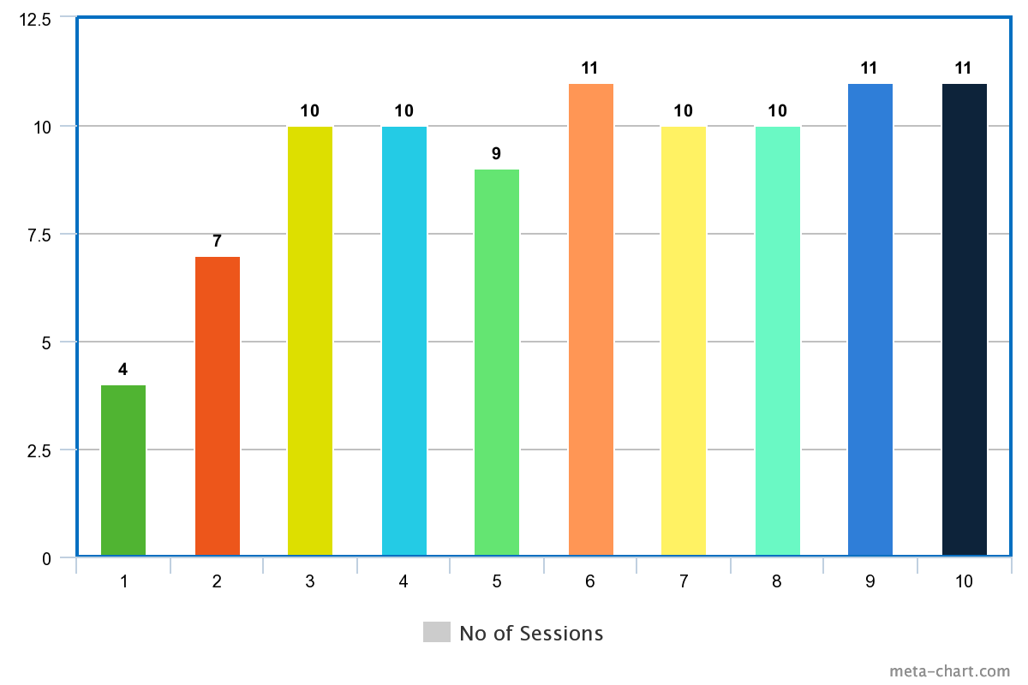

Case -2, Severe Autism
Session :- 01 (1st) Session:- 10 (Last)
Domain | Score
Duration | 2
Prompts & Cues | 1
Focused Area | 1
Strength | 2
Total Score | 6
Domain | Score
Duration | 4
Prompts & Cues | 3
Focused Area | 5
Strength | 4
Total Score | 16

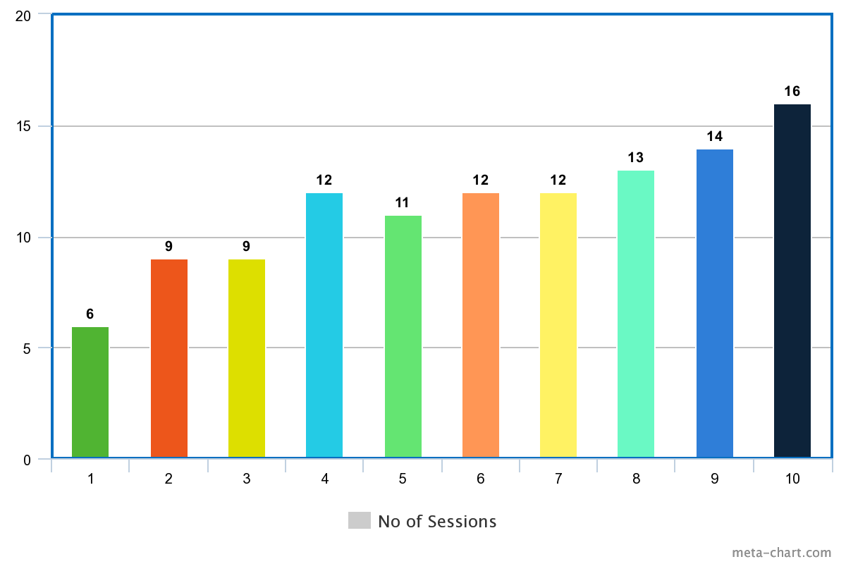

Case -3, Non-verbal severe autism
Session :- 01 (1st) Session:- 10 (Last)
Domain | Score
Duration | 1
Prompts & Cues | 1
Focused Area | 1
Strength | 1
Total Score | 4
Domain | Score
Duration | 3
Prompts & Cues | 2
Focused Area | 3
Strength | 3
Total Score | 11

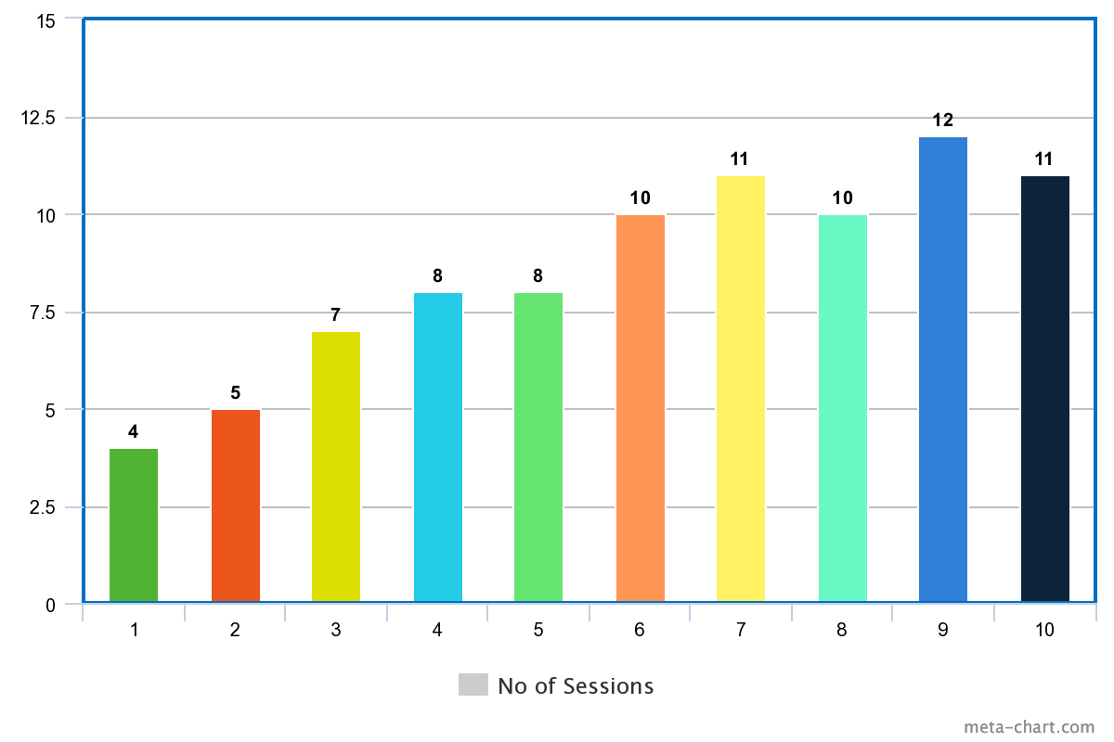

Case- 4, Mild Autism
Session :- 01 (1st) Session:- 10 (Last)
Domain | Score
Duration | 3
Prompts & Cues | 3
Focused Area | 2
Strength | 3
Total Score | 11
Domain | Score
Duration | 4
Prompts & Cues | 4
Focused Area | 6
Strength | 5
Total Score | 19

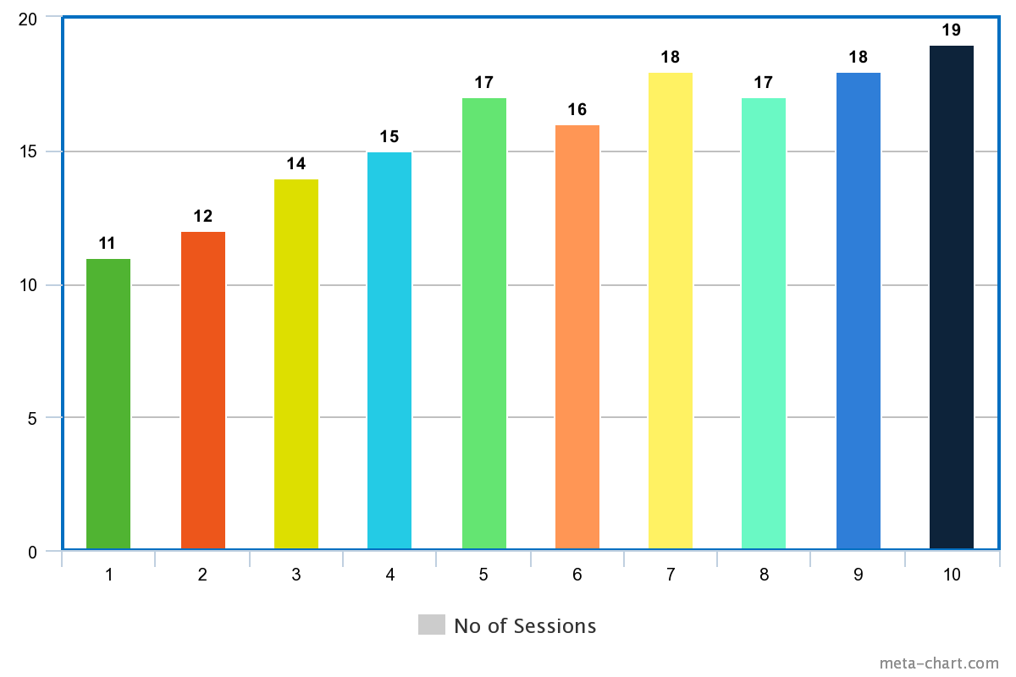

Case – 4, Mild autism with average I.Q

Session :- 01 (1st) Session:- 10 (Last)
Domain | Score
Duration | 1
Prompts & Cues | 2
Focused Area | 1
Strength | 1
Total Score | 5
Domain | Score
Duration | 3
Prompts & Cues | 3
Focused Area | 6
Strength | 5
Total Score | 17

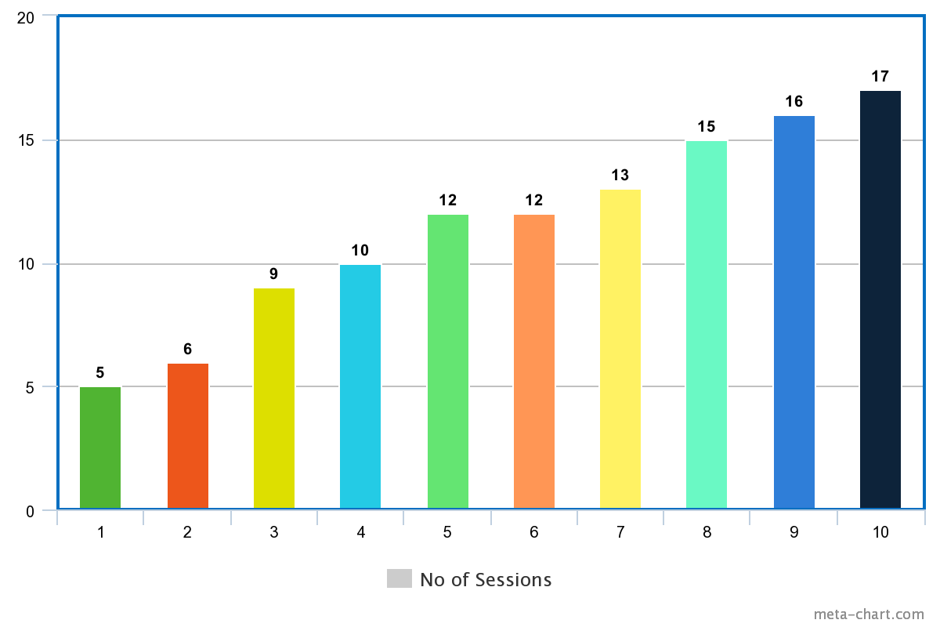

Interpretation
On the basis of above result table and graph it can be interpreted that Case 1 scored 4 in session 1, and gradually it increase to 11 score on 10th session. Case 2 session starts with score 6 and improved up-to 16 at session no 10.Case 3 also starts the session with very low score of 4 , there were some ups and downs in between sessions but ended with score 11 on last session. Case 4 starts with a very good score with 11 and visible improvement at session 10 with score 19. And finally in case of case 5 a vast amount of changes happened, she starts with score 5 and reach 17 on last session.
Discussion
According to the interpretation it seems that there are positive changes in score. Not only in score but also in daily life functioning the improvement seems. There are some areas where improvements seems as follows- eye hand coordination, motor skill, attention, cognitive skills, conceptual learning, confidence, hypo and hyper activity etc. Skillful activities reported by the parent and the special educators after the intervention. Without a combination of good cognition the concept of empowerment is a bit difficult to incorporate in disability sector. But it is also true that they have high self-esteem, they feels bad if not able to do anything or anyone scolding them. So from that point of view if we try to make them understand that if you do better, people appreciate you then it will be an effecting factor of their empowerment. And obviously those who are disabled but cognitively functional counselling and rational art work can help them to empower themselves. And definitely awareness regarding laws, rights will help them to live successfully.
Laws -Rights & Disability
To contribute more significantly to the empowerment of people with disabilities, governments should include representatives of the minorities in law-making processes and general decision-making.
The opportunities brought about by empowerment programs worldwide aim to create an all-inclusive society where people with disabilities are afforded the same respect, love, and kindness as everybody else.
If people with disabilities can raise their voices and demand their rights, the impact could be truly transformative. But we must all contribute. Therefore, empowerment is crucial as it unlocks the potential of people with disabilities and delivers real change in society.

Conclusion
- Null hypothesis rejected
- Art activity can improve psychological condition
- Quantitative measurement of art intervention works
- With the help of quantitative art intervention improvement can be shown
- Art intervention helps individual to deal the various factors of human empowerment

Limitations of the Study
Sample - The sample is a convenience sample which makes generalisation impossible. But even without generalisation as the goal of the research, the sample can influence the quality of the results. Wanting to give a general picture of how art is use in quantitative way.
Language – Language of instruction & interaction were different according to the comfort zone of the candidates.
Session – Total no of sessions were not same it were different from individual to individual.
No. of focus areas can be increased after reaching the basic goal areas.

References

https://www.worldvision.com.au/womens-empowerment/#:~:text=What%20is%20women's%20empowerment%3F,change%20for%20themselves%20and%20others.
https://thedocs.worldbank.org/en/doc/517421606767152867-0050022020/original/WBL2020DisabilityTopicNote.pdf
https://www.google.com/search?q=empowerment+definition&rlz=1C1CHBF_enIN982IN982&sxsrf=AJOqlzWj
https://www.zenartsupplies.co/blogs/inspiration/successful-women-art-as-empowerment
https://epgp.inflibnet.ac.in/epgpdata/uploads/epgp_content/women_studies/gender_studies/07._women_and_law/32.__women_and_disability_laws/et/8055_et_et_32.pdf
http://docs.manupatra.in/newsline/articles/Upload/7102F404-0902-4EEC-BA55-F8EFC25DA6D4.pdf
www.diva-portal.org
www.enableme.ke
https://onlinelibrary.wiley.com/
www.coursehero.com
www.mdpi.com
www.seniorcare2share.com

