Factors Related to Bioremediation of Oil contaminated Soil by Bacteria
Abujur Ansari*, Rohit Oraon, Rupa Verma
1. Msc Biotechnology, University Department of Botany, Ranchi University, Ranchi-834006, Jharkhand, India,834008
* Correspondence:abujursd1280@gmail.com
Abstract
Bioremediation refers to any process where a biological system is employed for removing environmental pollutants from Soil,AirWater, etc. Removing or degrading oil contaminants i.e. pollutants by biological means using bacteria. Oil leakage causes several environmental impacts, and in soil, oil contamination decreases water and nutrient availability and compaction, directly affecting plant growth and development and eventually harming the health of plant and animal life. These oil contaminants are accumulated in the environment by various anthropogenic activities. This Oil includes Gasoline, Kerosene, Diesel, lubricants, and Tar, etc. These oils contain hydrocarbons such as aliphatic and aromatic (PAHs). Polycyclic aromatic hydrocarbons (PAHs) are acyclic abiotic components in an ecosystem and easily accumulated in soil and sediment due to their low solubility and high hydrophobicity, which affects their bioavailability and causes less accessibility for degradation. Microorganism such as bacteria which are capable of degrading Oils can prevent these harmful effects, which eventually converts aliphatic and aromatic hydrocarbons into CO₂ and H₂Oin their metabolic pathway which are the cyclic abiotic component in any ecosystem. In this Review, we are going to talk about the factors which will affect positively the biodegradation of oil contaminants in the soil if taken into consideration. This review will help to study the major factors which can increase the biodegradation rate even at higherlevels to remove oil contaminants from soil.

Keywords: -Bioremediation, Biodegradation Rate, Hydrocarbons, PAHs, Bacteria, Bioavailability, Biochar

1. Introduction

Soil Pollution by Hydrocarbons can be a major global issue because of the various problems it causes by its bioaccumulation in an ecosystem.¹ As soil comes into contact with oil due to extraction, refining, transportation, and industrial activities, etc. reduces soil fertility by decreasing the diversity of plants and microbes (bacteria) in the soil, disrupting soil ecological balance, germination is delayed, the chlorophyll content becomes poor and some crops perish when grown in high petroleum-contaminated soil [1], ultimately affects agriculture and even put human health at risk. Hydrocarbons found in oil can be aliphatic or PAHs, Aliphatic hydrocarbons are easily biodegradable as compared to PAHs. The molecular weight of hydrocarbons influences their degradability. Low-molecular-weight hydrocarbons have better bioavailability than high-molecular-weight hydrocarbons because they are comparatively less hydrophobic. Aliphatic have greater hydrocarbon susceptibility to microbial breakdown than PAHs because of their bioavailability. The greater the fused rings in PAHs, the more hydrophobic it is and less susceptible to microbial biodegradation.

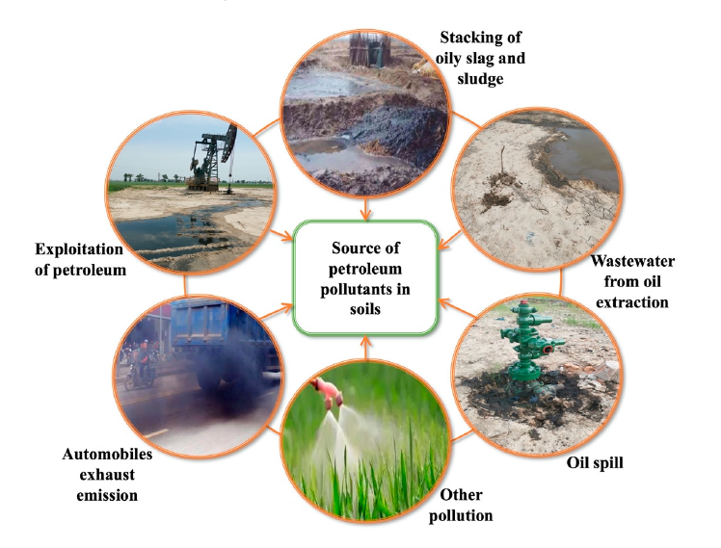
Figure 1. Major sources of hydrocarbons in the soils[2]

Polycyclic Aromatic Hydrocarbons (PAHs) are a class of organic compounds with two or more fused benzene rings in linear, angular, or cluster structural arrangements [3].They are produced from fossil fuel combustion, waste incineration, coal gasification, and petroleum refining. PAHs are ubiquitous in nature environments, including air [3], water, soil, sediment, etc. The United States Environmental Protection Agency (USEPA) listed PAHs as of major concern due to their toxicity to various organisms and their mutagenic and carcinogenic potential to humansthroughoutthe food chain.Polycyclic Aromatic Hydrocarbons include Naphthalene, Fluorene, Anthracene, Pyrene, etc. They become less soluble as their molecular weight increases and become more hydrophobic in nature.

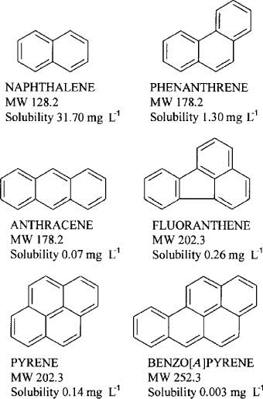

Figure 2. Some soil contaminating PAHs chemical structure [3]

Up till now, there are various techniques to remove oil contamination such as physical and chemical treatment methods, generally limited to spill containment with booms or synthetic chemical surfactants that generate toxic byproducts [4]. Therefore, the most economical and sustainablei.e.less physical, chemical, and biological changes in environmental conditions treatment method is bioremediation by microbes. A bacterium uses hydrocarbons as its sole carbon source inits metabolic activities.Bacterial bioremediation of hydrocarbons includes adsorption, bioaugmentation,and biodegradation by microbial metabolic activity and eventually complete mineralization into CO_{2,} H₂O, Inorganic compounds, and cell proteins, or convert complex organic pollutants into other simpler organics.As PAHs have less bioavailability, and less solubility in aqueous and are a major concern to affect soil fertility and eventually the food chain and ecosystem,therefore,some factors need to be taken into consideration for better results of bioremediation of soil from PAHs using bacteria.
For example, environmental conditions, Bacterial consortia, biochar, biosurfactants, etc. (i) Biosurfactants have amphiphilic nature andwork as an emulsifier andincreasing surface contact with PAHs, hence, increasingthe biodegradation rate of hydrocarbons from the soil. [5] (ii) Microbial consortia have a higher degradative capacity than a single microbial species, as using a single microorganism would limit the effectiveness percentage since an organism’s metabolism capacity is reduced to a certain amount of substrate[4].(iii) The biochar-immobilized bacterial consortium had the optimal remediation effect on oil-contaminated soil, and the removal rate of petroleum hydrocarbons was 78.32% after 28 days of remediation [6]. (iv)Each Bacterium has its optimum physical conditions where it can grow to its maximum capacity. When the soil salinity is higher than 8%, and the pH value is lower than 4 or higher than 9, the activity of certain microbes is affected as these environmental conditions are not favorable.
Hence, we can observe that these factors are very useful for maximum results of bioremediation of hydrocarbons by bacteria.

2.Biosurfactants

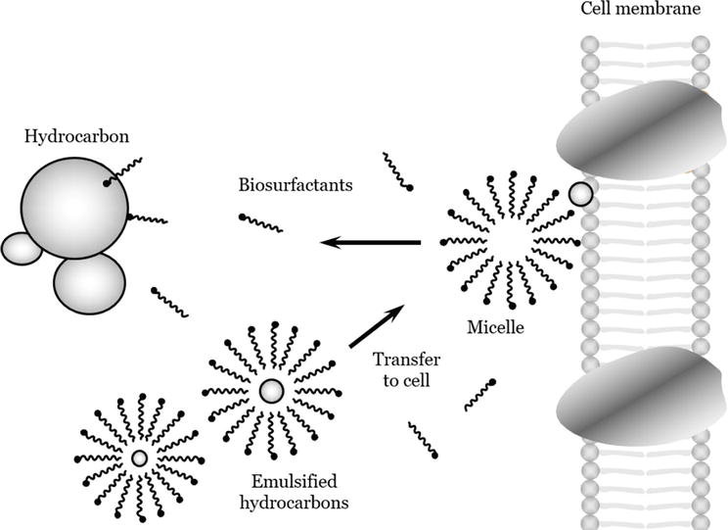

Figure 3. Emulsification process by biosurfactants [7]

Biosurfactants are emulsifiersthathave both hydrophobic and hydrophilic nature and due to their amphiphilic nature they are soluble with all liquids, hence they increase the accessibility of hydrocarbons with bacteria, ultimately increasing the biodegradation rate. Three isolates namely F1, F4, and F5 were from the waste oil-contaminated soil and the remaining two (F2 and F3) were from pesticide-contaminatedsites among all the five isolates, F1 showed a maximum emulsification index (of 44.44%) followed by F4 (35%) both belonging to strains of Staphylococcus aureus and the remaining isolates F2, F3 and F5 also showed appreciable level of E24(24-28%)F1, F4 and F5 isolates belong to Staphylococcus aureus and F2 and F3 to Bacillus subtilis species [5].
From the above findings, we can conclude that bacteria found in oil-contaminated sites have a high biodegradation rate, because, unlike other microbes, they can produce surfactant chemicals biologically. We can see that pesticide-contaminated site shows comparatively lower biodegradation rate which means we can conclude that bacteria found anywhere but oil-contaminated regions have higher biosurfactants-producing microbes and we can choose specific isolate from there with a high rate of remediation and introduce them into soil contaminated with oil sites for the high rate of biodegradation and bioremediation. However, indigenous bacteria show less time in the lag phase compared to bacteria that are introduced in a different environment, it is because they take some time to adapt and accommodate according toa new environment.

3. Microbial (bacterium) Consortia

The consortia have hydrocarbon degradation efficiencies of 55–84%, while in individual cultures was 25–47% and in vitro oil degradation test for 60d; the consortium with the highest number of strains had a 43% degradation for aliphatic compounds compared to the consortium with fewer strains [4].In axenic cultures and mixed consortia, finding better results (90%) for the mixed consortia compared to the axenic cultures in C32 alkanes [4].The bacterial consortium degraded each petroleum component more evenly, and the removal rates of the saturated hydrocarbons and aromatic hydrocarbons reached 89.93% and 82.08%, respectively, and after 28 days of cultivation, the petroleum hydrocarbon degradation rates of A2(Pseudomonas putida), A4(Acinetobacter calcoaceticus) and L5(Sphingomonasp) and the bacterial consortium were 42.8%, 48.01%, 26.56%, and 81.07%, respectively [6].
From the above findings, we can conclude that different strains or species of bacterium capable of biodegradation of PAHs when used altogether have better output results, it is because they can act on different oil substrates individually and produce a higher rate of degradation. However certain bacterium works better in their action, for example, in C40 alkanes, a greater degradation was observed with pure strains [4].
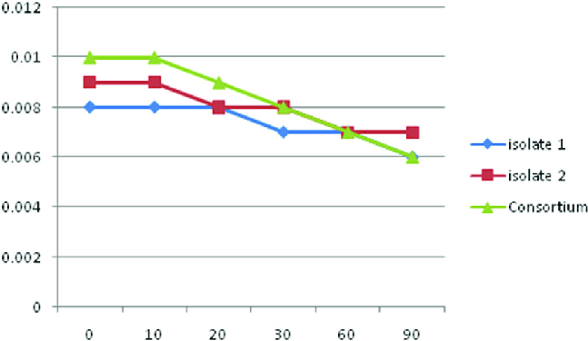

Figure 4. Consortium showing higher biodegradation rate than isolates [8]

4.Biochar

The number of microorganisms, intensity of soil respiration, and dehydrogenase activity in the free bacterial consortium (TB), biochar-free bacterial consortium (TB-BC), and biochar-immobilized bacterial consortium (CTB) removal rate of petroleum hydrocarbons are, CTB treatment was 78.32%, which was 18.0% or 32.51% higher than that in the TB-BC or the TB treatment, indicating that the addition of biochar could promote soil respiration and microbial activity [6].This was because the large quantities of nutrients and porous characteristics of the biochar can not only meet the needs for the growth, metabolism, and reproduction of microorganisms but also shield them from the harmful soil environment [6].
As we know PAHs have very less bioavailability, hence, poor in adsorption with bacteria and fewer PAHs biodegradation rate, but it’s the biochar that immobilizes petroleum hydrocarbons into its pores, increasing the adsorption and bioavailability, hence increasing biodegradation rate.

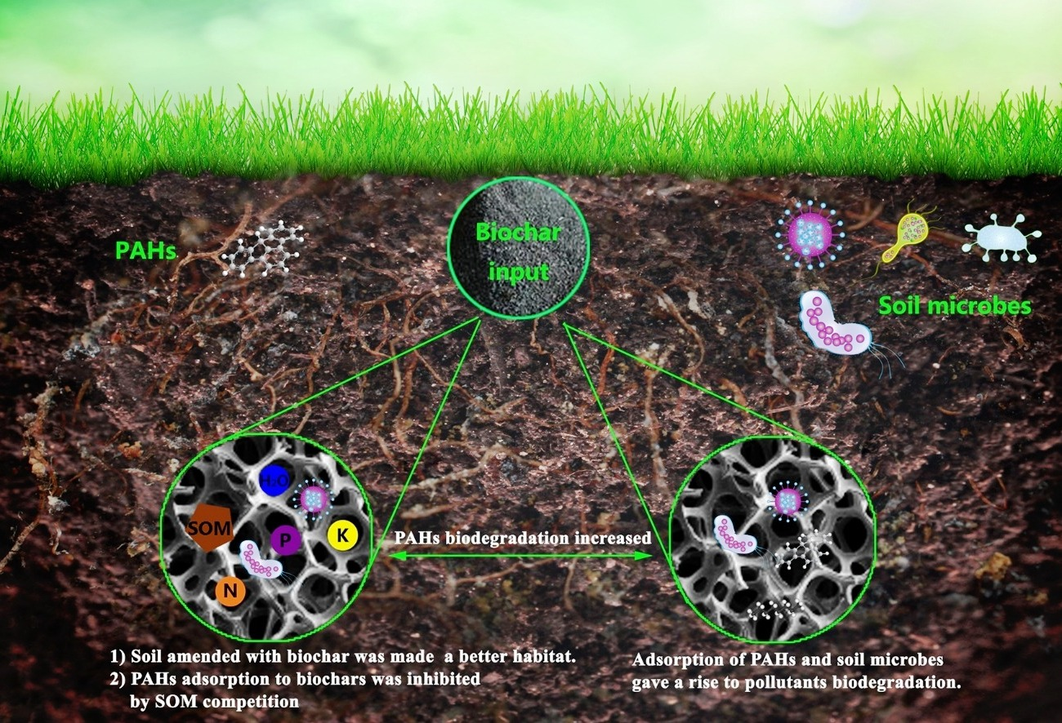

Figure 5. Biochar increased adsorption and bioavailability of hydrocarbons [9]

5.Environmental Conditions
5.1 Temperature: -
At low temperatures, the degradation rate is generally observed to decrease, which is thought to be a result of reduced enzymatic activity rates [10]. Temperature is among the factors that influence PH biodegradation by affecting the physical and chemical compositions of PAHs [11]. Despite the biodegradation of hydrocarbons can take place at a wide domain of temperatures, the degradation rate decrease through declining temperatureThe highest rates of degradation occurred at the temperature range of 30–40ºC, 20–30ºC, and 15–20ºC in soil, marine, and freshwater environments, respectively [11]. At 4ºC and 10ºC, microbial mineralization of hexadecane generates 45% CO₂, while at 25ºC, 68% CO₂ is generated in 50 days [12]. Hence, it’s obvious thatthe higher the temperature, reaching towards optimum temperature increases the rate of biodegradation of hydrocarbons, and in the soil,this optimum temperature always lies above 30ºC

5.2 pH: -
The pH can be highly variable and must be taken into consideration when improving biological treatment methods. The environmental pH affects processes such as cell membrane transport and catalytic reaction balance as well as enzyme activities [13].Pawar (2015), [14]observed that the soil pH of 7.5 was most convenient for the degradation of all the PAHs. When the soil salinity is higher than 8% and the pH value is lower than 4 or higher than 9, the activity of Acinetobacter baylyi ZJ2 is affected, and a certain amount of lipopeptide surfactant cannot be produced, thereby reducing the degradation of petroleum by microorganisms [15]. All bacterium has an optimum pH where they are very active as their enzymes and proteins structures aren’t affected, and changes can affect their maximum degradation rate of hydrocarbons, and for most bacterium, this pH is around 7.0 – 8.0, which is found in soil.

5.3 Nutrients: -
In Nutrients hydrocarbons are used as a sole source of Carbon for better bioremediation by a bacterium, however, some of those nutrients can become a limiting factor thus impacting the processes of biodegradation [16].Improvementwas found in the bioremediation of coastal sand contaminated with crude oil by using commercial mineral NPK fertilizer [17]. The highest phenanthrene removal efficiency was observed in run 1 with the presence of high levels of KH₂PO₄ and NH₄ NO₃ in the mineral salt medium [16].Hence, biostimulation of oil-contaminated soil with the addition of nutrients such as macro, micro, and trace elements improves the biodegradation rate and macronutrients NPK (Nitrogen, Phosphorus, and Potassium) can affect the rate of biodegradation most.
Maximum growth attained by the Bacillus foraminis also decreased with the increase in anthracene concentration [18]. The average removal rates of anthracene were 0.298 ±0.009 mg hr⁻¹ at 50 mg l⁻¹ and 0.25±0.012 mg hr⁻¹ at 100 mg l⁻¹. As observed in the case of anthracene, the lag phase increased with a higher concentration of anthracene[18]. As we can see, the sole carbon source nutrient, here PAHs anthracene, is giving maximum biodegradation output at a certain concentration.

5.4 Other Factors: -
The concentration of oxygen has been determined as the rate-limiting variable for PHs degradation in the environment [19] and the oxygen availability in the soil depends on microbial oxygen consumption rates and soil type, whether the soil is water-logged, and the presence of the useable substrate which can drive to oxygen depletion [20].For anaerobic obligates or facultative anaerobes with hydrocarbon-degrading bacterium, is an advantageous point, as it is free from limited access to O₂, however, things can be disadvantageous in the case of obligate aerobes.
Salinity had a major influence on the bioremediation and biodegradation process, and it also affectsmicrobial growth and diversity. Salinity has an adverse influenceon the activity of some key enzymes complicated in the processof hydrocarbon degradation [21]. A more saline environment can cause osmotic pressure due to the transfer of solvent across; this may be the reason salinity decreases microbial action.

6. Conclusion

In this review article we have discussed some factors that can affect the bioremediation rate very positively, these factors can be used in combination or individually for better results of biodegradation, however combination or individual use open for researches findings only then we can draw certain units that can be considered for better bioremediation. As we know PAHs are more harmful than aliphatic hydrocarbons and they are less accessible for biodegradation, however when we consider these factors we draw better outlets for higher bioremediation rate of PAHs and the removal of these contaminants from the environment, hydrocarbon-free soil affects its fertility positively, deceases biomagnifications in ecosystems and eventually reduces health risk of animals and plants.

References

- E O Ekundayo , T O Emede, D I Osayande, Effects of crude oil spillage on growth and yield of maize (Zea mays L.) in soils of midwestern Nigeria. Plant Foods Hum. Nutr. 2001, 56, 313–324.

- Sui X, Wang X, Li Y, Ji H. Remediation of Petroleum-Contaminated Soils with Microbial and Microbial Combined Methods: Advances, Mechanisms, and Challenges. Sustainability. 2021; 13(16):9267. https://doi.org/10.3390/su13169267.

- Bamforth SM, Singleton I (2005) Bioremediation of polycyclic aromatic hydrocarbons: current knowledge and future directions. J Chem Technol Biot 80: 723-736.

- Sergio Gómez-Cornelio , Mariana Castillo-Vidal ,Carina Shianya Alvarez-Villagomez , Patricia Quintana , Susana De la Rosa-García. Biodegradation of hydrocarbons from contaminated soils by microbial consortia: A laboratory microcosm study. Electronic Journal of Biotechnology 61 (2023) 24–32.

- Rupa Verma, Mukul Agrawal, Abhay Dundung and Ladly Rani. Screening of Biosurfactant Production in Bacteria Isolated from Oil and Pesticide Contaminated Soil of Ranchi District. Journal of Scientific Research, Volume 66, Issue 4, 2022.

- XiaoNa Wei, Pai Peng, Yao Meng, TingTing Li, ZhiPing Fan, Qiong Wang, JiaBo Chen. Degradation Performance of Petroleum-Hydrocarbon-Degrading Bacteria and its Application in Remediation of Oil Contaminated Soil. Earth and Environmental Science 766 (2021) 012096.

- M. Stainsby F, Hodar J and Vaughan H (2022) Biosurfactant Production by Mycolic Acid-Containing Actinobacteria. Actinobacteria - Diversity, Applications and Medical Aspects. IntechOpen. DOI: 10.5772/intechopen.104576.

- Skariyachan, Sinosh & Megha, M. & Kini, Meghna & Kamath, Manali & Rizvi, Alya & S Vasist, Kiran. (2014). Selection and screening of microbial consortia for efficient and eco-friendly degradation of plastic garbage collected from urban and rural areas of Bangalore, Environmental Monitoring and Assessment, India. 187, 10.1007/s10661-014-4174-y.

- Lulu Kong, Yuanyuan Gao, Qixing Zhou, Xuyang Zhao, Zhongwei Sun, 2018. Biochar accelerates PAHs biodegradation in petroleum-polluted soil by biostimulation strategy. Journal of Hazardous Materials, Volume 343, Pages 276-28.

- Bisht S, Pandey P, Bhargava B, Sharma S, Kumar V, Sharma KD. Bioremediation of polyaromatic hydrocarbons (PAHs) using rhizosphere technology. Braz J Microbiol. 2015 Mar 1;46(1):7-21. doi: 10.1590/S1517-838246120131354. PMID: 26221084; PMCID: PMC4512045.

- Atlas, R.M. 1985. Effects of hydrocarbons on microorganisms and petroleum, Biodegradation in arctic ecosystems, and petroleum effects in the arctic environment. 63-100.

- Hamamura N, Fukui M, Ward DM, Inskeep WP. Assessing soil microbial populations responding to crude-oil amendment at different temperatures using phylogenetic, functional gene (alkB), and physiological analyses. Environ. Sci. Technol. 2008, 42, 7580–7586.

- Bonomo RP, Cennamo G, Purrello R, Santoro AM, Zappalà R (2001). Comparison of three fungal laccases from Rigidoporusdiagnosis and Pleurotusostreatus: correlation between conformation changes and catalytic activity. J. Inorg. Biochem. 83 (1), 67–75.

- Pawar, R., 2015. The effect of soil pH on bioremediation of polycyclic aromatic hydrocarbons (PAHs). J. Bioremediation. Biodegrad., 2015.

- Zou, Changjun & Wang, Meng & Xing, Y.Z. & Lan, Guihong & Ge, Tingting & Yan, Xueling & Gu, Tong. (2014).Characterization and optimization of biosurfactants produced by Acinetobacter baylyi ZJ2 isolated from crude oil-contaminated soil sample toward microbial enhanced oil recovery applications. Biochem. Eng. J. 2014, 90, 49–58.

- Kalantary RR, Mohseni-Bandpi A, Esrafili A, Nasseri S, Ashmagh FR, Jorfi S, Ja'fari M. 2014. Effectiveness of biostimulation through nutrient content on the bioremediation of phenanthrene contaminated soil. Iranian J. Environ. Health Sci. Eng. 12 (1), 143.

- da Silva AC, de Oliveira FJ, Bernardes DS, de França FP. Bioremediation of marine sediments impacted by petroleum. Appl BiochemBiotechnol 2009, 153:58–66.
- T. Velayutham, N. Ashokkumar and S. Sankaran. Biodegradation of Polycyclic Aromatic Hydrocarbons by Bacteria.JETIR May 2019,Volume 6, Issue 5.

- von Wedel, R. J., Mosquera, J. F., Goldsmith, C. D., Hater, G. R., Wong, A., Fox, T. A., Hunt, W. T., Paules, M. S., Quiros, J. M. and J. W. Wiegand (1988). Bacterial biodegradation of petroleum hydrocarbons in groundwater: in situ augmented reclamation with enrichment isolates in California. Water Sci. Technol. 20 (11–12), 501–503.

- Haritash, A., Kaushik, C., 2009. Biodegradation aspects of polycyclic aromatic hydrocarbons (PAHs): a review. J. Hazard. Mater. 169 (1–3), 1–15.

- Skariyachan, Sinosh & Megha, M. & Kini, Meghna & Kamath, Manali & Rizvi, Alya & S Vasist, Kiran. (2014). Selection and screening of microbial consortia for efficient and eco-friendly degradation of plastic garbage collected from urban and rural areas of Bangalore, Environmental Monitoring and Assessment, India. 187, 10.1007/s10661-014-4174-y.

- Ramsay JA, Li H, Brown RS, Ramsay BA (2003) Naphthalene and anthracene mineralization linked to oxygen, nitrate, Fe(III) and sulfate reduction in a mixed microbial population. Biodegradation 14: 321-329.

- Robert E. Hinchee, John T. Wilson, Downey. DC (eds) (1995) Intrinsic bioremediation. Battelle Press, Columbus Rockne KJ, Chee-Sanford JC, Sanford RA, Hedlund BP, Staley JT, Strand SE (2000)

- Rockne KJ, Strand SE (1998) Biodegradation of bicyclic and polycyclic aromatic hydrocarbons in anaerobic enrichments. Environ Sci Technol 32: 3962-3967.

- Rockne KJ, Strand SE (2001) Anaerobic biodegradation of naphthalene, phenanthrene, and biphenyl by denitrifying enrichment culture. Water Res 35: 291-299.

- Saito A, Iwabuchi T, Harayama S (2000) A novel phenanthrene dioxygenase from Nocardioidesspstrain KP7: Expression in Escherichia coli. J Bacteriol 182: 2134-2141.

- Santos EC, Jacques RJS, Bento FM, Peralba MDR, Selbach PA, Sa ELS, Camargo FAO (2008) Anthracene biodegradation and surface activity by an iron-stimulated Pseudomonas sp. Bioresource Technol 99: 2644-2649.

- Sartoros C, Yerushalmi L, Beron P, Guiot SR (2005) Effects of surfactant and temperature on biotransformation kinetics of anthracene and pyrene. Chemosphere 61: 1042-1050.

- Seeliger S, Cord-Ruwisch R, Schink B (1998) A periplasmic and extracellular c-type cytochrome of Geobactersulfurreducens acts as a ferric iron reductase and as an electron carrier to other acceptors or to partner bacteria. J Bacteriol 180: 3686-3691.

- Seo Y, Bishop PL (2007) Influence of nonionic surfactant on attached biofilm formation and phenanthrene bioavailability during simulated surfactant enhanced bioremediation. Environ Sci Technol 41: 7107-7113.

- Rockne KJ, Chee-Sanford JC, Sanford RA, Hedlund BP, Staley JT, Strand SE. Anaerobic naphthalene degradation by microbial pure cultures under nitrate-reducing conditions. Appl Environ Microbiol. 2000 Apr;66(4):1595-601. doi: 10.1128/AEM.66.4.1595-1601.2000. PMID: 10742247; PMCID: PMC92028.

