A COMPREHENSIVE REVIEW OF DIFFERENT FTTH CONFIGURATION AND FEATURES OF DIFFERENT PON NETWORK

Megha Gupta Sangita Vishwakarma Dr. Payal Jindal Assistant Professor , Computer Assistant Professor , Computer Assistant Professor , Computer
Applications Department Applications Department Applications Department
DPGITM,Gurgaon,INDIA DPGITM,Gurgaon,INDIA DPGITM,Gurgaon INDIA
megha08in88@gmail.com sangita.rit18@gmail.com bhavayapayal@gmail.com
.

Abstract - FTTH(Fiber to the habitat) is an optical fiber network architecture that use dedicated optical fiber to the subscriber end. Due to its long distance high speed and it is widely used in corporate, commercial as well residential purpose. Because of PON Architecture it is cost efficient also.
Keywords- ONU, FTTH, RU, OLT, ASE, PON, AON.
- INTRODUCTION
FTTH (NGPN) stands for fiber to the habitat(next generation play networks). As the name depicts it uses the optical fiber to the consumer end. As demand for expeditious web is the key reason for the recent retrieve technologies, Yet, dated technologies like DSL (Digital Subscriber Line) and wire modem, which are frequently used for broadband access and have MBPS speeds, are unable to meet the demands of modern customers for high bandwidth applications like HDTV because of a variety of factors, including distance from the local exchange and copper cable quality[1]. fast web access,IPTV,broadband delivered, gambling games and electronic learning etc.
This technology has a variety of advantages over the traditional technologies like it provides unlimited bandwidth and long distance reach. , It uses a single fiber to deliver several services (phone, video, and data, among others). Long-distance communication has historically made use of optical fiber lines.
As the demand increase for the high speed internet and high bandwidth with stability by the businesses and by the education department and by general households works in recent years the need of optical fiber cable has increased.
- FTTX(FIBER TO THE X)
Depending on the type of fiber network—passive network (point to multipoint) or active network (point to point)—and the termination point—building (fiber to the building), habitats (fiber to the habitats), curb (fiber to the curb), etc.—fiber networks can be arranged in a variety of ways.
So, there is various type of FTTX architecture to take into account FTTH, FTTB and FTTC each one have their different configuration and characteristics.
A .FTTH(Fiber To The Habitat)
FTTH is the best and cost effective substitute to the conventional technology i.e DSL. In the fiber to the habitat technology a communication path is provided over optical fiber cable extending from OLT(optical Line terminal) unit situated in telecommunication operators switching equipment(exchange) to an ONT( Optical Network Terminate) at customer premises[3]. It provides communication path for carrying telecommunication traffic to subscribe for one or many series like data, voice, video etc.
As shown in fig 1. OLT situated at base station (exchange) is connected to the ONT situated at customer end via optical fiber cable. The output from the ONT is connected to customer’s PC via LAN cable.
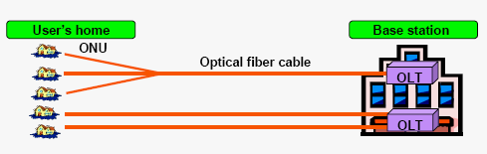
Fig. 1 FTTH configuration

- FTTB(Fiber To The Building)
The fiber to the building architecture provides an optical fiber cable communication path between an ONU (Optical Network unit) or RT (Remote control) at the edge of the apartment, building, or office enclosing set of subscribers and the OLT (optical Line Terminal) located in the Base station (Exchange)[5].'
In this structure, optical fiber terminate to ONU or RT units located at the frontier of the building, office and apartments and copper cable other than optical fiber is used as the physical medium which provide the access path to the subscribe. As shown in figure 2. Up to the metallic cable that is installed within the building, optical fiber cable is installed. and a Ethernet cable can be used to connect to the subscriber.
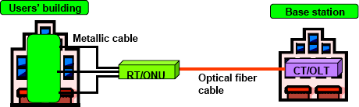

Fig. 2 FTTB Configuration

C. FTTC (Fiber to the Curb)

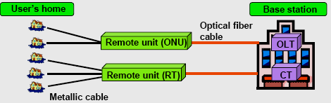
In the fiber to the curb/cabinet architecture, an optical fiber is used from the Base Station (Exchange) to the remote unit (RO)/ optical network unit (ONU)[4] installed outside near the curb or on street cabinet. Finally copper cable or coaxial cable is used between the remote unit (ONU) and the subscribe end as shown in figure 3.

Fig.3. FTTC Configuration

- TECHNOLOGY OPTIONS FOR FTTH ARCHITECTURE
In the current scenario, there are various technology options are available for Fiber to the home Architecture. The Architecture can be installed in various networks
- Attribute overlay network (AON)
- Passive optical network (PON).

- Attribute Overlay Network
AON (Attribute Overlay network)[17] is commonly known as Active node. It mainly use a point to point (PTP) network Architecture and every subscriber or customer are provided with a committed optical cable and the distribution points are handled by active optical equipment.
Attribute Overlay network[12] can be setup in two architecture
- HOME RUN Fiber (Point to Point )
- Active Star Wired Network(ASWN)
1).Home RUN fiber (Point to Point) Architecture
In this architecture, a devoted fiber line is connected between the ONT (optical network terminal) located at local exchange office to the OLT(Optical Line Terminator) equipment situated at the subscriber end.

In this, both devices ONT and OLT are active, powered device and each one is equipped with an optical laser. This technique offers unlimited bandwidth for the subscriber and therefore it has greatest potential for growth.
It is the most flexible architecture but Home Run fiber requires much more fiber because a dedicated fiber is provided to each subscribe end. So, it is very costly and become less attractive.
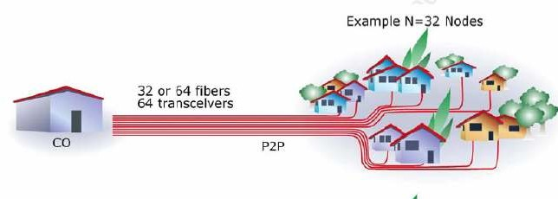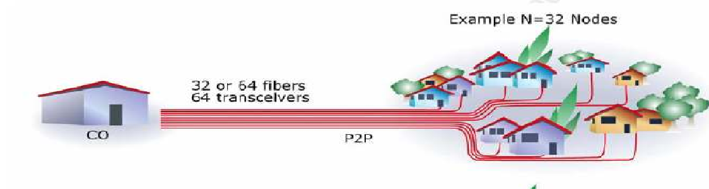The figure of habitat run fiber architecture is shown in figure 4.
P2M

Point To Point User’s Premise

CO
P Switched
Ethernet
CO
Fig. 4 Habitat Run Fiber (Point-to-Point) architecture

2). Active Star wired network (Point to Multi point) architecture
Active star wired network (ASE)[18] Architecture is point to multipoint architecture in which wired network switch is used between the exchange (CO) and the subscribe premises. In this, multiple subscribe share one feeder fiber connected from the exchange (CO) to one end of switched Ethernet and other multiple end of switched wired network is connected to multiple subscribe premises.
In the Active Star Wired network Architecture[19], end user get a dedicated fiber, Like habitat run fiber, the fiber connects their site to an Ethernet switch, and each subscriber has a dedicated pipe that offers full bi-directional band width.
Active Star Wired network reduce the amount of fiber .So, it is cost effective.
The figure of active Star wired network is shown in Fig 5.

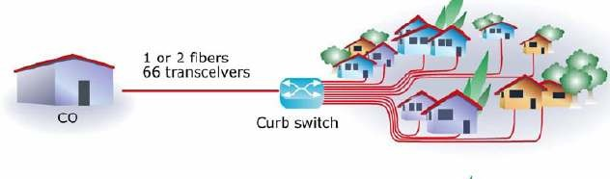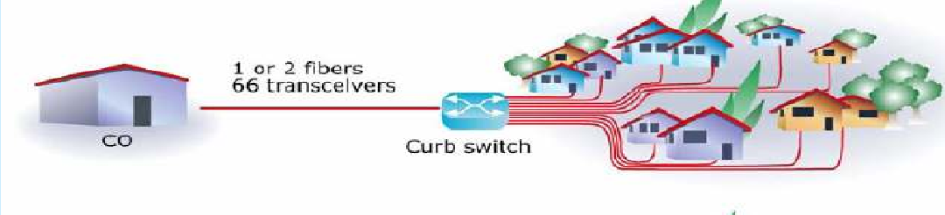
User’s Premise

CO
P2M Switched Ethernet

Fig. 5 Active Star Wired Network (ASWN)

- Passive Optical Network (Point to multipoint) Architecture
A relatively affordable optical fiber-based access system for providing multiservice (voice, data, video, etc.) to residential and corporate customers is the passive optical network.
The point-to-multipoint design forms the foundation of a passive optical network.
The optical line terminal (OLT) at the local exchange and the optical Network unit (ONU) at the subscriber's premises are connected via a passive optical network (PAN)[23] that uses optical fiber and optical power splitters.
Passive splitter can split the fiber signal up to 32 or more time( which means that they split the bandwidth and shared between the users) over a maximum distance of ten to twenty km. passive splitters are generally located downstream from the local exchange.
This architecture is also known as passive because all the splitters and other equipment located in intermediate between the local exchange and the Optical Network unit is passive that is they does not require separate power and there is not active electronics..So, by using this architecture, it simplifies the network maintainance and operation and reduces the cost and another advantage is it requires less fiber than Habitat Run technology.
Two splitter configurations are commonly utilized in passive optical network architecture.
- Centralized Approaches
- Cascaded Approaches (as shown in Fig.6)
1).Centralized splitter approach
It generally uses a 1*32 splitter which means bandwidth can be shared between the houses or subscriber. as depicted in Figure 6. The 32 optical network terminals (ONT) at each of the 32 subscriber/houses are connected to a single optical splitter concentrator.
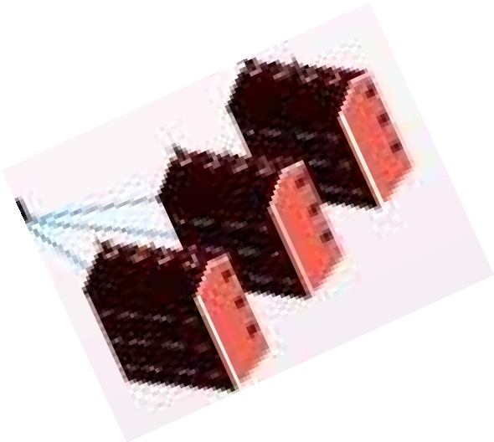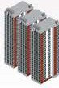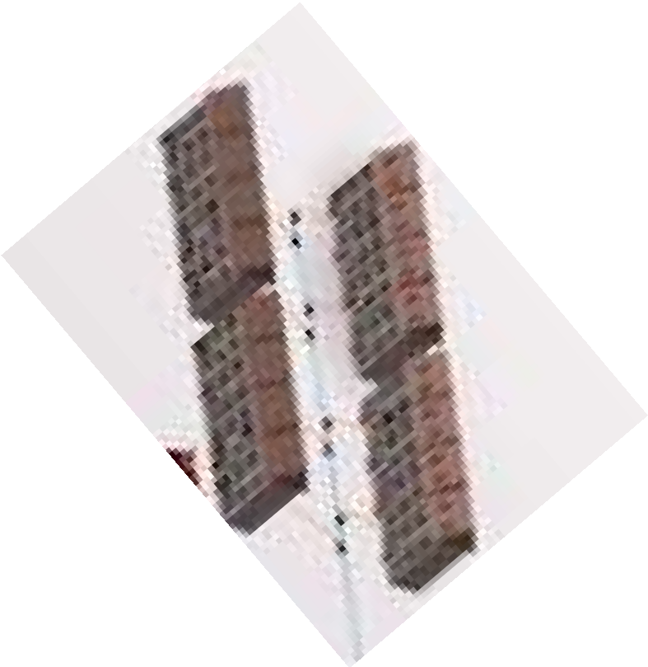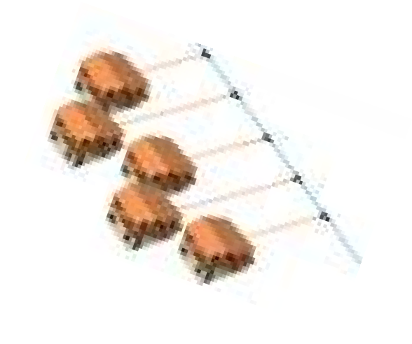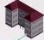
1X4
1X16
1X4
1X8
1X4
Splitters PONs
1X2 1X16
Splitter
1X32
1X32
Central Office
Fig. 6 Centralized and the Cascaded Passive Optical Network architecture

2). Cascaded Splitter approach
When using a cascaded splitter technique, the passive optical network (PON)[26] can support many homes or subscribers using a single fiber. This approach use more than one splitter of different capacity located in the pathway from the local exchange to customer/subscriber end, like a network may have 1*4 splitter leading to a 1*8 splitter further downstream in four different location. Standard splitter format range from 1*2, 1*4, 1*8,1*16 and
1*32. Ultimately, there would be 32 fiber reaching to the ONTs of 32 habitats.
There is Various PON technology
- APON
- BPON
- EPON
- GPON
GPON delivers gigabit per second bandwidth and offer low cost and high reliability
.Features | BPON | GPON | EPON
Responsible  Standard body | FSAN & ITU-T SG15  (G-983 Series) | FSAN & ITU-T SG15  (G-984 Series) | IEEE 802.3ah

Bandwidth | Down Stream up to 622 Mbps  Up Stream up to 155.52  Mbps | Down Stream up to 2.5 Gbps  Up Stream up to 2.5  Gbps | Down Stream up to  1.25 Gbps  Up Stream up to 1.25 Gbps
Posterior ג | 1490 nm & 1550 nm | 1490 nm & 1550 nm | 1490 nm
Ambitious ג | 1310 nm | 1310 nm | 1310 nm
Layer-2  Protocols | ATM | ATM, Ethernet, TDM  over GEM | Ethernet
Frame | ATM | GPON Encapsulation  Method | Ethernet Frame
Highest. Distance  (OLT to ONU) | 20 km | 20 Km (supports logical  reach up to 60 Km) | 10 and 20 Km.
Split Ratio | 1:16, 1:32 and 1:64 | 1:16, 1:32 and 1:64 | 1:16 and 1:32
TABLE 1 FEATURES OF DIFFERENT PON NETWORKS

- NEED OF FTTH
FTTH is a multi-service communication access that can manage multiple phone conversations, TV/video streams, and internet users in the home or workplace at the same time. The following are some of the advantages this method has over other conventional access methods (DSL):.
- This technique provides multiply (i.e. Voice, videos and data etc) services.
- FTTH Provides wide range of communication, entertainment services and many other new services to the end users.
- FTTH technology deploys a fiber optical cable to every premise which will provide unlimited bandwidth (i.e. very high speed) as compare to DSL technology.
- 4) There is potential for FTTH technology to lower capital costs and increase average revenue per user (ARPU). FTTH has the feature to deliver multiple services which result in less operational expense.
- FTTH technology requires local battery breakup and low power consumption.
- FTTH technology is trustworthy, scalable and vulnerable, trustworthy and it is potentially productive and future ready Architecture.

- CONCLUSION
The desire of multiply services (i.e. Voice, data, and video) and heavy application like distance learning video application, best picture quality, video conferencing and video phone is expected to continuously increase and some observer already believe that there is already a demand in world wide today also.
FTTH is a new leading technology which uses optical fiber to provide unlimited bandwidth for new generation of bandwidth application.
As this technology uses passive network component so, it requires less maintenance and less power consumption which results in economical than active network technology.
Many countries like China, Japan, Korea, Taiwan and many others has already is in use of this technology and even in India also it has gained a reputation very quickly because of its high performance, low cost and higher constancy.

REFERENCES
[1] Stephan Smith, “Business class services over a GPON network,” in proc. IEEE Optical Fiber Communication Conference, 2006 and the 2006 National Fiber Optic Engineers Conference. OFC 2006.
[2] M. Chardy et al., “Optimizing splitter and fiber location in multilevel optical FTTH network,” European Journal of Operational Research: Elsevier B.V, pp. 430-440,
May 2012
[3] Deeksha Kocher et al., “Simulation of fiber to the home triple play services at 2 Gbit/s using GE-PON architecture for 56 ONUs,” Optik: Elsevier B.V, pp. 5007-5010, 2013
[4] Deepak Malik et al., “ Quality of service in two-stages epon for fiber-to- the-home,” International Journal of Soft Computing and Engineering (IJSCE), vol. 2, No. 2, pp.387-390, May 2012.
[5] Mohd Syuhaimi Ab-Rahman et. al, “New optical splitter design for application in fibre-to-the home passive optical network using virtual lab platform,” Journal of Computer Science: Science Publications, pp. 846-871, 2012.
[6] James O. “High speed data to the home - an update,” in proc. 2011 IEEE International Conference on Consumer Electronics (ICCE), pp. 663-664, 2011.
[7] M. S. Rahman et al., “Ideal and non ideal condition analysis based on protection scheme in distributed fiber for immediate split Ftth-pon,” Journal of Applied Science: Asian Network for Scientific Information, pp. 1026-1032, 2011
[8] Duo Peng and Peng Zhang, “Design of Optical Integrated Access Network Based on EPON,” in proc. 2011 International Conference on Electronics and Optoelectronics (ICEOE 2011), pp. 65-68, 2011
[9] Rajneesh Kalera and R.S. Kalerb, “Simulation of Fiber to the Home at 10 Gbit/s using GE-PON architecture,” Optik: Elsevier B.V, pp. 1362-1366, 2011.
[10] Bogyum KIM , Wonhyung LEE and Jinwoo HAN, “Outside Plant Architecture of Fiber-based Access Network,” Digest of the 9th international conference on optical Internet (COIN 2010).
[11] Edoardo Bonetto, Marco Mellia, and Michela Meo, “Energy Profiling of ISP Points of Presence,” in proc. IEEE ICC'12 Workshop on Green Communications and Networking, pp. 5973-5977, 2012.
[12] Salah Al-Chalabi, “Optically Powered Telephone System over Optical Fiber with High Service Availability and Low Risk of Investment in FTTH Infrastructure,” IEEE Communications Magazine, August 2012.
[13] Christoph Lange and Andreas Gladisch, “On the Energy
Consumption of FTTH Access Networks,” IEEE,
[14] Andreas Gladisch , Christoph Lange and Ralph Leppla, “Power efficiency of optical versus electronic access networks,” in proc. ECOC 2008, 21-25 September 2008, Brussels, Belgium, pp. 1-4.
[15] Juan Rendon Schneir and Yupeng Xiong, “Economic implications of a co-investment scheme for FTTH/PON architectures,” Telecommunications Policy: Elsevier B.V, pp. 849-860. 2013.
[16] Stephan Jay, Karl-Heinz Neumann n and Thomas Plückebaum, “Comparing FTTH access networks based on P2P and PMP fibre topologies,” Telecommunications Policy: Elsevier B.V, 2013, http://dx.doi.org/10.1016/j.telpol.2013.04.010i.
[17] Steffen Hoernig et al., “The impact of different fiber access network technologies on cost, competition and welfare,” Telecommunications Policy: Elsevier B.V, 2012, pp. 96-112.
[18] Marco Araújo and A. Manuel de Oliveira Duarte, “A comparative study on cost-benefit analysis of fiber-to-the-home telecommunications systems in Europe,” in proc. IEEE 2011 Baltic Congress on Future Internet and Communications, pp. 65-69.
[19] Marco Forzati et al., “The uncaptured value of FTTH networks,” ,” in proc. IEEE 2011 13th International Conference on Transparent Optical Networks ICTON-2011, pp. 1-4.
[20] Dirk Breuer et al., “Opportunities for Next-Generation Optical Access,” IEEE Communications Magazine, February 2011.
[21] Sotiria Chatzi and Ioannis Tomkos, “ Techno-economic study of high–splitting ratio PONs and comparison with conventional FTTH-PONs/FTTH-P2P/ FTTB and FTTC deployments,” in proc. IEEE 2011 Optical Fiber Communication Conference and Exposition and the National Fiber Optic Engineers Conference, pp.1-3.
[22] Sofie Verbrugge et al., “Research Approach towards the Profitability of Future FTTH Business Models,” in proc. 2011 Future Network & Mobile Summit, pp. 1-10, 2011.
[23] Zijad Havic, “Economic Model Computing for FTTH Access Network,” in proc. IEEE 5th International Conference on Pervasive Computing and Applications, pp. 218-222, 2010.
[24] Bruno Van Den Bossche et al., “ Maximizing the return on investment for FTTX-rollout through the use of GIS street maps and geomarketing data,” in proc. IEEE 2010 9th Conference of Telecommunication, Media and Internet, pp.1-6, 2010.
[25] Rong Zhao et al., “Dynamic Migration Planning towards FTTH,” in proc. IEEE 2010 9th Conference of Telecommunication, Media and Internet, pp.1-6, 2010.
[26] Boyer Heard, “Availability and cost estimation of secured FTTH architectures,” in proc. IEEE 2008 International Conference on Optical Network Design and Modeling, pp.1-6.
[27] Yinghui Qiu, “Availability estimation of FTTH architectures based on GPON,” in proc. IEEE 2011 7th International Conference on Wireless Communications, Networking and Mobile Computing, pp. 1-4.
[28] Jani Saheb Shaik, “FTTH deployment options for telecom operators,” www.sterlitetechnologies.com.
[29] Frank Effenberger et al., “An Introduction to PON Technologies,” IEEE Communications Magazine, March 2007, pp. 517-525.
[30] Cláudio Rodrigues et al., “Evolution of FTTH Networks Based on Radio-Over-Fibre,” in proc. IEEE 2011 13th International Conference on Transparent Optical Networks ICTON, pp. 1-4
[31] Satyanarayana Katlay and Abhinov Balagoni, “Technological and Cost based Analysis of Future-Proof Fiber Access Passive Networks: GPON and WDM
PON,” arXiv, pp. 1-4, 2013.
[32] Jagjit Singh Malhotra, Manoj Kumar and Ajay K. Sharma, “Low cost solution to high capacity 32 × 32 channel FTTH duplex link employing triple play
services,” Optik: Elsevier B.V, pp. 93-96, 2014.
[33] Josep Prat, Ed., Next-Generation Passive Optical Networks: Research Twords Unlimited Bandwidth Access, Springer, 2008.

