Modeling and Analysis of Cement free Composite Tiles using ANSYS Workbench
Anuja N^{1*}, Amutha Priya N², Jeganmurugan P³, Sree Rameswari A⁴
^{1*}Assistant Professor (Senior Grade), Department of Civil Engineering, Mepco Schlenk Engineering College, Sivakasi – 626 005, Virudhunagar Dist, Tamilnadu, India. * : anu_priya1031@yahoo.com
² Associate Professor, Department of Electrical and Electronics Engineering, Rohini College of Engineering and Technology, Kanyakumari, India.

³ Assistant Professor, Department of Civil Engineering, Karpagam College of Engineering, Coimbatore, India
⁴ Assistant Professor, Department of Civil Engineering, PSNA College of Engineering and Technology, Dindigul, India
ABSTRACT
Geopolymer as a precast element serves as a better structural member when compared to cement concrete. In order to make it further structurally effective, admixture and fibre are added as a composite. This paper deals with the Finite Element Analysis of flyash-based geopolymer composite tiles that are carried out using ANSYS software. Here admixtures such as titanium dioxide and zinc oxide along with the discrete fibre materials such as glass, polyester and basalt are added at various proportions to enhance the structural behaviour of geopolymer tiles. From the above analysis, it is found that TiO₂ blended FG tile reinforced with basalt fibre (TM7) of 12 mm thickness shows lower stress and deformation of 43.48% and 39.39% than the experimental results.

Keywords: Tiles, Geopolymer, Bending strength, Ansys, Stress, Deformation
- INTRODUCTION
In [1], the Precast Geopolymer tiles that are subjected to different curing methods are experimentally concluded with the effective curing method that can be adopted for the tile manufacture. Several parameters that plays a key role in the manufacture of geopolymer has been discussed in [2]. Finite Element Analysis (FEA) is an effective tool to evaluate the reactions of a structure such as displacements and stresses that are likely to occur due to the operational loads like forces, pressures, accelerations, temperatures and contact between the components. [3] analyzed mangalore clay roofing tiles using SolidWorks software model and the validation was made with ANSYS Workbench. The results concluded that when the thickness of the tile was reduced by ¾ of its original weight, sufficient strength was attained and it saved about 25% of the total weight. [4] evaluated the load-deflection criteria of multi-walled carbon nanotube-reinforced polymer-based nano composites by three point bending test. Modelling of the composite was done by SOLID187 and the analysis was done using ANSYS Workbench. The variation in deflection between the experimental and Finite Element Analysis (FEA) was only 3% and the roller support gave a better result when compared to the fixed support. [5] analyzed a reinforced concrete slab, with and without opening which was strengthened with fibre reinforced polymer (FRP) wraps using ANSYS. From the result, it was found that the load carrying capacity of solid slab was 24% greater than that of the one with openings. The load carrying capacity of CFRP wrapped slab was 20% greater than the GFRP wrapped slab.
[6] conducted an analysis on a beam which was retrofitted with different FRP composite sheets using ANSYS 15. The beam used in their study was wrapped with three different materials, namely CFRP, GFRP and Aramid fibre reinforced polymer. From the analysis, they concluded that the reinforced concrete beam retrofitted with FRP showed higher load carrying capacity than the control specimen. The percentage increase in load carrying capacity of CFRP, GFRP and Aramid fibre reinforced polymer was 10%, 5% and 3.15%. CFRP retrofitted beam with 6 mm thickness and 90º fibre orientation showed maximum load carrying capacity and reduced crack width and crack propagation.
[7] studied the comparative analysis of a slab to know the variation of displacement, strain and stresses with four different boundary conditions and two slab opening sizes with two different shapes using ANSYS. The slab which was simply supported on all edges showed the highest displacement with least stress whereas on the other hand the fixed support showed least displacement with high stress. In case of the stress and strain, the square slab with two adjacent edge discontinuous support of rectangular opening and the square slab with fixed support of circular opening showed better results respectively. Other boundary conditions showed only a negligible variation in displacement and stress.
[8] studied the design process for plastic voided slab with reinforced concrete solid flat slab using ANSYS Workbench 14.5. The deflection behaviour of two different types of two-way flat slabs with four different bays was analyzed. From the structural efficiency point of view, the plastic voided slab performed well when compared to reinforced concrete solid flat slab and the deformations were under the limits according to American Concrete Institute (ACI) 318-11. [9] enhance the behaviour of geopolymer with the addition of foaming agents. This paper evaluates the experimental results of [10] obtained for flyash based geopolymer tile. In the present research the entire Finite Element Analysis (FEA) computations were performed using ANSYS® WORKBENCHTM 17.2 for predicting the equivalent stress and total deformation by assigning various materials and thicknesses of tiles. It is a very simple and user-friendly method to represent the actual behaviour of a structure under various loading environment.
- PROCESS FOR ANALYSIS
The size of the tile considered in the present research is 200 mm × 200 mm × 12 mm and the step-by-step procedure to be followed in the analysis of the geopolymer tiles are Pre-processing, Analysis and Post –processing. In the first step, all the required engineering data such as element type, density, Young’s modulus, Poisson’s Ratio and Ultimate Compressive Strength are given.
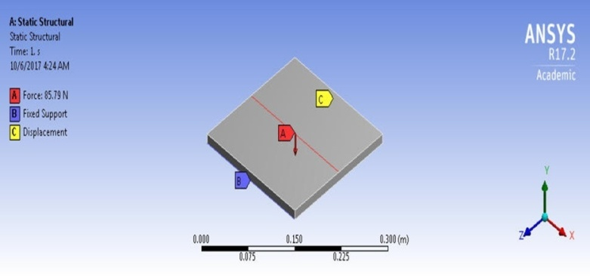
Figure 1 Loading and boundary conditions of FG tile
In the second step, the analysis part is carried out by fixing the geometry, modelling, meshing, loading and boundary conditions are given as shown in Figure 1. Then the analysis part is performed to get the required results. In the final step, the results are viewed in different pictorial and graphical pattern to further interpret and present the effective comparison between them.
- STRESS AND DEFORMATION ANALYSIS
In the present numerical investigation, the stress and deformation behaviour of 12 mm tiles made from seven different materials are analyzed. The detailed description of the tile with various parameters and its material properties are given in Table 1.

Table 1 Tiles with various parameters
S. No. | Parameter | Specimen | Description
1. | For different materials with 12 mm tile thickness | TM1 | Geopolymer
2. |  | TM2 | Geopolymer + 0.5% ZnO
3. |  | TM3 | Geopolymer + 0.5% TiO₂
4. |  | TM4 | Geopolymer + 0.2% Polyester Fibre
5. |  | TM5 | Geopolymer + 0.03% Glass Fibre
6. |  | TM6 | Geopolymer + 0.5% Basalt Fibre
7. |  | TM7 | Geopolymer + 0.5% TiO₂ + 0.5% Basalt Fibre

3.1 Stress plot
From the analysis, the equivalent stress is obtained for each material and is shown in Figure 2. When compared to other materials, equivalent stress of TM7 is found to be higher and it is mainly due to the presence of TiO₂ and basalt fibre in geopolymer mix. It shows a higher stress of 76.51%, 64%, 28.30%, 19.31%, 12.75% and 1.92% than TM1, TM2, TM3, TM4, TM5 and TM6.
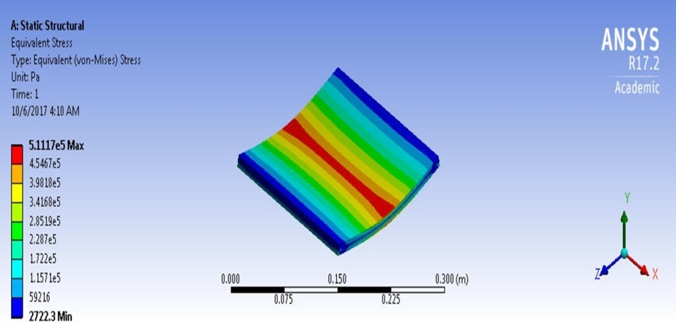
(a)
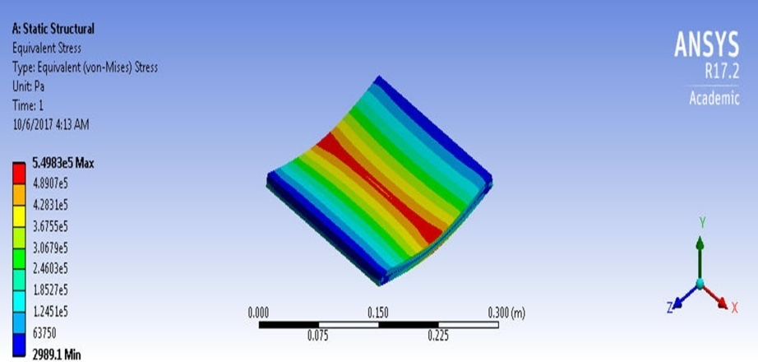
(b)
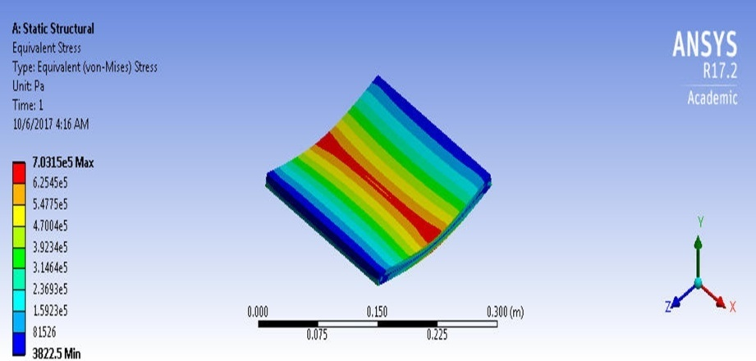
(c)
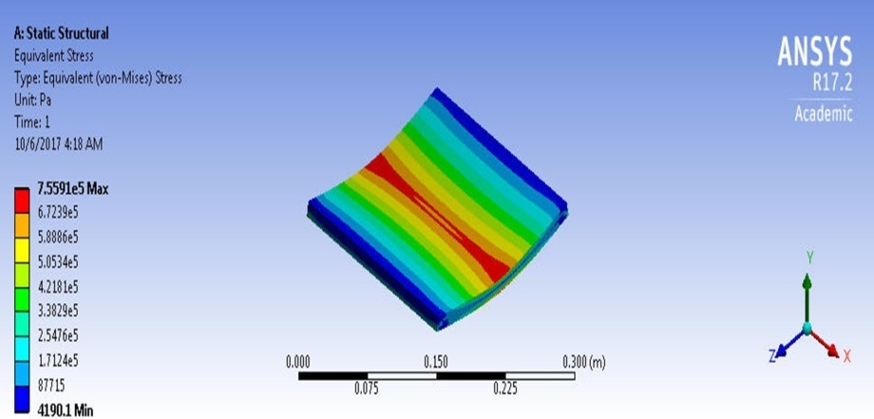
(d)
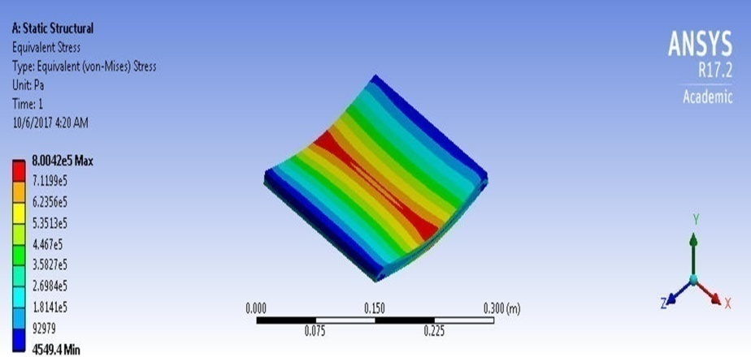
(e)
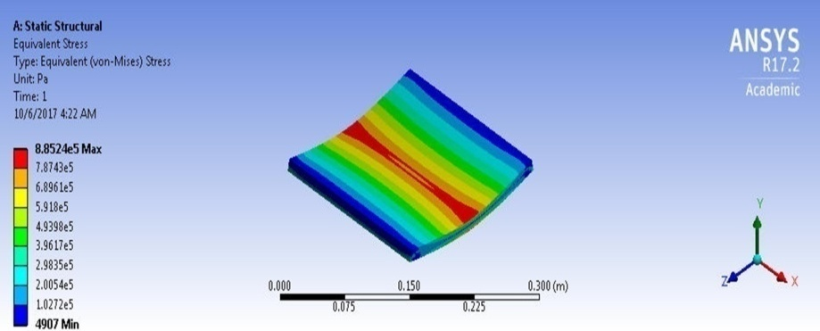
(f)
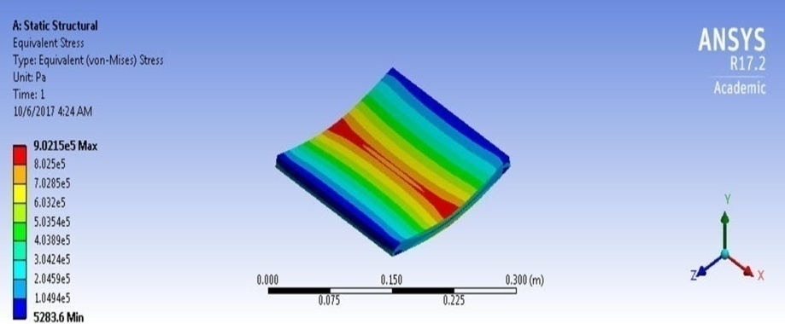
(g)
Figure 2 Equivalent stresses developed in a) TM1, b) TM2, c) TM3, d) TM4, e) TM5, f) TM6 and g) TM7
3.2 Total deformation plot
When the specimens are subjected to bending load, the tile gets deflected to a certain limit before breakage. The total deformation that occurs in each tile is clearly shown in Figure 3. It is numerically observed that, there is only a slight deflection in all the geopolymer tiles which does not exceed 0.021 mm. The total deformation of TM7 tile is 53.84%, 53.84% and 11.11% higher than TM1, TM2 and TM3 while it is 4.76% lower than TM5 and TM6. The total deformation in TM4 and TM7 is found to be at the same level.
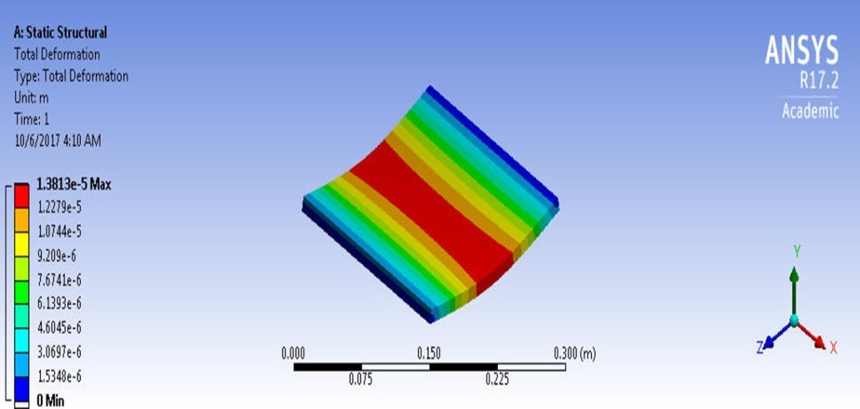
(a)
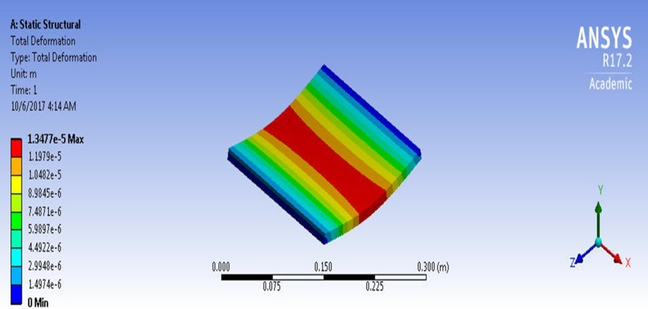
(b)
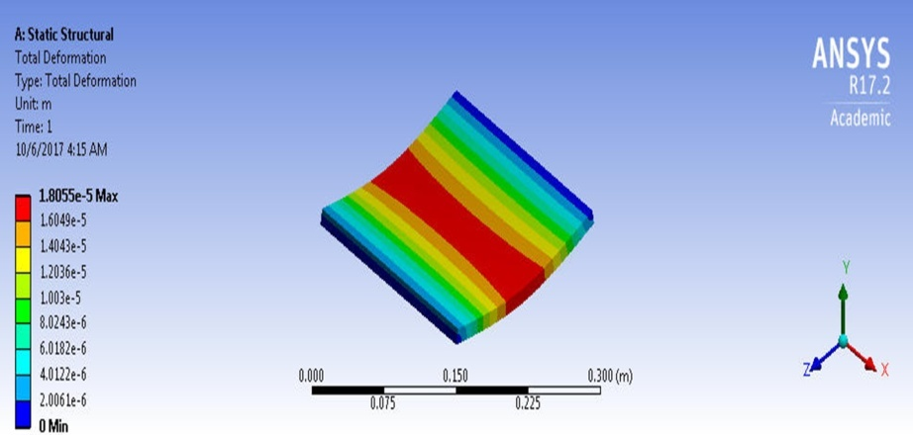
(c)
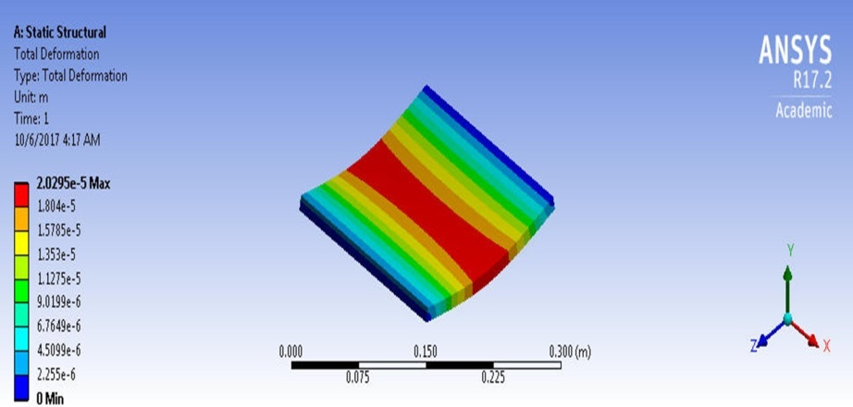
(d)
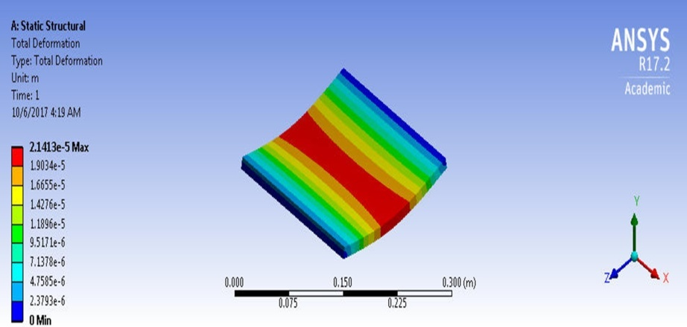
(e)
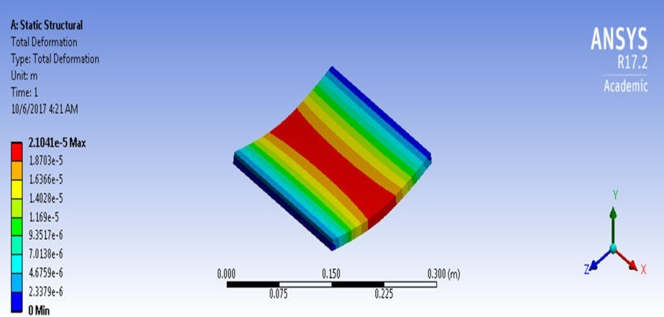
(f)
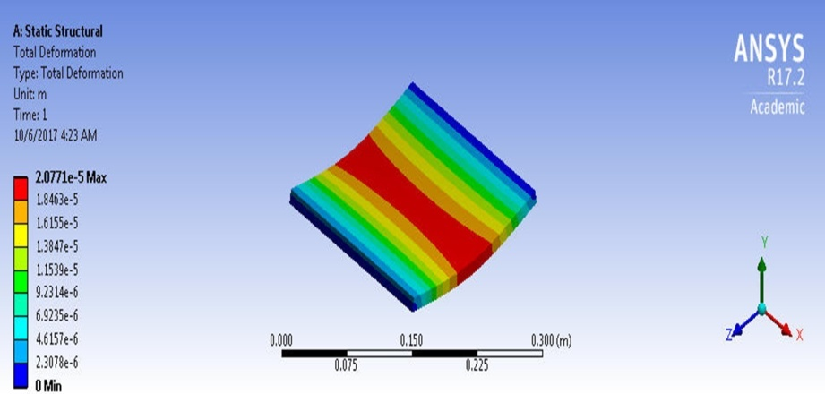
(g)
Figure 3 Total deformations in a) TM1, b) TM2, c) TM3, d) TM4,
e) TM5, f) TM6 and g) TM7
- RESULTS AND DISCUSSION
A comparison is made between the results obtained from the finite element study and experimental counterpart in order to find the variation in the stresses and deformations for the same loading condition.
Table 2 Comparison of FEA results of equivalent stress with the experimental results
S. No. | Specimen | Load Applied (N) | Equivalent Stress (MPa)
 |  |  | Experimental | FEA | Difference
1. | TM1 | 48.85 | 0.998 | 0.511 | 0.487
2. | TM2 | 52.43 | 1.081 | 0.550 | 0.531
3. | TM3 | 67.05 | 1.397 | 0.703 | 0.694
4. | TM4 | 72.01 | 1.442 | 0.756 | 0.686
5. | TM5 | 76.18 | 1.483 | 0.800 | 0.683
6. | TM6 | 84.33 | 1.582 | 0.885 | 0.697
7. | TM7 | 85.79 | 1.596 | 0.902 | 0.694

Table 3 Comparison of FEA results of total deformation with the experimental results
S. No. | Specimen | Load Applied (N) | Total Deformation (mm)
 |  |  | Experimental | FEA | Difference
1. | TM1 | 48.85 | 0.020 | 0.013 | 0.007
2. | TM2 | 52.43 | 0.021 | 0.013 | 0.008
3. | TM3 | 67.05 | 0.024 | 0.018 | 0.006
4. | TM4 | 72.01 | 0.026 | 0.020 | 0.006
5. | TM5 | 76.18 | 0.030 | 0.021 | 0.009
6. | TM6 | 84.33 | 0.032 | 0.021 | 0.011
7. | TM7 | 85.79 | 0.033 | 0.020 | 0.013

The comparative results of equivalent stresses and total deformations are presented in Table 2 and 3. The results obtained through FEA simulation are found to be lower than the outcome achieved experimentally. The results show that the variation in the equivalent stress is not beyond 0.7 MPa and the total deformation does not exceed 0.013 mm.
In this work, geopolymer tiles with different materials were modelled and analyzed using the Finite Element Software, ANSYS® WorkbenchTM 17.2. The tile with adequate size and thickness was modelled in the Design Modeler. The loads and boundary conditions were given in accordance to the experimental procedure. Analysis results show a decrease in value when compared to the outcome obtained experimentally. It is seen from Finite Element perspectives that, TiO₂ blended FG tile reinforced with basalt fibre (TM7) of 12 mm thickness shows lower stress and deformation of 43.48% and 39.39% than the experimental results. It is concluded that TM7 tile of 12 mm thickness gives better stress and deformation value when compared to the other tiles.
References
- Anuja. N., Prabavathy. S., “An Experimental Investigation on Flyash-based Geopolymer Mortar under Different Curing Regime for Thermal Analysis”, Energy and Build., Vol 138, 2016, pp 539–545, doi: 10.1016/j.enbuild.2016.12.079.
- Anuja. N., Prabavathy. S., “Development of Flyash-based Geopolymer Mix using Parametric Analysis” in the International Journal of Recent Technology and Engineering (IJRTE), vol.8, no.1, pp.3054-3059, May 2019.
- Sarathraj, RL & Somayaji, AK 2014, ‘Design and optimization of Mangalore clay roofing tile’, International Journal of Science and Research, vol. 3, no. 10, pp. 1286-1290.
- Hallad, SA, Banapurmath, NR, Patil, AY, Hunashyal, AM & Shettar, AS 2015, ‘Studies on the effect of multi-walled carbon nanotube-reinforced polymer-based nano-composites using finite element analysis software tool’, Proceedings of the Institution of Mechanical Engineers, Part N: Journal of Nanoengineering and Nanosystems, vol. 250, no. 4, pp. 200-212.
- Garg, T, Kaur, I & Singh, Y 2016, ‘Finite element analysis of RC slab with or without opening strengthened with FRP wraps’, Proceedings of the International Conference on Advances in Emerging Technology, ICAET 2016, no. 11, pp. 9-12.
- Martin, AM & Kuriakose, M 2016, ‘Finite element modeling and analysis of reinforced concrete beam retrofitted with fibre reinforced polymer composite’, International Journal of Engineering Trends and Technology, vol. 38, no. 4, pp. 190-197.
- Durgadevagi, S & Jabez, NA 2016, ‘A comparative analysis of slab with different shape of cutout for various end conditions using ANSYS’, Journal of Chemical and Pharmaceutical Research, vol. 8, no. 12, pp. 180-184.
- Purushottam, YJ & Hemantkumar, TY 2016, ‘Analytical study of solid flat slab and voided slab using ANSYS Workbench’, International Research Journal of Engineering and Technology, vol. 03, no. 10, pp. 1000-1003.
- Anuja. N., Prabavathy. S., “Study on geopolymer mortar using hydrogen peroxide as foaming agent” in the Journal of Structural Engineering (Madras), vol.45, no.2, pp.139-147, June-July 2018.
- Anuja. N., Prabavathy. S., “Evaluation of Heat Resisting Behaviour of Basalt Fibre Reinforced FG Tiles” in Construction and Building Materials, Vol.170, 2018, pp: 679-689, DOI: 10.1016/j.conbuildmat.2018.03.110.

