Forest Wetlands as Nature Based Solution for Climate Regulation, Water Resource Management and Biodiversity Conservation

Abhishek Maitry, Animesh Shukla and Shishir Chandrakar
Department of Forestry, Wildlife & Environmental Sciences,
Guru Ghasidas Vishwavidyalaya,
Bilaspur, Chhattisgarh- 495009, India
abhimaitry@gmail.com

ABSTRACT
Wetlands are one of the planet's wealthiest ecosystems, offering numerous valuable advantages to human society while being extremely delicate to environmental changes. Wetlands are important biological and economic systems that contain abundant natural resources and are essential for maintaining several services like hydrological cycle, carbon sequestration, and biodiversity. According to the National Wetland Inventory and Assessment (and Indian Space Research Organisation), in India, wetlands cover over 1 lakh, 52 thousand and 6 hundred square kilometers which comprise 4.63 percent of the total geographical area of the country. The wetland provides a wide range of benefits like diversity, and providing basic biophysical needs (food, fresh water, etc.), regulation of the environment, and cultural enrichment and also support internal processes to ecosystems that maintain their functioning, resilience, and capacities to produce more directly consumed services and hence being a great nature-based solution for different ecological, hydrological and forest diversity issues. Despite the significant ecological, hydrological, and socio-economic values provided by them, wetlands are facing threats from several natural and man-made induced factors even in densely forested areas. In this chapter, we have tried to justify the importance of forest-surrounded wetlands as a nature-based solution that provides various ecosystem services either directly or indirectly for the benefit of the human population which comprises its positive impacts on the regulation of climate for mitigation of climate change scenarios, managing hydrological resources for water security and conserve important floral and faunal species. These positive impacts evaluate the importance of forest wetlands and provide insights into planning, conservation, and sustainable management of wetland resources.

Keywords-wetland; biodiversity; climate; forest; water resource.

INTRODUCTION

Wetlands are one of the most productive ecosystems on the Earth, providing many important services to human society but are highly ecologically sensitive. ‘Wetlands are area of marsh, fen, peat-land or water, whether natural or artificial, permanent or temporary, with water that is static or flowing, fresh, brackish or salt, including areas of marine water, the depth of which at low tide does not exceed six meters', as defined by Ramsar convention 1971. Each of the services offered by wetlands, which support immense diversity, is defined by their genesis, geographic location, water regime and chemistry, dominant species present, and soil and sediment features [1, 2]. Globally, the areal extent of wetland ecosystems ranges from 917 million hectares (mha) [3] to more than 1275 mha with an estimated economic value of about US$15 trillion a year [4]. There are currently more than 2,200 Ramsar Sites recognised worldwide, covering 2.1 million square kilometres of these global wetlands. According to the National Wetland Inventory and Assessment (compiled by the Indian Space Research Organisation), over 1,52,600 square kilometres, or 4.63 percent of the nation's total land area, are covered by wetlands in India [5]. As per the statement by Musonda Mumba who is a United Nations Environment Programme (UNEP) terrestrial ecosystems expert and chair of the Global Partnership for Forest and Landscape Restoration, “The UN Decade on Ecosystems Restoration 2021–2030 will help drive the conservation and restoration of terrestrial and marine ecosystems, and wetlands will be very much part of the picture”.
They can be found in every climatic region, from warm deserts to frigid tundra, and at every elevation, from sea level to around 6000 m in the Himalaya. Wherever water collects for long enough periods of time, allowing the establishment of plants and animals specifically adapted to the watery environment, wetland formation occurs. Presence of water permanently is not a criterion and its depth may generally fluctuate [6]. Therefore, wetland areas can be found in or near bodies of water, such as transient ponds, shallow or deep lakes, springs, streams, and rivers. Wetlands are defined as " lands that connect aquatic and terrestrial ecosystems when the water table is frequently at or near the surface or when the land is submerged in shallow water," and they compulsorily contain at least one of the following three points: a) The substrate is primarily undrained hydric soil; b) at least occasionally, the land supports primarily hydrophytes; and c) at some point during the growth season of each year, the substrate is non-soil and is saturated with water or covered by shallow water [7]. Despite the fact that the world is surrounded by water on all sides, there is just a small amount of fresh water available—less than 1%. Only 0.0001% of the available fresh water is shared by the 6.45% of the world's surface that is made up by wetlands.

- IMPORTANCE OF WETLANDS

Their importance in human and nearby forest lives grew as the population and the population-based pressures have increased recently [8, 9]. The wetland offers a variety of advantages, including meeting basic biophysical demands (food, fresh water, etc.), regulating the environment, and enhancing culture [10, 11]. Additionally, support ecosystems' internal processes so they can continue to function, be resilient, and be able to provide more directly consumed services [12]. Carbon sequestration, erosion management (wetlands support vegetation that serves as a flood barrier and lessens stream bank erosion during flooding episodes), and other important services are of particular relevance. Flood water storage (storing water during periods of severe rain and flooding and then gradually releasing the water to minimise downstream damage); Recharge of groundwater is the process through which stored surface water seeps into the earth and replenishes aquifers, which then slowly release water to nearby surface water bodies, such as streams, to supply water during times of low flow; Water filtration (catch sediments, use extra nutrients in runoff, and decompose many toxins in water); recreation & economic benefits (cultural heritage, visited for leisure, hiking, bird viewing, wildlife photography, and hunting).

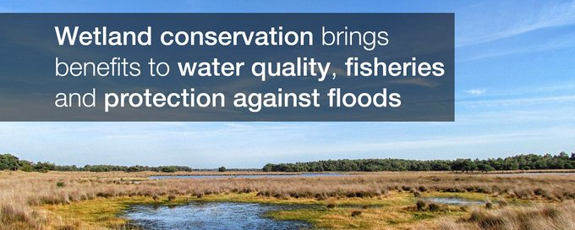

Figure 1. Global recognition of importance of wetlands. (Source: https://twitter.com/IUCN)

- THREATS TO WETLANDS

Wetlands are threatened by a number of man-made reasons, despite the significant ecological, hydrological, and socioeconomic roles they serve [13]. Due to anthropogenic concerns, even wetlands that are legally protected are not entirely free from degradation [14]. Moreover, many wetlands in rural and suburban areas are not covered either by the Indian Forest Act 1927 or Wild Life Protection Act 1972.

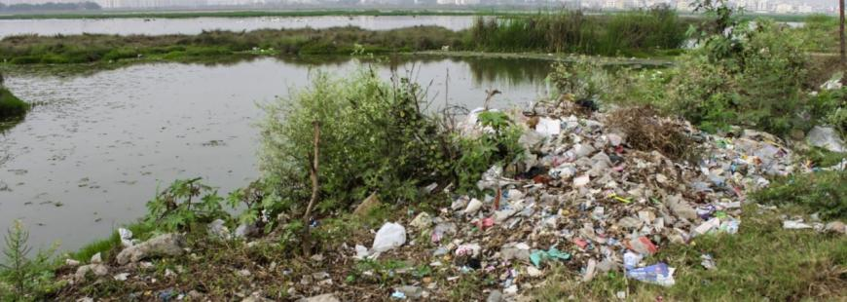

Figure 2. Major threats to wetlands. (Source: https://www.ramsar.org/resources/recognising-and-assessing-threats-to-the-site)

These wetlands face multiple threats, thus proper attention should be paid to their conservation and management. In India, there are many different types of wetlands that are dynamic and influenced by both natural and man-made activities. These wetlands require frequent monitoring and regular updates on their status through planning for conservation and sustainable management, which is significant in view of the accelerating pressure [15].

- WETLANDS IN INDIA

Wetland habitats in India are supported and maintained by the country's geography and climate patterns. Examples of natural wetlands in India include the high-altitude Himalayan lakes, coral reefs, marine wetlands, wetlands in the floodplains of the major river systems, saline and transitory wetlands, coastal wetlands (lagoons, backwaters, estuaries), mangrove swamps, etc. With the exception of forbogs, fens, and traditional salt marshes, Indian wetlands are home to a variety of ecological types. In addition to the natural wetlands, there are a lot of man-made wetlands that were created to meet needs for irrigation, water supply, electricity, fisheries, and flood control, among other things (Sarkar et al. 2020). These wetlands significantly increase the richness of the fauna and flora [11]. In addition, countless tanks, shallow ponds, and reservoirs all contribute to the biodiversity of wetlands.

Table 1. Wetland categories found in India.

 | Wetland Category | Total wetland area (ha) | % of wetland area
1. | Inland wetlands- Natural | 6623067 | 43.40
2. | Inland wetlands- Man-made | 3941832 | 25.83
 | Total – Inland | 10564899 | 69.22
3. | Coastal wetlands- Natural | 3703971 | 24.27
4. | Coastal wetlands- Man-made | 436145 | 2.86
 | Total – Coastal | 4140116 | 27.13
 | Sub- Total | 14705015 | 96.36
 | Wetlands (< 2.25 ha) | 555557 | 3.64
 | Total | 15260572 | 100
Source: National Wetland Inventory and Assessment, India

- FOREST WETLANDS FOR CLIMATE REGULATION

Wetlands are one of the most valuable and prolific ecosystems on the planet. Wetland systems are sensitive to variations in the amount and quality of their water resource. Climate change is anticipated to significantly impact wetlands via modifications to highly variable hydrological systems worldwide. Wetlands are a complex system that encounters wet and dry phases in cycles over the course of seasons, years, and decades. The multitude of advantages wetland habitats offer to human society were emphasized by the Millennium Ecosystem Assessment [4]. Climate regulation is one of the most crucial environmental functions that connect wetlands to human well-being [16]. Wetlands are increasingly acknowledged to be important climate regulators additionally in the sequestration and storage of carbon [17]. Wetlands are involved in multiple facets of climate regulation beyond just the kinetics of carbon. In addition, to serve as a sink for greenhouse emissions, wetlands have the ability to regulate local and regional climate as well. Wetlands are one of the major uncharted territories in the near future for element dynamics and matter fluxes in the near future in a world of global climate change [18].

- Wetland and Carbon
Globally wetlands occupy 6% of the total land area yet contain around 12% of the world's carbon reserves, contributing significantly to the global carbon cycle [19, 20]. From the poles to the equator, vegetated wetlands serve as important carbon sinks. The carbon density of terrestrial ecosystems is highest in wetlands which account for 20–25% of the organic soil carbon worldwide [21]. Mangroves are considered as one of the major forest wetland habitats with the highest concentrations of carbon in accordance with the current biogeochemical and physical circumstances being very favourable for carbon retention over the long term. Global assessments indicate that these systems are substantial carbon sinks as they could store up to 19.9 Gt of organic carbon [22]. The quantity of carbon retained in wetland soils is strongly correlated with climate. The role of tropical forest wetlands has garnered a great deal of attention in climatic budgets on a global scale. According to estimates, as much as 88.5 Gt of carbon (range 81.5–91.8 GtC), equivalent to 17–19% of the worldwide wetland carbon stock are stored in tropical peatlands [23]. Wetland has the potential to store a considerable amount of carbon in its soils and standing vegetation. Wetlands are essential pertaining to the carbon complex and thus, they have the potential to mitigate the effects of climate change.

- Wetland and Greenhouse Gases
One crucial aspect of wetlands is their ability to act as a source and sink of greenhouse emissions. Wetlands are essential for regulating the climate since they can alter the levels of greenhouse gases in the atmosphere such as carbon dioxide, nitrous oxide and methane [24]. Different wetlands produce and emit GHGs at varying rates in accordance with the dominant biogeochemical processes. In the anaerobic soils that predominate in wetlands, CH4 can also be produced along with CO2. So, wetlands can be an innate CH4 source. Wetlands often emit less N2O into the air. Although due to groundwater contamination or adjacent uplands leaching where substantial nitrogen infusions are present, wetlands may produce N2O emissions. Wetlands that hold a considerable amount of water throughout the year, maintaining anoxic conditions, will typically produce less N2O emissions and more CH4 emissions. The risk of rising CH4 emissions has been cited to argue against restoring wetlands. Nevertheless, it is crucial to comprehend the potential GHG fluxes to avoid unfavourable results. Therefore, at any wetland, the primary GHG emission controls are climatic conditions and the accessibility of nutrients along with the period of waterlogging and water table elevation.

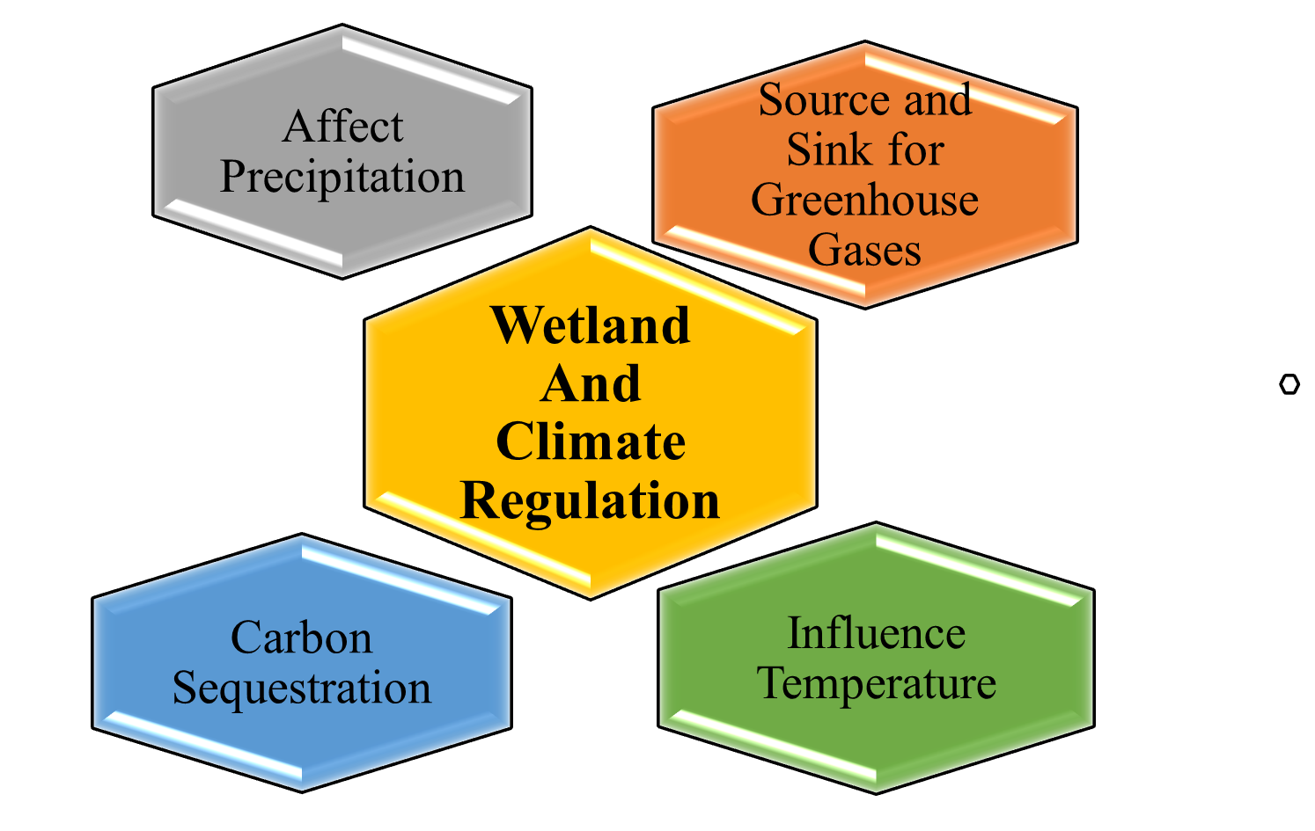

Figure 3: Multiple Aspects of Climate Regulation through Wetland.

- Wetland and Local Climate
Wetlands have a localized impact on climate by transferring energy and dissipating it. Wetland affects fluctuations in temperature and impacts variation in precipitation intensity and frequency. Wetlands have been predicted to have a localized cooling influence on the environment and can lower temperatures thereby up to 50C compared to the surroundings [25]. Since water is frequently present in wetlands, energy input is converted into latent heat of evaporation, however, on dry grounds solar energy is transformed into perceptible heat increasing the ambient air temperature noticeably. Wetlands serve as the first line of defence against severe weather conditions and create a physical barrier to lessen the force and speed of floodwaters. Wetlands offer a coping mechanism to guard against storms. Wetlands may assist in providing water during dry spells. Wetland provides a reliable and realistic approach for mitigating the effects of climate change.
Wetland habitats are essential to both nature and mankind. They are frequently the landscape's most valuable ecosystems. Effective and sustainable wetland resource management is becoming more difficult and crucial but it is essential to protect, preserve and conserve the wetland as they are continually being lost due to improper management yet it is increasingly clear that the services, they offer are indispensable for society. Due to their crucial function in regulating the climate, activities for managing wetlands and restoring them are being incorporated into local, regional and international levels which aspire to both prevent and respond to climate change [26]. Wetlands can act as a "safety net" against the effects of climate change if they are globally preserved, safeguarded, and restored [27].

- FOREST WETLANDS FOR WATER CONSERVATION

Wetlands are the ideal natural option for risk reduction and adaptation while preserving both flood and drought-related climatic extremes. Water and land are divided by areas known as wetlands. They can be freshwater or saltwater and exist in a transitional zone that is occasionally wet and occasionally dry. Normally, the Wetlands will remain moist during rain occurrences. Wetlands can be either natural or man-made, and the water they contain can be either still or moving, fresh, brackish, or salty. Even subsurface wetlands exist. Swamps, marshes, bogs, and fens are the principal types of wetlands.
Wetland ecosystems are associated with a diverse and complex array of direct and indirect uses depending on the type of wetlands, soil and water characteristics, and associated biotic influences. Direct uses include water supply source and harvesting of wetland products such as fish and plant resources. Indirect benefits are derived from environmental functions such as floodwater retention, groundwater recharge/discharge, climate mitigation, and nutrient abatement [28]. Based on the immense environmental and sustainability benefits, wetlands have been demarcated as essential for the future of human existence. The future challenges pertaining to food, clean water and energy security, well-being of humans, natural disaster risk reduction, and climate change resilience can be met by preserving the wetlands [29].

- Water Purification
Natural wetlands provide a variety of purposes that are advantageous to both people and wildlife. The filtering of water is one of its most crucial roles. As water moves slowly through a wetland, many of the sediments that carry contaminants and nutrients also do so. As a result, the suspended solids in the water become trapped by the plants and settle out. Other contaminants are rendered inert or changed into less soluble forms that plants can absorb.

- Flood Protection
As water enters a wetland through a stream channel or surface runoff, it spreads out and passes through a lot of plant. The rate of water flow has slowed, which could decrease the probability of an extensive flood. The size of the area, the type and health of the vegetation, the slope, the placement of the wetland in the flood channel, and the saturation of the wetland soils before to flooding can all affect how efficient wetlands are at reducing flood damage. A one-acre wetland can typically store about three-acre feet of water, or one million gallons [30]. As the flow of water get reduced by wetland via storing more water by infiltration than terrestrial land, the chances of causing flood get reduce.
- Ground Water Recharge
Some freshwater wetlands exist where groundwater recharges from surface water reaching an underground aquifer. Wetlands are more frequently the locations where groundwater seeps to the surface of the land, like springs. The groundwater discharge may be significant for providing stream flows for fish, animals, plants, and other creatures that live in or near the stream during the dry summer months. It may also be significant as a local source of drinking water.

- Trap Sediments that contain Contaminate and Pollutants
The flow's velocity is decreased, allowing floating debris to settle to the wetland's surface. The accumulating sediments can then be bound by the roots of wetland plants. If the water travels through wetlands, up to 90% of the sediments that are present in runoff or streamflow may be eliminated. Additionally, because contaminants like heavy metals are bound to soil particles, the settling of sediments in wetlands enhances the quality of the water even more.

- FOREST WETLANDS FOR BIODIVERSITY CONSERVATION

Wetlands are essential for preserving numerous natural cycles and providing habitat for a wide variety of wildlife. The phrase "kidneys of the landscape" is frequently used to characterise wetlands [31]. Wetlands play important ecological roles in the preservation of biodiversity, hydrological equilibrium, and human wellbeing. More than 40% of all plant and animal species have habitats in surface freshwater wetland areas around the world. Wetland microhabitats offer abundant and high-quality food sources and shelter for avifauna populations all year long. Wetlands have sometimes been referred to as "biological super systems" because of the enormous amounts of food they produce and the extraordinary degree of biodiversity they support. They are just as rich in species diversity and number as coral reefs and rainforests. Their shallow water, high nutrient content, and high primary productivity (amount of biomass generated) are perfect for the growth of organisms that are the foundation of the food chain on our planet.
- Floral Diversity Conservation
Wetland plant communities serve as effective indicators of the health of wetlands because they include species with a range of ecological tolerances and adaptations, as well as reflecting the biological integrity of wetlands [32]. Species commonly seen growing in wetlands of all types, on or in the water, or when soils are flooded or saturated long enough for anaerobic conditions to develop in the root zone are referred to as wetlands plants. The maintenance of the water cycle, nutrient cycle, carbon sequestration, storage/retention and purification of water, waste treatment, and pollution control are all greatly aided by the crucial habitat that wetland provides for plant diversity [33]. In order to assess the effects of human interference on wetlands, different plant species respond to environmental change in different ways [34].

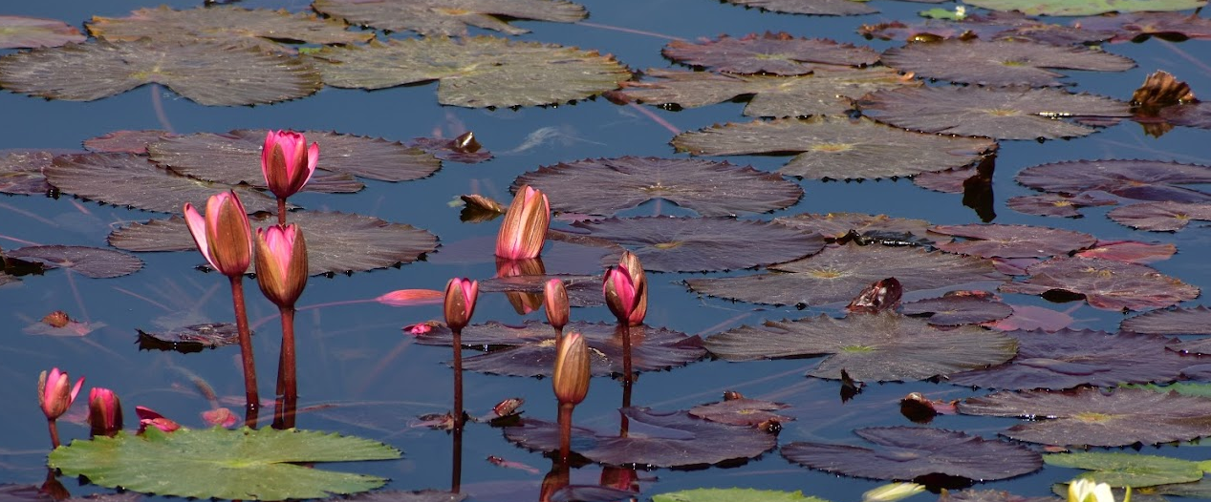

Figure 4. Floral diversity supported by wetlands. (Source: GPWC, Bemetara ©Abhishek Maitry)

- Faunal Diversity Conservation
Wetlands are an important habitat for migratory species and the majority of the world's waterbirds [35, 36]. Wetlands are used by almost all water birds in the world as breeding and feeding grounds [37]. Wetlands are used by migratory waterbirds throughout their range, which can occasionally extend practically from pole to pole. Coordinated wetlands conservation efforts spanning several nations are needed to protect the feeding, nesting, and stopover habitats that migratory birds depend on across and between continents. Similar to how other animal species benefit from wetlands, they also provide the necessary habitat for other species to coexist peacefully within an ecosystem [38]. The present information on faunal diversity in wetland is of immense use for the conservation and management of wetlands as well as their sustainable livelihood.

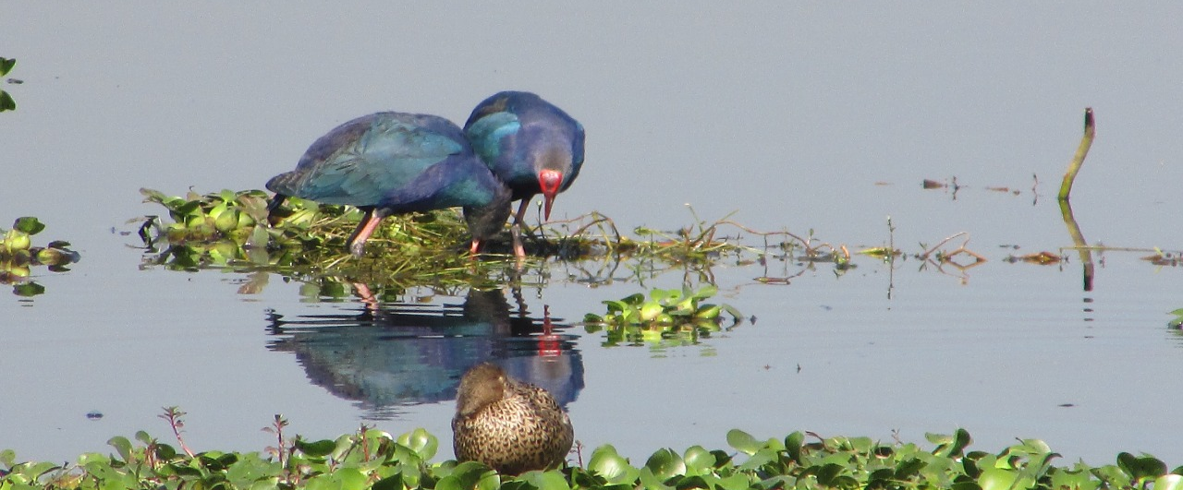

Figure 5. Faunal diversity supported by wetlands. (Source: GPWC, Bemetara ©Abhishek Maitry)

- CONCLUSION

The wetland offers a wide range of advantages, including diversity, provision of basic biophysical needs (food, fresh water, etc.), environmental regulation, and cultural enrichment. It also supports internal processes in ecosystems that maintain their functioning, resilience, and capacities to produce more directly consumed services, making it a great natural solution for various ecological, hydrological, and forest diversity problems. One of the most important environmental services that links wetlands to human well-being is climate management. Wetlands are becoming seen as crucial climate regulators that also help to sequester and store carbon. Depending on the kind of wetlands, the features of the soil and water, and any related biotic impacts, wetland ecosystems are linked to a broad and complicated array of direct and indirect uses. Water supply sources and the harvesting of wetland resources like plants and fish are examples of direct applications. Environmental processes include floodwater retention, groundwater recharge and outflow, climate mitigation, and nutrient abatement produce indirect benefits. Wetlands also generate large amounts of food and maintain an astonishing level of biodiversity, earning them the moniker "biological super systems" in certain circles. They are equally as diverse and abundant in species as coral reefs and rainforests. These positive impacts evaluate the importance of forest wetlands as nature-based solution for climate regulation, water resource management and biodiversity conservation and provide insights into planning, conservation, and sustainable management of wetland resources.

REFERENCES

- M. R. Goswami, A. Mukhopadhyay, An Overview of the Determination of Biodiversity of Wetlands. Handbook of Research on Monitoring and Evaluating the Ecological Health of Wetlands, 2022, pp. 150-170.
- T. Xu et al., Wetlands of international importance: status, threats, and future protection. Int. J. Environ. Res. Public Health 16(10), 1818 (2019).
- Lehner, P. Döll, Development and validation of a global database of lakes, reservoirs and wetlands. J. Hydrol. 296(1-4), 1-22 (2004).
- Millennium Ecosystem Assessment, Ecosystems and Human Well-Being: Wetland and Water Synthesis. Available at (http://www.millenniumassessment.org/proxy/Document), 2005, vol. 358.
- N. Bassi, M. D. Kumar, A. Sharma, P. Pardha-Saradhi, Status of wetlands in India: a review of extent, ecosystem benefits, threats and management strategies. J. Hydrol. Reg. Stud. 2, 1-19 (2014).
- Y. Qu et al., Prediction of wetland biodiversity pattern under the current land-use mode and wetland sustainable management in Sanjiang Plain, China. Ecol. Indic. 147, 109990 (2023).
- L. M. Cowardin, Classification of Wetlands and Deepwater Habitats of the United States (Fish and Wildlife Service, US Department of the Interior), 1979.
- W. J. Mitsch, J. G. Gosselink, The value of wetlands: importance of scale and landscape setting. Ecol. Econ. 35(1), 25-33 (2000).
- K. Avishek, M. S. Nathawat, Geoinformatics for the assessment of anthropogenic impact on landscape. Natl. Geogr. J. India 50(1-2), 13-24 (2004).
- P. A. Hambäck et al., Tradeoffs and synergies in wetland multifunctionality: A scaling issue. Sci. Total Environ. 862, 160746 (2023).
- S. Bhowmik, Ecological and economic importance of wetlands and their vulnerability: a review. Research Anthology on Ecosystem Conservation and Preserving. Biodiversity, 11-27 (2022).
- S. Thapa et al., Valuation of ecosystem services from an important wetland of Nepal: A Study from Begnas watershed system. Wetlands 40, 1071-1083 (2020).
- K. Ostad-Ali-Askari, Review of the effects of the anthropogenic on the wetland environment. Appl. Water Sci. 12(12), 260 (2022).
- A. Moi et al., Human pressure drives biodiversity–multifunctionality relationships in large Neotropical wetlands. Nat. Ecol. Evol. 6(9), 1279-1289 (2022).
- R. Abell et al., Freshwater biodiversity conservation through source water protection: quantifying the potential and addressing the challenges. Aquatic Conserv: Mar. Freshw. Ecosyst. 29(7), 1022-1038 (2019).
- A. Maitry et al., Assessment of Wetland Ecosystem Services (RAWES approach) in Urban Settlement Area: A case study of Bilaspur, Chhattisgarh, India. Indian Journal of Ecology 50(4), 954-962 (2023).
- S. Frolking, N. T. Roulet, Holocene radiative forcing impact of northern peatland carbon accumulation and methane emissions. Global Change Biol. 13(5), 1079-1088 (2007).
- IPCC (International Panel on Climate Change), 2001: impacts, adaptation, and vulnerability. Technical summary, and summary for policymakers. Third assessment report of working group I of the intergovernmental panel on climatic change, Climate Change, 2001.
- IPCC (International Panel on Climate Change) (1996), Climate change 1996—impacts, adaptations and mitigation of climate change: scientific technical analysis. Contribution of Working Group II to the Second Assessment Report of the IPCC (Cambridge University Press, Cambridge).
- R. Ferrati, G. Ana Canziani, D. Ruiz Moreno, Esteros del Ibera: hydrometeorological and hydrological characterization. Ecol. Modell. 186(1), 3-15 (2005).
- Gorham, Northern peatlands: role in the carbon cycle and probable responses to climatic warming. Ecol. Appl. 1(2), 182-195 (1991).
- J. W. Fourqurean et al., Seagrass ecosystems as a globally significant carbon stock. Nature Geosci. 5(7), 505-509 (2012).
- S. E. Page, J. O. Rieley, C. J. Banks, Global and regional importance of the tropical peatland carbon pool. Globa Chang Biol. 17(2), 798-818 (2011).
- IPCC, Climate Change 2007 Synthesis Report. Contribution of Working Groups I, II and III to the Fourth Assessment Report of the Intergovernmental Panel on Climate Change (IPCC), 2007.
- H. Taha, Urban climates and heat islands: albedo, evapotranspiration, and anthropogenic heat. Energy Build. 25(2), 99-103 (1997).
- K. L. Erwin, Wetlands and global climate change: the role of wetland restoration in a changing world. Wetlands Ecol. Manage. 17(1), 71-84 (2009).
- Ramsar 2009h. Factsheet 10: Climate change mitigation & adaptation. Gland, Switzerland, Ramsar Convention Secretariat.
- S. Abraham, The relevance of wetland conservation in Kerala. Int. J. Fauna Biol. Stud. 2(3), 01-05 (2015).
- A. Nayak, B. Bhushan, Wetland ecosystems and their relevance to the environment: importance of wetlands, in Handbook of Research on Monitoring and Evaluating the Ecological Health of Wetlands (IGI Global), 2022, pp. 1-16.
- US Environmental Protection Agency (EPA), Wetlands: Protecting Life and Property from Flooding, 2006.
- S. Jamal, M. A. Ali, Remote sensing application for exploring land use and land cover dynamics in and around Chatra wetland, English Bazar, West Bengal. Creat. Sp. 9(1), 15-27 (2021).
- N. Yapa, K. Amarasekara, S. Rathnasri, Floral Diversity Status in Urban Coastal Wetland & Associated Coastal Ecosystems of Crow Island Mattakkuliya, Sri Lanka. Open J. Ecol. 12(1), 51-65 (2022).
- R. S. Rathore, R. S. Yadav, H. A. Solanki, Wetland ecosystem – home to plant species diversity. Plant Arch. 20(2), 5341-5352 (2020).
- J. J. Sieben, R. P. Glen, H. Van Deventer, A. Dayaram, The contribution of wetland flora to regional floristic diversity across a wide range of climatic conditions in southern Africa. Biodivers. Conserv. 30(3), 575-596 (2021).
- A. Chatterjee, S. Adhikari, S. Pal, S. K. Mukhopadhyay, Foraging guild structure and niche characteristics of waterbirds wintering in selected sub-Himalayan wetlands of India. Ecol. Indic. 108, 105693 (2020).
- M. A. Salim et al., Diversity of Avian fauna of Al-Dalmaj Wetlands and the surrounding terrestrial areas, Iraq, in J. Phys.: Conf. Ser. (Vol. 1664, No. 1, p. 012105) (IOP Publishing) 1664(1) (2020, November).
- M. Mola, D. Ejigu, Y. Yitayih, Species composition, relative abundance, and habitat association of avifauna in zegie peninsula forest patches and associated wetlands, Bahir Dar, Ethiopia. Int. J. Zool. 2021, 1-12 (2021).
- T. K. Goswami, M. M. Goswami, Ichthyo Faunal Diversity and Catch Statistics of Jamlai Wetland in Kamrup District of Assam, India, 2020.

