A Novel Method for Detecting Faults in Power Systems Using Machine Learning.
Debshree Bhattacharya, Dr. Manoj Kumar Nigam, Dr. K.P. Yadav
Research Scholar, MATS School of Engineering and Information Technology, Aarang, Raipur
Professor, MATS School of Engineering and Information Technology, Aarang , Raipur
Vice Chancellor, MATS University, Raipur
Abstract:
Transmission lines are in charge of transferring power across the grid in electrical power systems. However, faults in these lines are abnormal conditions that, if prolonged, can destabilise the transmission system. IEC61850-based digital substations provide sampled value measurements in the substation to diagnose faults. Machine Learning (ML) techniques are being investigated in the literature in addition to existing model-based techniques for fault diagnosis. In this book chapter, we're studying an ML-based fault classifier that takes current and voltage measurements as input. When compared to other methods proposed in the literature, such as RNN and SVM, the ML-based fault classifier is intended to improve performance in fault classification. The model will make use of data from a PSRC D6 benchmark dataset. To demonstrate classification performance, the classifier's performance will be evaluated using evaluation metrics such as accuracy, precision, recall, F1 score, and confusion matrix.
- Introduction
The power grid is evolving toward a smart grid with bidirectional energy and data flow. With increasing generations and demand over time, the goal of a stable and reliable grid operation is critical in a smart grid. The transmission system in the smart grid connects various generations, including renewable energy resources, to consumers. The transmission system must be protected in order for the smart grid to function properly.
However, abnormal conditions, such as transmission system faults, can occur as a result of natural disasters, extreme weather, and human-made interventions. To overcome the negative impact of faults on the dynamics and stability of this infrastructure, the role of the power grid protection system is critical, and it requires continuous improvement. Fault diagnosis, i.e. fault detection, classification, and location of faults, is performed in transmission line protection systems using various protective relays. However, the post-fault diagnosis tool based on recorded events was created using both model-based and data-driven approaches.
In the online implementation, the goal of fault diagnosis is to analyse the fault in terms of its type, location, and reasoning due to system disturbances. Data-driven methods have been investigated to provide this fault diagnosis task for the transmission line in digital substations. Methods for detecting and classifying faults in transmission line protection systems range from classical algorithms to modern techniques.
Fault detection in transmission lines is accomplished through the use of over-current relays, distance relays, and directional relays, each with distinct characteristics. The fault classification is traditionally done using sequence component distance relays to classify the fault in the system using positive, negative, and zero sequence components. Particularly for fault classification, sequence component-based relays are used; however, with the addition of distributed energy generations, the effectiveness of sequence component-based approaches is declining. As a result, signal processing techniques such as wavelet transforms, S-transforms, and fuzzy logic-based techniques have been used to solve the fault classification problem with improved analysis of current and voltage signals. Recent data-analytic techniques, particularly sequence learning models, are thought to be promising for fault detection and classification tasks in transmission lines.
There are two reasons for using sequence models. First, deep learning (DL) networks are the best at extracting features from temporal data sequentially. Second, unlike RNNs, it overcomes the vanishing gradient problem when learning from sequential data. Another candidate approach was the transformer model, but it does not provide learning in a sequential manner, which is required in power system measurement data. For example, using Long Short Term Memory (LSTM) networks, temporal information from sequential data can be learned and classified for various abnormal behaviours, including faults.
The fault detection and classification task is carried out using input current and voltage measurement data from the substation. The approach of sequence learning models is used to solve the fault classification problem.[1].
The intended end-user of this LSTM-based fault diagnosis tool is the manufacturer of digital substation devices, which are used to diagnose faults in online implementation in IEC 61850-based substations. Because these ML models are not in compliance with the time requirement of the real-time protection system when used for online fault classification. The goal is to use this data-driven tool for online post-fault analysis of fault events in the substation to build a classifier based on the history of recorded measurement data.
1.1. Importance of Fault Diagnosis
Transmission lines are three-phase connections between various substations in power systems that transfer power from generating stations to the distribution system at high voltage levels. In a transmission line system, a fault can be caused by contact between conductors or with the ground. These faults are classified as Single Line to Ground (LG), Double Line to Ground (LLG), and Three Lines to Ground (LLLG) in a three-phased transmission line, among others.
The change in measurement data, i.e. voltage and current signals, is frequently experienced in the power system, a complex and critical infrastructure. Along with several disturbances, various system faults in power systems are caused by a variety of factors [3], with transmission system faults accounting for approximately 85% of them [4]. Faults in power systems are unavoidable due to their physical nature, for example, in overhead transmission lines and underground cables [5]. These flaws can result in significant economic damage as well as personal and equipment loss [6]. These consequences in the complex transmission line network have highlighted the need to diagnose the fault as soon as possible.
Fault detection is the procedure to detect the abnormal condition of the transmission line based on the data obtained by the current transformer (CT) and voltage transformer (VT) protective relays and the status of circuit breakers of the protective zone. The goal of fault classification is to categorize the fault by its type, i.e. which phase of the system is at fault and its nature.
Symmetric component-based relays are a popular technique for fault classification in power systems. This technique is entirely reliant on estimating the fundamental components of the current and voltage signals during the fault. In addition to the Symmetric Component Distance Relay [7], the advancement of data analytics and machine learning has prompted increased research into the depth and breadth of fault diagnosis techniques via decisions made with the help of the system's history of data and learning from it.
1.2 Data-Driven Fault Diagnosis in Transmission Line
The transmission system fault diagnosis is defined as identifying the fault, classifying its nature, and locating it within the transmission system. The goal of transmission system fault diagnosis is to detect a fault in the line, classify the type of fault, and localise the fault in order to restore the line. Transmission line protection systems are used to monitor line health and isolate lines in the event of a fault. Circuit breakers isolate the line, CT and VT measure current and voltage signals, merging units, and protective relays are all part of the protection system.
Fault diagnosis is classified as model-based or history data-based. Model-based fault analysis involves describing a system (or process) using quantitative or qualitative models. Without performing any prior mathematical estimation, data history-based techniques rely on empirical measurements of the process to develop a mapping between inputs and desired outputs. Model-based techniques find few applications in power systems due to their computational intensity and sensitivity to parameter changes, resulting in slow and inconsistent diagnosis [8].
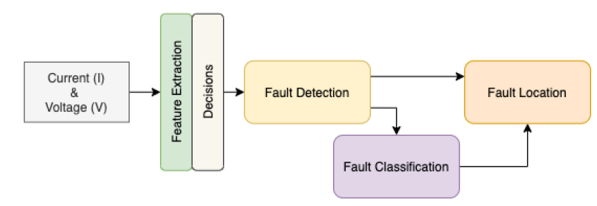
Figure 1: Stages of fault diagnosis in transmission system
A suitable mathematical model describing the system is required in model-based methods for fault diagnosis. This description, or prior knowledge, is derived from the underlying physics of the system's behaviour and can be quantitative or qualitative. When it comes to model-based fault diagnosis in transmission lines, there are several types of protective relays that are based on model-based fault detection methods. A sequence component-based protective relay, for example, is a commonly used protective relay for fault classification.
Process history-based (or pattern recognition) methods, on the other hand, require a sufficient amount of historical process data. This task appears to be described intuitively by a set of measurement data, which can be mathematically expressed as a function between measurements and decisions. An approximate mathematical description of the underlying physical process is not required [8]. In transmission line protection, for example, fault classification can also be accomplished by analysing the data's history and abnormal conditions.
In recent years, data-analytic techniques have been extensively used to investigate fault diagnosis methods, such as fault detection, classification, and location of transmission lines [9] [10]. The importance of intelligent health monitoring of transmission systems and fault diagnosis, with a focus on the smart grid, led to the development of statistical and machine learning-based methods for detecting and classifying different types of fault in power systems [11].
1.3 Scope of Fault Diagnosis Tool
The goal of the fault diagnosis tool is to use a neural network-based sequential model architecture for the detection and classification of faults in power system transmission lines using the history of data measurements such as current and voltage signals. In comparison to the various stages of fault diagnosis in the transmission system, our work is limited to the first two tasks, whereas the classification task includes the detection task, i.e., as the fault is detected in the system, it directly outputs the type of fault detected. Furthermore, the detection task could be distinguished in the work's architecture, which is unique to the classification task.
As shown in Figure 2, the goal of the fault diagnosis tool used in our work is to use a deep learning-based diagnosis tool to classify the input measurement as normal or fault, with the fault class designed to output three types of fault, namely Single Line to Ground (SLG), Double Line to Ground (DLG), and Triple Line to Ground (TLG) (TLG).
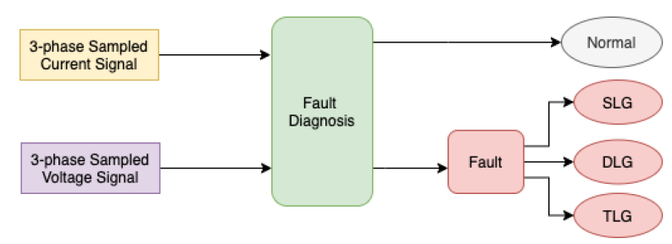
Figure 2: Illustration of Fault Diagnosis tool with its objectives
1.3.1 Overview of the Problem
The goal of this chapter is to develop a fault classifier for fault diagnosis in the transmission line protection system, using DL networks as feature extractors and Softmax layers as decision layers, where it exploits the temporal nature of historical measurement data to extract features for improved fault classification.
The problem statement's goal is to achieve post-fault diagnosis classification performance using a data-driven approach rather than a model-based approach. Sequential models, particularly neural networks, are being considered as potential candidates for sequentially learning temporal information from sampled current and voltage data available from CT and VTs in digital substations via IEC61850-based standard communication infrastructure.
The goal of the following chapter is to explain the existing model-based methods for fault classification, as well as data-driven methods ranging from classical signal processing methods to artificial neural network methods, based on the formulation of the problem. Furthermore, the vanilla neural network will be explained in conjunction with the proposed classifier architecture, where it can exploit the temporal information of input signals and produce potential results in the fault diagnosis classification task. The detection of fault is implied in this goal because the classification of the input sample as a normal condition and one of three types of transmission line fault conditions will be considered.
- Literature Review
This section provides background concepts in protective relay principles, fault detection, and classification, as well as a literature review of previous work in this field. The classical approaches to fault classification are briefly explained first, followed by machine learning and deep learning-based techniques.
2.1 Protective Relay Principles
2.1.1 Protection System
A power system's protection system shields the grid from the damaging effects of a persistent fault. An aberrant system situation known as a fault most often manifests as a short circuit. Instability in the power system or further disintegration of the system by other protective devices may result from a faulty power system component (in our case, a transmission line) that is not promptly removed from the system. Therefore, a protection system must quickly isolate the electricity coming from this faulty component from the rest of the system.
The circuit breaker (CB) isolates the faulty circuit by halting the current at or close to current zero. The protective system is made up of subsystems that assist in removing the fault. A significant component of the protection systems' measuring transducers (current and voltage transformers) is the protection systems. By lowering the high magnitude of current and voltage from the primary circuit to low values in the secondary circuit, CTs and VTs are required to measure current and voltage signals. The conventional secondary circuit values for CT and VT are 1 Amp or 5 Amp and 67 volts phase-to-neutral, respectively [12]. As a result, the relay observes reduced versions of the currents and voltages seen in power systems.
The protective relay is the most significant component of the protection system (figure 3). In order to send a trip signal to CB when input conditions match the faults the relay is intended for, this device accepts inputs (voltage signal, current signal, or contact status). Relay must meet two criteria: it must be dependable and secure. Dependability refers to the relay's ability to function as intended under all fault scenarios. Security refers to the relay's inability to function in the event of additional power outages.
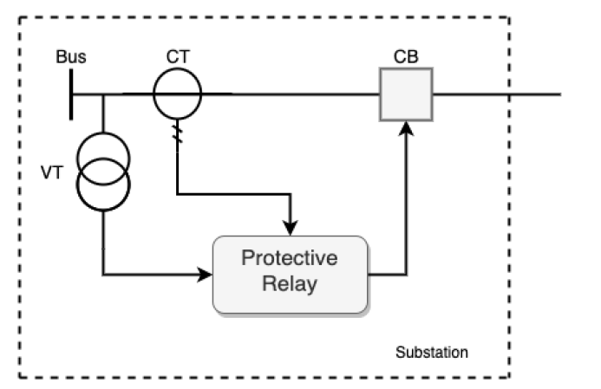

Figure 3: Overview of sub-systems of protection system
2.1.2 Protection of transmission lines
In order to prevent similar failure modes among various protection systems, the traditional fault detection is carried out in many relays in the transmission line protection system. Nevertheless, all of the relays can be categorised as
- Pick-up Relays: Pick-up relays are those that react to the size of the input quantity. For instance, an over-current relay reacts if the input current's magnitude (often its RMS value) exceeds a predetermined threshold.
- Directional Relays: Relays that respond to the phase angle between two AC inputs are known as directional relays. A typical directional relay, for instance, contrasts the phase angles of the current and voltage signals. Another approach is to contrast the phase angles of different current signals.
- Ratio Relays: Relays that react to the ratio of two input signals, expressed as phasors, are known as ratio relays. The relay can be set up to react to the magnitude of the complex number or the complex number itself because the ratio of two phasors is a complex number. Impedance or distance relays are two examples of common ratio relays.
- Differential Relays: Differential relays are those that react to how much the algebraic sum of two or more inputs is more than zero. The relays react to the algebraic sum of currents entering a zone of protection in the usual form.
- Pilot Relays: These relays rely on the communication infrastructure that exists between two remote substations. For example, the local relay's decision is communicated to the transmission line's other terminals.
- Methodology
This section discusses the methodology adopted for the development of a fault detection framework.
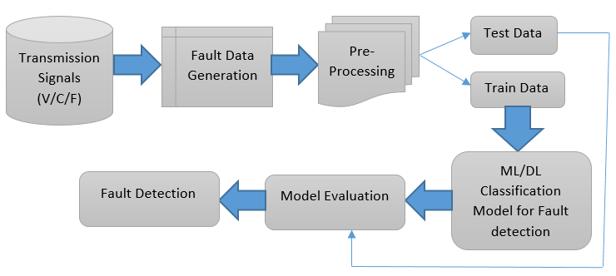
Figure 4. framework

3.1 Transmission Line Testbed
A standard test system, the IEEE Power System Relaying Committee (PSRC) D6 benchmark system [2], [42], [43], is used to demonstrate the transmission line protection system and fault classification using the proposed classifier. This test system is part of a 500kV transmission system and consists of four transmission lines L1-L4 and four identical 400 MVA generators G1-G4 as power sources. The remaining power grid is represented by a 230 kV infinite bus, S1, which is the remaining network. Except for CB10, all circuit breakers are closed, as shown in Figure 5. Power generated by G1-G4 is transmitted to S1 via transmission lines.
Data from measuring instruments, such as current transformers CT1 and voltage transformers VT1, installed at Line L1 at substation A, are used to classify faults on line L1.
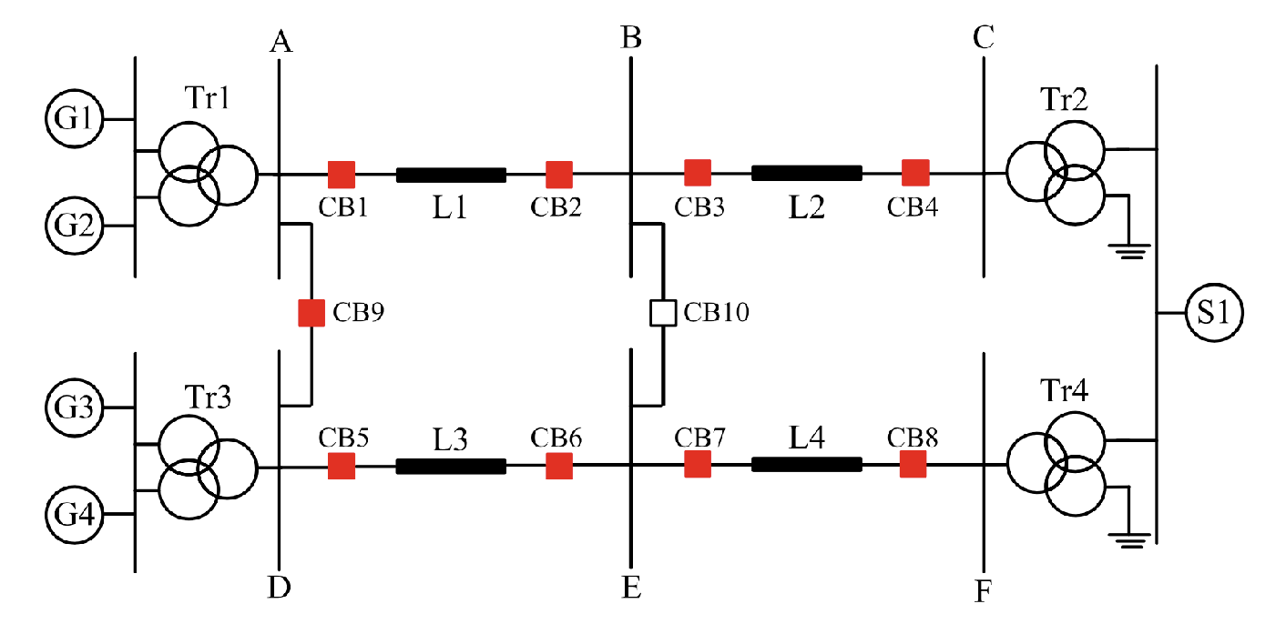
Figure 5. Illustration of IEEE PSRC D6 Test System [2]

3.2 Dataset Generation
The fault dataset for the classifier's training and performance testing was generated from the PSRC D6 benchmark test system simulated in the OPAL-RT HyperSIM simulator. We consider A-G (Single Line to Ground) fault, A-B-G (Double Line to Ground) fault, and A-B-C-G (Triple Line to Ground) fault for this classifier, as well as all combinations of the fault occurring in the line L1 with different generations. For all generators, the minimum generation limit is 300 MW and the maximum generation limit is 400 MW. For each new simulation, the generation is changed in 10-MW steps. To generate the data, several simulations were run for 200 milliseconds with a fault occurring at t = 100 ms at multiple locations to create variance in the classifier's dataset. The data in the simulator is sampled at a sampling frequency of 4800 samples per second, or 80 samples per cycle, in accordance with the Sampled Values (SV) specifications of IEC 61850-9-2 in digital substations [44]. As a result, for each simulation, 920 samples of three-phase current and voltage measurements were obtained. The simulated data are exported in COMTRADE format from Line 1's CT and VT.
3.3 Pre-Processing
This section demonstrates training methodologies for fault detection and classification, from data pre-processing to regularisation comparison.
- Data Pre-Processing: To train the proposed classifier, the simulated data samples are processed for RMS current and voltage values, followed by normalisation. The COMTRADE data is formatted to true current and voltage values obtained from CT and VT based on the given bias and factor values in configuration. All samples will be scaled to a mean of 0 and a standard deviation of 1 using any suitable normalisation technique to obtain normalised data for efficient training of the classifier with a higher convergence rate.
- Data Windows Generation: To train the classifier with a parameter of data input size, i.e. the number of samples fed to the classifier, the simulated samples are converted to windows of fixed window size with a step size, where windows are slid with a number of sample step size. The window size parameter affects the number of samples fed to the classifier as well as its computation time during testing. The longer it takes to output the predicted class of samples, the larger the window size.
- Labelling of Datasets: The training dataset's labelling is critical for training the proposed supervised learning-based classifier. Labeling will be done for four classes based on the simulated data for the various types of faults in this case: Normal, A-G Fault, A-B-G Fault, and A-B-C-G Fault. To begin, each simulation data set was converted into running windows with a window size and a step size, with each window representing one of four classes. If all of the samples in the window are in the no-fault scenario, the window is labelled normal; otherwise, it is labelled fault (A-G, A-B-G, or A-B-C-G).
3.4 Training of the Classifiers
The proposed ML/DL-based classifier will be trained to classify the four classes from measurement current and voltage data, with a focus on the extraction of temporal information from training data.
Data Split: The available normalised data is divided into three sets for the training classifier: training, validation, and test. Among the available data windows, each of which is a labelled data point, the data is divided into 80% for training and validation and 20% for testing. In addition, the training and validation sets are divided into 80% and 20%, respectively. As a result, the data is divided into 64% for training, 16% for validation, and 20% for testing.
3.5 Model Assessment
The proposed model will be evaluated by using the following metrics:
(1)

(2)

(3)

(4)

The higher values of Precision, Recall, F1-Score, and Accuracy shows the superiority of any prediction model.
- Result and Conclusion
The classifier's goal is to accurately predict the type of fault in the transmission line using the window on the test samples. During test execution, the sampled testing data was taken from the ADCs of CT and VT, normalised, and sampled into windows. During the test training phase, each test sample was sampled in a window sample of the classifier's window size. The trained model classified the type of fault or normal condition of the input test samples as it was loaded into the computer relay. It looped through the windows containing the input test sample data.
5. Future implications
For testing, we can design a system with real-time data recording from the real power system. End-to-end learning can be used to detect faults in modern power system operations from a variety of conventional and unconventional data nodes. We can concentrate on the communication delay of the voltage and current signal sent from the intelligent electronic device to the central processing unit in the power system.
References:
[1] C. Olah, “Understanding long short term memory networks" https://colah.github.io/posts/2015-08-Understanding-LSTMs/, 2015.
[2] A. A. Jahromi, A. Kemmeugne, D. Kundur, and A. Haddadi, “Cyber-Physical Attacks Targeting Communication-Assisted Protection Schemes" IEEE Transactions on Power Systems, vol. 35, no. 1, pp. 440-450, Jan. 2020.
[3] N. Tleis, “Power systems modelling and fault analysis: theory and practice”, Elsevier, 2007.
[4] M. Singh, B. Panigrahi, and R. Maheshwari, “Transmission line fault detection and classification", International Conference on Emerging Trends in Electrical and Computer Technology. IEEE, 2011, pp. 15-22.
[5] I. Farhat, “Fault detection, classification and location in transmission line systems using neural networks" Ph.D. dissertation, Concordia University, 2003.
[6] Z. Xiangjun, W. Yuanyuan, and X. Yao, “Faults detection for power systems", Fault Detection, pp. 71, 2010.
[7] A. G. Phadke, M. Ibrahim, and T. Hlibka, “Fundamental basis for distance relaying with symmetrical components" IEEE Transactions on Power Apparatus and Systems, vol. 96, no. 2, pp. 635-646, 1977.
[8] S. A. Aleem, N. Shahid, and I. H. Naqvi, “Methodologies in power systems fault detection and diagnosis", Energy Systems, vol. 6, no. 1, pp. 85-108, March 2015. https://doi.org/10.1007/s12667-014-0129-1
[9] M. Jamil, S. K. Sharma, and R. Singh, “Fault detection and classification in electrical power transmission system using arti_cial neural network", SpringerPlus, vol. 4, no. 1, p. 334, Jul. 2015. https://doi.org/10.1186/s40064-015-1080-x.
[10] O. Dag and C. Ucak, “Fault classification for power distribution systems via a combined
wavelet-neural approach", International Conference on Power System Technology, 2004. PowerCon 2004., vol. 2, 2004, pp. 1309-1314 Vol.2.
[11] K. Chen, C. Huang, and J. He, “Fault detection, classification and location for transmission lines and distribution systems: a review on the methods", High Voltage, vol. 1, no. 1, pp. 25-33, 2016.
[12] A. G. Phadke and J. S. Thorp, “Computer Relaying for Power Systems”, USA: John Wiley Sons, Inc., 2009.
[13] F. B. Costa, B. A. Souza, and N. S. D. Brito, “Real-time classification of transmission line faults based on maximal overlap discrete wavelet transform", in PES T D 2012, 2012, pp. 1-8.
[14] A. D. Kumar and S. R. Sagar, “Discrimination of faults and their location identification on a high voltage transmission lines using the discrete wavelet transform", International Journal of Education and Applied Research, vol. 4, no. 1, pp. 107-111, 2014.
[15] P. Jose and V. Bindu, “Wavelet-based transmission line fault analysis", International Journal of Engineering and Innovative Technology (IJEIT) Volume, vol. 3, 2014.
[16] A. Ferrero, S. Sangiovanni, and E. Zappitelli, “A fuzzy-set approach to fault-type identification in digital relaying", IEEE Transactions on Power Delivery, vol. 10, no. 1, pp. 169-175, 1995.
[17] P. Kumar, M. Jamil, M. S. Thomas, and Moinuddin, “Fuzzy approach to fault classification for transmission line protection", in Proceedings of IEEE. IEEE Region 10 Conference. TENCON 99. 'Multimedia Technology for Asia-Pacific Information Infrastructure' (Cat. No.99CH37030), vol. 2, 1999, pp. 1046-1050 vol.2.
[18] C. Cecati and K. Razi, “Fuzzy-logic-based high accurate fault classification of single and double-circuit power transmission lines", International Symposium on Power Electronics Power Electronics, Electrical Drives, Automation and Motion, 2012, pp. 883-889.
[19] S. R. Samantaray, “A systematic fuzzy rule based approach for fault classification in transmission lines", Applied Soft Computing, vol. 13, no. 2, pp. 928-938, 2013. http://www.sciencedirect.com/science/article/pii/S1568494612004309
[20] T. Dalstein and B. Kulicke, “Neural network approach to fault classification for high speed protective relaying", IEEE Transactions on Power Delivery, vol. 10, no. 2, pp. 1002-1011, Apr. 1995.
[21] M. Oleskovicz, D. V. Coury, and R. K. Aggarwal, “A complete scheme for fault detection, classification and location in transmission lines using neural networks", Seventh International Conference on Developments in Power System Protection (IEE), 2001, pp. 335-338.
[22] M. Sanaye-Pasand and H. Khorashadi-Zadeh, “Transmission line fault detection & phase selection using ANN", International Conference on Power Systems Transients, 2003, pp. 1-6.
[23] A. Jain, A. Thoke, and R. Patel, “Fault classification of double circuit transmission line using artificial neural network", International Journal of Electrical Systems Science and Engineering, vol. 1, no. 4, pp. 750-755, 2008.
[24] A. Yadav and Y. Dash, “An Overview of Transmission Line Protection by Artificial Neural Network: Fault Detection, Fault Classification, Fault Location, and Fault Direction Discrimination", Hindawi, 2014. https://www.hindawi.com/journals/aans/2014/230382/
[25] N. Saravanan and A. Rathinam, “A comparative study on ann based fault location and classi_cation technique for double circuit transmission line", Fourth International Conference on Computational Intelligence and Communication Networks, 2012, pp. 824-830.
[26] Y. Sekine, Y. Akimoto, M. Kunugi, C. Fukui, and S. Fukui, “Fault diagnosis of power systems," Proceedings of the IEEE, vol. 80, no. 5, pp. 673-683, May 1992
[27] C. Nan, F. Khan, and M. T. Iqbal, “Abnormal Process Condition Prediction (Fault Diagnosis) Using G2 Expert System", 2007 Canadian Conference on Electrical and Computer Engineering, Apr. 2007, pp. 1507-1510, ISSN: 0840-7789.
[28] X. Xu and J. Peters, “Rough set methods in power system fault classification", IEEE CCECE2002. Canadian Conference on Electrical and Computer Engineering. May 2002, pp. 100-105 vol.1,
[29] S. S. S. Rawat, V. A. Polavarapu, V. Kumar, E. Aruna, and V. Sumathi, “Anomaly detection in smart grid using rough set theory and K cross validation", International Conference on Circuits, Power and Computing Technologies [ICCPCT-2014], Mar. 2014, pp. 479-483.
[30] Z. Yongli, H. Limin, and L. Jinling, “Bayesian networks-based approach for power systems fault diagnosis", IEEE Transactions on Power Delivery, vol. 21, no. 2, pp. 634-639, Apr. 2006, conference Name: IEEE Transactions on Power Delivery.
[31] A. Ashouri, A. Jalilvand, R. Noroozian, and A. Bagheri, “A new approach for fault detection in digital relays-based power system using Petri nets", in 2010 Joint International Conference on Power Electronics, Drives and Energy Systems 2010 Power India, Dec. 2010, pp. 1-8.
[32] S. Bhattacharya, “Fault detection on a ring-main type power system network using artificial neural network and wavelet entropy method," in Communication Automation International Conference on Computing, May 2015, pp. 1032-1037.
[33] W. Li, A. Monti, and F. Ponci, “Fault Detection and Classification in Medium Voltage DC Shipboard Power Systems with Wavelets and Artificial Neural Networks", IEEE Transactions on Instrumentation and Measurement, vol. 63, no. 11, pp. 2651-2665, Nov. 2014,
[34] S. U. Jan, Y.-D. Lee, J. Shin, and I. Koo, “Sensor fault classification based on support vector machine and statistical time-domain features", IEEE Access, vol. 5, pp. 8682-8690, 2017.
[35] M. Bigdeli, M. Vakilian, and E. Rahimpour, “Transformer winding faults classification based on transfer function analysis by support vector machine", IET electric power applications, vol. 6, no. 5, pp. 268-276, 2012.
[36] S. Zhang, Y. Wang, M. Liu, and Z. Bao, “Data-Based Line Trip Fault Prediction in Power Systems Using LSTM Networks and SVM", IEEE Access, vol. 6, pp. 7675-7686, 2018.
[37] V. Malathi and N. S. Marimuthu, “Multi-class support vector machine approach for fault classification in power transmission line", in 2008 IEEE International Conference on Sustainable Energy Technologies, 2008, pp. 67-71.
[38] Zufeng Wang and Pu Zhao, “Fault location recognition in transmission lines based on support vector machines", 2nd IEEE International Conference on Computer Science and Information Technology, 2009, pp. 401-404.
[39] O. A. S. Youssef, “An optimised fault classification technique based on support vector machines", in 2009 IEEE/PES Power Systems Conference and Exposition, 2009, pp. 1-8.
[40] M. Singh, B. K. Panigrahi, and R. P. Maheshwari, “Transmission line fault detection and classification", International Conference on Emerging Trends in Electrical and Computer Technology, 2011, pp. 15-22.
[41] P. Tripathi, A. Sharma, G. N. Pillai, and I. Gupta, Accurate Fault Classification and Section Identification Scheme in TCSC Compensated Transmission Line using SVM.
[42] P. W. D6, “Power swing and out-of-step considerations on transmission lines", Jul 2005.
[43] H. Gras, J. Mahseredjian, E. Rutovic, U. Karaagac, A. Haddadi, O. Saad, I. Kocar, and A. El-Akoum, “A new hierarchical approach for modeling protection systems in emt-type software", Int. Conf. Power Syst. Transients, 2017.
[44] “IEC 61850-9-2:2011 j IEC Webstore j cyber security, smart city, LVDC". https://webstore.iec.ch/publication/6023.
[45] Ghashghaei, S., & Akhbari, M. (2021). Fault detection and classification of an HVDC transmission line using a heterogenous multi‐machine learning algorithm. IET Generation, Transmission & Distribution, 15(16), 2319-2332.
[46] Gutierrez-Rojas, D., Christou, I. T., Dantas, D., Narayanan, A., Nardelli, P. H., & Yang, Y. (2022). Performance evaluation of machine learning for fault selection in power transmission lines. Knowledge and Information Systems, 64(3), 859-883.
47. Nitish Pathak, Anjani Kumar Singha, Shams Tabrez Siddiqui, “COVID 19 pandemic prediction and forecasting using machine learning classifiers”, Intelligent Automation & Soft Computing, ISSN: 1079-8587, vol.32, no.2, pp. 1007-1024, Published 17 November 2021, DOI:10.32604/iasc.2022.021507.
48. Nitish Pathak, Karan Singh and Neelam Sharma “A Novel Hybrid Clustering Based Transmission Protocol for Wireless Body Area Networks”, CMC-Computers, Materials & Continua, ISSN:1546-2226, Vol.69, No.2, pp. 2459-2473, published 21 July 2021, DOI:10.32604/cmc.2021.014305, Tech Science Press, USA.

