Delination and Morphology Analysis of Watershed Catchment Areas of Tuggali Mandal, Kurnool District, Andhra Pradesh by using Toposheet
B Dileep Kumar Reddy1, Assistant Professor
JNT University, Anantapur, Civil Engineering dept. JNTUA College of Engineering, Pulivendula
YSR Kadapa, India
b.dilip92@gmail.com
G Sivanatha Reddy2, Assistant Professor
JNT University, Anantapur, Civil Engineering dept. JNTUA College of Engineering, Pulivendula YSR Kadapa, India
Sivanathg17@gmail.com
B L Niranjan Reddy3, Assistant Professor
JNT University, Anantapur, Civil Engineering dept. JNTUA College of Engineering, Pulivendula YSR Kadapa, India
bniranjancivil@gmail.com
S Jyothirmayee Assistant Professor
JNT University, Anantapur, Civil Engineering dept. JNTUA College of Engineering, Pulivendula YSR Kadapa, India
jyothi.sirigireddy16@gmail.com
ABSTRACT
Land and water resources are scarce in nations like India, where the strain from an expanding population is constant, making extensive use of them necessary. Watersheds must be properly identified and prioritised within a large drainage basin for suitable natural resource planning and management for sustainable developmen. It is not only uneconomical, but also difficult to delineate prospective zones for the adoption of conservation measures above the entire watershed. The practise of identifying the ridge border encircling a water body or runoff outlet is known as "watershed delineation" on a geographical area. Understanding of the fundamentals of topographical watershed delineation (based on contours and runoff outflow). watershed mapping and Geomorphology uses morphometry analysis to make quantitative measurements of the physical properties of landforms. It is done primarily to comprehend the composition, development, and processes of the landscape. It is possible to link the runoff features to the morphometric parameters by analysing the flow pattern in the basin. In this study, the investigation of the flow pattern and the morphometric elements of the streams and landforms of the Girigetla, Rampalli, and Chennampalli Villages drainage are both addressed. Topographic maps at a resolution of 1:50000 were used to locate and analyse watershed boundaries. The drainage basin has an area of 100.7 km2. The areal aspects of morphometry—stream frequency, drainage density, form factor, circularity ratio, and elongation ratio—as well as the linear aspects—stream length ratio, stream order, stream length, and bifurcation ratio—were calculated for the drainage basins. The decision-making authorities can utilise the findings to develop and put the practises for managing the watershed into action.
Keywords: watershed delineation, Morphology, Catchment Area, Drainage basin, Toposheet

I INTRODUCTION
Land and water resources are rare in countries such as India, where population pressure is always increasing, making extensive utilisation of these resources important. Catchments, drainage basins, and sub-catchments are the core organisational units for managing natural resource conservation [1]. The notion of watershed management acknowledges the connections between uplands, low lands, land use, geomorphology, slope, and soil. When managing watersheds and defining watersheds, soil and water conservation are the main concerns.[2]
watershed planning because it offers information on the topography, slope of the basin, soil quality, runoff characteristics, potential for surface water, and other factors[1]. The morphological examination of the watershed is thought to be the most satisfactory method because it allows for a knowledge of the connection that exists between multiple factors within a drainage basin, a comparative examination of several drainage basins produced in various geomorphological and topographical features, and a comparison of many drainage basins formed by different geomorphological and topographical factors [1]. In order to manage water resources sustainably, water availability in a watershed must be assessed, and the disparity between the supply and the demand must be as little as feasible. Nowadays, Many topographical and morphometric aspects of basins of drainage and watersheds are analysed utilising remote sensing and GIS techniques because they provide a customizable basin environment as well as a powerful tool for spatial data modification and analysis. [5]. In the present study of Girigetla, Chennampalli and Rampalli Drainage basins. The geomorphology and flow pattern of each basin was analysed in detail by Manual method.
Topographic characteristics such as contour lines, as well as other natural and man-made features like as water bodies, drainage lines, benchmarks, and so on, are effectively represented in Survey of India (SOl) Topographic sheets/maps. The contour interval varies from 10 to 20 metres based on the scale of the map (topo-sheet), with a typical interval of 20 metres for top sheets with a scale of 1:50,000.[3]
On a geographical scale, "watershed delineation" refers to the practise of delineating the ridge border around a body of water or runoff outlet. Understanding of the foundations of contour-based topo-sheet-based delineation of watersheds (based on runoff output). In this case, we will use topographic sheets as the primary input and the defined watershed limits as the final output.[8]
II METHODOLOGY
- Study area
The study's catchment region is the Girigetla, Chennampalli, and Rampalli basins of drainage in the Indian state of Andhra Pradesh. Figure 1 depicts the position of Tuggali Mandal on a base map. The drainage basins have a catchment area of 100.07 km2 with an annual rainfall of roughly 1433.1 mm. These basins are located between 15°15′ and 15°30′ N, as well as between 77°30′ and 77°45′ E. [8]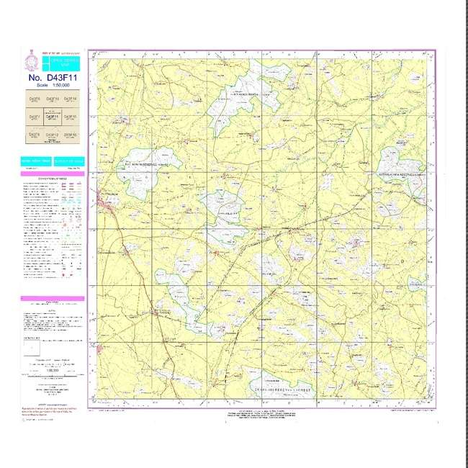
Fig-1: Toposheet of respective locations
B. Data collection:
The paper concentrates on the morphology evaluation of watersheds in order to recognise and prioritise the regions most vulnerable to soil erosion. The toposheets issued by the Survey of India (SOI) at an aspect ratio of 1:50,000 serve as the primary source of data. Table 1 completely describes the data used in this investigation. [8] The Girigetla, Chennampalli, and Rampalli Drainage The basins Catchments were created using Survey of India (SOI) topographic maps at a scale of 1:50,000. The aforementioned catchment streams networks have been traced and examined. Strahler's (1957) technique of stream ranking was used to calculate the morphometric properties of catchments in this study. [1]
C. Watershed delineation
The Following steps are used for watershed delineation:
Step 1: Mark the position of the water body or tributary that joins the main stream on a topographical map.
Step 2: Examine the lines of contour on the topo-sheet for the area that connect locations with the same height above the mean sea level or the GTS Benchmark. Valleys are depicted by contours (contour lines) heading upstream, which also function as the watershed's drainage line.The outline that point downward represent ridges.[2] The terrain appears to be more or less level, with gently sloping ground, based on the large distances between the contours. Contour lines that are closely spaced apart suggest a region with steep slopes or rapid changes (rise or decrease) in elevation over a short distance.
Step 3: Follow the drainage line or river from its inlet to its outflow, taking into account any tributaries. This process aids in establishing the drainage area's beginning and end points.
Step 4: A sequence of contour lines "pointing" in the direction of the greatest elevation are used to depict a valley line or drainage line (Fig. 1). By drawing arrows perpendicular to a set of contour lines that decrease in height, you may determine the direction of drainage in the region. Water runoff follows the route of least resistance as it descends a hill. The perpendicular path between contours is the runoff travel path.
Step 5: A succession of contour lines "pointing" in the direction of the lowest elevation depict a higher area or ridge line (Fig 1).
Step 6: Identify and record the highest elevations/divide points where some runoff would go to one body of water and the remainder would go to another.
Step 7: Connect the division points to create the watershed border, which is a line based on the area's highest elevations.
Step 8: The procedure of defining a watershed using a topo-sheet is now complete.
Step 9: You may now take this map of a delimited watershed or sub-watershed to the field for validation, if necessary.
Step 10: Convert various metrics, such as the number of channels, their lengths, watershed boundaries, etc., to real lengths according to map scale.
D. Measuring Watershed Areas:
There are two frequently used methods for estimating watershed areas: a) the dot grid method and b) the planimeter approach. These approaches can also be used to determine the size of the wetland, if needed by The New Hampshire Method.[3]
The grid technique is used because it is simple and does not require expensive equipment. The user uses an acetate or mylar sheet printed with a sequence of dots of the same size as the one at the end of this line to cover the region to be measured on the map. To calculate the area, the user counts the dots that are within the measurement region and multiplies the result by a multiplier.[3]
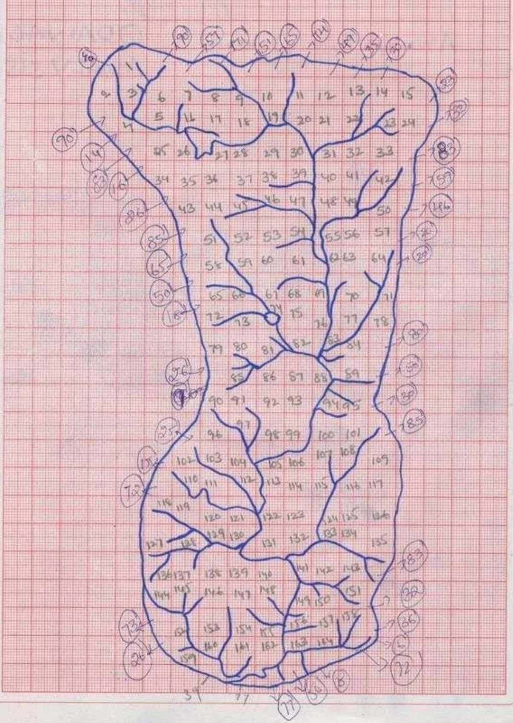
Fig-2: Girigetla village's Delinated Watershed Area
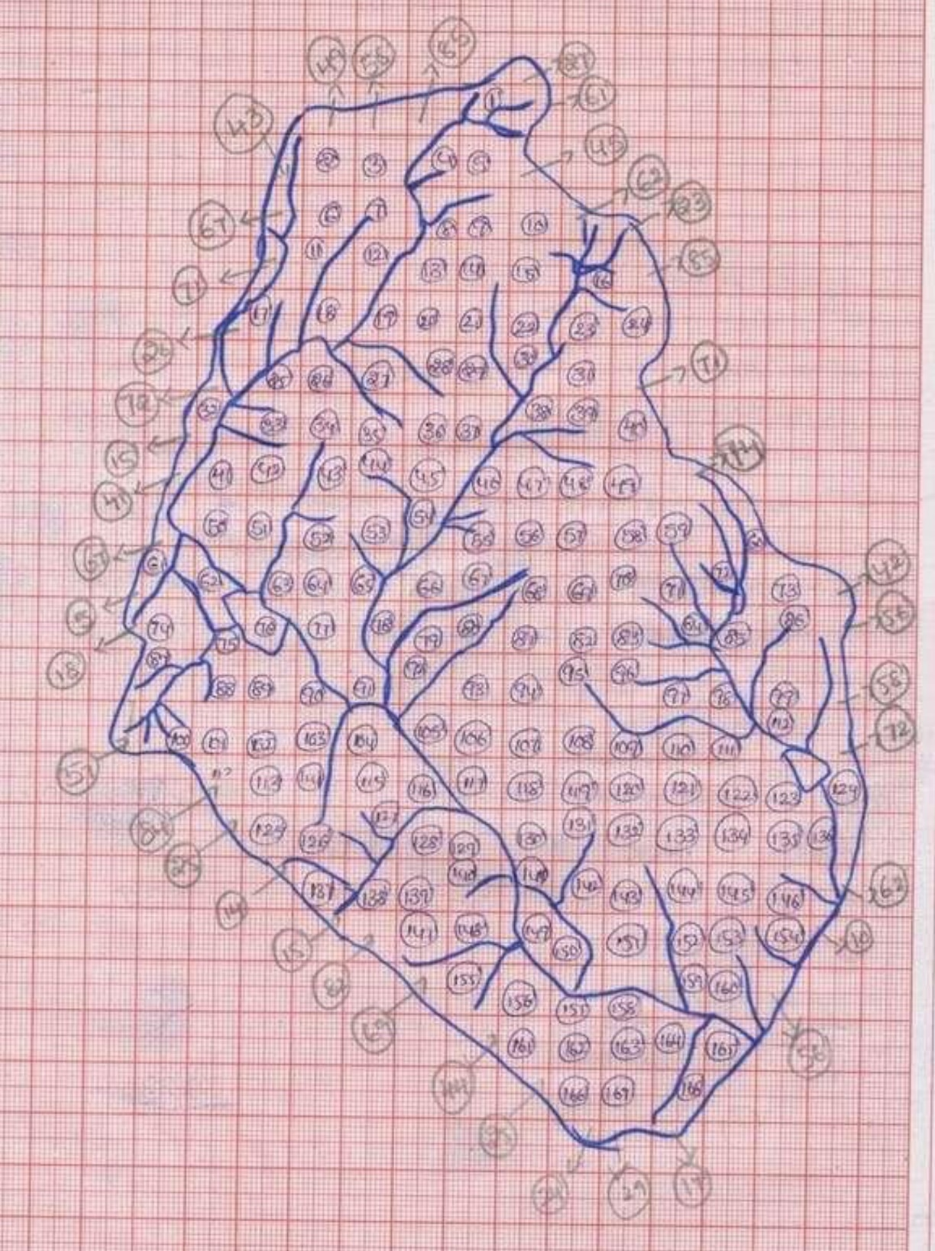
Fig-3: Chennampalli village's Delinated Watershed
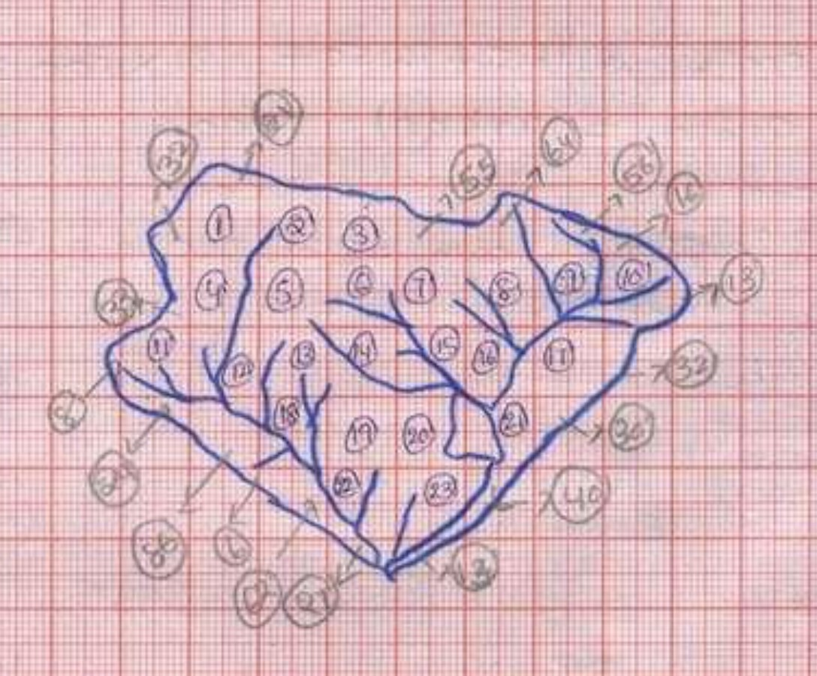
Fig-4: Rampalli village's Delinated Watershed Area
E. Stream frequency (F): “Stream frequency was defined by Horton as the number of segments of stream Nu per unit area Au, therefore F = Nu/Au (expressed per km2). Melton's (1957) detailed analysis of the connection between drainage density and frequency of streams for 156 drainage basins covering a wide range of scale, climate, relief, surface cover, and geologic type revealed a remarkably small scatter, indicating that the connection between the density and frequently tends to be conserved in nature as a constant. A basin for drainage can be classed into one of four textures based on the drainage density as 0 to 2 Very poor runoff , 2 to 4 Poor runoff, 4 to 6 Moderate runoff ,6 to 8 High runoff and >8 Very high runoff”.[1]

F. Stream order and number (Nu): “The initial stage in drainage-basin analysis is the naming of stream orders. A method developed by Horton and revised by Strahler (Strahler 1952b, Schumms 1956) was used in this investigation. Each stream segment was numbered from its initial order to the maximum order existent in each of the sub-basins. Following numbering, the drainage-network elements are allocated order numbers, and the segments of each order are tallied to obtain the number Nu of segments of the given order u. The bifurcation ratio Rb is defined as the ratio of the number of segments of a certain order Nu to the number of segments of a higher order Nu+1, therefore Rb = Nu/Nu+1”. A plot of stream order (abscissa) vs stream numbers (ordinate) displayed on a semi-log sheet illustrates the slope of the fitted regression of order Vs numbers of stream segments, according to Horton's law of stream numbers. Bifurcation ratios typically vary between 3.0 and 5.0.[2]
G. Stream Length (Lu): “The mean length Lu of the stream segment of order u is a dimensional parameter that exposes the distinctive size of drainage network components and their contributing basin surfaces. A digital curvimeter was used to measure the channel lengths. A plot of the exponential of stream length (ordinate) as a function of order (abscissa) will provide a collection of points lying along a straight line, according to Horton's law of stream lengths”. This implies that the basin's evolution is dictated by erosion laws operating on geologic material with uniform weathering-erosion characteristics. Any point variation might be attributed to the structural management of the streams. A semi-log sheet graph of stream order (abscissa) vs stream length (ordinate) demonstrates a linear connection.[1]
H. Drainage density (Du): “According to Horton, the density of drainage is a key measure of the linear scale of landform elements in stream-eroded topography and simply represents the ratio to the total channel-segment lengths (Lu) cumulated for all orders within a basin to basin area Au, so D = Lu/Au (expressed in km/km2)”. High drainage density is preferred in areas with porous or impermeable underlying materials, sparse vegetation, and hilly terrain. Low drainage density is preferred in areas with very resistant or highly permeable subsurface materials, dense plant cover, and low relief. On the basis of the drainage density, a drainage basin can be classified into any of the four different textures as 0 to 2 Low infiltration, 2 to 4 Moderate infiltration,4 to 6 High infiltration and >6 Very high infiltration.[2]
III RESULTS:
Table-1: Girigetla village Morphology Details
Stream No  (1) | Total number of Stream orders (2) | Total length in KM  (3) | Watershed area in Sq KM  (4) | Bifurcation ratio  (5) | Drainage Density  (6) | Stream frequency  (7)
1 | 63 | 38.75 | 46.635 | 3.93 | 1.474 | 1.80
2 | 16 | 15.5 |  | 4
3 | 4 | 7.0 |  | 4
4 | 1 | 7.5

Table-2: Chennampalli village Morphology Details
Stream No  (1) | Total number of Stream orders (2) | Total length in KM (3) | Watershed area in Sq KM  (4) | Bifurcation ratio  (5) | Drainage Density  (6) | Stream frequency  (7)
1 | 60 | 36 | 46.765 | 4 | 1.464 | 1.58
2 | 10 | 14 |  | 3.33
3 | 3 | 13 |  | 3
4 | 1 | 5.5

Table-3: Rampalli village Morphology Details
Stream No  (1) | Total number of Stream orders (2) |  | Total length in KM (3) | Watershed area in Sq KM  (4) | Bifurcation ratio  (5) | Drainage Density  (6) | Stream frequency  (7)
1 |  | 20 | 10.25 | 7.3 | 4 | 2.260 | 1.80
2 |  | 5 | 2.5 |  | 2.5
3 |  | 2 | 3.75 |  | 4

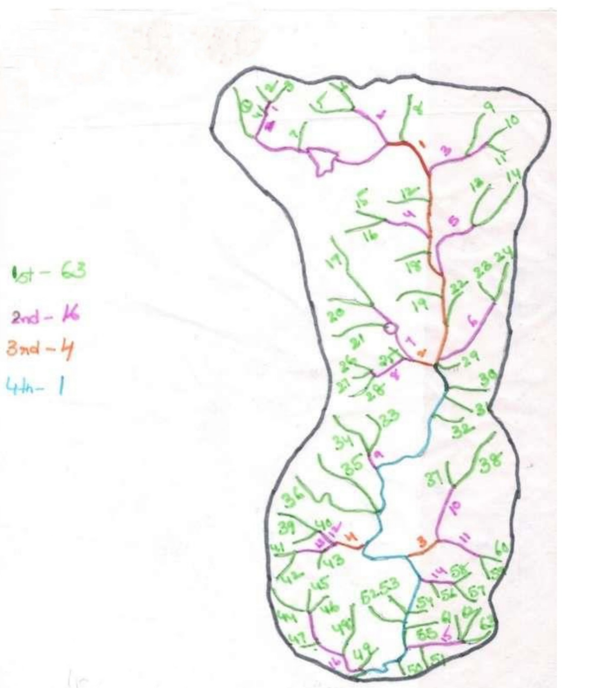
Fig-5: Stream Network of Watershed area of - Girigetla village
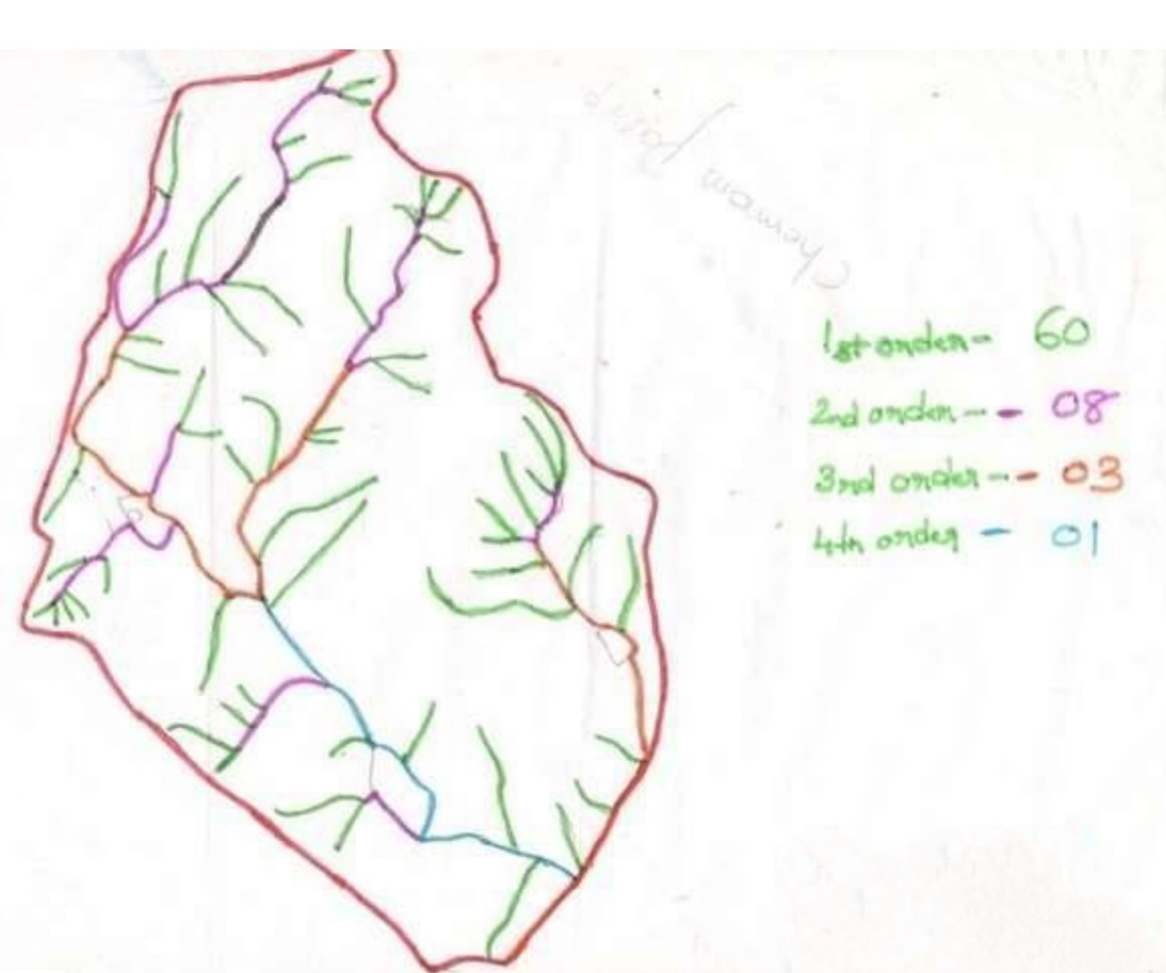
Fig-6: Stream Network of Watershed area -Chennampalli village
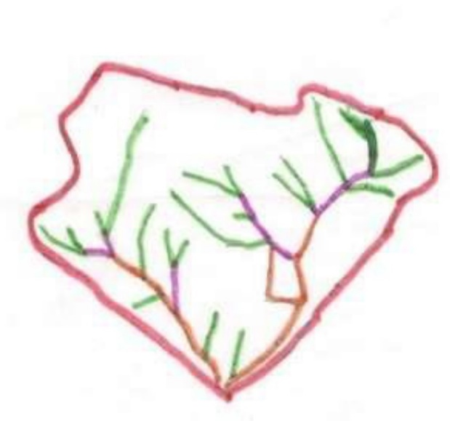
Fig-7: Stream Network of Watershed area of - Rampalli village
IV DISCUSSIONS AND CONCLUSIONS:
A. Bifurcation ratio:
”The bifurcation ratio (Rb) is less than 5, the drainage basin has homogeneous materials, and streams are often branched systematically with a large number of first, second, and third order streams”. The Girigtela catchment has a bifurcation ratio of 4, the Chennampalli catchment has a bifurcation ratio of 3.4, and the Rampalli catchment has a bifurcation ratio of 3.5; as a result, “the catchments are distinguished by homogeneous materials, streams are frequently branched systematically, and there are numerous first, second, and third order streams”.[1]
B. Drainage density:
The drainage density of both the Girigtela and Chennampalli catchments is less than 2 and the Rampalli catchment is 2.26, indicating that both catchments have relatively coarse texture.[2]
C. Stream frequency: Girigtela, Chennampalli, and Rampalli catchments all have a drainage density of 2. The catchments chosen for investigation have very coarse texture, which means they have very low run-off.[2]
- Morphometric analysis findings give information regarding watershed development priorities and areas sensitive to land degradation.
- The catchments chosen for investigation have a fairly granular texture.
- Higher stream frequency values in the Girigetla, Chennampalli, and Rampalli catchments suggest poor conducting underlying material, sparse vegetation, and high terrain.
- The stream flow at ungauged areas of the drainage basins can be estimated using these relationships.
- However, the applicability depends on the basin's land use pattern, lithology, structure, and regularity of rainfall patterns.
- Various elements influence drainage density, the most important of which are rock erosion resistance, land infiltration capacity, and climatic circumstances.
- It indicates a tight relationship with the density of drainage number of the sub basin. A higher drainage frequency value indicates a high runoff. The watershed in this research produces low runoff.
- The comprehensive morphological study of drainage basins reveals that the specified area has a Medium Ground water possibility.
- The comprehensive morphometric analysis of the drainage basin reveals that the offered region has an excellent groundwater possibility.

REFERENCES
- H. Chandrashekara, K.V. Lokeshb , M.Sameenac , Jyothi roopad ,G.rangannae, GIS –Based Morphometric Analysis of Two Reservoir Catchments of Arkavati River, Ramanagaram District, Karnataka: Aquatic Procedia 4 ( 2015 ) 1345 – 1353.
- R. K. Jaiswala, N. C. Ghoshb , R. V. Galkatea , T. Thomasa, Multi Criteria Decision Analysis (MCDA) for watershed Prioritization: Aquatic Procedia 4 ( 2015 ) 1553 – 1560.
- Berhanu G. Sinshaw , Abreham M. Belete , Agumase K. Tefera, Abebe Birara Dessie , Belay B. Bizuneh, Habtamu T. Alem, Simir B. Atanaw, Daniel G. Eshete, Tsegaye G, Prioritization of potential soil erosion susceptibility region using fuzzy logic and analytical hierarchy process, upper Blue Nile Basin, Ethiopia: Water-Energy Nexus Volume 4, 2021, Pages 10-24
- Aparna P, NigeeK , Shimna P and Drissia, Quantitative Analysis of Geomorphology and Flow Pattern Analysis of Muvattupuzha River Basin Using Geographic Information System: Aquatic Procedia 4 ( 2015 ) 609 – 616.
- A Bharatha, K Kiran Kumar, Ramesh Maddamsetty, M Manjunatha, Ranjitha,B Tangadagi , S Preethi, Drainage morphometry based sub-watershed prioritization of Kalinadi basin using geospatial technology: Environmental challenges 5(2021) 100277.
- SangitaMishra.S. andNagarajan,R., 2010, Morphometric analysis and priotization of sub- watersheds using GIS and Remote Sensing techniques: a case study of odisha, India, International Journal of Geomatics and Geosciences Vol 1, No3. pp501-510.
- Kafaky, B.S., Mataji, A., Naser, S.A. 2009. Ecological capability assessment for multiple-use in forest areas using GIS- based multiple criteria decision making approach. American Journal of Environmental Sciences 5(6), 714-721.
- Mishra, S.S., Nagarajan, R. 2010. Morphometric analysis and prioritization of sub-watersheds using GIS and Remote Sensing techniques: a case study of Odisha, India. International Journal of Geomatarics and Geosciences, 1(3), 501-510.
- Lee A.H.I., Chen, W.C., Chang, C.J. 2008. A fuzzy AHP and BSC approach for evaluating performance of IT department in the manufacturing industry in Taiwan. Expert Systems with Applications, 34, 96–107.
- De Steiguer, J.E., Duberstein J., Lopes V., 2003. The analytic hierarchy process as a means for integrated watershed management. In Renard, K. G. (Ed.). First Interagency Conference on Research on the Watersheds. Benson Arizona: U.S. Department of Agriculture, Agricultural Research Service Oct 27-30, 736–740.
- A.U., A., K.R., B., Thomas, P.K., Anns, M., P.B., R., Babu, S., 2021. Status of GIS-enabled morphometric analysis of river basins of Kerala, Southern India: a review and assessment.

- Nag, S., Roy, M.B., Roy, P.K., 2020. Optimum prioritisation of sub-watersheds based on erosion-susceptible zones through modeling and GIS techniques. Model. Earth Syst. Environ. 6, 1529–1544.

