**Chemical Derivatization of Phytochemicals: A Constant Source of New Drug Molecules**

Prafulla Sabale1, Manish Kamble*1, 2, Kamlesh Machewar1, Mahendra Gunde2, Tejaswini Selwate2, Kalyani Dongarwar2.

1. University Department of Pharmaceutical Sciences, R. T. M. N. U. Nagpur-440033 (India)

2 Kamla Nehru College of Pharmacy, Butibori, Nagpur -441108 (India)

**Abstract:** An overview is presented of the well-established role of phytochemicals as a source of novel drug leads. initiation of combinatorial chemistry provided new hope of new chemical entities with significant molecular activities as well as pharmacological properties. Phytochemicals and their analogues structures possess the characteristics of high chemical diversity, apex biochemical specificity, and therapeutic efficacy which further employed as precursor materials for analogue design and synthesis as semisynthetic new drug entities exhibiting higher therapeutic efficacy. The initiation or design of new phytochemical entity involves identification of right candidate phytomedicine through Bioassay-guided fractionation and isolation of desired phytoconstituents. To enhance physic-chemical and pharmacokinetic activities of plant derived chemicals, structural modification of phytomedicinesis essential in several cases resulting into modified therapeutic action and enlarge selectivity. The advantageous eminence of semisynthetic derivatives as a whole encourages exploring the new derivatized chemical entities. The present review is aimed to overview chemical derivatization of phytochemicals.

**Keywords:** Phytochemicals, Semisynthetic derivatives, Synthetic drugs.

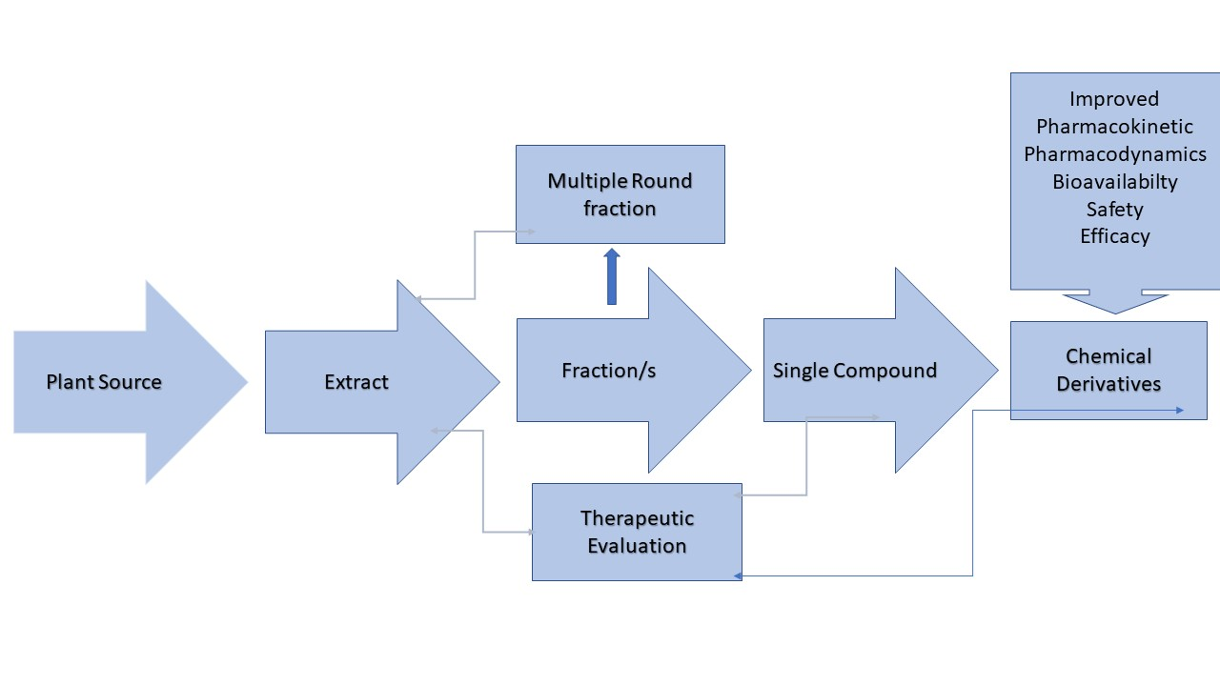

**Graphical Abstract:** Phytochemicals in the drug development

**Introduction:** Throughout the ages humans, plants are recognized to fulfill human necessities like food, clothes, shelter and remedies for wide spectrum of diseases. Since the ancient times, mankind has relied on Nature to cater for their basic needs, explored natural resources and used them as a remedy for the cure of diseases. Traditional medicines were practiced in prehistoric civilizations; the knowledge transforming through generation to generation. Plant-based traditional medicinal systems continue to play an essential role in healthcare, and their use by different cultures has been extensively documented [1-2]. Approximately 65% of the world’s population predominately relied on plant-derived traditional medicines for their primary health care hence plants derived molecules play an important role in health care system [3]. Plant derived drugs came into use in the modern medicine through the uses of plant material as indigenous cure in folklore or traditional systems of medicine. Photochemical are generally considered safe compared to synthetic drugs having more chemical diversity and considered superior to synthetic combinatorial chemicals. Also, the plant derived metabolites have a better number of stereogenic centers, diverse proportions of heteroatoms, privileged assorted core ring scaffolds, and therapeutic activity [4-5]. Isolated compound from known plant sources were employed as very good precursor points for analogue design and synthesis. Although the valuable lead compounds are natural products, rarely can these products be directly employed in clinical applications [6]. Hence, structural modifications of isolated compounds are essential in several cases because the assessment of modern research revealed that natural products and their semisynthetic derivatives are precious sources of new drug candidates with a variety of biological as well as pharmacological activities [7-8]. It is exciting to note that semisynthetic derivatives represent the major part (21%) of the whole medicinal contribution. Increasing lipophilicity and inserting halogen atoms in natural products are excellent examples of modifications that enhanced the biological activity [9].

**Fig 1:** Utilization of Plant derived medicines, Semisynthetic medicines and other systems of medicine

To enhance selectivity and therapeutic efficacy along with pharmacokinetic and physicochemical characteristics, the structural modification is employed as normal medicinal chemistry principles. New semisynthetic drug discovery faces the challenges from prevailing paradigm for drug discovery in large pharmaceutical industries and technical limitations in identifying new compounds with desirable activity. Structural modifications needed for development of analogue either to improve the absorption or to reduce the toxicity and improve upon efficacy which is often achieved by addition or deletion of selected functional groups.The current review recaps natural sources of the parent natural compounds, design, and chemical modification of natural products. This article, is also intended to offer an overview of the biological activities of their analogues.

**Chemical derivatization of natural products:**

**Alkaloids**

Alkaloids are nitrogen containing secondary metabolites with a relatively wide occurrence in nature around the world possessing a variety of biological activities. In 1805, the first alkaloid was isolated in crude form, morphine, from opium, it remains an important medicinal agent [10]. More than 20000 alkaloids are identified as yet and a fanciful number of them have been employed in clinical practice. Currently, at least 60 plant-derived alkaloids are approved as drugs in various countries [11]. Few alkaloids (purine alkaloids) that are consumed daily and mainly found in tea leaves, cocoa beans, and coffee. In excessive doses, most of the alkaloids are pharmacologically active or poisonous; they exhibit diverse biological activities such as anticancer, antimicrobial, anticholinergic, antihypertensive, antidepressant, anti-inflammatory, antiulcer and many more [12].

**Table 1: Few alkaloids used in marketed medicines**

|  |  |  |
| --- | --- | --- |
| **Alkaloid name** | **Applications** | **Example product** |
| Ajmaline | Antiarrhythmic agent | AritminaTM, GilurytmalTM, RauwopurTM, RitmosTM |
| Caffeine | Neonatal apnea, atopic dermatitis | AgevisTM, AnlagenTM, ThomapyrineTM, Vomex ATM |
| Codeine (Methylmorphine) | Antitussive, analgesic | AntitussTM, CodicapsTM, TussipaxTM |
| Lobeline | Anti-smoking, asthma, cough | CitotalTM, LobatoxTM, RefraneTM, StopsmokeTM |
| Morphine | Pain relief, diarrhea | DiastatTM, DuromorphTM, OramprphTM, SpasmofenTM |
| Quinine | myotonic disorders | AdaquinTM, BiquinateTM, QuinoctalTM, Zynedo-BTM |
| Taxol (Paclitaxel) | ovary carcinoma | TaxolTM |
| Vinblastine | Hodgkin’s disease, testicular cancer, blood disorders | PeriblastineTM, VelbanTM, VelbeTM, VelsarTM |
| Vincristine | Burkitt’s lymphoma | NorcristineTM, OncovinTM, VincrisulTM |

**Ajmalin:** Ajmalin and ajmalicine are the medicinally important terpenoid indole alkaloids. The most important indole alkaloid is clinically useful anticancer agent. Ajmalicine is used in the treatment of circulatory disease. A[jmalicine](https://www.sciencedirect.com/topics/chemistry/ajmalicine) was found to occur in *[Uncaria](https://www.sciencedirect.com/topics/biochemistry-genetics-and-molecular-biology/uncaria" \o "Learn more about Uncaria from ScienceDirect's AI-generated Topic Pages)* elliptica and Petchiaceylanica , whereas its 10,11-dimethoxy derivative, [reserpiline](https://www.sciencedirect.com/topics/chemistry/reserpiline" \o "Learn more about Reserpiline from ScienceDirect's AI-generated Topic Pages) , and the C-20 [epimer](https://www.sciencedirect.com/topics/chemistry/epimer" \o "Learn more about Epimer from ScienceDirect's AI-generated Topic Pages) of [reserpiline](https://www.sciencedirect.com/topics/chemistry/reserpiline" \o "Learn more about Reserpiline from ScienceDirect's AI-generated Topic Pages), isoreserpiline, have been isolated from Neiosospermaoppositifolia .

R=h, 20β-H Ajmalicine

R=, 20β-H Reserpiline

R=OMe, 20α-HIsoresserpiline

R=H, 20α-HTetrahydroajmalicine



**Fig 2:** Chemical derivatives of Ajmalin

**Caffeine:**The oxidation of [purines](https://www.sciencedirect.com/topics/chemistry/purine" \o "Learn more about purines from ScienceDirect's AI-generated Topic Pages) is of particular interest for understanding the mechanism and chemical consequences of [oxidative damage](https://www.sciencedirect.com/topics/materials-science/oxidative-damage) to [purine](https://www.sciencedirect.com/topics/chemistry/purine" \o "Learn more about purine from ScienceDirect's AI-generated Topic Pages) bases which occurs predominantly at C-8. caffeine and analogues, also involves oxidation at C-8 of the embedded purine ring system. Thereaction was highly selective, with no other oxidation products observed, and was presumed to occur through formation and rearrangement of the 8,9- or 7,8-oxaziridines [13].

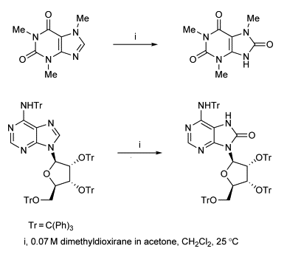

**Fig 3:**Different chemical derivatives of Purine Bases

**Morphine:** Morphine is a strong [opiate](https://en.wikipedia.org/wiki/Opiate), a dark brown resin that is found naturally in [opium](https://en.wikipedia.org/wiki/Opium) poppies (*[Papaver somniferum](https://en.wikipedia.org/wiki/Papaver_somniferum" \o "Papaver somniferum)*). It is mainly used as a [pain medication](https://en.wikipedia.org/wiki/Analgesic), and is also commonly used [recreationally](https://en.wikipedia.org/wiki/Recreational_drug), or to make other [illicit](https://en.wikipedia.org/wiki/Illicit_drug) [opioids](https://en.wikipedia.org/wiki/Opioid" \o "Opioid). Morphine is used to make other [opioids](https://en.wikipedia.org/wiki/Opioids" \o "Opioids) such as [hydromorphone](https://en.wikipedia.org/wiki/Hydromorphone" \o "Hydromorphone), [oxymorphone](https://en.wikipedia.org/wiki/Oxymorphone" \o "Oxymorphone), and [heroin](https://en.wikipedia.org/wiki/Heroin) [14].

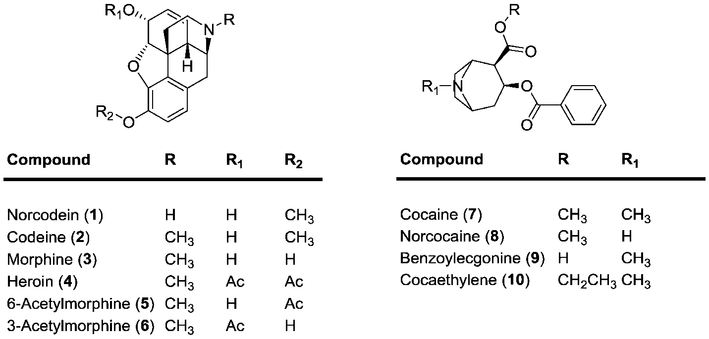

**Fig 4:**Various semisynthetic derivatives of Morphine

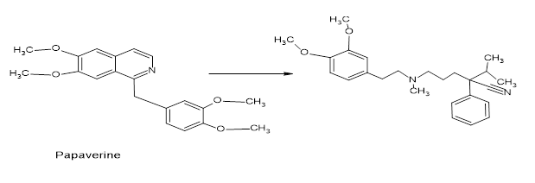

**Fig 5:**Semisynthetic modification of some alkaloids

**Quinine:** Malaria remains one of the greatest health challenges confronting humankind, and the search for better drugs, both in terms of efficacy and cost, is a global health imperative. For the treatment of fevers, the bark of cinchona species had long been used by indigenous groups in the Amazon region, which was further introduced for the treatment of malaria in Europe. The isolation of the antimalarial drug, quinine from the bark of Cinchona species (e. g., C. officinalis). Quinine formed the basis for the synthesis of the commonly used antimalarial drugs, chloroquine and mefloquine which largely replaced quinine. With the advent of resistance to both these drugs in many tropical regions, another plant long used in the treatment of fevers in Traditional Chinese Medicine (TCM), Artemisia annua (Quinhaosu), gained prominence[15]. Traditional Chinese Medicine provided a promising new natural product lead compound, known as artemisinin. Artemisinin analogues are now used for the treatment of malaria in many countries [16]. Many analogues of artemisinin have been prepared in attempts to improve its activity and utility, and two of the more promising of these are the totally synthetic analogue OZ277 (Fig.7 ) [17], and the dimeric analogue.

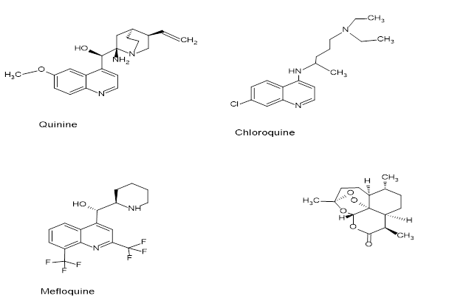

**Fig6:**semisynthetic analogue of antimalarial Quinine

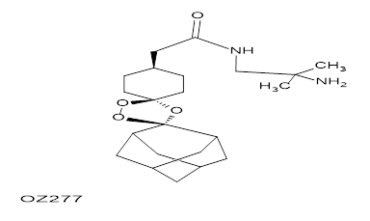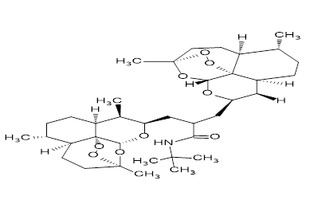

**Fig7:** semisynthetic analogue of antimalarial Artemisin

Plants have a long history of use in the treatment of cancer [18], though many of the claims for the efficacy of such treatment should be viewed with some skepticism because cancer, as a specific disease entity, is likely to be poorly defined in terms of folklore and traditional medicine [19]. some of the best known are the so-called vinca alkaloids, vinblastine and vincristine isolated from the Madagascar periwinkle, Catharanthus roseus together with the two clinically-active agents, etoposide and teniposide (Fig. 8), which are semisynthetic derivatives of the natural product epipodophyllotoxin [20-22].

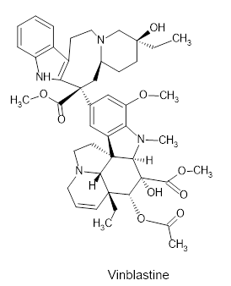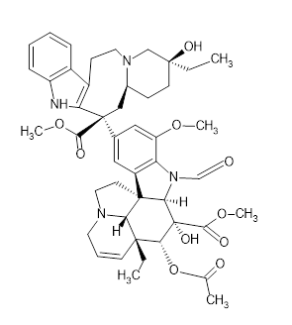

Etoposide

**Fig 8:** Chemical Modification in anticancer phytochemicals from Vinca & Taxol

**Flavone:**Flavones are an important class of flavonoids that include a 2- phenyl-1-benzopyran-4-one skeleton. The scaffold has been widely used for multitargeting in complex diseases like cancer, inflammation, cardiovascular disease, diabetes, and various neurodegenerative disorders. Due to the wide range of biological activities of flavones, their structure–activity relationships have generated interest among medicinal chemists. Flavonoids are low molecular weight polyphenolic phytochemicals derived from secondary metabolism of plants [23]. Flavonoids would be classified into different classes: flavonols (quercetin, kaempferol, myricetin, fisetin), flavones (luteolin, apigenin), flavanones (hesperetin, naringenin), flavonoid glycosides (astragalin, rutin), flavonolignans (silibinin), flavans (catechin, epicatechin), isoflavones (genistein, daidzein), anthocyanidins (cyanidin, delphinidin), aurones (leptosidin, aureusidin), leucoanthocyanidins (teracacidin), neoflavonoids (coutareagenin, dalbergin), and chalcones (Fig.9). Many natural, semisynthetic, and synthetic derivatives of flavones have been synthesized and evaluated for various therapeutic activities. As oxidative stress is responsible for major metabolic diseases, flavones shown the positive effect on diseases related to oxidative stresse.g. cancer, Alzheimer’s disease etc. Flavones can be structurally modified in several ways including reduction reactions, degradation in the presence of base, oxidation, rearrangement, substitution, addition, condensation, and reaction with organometallic reagents to get the products of high yield, purity, and desired quality.



**Fig 9:** Different Flavones with vast therapeutic activity

**Lignans:** Lignans are a diverse group of phenylpropane derivatives that are extensively distributed in higher plants and they are important components of food and medicine. They have concernedsignificant attention because of their diverse structures (dimers, trimers, or tetramers) and pharmacological activities such as anti-tumor, antiviral, antimitotic, antihypertensive, anti-oxidant properties. due to various types of bonding of the C6 e C3 units, and oxidation of the interesting structures, lignans were choice as starting material to prepare semisynthetic derivatives [24-25].



**Fig 10:** Lignans and Semisynthetic analogue

**Phenolic compounds:**Phenolic compounds or polyphenols aresecondary metaboliteswith a wide range of applicability. Because of their wide occurrence, diverse chemical structure, and attracting pharmacological properties.Aaffluent source of these phytochemicals is the functional foods. The therapeutic efficacy of phenolic compounds include antioxidant, antimicrobial activity, inhibition of carcinogenesis, stabilization of ascorbic acid, etc [26-28].



**Fig 11:** Commonly used Polyphenols for synthesizing analogues

**Steroid**

Steroids, a characteristic cyclo-pentanoperhydrophenanthrene ring motif obtained from the metabolism of cholesterol; Steroids play a significant role in drug discovery, medicinal chemistry, and chemical biology. Several FDA-approved drugs are steroid-based that are employed to treatan assortment of medical ailments like inflammation, heart disease, cancer, and allergic reaction and they have a profound role in other important health-linked areas that contain contraception and fitness [29-31].

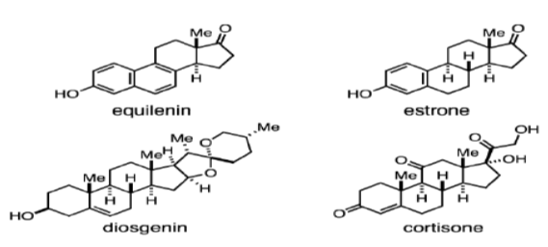

**Fig 12:** Plant derived steroids and analogue

**Conclusion:**Natural products and their semisynthetic derivatives perform as exceptional sources of novel drug candidates with a miscellany of therapeutic activities. The natural, physical, and technological resources are present or under rapid development for new drug molecules. With the advent of synthetic biology technologies, a number of modified semisynthetic drug molecules are synthesized. It has been extensively investigated that a semisynthesis is an essential tool for enhancing the biological activity of starting natural products. there are a good number of promising natural and/or semi-synthetic phytochemicals that would meet the criteria to become candidates in the drug discovery. Researchers are currently being undertaken to isolate the active compounds by bioassay-guided fractionation from the species that showed high biological activity during screening. These scientific investigations may be exploited to maturedrugs for these diseases. Further research is deserved to isolate the compounds responsible for the observed biological activity, derivatized for desired pharmacokinetics, pharmacodynamics and therapeutic efficacy and may serve as the leads and scaffolds for the development of new drugs.

**References:**

1. T. Johnson, CRC ethnobotany desk reference, CRC Press, Boca Raton, FL, 1999.
2. N.R. Farnsworth, R.O. Akerele, A.S. Bingel, D.D. Soejarto, Z. Guo, Medicinal plants in therapy, Bull. World Health Organ. 63 (1985) 965–981.
3. G. Samuelsson, Drugs of Natural Origin: A Textbook of Pharmacognosy, fifth ed., Swedish Pharmaceutical Press, Stockholm, 2004.
4. K. Grabowski, K.-H. Baringhaus, G. Schneider, Nat. Prod. Rep. 25 (2008) 892
5. Z. Guo, Acta Pharm. Sin. B. 7 (2017) 119.
6. D.J. Newman, G.M. Cragg, J. Nat. Prod. 79 (2016) 629.
7. E.C. Barnes, R. Kumar, R.A. Davis, Nat. Prod. Rep. 33 (2016) 372.
8. S.N. Dupuis, A.W. Robertson, T. Veinot, S.M.A. Monro, S.E. Douglas, R.T. Syvitski, K.B. Goralski, S.A. McFarlandc, D.L. Jakeman, Chem. Sci. 3 (2012) 1640.
9. A.M. Lourenco, L.M. Ferreira, P.S. Branco, Curr. Pharmaceut. Des. 18 (2012) 3979.
10. Devereaux, A.L.; Mercer, S.L.; Cunningham, C.W. DARK classics in chemical neuroscience: Morphine. ACS Chem. Neurosci. 2018, 9, 2395–2407.
11. Cordell, G.A.; Quinn-Beattie, M.L.; Farnsworth, N.R. The potential of alkaloids in drug discovery. Phytother. Res. 2001, 15, 183–205.
12. Falcao de Sousa, J.A. Leite, J.M. Barbosa-Filho, P.F. de Athayde-Filho, M.C. de Oliveira Chaves, M.D. Moura, A. Luiz Ferreira, A.B. Albino de Almeida, A.R.M. Souza-Brito, M. de Fatima Formiga Melo Diniz, L.M. Batista, Molecules 13 (2008) 3198.
13. I. Collins, J.J. Caldwell, in [Comprehensive Heterocyclic Chemistry III](https://www.sciencedirect.com/referencework/9780080449920/comprehensive-heterocyclic-chemistry-iii), 2008.
14. David H. Chestnut MD, in Chestnut's Obstetric Anesthesia, 2020.
15. D.L. Klayman, A.J. Lin, N. Acton, J.P. Scovill, J.M. Hoch, W.K. Milhous, A.D. Theoharides, Isolation of artemisinin (qinghaosu) from artemisia annua growing in the United States, J. Nat. Prod. 47 (1985) 715–717.
16. P.M. O'Neill, G.H. Posner, A medicinal chemistry perspective on artemisinin and related endoperoxides, J. Med. Chem. 47 (2004) 2945–2964.
17. J.L. Vennerstrom, S. Arbe-Barnes, R. Brun, S.A. Charman, F.C.K. Chiu, J. Chollet, Y. Dong, A. Dorn, D. Hunziker, H. Matile, K. McIntosh, M. Padmanilayam, J. Santo Tomas, C. Scheurer, B. Scorneaux, Y. Tang, H. Urwyler, W. Sergio, W.N. Charman, Identification of an antimalarial synthetic trioxolane drug development candidate, Nature 430 (2004) 900–904.
18. J.L. Hartwell, Plants used against cancer, Quarterman, Lawrence, MA, 1982.
19. G.M. Cragg, M.R. Boyd, J.H. Cardellina II, D.J. Newman, K.M. Snader, T.G. McCloud, Ethnobotany and drug discovery: The experience of the US National Cancer Institute, in: D.J. Chadwick, J. Marsh (Eds.), Ethnobotany and the search for new drugs, ciba foundation symposium, vol, vol. 185, John Wiley & Sons, Inc., New York, NY, 1994, pp. 178–196.
20. F. Gueritte, J. Fahy, The vinca alkaloids, in: G.M. Cragg, D.G.I. Kingston, D.J. Newman (Eds.), Anticancer agents from natural products, Taylor and Francis, Boca Raton, FL, 2005, pp. 123–135.
21. F. Roussi, F. Gueritte, J. Fahy, The vinca alkaloids, in: G.M. Cragg, D.G.I. Kingston, D.J. Newman (Eds.), Anticancer agents from natural products, 2nd ed., Taylor and Francis, Boca Raton, FL, 2012, pp. 177–198.
22. K.-H. Lee, Z. Xiao, Podophyllotoxin and analogs, in: G.M. Cragg, D.G.I. Kingston, D.J. Newman (Eds.), Anticancer agents from natural products, 2nd ed., Taylor and Francis, Boca Raton, FL, 2012, pp. 95–122.
23. Singh, M., &Silakari, O. (2018). *Flavone. Key Heterocycle Cores for Designing Multitargeting Molecules, 133–174.*
24. T. Sugahara, S. Yamauchi, S. Nishimoto, A. Kondo, F. Ohno, S. Tominaga, Y. Nakashima, T. Kishida, K. Akiyama, M. Maruyama, Y. Kakinuma, Interdiscipl. Stud. Environ. Chem. 2 (2008) 263.
25. M. Gordaliza, P.A. Garca, J.M. Miguel del Corral, M.A. Castro, M.A. Gomez- Zurita, Toxicon 44 (2004) 441.
26. R. Tsao, Nutrients 2 (2010) 1231.
27. C. Tanase, I. Boz, A. Stingu, I. Volf, V.I. Popa, Ind. Crop. Prod. 60 (2014) 160.
28. M. Naczk, F. Shahidi, J. Pharmaceut. Biomed. Anal. 41 (2006) 1523.
29. M. Adamczyk, D.D. Johnson, R.E. Reddy, Steroids 62 (1997) 771.
30. Y. Xu, S. Gao, D.P. Bunting, A.A.L. Gunatilaka, Phytochemistry 72 (2011) 518.
31. P.H.J. Batista, K.S.B. de Lima, F. Pinto, C.L. das, J.L. Tavares, D.E. Uchoa, D.E.de A. Uchoa, L.V. Costa-Lotufo, D.D. Rocha, E.R. Silveira, A.M.E. Bezerra, K.M. Canuto, O.D.L. Pessoa, Phytochemistry 130 (2016) 321.