THE DURABILITY PERFORMANCE OF CONTROLLED PERMEABLE FORMWORK LINER SELF COMPACTING CONCRETE

S. Kandasamy^{1*}, N. Pannirselvam ², S. Syed Ibrahim ³, J. Vanjinathan⁴, S. Sundararaman⁵
¹ Professor, Department of Civil Engineering, Vel Tech Rangarajan Dr. Sagunthala R&D Institute of Science and Technology, Chennai-600062, Tamil Nadu, India
² Professor, Department of Civil Engineering, SRM Institute of Science and Technology, Chennai, Tamil Nadu, India
³ Associate Professor, Department of Civil Engineering, Ilahia College of Engineering and Technology, Ernakulam, Kerala, India
⁴ Assistant Professor, Department of Civil Engineering, Sathyabama Institute of Sciences and Technology, Chennai, Tamil Nadu, India
⁵ Professor, Department of Civil Engineering, Sri Manakula Vinayagar Engineering College, Puducherry, India

*Corresponding author E-mail: skandasamyisha@gmail.com
Abstract: The corrosion of reinforced concrete structures as a major problem throughout the world, it leads to significant costs of repair and retrofitting. All the aggressive agents are penetrate into the concrete through the surface of concrete to initiate the rebar corrosion. Controlled Permeability Formwork (CPF) is the active method to improve the quality of surface zone of concrete. This technique is used to drain the surplus water and entrapped air from the near surface of fresh concrete whilst retaining the cement and other fine particles. This ensures reducing the water-cement (w-c) ratio, enrich of cement content and decrease of surface porosity in the cover zone of the concrete. CPF action creates smooth surface with free from pin and blow. This paper reports an experimental study carried out to investigate the influence of CPF liner on durability properties of self-compacting concrete (SCC). The specimens were prepared against CPF liner and impermeable steel formwork (IMF) and tested at various ages. The tests that were carried out include water absorption, sorptivity, hydrochloric acid resistance and sulfate resistance. The findings revealed that CPF concretes had an excellent resistance to water absorption (sorptivity) of 22 to 67 percent. The residual compressive strength of CPF concrete was more by 14% - 143% compared to IMF concretes under hydrochloric acid environment.
Keywords: Water absorption · Sorptivity · Controlled permeability formwork · Sulfate resistance · Hydrochloric acid resistance

INTRODUCTION
The corrosion of reinforced concrete structures as a major problem throughout the world, it leads to significant costs of repair and retrofitting. All the aggressive agents are penetrate into the concrete through the surface of concrete to initiate the rebar corrosion. The quality of the surface/cover zone of the concrete is a major influence on the durability of concrete structures. Because, it is acted as the first line of resistance against either physical or chemical deterioration. Improvement of durability of cover zone of concrete to extend service life of reinforcement concrete structure is an important and economic issue. Now a days, durability of concrete has traditionally been addressed through increased cement contents, decreased water-cement ratio and adding admixtures. But these materials/methods influenced on the bulk/core properties of concrete, not at the surface level. Practically, the surface skin of concrete is direct contact with atmospheric conditions. All the aggressive agents, gaseous or liquid, particularly chloride or carbon dioxide are penetrating to the concrete through the surface skin of concrete to destroy the concrete structures. The performance of the surface skin is significantly affected by the type of formwork used during the construction [1].
The commonly used formwork made from impregnated plywood or steel are essentially impermeable to air and water. During the compaction process, the surplus water and entrapped air is towards the formwork. As conventional wood or steel is an impermeable formwork (IMF), the migration within in the mix ceases as the concrete/formwork interface is reached. Visually, this may be observed on all concrete surfaces through the presence of blowholes and pinholes after removal of formwork [2]. The matrix within the core of any structural element is generally dense and of better quality compared to the surface as a direct result of the compaction. However, the concrete surface is more vulnerable to poor curing and compaction than the bulk of the concrete [3]. Therefore for good durability a well compacted strong concrete surface zone is needed with low permeability, low diffusion and no surface porosity.
Controlled permeable formwork (CPF) is the active technique used for improving the quality of the surface skin of concrete. CPF system consists of a textile liner affixed on usual formwork as shown in Fig. 1. The CPF liner allows the mix water and entrapped air to drain out from the near surface concrete whilst retaining cement and other fine particles [5-16]. This mechanism to lower the w-c ratio and enrich of cement content and decrease of surface porosity in the cover zone of concrete. This action creates a uniform surface without blowholes, pinholes and surface blemishes.
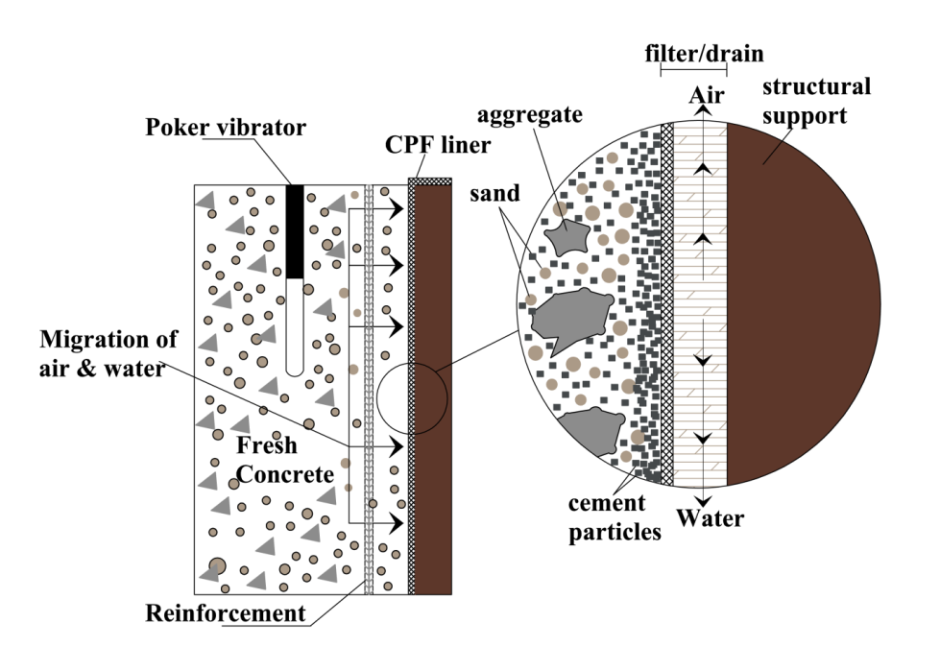
Fig. 1 Function of CPF liner [4]
All the researchers have uniquely reported that certain quantity of mix water and entrapped air are driven towards the formwork due to vibration caused by compaction process. The performance and efficiency of CPF liner against self-compacting concrete (SCC) is very limited. In the present experimental study in order to check the performance of CPF liner on self-compacting concrete, where no vibration is required for compaction.
EXPERIMENTAL WORK
Materials
Ordinary Portland Cement (OPC) of 43 grade conforming to IS: 8112-1989 [17] with specific gravity of 3.15 was used throughout the investigation. Locally available natural river sand conforming to zone II as per IS: 383-1987 [18] with specific gravity of 2.6 and fineness modulus of 2.54 was used. Crushed natural rock stone aggregate conforming to IS: 383-1987 [18] with specific gravity of 2.79 and fineness modulus of 7.8 was used. Normal tap water available in the concrete laboratory confirming to the requirements as per IS: 456-2000 [19] was used. Fly ash procured from Ennore Thermal Power Station, Chennai, was used. In this study polycarboxylate ether polymer based super plasticizer (SP) conformed to IS: 9103-1999 [20] was used. The viscosity modifying admixture (VMA) was also added to avoid segregation.

In this study, the CPF liner used was type II. It is a single layer system. The inner face (concrete side) acts as filter and the outer face (formwork side) acts as drain as shown in Fig. 1. The specifications of CPF liner as furnished by the manufacturer is given in Table 1.

Table 1 Specifications of CPF liner [21]
Specifications | Unit | Value
Mean pore size | µm | <30
Unit weight | g/m² | 250
Air permeability at 800 Pa | l/s/m² | 250
Tear strength in longitudinal | N | 250
Tear strength in transverse | N | 200
Thickness at 2 KPa | mm | 1.2
Composition | 100% polypropylene

Concrete mixture proportions

The concrete mixture proportions and properties of SCC are presented in Table 2.

Table 2 Mix proportions and properties of SCC

Constituent materials (kg/m³) |  |  |  |  |  |  | Constituent ratios |  |  | Flow properties
Cement | Fly ash | Coarse aggregate | Fine aggregate | Water | Super plasticizer | Viscosity modifying admixture |  |  |  | Slump Flow  (mm) | V-Funnel  (sec) | L-Box
 |  |  |  |  |  |  | $$\frac{W}{C}$$ | $$\frac{W}{(C+F)}$$ | $$\frac{CA}{FA}$$
(C) | (F) | (CA) | (FA) | (W) | (SP) | (VMA)
435 | 100 | 860 | 875 | 210 | 5.4 | 1.0 | 0.48 | 0.39 | 0.98 | 660 | 6.70 | 0.86

Preparation and curing of specimens

Steel moulds were used to cast reference test specimens. CPF liner was affixed to the side plates of moulds and specimens were cast (Fig. 2). The concrete specimens cast using steel moulds were identified as “IMF” specimens and those made steel moulds affixed with CPF liner as “CPF” specimens. The concrete mixes were prepared in a drum mixer of capacity 55 litre. The moulds were filled with concrete and demoulded after 24 hours. The cast specimens were water cured till the date of test.
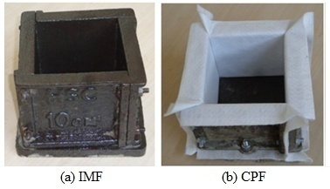
Fig. 2 Mould preparation to cast cube specimens.

TEST PROGRAMME
Water absorption
A cube-shaped specimen with 100 mm was utilised for the test. The test was performed at 7, 14, 28, 60 and 90 days, according to ASTM C 642 [22]. The specimens were dried for 24 hours in an oven at 105±5◦C before being tested. The samples were subjected to cool and weighed (W₁). After that, the samples were submerged in water for 72 hours. The samples were dried on the surface and weighed (W₂) after being removed from the water bath.
Sorptivity
A cube-shaped specimen with 100 mm was utilised for the test. The test was performed at 7, 14, 28, 60 and 90 days, according to ASTM C 1585 [23]. The samples were dried for three days at 50±2◦C in an oven, after taken out from the curing tank. Then the samples were subjected to room temperature to cool, except the suction face (contact face with water), the samples were coated with epoxy. The specimen's original weight was determined. As shown in Fig. 3, the samples were placed on a tray on a support and immersed in water around 3 mm depth. The sample was taken out and weighed after blotting out extra water.

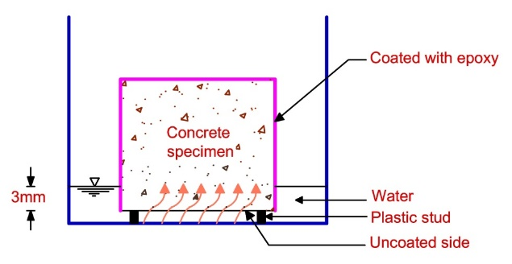
Fig. 3 Layout for sorptivity test.

Hydrochloric acid resistance
A cube-shaped specimen with 100 mm was utilised for the test. The specimens were withdrawn from the curing chamber after 28 days and left to dry for one day. The cube's original weights were determined. A solution prepared with 5% concentration of Hydrochloric acid (HCl). The specimens were submerged in the acid solution for 60, 90, 120, and 180 days, respectively. Throughout this time, the solution's concentration remained maintained. The specimens were removed from the acid solution after the specified time interval. The cube's surfaces were cleaned, the weights of the specimens were recorded, and they were then tested in a 3000 kN compression testing machine at a consistent rate of loading of 140 kg/cm²/min. Three specimens were used for each period of test. The concrete specimen's weight loss and residual compressive strength were analyzed.
Sulfate resistance
A cube-shaped specimen with 100 mm was utilised for the test. The samples were withdrawn from the curing chamber after 28 days and original weights were determined. The solution prepared with 5% concentration of sodium sulfate (Na₂SO₄) and magnesium sulfate (MgSO₄) by the weight of water. The specimens were submerged in sodium sulfate and magnesium sulfate solution for 60, 90, 120 and 180 days, respectively. Throughout this time, the solution's concentration remained maintained. The samples were withdrawn from the sulfate solution after the specified time interval. The cube's surfaces were cleaned, the weights of the specimens were recorded, and they were then tested in a 3000 kN compression testing machine at a consistent rate of loading of 140 kg/cm2/min. Three specimens were used for each category and each period of test. The concrete specimen's weight loss and residual compressive strength were analyzed.
RESULTS AND DISCUSSION
Water absorption
The water absorption results are displayed in Fig. 4. The CPF concrete samples showed a water absorption reduction by 22% to 30%, which was much less than the IMF specimens. Also, it’s noticed that the CPF liner's construction (through a strong and solid cover) has effectively prevented the water content. Similar studies [8,11] found a 29 % to 50 % reduction in water absorption in CPF samples.

Fig. 4 Water absorption vs age.
Sorptivity
The findings of water sorptivity are shown in Fig. 5. It shows that when comparing CPF specimens to IMF specimens in all ages, the decrease in water sorptivity of CPF specimens was considerable. The improvement in water sorptivity of CPF liner is 67% and 51% at 7 and 90 days respectively.

Fig. 5 Sorptivity vs age.
Hydrochloric acid resistance
The weight loss of IMF and CPF concrete specimens under HCl solution are presented in Fig. 6. The results reveal that the IMF specimens had more weight loss compared to CPF specimens in all the ages. The reduction in weight loss in CPF specimens was in the range of 42% - 48%.
Fig. 7 shows the residual compressive strength of IMF and CPF specimens under HCl solution. The results revealed that the IMF specimens had less residual compressive strength than CPF specimens in all the ages. The improvement of CPF liner was in the range of 14% - 143%. The weight loss of concrete specimens also reflect on residual compressive strength of concrete.

Fig. 6. Weight loss vs duration of exposure.

Fig. 7. Residual compressive strength vs duration of exposure.

Sulfate resistance
The weight loss of IMF and CPF concrete specimens under sulfate solution are shown in Fig. 8. The test results revealed that the weight loss has been more in IMF specimens compared to CPF specimens. The reduction in weight loss in CPF specimens was in the range of 37% - 43%. However, the weight loss less when compared to HCl solution both in IMF and CPF specimens.
Fig. 9 shows the residual compressive strength of IMF and CPF specimens under sulfate solution. From the results, the IMF concrete specimens had less residual compressive strength than that of CPF concrete specimens. However, the diffrence in residual compressive strength of IMF and CPF specimen was minimal. The improvement of CPF liner was in the range of 8% - 28%.

Fig. 8. Weight loss vs duration of exposure.

Fig. 9. Residual compressive strength vs duration of exposure.

CONCLUSIONS
Based on the recent experimental inquiry, the following results were reached:
- CPF concrete specimens have a low value of water absorption than IMF concrete specimens. The range of improvement is around 22% to 30%. Similarly, the rate of sorptivity (absorption of water) of CPF samples is significantly reduced than the Impermeable Formwork samples. The improvement was in the range of 51 to 67%.
- The CPF concrete samples have a lesser weight loss than the Impermeable formwork samples under both hydrochloric acid and sulfate environment. The percentage of improvement ranges from 37 to 48%.
- Under chemical environment, CPF concretes exhibited outstanding performance. The residual compressive strength of CPF concrete was more by 14% - 143% compared to IMF concretes under hydrochloric acid environment. In sulfate environment, this improvement was 8% - 28%.

References
[1] A. Ajdukiewicz, On durability aspects of concrete members formed against permeable formwork, Foundation of Civil and Environmental Engineering 7 (2006) 007-016.
[2] W.F. Price, S.J. Widdows, The effect of permeable formwork on the surface properties of concrete, Magazine of Concrete Research 43 (1991) 93-104.
[3] J. Cairns, Enhancements in surface quality of concrete through use of controlled permeability formwork liners, Magazine of Concrete Research 51 (2) (1999) 73-86.
[4] J.S. Coutinho, Effect of controlled permeability formwork (CPF) on white concrete, ACI Materials Journal 98 (2) 2001 148-169.
[5] W.F. Price, Controlled permeability formwork, CIRIA Report, C 511, 2000.
[6] J.S. Coutinho, The combined benefits of CPF and RHA in improving the durability of concrete structure, Cement& Concrete Composites 25 (2003) 51-59.
[7] E. Nolan, P.A.M. Basheer and A.E. Long, Effects of three durability enhancing products on some physical properties of near surface concrete, Construction and Building Materials, 9 (1995) 267-272.
[8] F. Helena, N. Sandra, S. Joana and F. Joaquim, Combined effect of two sustainable technologies: self compacting concrete and controlled permeability formwork, Construction and Building Materials 23 (2009) 2518-2526.
[9] A.A. Adam, D.W. Law, T. Molyneaux, I. Patnaikuni and T. Aly, The effect of using controlled permeability formwork on the durability of concrete containing OPC and PFA, Australian Journal of Civil Engineering 6 (1) 2010 1-12.
[10] McKenna, P., The effect of controlled permeability formwork on carbonation-induced corrosion, 3rd FIB International Congress, Scotland, 2010.
[11] L. Basheer, S.V. Nanukuttan and P.A.M. Basheer, The influence of reusing ‘Formtex’ controlled permeability formwork on strength and durability of concrete, Materials and Structures 41 (2008) 1363-1375.
[12] P.J. Schubel, N.A. Warrior, K.S. Elliott and M. Jones, An Investigation into the critical factors affecting the performance of composite controlled permeability formwork liners, Construction and Building Materials 22 (2008) 1551-1559.
[13] M.J. McCarthy, A. Giannakou and M.R. Jones, Specifying concrete for chloride environments using controlled permeability formwork, Materials and Structures 34 (2001) 566-576.
[14] M.J. McCarthy, A. Giannakou, In-situ performance of CPF concrete in a coastal environment, Cement and Concrete Research 32 (2002) 451-457.
[15] A.K. Suryavanshi, R.N. Swamy, An evaluation of controlled permeability formwork for long- term durability of structural concrete elements, Cement and Concrete Research 27 (1997) 1047-1060.
[16] A Metin, The effects of permeable formworks with sucker liners on the physical properties of concrete surfaces, Construction and Building Materials 15 (2001) 149-156.
[17] IS 8112-1989, Specification for 43 grade ordinary portland cement, Bureau of Indian Standards, New Delhi, 1989.
[18] IS 383-1987, Specification for coarse and fine aggregates from natural source for concrete, Bureau of Indian Standards, New Delhi, 1987.
[19] IS 456-2000, Plain and reinforced concrete, Code of Practice, Bureau of Indian Standards, New Delhi, 2000.
[20] IS 9103-1999, Specification for concrete admixtures, Bureau of Indian Standards, New Delhi, 1999.
[21] Fibertex A/S, Denmark, BBA Agreement Certificate 03/4038, 2009.
[22] ASTM C 642: 1997. Standard test method for density, absorption and voids in hardened concrete, American Society for Testing Materials, 1997.
[23] ASTM C 1585: 2004. Standard test method for measurement of rate of absorption of water by hydraulic cement concrete, American Society for Testing Materials, 2004.

