GROUNDWATER POLLUTION STUDIES OF EACHANARI INDUSTRIAL ESTATE, COIMBATORE
V. Yogeshwaran^{1*}, M. Rithy Chellah², M. Banuprakash³ & P. A. Kavin Karthick⁴
^{1*}Assistant Professor, Department of Civil Engineering, Sri Krishna College of Engineering and Technology, Coimbatore – 641008
^{2,3,4} Department of Civil Engineering, Sri Krishna College of Engineering and Technology, Coimbatore – 641008
svyogi23190@gmail.com

Abstract - The South India's geology is unfavorable consisting of hard rocks like granite and basalt, which prevent precipitation from freely penetrating, has a negative impact on the declining groundwater levels besides monsoonal failures and anthropogenic activities. Six groundwater samples were taken for the current study from various places throughout Eachanari, Coimbatore to acquire water that is suitable for drinking and other uses other useful purposes by analyzing the following physiochemical parameters such as turbidity, EC, pH, Total Hardness, BOD, and ions (Ca²⁺, Cl⁻ & Mg²⁺). Also, a mapping of groundwater quality was produced utilizing a geographic information system.

Keywords: Groundwater studies, Pollution, Physico-chemical characteristics, prediction of distribution.

Introduction
After 1854 the rapid industrialization has interconnected panacea of advantages such as optimal use of indigenous resources, raising income of people and thus upgrading the overall livelihood of the compatriots. The drawbacks of industrialization are categorized into two: social and environmental. Despite massive employment generated, rapid industrialization has significant impacts on the abiotic factors of environment such as air, water, and soil. Pollution has become a major concern only after urbanization. The release of toxic gases in the atmosphere by the thermal power plants is one such example of air pollution. Soil and water pollution goes hand in hand which means once the soil gets affected water also gets affected [1]. Water that is found in soil pores, rock pore spaces, and rock formation cracks is known as groundwater. Groundwater makes up to 30% of all readily available freshwater worldwide. Today, groundwater resource pollution has grown to be a serious issue. Groundwater pollution and contamination are influenced by the pollution of the air, water, and land. Toxic chemicals may be dumped by factories, and rainwater may include dangerous pesticides or farm animal excrement. This has contributed to the severe scarcity of groundwater in India which majorly depends on it for meeting more than 50% of its needs. One-fourth of the world's water is used annually, or around 230 cubic kiloliters of groundwater.85% of the drinking water supplies and more than 60% of irrigated farmland depend on ground water [2]. The prime aim of the paper is to illustrate the characteristics of ground water in and around the vicinity of SIDCO Private Industrial Estate in Coimbatore and direct some remedial measures to reduce the toxicity of contaminated ground water. Thus, the current study paper's objectives are to classify the impact of anthropogenic and natural processes on groundwater quality using simple testing techniques, identify the physicochemical properties of groundwater suitable for drinking, and use the pollution index of groundwater (PIG) to describe variation in groundwater quality.
Experimental Investigations
Site Selection
The Coimbatore District is situated in Tamil Nadu's western region. The city is situated along the Noyyal River. According to the 2011 census, it has a population of almost 34.7 lakh people. The city is also known as Manchester of South India. It is one of the most industrialized neighborhoods and is well known for its motor, pump, and wet grinder industries. Establishments in the foundry and electroplating sectors are growing to meet the demands of the aforementioned and to create machinery for the companies. Hence there are panacea of chances for pollutants to intrude the groundwater bodies, so this paper ought to describe the distribution of some of the pollutants in and around Eachanari. The Small Industries Development Corporation (SIDCO) private industrial estate is situated in Kurichi, Coimbatore. The estate is about 700 acres with 300 units. It is one of the industrial clusters and spans an area of 88.43 acres. It is situated 7 kilometers from Coimbatore Town. SIDCO's Kurichi is situated in the Coimbatore District between 10⁰ 55’11” N latitude and 76⁰ 57’35” E longitude. SIDCO is located adjoining to the Tamil Nadu Colonial Housing Board. Coimbatore Corporation has administrative control over this cluster. This industrial area is situated along the NH-209 from Bangalore to Dindigul. The map provides the location of the SIDCO industrial cluster in the Coimbatore district. along with the site of study i.e., Eachanari. The Coimbatore District is situated in Tamil Nadu's western region. The city is situated along the Noyyal River. According to the 2011 census, it has a population of almost 34.7 lakh people. The area is frequently referred to as the South Indian Manchester. One of the most industrialized neighborhoods, it is well known for its wet grinders, pumps, and motor manufacturing sector. Establishments in the foundry and electroplating sectors are growing to meet the demands of the aforementioned and to create machinery for the companies. The study area is shown in figure 1 and the sampling area also indicated in this diagram.

Figure 1 – Study area – Eachanari, Coimbatore
Methodology
During the month of August 2022, the groundwater samples were collected from 6 locations in and around Eachanari (i.e., SIDCO – Industrial Estate) depicted in Fig 1. From each site 3 liters of water samples were collected in polyethylene bottles and got transported to the laboratory keeping them in them in the ice box and then kept at 4ºC in the incubator for further physical and chemical parameter analysis of water samples. The pH, Turbidity and EC were tested in the field using digital water analysis kit. The pH content was measured using pH meter. The MOHR titration method was used to assess the chloride concentration. Nephelometric analysis was used to estimate the turbidity, and EDTA was used to calculate the total hardness. The magnesium and calcium concentration were analyzed using complexometric titration. Biological Oxygen Demand (BOD) was analyzed by using BOD incubator. Electrical conductivity of water was analyzed using conductivity meter. Using Arc-GIS software, spatial distributions of various geochemical parameters were created using the inverse distance weighted (IDW) method.
Results and Discussion
Eachanari groundwater quality characteristics such as pH, EC, TH, BOD, TDS, and principal cations (Ca²⁺ and Mg²⁺) and anions are shown in Table 1 together with their minimum, maximum, mean, and standard deviation (Cl-). The hydrogen ion concentration is controlled by the amount of dissolved CO2, bicarbonate and carbonate in groundwater and is an especially important indicator of quality of ground water [3]. Anthropogenic causes like human induced pollution affects ground water to the maximum. In the flanks of industrial areas, there are high chances of metals getting dissolved if the water is acidic, with a low pH level [4]. Quality of water depends on proper levels of pH. According to BIS, the acceptable limit range for portable water is between 6.5 and 8.5.The pH values in the examined samples ranged from 7.27 to 7.62, showing that the HCO₃⁻ form of dissolved carbonate was the primary cause of the groundwater's alkaline nature. The variation of pH in the selected areas are shown in figure 2.
Table 1 ASSESSMENT OF PHYSIOCHEMICAL PARAMETERS
Sample  No. | Location | Turbidity NTU | EC  µ mhos/cm | pH | TH  mg/L | Ca  mg/L | Mg  mg/L | Cl  mg/L | BOD  ppm
1 | Indira Nagar | 2 | 1707 | 7.38 | 596 | 150 | 446 | 236 | 4.65
2 | Pillayar puram | 1 | 3270 | 7.27 | 769 | 450 | 319 | 380 | 3.22
3 | Annapuram | 1 | 4030 | 7.62 | 1200 | 633 | 567 | 370 | 3.1
4 | Mullai Nagar | 2 | 2160 | 7.55 | 498 | 215 | 283 | 232 | 3.78
5 | Sundarapuram | 2 | 1203 | 7.48 | 377 | 90 | 287 | 78 | 3.49
6 | Madukkarai | 1 | 481 | 7.33 | 189 | 72 | 117 | 118 | 3.61
 | Min | 1 | 481 | 7.27 | 189 | 72 | 21 | 78 | 3.1
 | Max | 2 | 4030 | 7.62 | 1200 | 633 | 95 | 380 | 4.65
 | MEAN | 1.5 | 2141.8 | 7.43 | 604.8 | 268.3 | 336.5 | 235.6 | 4.37
 | Std. Div | 0.5 | 1316.5 | 0.1349 | 351.4 | 225 | 154.2 | 124.5 | 3.55
 | STD. VALUES | 1 | 620-1820 | 6.5-8.5 | 200-600 | 75-200 | 100 | 250 | 3-5
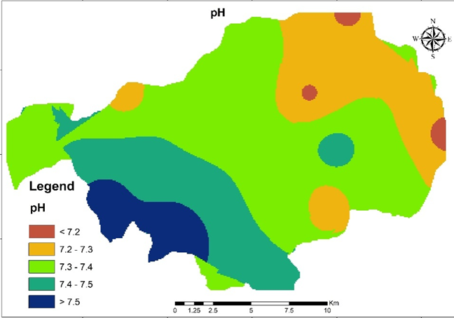
Figure 2 – Variations pH in the ground water at Eachanari industrial estate.
Pure water is not a good conductor of electricity, as there is absence of ions. Whereas polluted water is a good conductor of electricity due to the presence of ample amount of ions [5]. The measurement of electrical conductivity is important because it shows how much dissolved substances, chemicals and minerals are present in water [6]. The permissible level of electrical conductivity is 620-1820 mhos/cm. According to the analysis, EC is present in 80% of the samples. which is moreover concentrated in the easternmost and central parts of Eachanari. The excess of EC indicates the presence of excess of turbidity. The Conductivity levels of groundwater samples in Eachanari area was shown in figure 3 along with distribution.
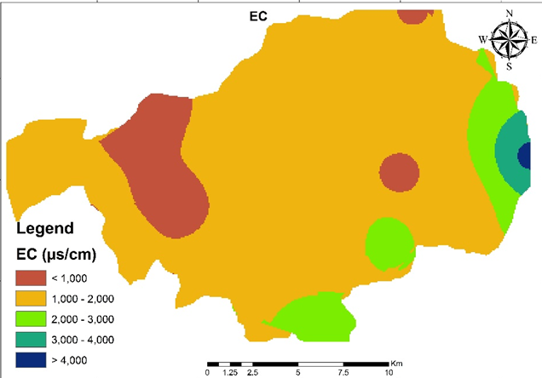
Figure 3 - Variations EC in the ground water at Eachanari industrial estate.
Relative clarity of liquid is measured by turbidity. Nephelometric Turbidity Unit (NTU) is the unit of measurement for turbidity. Turbidity of drinking water should be kept below 1NTU. It makes the water appear cloudy that scatters light caused by suspended particles [7]. The suspended particles include microscopic organisms, organic and inorganic matter, clay, and silt. Tourism can be significantly afflicted by the high turbidity in lakes and streams. Turbidity provides room for various kinds of micro-organisms [8]. Certain studies reveal that the removal of protozoa is related to the removal of turbidity. Turbidity is measured using specially designed equipment. The water sample is subjected to the light rays from a source. The total amount of light scattered is measured. Low turbidity indicates better water quality. Turbidity provides room for various kinds of micro-organisms. Certain studies reveal that the removal of protozoa is related to the removal of turbidity. According to Water quality standards 10500:2012 the permissible level of turbidity is 1. Our observation shows a mean TDS of 1.5 which is slightly above the standard value which makes it clear that the groundwater cannot be consumed directly without purification [9]. Unlike other physiochemical parameter turbidity is found to spread in the groundwater to a larger extent. The turbidity level of selected industrial site and its distribution was shown in figure 4.
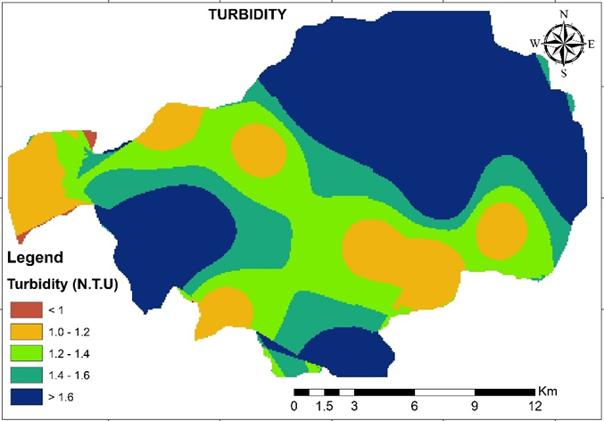
Figure 4 - Variations turbidity in the ground water at Eachanari industrial estate.
Compounds of calcium, magnesium, and several other metals contribute to hardness. The harder the water is, the less toxic other metals are to aquatic life [10]. Hard water causes some of the metal ions to precipitate out of solution as insoluble precipitates, rendering them indigestible to living things [11]. Hardness levels that are too high are typically undesirable for aesthetic or budgetary reasons. According to Water quality standards 10500:2012 the permissible level of TH is between 200-600 mg/dl. From observing the above table, we find that the maximum and minimum TH is found to be 189 and 1200. The maximum TH observed is found to be double that of the maximum permissible limit. Like EC, the TH is majorly found in the easternmost parts and northern and southern borders of Eachanari. The distribution of hardness in the ground water at Eachanai industrial area is shown in figure 5.
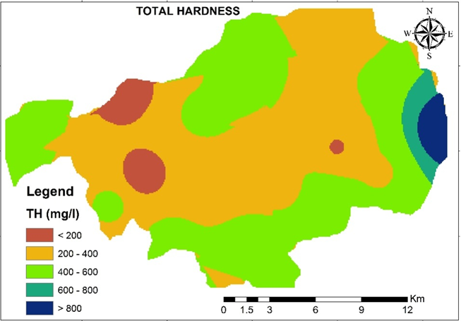
Figure 5 - Variations total hardness in the ground water at Eachanari industrial estate.
Water is considered to be hard when it contains higher amounts of calcium in it. Hard water is an inconvenience but does not provide any health issues due to mineral buildup on plumbing fittings and poor soap and/or detergent performance [12]. Water works well as a solvent and easily absorbs impurities. The permissible amount of calcium is between 75 to 200 mg/dl. From the table 1 we could observe that the maximum amount of calcium is 268 mg/dl which is slightly above the standard value. Calcium ion distribution also shown in the figure 6 for the entire industrial site at Eachanari, Coimbatore.
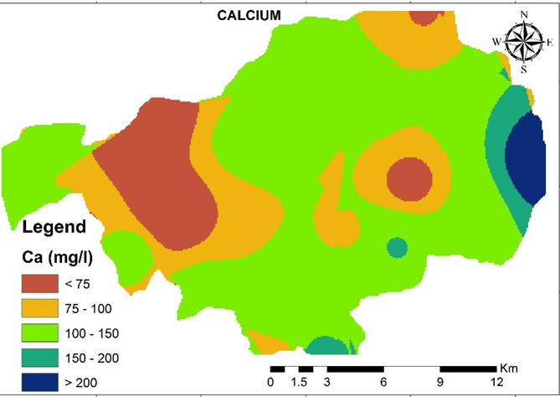
Figure 6 - Variations total calcium in the ground water at Eachanari industrial estate.
The acidity of the groundwater at Eachanari was highest in the southwest and gradually decreased towards the east and northeast. Electrical Conductivity (EC) is found to be maximum in the eastern most part of the project site whereas it is moderate in the remaining parts of the city. The water samples showed higher levels of turbidity in most of the northwestern parts of Eachanari and similar trends is found in some parts of southwestern region. Unlike Electrical conductivity Total hardness is only concentrated in the east central region. The spatial distribution of calcium is more or less similar to total hardness [13, 14]. Magnesium levels also exceeds standards prescribed by 1S 10500:2012. The aforementioned facts led to the conclusion that the groundwater in Eachanari's northern and northwestern regions is more contaminated and unfit for direct human consumption than that in its western and southern regions. The greater density of industries in the area may be to blame for this discrepancy [15]. It was discovered that using geostatistical techniques was an effective way to forecast the concentration of groundwater parameters in unmeasured places.
CONCLUSION
The groundwater in the northern and northwestern regions of Eachanari is more polluted and unfit for human consumption than the western and southern regions, according to the aforementioned observations. The greater density of industries in the area may be to blame for this discrepancy. It was discovered that using geostatistical techniques was an effective way to forecast the concentration of groundwater parameters in unmeasured places. The Turbidity, Total Hardness, Calcium, and magnesium values of each location were found to be high. Consuming the contaminated water creates severe effects to the living beings – long term effects. Hence, it is necessary to reduce the concentrations of each parameter (Ca, Turbidity, TH, Mg) Therefore, we recommend a normal RO treatment systems or RO treatment plant and its purification before consuming the water in the target locations.
REFERENCES
[1]. Muhammad Mazhar Iqbal, Tehmena Rashid, Saddam Hussain, Muhammad Umer Nadeem, Muhammad Sohail Waqas, Muhammad Amin and Muhammad Naveed Anjum, Eutrophic Status Assessment Based on Very High-Resolution Satellite Imagery in the Coastline Environment of Korea, Pollutants. 3 (1) (2023) 59-73.
[2]. Vasant Wagh, Shrikant Mukate, Aniket Muley, Ajaykumar Kadam, Dipak Panaskar, Abhay Varade, Study of groundwater contamination and drinking suitability in basaltic terrain of Maharashtra, India through PIG and multivariate statistical techniques, Journal of Water Supply: Research and Technology-Aqua. 69 (4) (2020) 398 – 414.
[3]. Thanh Giao Nguyen, Thi Hong Nhien Huynh, Assessment of surface water quality and monitoring in southern Vietnam using multicriteria statistical approaches, Sustainable Environment Research. 32 (2022) 20.
[4]. Ahsan Saif Ullah, Haroon Rashid, Shahbaz Nasir Khan, Muhammad Umar Akbar, Arfan Arshad, Md. Masudur Rahman, Shumaila Mustafa, A Localized Assessment of Groundwater Quality Status Using GIS-Based Water Quality Index in Industrial Zone of Faisalabad, Pakistan, Water. 14 (2022) 3342.
[5]. Nandini Krishnan, Suriya Saravanan, Assessment of Groundwater Quality and Its Suitability for Drinking and Irrigation Usage in Kanchipuram District of Palar Basin, Tamilnadu, India, Polish Journal of Environmental Studies. 31 (3) (2022) 2637 – 2649.
[6]. T. Riedel, Temperature-associated changes in groundwater quality, Journal of Hydrology. 572 (2) (2019) 206.
[7]. Rizwan Reza, Gurdeep Singh, Assessment of Ground Water Quality Status by Using Water Quality Index Method in Orissa, India, World Applied Sciences Journal. 9 (12) (2010) 1392 – 1397.
[8]. Hanaa A. Megahed, GIS-based assessment of groundwater quality and suitability for drinking and irrigation purposes in the outlet and central parts of Wadi El-Assiuti, Assiut Governorate, Egypt, Bulletin of the National Research Centre. 44 (2020) 187.
[9]. Samir Amrani, Said Hinaje, Mohamed El Fartati, Youssef Gharmane, Driss Yaagoub, Assessment of groundwater quality for drinking and irrigation in the Timahdite–Almis Guigou area (Middle Atlas, Morocco), Applied Water Science. 82 (2022) 12.
[10]. Doris O. Okoroh, Johnson Cletus Ibuot, Hydrogeochemical assessment of groundwater quality: a case study of Federal College of Education (Technical), Omoku, Rivers State, Water Practice and Technology. 17 (7) (2022) 1458 – 1469.
[11]. H. Annapoorna, M.R. Janardhana, Assessment of Groundwater Quality for Drinking Purpose in Rural Areas Surrounding a Defunct Copper Mine, Aquatic Procedia. 4 (2015) 685 – 692.
[12]. Mohamad Najib Ibrahim, Assessing Groundwater Quality for Drinking Purpose in Jordan: Application of Water Quality Index, Journal of Ecological Engineering. 20 (3) (2019) 101 – 111.
[13]. Yanan Chen, Yichen Zhang, Jiasheng He, Jiquan Zhang, Qiuling Lang, Huanan Liu, Chenyang Wu, Assessment of Groundwater Quality and Pollution in the Songnen Plain of Jilin Province, Northeast China, Water. 13 (2021) 2414.
[14]. P. A. Sakyi, R. Asare, O.F. Fynn, G. M. Osiakwan, Assessment of Groundwater Quality and its Suitability for Domestic and Agricultural Purposes in parts of the Central Region, Ghana, West African Journal of Applied Ecology. 24 (2) (2016) 67 – 89.
[15]. Soumaya Aouiti, Fadoua Hamzaoui Azaza, Fetheddine El Melki, Monji Hamdi, Fulvio Celico, Mounira Zammouri, Groundwater quality assessment for different uses using various water quality indices in semi-arid region of central Tunisia, Environmental Science and Pollution Research. 28 (2021) 46669 – 46691.

