Nursing As a Profession
Rehana Quasar (Msc Community Health Nursing) Tutor College of nursing Govt. Medical College, Srinagar ahmadzaynrehana@ gmail.com, 7051528918

INTRODUCTION

Profession is defined as "a career requiring advanced training and usually involving mental rather than manual work, as teaching, engineering, especially medicine and law“ So, nursing is a profession because is based on knowledge and training

Definition:
“The unique function of the nurse is to assist the individual, sick or well, in the performance of those activities contributing to health or its recovery (or to peaceful death) that he would perform unaided if he had the necessary strength, will or knowledge.”
—Virginia Henderson

“Nursing consists of autonomous and collaborative care of individuals of all ages, families, groups and communities, sick or well and in all settings. It includes the promotion of health, the prevention of illness, and the care of ill, disabled and dying people.”
World Health Organization “WHO”

ASPECTS OF NURSING
Spiritual: When an individual is physically unwell, the belief system, religious/spiritual rituals and practices are challenged. Nurse do provide spiritual care and while doing so she encourages patient to keep the faith and helps to perform the routine or rituals related to spiritual beliefs of the patient. Purpose is to provide a support to patient and help to cope up with illness, loss or grief or pain.
Emotional; Emotional care includes acceptance of the patient as an individual being empathetic and compassionate towards the individual in sickness, loss or grief or pain. Nurse need to be emotionally stable and possess emotional intelligence to provide effective care.
Social: Social care is related to the interpersonal relationships patient has and empowering the patient to maintain them in a healthy way is providing social care. Nurse need to be free from personal prejudices and bias in order to incapacitate the patient for better understanding of others’ mind set so that empathetic approach is developed and conflict resolution occurs.
Physical: Physical care is the most important and responsible for disturbance of other dimensions of health. Patients are mainly focused on the physical (bodily) sickness, due to which the other aspects are affected therefore nurse provides care catering to all the aspects leading to provision of holistic care.

CONCEPTS OF NURSING
Fair and justice | The delivery of care should be impartial regardless of physical and psychological condition of individual, their age, gender, race, belief and status in society
Respect | Respect fundamental human rights while providing health care to individual.
Therapeutic | Build a helping relationship with the patient, his family and society.
Collaboration | Ability to walk independently and in collaboration with the multidisciplinary team in view of developing her skills and professional knowledge.
Judicious | Timely and thoughtful implementation of health policies.
Evidence based practice | Participate in research-based nursing and evaluation of research to propose evidence-based practices
Patient autonomy | Respect the rights of patient to accept and refuse the treatment
Informed practices | Disseminate appropriate information to patients and his family members about health status, investigations and procedures done, diagnosis, treatment and prognosis of patient

NURSING METAPARADIGM
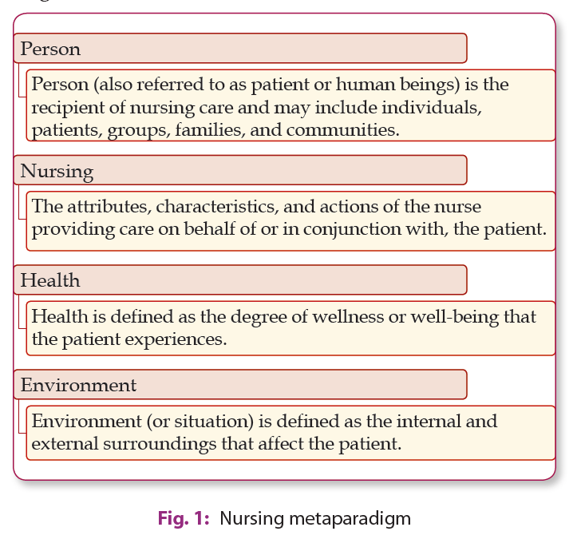
PHILOSOHY OF NURSING
- Philosophy of nursing care states our thoughts that what we believe to be true about the nature of the profession of nursing and provide a basis for nursing activities.
- According to philosophy, nursing is considered as ’profession of charity’. It covers following aspects
PHILOSOPHY OF NURSING BARRIERS
- Spiritual:- spirituality provides the motives for the nurse influenced by spiritual principles. It focuses on developing a sense of meaning, purpose, and hope for the person in their current life experience. Spiritual interventions involve listening to the person's story and facilitating the person to connect to God using meditation or prayer.
- Moral: Understanding of moral principles and actions lead the nurses to study ethics. Nurse has to apply the right conduct in various situations of daily life, based on moral character, adequate understanding and application of moral standards.
- Intellectual: Nurse should be intellectually sound. Nursing education should give training in memory development, communication skills, acting reasonably, judging wisely, strengthening and expansion of capacity.
- Emotional needs: Nurse must be able to function as mature, self-depending personality. She must also be able to relate well to other people
- Physical: Nurse should have knowledge, ability and skills to guide and assist others in carrying out their physical activities. Nurse must have knowledge of, how to keep well and improve health.
- Social: Nursing is linked to social culture, in which nursing is carried out. Nurse is a social being, who passes her life in society in relation to which she has privilege and obligations. Nursing is a support of individual, family and society. It depends on art and science, which form the position, intellectual fitness and showing abilities of the individual nurse, to help individuals, debilitated or well, to meet their wellbeing needs in clinical way.
- Other Barrier:
CHARACTERISTICS OF NURSING PRACTICE
Respects the diversity
Nursing practice respects the diversity and is individualized to meet the unique needs of the patient, family and group or community. All these are health

COORDINATION
The nurses establish coordination with the heath care team and address the needs of the patients and achieve the goals to deliver the quality health care.
SYSTEMATIC AND SCIENTIFIC APPROACH
Nurses use nursing process (cognitive skills and evidence-based practice) to make diagnosis, identify objectives, plan and implement and evaluate the care. Critical thinking underlines each step of nursing process.
HEALING ENVIRONMENT
Nursing practice is a strong link between the professional work and environment to provide optimal level of health care services and to achieve optimal outcomes.
CONTINUUM OF CARE
Professional nurse provides hospital or community based specialized care to the patients experiencing health problems.
THERAPEUTIC COMMUNICATION
It is a process of interacting with the patients that focuses on advancing their physical and emotional well-being.
With therapeutic communication, the nurse understands the response of the patient that is beneficial to the patient’s mental and physical health.
Therapeutic communication is the backbone of the nursing.
PHYSICAL AND BIOLOGICAL INTERVENTIONS
Nursing involves delivering or assisting in various psychical and biological interventions such as medications, surgery and direct physical care (personal hygiene, nutrition, sleep, etc) of the patients having illness.
PSYCHOSOCIAL INTERVENTIONS
Psychosocial interventions are increasingly used in health care settings.
It includes psychotherapy interventions, such as cognitive behavioral therapy, family therapy, milieu therapy and psychodynamic approaches.
These interventions are used by the nurses to a broad range of psychological problems

SPIRITUAL INTERVENTIONS
It focus on developing a sense of meaning, purpose, and hope for the person in their current life experience. Spiritual interventions involve listening to the person's story and facilitating the person to connect to God using meditation or prayer
THERAPEUTIC RELATIONSHIP
The fundamental elements of nursing care revolve around the interpersonal relations and interactions established between nurses and patients. Caring for people demands an intensified presence and a strong desire to be supportive
EMPATHETIC NURSING
It is the core of nursing where nurse try to Understand patient’s perspective. Empathy reinforces a positive psychological and enhances patient’s sense of importance.
SUPPORTIVE CARE
Successful therapeutic relationships between nurses and patients need to have positive support. Minor activities, such as sitting with the patients or reading the newspaper together can improve the quality of support provided. Therapeutic touch is intended to comfort and console patients.
LEGAL AND ETHICAL PARAMETERS
Professional nursing takes place in legal and ethical boundaries. Nurse must have clear sense of professional ethics, one's own values that helps her to be honest and committed nursing professional
SCOPE OF NURSING PRACTICE
The scope of nursing practice is defined as the range of roles, functions, responsibilities, and activities which registered nurses are educated and authorized to perform. The broad scope of nursing practice reflects all of the roles and activities undertaken by the nurses to address the full range of human experiences and responses to health and illness. Nursing practice is accomplished through the following:
1) EXPANDED ROLES OF NURSES
- Home care Nursing
- Institutional nursing
- School health nursing
- Geriatic nursing
- Industrial nursing
- Nurse educator
- Nurse epidemiologist
- Rehabilitation nurse
- Military nursing
- Diaster nursing
- Nurse researcher Nurse enterrpreneur
EXTENDED ROLES OF NURSES
- Certified Registered Nurse Anaesthetist
- Nurse Practitioner
- Psychiatric Nurse Practitioner
- Adult Nurse Practitioner
- Paediatric Nurse Practitioner
- Nurse Midwife Practitioner
- Oncology Nurse Practitioner
- Nurse Informatics Specialist
- Registered Nurse Lawyer
FACTORS AFFECTING SCOPE OF NURSING PRACTICE
- Issues and Challenges - Issues such as kind infrastructure, co-morbidity illness, cost of treatment, availability of resources and manpower, community awareness, stigma etc. are the important factors affecting the role and functions of a nurse .
- Practice Trends -Trends such as deinstitutionalization, integrated and continuity of services, holistic aspects of care, Use of information technology, Evidence Based Practice and pandemic such as COVID 19 has broaden the role and functions of the nurses
- Professional Practice Standard and Quality of Care- These standards identify the competency requirements for a nurse to practice and guide them to functions according to the expected norms
- Personal Characteristics of a Nurse - Interest, altruism, professional competencies, emotional wellbeing, values and many personal characteristics of a nurse influences their roles and functions.

FUNCTIONS OF A NURSE
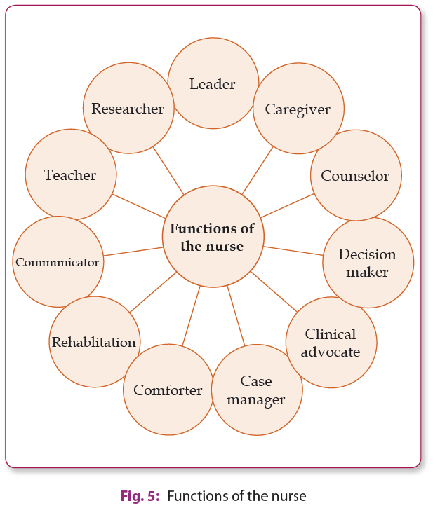
QUALITIES OF NURSE
As new nurses are entering the workforce, identifying and encouraging specific nursing qualities will help hospitals and health systems recognize strong nursing candidates for hire and understand which current nurses on staff would make great leaders.

1. Caring
Many nurses who choose the nursing career for job security,. But as a nursing quality, caring makes all the difference to patients. A nurse showing a natural tendency to truly care about how their patients feel (and in turn, how well they perform their job) will have a significant impact on their success in the nursing field, which makes caring a key indicator of a nurse’s success.

2. Communication Skills
Strong communication skills are critical characteristics of a nurse. A nurse’s role relies on the ability to effectively communicate with other nurses, physicians, disciplines across other units, patients, and their families.
Without the ability to interpret and convey communication correctly, medical errors are more likely to occur, patients often feel neglected or misinformed, and the entire unit will feel the impact. By practicing communication skills, nurses will provide safer care and benefit their patients, their unit, and the entire hospital/health system.

3. Empathy
A characteristic of a good nurse is one that shows empathy to each patient, making a true effort to put themselves in their patients’ shoes. By practicing empathy, nurses are more likely to treat their patients as “people” and focus on a person-centered care approach, rather than strictly following routine guidelines.

4. Attention to Detail
A good nurse knows the stakes are high and that unlike in most other industries, they’re responsible for peoples’ well being and more importantly—their lives. Having a strong attention to detail is one of the nurse personality traits that can easily and quickly determine how successful they’ll be in their role.

5. Problem Solving Skills
Problem solving skills are essential to nursing, as nurses generally have the most one-on-one time with patients and are often responsible for much of the decision-making related to their care. Even seemingly small decisions can have major impacts and cause adverse patient outcomes if incorrectly made.

6. Stamina
As nursing is over whelmed with lot of pressure due to lack of proper nurse patient ratio and other. Therefore an effective managing skill is important that helps a nurse to cope and improve her occupational role . This extremely important skill impacts nurses, their coworkers, and of course, the patients. Having sufficient stamina is one of the most important qualities of a great nurse.

7. Sense of Humor
Having a good sense of humor also helps spread positivity to other nurses, patients, and their families. A good sense of humor is not only a characteristic of a nurse leader, but reminds patients and their families that “nurses are people, too” and ultimately increases their trust and openness with sharing feedback and concerns

8. Commitment to Patient Advocacy.
As one of the leading qualities of a nurse leader, a great nurse understands that patient advocacy is a mindset that must be practiced every day, with every patient, throughout every stage of the care continuum. Many patients enter a hospital or healthcare setting disoriented, confused, and unable to truly “speak up” and advocate for their safety. Having a nurse that practices with a strong passion for patient advocacy will ensure they’re always fighting for the very best care for their patients.

9. Willingness to Learn
With technological improvements and breakthrough studies in science, the healthcare industry (and healthcare workers) must prove to be successfully adaptive to provide the highest quality patient care possible. Nurses spend more bedside time with patients than any other role in healthcare and their willingness to learn and put new knowledge into practice is one of the leading traits of a good nurse.
Improvements in education approaches (e.g., multidisciplinary training, personalized learning, etc.) can help foster successful learning environments, but a good nurse must possess a natural willingness to learn for them to be truly beneficial. This important skill applies to nurses of all ages, throughout every stage of their career, from recent graduates to the highly experienced.

10. Critical Thinking
While having a strong willingness to learn is an important skill in a good nurse, putting that knowledge into successful practice requires an ability to think critically—especially in high-stress situations. A nurse with highly functioning critical thinking skills is one of the most important characteristics of a professional nurse.
After years of education and training, the ability to apply clinical guidelines and best practices on the floor depends on a nurse’s ability to think critically, which is quickly noticed (either positively or negatively) by leadership, other nurses, and ultimately, patients. While this skill can be improved over time, it’s often something that comes more naturally to some nurses than others.

11. Time Management
Having the ability to implement effective time management is a key personality trait for nursing, as is being able to concentrate on the most critical issues first, which isn’t necessarily the patient/family that’s demanding the most. Setting time aside for self care is also a crucial component to time management.

12. Leadership.

Exercising leadership skills in any role/level of the organization shows a willingness to grow and adapt at one’s own pace. Mentorships from nursing leaders can also teach invaluable lessons on how to become a great nurse.

13. Experience
As nursing leaders work to bring new nurses in the door, most available candidates are predominantly new graduate nurses—a stark contrast to their predecessors in terms of experience and the many patient care skills and knowledge that can only come with time and practice.

References
- Kozier & Erb's Fundamentals of Nursing, concepts, process and practice , (10th Edition). Tenth Edition
- Audrey Berman and, Shirlee Snyder. 2016.
- Potter, P. A., Perry, A. G., Hall, A., & Stockert, P. A. (2017). Fundamentals of nursing. Ninth edition. St. Louis, Mo.: Mosby Elsevier.
- Barbara Kozier - Fundamentals of Nursing ed. Fourth Addison Wesley Canada 1991
- Textbook of Foundation of Nursing" by Jyoti Kathwal
- Alisha Cornell, Natalie Vaughn, February 25, 2020, Cited On 12/7/2023

Internet
1.https://www.who.int/news-room/campaigns/year-of-the-nurse-and-the-midwife- 2020 2.https://www.icn.ch/ 3.www.un.org 4.https://archive.org/account/login 5.https://theweek.com/audio/623296/brief-history-florence-nightingale-founder- modern-nursing 6.https://www.icn.ch/nursing-policy/nursing-definitions 7.https://www.ukessays.com/ 8. https://www.nursingschoolhub.com/history-nursing/ 9. https://www.nursingtimes.net/

