Four-Element MIMO antenna design for capacity enhancement in 5G Smartphones
Ms. Sarabjeet Kaur Dr. Niraj Agrawal Md. Sazid Dr. Pavan Kumar Shukla
ECE, NIET ECE, NIET ECE, NIET ECE, NIET
Greater Noida Greater Noida Greater Noida Greater Noida
India India India India

- INTRODUCTION
People have been obtaining a progressively quick information transfer rate because of the immense prosperity of current communication networks. As a result, new wireless communication systems must have a substantially higher channel capacity, which greatly encourages the development of 5G communications. The introduction of 5G connectivity is imminent. It is commonly known that one of the essential technologies to be employed is 5G, Multiple antennas employed expand the capacity of channels and enhance the reliability of communication by using Multiple input multiple output (MIMO) systems.
Communication over 5G must be able to accommodate a greater data transfer rate, a shorter transmission delay, and a larger channel capacity in comparison to 4G communications.
In comparison to single-antenna systems, MIMO diversity strategies greatly increase a system's reliability and transmission capacity without the increase in power and bandwidth [1]. MIMO communication systems need mutual coupling to work. The installation of many antennas in the transmitter and/or receiver with small dimensions is usually the primary constraint for antenna designers. When multiple antennas are packed closely together in portable MIMO systems, there is inevitably strong mutually beneficial coupling between the antenna elements, which degrades diversity performance. Constructing a MIMO antenna demands addressing the essential issue of mutual coupling which is high between the antenna components while maintaining the acceptable size.
Although UWB systems have several benefits, signal fading in multipath situations is a problem. UWB and multiple-input multiple-output (MIMO) techniques combinedly solve this problem using MIMO as compared to MIMO implemented in narrowband systems like UMTS [4] and WLAN [5] has been investigated in [3], which arrived at the opinion that it significantly increases channel capacity in ultra-wideband (UWB) systems.
In UWB MIMO systems, multiple techniques have been proposed forth for reducing mutual coupling between the radiating components. In [1]– [6] inserting MIMO antennas has been researched for enhancing isolation using various defective ground structures (DGS), including stubs and slots between the two radiating elements. A rectangular patch has been attached to the back portion of the radiator and an I-shaped slot created which is used to fed in asymmetric coplanar strips (ACS), While enhancing the isolation through the application of an electromagnetic band gap development in the kind of shape of a mushroom between two antennas. A further challenge is electromagnetic interference (EMI), which impacts MIMO devices employing the UWB frequency. Designing a UWB antenna with band-notched characteristics is an acceptable answer to the issue at hand. As a result, plenty of techniques for minimizing interference have been provided in the literature, featuring others such as creating two split ring resonator slots inside the antenna element along with inserting a short stub, arc-shaped slot, or alternative approaches.

Table 1 The MIMO which has been proposed compared to other existing antennas.

Ref. | Size S₁₁ (mm²) | S₁₁  (GHz) | Isolation  (dB) | Gain | Efficiency
[1] | 35×40 = 1400 | 3.1-10.6 | -16 | within 3.1 | -
[2] | 27×28 = 756 | 3-10.6 | -16 | stable (variation < 3 dBi) | more than 82%
[3] | 32×32 = 1024 | 3.1-10.6 | -15 | 1.7 to 4.2 dB | above 60%
[4] | 26×40 = 1040 | 3.1-10.6 | -15 | 0.9 to 6.5 dBi | above 80%
[5] | 30×40 = 1200 | 3-10.6 | -16 | - | 70 to 77.5%
[6] | 26×26 = 676 | 3.1-10.6 | -15 | almost constant (variation < 0.85 dBi) | -
Proposed | 39.6mm×34mm | 2.9-20 | -22 | Upto 7 dB

However, comparable to the described design, multiple MIMO antennas, both with and without the band-notching properties shown in Table 1, are significantly larger and have smaller isolation. Because of its compact dimensions and low mutual coupling, the newly designed antenna provides an excellent option for various portable wireless applications. In this study, an efficient dual band-notched tapered-fed MIMO/diversity is suggested.
- ANTENNA DESIGN
Here, a common proposed structure is made up of a ground plane and four identical radiating elements. The intended antenna's overall dimensions are only 39.6mm×34mm or about 0.396λ₀×0.34λ₀ where λ₀ is the needed first resonance frequency's 3.0 GHz free-space wavelength. However, the fundamental requirement of the objective of the UWB antenna is to maintain the compactness of the design while maintaining a decrease in the cut-off frequency, especially 3 GHz. The procedure for establishing the antenna structure and its size to satisfy the operating frequency requirements is the first phase in the basic design of the antenna. The equation of frequency can be used to get the monopole's fundamental lower resonant frequency. A monopole structure has been employed for the design of a compact UWB antenna.
The equation of frequency can be used to get the monopole's Lower basic resonant frequency. For a compact UWB antenna, a monopole structure has been proposed. Without L strips, it is obvious This happens when port 1 is activated and port 2 is closed, there is a combination of the entire ground plane having current passing through both ports. When port 1 is excited and port 2 is terminated, Fig. 1(b) illustrates the current distribution with I-slits. Port 1 on the ground plane collects almost all the surface current. In other words, it decreases the power, which is delivered from port 1 to port 2, but some currents are still associated with port 2, leading to insufficient isolation. Additionally, the isolation between ports 1 and 2 was substantially enhanced through the conversion of the I-strip to an inverted L-strip., S₁₂ and S₂₁ are more than -18 dB throughout the entire used band, indicating that the strong surface current occurs at the feeding strip, and radiating element at port 1.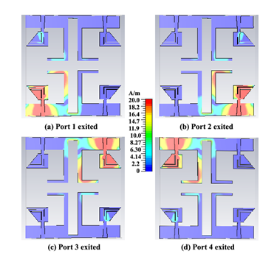
Figure 1: Current distributions of the proposed design
To further improve the isolation between the four antennas the thing which can be done is etching a rectangular slot that generates an entirely novel ground plane that has an inverted L form. MITS-Eleven Lab PCB machine is utilized for fabricating the MIMO antenna on the FR4 dielectric substrate. Different radiator forms were used as the final antenna developed. For excellent UWB performance, (antenna A) recommends a tapered fed line with one side of the substrate, however, is an inverted L-shaped ground plane (as seen in Fig. 1), and a polygon-shaped radiator on the other.
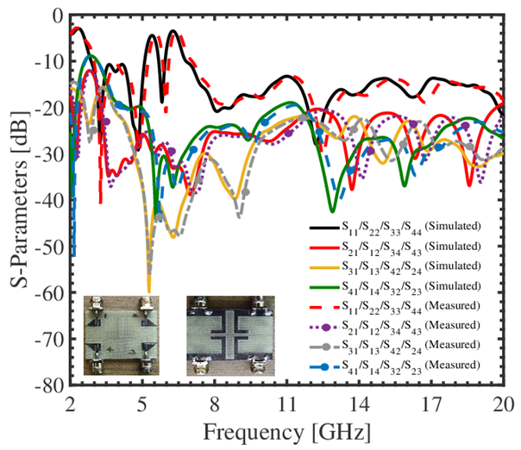
Figure. 2 Simulated and measured S-parameters
Fig. 2 shows an analysis of simulated S₁₁ and frequency for several radiator designs. For decreasing interference in the WLAN band, Antenna B's UWB performance was also modified. As shown in Fig. 1, an L-shaped slot is etched into the radiator's upper section. to suppress the WLAN band (5.09-5.8 GHz) in the UWB band. The bottom portion of the radiator gets etched with an L-shaped slit for reducing higher frequencies. The simulated S11 is illustrated in Figure 2 for every contour that was applied to construct the final design.

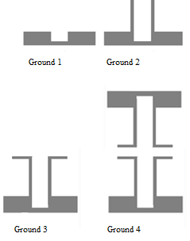
Figure 3: Ground plane evolution
Fig. 3 represents the ground plane's evolution geometry for the proposed MIMO antenna. In addition, there is very little isolation between the antennas. Even though there is extremely limited mutual coupling in the frequency range below 4 GHz, the resonance in the ground plane has been reduced to 3.5 GHz by introducing two vertical rectangular strips. Furthermore, the ground plane resonance frequency decreases to 3 GHz with a 2.5 GHz lowest cut-off frequency whenever inverted L-shaped strips are utilized. Throughout the entire frequency spectrum (2.5–20 GHz), these inverted L-shaped strips significantly decrease mutual coupling.
- PERFORMANCE OF PROPOSED MIMO
The proposed antenna's MIMO performance is being examined employing the envelope correlation coefficient (ECC), diversity gain (DG), mean effective gain (MEG), and total active reflection coefficient (TARC). While determining the mutual coupling as well as the strength of correlation between each antenna element, the envelope correlation coefficient (ECC), which can also be determined via S-parameters, is employed.
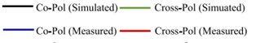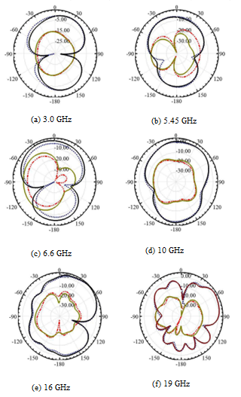
Figure 4: Shows the MIMO antenna's radiation patterns at (a) 3.0 GHz, (b) 5.45 GHz, (c) 6.6 GHz, (d) 10 GHz, (e) 16 GHz, and (f) 19 GHz.
Multiple-Input Multiple-Output (MIMO) antennas have been employed in modern wireless communication systems. Several wireless communication technologies, including Wi-Fi (802.11n/ac/ax), LTE, and 5G, use MIMO technology to boost data speeds, improve system capacity, and increase link dependability. Several significant factors influence how well a MIMO antenna system operates, such as Improvements in diversity, channel capacity, spatial multiplexing efficiency, beamforming, spatial processing, interference reduction, and channel conditions are every aspect that affects spatial multiplexing.
To achieve the projected efficiency increases, these aspects must be considered throughout the design and deployment of MIMO antenna systems. A modern wireless communication system includes MIMO technology as an essential element since it provides achievable enhance data rates to improve coverage and trustworthiness.
- REFERENCES
[1] S. Zhang, Z. Ying, J. Xiong, and S. He, “Ultrawideband MIMO/Diversity antennas with a tree-like structure to enhance wideband isolation,” IEEE Antenna and Wireless Propagation Letters, vol. 8, pp. 1279–1282, 2009.
[2] G. Srivastava and A. Mohan, “Compact dual-polarized UWB diversity antenna,” Microwave and Optical Technology Letters, vol. 57, no. 12, pp. 2951–2955, December 2015.
[3] J. Ren, W. Hu, Y. Yin, and R. Fan, “Compact printed MIMO antenna for UWB applications,” IEEE Antenna and Wireless Propagation Letters, vol. 13, pp. 1517–1520, 2014.
[4] L. Liu, S. W. Cheung, and T. I. Yuk, “Compact MIMO antenna for portable devices in UWB applications,” IEEE Transactions on Antennas and Propagation, no. 8, pp. 4257–4264, August 2013.
[5] J.-Y. Deng, L.-X. Guo, and X.-L. Liu, “An ultrawideband MIMO antenna with a high isolation,” IEEE Antenna and Wireless Propagation Letters, vol. 15, pp. 182–185, 2016.
[6] J.-Y. Zhang, F. Zhang, W.-P. Tian, and Y.-L. Luo, “Acs-fed UWB-MIMO antenna with shared radiator,” Electronics letters, vol. 51, no. 7, pp. 13011302, 2015.

