NOSOCOMIAL INFECTION AND CONTROL MEASURES
*Dr.R.Krishnaveni¹, S. Lavanya¹, N.Najma Begam¹, R.Raja Rajeshwari¹
*Dr.R.Krishnaveni¹,Assistant professor and Head,Department of Microbiology,Idhaya college for women.Kumbakonam.
S. Lavanya¹, N.Najma Begam¹, R.Raja Rajeshwari¹,Research students ,Department of Microbniology.Idhaya college for women.Kumbakonam.
Corresponding Author ;R.Krishnaveni ,Mail.id;.krishnavenimicro@gmail.com

INTRODUCTION
The hospital acquired infections otherwise called Nosocomial infection. It occurs in hospital or other healthcare or other healthcare facilities. It occurs in hospital, nursing home, outpatient clinic or other. The contaminant equipment, bed lines or air droplet spread infection.
Indwelling catheters, procedure using intravascular, antimicrobial lock therapy. Unexpected blood borne pathogens introducing antibiotics, catheter. Main route of transmission contact by direct contact method. Droplet transmission by droplet containing microbes from infected person. Droplet is generated from coughing, sneezing and taking bronchoscope. Particle less then 5Mm or small size suspend air for long time so the dust particle contain infectious agents. Air borne transmission by environmental factors. Transient flora Staphylococcus aureus, Klepsiella pnemoniae, Acinetebacter, Enterobacter, Candida spp. This goal of hand hygiene by washing normal antiseptic soap hand washing, alcohol based hand rubs. Gloves use of reduce risk. Fomite can transmit microbes. Surface sanitation by non-flammable alcohol vapor in co₂ . For this study, we used settle plates technique to estimate bacterial load in the indoor air of wards.
The present study carried out on the Government hospital, Kumbakonam, Thanjavur(D.t) health care facility in the city of kumbakonam provides high level Medicare to a large population of people in a highly populated state, and render mostly free medical services.
RESULT
Pseudomonas aeruginosa is a very significant contaminant presnt in hospital environment
SUMMARY
Nosocominal infection make up an important problem in public health care nosocominal infections are influenced by the microbes intrinsic virulence as well as its ability to colonize and survive with in institution in the present study the microbes are collected from Kumbakonam Government hospital.
The microorganisms are identified biochemical and culture technique the microbes like Environmental Klebsiella sp., Pseudomonas sp., Aeromonas, Proteus sp., E.coli, Staphylococcus sp., Outpatient ward E.coli, Klebsilla sp., Pseudomonas sp., Enterobacteria, Citrobacteria ICU E.coli, Staphylococcus sp., Male surgery ward Pseudomonas sp., Enterobacteria, Proteus sp., Klebsilla sp., Materity ward E.coli, citrobacter, Pseudomonas sp., Shiella sp., Salmonella sp., the microbes was isolated.
the bacteria isolates listed above as common pathogens isolated from hospital environment (Amadi and Amadife,2006; Madigan et al., 2000;

In this study proved that hospital environment had a more microbial load .The plating techniques more colonies observed in environment and all wards due to hygienic and poor waste management system. So care should be taken to control those environment factors which favours the growth of microbes in indoor environment.
A hospital environment may not be a place the where people get well and but also be a place where sick people get sicker(Madigan et al., 2000).

\
The alarming frequently with which microorganisms in hospital environment resistant to antibiotics, particularly by the mechanisms of transmissible drug resistant and the fact that the antibiotics to which they remain sensitive often highly toxic has made nosocominal infection in a serious problem (Thomas, 1987).
In our present investigation the hospital surroundings and different ward like maternity ward ICU and male surgery ward. Outpatient ward, consist of more antibiotic resistance bacteria, care should taken for maintain environment and wards, cleanliness and make reduce transient microbes and its diseases.
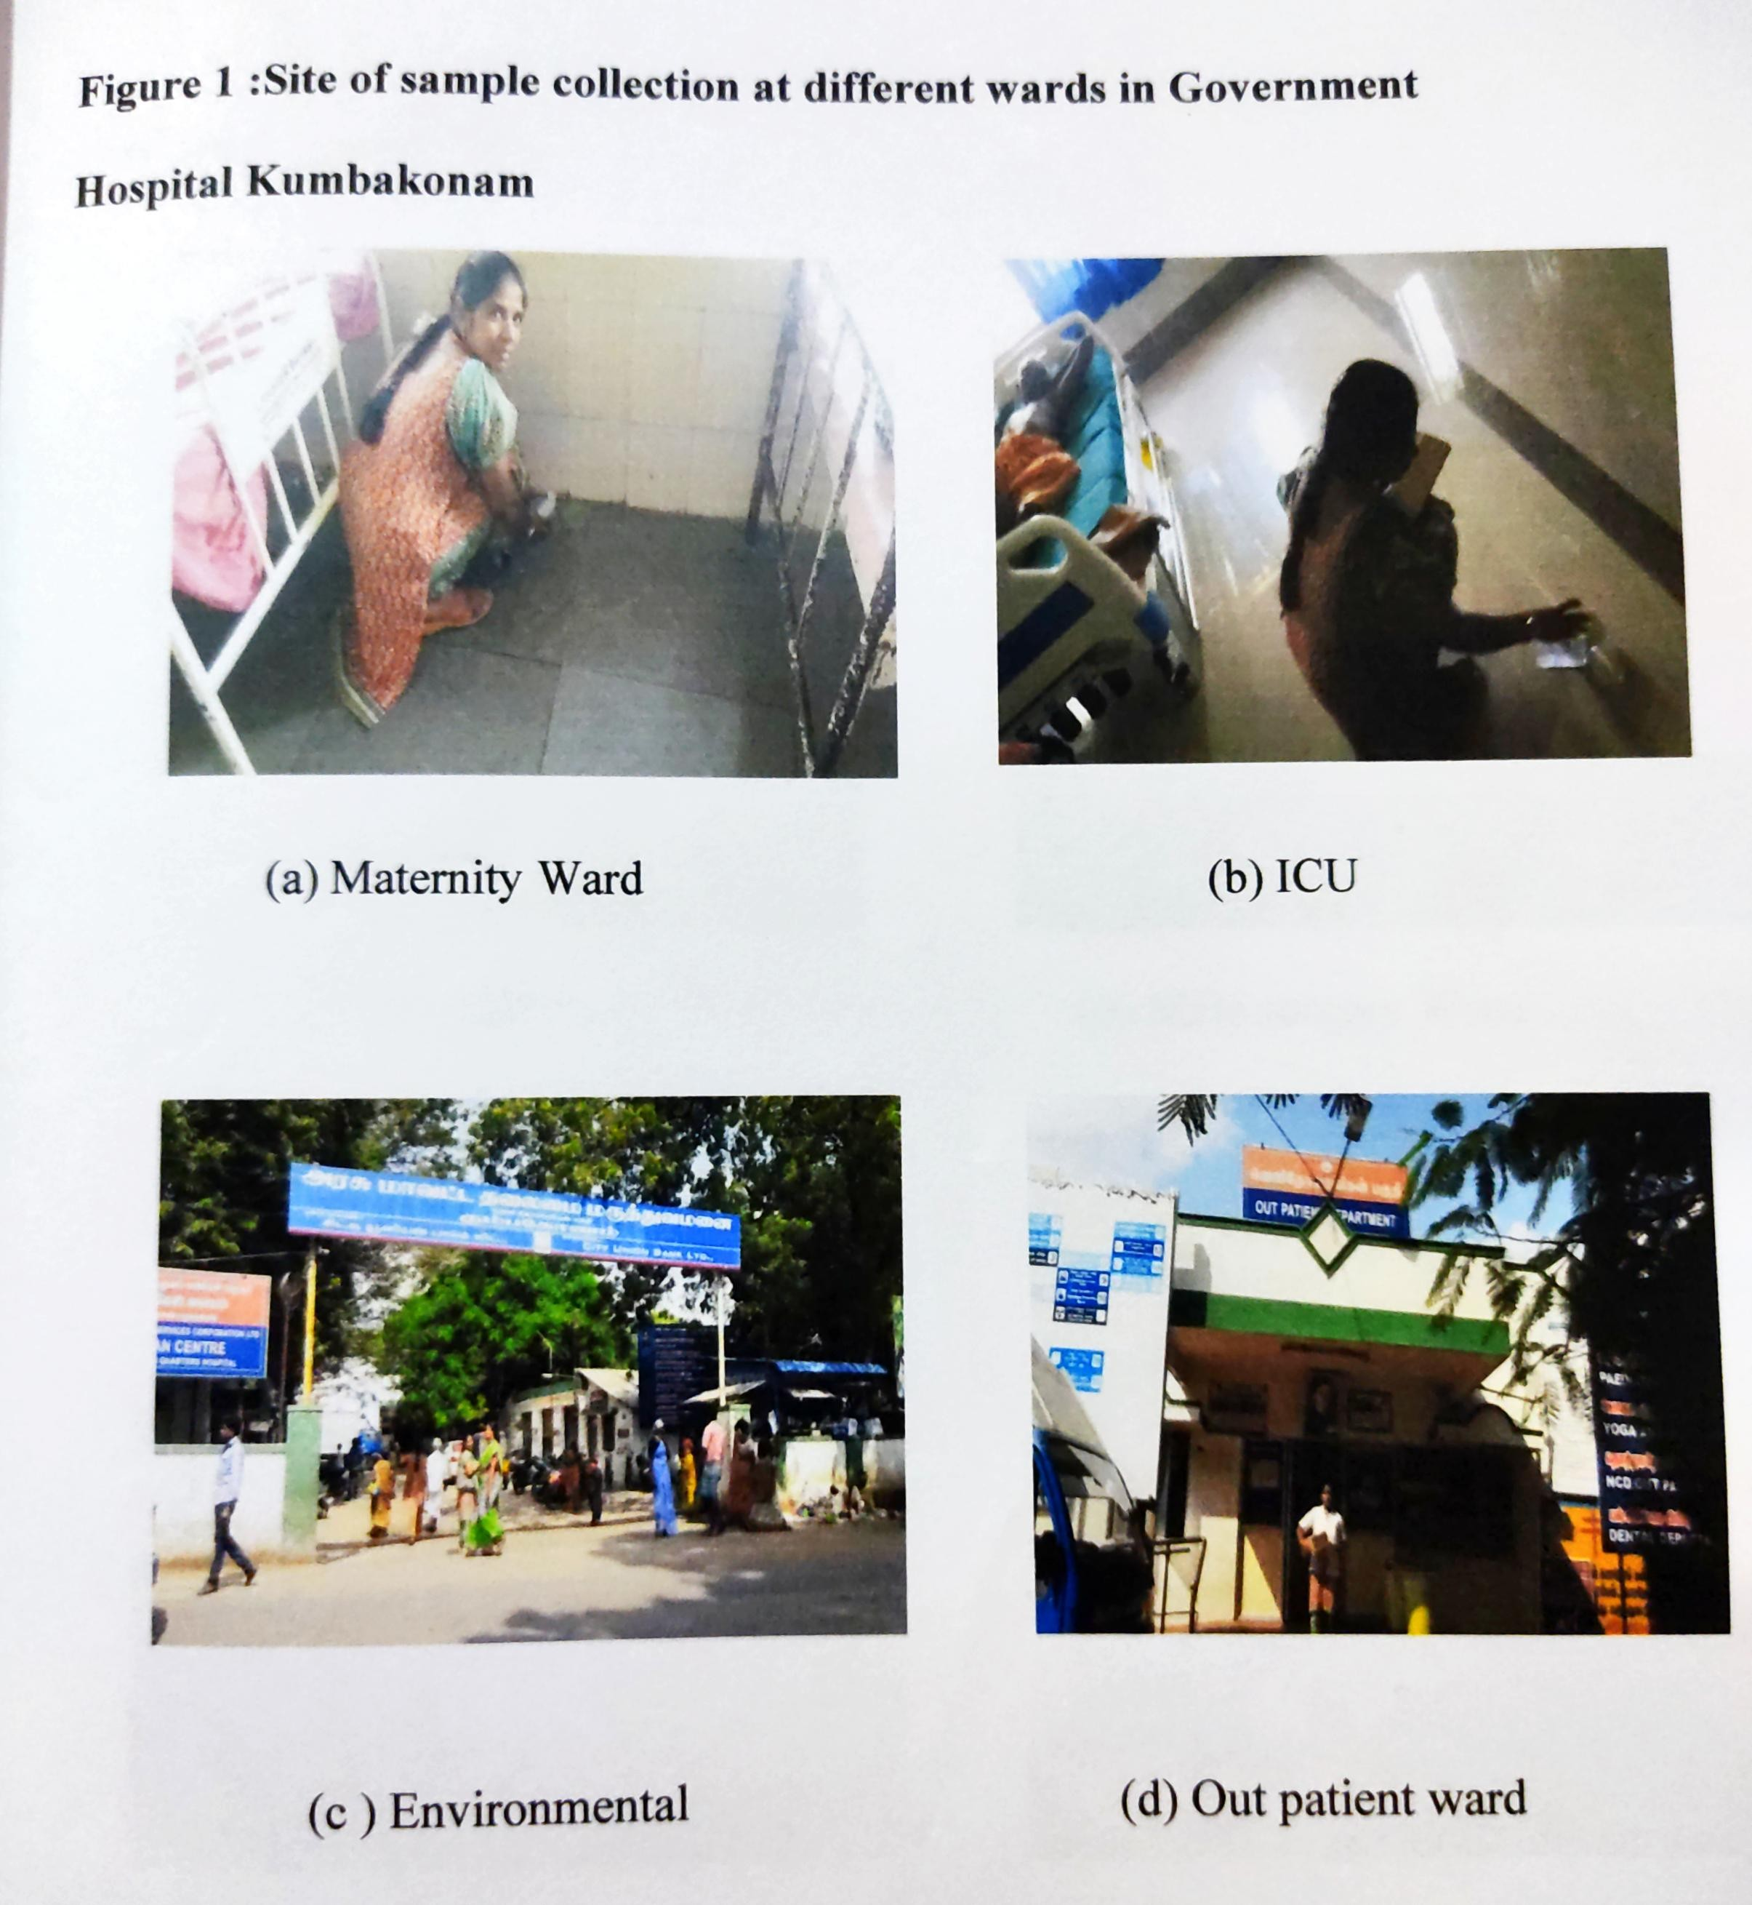

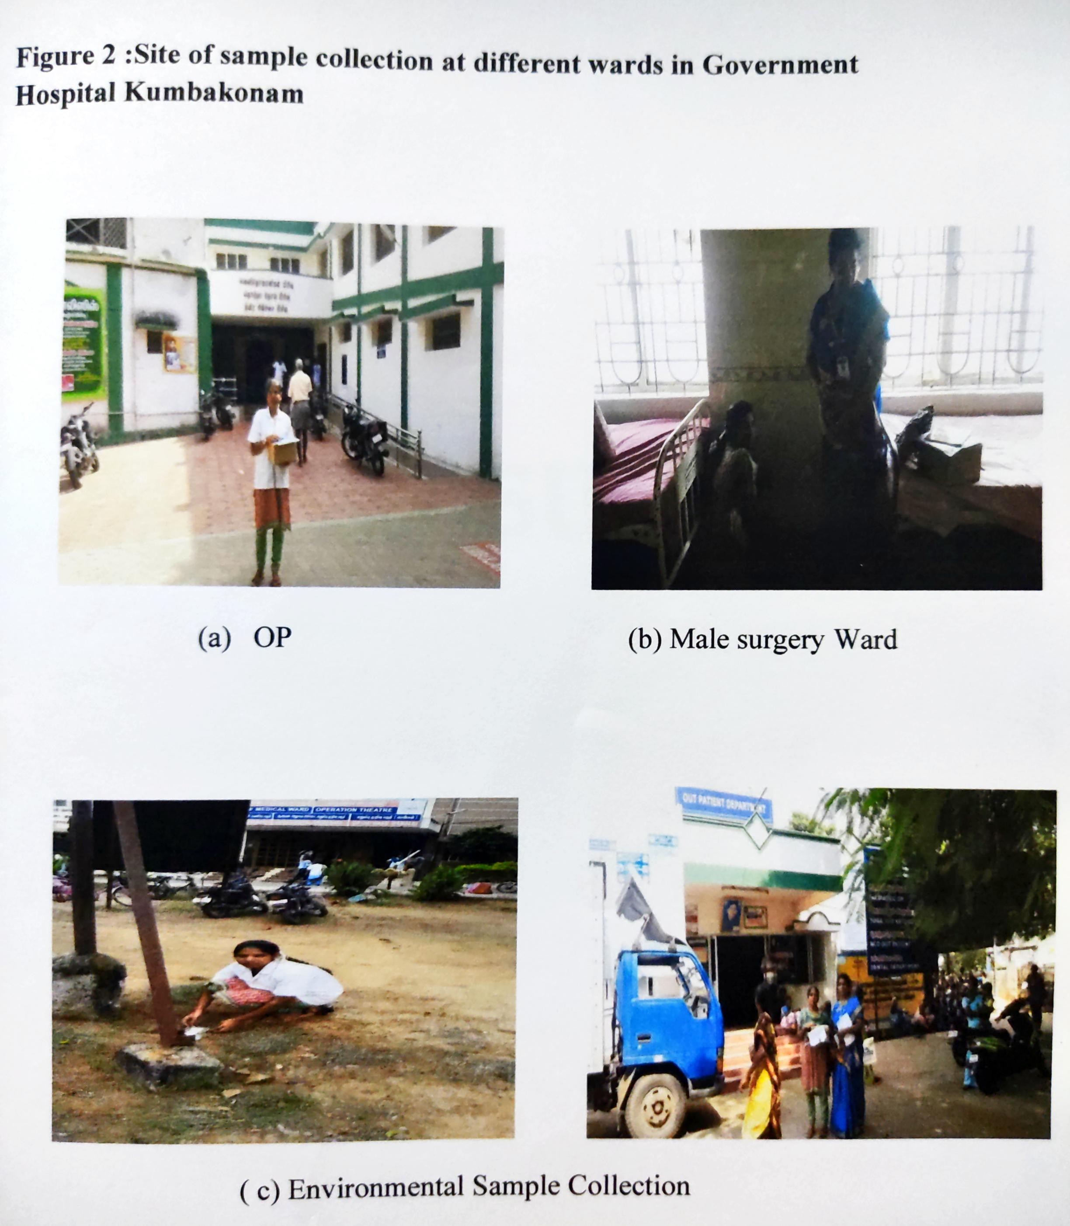

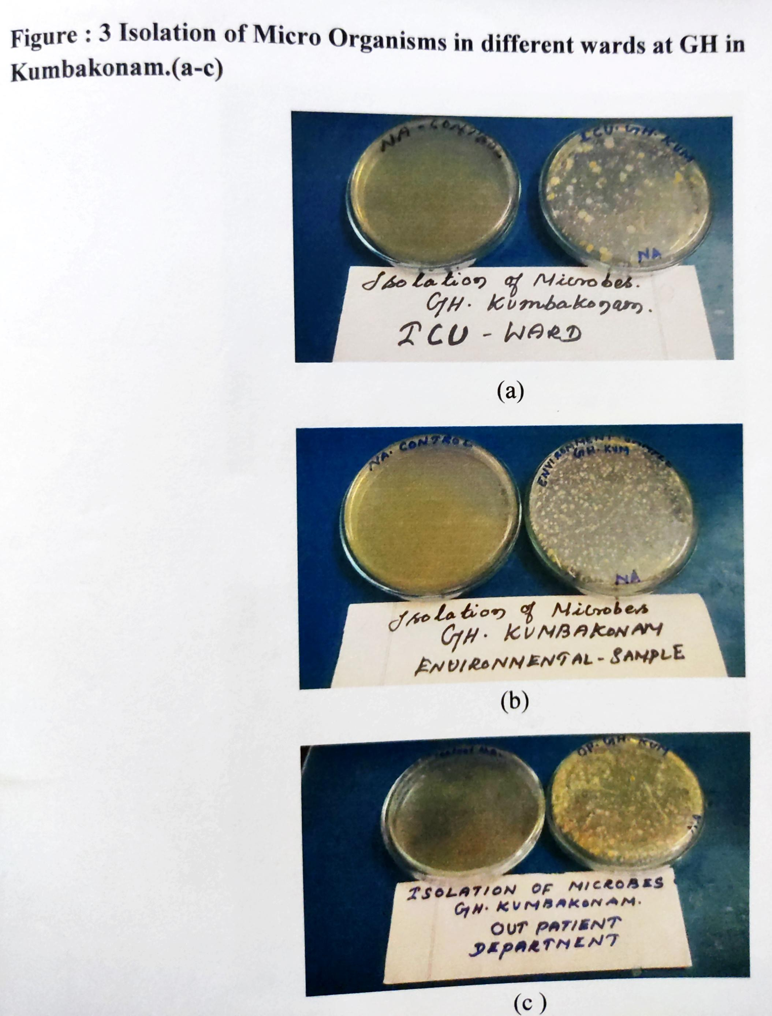

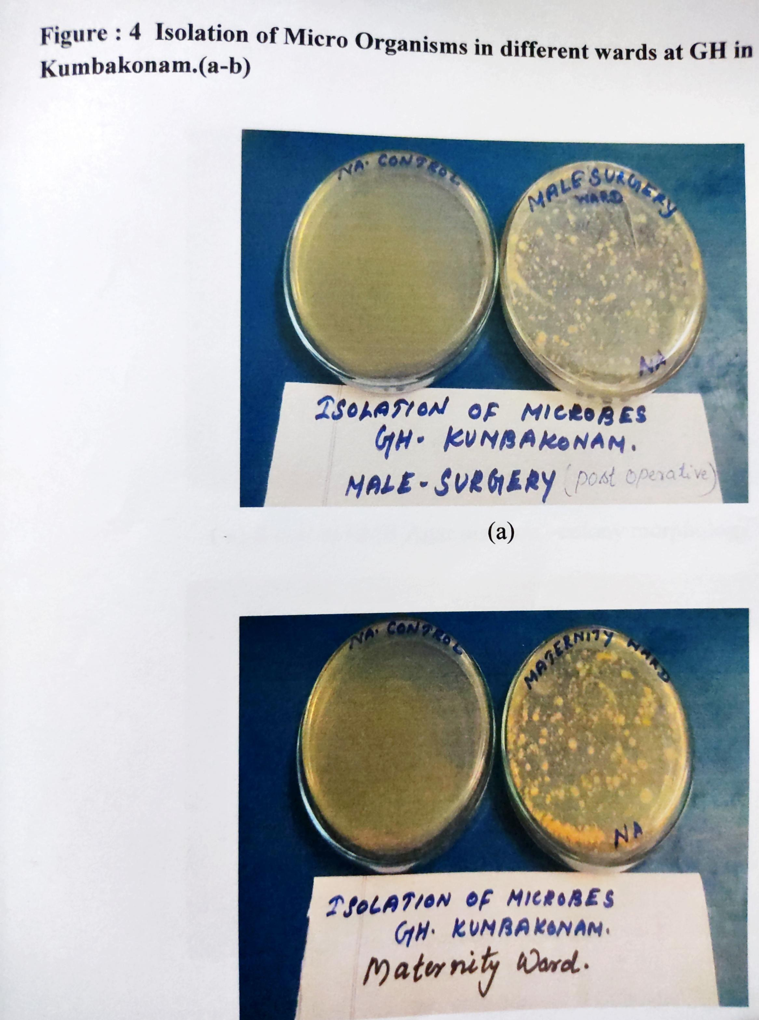

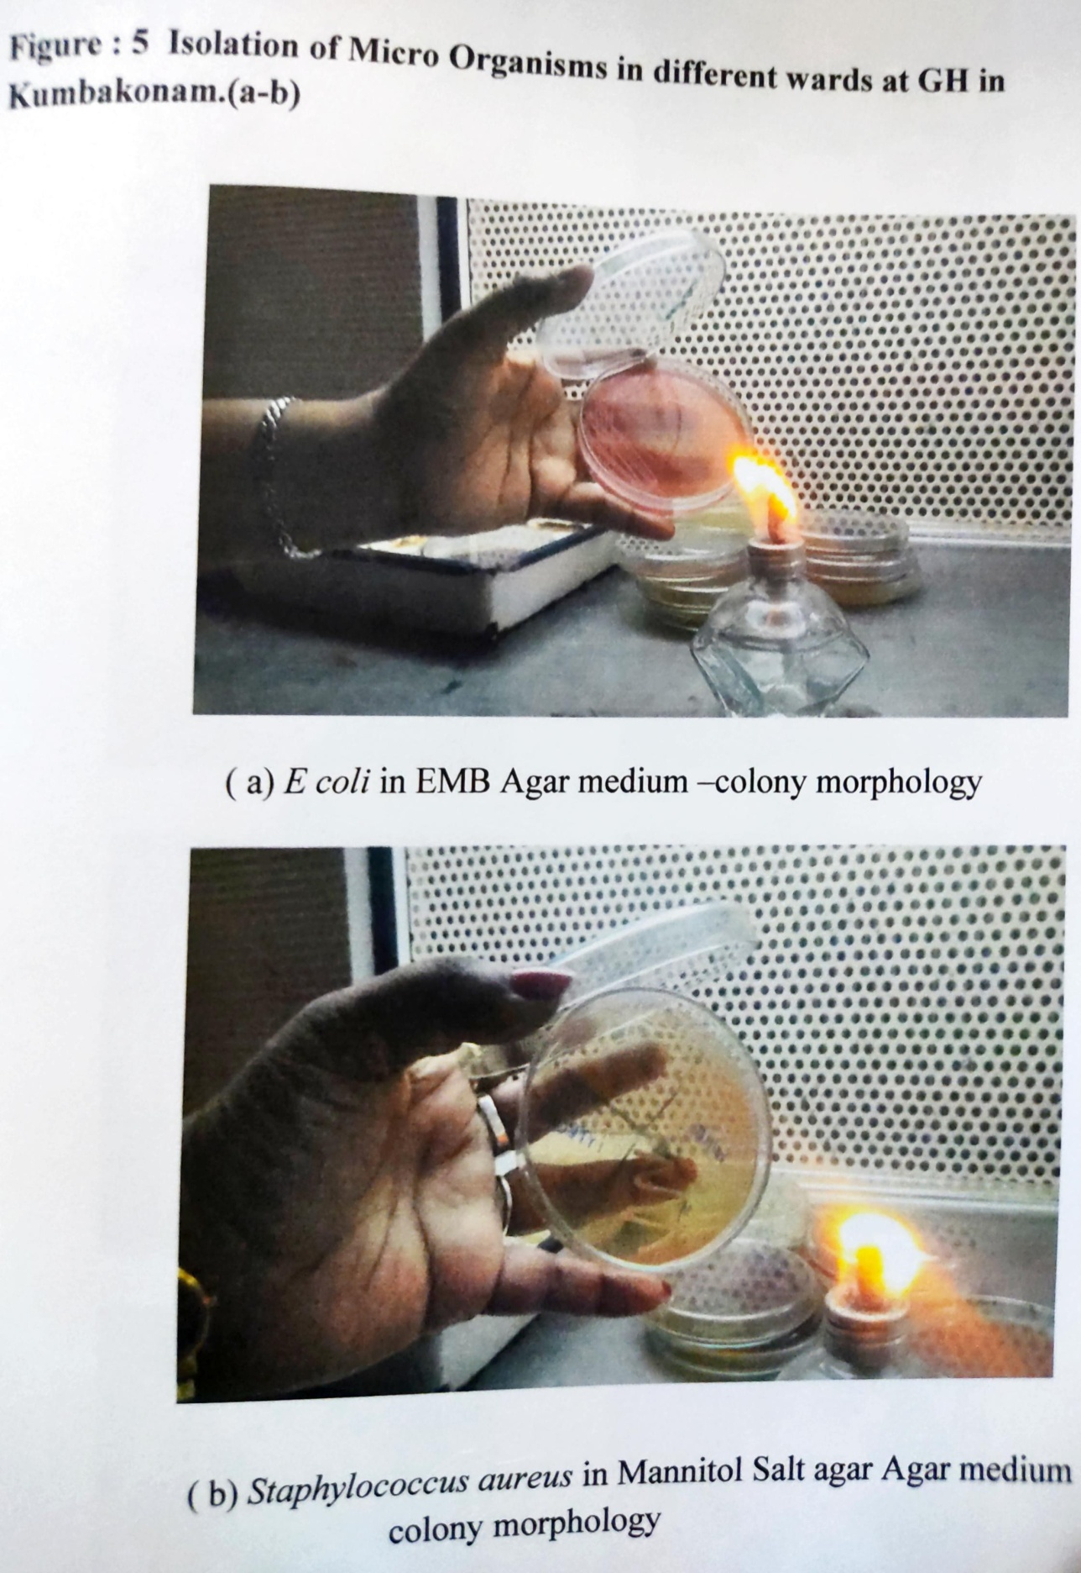

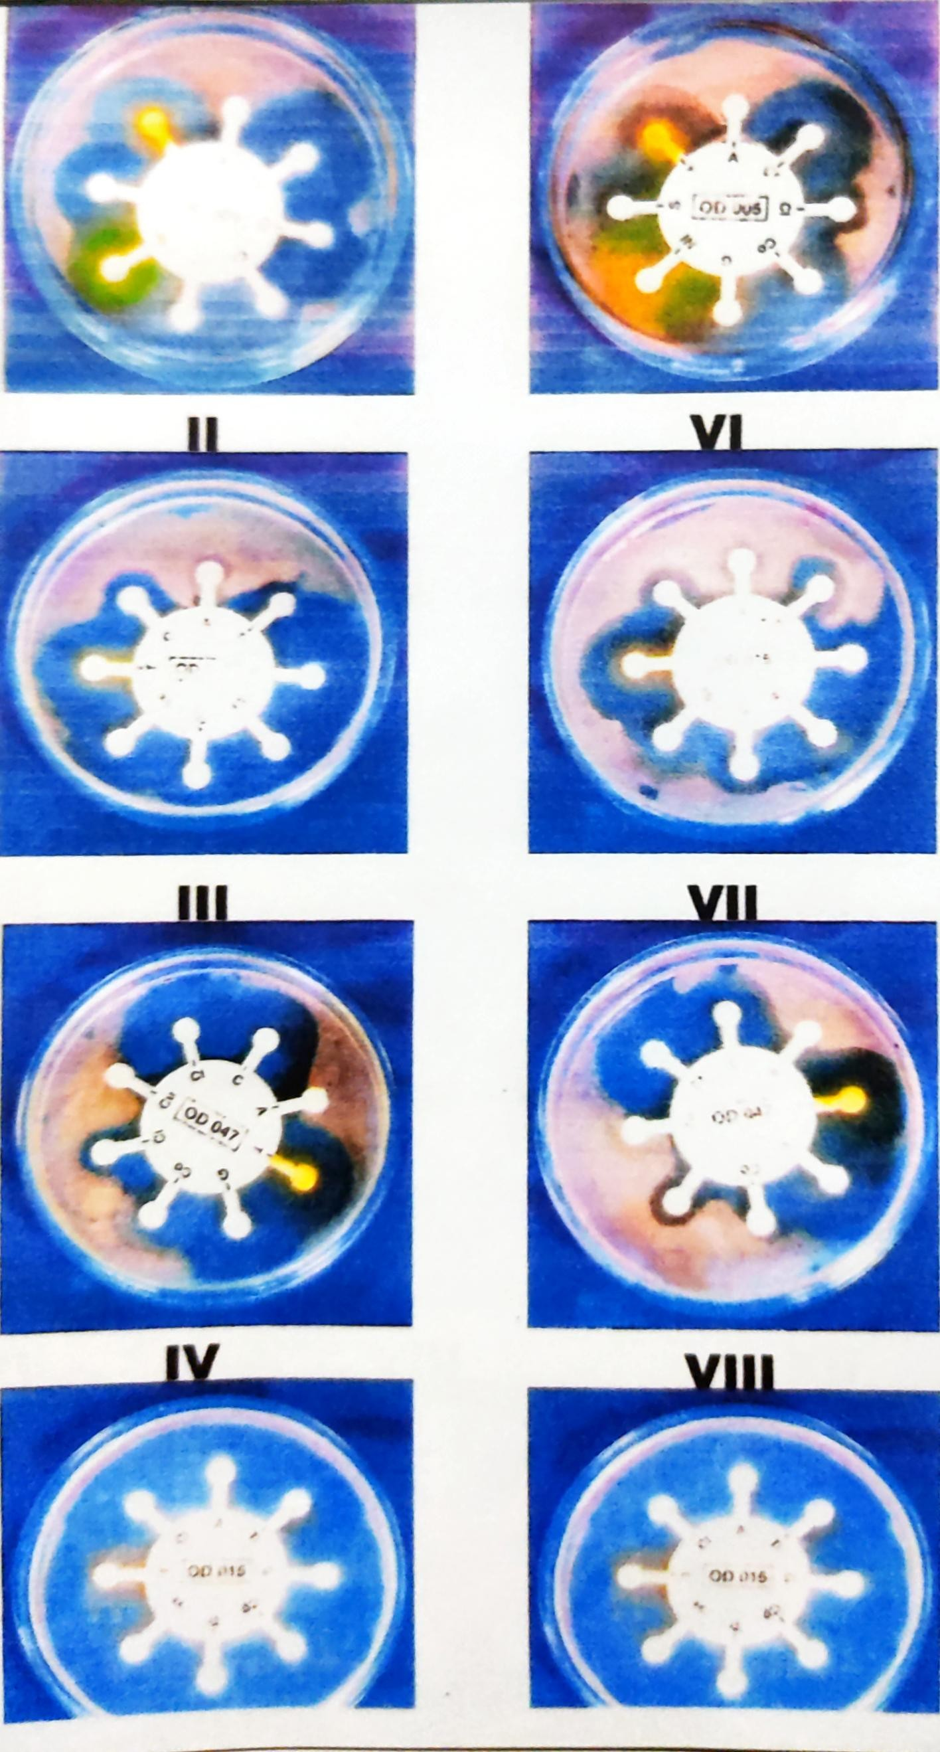

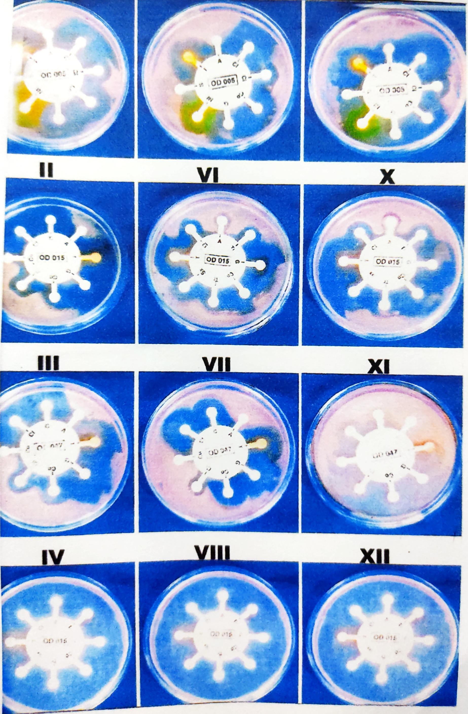

REFERENCE:

- Amadi, E.C.and A.M.Amadifi, 2006. Bacteria air micorflora of medical in the surgical wards of a Teaching Hospital in Nigeria . Proceedings, workshop Foundation for Africal Development Through International Biotechnology(FADIB).
- Madigan, M.T.,J.M.Martinko and J.parker , 2000. Brock Biology of Microorganisms 8th Edition. Prentice Hall, Upper saddle River, NJ.
- Ogunbi O. and C.E.Anywo, 1998. Lagos University Teaching Hospital (LUTH) infection control programme. Proceedings Third Edition National symposium on Nsoscominal infections, lagos.pp
- Thomas, C.G.A. 1988 medical microbiology 6th Edn., Bailler Tindall, London,pp.
- Shigemura K. Tanaka k, Okada H, Nakano Y, kinoshita S, Gotoh A, Arakakwa S, fujisawa M, (2005). Pathogen occurrence and antimicrobial susceptibility of urinary tract infections during a 20 year period JPN.
- Silberg SL, Adess ML, Parker DE, Corrie RN,(1976). Epidemiologic aspects of nosocominal infections . South Med J. Wells WF.(1995). Airborne contagion and air hygine. Chapter 1, Harvard University Press, Cambridge, Massachusetts.
- York MK, Baron EJ, Clarridge JE, Thomoson RB, Weinstein MP, (2000). Multi laboratory validation of rapid spot tests for identification of Escherichia coli.J clin Microbiol.

