HYDROGELS: A review

INTRODUCTION
The most popular drug-delivery nowadays is Nano science and in that Hydrogels have received considerable attention due to their exceptional wide range of applications in Therapeutics [2–4]. In recent years, thorough research has been done on hydrogels with about 5000 papers published in 2010 indicating a promising area in the scientific community (Lee et al., 2013). Hydrogels characteristics are still in research and can be define in different ways like it is a water-swollen, and cross-linked polymeric network with one or more monomers having the ability to swell to retain a higher fraction of water within its structure, but insoluble in water. This water absorption capacity is due to hydrophilic functional groups attached to the polymeric backbone. The cross-links between network chains provides resistance against dissolution. Hydrogels are smart systems and respond according to environmental stimuli like temperature and pH changes resulting in the release of entrapped drugs in a controlled and sustained manner [7-9].
FEATURES OF HYDROGELS
- Water holding capacity
Hydrogels are soft, porous, three-dimensional molecules entangled in web of natural or synthetic polymers possessing the capacity to hold large amounts of water or biological fluids and able to simulate natural living tissue in comparison to any other class of synthetic biomaterials. The amount of the aqueous medium incorporated in a hydrogel is determined gravimetrically and can be expressed by its swelling ratio [8] as
Swelling Ratio=Ws-Wd/Wd
Ws= weight of hydrogel in swollen state
Wd=weight of hydrogel in dry state
Hydrogels containing any acidic or basic functional groups respond to the fluctuations in the pH of external environment, changes in osmotic pressure. The degree of ionization of the functional groups indicates its swelling profile.
- Mechanical strength
This property makes use of hydrogels as
- ligament and tendon repair
- wound dressing material
- matrix for drug delivery
- tissue engineering
- cartilage replacement material.
Hydrogels should maintain its physical texture during the delivery of therapeutic moieties for the predetermined period of time. For stronger hydrogel, the desired mechanical property can be achieved by changing the degree of crosslinking.
- Biocompatibility
Biocompatibility and nontoxic nature is mandatory in biomedical tissue engineering field. To solve the purpose, polymers must pass cytotoxicity and in-vivo toxicity tests. It consists of two parameters: (a) Biosafety- require to protect from cytotoxicity, mutagenesis, and carcinogenesis (b) Bio functionality i.e. material ability to perform particular task for which it is intended.
BENEFITS OF HYDROGELS
- Possess great degree of flexibility same as that of human tissues due to their significant water content.
- Timely release of medicines or nutrients.
- Biocompatible, biodegradable and injectable.
- Possess ability to sense changes of pH, temperature and metabolite concentration.
- Possess good transport properties and easy modifiable.
DRAWBACKS OF HYDROGELS
- High cost.
- Hard to handle.
- Low mechanical strength.
- Non-adherent and needed to be secured by secondary dressing.
- Difficult to load with drugs/nutrients.
CLASSIFICATION OF HYDROGEL
For effective drug delivery hydrogels must exhibit nontoxicity, biocompatibility, and biodegradability. Hydrogels can be obtained from natural and synthetic polymers. So they can be classified based on source, composition, appearance, type of cross links, type of charge etc.
- Classification according to Source
- Classification according to polymeric composition
- According to the biodegradability
- Classification based on configuration
- Classification based on type of cross-linking
- Based on appearance of hydrogel
- According to type of charge on network
- Classification according to mechanism controlling the drug release
- Classification according to Source
- Natural hydrogels- Natural hydrogels have unique features like abundance, nontoxicity, biocompatibility, and biodegradability with good cell adhesion properties. There are two major types of natural polymers which are used to produce natural hydrogels are proteins such as collagen, gelatin and, lysozyme (LYZ) and polysaccharides such as hyaluronic acid (HA) and alginate and Chitosan (Cts) as given in Table 1.
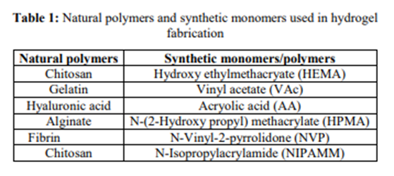
b. Synthetic hydrogels- Synthetic hydrogels are advanced version as their physical and chemical properties can be altered according to need. Polyethylene glycol (PEG) based hydrogels are one class of the widely used material in biomedical application due to their nontoxicity, compatibility and low immunogenicity.
c. Hybrid hydrogels- They are the combination of natural and synthetic polymer hydrogels and make use of naturally occurring biopolymers such as dextran, collagen, Chitosan with synthetic polymers such as poly (N-isopropyl acrylamide) and polyvinyl alcohol.

II. Classification according to polymeric composition
- Homo-polymeric hydrogels- Homo-polymers are cross-linked skeletal structure derived from a single species of monomer. Combination of monomer like poly (2-hydroxyethyl methacrylate) (poly HEMA) and cross linker polyethylene glycol di-methacrylate with polymerization technique. This film can be used for contact lenses, artificial skin manufacturing, burn dressings and also for bone marrow and spinal cord cell regeneration.
- Co-polymeric hydrogels- These are combination of two or more different monomer species with at least one hydrophilic component, arranged in block or alternating configuration. Synthesized by polymerization of BLG N-carboxy anhydride, initiated by diamine groups located at the ends of poly (ethylene oxide) chains of the poly-oxamer a thermoplastic co-polymeric hydrogel based on γ-benzyl L-glutamate (BLG) and poly-oxamer was formed. These hydrogel was pH and temperature sensitive and characterized for drug delivery application.
- Multi-polymer interpenetrating polymeric hydrogel (IPN)- When natural and synthetic polymers are arranged in cross-linked and Non-cross linked network system are called Multi-polymer interpenetrating polymeric hydrogel (IPN). This system is used to confirm stability of bulk products as well as to ensure morphology of surfaces. IPN method can overcome thermodynamic incompatibility occurs due to the permanent interlocking of network segments and limited phase separation can be obtained.
III. According to the biodegradability
- Biodegradable hydrogels- Hydrogels are naturally biodegradable such as Chitosan, fibrin and agar. Some synthetic biodegradable polymers are Poly (aldehyde gluco-uronate), Poly-anhydrides and poly (N-isopropyl acrylamide).
- Non-biodegradable hydrogels- These inclue vinylated monomers or macromers such as 2- hydroxyl ethyl methacrylate (HEMA), methoxyl poly (ethylene glycol) (MPEG), 2- hydroxypropyl methacrylate(HPMA) and acryl amide (AAm).
IV. Classification based on configuration- Based on configuration, hydrogels are classified as Semi crystalline, crystalline and amorphous (non-crystalline).
V. Classification based on type of cross-linking: Chemically cross-linked networks having permanent junctions and Physical networks have transient junctions that arise from either polymer chain entanglements or physical interactions as hydrogen bonds, or hydrophobic interactions.
VI. Based on appearance of hydrogel- Hydrogels appear as matrix, film, or microsphere.
VII. According to type of charge on network-
  - Nonionic (neutral).
  - Ionic (including anionic or cationic).
  - Amphoteric electrolyte (ampholytic) containing both acidic and basic groups.
  - Zwitter ionic (polybetaines) containing both anionic and cationic groups.
    - Classification according to mechanism controlling the drug release
a. Diffusion controlled release systems
b. Swelling controlled release systems
c. Chemically controlled release systems
d. Environment responsive systems
SYNTHESIS OF HYDROGEL
Hydrogels can be produced by reacting hydrophilic monomers with multifunctional cross-linkers by using Copolymerization/ cross-linking free-radical polymerizations. The three integral parts of the hydrogels preparation are monomer, initiator, and cross-linker.
There are some ‘‘classical’’ chemical ways such as:
    - Using ionizing radiation to generate main-chain free radicals which can recombine as cross-link junctions.
    - Linking polymer chains via chemical reaction.
    - Physical interactions such as entanglements, electrostatics, and crystallite formation.
Other preparation techniques for hydrogels are given as:
Bulk polymerization
For preparation of rods, particles, films, membranes and emulsions bulk polymerization is suitable. One or more types of monomers mainly include vinyl monomers and small amount of cross-linking agent is added in hydrogel formulation. Radiation, ultraviolet, or chemical catalysts is used for the initiation of the polymerization reaction. The initiator is chosen which depends upon the type of monomers and solvents being used (Fig. 1).
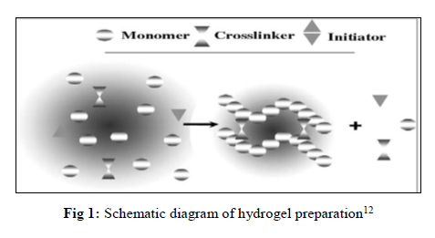
Free radical polymerization
This is a stepwise procedure which involve typical free-radical polymerizations it includes propagation, chain transfer, initiation, and termination steps. The polymer used in this process must have proper functional group it can be radically polymerized also; the radicals react with the monomers which convert them into active forms. The main monomers which are used in this method are acrylates, vinyl lactams and amides.
Solution polymerization/cross-linking
This method is better than bulk polymerization because in it solvent like water–ethanol mixtures, water, ethanol, and benzyl alcohol is used as heat sink so fast and economic also. Both ionic or neutral monomers can be used with the multifunctional crosslinking agent The polymerization is initiated thermally by UV-irradiation or by a redox initiator system. The prepared hydrogels are washed with distilled water to remove the initiator, the soluble monomers, oligomers, cross-linking agent, and extractable polymer, and other impurities (Fig. 2 and 3).
Fig. 2: Hydrogel preparation block diagram Fig. 3: Solution Polymerization with recycle loop
Suspension polymerization or inverse-suspension polymerization
The monomers and initiators are dispersed in the hydrocarbon phase as a homogenous mixture. Since water-in-oil (W/O) process is chosen instead of the more common oil-in-water (O/W), the polymerization is referred to as “inverse-suspension” technique. Hydrogel obtained in the form of powder or microspheres (beads), and thus, grinding is not required so advantageous over other methods. In this technique, the dispersion is thermodynamically unstable and requires both continuous agitation and addition of a low hydrophilic–lipophilic-balance (HLB) agent [5].
Grafting
This technique involves the generation of free radicals onto a stronger support surface and then polymerizing monomers directly onto it. Generally, hydrogels having weak structure can be grafted on surface coated onto a stronger support to improve the mechanical properties of a hydrogel.
BIOMEDICAL APPLICATIONS OF HYDROGELS
Hydrogels are large polymeric networks have a porous structure and soft surface and behave similarly to natural living tissues. Hydrophilic gels called hydrogels receive considerable attention for their use in the field of pharmaceutical and biomedical engineering. For their delivery of drugs into specific sites of the body new therapeutic moieties are discovered with specialized carrier by the use of medical science. By the help of conventional methods hydrogels are capable of delivering genetically engineered pharmaceuticals, viz. protein and peptides and improve the therapeutic efficacy of drugs. Depending on the preparation methods the hydrogels could be homo-polymeric, co-polymeric, semi interpenetrating and interpenetrating polymer networks. Recently, for biomedical applications thermoplastic co-polymeric biodegradable hydrogels with optimum mechanical strength have been designed. Due to its simplicity in manufacturing and self-application hydrogels have been widely used as a drug carrier. Some of the applications are given in Fig. 4 [4-16].

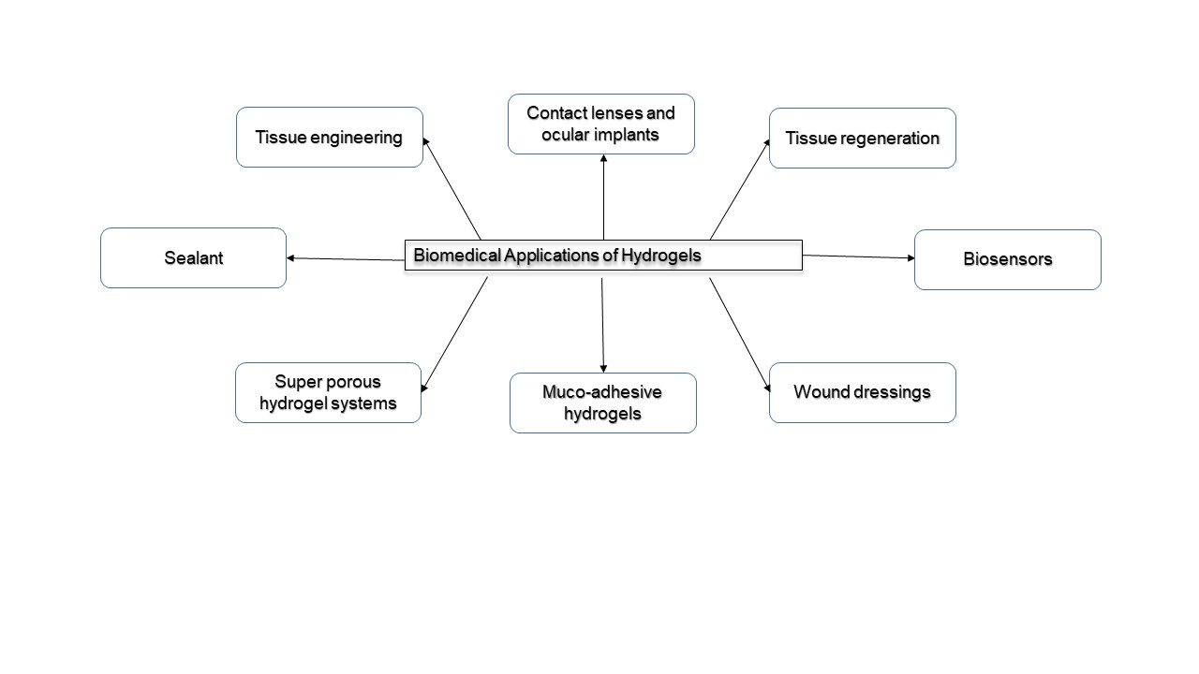
Fig. 4: Biomedical Applications of Hydrogels

CONCLUSION
Hydrogels are hydrophilic polymeric networks which are capable of absorbing large amounts of water or biological liquids, due to which they are widely being used in the medical industry as dressings and even in tissue regeneration and tissue engineering. Vast improvements have been made in the properties of hydrogels used in drug delivery. However further improvements need to be made to improve the applicability of hydrogels.

References
- Shetye SP, Dr. Godbole A, Dr. Bhilegaokar S, Gajare P. Hydrogels: Introduction, Preparation, Characterization and Applications, International Journal of Research of Research Methodology. 2015; 1(1):47-71.
- Singh. S, Dhyani. A, Juyal.D. Hydrogels: Introduction, Preparation, Characterization and Applications, The Pharma Innovation Journal 2017; 6(6): 25-35.
- Das N., Preparation methods and properties of hydrogels: a review, International Journal of Pharmacy and Pharmaceutical Sciences, Vol 5, Issue 3, 2013 :112-117.
- Hoare T.R., Kohane D.S., Hydrogels in drug delivery: Progress and challenges, Polymer, Volume 49, Issue 8,15April 2008:1993–2007.
- Ahmed E.M., Hydrogel: Preparation, characterization and applications, Journal of advanced research, Volume 6, Issue 2, March 2015:105–121.
- Caló E., Khutoryanskiy V.V., Biomedical applications of hydrogels: A review of patents and commercial products, Volume 65, April 2015: 252-267.
- Phadke A, Zhang C, Arman B, Cheng-Chih Hsu, Mashelkar R., Lele A., Tauber M., Arya G., and Varghese S.,Rapid self-healing hydrogels:4383-4388.
- Swarbrick J., Encyclopedia of Pharmaceutics, 4thedition, Vol III, F-O, 6000 Broken Sound Parkway NW, Suite300, Boca Raton, FL 33487-2742, Taylor & Francis Group, 2013.
- Das N. Preparation Methods and Properties of Hydrogel: A Review, International Journal of Pharmacy and Pharmaceutical Sciences. 2013; 5(3):1-2.
- Flowerlet M, Arya S, Mini A, Nayir SS, Joseph J, Vineetha VC et al. Hydrogel - A Drug Delivery Device, International Journal of Universal Pharmacy and Bio Sciences. 2014; 3(2):2-4.
- Devi A, Nautiyal U, Kaur SK. Hydrogels: a smart drug delivery device, Asian Pacific Journal of Health Sciences. 2014; 1(4S):93-94.
- Zaman M, Siddique W, Waheed S, Muhammad SS, Mahmood A, Qureshi J et al. International Journal of Biology, Pharmacy and Allied Sciences. 2015; 4(12):6581-6603.
- Rana P, Ganarajan G, Kothiyal P. Review on Preparation and Properties Hydrogel Formulation, World Journal of Pharmacy and Pharmaceutical Sciences. 2015; 4(12):1069-1080.
- Aulton M., Aulton’s pharmaceutics, The Design and Manufacture of Medicines, Third Edition, Elsevier’s Health Sciences Rights Department, 1600 John F. Kennedy Boulevard, Suite 1800, Philadelphia, PA 19103-2899, Harcourt Publishers Limited 2001
- Tan H, Marra KG. Injectable, biodegradable hydrogels for tissue engineering applications. Materials. 2010; 3:1746-1767.
- Susana S, Figueiras A, Veiga F. Modular Hydrogels for Drug Delivery, Journal of Biomaterials and Nanobiotechnology. 2012; 3:185-199
- . Enas MA. Hydrogel: Preparation, characterization, and applications: A review. Journal of Advanced Research. 2015; 6:105-121.
- Yang L, Chu JS, Fix JA. Colon-specific drug delivery: new approaches and in vitro/in vivo evaluation. International Journal of Pharmacy. 2002; 235:1-15.
- Abdelhalim SMI. Preparation and characterization and In-vitro evaluation of chitosan based smart hydrogels for controlled drug release, Massey University, North New Zealand, 2006, 5-6.

