Positive Organizational Behaviour in Enhancing the Employee’s Work Performance

Authors Details
Ms. Pushpa Chauhan, Research scholar,
Institute of Management studies, Banaras Hindu University,
Varanasi (UP), India
Phone- 8299524849,
Email: pushpa.chauhan.du@gmail.com

Dr. R.K. Lodhwal, Professor,
Institute of Management studies, Banaras Hindu University,
Varanasi (UP), India
Phone: 8573933999
Email: Lodhwalrk@gmail.com

Dr Vinita Kaura, Post-doctoral fellow, ICSSR,
Institute of Management studies, Banaras Hindu University,
Varanasi (UP), India
Kaura2005@rediffmail.com

Abstract
This study is conducted to justify the importance of positive organizational behaviour in organizations. Performance of the organization is focused on by POB, which can develop strategies of the organization. On the other hand, this study can provide information about organizational work performance and its attributes. Individual human behaviour in an organization is controlled and predicted with the help of organizational behaviour. Positive organizational behaviour is involved in the determination of the relationship between work and happiness. Positive psychology can play a crucial role in the application of a positive organizational behaviour approach. Employees are motivated and empowered by POB to provide their opinion on any issues of the organization. POB can provide optimism training for employees to improvise their performance.

Keywords: positive organizational behaviour, human behaviour, psychology, work performance, optimism

- INTRODUCTION
This study explains the efficiency of positive organizational behaviour in the maintenance of the work performance of the organization. Weakness and strengths of employees are justified with the help of positive organizational behaviour. POB can encourage managers and leaders of organizations, by which they can provide their ultimate effort towards the organization. Four factors are involved in POB such as hope, optimism, resilience, and self-efficacy. These factors can maintain fundamental personality traits, which are included in this study. Positive behaviour inside the organization is promoted by POB such as civic virtue, sportsmanship, courtesy, conscientiousness, and altruism. This study explains that work performance and employee well-being is positively impacted by positive organizational behaviour. On the other hand, five key attributes of organizational work performance are evaluated in this study.

- APPROACHES AND ATTRIBUTES OF POSITIVE ORGANIZATIONAL BEHAVIOUR
The strategy and performance of an organization are maintained with the involvement of positive organizational behaviour. Along with this human resource strengths and psychological capacities are justified with the help of this factor. Muchiri et al. (2019) stated that positive organizational behaviour can develop measure and control performance improvement in the workplace. Four key psychological resource capacities are present in positive organizational behaviour, which is illustrated in figure 1. These psychological resource capacities are hope, self-efficacy, resiliency, and optimism. Managing effectiveness and organizational performances are improvised with the involvement of these four resource capacities. Positive psychology can play a crucial role in the maintenance of positive organizational behaviour. Along with this strength and talent of employees depends on positive organizational behaviour. Movement of management and organization are justified with the involvement of positive organizational behaviour. The relationship between a people’s broader and work is identified and maintained by positive organizational behaviour. Resource capacities of POB are described below:

- Self-efficacy:
Self-efficacy is treated as an effective component of positive organizational behaviour, which directly has an impact on the working efficiency of employees. To manage prospective situations self-efficacy can help employees to take proper action. All criteria of positive organizational behaviour are maintained with the help of the self-efficacy process. The Effort of people is adequately justified with the involvement of the self-efficacy process; this factor improvises quality of work. On the other hand, efficacy can evaluate the persistency of workers, which is useful for organizations (Kim et al. 2017). Self-efficacy helps employees to select the proper targets for themselves that clear their role in the organization. Commitment level towards the goal and degree of challenges of their goals are influenced easily by the self-efficacy process. Due to lack of proper self-efficacy, many employees are unable to maintain changes in their goals, due to these factors they are trying to select less challenging goals. Self-efficacy can help employees to work hard that can help them to perform new tasks. High self-efficacy can increase the persistence of employees, which can help to attempt new and difficult tasks. On the other hand stress and anxiety of employees are decreasing with the involvement of the self-efficacy process.
- Hope:
Hope has treated as a positive motivational state of workers. Few interactively derived sense of success can play a crucial role in the maintenance of this positive motivational state. These interactively derived factors are goal-directed energy and proper planning to meet the goal. Hope can help employees to achieve their desired target, which directly has an impact on the success of the organization. According to Omar et al. (2019), motivation and determination to achieve goals are maintained with the involvement of a sense of agency and internationalized control. With the help of these factors employees can easily accomplish their goals easily. Many contingency plans and alternative pathways are used increasingly to achieve goals. These processes are important for employees to overcome obstacles easily. This component of positive organizational behaviour can maintain practical approaches to development. Agency and pathway can maintain the determination of employees that can help them to achieve their goals. To avoid false hope it is important to maintain contingency, planning, and other effective factors. To avoid improper goals it is important to implement alternative paths by pathways. Hope can help employees to set goals and identify the proper way to achieve the selected target. Higher employee satisfaction and retention of employees is increased due to the presence of hopeful employees in the organization.
- Optimism:
The power of positive thinking is maintained with the involvement of optimism, which is an effective component of positive organizational behaviour. As a cognitive characteristic, positive psychologists are defined with the help of the optimism process. Along with this positive outcomes and positive casual attribution of employees are maintained by this component of positive organizational behaviour. The manager of the organization should learn about the state of optimism. Along with this, optimism is pervaded with the of emotions flavour through optimism (Larijani and Saravi-Moghadam 2018). Optimism is treated as a motivated and motivating comment of positive organizational behaviour. Positive events of an organization such as personal, permanent, and pervasive causes are explained properly by the optimism process. On the other hand, many negative factors are also justified by the optimism process such as temporary, external, and situation-specific actors. The optimism process can maintain the flexibility of employees. Optimism is treated as a recognized approach that can develop the efficiency of employees. Along with this validity and reliability of the organization are justified properly, which directly has an impact on the work setting of the organization. Training and development of employees are controlled with the help of the optimism process. Higher-level aspirations and motivations can help employees to work harder.
- Resiliency:
Resiliency is understood as a developing capability, which is treated as an effective aspect of positive organizational behaviour. Persona failure of employees is maintained with the involvement of this resource capability of employees. This component helps employees to rebound and bounce back from failure, conflict, and adversity. On the other hand, employees can progress their responsibility with the involvement of resilience. Adomako et al. (2016) stated that effective coping mechanisms and strategic behaviours are maintained by this developing capability. Growth, future advancement, and development in the workplace are maintained by these. The developing capability of positive organizational behaviour is related to with positive psychological perspectives of employees (Heinitz et al. 2018). The absence of external threats and discrepancy creation is promoted by proactive dimensions in the workplace, which justified with the involvement of resilience. Along with this extraordinary capacity of employees is justified with the help of conceptualization of resilience. Weakness and strength of people identify easily by this aspect and help them to solve this. This component can play a crucial role in the learning of employees, which directly has an impact on the productivity of the organization. With the help of various resources, it is noticed that resilience is measurable, which can contribute to performance in the workplace. Proactive learning and growth through conquering challenges are justified with the involvement of this developing component of positive organizational behavior (Nwanzu and Babalola 2019).

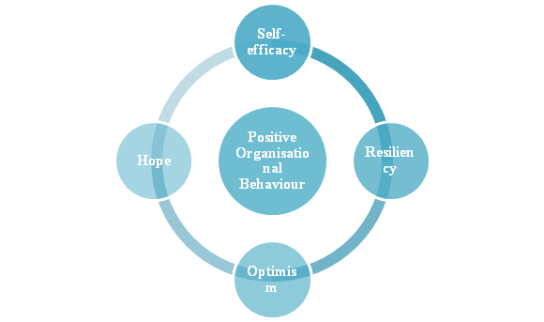
Figure 1: Resource Capabilities of Positive Organizational Behaviour
(Source: Nwanzu and Babalola 2019, p. 824)

Impact of Positive Organizational Behaviour on Work Performance
To increase work performance it is important to maintain positive organizational behaviour. Along with this involvement of employees is also justified with the help of this factor. Along with this corporate goals and strategies are also maintained with the involvement of positive organizational behaviour. Strategic behaviour and performance positively impacted by this aspect can maintain the profitability of the organization. Chumg et al. (2016), the efficiency of employees is maintained properly with the help of positive organizational behaviour. On the other hand, this aspect can play a crucial role in the maintenance of collaboration management. Positive organizational behaviour is involved in encouraging and empowering employees, by which they can provide their opinion on any effective issues in the organization. In the workplace, maintenance and development of optimism are justified with the help of POB, which directly has an impact on the work performance of the organization.
Optimism training can play a crucial role in the enhancement of work outcomes; however, optimism training is conducted with the involvement of special guidelines. Effective recruitment and appraisal strategies are implemented in organizations with the help of this process (Bakotic 2016). The self-efficacy of employees is improvised by positive organizational behaviour, which directly has an impact on work performance. Positive psychological movement and application and POB are the main components of the modern management of any organization. Positive organizational behaviour can maintain five important factors of an employee, which is illustrated in figure 2. These five effective factors are skill variety, autonomy, feedback, task significance, and task identity. Ability, motivation, and opportunities of employees are justified with the help of positive organizational behaviour of employees.

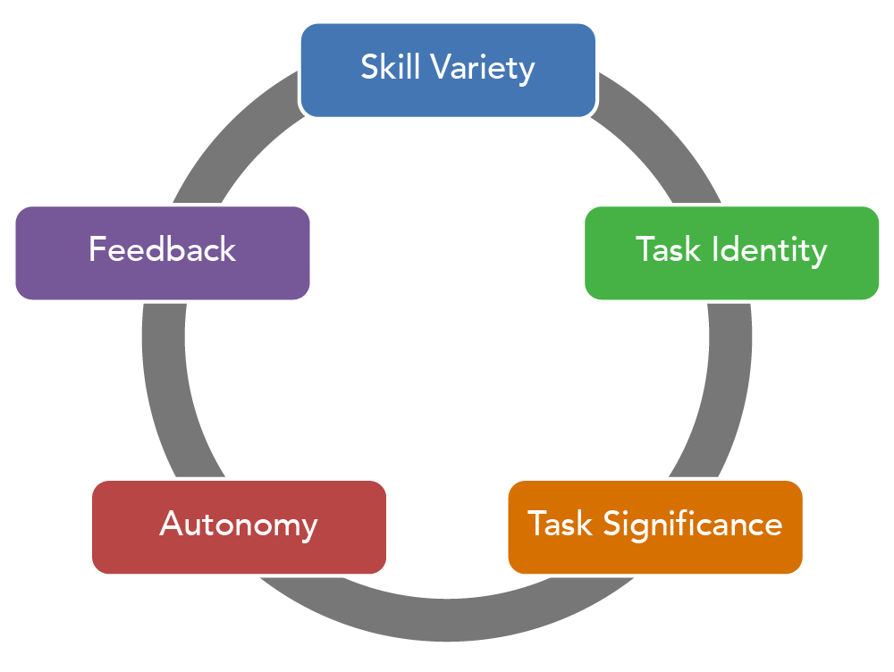
Figure 2: impact of POB on employee’s performance
(Source: Bakotic 2016, p. 425)
Skill variety is consists of employee’s persistency, which is controlled with the help of positive organizational behaviour. Motivation can play a crucial role in the maintenance of skill variety, which is involved in the maintenance of work performance. On the other hand need of employees is evaluated by positive organizational behaviour. Persistency can help employees to learn about new issues and serious of the task, as well as intensity and direction of employees, can play a crucial role in this case (Agarwal and Farndale 2017). The work performance of an organization depends on three important factors such as intensity, direction, and persistence of employees.
Good performance and outcomes of workers are justified easily with the help of the motivation process. Positive organizational behaviour can help employees to identify the task and significance of the task, which directly has an impact on the authenticity of work performance. With the help of these resources, it is easy to state that the efficiency of work performance depends on positive organizational behaviour. On the other hand outcome of employees depends on their psychological health. Due to this factor, it is important to justify their job satisfaction and other psychological issues (Jyoti and Rani 2017).
Positive traits and positive interpersonal processes of employees are maintained by this aspect, which directly has an impact on work performance. Tang et al. (2017) stated that positive behaviour of employees is important in the workplace that can maintain the working environment inside the organization. Positive organizational behaviour and positive psychological applications are related to each other. Understanding of the attitude and performance of the employees is maintained with the help of organizational behaviour. Workability of an organization depends on this factor. Positive organization behaviour is involved in the maintenance of the culture, policies, and structure of the organization, as well as employee’s productivity and commitment, are impacted by these factors. The capacity of employees is improvised by POB and helps to overcome all kinds of obstacles. This process can maintain meaningful changes in an organization that can improvise work performance (Pan et al. 2018).

Concept and Models of Positive Organizational Behavior
Positive organizational behaviour simply translates to the incorporation of certain traits, methods and ways in one’s workplace activity so that he/she can maintain a stable and successful performance rate in his/her respective workplace. As per Dutta and Khatri (2017), the idea of focusing upon the positiveness of people started shortly after the period of World War II when people started getting employment opportunities everywhere. This idea is also termed as the positive psychology movement. In this movement, people who got jobs in the mental health facilities and institutes started to observe the behavioural instances and habits of patients and other people. Upon periodic observation and behaviour, it was found out that aspects such as wishful thinking, motivation and confidence greatly affected a person’s behavioral tendencies, be it in the workplace environment or in their personal lives. Positive psychology simply targets every positive and good thing within circumstances, people and situations, instead of the bad ones. It also opposes the conventional ideology of “feel good” and focuses on the idea of “think positive”. Another literary aspect of positive psychology and behavior is changing the mindsets into solution-oriented think-ability, rather than being problem-oriented (Zulkifli and binti Ali 2017).
Positive organizational behavior comes with a wide variety of dependent aspects, such as contentment with past, optimism, hopefulness, courage, sensibility, perseverance, forgiveness, high talent, spirituality, etc. (Kondalkar 2020). But, among all the inclusive criteria, positive work behaviour usually consists of four primary factors, which are respectively known as self-efficacy, optimism, resiliency and hope. All of these four aspects are important in terms of enhancing organizational performance as well as managing the efficiency and effectiveness of one’s professional work behaviour.
Apart from the technical aspects and criterions inclusive in positive organizational behaviour, there is a generalized idea about it among the departments and job roles within employees. When the term organizational behaviour is mentioned, it simply translates to the behavioural habits that are fit for the respective organization. This can be further understood with a descriptive example. If for instance an individual is recruited in an organization, he/she needs to conceptualize and formulate the behavior according to his/her responsibilities and requirements in the workplace. The responsibilities or behavior of the individual should be in par with the others who are involved in the workplace or else mental clashes and agitations will come into play. Not only should the individual relate according to the behavioral traits of the other employees, but he or she should also incorporate certain behavioral skills that will prove to make her organizational work experience better. Such an instance translates to the fact that positive organizational behavior is directly proportional to the aspect of job satisfaction and continuity. Negative factors, like over-confidence, vague criticism, and mental clashes due to self-established hierarchy can prove to be demeaning factors for positive organizational behavior. As per Yavuz (2020), collaborative effort and relationship also account for a significant aspect of positive organizational behavior.
Positive organizational behavior also includes the aspect of mental peace within the respective individual. On the other hand, mental peace is also dependent upon the inclusive measures and traits of positive organizational behavior.

Figure 3: Optimal models for positive organizational behavior
(Source: Buchanan and Huczynski 2019, p. 78)
Organizational behavior is an amalgamation of activities required within the organization along with the work performance of the individuals (Buchanan and Huczynski 2019).
Among all the theoretical instances and models that have been created to aid the aspect of organizational behavior, four models have been evident to promote positiveness. These models are:
- Autocratic model
Organizations which try to follow up on the autocratic model of organizational behavior usually tend to be authority oriented. In simple terms, it means that the respective organization has specific designations and powers assigned to individuals who have the right to command over the subordinates and employees. Such a form of models also focuses upon the idea of pushing and persuading its employees to procure the best performance from them. Under this model, obedience to the higher authority is usually the topmost concern. When employees are designated under specific authorities, they get a sense of reliability on their “bosses”, which usually makes them work upon their respective responsibilities in a relaxed way. Tensed work environment has always been seen as a negative factor in the aspect of organizational behaviour. Cunha et al. (2020) stated that although autocratic organizational behavior model can be implied on most organizations, it can pose a negative impact on organizations where the responsibility to wage ratio is low. Moreover, educated and skilled employees and workers usually do not like the idea of being dictated by some other officials when they already have an understanding of their responsibilities.
- Custodial Model
Custodial organizational behavior model came to existence as a measure to overcome the autocratic model. Often times, the autocratic model tends to create agitation and frustration among the inclusive employee in the concerning organization. This model primarily focuses on the relationship between the employer and the employee. According to Kim et al. (2019), economic benefits are one of the core aspects of this model. It means that the organization aids and looks after the economic needs of the employees so that they can stay motivated towards their responsibilities and the organization. Though this model successfully satisfies the aspect of job satisfaction of the employees, usually the workplace behavior and relationships turn out to be passive. Therefore, to mitigate the drawbacks of this model, another organizational behavior model was developed, which is popularly known as the supportive model (Singh 2020).
- Supportive Model
Originally developed from the principles of supportive relationships, this respective model emphasizes increased support and successful relationship between the employees and authorities within the organization. The inclusive variables are interaction, communication, successful organizational behavior and professional relationships. The model also depends upon the aspect of leadership rather than command-like authority, so that employees can look up to the designated leaders and stay motivated in their respective job assignments and responsibilities. Such a model also tends to increase the aspect of innovative thinking and creativity within the employees of the organization, resulting in positive organizational behavior atmosphere and organizational prosperity. As per King and Lawley (2016), it demands the relationship between the employee and the managers to be friendly rather than being automotive, which enables higher trust and confidence buildup. Though being one of the best organizational behavior models, it can still tend to be irrelevant in organizations where physiological needs and financial security are the top-most priority of the employees.
- Collegial Model
This respective model focuses upon the amalgamation of purposes between the employee and the management. It is an augmentation of the supportive model discussed above. The organizational climate is one of the focal aspects of this model. According to this model, the foundational relationship between the employee and the respective higher authorities in an organization is to be based upon mutual respect and purpose-sharing (Aithal and Kumar 2016). The employees should not feel obligated to do their job because of organizational fear but should perform their duties and responsibilities purely based on self-interest. Such a model tends to maintain a balanced discipline in the workplace and organizational environment. Aspects like positive organizational behavior, job commitment, job involvement and job satisfaction are successfully maintained in this model. This respective model is best in terms of implementation advantage but usually does not comply with the conventional organizations and business firms (Warr and Nielsen 2018).
Therefore, according to the work and responsibility criteria of most companies and organizations, supportive organizational behavior model tends to be the best suitable model, as it satisfies both the professionalism as well as the positiveness of the work environment.

WORK PERFORMANCE
Work performance is an inclusive aspect of performance management within an organization (Wang et al. 2016). It simply translates to the effort and outcome of the work done by the respective employees within an organization according to the roles and responsibilities assigned to him/her.

Figure 4: Five Key Attributes of Organizational Work Performance
(Source: Wang et al. 2016, p. 37)
Work performance is also related to the aspect of organizational behaviour and is usually measured upon its impact upon organizational goal accomplishment. The behavioural domains within an employee organizational behaviour greatly impacts his/her work performance. As an example, a data scientist who is working for a big company that has good work environment and facilities will have better work performance than a data scientist who is working in a start-up or mediocre IT company. The domain on which the aspect of work performance depends upon consists of a wide variety of attributes.
Among the various attributes that are inclusive within the criterion of work performance, five attributes tend to be the most determining ones. These are respectively named as delivery to commitments, strategy implementation, Optimization and solving skills, Ethics and compliance, and finally risk management.
- Delivery to commitments.
As per Kaplan and Kaplan (2018), delivery to commitment consists of sub-ordinate attributes within it which include aspects like Customer Satisfaction, reliability, deadline maintenance, etc. If explained n simple terms, an employee or an individual who can live up to his commitments and requirements are usually appraised at workplaces and organizations. Often times, skills related to the respective responsibility and job assignment come much later than the finishing of the task according to the subjective deadlines. Therefore, maintenance of the subjected deadlines along with proper client and customer satisfaction are the major boosters of work performance of and individual.
- Strategy implementation
Each and every work or responsibility can be done in multiple ways. When it comes to the professional environment, the implementation of optimal strategies is one of the key factors for the smooth completion of any task (Tenney et al. 2016). Disregarding strategically workability and trying to do some work in an irrational way can result in excess time and effort expenditure to complete the task, which might also include poor output results. Therefore, knowledge about different relative strategies and its implementation procedure is one of the key aspects to elevate one’s overall work performance.
- Optimization and problem-solving skills
Optimization of work responsibilities simply translates to proper management and understanding of the responsibility, the ways to act upon it and finally efficient completion of the responsibility. Problem-Solving skills translate to the ability of an individual to look at any problematic situation and act upon it in such a way that the resultant problem gets solved. Problem-solving skills, therefore, requires an individual to have critical think-ability and solution-oriented mindset. Both of these aspects assist in heightening the work performance aspect of an individual and results in longevity and sustainment of the respective person in his/her work field (Çetin and Aşkun 2018).
- Ethics and compliance
Human beings are not autonomous robots. Consideration of certain ethical rules and regulations along with the compliance to certain regulatory laws is very essential during the process of working. Responsibility can be carried out in many different ways. But, as educated and mindful beings it becomes the job of oneself to consider the ethical rules relative to the job responsibility. As per Henttonen et al. (2016), not only does it satisfy the technicalities for the job or work process, but it also satisfies the respective employee on a personal level, providing him with a satisfactory work environment and peace.
- Risk Management
One of the essential attributes that affect the aspect of work performance is risk management. If explained simply, most task and job responsibilities have some form of risk associated with it. These risk factors can be minimal or something of greater concern. Risk management skill refers to an employee or individual’s ability to assess, identify and control the associated risk factor of the respective tasks. According to Ibrahim et al. (2017), it is also one of the directly proportional attributes to the aspect of work performance; meaning the more the risk management ability of the individual, the better is his/her work performance. Organizational risk management requires the expertise and knowledge of the employees on different domains. These domains include legal liabilities, strategic management, and financial uncertainty, critical understanding of the risk situation, and finally the degree of associated risk. Experience is also a determining factor in the aspect of organizational risk management.

As per the analysis of the relevant data from secondary data resources, positive organizational behavior is also and aiding aspect for increasing the work performance of an individual (Obeidat et al. 2016). Amalgamated with job satisfaction, positive work environment, and proper implementation of optimal organizational behavior model, work performance ratios get hugely elevated resulting in growth and prosperity of the concerning organization.

CONCLUSION
Based on this study it is concluded that positive organizational behaviour can maintain the efficiency of employees. Four effective aspects are present in positive organizational behaviour such as self-efficacy, hope, resilience, and optimism. Resilience can help employees to maintain adversity, conflict, and failure, which is concluded in this study. The extraordinary capacity of employees is justified with the involvement of conceptualization of the resilience process, which directly has an impact on work performance. Based on this study it is concluded that positive outcomes and positive casual attribution of employees are controlled with the involvement of the optimism process. On the other hand, the persistence of employees is increased through positive organizational behaviour. Hope can maintain the determination and motivation of employees that can increase the productivity of organisation. This study provides information about positive traits and positive interpersonal processes for employees. Positive behaviour and attitude of employees are important to maintain the working environment in the organization.

REFERENCES
- Adomako, S., Danso, A., Uddin, M. and Damoah, J.O., 2016. Entrepreneurs’ optimism, cognitive style and persistence. International Journal of Entrepreneurial Behavior & Research.
- Agarwal, P. and Farndale, E., 2017. High‐performance work systems and creativity implementation: the role of psychological capital and psychological safety. Human Resource Management Journal, 27(3), pp.440-458.
- Aithal, P.S. and Kumar, P.M., 2016. Organizational behaviour in 21st century–'Theory A'for managing people for performance. IOSR Journal of Business and Management (IOSR-JBM), 18(7), pp.126-134.
- Bakotić, D., 2016. Relationship between job satisfaction and organisational performance. Economic research-Ekonomska istraživanja, 29(1), pp.118-130.
- Buchanan, D.A. and Huczynski, A.A., 2019. Organizational behaviour. Pearson UK.
- Çetin, F. and Aşkun, D., 2018. The effect of occupational self-efficacy on work performance through intrinsic work motivation. Management Research Review.
- Chumg, H.F., Seaton, J., Cooke, L. and Ding, W.Y., 2016. Factors affecting employees' knowledge-sharing behaviour in the virtual organisation from the perspectives of well-being and organisational behaviour. Computers in Human Behavior, 64, pp.432-448.
- Dutta, S. and Khatri, P., 2017. Servant leadership and positive organizational behaviour: The road ahead to reduce employees’ turnover intentions. On the Horizon.
- Cunha, M.P., Rego, A., Simpson, A. and Clegg, S., 2020. Positive Organizational Behaviour: A Reflective Approach. Routledge.
- Heinitz, K., Lorenz, T., Schulze, D. and Schorlemmer, J., 2018. Positive organizational behavior: Longitudinal effects on subjective well-being. PloS one, 13(6), p.e0198588.
- Henttonen, K., Kianto, A. and Ritala, P., 2016. Knowledge sharing and individual work performance: an empirical study of a public sector organisation. Journal of Knowledge Management.
- Ibrahim, R., Boerhannoeddin, A. and Kayode, B.K., 2017. Organizational culture and development: Testing the structural path of factors affecting employees’ work performance in an organization. Asia Pacific Management Review, 22(2), pp.104-111.
- Jyoti, J. and Rani, A., 2017. High performance work system and organisational performance: Role of knowledge management. Personnel Review.
- Kaplan, M. and Kaplan, A., 2018. The relationship between organizational commitment and work performance: A case of industrial enterprises. Journal of Economic and Social Development (JESD), 5(1), pp.46-50.
- Kim, M., Kim, A.C.H. and Reid, C., 2017. Positive organisational behaviour in NCAA Division I football: a head coach's authentic leadership and assistant coaches' psychological constructs. International Journal of Sport Management and Marketing, 17(1-2), pp.121-143.
- Kim, M., Kim, A.C.H., Newman, J.I., Ferris, G.R. and Perrewé, P.L., 2019. The antecedents and consequences of positive organizational behavior: The role of psychological capital for promoting employee well-being in sport organizations. Sport Management Review, 22(1), pp.108-125.
- King, D. and Lawley, S., 2016. Organizational behaviour. Oxford University Press.
- Kondalkar, V.G., 2020. Organizational behaviour. New Age.
- Larijani, F. and Saravi-Moghadam, N., 2018. The effects of positive organisational behaviour on entrepreneurial personality and innovation. International Journal of Productivity and Quality Management, 23(2), pp.247-272.
- Muchiri, M., Shahid, S. and Ayoko, O., 2019. And now for something completely different: Reframing social processes of leadership theory using positive organisational behaviour. Journal of Management & Organization, 25(3), pp.370-373.
- Nwanzu, C.L. and Babalola, S.S., 2019. Examining psychological capital of optimism, self-efficacy and self-monitoring as predictors of attitude towards organizational change. International Journal of Engineering Business Management, 11, p.1847979019827149.
- Obeidat, S.M., Mitchell, R. and Bray, M., 2016. The link between high performance work practices and organizational performance. Employee Relations.
- Omar, S., Jayasingam, S. and Bakar, R.A., 2019. Does positive organisational behaviour and career commitment lead to work happiness?. International Journal of Business Excellence, 19(1), pp.44-64.
- Pan, X., Chen, M., Hao, Z. and Bi, W., 2018. The effects of organizational justice on positive organizational behavior: Evidence from a large-sample survey and a situational experiment. Frontiers in psychology, 8, p.2315.
- Singh, K., 2020. Organizational Behaviour Text and Cases.
- Tang, G., Yu, B., Cooke, F.L. and Chen, Y., 2017. High-performance work system and employee creativity. Personnel Review.
- Tenney, E.R., Poole, J.M. and Diener, E., 2016. Does positivity enhance work performance?: Why, when, and what we don’t know. Research in Organizational Behavior, 36, pp.27-46.
- Wang, P., Chaudhry, S., Li, L., Cao, X., Guo, X., Vogel, D. and Zhang, X., 2016. Exploring the influence of social media on employee work performance. Internet Research.Warr,
- P. and Nielsen, K.A.R.I.N.A., 2018. Wellbeing and work performance. Handbook of well-being. Salt Lake City, UT: DEF Publishers.
- Yavuz, M., 2020. Transformational leadership and authentic leadership as practical implications of positive organizational psychology. In Handbook of research on positive organizational behavior for improved workplace performance (pp. 122-139). IGI Global.
- Zulkifli, N. and binti Ali, K., 2017. Accentuating The Positive Organizational Behaviour and Work Engagement Concepts Towards Job Performance Quality of Public Sector Staff in Wilayah Persekutuan Putrajaya. Humanities & Social Sciences Reviews, 5(2), pp.134-140.

