AGRICULTURE REVOLUTION 4.0 - WAY FORWARD
K. Mounika¹, D. Rafi¹, Sangappa¹
¹ICAR-IIMR, Hyderabad
Ph: 9440990801, email: kosgimounika08@gmail.com

Abstract:
First Agriculture revolution promoted advent of using farming tools, the second revolution promoted the use of mechanised tools in farming practices, increasing the rate of production as well as the quantity of crop yield and third revolution or the Green Revolution was for developing genetically modified crops. Agriculture Revolution 4.0 involves the application of various technologies such as the Internet of Things, artificial intelligence, robotics, drones, big data analytics, and precision agriculture. These technologies enable farmers to collect and analyse real-time data, make data-driven decisions, and optimize their farming practices.
Keywords: Green revolution, Agriculture revolution, artificial intelligence, precision agriculture
Introduction:
An agricultural revolution is when farming techniques drastically improve within a relatively short period of time. This leads to a greater production of food and allows humans to pursue other types of work. The First Agriculture revolution promoted advent of using farming tools. The second revolution promoted the use of mechanised tools in farming practices, increasing the rate of production as well as the quantity of crop yield. The third revolution or the Green Revolution was the phase when genetically modified crops began to be used by almost everyone, leading to greater output of the produce. The future of the agricultural industry has never looked brighter, or more profitable, especially in farming operations. With a worldwide focus on Agriculture 4.0, which aims to grow precision farming and tech advancements within the agricultural sector at a mass scale, farming operations are not only becoming more profitable but also productive.
Agriculture 4.0, also known as the fourth agricultural revolution, differs from precision farming in that it adopts technology in all aspects of farming, from crop yields to harvesting, to logistics and transportation. The main focus of Agriculture 4.0 is to increase technology adoption rates in farming, driving effective and efficient change, that increases productivity in a sustainable and eco-friendly way. It also focuses on using robotics and artificial intelligence (AI), Internet of Things (IoT), vertical farms, drones, and solar energy in farming practices. This adoption ultimately leads to increased crop yields, cost and manual labour reductions, along with reducing the wastage of water, pesticides and fertilizer.
The fourth industrial revolution is starting to change how every agricultural player, from a family farmer to a global conglomerate, produces food and related products. The spread of the so-called essential eight technologies — such as AI, blockchain, drones, and the Internet of Things (IoT) — to agriculture is leading to increased yields, lower costs, and reduced environmental impact. These tools are also empowering farms to unlock new plant-based innovations and increasing their resilience to extreme weather events and climate change. Techniques such as land enclosure, field drainage, selective breeding, trailed metal cultivations replacing wooden tillage, and nitrogen supplementation (using human and animal manures) provided food for a human population were followed. The mechanization and rationalization of agriculture was a key factor of the Agricultural Revolution.
Fourth agricultural revolution is associated with emergent, game-changing technologies, at least in media and policy documents. In these sources, the benefits to productivity and the environment were prioritised with less attention to social consequences, but impacts were overwhelmingly presented positively. Farmers and advisers experienced many benefits of technologies and some predicted higher-tech futures. Total of 155 countries were classified into five food system types: rural and traditional; informal and expanding; emerging and diversifying; modernizing and formalizing; and industrial and consolidated. These types are exhaustive and mutually exclusive. The countries included in the typology represent 97% of the global population, 93% of global land area, and 97% of global gross domestic product (GDP).
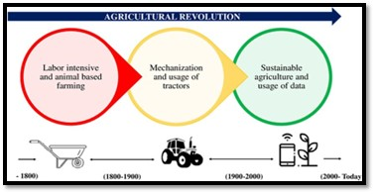
Figure: 1 Overview of Agriculture Revolution
By design, the mean values for each typology variable follow a gradient from rural to industrial food system types. These transitions are not linear. There are abrupt increases in agricultural productivity and supermarkets for modernizing and formalizing, and industrial and consolidated food system types, due to positive skewness in the distribution of those variables. As is common with typologies, some countries are located near the center of a given type, while others are closer to the margin between two different types. The similarities between food system types are evident by the overlapping interquartile ranges of urbanization, share of dietary energy from staples, and supermarkets. Latin America and the Caribbean contain four food system types and all five can be found in the Middle East. Industrial and consolidated food systems and modernizing and formalizing food systems account for a smaller share of the global population (13 and 11% respectively), yet occupy a larger share of global land area, while the other three types have a relatively larger share of the global population, with a smaller share of global land area. Nearly one-third of the global population lives in a country characterized as having a rural and traditional food systems.

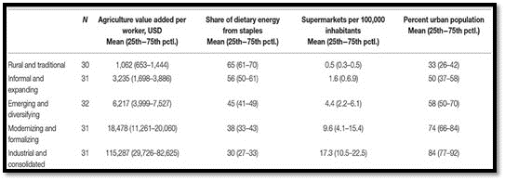
Figure:2 Food System Types across the country’s

What Is Agribusiness?
The agricultural sector in India is undergoing a metamorphosis since the economic liberalisation of 1991-92. Globalisation’s effects in this sector are showing healthy signs of transition from inhibitive to innovative farming and from subsistence to a sustainable one. The vast changes from traditional farming to hi-tech agribusiness have opened new areas for growth in the country. Globalisation of agribusiness paved way for high competition, fast technological changes, mobility of capital and rapid dismantling of barriers in the international tradability of goods and services. All these demand for increasing professionalism in the management of agriculture and allied activities. Agribusiness management therefore aims at developing analytical and cognitive skills of entrepreneurs dealing with agriculture and allied activities on individual as well as on institutional basis. Agribusinessmen are now following better strategies and managerial techniques for value added agriculture to improve quantitatively and qualitatively. The global character of perfectly competitive market demands standardised products, need for reorganisation of input supply to output marketing channels, broadening the vision of agriculture by including both on-farm and off-farm activities. Analysis of agribusiness in India from the globalisation perspective, identification of principal areas of agribusiness which need specialised managerial techniques, exploring the prospects of agribusiness in the present time of globalisation, examining the challenges faced by agribusiness in context of globalisation, suggesting measures to improve effectiveness and efficiency in view of changing global scenario. It involves all the steps required to send an agricultural good to market, namely production, processing, and distribution. The agriculture industry in India also includes animal husbandry horticulture, sericulture, and also many other subsectors related to the agriculture and cultivation.
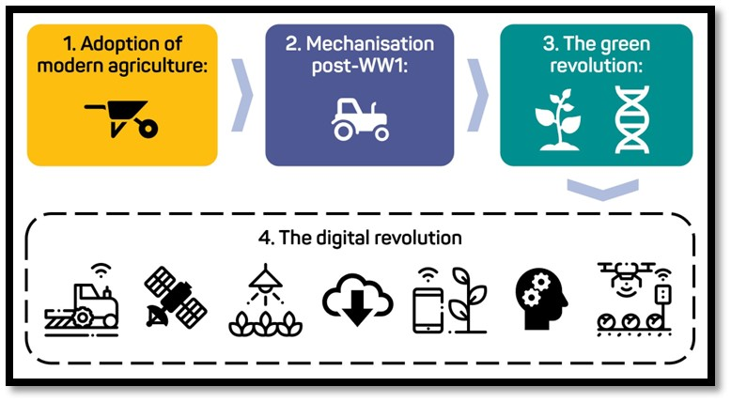
Figure: 3 Evolution of Digital Agriculture Revolution
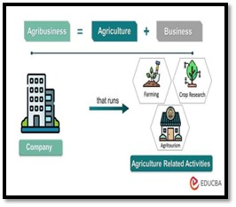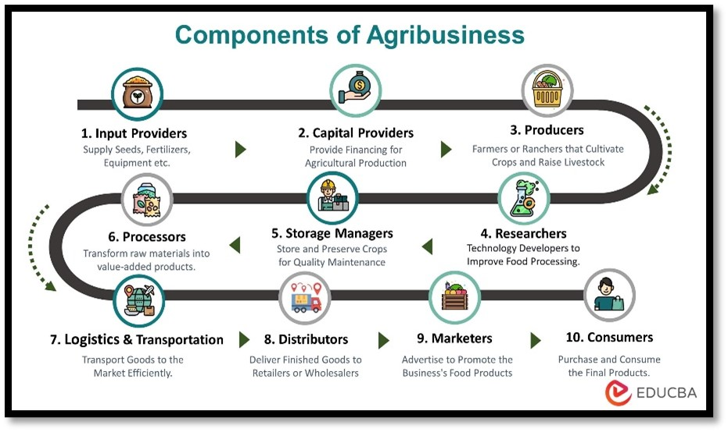
Figure: 4 Components of Agribusiness

Suggestive measures include need to address the socio-economic imbalances particularly at the grass root level, facilitate rapid innovation, reduce bureaucracy by streamlining government procedures to make them more transparent, ensure that Indian agribusinesses are not the victims of unfair trade practices. Good governance in agribusiness is needed to meet the risks, uncertainties and challenges and avoid further crises. It will ensure empowerment, development of infrastructure to improve standard of living and boost economic performance and equity in the agricultural sector.
The Causes of surge in agribusiness:
- Growing Population: The global population continues to increase, leading to a greater demand for food and agricultural products. Agribusinesses have capitalized on this demand by expanding production and finding innovative ways to meet the needs of a larger population.
- Increasing Urbanization: Urbanization has led to a shift in consumer preferences and lifestyles. As more people move to cities, there is a greater demand for convenience and ready-to-eat food products. Agribusinesses have responded by developing technologies and practices that enable efficient production and distribution of processed and packaged foods.
- Technological Advancements: The advancements in agricultural technology have revolutionized the industry and made it more attractive for entrepreneurs. Precision farming techniques, automation, remote sensing, and data analytics have increased productivity, reduced costs, and improved overall efficiency in agribusiness operations.
- Rising Awareness of Health and Sustainability: Consumers are increasingly concerned about their health and the environmental impact of food production. This has led to a growing demand for organic, natural, and sustainably produced agricultural products. Agribusinesses that focus on producing high-quality, environmentally friendly food have gained popularity and market share.
- Government Support and Policies: Many governments around the world have recognized the importance of agriculture and have implemented policies to support and promote agribusiness. These policies may include financial incentives, subsidies, infrastructure development, and research and development support, all of which contribute to the growth of the sector.
- Market Opportunities: Agribusinesses have identified and tapped into various market opportunities. These include niche markets for specialized products such as organic, locally sourced, or ethically produced food, as well as international markets where agricultural products from one region are in high demand in another.
- Changing Consumer Preferences: Consumer preferences and tastes have evolved over time. There is an increasing demand for diverse and exotic food products, as well as convenience foods that cater to busy lifestyles. Agribusinesses have adapted to these changing preferences by diversifying their product offerings and introducing new varieties and Flavors.
- These factors, among others, have contributed to the surge in agribusiness and have created opportunities for entrepreneurs and investors in the agricultural sector.
With the consistent rise of E-commerce, home delivery grocery stores have created an opportunity for agriculture enthusiasts to start their own farms with the help of advisors for the development and growth in their business. The ever-growing population has increased the demand for food produce Startups with the innovative idea of agri business related which are included many small businesses. The growing awareness and popularity of high-quality organic farm produce that sells at high value in the market. Production resources, which include seed, feed, fertilizer, energy, equipment, machinery and the Agricultural commodities like raw or processed items of food and fibre. Facilitative services like insurance, marketing, credit, processing, storage, packaging, transportation. So that starting an agricultural business also needs systematic planning and strategising in order to achieve the desired goals. These factors, among others, have contributed to the surge in agribusiness and have created opportunities for entrepreneurs and investors in the agricultural sector.
References:
- Asveld, L., Ganzevles, J., and Osseweijer, P. (2015). Trustworthiness and responsible research and innovation: the case of the bio-economy. J. Agric. Environ. Ethics 28, 571–588. doi: 10.1007/s10806-015-9542-2
- Bear, C., and Holloway, L. (2015). Country life: agricultural technologies and the emergence of new rural subjectivities. Geogr. Compass 9, 303–315. doi: 10.1111/gec3.12217
- Blok, V., Scholten, V., and Long, T. B. (2018). Responsible innovation in industry and the importance of customer orientation: introduction to the special issue. IFAMA 21, 455–461. doi: 10.22434/IFAMR2018.x001
- Bronson, K. (2018). Smart farming: including rights holders for responsible agricultural innovation. Tech. Innov. Manage. Rev. 8, 7–14. doi: 10.22215/timreview/1135
- Burall, S. (2018). Rethink public engagement for gene editing. Nature 555, 438–439. doi: 10.1038/d41586-018-03269-3
- Carbonell, I. (2016). The ethics of big data in big agriculture. Int. Policy Rev. 5, 1–13. doi: 10.14763/2016.1.405

