Chapter Title: Pharmacodynamics

Akansha Singh¹, Priyadarshini Soni*¹, Neeru Singh¹, Kulsoom Hamid¹.

1. Faculty of Pharmacy, Swami Vivekanand Subharti University, Meerut, Uttar Pradesh, India.
*Corresponding Author: Priyadarshini Soni, Assistant Professor, Faculty of Pharmacy, Swami Vivekanand Subharti University, Meerut, Uttar Pradesh, India.; +91-8851040274., priyadarshinisoni274@gmail.com

- Introduction
"Pharmacodynamics, also known as drug actions on the human system, is the comprehensive study of drugs' biochemical, physiological, and molecular actions." It analyses a number of subjects, including receptor binding, receptor sensitivity, post-receptor effects, and chemical interactions. By bringing together pharmacodynamics and pharmacokinetics, both emphasize the body's reactions to a medicine and the drug's fate within the body, one can obtain insight into the complex relationship between drug dosage and the effects it produces. Basically, the pharmacological response is established by the drug's ability to bind to its intended target, and the concentration of the drug at the receptor site determines the drug's overall effect." The pharmacodynamics of a medication can be influenced by many different kinds of physiological changes mediated by:
A disorder or disease
- The aging processes
- Interactions with other drugs
Particular conditions, such as genetic mutations, thyrotoxicosis, malnutrition, & myasthenia gravis, may have a major impact on pharmacodynamic response, Parkinson’s disease and certain types of insulin-resistant diabetes.¹ These conditions have a tendency to influence receptor binding, affect binding protein levels, or impair receptor sensitivity. As an outcome, the drug's effectiveness and mode of action might be significantly altered in humans suffering from these types of diseases.

- PRINCIPLES OF DRUG ACTION
Drugs (until those based on genes) are not effective for the advancement of new functions for any system, organ, or cell. It simply modifications the rate of activity in advancement, but due to its toxicological effects, deep medical effects can be predicted.
The following are some broad categories of actions:
2.1 Stimulation
2.2 Depression
2.3 Irritation
2.4 Replacement
2.5 Cytotoxic action
2.1 Stimulation
A targeted improvement in the function of particular cells.
Example - adrenaline stimulates the heart and pilocarpine stimulates the salivary glands.
Though, over-stimulation is common suppression of this function.
Example – high dose Picrotoxin, a central nervous system stimulant, causes seizures followed by coma and respiratory depression.
2.2 Depression
Means selective reduction of activity for specialized cells, e.g., barbiturates depress the central nervous system, quinidine Omeprazole suppresses gastric acid secretion. Certain drugs stimulate cell types but suppress them Others, for example: Acetylcholine stimulates intestinal smooth muscle. But press the cardiac SA node. Therefore, this is not possible with most drugs It is easily classified as a stimulant or depressant.
2.3 Irritation
This is non-selective & used especially in non-specialized cells. (Epithelium, connective tissue). Intense stimulation, inflammation, corrosion, necrosis, morphological damage. It may accelerate degradation or loss of functionality.
2.4 Replacement
This implies using common materials, deficiencies of metabolites, hormones, or their congeners; Examples: levodopa for Parkinson's disease, insulin for diabetes, iron in anemia.

2.5 Cytotoxic action
Selective cytotoxic effect on penetrating parasites and cancer cells weakens them. It has extreme effects on host cells and is used to cure/reduce infections and neoplasia. Penicillin, chloroquine, zidovudine, cyclophosphamide, etc.
- MECHANISM OF DRUG ACTION
Pharmacodynamic mechanisms is to manage the effects of drugs on the human body.² As earlier mentioned, drug-receptor binding related to multiple complex chemical interactions. The site on the receptor where the drug binds is known as the binding site. The reactivity of the drug and the reactivity of the binding site regulate how tightly the two molecules bind to each other. Facilitating the drug-receptor interactivity is known for the drug's affinity for the binding site on the receptor.
Affinity is based on intrinsic properties of a particular drug-receptor set and is represented by the dissociation constant (K_{d}). The K_{d} is defined as the drug concentration at which 50% of the available receptors are occupied. When an adequate no. of receptors is occupied on or inside the cell, the cumulative effect of receptor occupancy on that cell becomes visible. Thus, we find that the drug-receptor binding relationship is firmly related to the dose-response relationship.
There are two major types of dose-response relationships: graded and quantal. The graded dose-response curve (Figure 1) shows the effect (E) of different doses or concentrations (L) of a drug on an individual from which two major parameters can be gathered: potency and efficacy. Potency (EC₅₀) of a drug is defined as the (L) at which the drug obtains 50% of its maximal response. Efficacy (Emax) is the maximal effect of a drug when all available rectors are occupied.
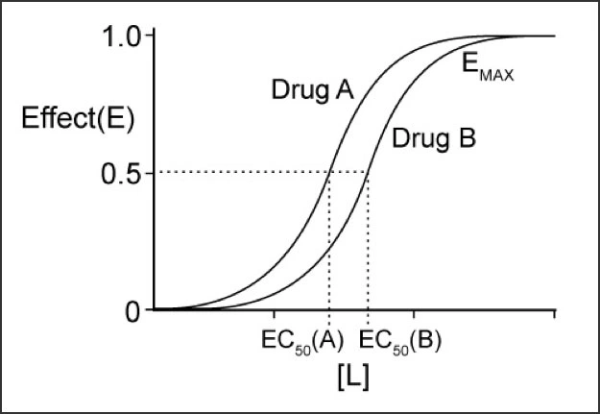
Figure 1. Graded dose-response curves for two drugs
Note that drug A is more effective than drug B. However, in this example, drug A and drug B have the same effect.

A quantitative dose-response curve (Figure 2) represents the mean effect of a drug as a function of drug dose in a population, from which 3 major parameters can be obtained as Efficacy, Toxicity, Lethality. Reactions are distributed as either present or absent. The doses that produce these responses in 50% of the population are described as the median effective dose (ED50), median toxic dose (TD₅₀) and median lethal dose (LD₅₀), appropriately.

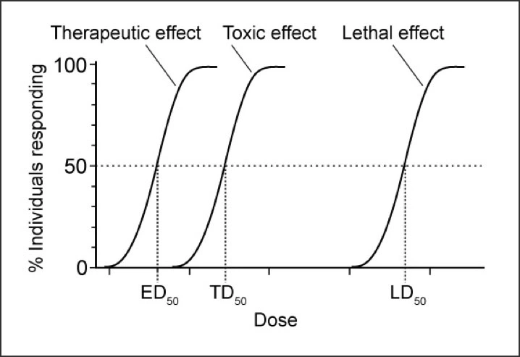
Figure 2 Quantal dose-response curve
Note that ED₅₀ is the dose at which 50% of the subjects respond to the drug, whereas EC₅₀ (see Figure 2) is the dose at which a drug elicits a half-maximal effect in an individual.

The therapeutic window is a range of doses of a drug that obtained a therapeutic response in a population of individuals without unacceptable toxic (adverse) effects. The therapeutic window can be measure by the therapeutic index (TI): TI = TD₅₀/ED₅₀. A large TI shows a wide therapeutic window, e.g., a hundred-fold variance between TD₅₀ and ED₅₀. A small TI shows a narrow therapeutic window, e.g., a two-fold variance between TD₅₀ and ED₅₀. Drug receptors exist in two conformational states in equilibrium with one another: an active state and an inactive state.³
Majority of drugs create their effects by interacting with a separate the target biomolecule, which usually is a protein

- PROTEIN TARGETS FOR DRUG ACTION
Present chapter, describe about proteins that drugs can affect in our bodies. (Figure 3) These proteins can be categorized into different groups
4.1 receptors
4.2 ion channels
4.3 enzymes
4.4 transporters (carrier molecules)
There are some irregularities, but great significant medications affect one or both of these protein types. For instance, the gout medication colchicine reacts with the structural protein tubulin while a number of immunosuppressive medications, such as ciclosporin, attaches to cytosolic proteins called immunophilins.⁴
  - Receptors
Receptors are glycoproteins generally found in cell membranes that particularly recognize and bind to ligands. These are smaller particles (including drugs) that are able to "bind" to the receptor protein. This binding activates the conformational change in the receptor protein, which accelerate a series of intracellular biochemical reactions ("signal transduction"), frequently involve the formation of "secondary messengers" that ultimately manifest a biological response (eg, muscle contraction, hormone secretion). Although the ligands of clinical relevance are exogenous (i.e., pharmaceuticals), human tissue receptors have been created to bind endogenous ligands like neurotransmitters, hormones, and growth factors. The generation of drug-receptor compounds typically reversible, and the quantity of receptors used (and thus the response) correlates to drug concentration. Reversibility allows for controlling of biological responses and implies similar ligands can compete for access to the receptor. The term "receptor" is mostly applied to define proteins with a primary function is to bind the ligands yet it is sometimes used commonly in pharmacology to refer to other types of drug targets that include voltage-sensitive ion channels, enzymes, and transporter proteins. Receptor ligands are identified by the capacity to induce a biological response after binding to the receptor.
4.1.1 Agonist: Agonists relate to the receptor the protein, causing it to change conformation for the purpose to send out a signal associated with a biological response. As the number of free ligands grows, so does the quantity of receptors used, and consequently the biological effect. The maximum physiological effect can be achieved when every receptor is used. It has been observed that in many receptor systems, carry out agonists may provide the greatest effect without occupying any available receptors, supporting the concept of "reserve receptors.". Because of the appear availability of receptors, full reactions can be elicited at lower ligand concentrations than would otherwise be required.
4.1.2 Inverse agonist: When they bind to a receptor, they produce the opposite effect of a full agonist. To identify inverse agonists, the relevant endogenous receptor must be linked to the biological response even though no ligand exists (ie, constitutive activity). Constitutive activity may be observed in a variety of receptors.
4.1.3 Antagonist: Antagonists join to the receptor yet do not trigger the conformational change that begins intracellular transmission. The existence of a competitive antagonist on the receptor blocks the other ligand from binding and so "antagonizes" the biological response to the agonist.
Antagonist inhibition may be overcome by raising the agonist amount.
Non-competitive antagonists are antagonists that alter the response to an agonist without interacting with the receptors. Increasing the agonist dose alone will not overcome these effects, limiting the agonist's maximal response (its "efficacy").
4.1.4 Partial agonist: Even when each of the receptors are occupied, partial agonists can't accomplish a maximal transmission affect similar to that of a full agonist. When paired with full agonists, partial agonists block receptor sites that might have been filled by the full agonist, limiting total response (i.e., they appear to antagonize the full agonist's impact).
As medications for treatment, partial agonists have various benefits. Although they fail to produce the same maximum effect as the full agonist, they are less likely to cause receptor-mediated adverse effects at the top of their dose-response curve (such as the fact that the partial opioid receptor agonist buprenorphine does not cause as much respiratory depression as morphine when used as an analgesic).
4.1.5 Ligand: Any compound that selectively attaches particular receptors or regions. A term that simply indicates affinity or ability to bind irrespective of functional shifts to stimulants and competitive antagonists both had the same receiver as mediators.⁵⁻⁶
  - Ion Channels
Ion-selective channels are proteins that participate in and regulate transmembrane communications and intracellular ionic composition. Some cells, identified as excitable cells, exhibit the capacity to generate electrical signals. Although neurons occur in a range of forms, including nerve cells, muscle cells, and touch receptors, they all depend on ion channel receptors for converting chemical or mechanical messages into electrical signals. An excited cell, like all cells, exhibits a different concentration of ions in its cytoplasm than in its extracellular environment. These concentration variations converge to produce a very small electrical potential across the plasma membrane. When the conditions are beneficial, certain pores in the plasma membrane permit the fast passage of ions into and out of the cell, that creates an electrical signal.
4.2.1 Ion channel receptors: They frequently multimeric proteins that are found in the membrane of the cell. Each of those proteins produces a channel or pore that bridges the membrane from one side to the other. These channels of ions, or pathways, may open and close in response to chemical or mechanical signals. Ions move through and out of the cell in a single direction when an ion channel is open. Individual ion channels are ion-specific, therefore they usually allow only one type of ion to move through. The amino acids which form the channel, together with its physical width, regulate which ions are able to move from outside to inside the cell and vice versa. The emergence of an ion channel is a transitory event. Most ion channels close and reach a resting state within milliseconds of opening, keeping them receptive to impulses for a brief period of time.
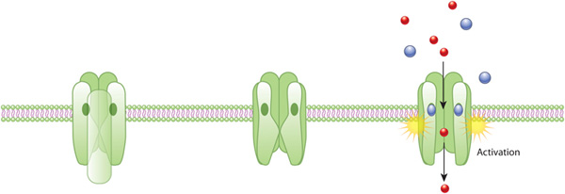

Figure 3. An example of ion channel receptor activation
In the plasma membrane, the receptor for acetylcholine (green) produces a closed ion channel. This receptor is a hydro permeable membrane protein that allows solutes circulate through the plasma membrane when it is open. If no external signal has occurred, the pore closed (middle). As acetylcholine molecules (blue) interact to the receptor, a change in conformation takes place opening the water pore and permitting ions (red) to enter the cell.
4.2.2 Generation of electrical signal: Ion channel opening modifies the charge distribution in the plasma membrane. Remember that the cytoplasm's ionic composition varies markedly from that of the outside environment.
For example: The level of sodium ions in the cytoplasm is significantly lower compared to that in the cell's external environment. On the other hand, potassium ions have a greater concentration inside the cell than outside. These differences produce an electrochemical gradient, which can be described as a combination of a chemical gradient and a charge gradient. Ion channels open, allowing ions on either side of the plasma membrane to flow down this dual gradient. This ion flow produces an electrical signal.⁷
  - Enzymes
Almost all of life's processes are initiated by enzymes; as a consequence, enzymes are a very significant target of pharmacological activity. Medicines can either speed through or reduce enzyme-mediated processes. In physiological systems, on the other hand, enzyme activity can be ideally fixed. Therefore, the stimulation of enzymes medicines that are actually foreign substances is perfect for some only natural metabolites work, for instance, pyridoxine cofactor and increases decarboxylase activity. The receptors and other messengers cause several enzymes, for instance, adrenaline encourages liver glycogen phosphorylase via b receptors and cyclic AMP. The stimulation of an enzyme improves its affinity for the substrate, diminishing the rate constant (kM) of the procedure.
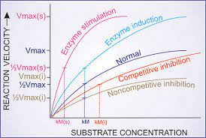
Figure 4. Effect of enzyme induction, stimulation and inhibition on kinetics of enzyme reaction
Vmax—Maximum velocity of reaction; Vmax (s) of stimulated enzyme; Vmax (i)—in presence of noncompetitive inhibitor; kM—rate constant of the reaction; kM (s)—of stimulated enzyme; kM (i)—in presence of competitive inhibitor.

Enzyme induction, or the synthesis of more enzyme protein, may result in an apparent increase in enzyme activity.
4.3.1 Enzyme inhibition: Certain compounds (heavy metal salts, strong acids and bases, formaldehyde, phenol, and so on) denaturant proteins and prevent all enzymes non-selectively. They have limited therapeutic value & may only be used topically. However, the drug's common mode of action is selective blockage of a specific enzyme. This kind of blocking might be competitive or non-competitive.
    - Types of Enzyme Inhibition
4.3.2.a Normal Enzyme Reaction
- The substrate attaches to the enzyme (through the active site) in a typical process that produces an enzyme-substrate complex.
- The substrate's structure and properties complement each other, leading to enzyme-substrate specificity.
- The active site undergoes a change in shape upon binding in order to ensure optimal interaction with the substrate (induced fit).
- This conformational change weakens the substrate's chemical bonds, reducing the activation energy.
- The substrate transforms into a product at a faster rate as a result of enzyme interaction.
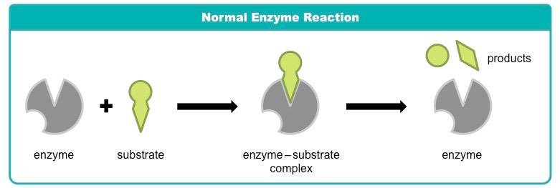
Figure 5. Normal Enzyme Reaction
4.3.2.b Competitive Inhibition
- A molecule other than the substrate connects to the active site of the enzyme in competitive inhibition.
- The inhibitor molecule is both chemically and physically equivalent to the substrate (and consequently can bind to the active site).
- Competing inhibitors prevent substrate binding by blocking the active site.
- When the inhibitor interferes with the substrate, increasing the concentration of the substrate decreases its effect.
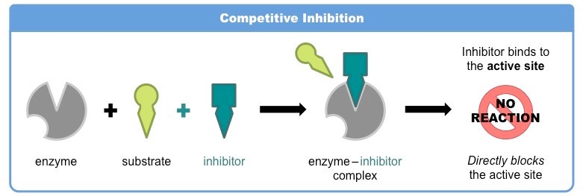
Figure 6. Competitive Inhibition

4.3.2.c Noncompetitive Inhibition
- Non-competitive inhibition takes place when chemicals connect to locations other than the active site (allosteric sites).
- Entry of an inhibitor to the regulatory site produces an alteration in conformation in the enzyme's active site.
- As a result of this alterations, the active site and substrate no longer share specificity, and the substrate is no longer capable of bind.
- When the inhibitor does not directly compete with the substrate, promoting the amount of substrate cannot decrease the inhibitor's effectiveness.⁸

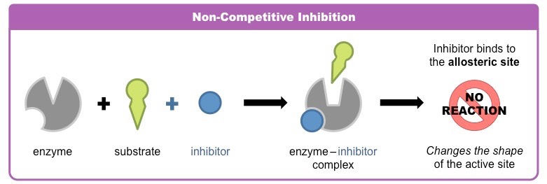
Figure 7. Noncompetitive Inhibition
- TRANSPORTERS
Some substrates go through membranes by connecting to specific transporters (carriers). It facilitates diffusion in that direction, in addition to gradients of concentration and exchangers. Concentration gradient of metabolite/ion pair application of metabolic energy. Many drugs have an immediate impact, interaction with the SLC (solute carrier class). Progression-inhibiting transporter proteins Metabolite/ion move in the body.
Examples are:
- Desipramine and cocaine block neurons reuptake of noradrenaline by interaction with Norepinephrine transporter (NET).
- Fluoxetine (and other SSRIs) inhibit neurons Reuptake of 5-HT through interaction with serotonin Transporter (SERT).
- Amphetamines selectively block dopamine Reuptake into brain neurons by dopamine Transporter (DAT).

- References
- Currie GM. (2018). Pharmacology, Part 1: Introduction to pharmacology and pharmacodynamics. J Nucl Med Technol 46:81–86. https://pubmed.ncbi.nlm.nih.gov/29599397/
- Baca QJ, Golan DE. Pharmacodynamics. Principles of Pharmacology: The pathophysiologic basis of drug therapy, 4th edition. David E. Golan (Ed). Philadelphia, PA. Wolters Kluwer. 2017. 17-26.
- FDA. Milestones in U.S. Food and Drug Law History. 2018 Feb 01. Accessed March 21, 2019.
- RANG AND DALE’S Pharmacology EIGHTH EDITION, H. P. Rang, et. al., (2014).
- IUPHAR, Pharmacology Education Project in our Clinical Pharmacology and Therapeutics Practice article that was published in the journal's Therapeutic Innovations themed January 2019 issue: https://doi.org/10.1002/cpt.1278 PMID: 30588614.
- Ashcroft, F.M., 2000. Ion Channels and Disease. Academic Press, London. (A useful textbook covering all aspects of ion channel physiology and its relevance to disease, with a lot of pharmacological information for good measure).
- 2008 Nature Publishing Group Moreau, C. J. et al. Coupling ion channels to receptors for biomolecule sensing. Nature Nanotechnology 3, 620-625 (2008) doi:10.1038/nnano.2008.242.
- 2016 The creator of the BioNinja, Cornell, B., The following is a link to a Harvard Referencing Generator for websites: http://harvardgenerator.com).
- Lippincott, Illustrated Reviews: Pharmacology, South Asian Edition.
- Essentials of Medical Pharmacology, K D Tripathi. Seventh Edition: 2013, ISBN: 978-93-5025-937-5.

