Biocatalysis : A Sustainable Processes
Dr. Sangeeta Sarkhel
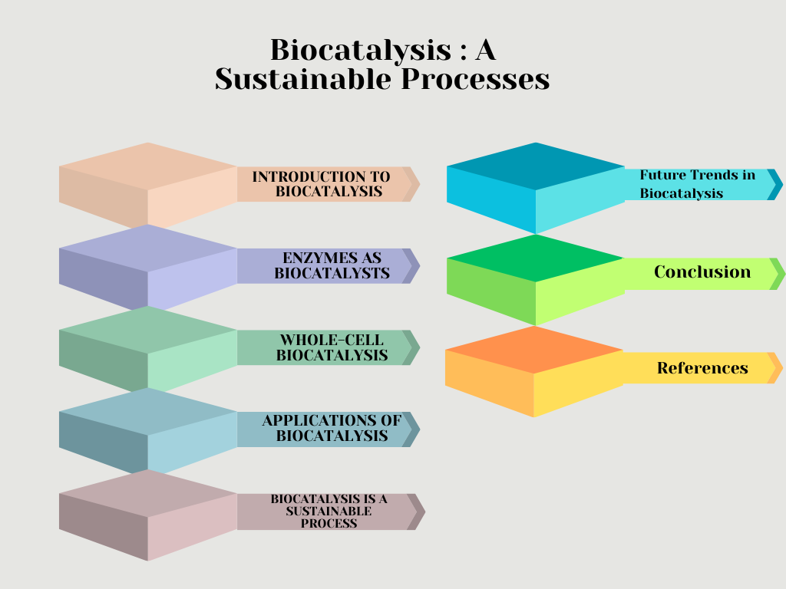

Introduction to Biocatalysis
Biocatalysis is the use of biological catalysts, such as enzymes or whole cells, to accelerate chemical reactions. Enzymes are proteins that are highly specific and efficient catalysts. They can catalyze a wide variety of reactions, including hydrolysis, oxidation-reduction, and isomerization. Whole cells can also be used as biocatalysts, and they can offer the advantage of being able to perform multiple reactions in a single step. Biocatalysis has many advantages over traditional chemical catalysis. Enzymes are typically more selective and efficient than chemical catalysts, and they are also less likely to produce harmful byproducts. Additionally, biocatalysts are often biodegradable and renewable, making them more environmentally friendly.
From ancient times, humankind took advantage of microorganisms to perform chemical transformations for their purposes. For example, the employment of yeast for the production of beer by fermentation can be dated back to the sixth millennium BC (Hartman, 2013). Around 19th century, revolutionary advances have been made in biocatalysis, allowing humans to expand its application from natural fermentation processes to engineered biocatalytic systems involving isolated enzymes or whole cells with optimized functions and performances for the production of useful chemicals including medicinal drugs, polymers or biofuels (Bornscheuer, 2012). Some of the counteracting biocatalytic activities are provided by nature. While nature has already developed large-scale approaches for certain problems, it can be a source of inspiration for others, like the hydrolysis of polyethylene terephthalate (PET) — the plastic from which many bottles are made (Yoshida et al, 2016).
In a bio-based economy, ideally waste biomass, particularly agricultural and forestry residues and food supply chain waste, are converted to liquid fuels, commodity chemicals and biopolymers using clean, catalytic processes. Biocatalysis has the right credentials to achieve this goal. Enzymes are biocompatible, biodegradable and essentially non-hazardous. Additionally, they are derived from inexpensive renewable resources which are readily available and not subject to the large price fluctuations which undermine the long-term commercial viability of scarce precious metal catalysts ( Sheldon, 2020).
Despite recent developments in chemistry and materials science, synthetic capacity and features such as self-replication of biological systems are so far hard to mimic. Indeed, microbial cell factories are a powerful tool to serve our needs in a sustainable and environmentally friendly manner ( Lee et. el., 2019). In their research group, they have steadily evolved towards including sustainability in all aspects of the process design, with particular attention to the stabilization and recovery of the biocatalyst to the overall process safety (Paradisi, 2022). For immobilization of enzymes, they have reported several methods which can significantly improve the lifespan of a biocatalyst, and these are not limited to single enzyme loading, but can exploit different chemistries leading to a rational immobilization approach for multi-enzyme systems (Padrosa et.al., 2020, Pardisi 2022, Romero-Fernández 2020).
Biocatalysis has a wide range of applications, including the production of pharmaceuticals, food and beverages, cosmetics, and chemicals. It is also used in environmental remediation and the development of new biofuels.
Biocatalysis can be classified into six main categories based on the type of reaction catalyzed:
- Oxidoreductases catalyze oxidation-reduction reactions, transferring electrons from one molecule to another. Examples of oxidoreductases include glucose oxidase, catalase, and alcohol dehydrogenase.
- Transferases catalyze the transfer of a functional group from one molecule to another. Examples of transferases include transaminases, kinases, and glycosidases.
- Hydrolases catalyze the hydrolysis of bonds, breaking them down by adding water. Examples of hydrolases include amylases, proteases, and lipases.
- Lyases catalyze the cleavage of bonds by mechanisms other than hydrolysis or oxidation, often forming a double bond or a new ring structure. Examples of lyases include deaminases, decarboxylases, and aldolases.
- Isomerases catalyze the rearrangement of atoms within a molecule to form a structural isomer. Examples of isomerases include mutases, epimerases, and racemases.
- Ligases catalyze the formation of a new chemical bond, often by joining two molecules together. Examples of ligases include DNA ligases, RNA ligases, and aminoacyl-tRNA synthetases.
These categories are not mutually exclusive, and some enzymes can catalyze more than one type of reaction. For example, an aldolase can catalyze both the hydrolysis of a sugar molecule and the isomerization of a sugar molecule.
The choice of biocatalyst for a particular application depends on a number of factors, including the type of reaction required, the substrate specificity of the enzyme, and the desired yield and selectivity. Here are some examples of the applications of biocatalysis in different industries:
- Food and beverage industry: Biocatalysis is used in the production of a variety of food and beverage products, including cheese, beer, wine, bread, and yogurt. Enzymes are used to hydrolyze starches, proteins, and fats, and to produce flavors and aromas.
- Pharmaceutical industry: Biocatalysis is used in the production of a variety of pharmaceuticals, including antibiotics, vitamins, and hormones. Enzymes are used to synthesize new compounds, to modify existing compounds, and to improve the stability and solubility of drugs.
- Chemical industry: Biocatalysis is used in the production of a variety of chemicals, including biofuels, plastics, and flavors. Enzymes are used to catalyze reactions that are difficult or impossible to achieve with chemical catalysts.
- Environmental remediation: Biocatalysis is used to degrade pollutants, such as pesticides and herbicides. Enzymes are used to break down these compounds into harmless products.
Biocatalysis is a rapidly growing field with many potential applications. The continued development of biocatalysis will help to make our world cleaner, healthier, and more sustainable.

Enzymes as Biocatalysts
Enzymes are proteins that are highly specific and efficient catalysts. They are made up of amino acids that are arranged in a specific three-dimensional structure. This structure determines the enzyme's active site, which is the region where the substrate binds and the reaction takes place.
The substrate is the molecule that the enzyme catalyzes. It must fit into the active site in order for the reaction to occur. The enzyme-substrate complex is formed when the substrate binds to the active site. The reaction then takes place, and the products are released.
Enzymes are highly specific for their substrates. This means that they will only catalyze the reaction of a specific molecule or group of molecules. This specificity is due to the shape of the active site.
Enzymes are also very efficient catalysts. They can catalyze reactions that would take place very slowly in the absence of a catalyst. This is because enzymes lower the activation energy of the reaction. The activation energy is the energy barrier that must be overcome for the reaction to occur.

Whole-Cell Biocatalysis

Whole-cell biocatalysis is the use of whole cells as catalysts. Whole cells can contain multiple enzymes, which can be used to catalyze a variety of reactions in a single step. This can be advantageous, as it can simplify the process and reduce the number of steps required.

Whole cells can also be used to catalyze reactions that are difficult to catalyze with enzymes alone. This is because whole cells contain other components, such as cofactors and chaperones, that can help to stabilize the enzymes and improve their efficiency.
Whole-cell biocatalysis is the use of whole cells, as opposed to isolated enzymes, as catalysts in chemical reactions. Whole cells can contain multiple enzymes, which can be used to catalyze a variety of reactions in a single step. This can be advantageous, as it can simplify the process and reduce the number of steps required.
Whole cells can also be used to catalyze reactions that are difficult to catalyze with enzymes alone. This is because whole cells contain other components, such as cofactors and chaperones, that can help to stabilize the enzymes and improve their efficiency.
Here are some of the advantages of whole-cell biocatalysis:
- High efficiency: Whole cells can be more efficient than isolated enzymes, as they can perform multiple reactions in a single step.
- Cost-effectiveness: Whole cells are often more cost-effective than isolated enzymes, as they can be grown and harvested in large quantities.
- Stability: Whole cells are often more stable than isolated enzymes, as they are protected from the harsh conditions of the reaction environment.
- Biosafety: Whole cells are often considered to be safer than isolated enzymes, as they do not pose the same risk of contamination.
However, there are also some disadvantages to whole-cell biocatalysis:
- Complexity: Whole cells are more complex than isolated enzymes, which can make it more difficult to control the reaction.
- Inflexibility: Whole cells are less flexible than isolated enzymes, as they are limited to the reactions that the cell is naturally capable of catalyzing.
- Purity: Whole cells are not as pure as isolated enzymes, which can lead to contamination and product impurities.
Despite these disadvantages, whole-cell biocatalysis is a promising technology with many potential applications. It is being used in a variety of industries, including the food and beverage industry, the pharmaceutical industry, and the chemical industry.
Here are some examples of the applications of whole-cell biocatalysis:
- Food and beverage industry: Whole-cell biocatalysis is used in the production of a variety of food and beverage products, including cheese, beer, wine, bread, and yogurt. Whole cells are used to hydrolyze starches, proteins, and fats, and to produce flavors and aromas.
- Pharmaceutical industry: Whole-cell biocatalysis is used in the production of a variety of pharmaceuticals, including antibiotics, vitamins, and hormones. Whole cells are used to synthesize new compounds, to modify existing compounds, and to improve the stability and solubility of drugs.
- Chemical industry: Whole-cell biocatalysis is used in the production of a variety of chemicals, including biofuels, plastics, and flavors. Whole cells are used to catalyze reactions that are difficult or impossible to achieve with chemical catalysts.
- Environmental remediation: Whole-cell biocatalysis is used to degrade pollutants, such as pesticides and herbicides. Whole cells are used to break down these compounds into harmless products.
The field of whole-cell biocatalysis is rapidly evolving, and there are many exciting new developments on the horizon. Some of the most promising trends include:
- The discovery of new whole-cell biocatalysts with novel properties
- The development of new methods for optimizing the performance of whole-cell biocatalysts
- The use of whole-cell biocatalysis in new and emerging industries
Whole-cell biocatalysis is a promising technology with the potential to revolutionize many industries. The continued development of whole-cell biocatalysis will help to make our world cleaner, healthier, and more sustainable.
Applications of Biocatalysis
Biocatalysis has a wide range of applications, including:
- The production of pharmaceuticals, such as antibiotics and vitamins
- The production of food and beverages, such as cheese and beer
- The production of cosmetics, such as sunscreen and shampoo
- The production of chemicals, such as plastics and fuels
- Environmental remediation, such as the degradation of pollutants
Biocatalysis is a sustainable process
- Enzymes are derived from renewable resources, such as plants, animals, and microorganisms. This makes them a more sustainable alternative to catalysts that are made from petroleum or other non-renewable resources.
- Enzymes are highly specific, meaning that they can catalyze a particular reaction with high selectivity. This can lead to the production of high-purity products, which reduces waste.
- Enzymes can operate under mild reaction conditions, such as low temperatures and pressures. This reduces the amount of energy required for the process and also minimizes the formation of byproducts.
- Enzymes are biodegradable, meaning that they can be broken down by microorganisms in the environment. This eliminates the need to dispose of them as hazardous waste.
Future Trends in Biocatalysis
The field of biocatalysis is rapidly evolving, and there are many exciting new developments on the horizon. Some of the most promising trends include:
- The discovery of new enzymes with novel properties
- The development of new methods for immobilizing enzymes
- The use of synthetic biology to engineer new biocatalysts
- The development of new biocatalytic processes for the production of chemicals and fuels.
Conclusion :
Biocatalysis is increasingly being used in a wide range of industrial applications, such as the production of pharmaceuticals, cosmetics, food and beverages, and biofuels etc. It is a promising technology with the potential to revolutionize many industries. The continued development of biocatalysis will help to make our world cleaner, healthier, and more sustainable.
There are just a few of the areas where biocatalysis has shown a significant impact. As the field of biocatalysis continues to develop, we can expect to see even more applications of this technology in the future. In addition to the areas where it has already made an impact, biocatalysis is also being explored for use in other applications, such as the production of polymers, the synthesis of fine chemicals, and the development of new diagnostic tools. The potential of biocatalysis is vast, and it is likely to play an increasingly important role in many different industries in the years to come.
References:
Bornscheuer, U. T. et al. (2012). Nature 485, 185–194.
Hartman, L. F. (2013).On Beer and Brewing Techniques in Ancient Mesopotamia.
Lee, S. Y. et al. (2019). Nat. Catal. 2, 18–33.
Padrosa D. Roura, Benítez-Mateos A. I., Calvey L., F. Paradisi, (2020) Green Chem., 22, 5310, https://doi.org/10.1039/d0gc01817a.
Paradisi Francesca (2022). Increasing the Sustainability of Biocatalytic Processes doi:10.2533/chimia.2022.669.
Romero-Fernández M., F. Paradisi, (2020). Curr. Opin. Chem. Biol., 55, https://doi.org/10.1016/j.cbpa.2019.11.008.
Sheldon R. A. (2020). Biocatalysis and biomass conversion: enabling a circular economy.
Philos Trans A Math Phys Eng Sci. Jul 24;378(2176):20190274. doi: 10.1098/rsta.2019.0274.
Yoshida, S. et al. Science 351, 1196–1199 (2016).

