DIGITAL WORKFLOW IN MAXILLOFACIAL PROSTHETICS
Meghna Budati, Subhabrata Maiti

INTRODUCTION:
On the basis of the defect type, the fabrication of maxillofacial prostheses to rehabilitate patients with facial disfigurements which can be congenital or acquired as a result of malignant disease or trauma can often be complicated. The primary objective of these prostheses is to enhance the patient's quality of life.^{[1]} They are designed to replace facial structures including the eye, ear, nose, and surrounding tissues, as well as sections of bone and soft tissue that are absent, and to restore oral functions like mastication, deglutition and speech. Conventional techniques for fabricating maxillofacial prostheses require a number of complicated steps that are expensive, time-consuming, and can be uncomfortable for the patient. Depending on the expertise of the maxillofacial clinician, dental physician, and maxillofacial team.^{[2]} Conventional maxillofacial prosthodontics production is a complex process and requires several weeks and a great number of visits by the patient for try-ins, functional and esthetic adjustments.^{[3]}
Maxillofacial prosthesis, which are classified as aesthetic devices and frequently are not covered under health insurance, serve a key role in aiding patients in reintegrating into society and in safeguarding anatomical tissues after surgical procedures.^{[4]} The standard fabrication process possesses numerous limitations, mainly because of the high degree of technical proficiency needed, the time, expenditure and effort involved in it, along with retention and cosmetic concerns, which reduces its accessibility to the entire patient community globally. Very few patients can afford these costly prostheses, and even fewer of them are able to quickly acquire such cutting-edge armamentarium.
Rapid prototyping, computer-aided design(CAD) and manufacturing (CAD-CAM), and digital design have all become increasingly popular over the last several decades, especially in the fields of medicine and dentistry. The major technological breakthroughs made in computer technology, software, and hardware are to blame for this. Such advancement makes it feasible for jobs like graphics rendering to be performed on home computers, which was previously considered to be impossible.^{[5]} The disciplines of computer-aided design (CAD) and computer-aided manufacturing (CAM) have advanced, enabling new methodologies for design and construction, and new materials and technology have been promptly incorporated in all dental fields.^{[6]}
Despite the urgent need to decrease production costs, simplify the process, improve comfort, and make patients more accessible, many parts of these technical improvements are still not fully functional for maxillofacial prosthetic treatment.^{[7],[8]} There is constant research that is being undertaken in view of incorporating technological aids in the field of maxillofacial prosthetics, with an emphasis on the data acquisition techniques that are available at present for complex extraoral and intraoral defects of the maxillofacial region.
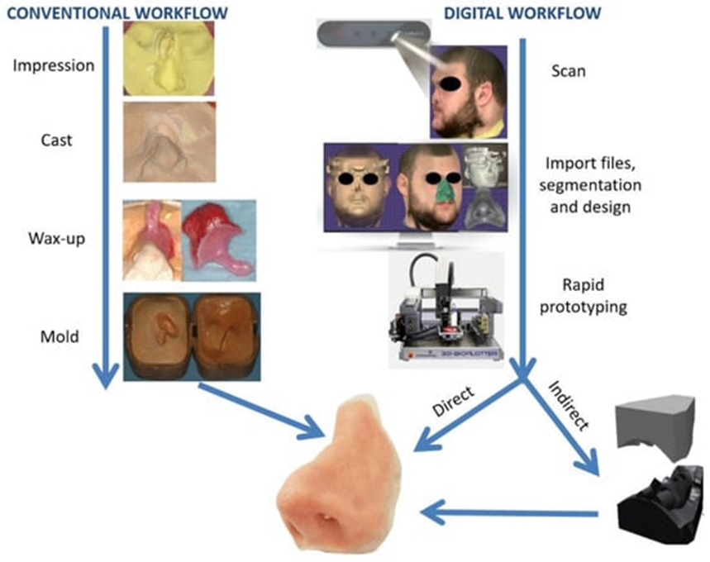
Fig 1: Comparison between conventional and digital workflow of a nasal prosthesis manufacturing^{[9]}
Conventional workflow:
A summary of the steps involved in the conventional workflow of fabricating a maxillofacial prosthesis is shown in figure 1.
An appropriate impression material should be chosen according to the defect's size, type, and whether or not there are any undercuts in the region. Elastomeric impression material and irreversible hydrocolloid or alginate are the most commonly used impression materials. The material is selected in order to obtain a precise impression of the prosthetic region, often requiring the use of a custom tray. In order to retrieve the impression without damaging or distorting the tissue surrounding it, the anatomic undercuts are blocked out prior to impression making. After the impression is taken and the gypsum cast is poured, the replacement anatomical part's wax model is made.
The wax is then carved to replicate the anatomical characteristics of the defect , after which the maxillofacial prosthesis is tried in and the necessary revisions are made for marginal fit and visual appeal. Using the lost wax technique, that involves pouring gypsum onto the wax model and subsequently melting and washing away the wax with hot water, the molds are formed from the final wax-up.^{[10]} The finished prosthesis is made from the suitable material. Complicated intraoral abnormalities which affect a portion or the entire dental arch, mounting on a semi-adjustable articulator and an impression of the opposing arch are needed prior to the try-in.
Digital Workflow:
The steps in fabricating a maxillofacial prosthesis using digital workflow are listed below:
1. Medical Imaging and Data Acquisition: The workflow starts with the collection of patient data using medical extraoral imaging modalities such as magnetic resonance imaging (MRI), cone beam computed tomography (CBCT) and intraoral scanning, which predominantly target the maxillofacial region.^{[11]}These imaging techniques give precise information on the patient's anatomy, particularly the location and size of the defect and the anatomical structures adjacent to it The digital imaging and communication in medicine (DICOM) format scan files are created in before being converted to 3 dimensional models of the patient's specific anatomy. An effective option for acquiring patient defect data is the use of surface scanners, such as intraoral, facial, and structured light scanners.^{[11,12]}
2. In the second stage of Image Segmentation and 3D Reconstruction, the important structures of the craniofacial region are segmented from the medical pictures using specialized softwares. A 3D digital model of the patient's anatomy is produced by segmenting the patient's anatomy to separate the healthy tissues from the damaged parts.^{[9]}
3. Virtual Surgical Planning (VSP): Maxillofacial surgeons and prosthodontists can conduct virtual surgical planning using the acquired 3D digital models. They can evaluate the patient's health, formulate treatment plans for the surgery, and choose the best site and form of the maxillofacial prosthesis.^{[13]}
4. Prosthetic Design: Using specialist computer-aided design (CAD) software, the maxillofacial prosthesis is designed according to the virtual surgical planning. The prosthesis is made specifically according to the patient's individual anatomy, ensuring the best possible comfort and appearance. ^{[1]}
5. 3D Printing and Rapid Prototyping: After the prosthetic design is complete, a digital file that can be used with 3D printers is generated. The actual model of the maxillofacial prosthesis is created using additive manufacturing methods, such as 3D printing or rapid prototyping. Before final production, this model is used as a prototype for checking and making adjustments.^{[14]}
6. Creation of the Complete Prosthesis: The final prosthesis is manufactured traditionally utilizing the physical model as a mold with maxillofacial prosthetic materials like silicone elastomers or other polymers like acrylic, polyphosphazenes, polyurethane, and many more. Depending on how complicated the prosthesis is, fabrication may either involve traditional methods or, as an alternative, cutting-edge techniques like additive manufacturing. In a research by Sabol JV et al., the technicians were given an Standard Triangulation Language (STL) model and a 3D printed model for fabrication. The technicians observed that it was more straightforward to distinguish the margins and contours of the defect on the 3D printed model than on the STL model, which showed slight over-contouring because of the layering. There were no discernible differences in the conformity of the final prosthesis between the two models as a master cast. ^{[15]}
7. Prosthesis Fit and Adjustment: The maxillofacial prosthesis is adjusted and checked for comfort and fit. To make certain an ideal adaptation to the patient's anatomy, extra adjustments may be done if necessary.^{[16]}
8. Prosthesis Delivery, follow up appointments and Patient Care: The maxillofacial prosthesis is delivered to the patient upon completion, along with post rehabilitation instructions on how to properly take care and maintain it. To keep track of the prosthesis' functioning and handle any potential problems, periodic follow-up appointments are planned.^{[17]}
Advantages of the Maxillofacial Prosthesis Digital Workflow:^{[18]}
The following are the benefits of using digital workflow. They are -
1. Precise Fit: Using digital workflow, the resultant prosthesis is more precise and customizable, allowing a precise fit.
2. Time Efficiency: Digital technologies speed up the process and cut down on production time as compared to traditional methods.
3. Improved Patient Communication: Patients can better understand treatment plans and expected outcomes thanks to 3D visualizations.
4. The capability to quickly develop digital files from scratch in the event that a new prosthesis is ever needed.
5. Modifiable Design Process: Modern digital procedures make it easy to make adjustments and modifications while the design is still being developed, leading to better outcomes.
Disadvantages of the Maxillofacial Prosthesis Digital Workflow:
There are few shortcomings to this. They are –
1. These systems are often costly since they need an investment of CAM equipment, CAD software, and imaging apparatus for capturing 3D maxillofacial tissues.
2. Color matching for 3D-printed models presently does not match the tones of real skin. In order to provide superior shade matching in digital processing, this topic has to be explored.
3. Tissues must be adequately supported since this technique may not be recommended if the tissue lacks tonicity.^{[15]}
Conclusion:
To conclude we can say that technological advancements are helping us to do superior treatments that result in better aesthetic results and patient comfort. But there are areas in which more research is needed. One must keep updated with the latest scientific evidence in this field.
References:
1. Farook TH, Jamayet NB, Abdullah JY, Asif JA, Rajion ZA, Alam MK. Designing 3D prosthetic templates for maxillofacial defect rehabilitation: A comparative analysis of different virtual workflows. Comput Biol Med. 2020 Mar;118:103646.
2. Jindal SK, Sherriff M, Waters MG, Smay JE, Coward TJ. Development of a 3D printable maxillofacial silicone: Part II. Optimization of moderator and thixotropic agent. J Prosthet Dent. 2018 Feb;119(2):299–304.
3. Elbashti M, Hattori M, Sumita Y, Aswehlee A, Yoshi S, Taniguchi H. Creating a digitized database of maxillofacial prostheses (obturators): A pilot study. J Adv Prosthodont. 2016 Jun;8(3):219–23.
4. Hooper SM, Westcott T, Evans PLL, Bocca AP, Jagger DC. Implant-Supported Facial Prostheses Provided by a Maxillofacial Unit in a U.K. Regional Hospital: Longevity and Patient Opinions. J Prosthodont. 2005 Mar 1;14(1):32–8.
5. Jamayet NB, Abdullah JY, Rahman AM, Husein A, Alam MK. A fast and improved method of rapid prototyping for ear prosthesis using portable 3D laser scanner. J Plast Reconstr Aesthet Surg. 2018 Jun;71(6):946–53.
6. Alghazzawi TF. Advancements in CAD/CAM technology: Options for practical implementation. J Prosthodont Res. 2016 Apr;60(2):72–84.
7. Aldaadaa A, Owji N, Knowles J. Three-dimensional Printing in Maxillofacial Surgery: Hype versus Reality. J Tissue Eng. 2018 Apr 20;9:2041731418770909.
8. M. Zardawi F, Xiao K. Optimization of maxillofacial prosthesis. In: Prosthesis. IntechOpen; 2020.
9. Cristache CM, Tudor I, Moraru L, Cristache G, Lanza A, Burlibasa M. Digital Workflow in Maxillofacial Prosthodontics—An Update on Defect Data Acquisition, Editing and Design Using Open-Source and Commercial Available Software. NATO Adv Sci Inst Ser E Appl Sci. 2021 Jan 21;11(3):973.
10. Cruz RLJ, Ross MT, Powell SK, Woodruff MA. Advancements in Soft-Tissue Prosthetics Part A: The Art of Imitating Life. Front Bioeng Biotechnol. 2020 Mar 31;8:121.
11. Marro A, Bandukwala T, Mak W. Three-Dimensional Printing and Medical Imaging: A Review of the Methods and Applications. Curr Probl Diagn Radiol. 2016 Jan-Feb;45(1):2–9.
12. Ciocca L, Mingucci R, Gassino G, Scotti R. CAD/CAM ear model and virtual construction of the mold. J Prosthet Dent. 2007 Nov;98(5):339–43.
13. Maglitto F, Dell’Aversana Orabona G, Committeri U, Salzano G, De Fazio GR, Vaira LA, et al. Virtual Surgical Planning and the “In-House” Rapid Prototyping Technique in Maxillofacial Surgery: The Current Situation and Future Perspectives. NATO Adv Sci Inst Ser E Appl Sci. 2021 Jan 23;11(3):1009.
14. Duryodhan S. Retentive aids and a comparison between conventional and digital workflow in maxillofacial prosthodontics: A review. 2021; Available from: https://zenodo.org/record/5205395
15. Sabol JV, Grant GT, Liacouras P, Rouse S. Digital image capture and rapid prototyping of the maxillofacial defect. J Prosthodont. 2011 Jun;20(4):310–4.
16. Bansod AV, Pisulkar SG, Dahihandekar C, Beri A. Rapid Prototyping in Maxillofacial Rehabilitation: A Review of Literature. Cureus. 2022 Sep;14(9):e28969.
17. Goiato MC, Pesqueira AA, Ramos da Silva C, Gennari Filho H, Micheline Dos Santos D. Patient satisfaction with maxillofacial prosthesis. Literature review. J Plast Reconstr Aesthet Surg. 2009 Feb;62(2):175–80.
18. A comparison of digital and conventional fabrication techniques for an esthetic maxillofacial prosthesis for the cheek and lip. J Prosthet Dent [Internet]. 2023 Mar 3 [cited 2023 Aug 31]; Available from: http://dx.doi.org/10.1016/j.prosdent.2023.01.020

