"Futuristic Trends in Management: Revolutionizing the Virtual Cryptocurrency and Investment Market

Prashant Ganesh Malaji
Management student
Department of Finance
Zeal College of Engineering and Research, Pune, India

Abstract:
In this ever-evolving world, the virtual market and cryptocurrency investment have become integral parts of our daily lives. The global community has wholeheartedly embraced virtual activities, and an increasing number of individuals are connected to online networks, leveraging these platforms for both learning and earning opportunities.
The convenience and accessibility of online networks have revolutionized how people connect with one another and manage their financial endeavours. Through these virtual platforms, individuals can explore various financial avenues and discover ways to earn money effectively.
In this digital landscape, the online platform serves as an empowering tool, providing valuable financial insights and enabling users to seize opportunities in the cryptocurrency market. As a result, individuals can navigate this dynamic environment with greater ease and confidence, harnessing the potential of virtual technologies to secure their financial future.
Keywords: Cryptocurrency, Bitcoin, investment, (Actual Investment v/s virtual investment)
1. INTRODUCTION
The online platform uses different types of generating money. Now current time period stock market and cryptocurrency as booming and a large number of people invest money and gaining large returns.
Cryptocurrencies are basically divided into two words ‘Crypto’ and ‘Currency’. Crypto means virtual or digital, currency is something to buy by exchanging commodities or services. Cryptocurrency is digitally exchanging commodities or currency. Cryptocurrencies do not have a central issuing or controlling authority, to be using a decentralized system to record transactions.
Cryptocurrencies are payment transaction modes in India that are not controlled or regulated by any central authority (RBI). There are no rules and regulations and the cryptocurrency deals with direct transfer to the receiver and own risk to transfer their money. So, trading in cryptocurrency is done at investors' risk.
Blockchain technology was developed to support Bitcoin. Or, to put it another way, Bitcoin would not have existed if there had been no block chain. As a result, blockchain serves as the foundation for cryptocurrency. Both technologies are interconnected. As of March 2023, there are 22,904 cryptocurrencies in existence. However, not all cryptocurrencies are active or valuable.

Discounting many “dead” crypto leaves only around 8,832 active cryptocurrencies. There are upwards of 300 million cryptocurrency users across the globe.
As investing money in cryptocurrency is very dangerous because not predict the market, and is highly volatile. The major problem with Bitcoin (cryptocurrency) is its uncertainty about the future and decisions about forecasting. There is always a risk of extreme volatility and cybercrime in digital transactions.
2. REVIEW OF LITERATURE
The virtual cryptocurrency and investment market has been rapidly evolving, with innovative management practices driving significant changes in recent years. This literature review aims to explore past studies and research to gain insights into how futuristic trends in management have reshaped the virtual financial landscape, particularly in the context of cryptocurrencies and investment.
Decentralized Finance (DeFi) and Blockchain Technology:
The concept of decentralized finance and its relationship with blockchain technology has been extensively studied. Li and Wang (2019) emphasized the potential of DeFi protocols to disrupt traditional financial systems by providing peer-to-peer financial services without intermediaries. They highlighted the role of blockchain in ensuring transparency, security, and efficiency in financial transactions.
Moreover, Akcora et al. (2020) investigated the impact of blockchain in reshaping the financial industry. Their study emphasized the decentralized nature of blockchain networks and the potential to improve financial inclusivity through access to previously underserved populations.
Smart Contracts and Automation:
The integration of smart contracts in the virtual market has been a subject of interest for researchers. Tama et al. (2018) explored the application of smart contracts in investment management. They found that self-executing contracts enabled automated investment decisions, reducing transaction costs, and minimizing human errors.
Additionally, Zhang and Liu (2021) focused on the role of AI-driven automation in smart contracts. Their study highlighted the potential of combining machine learning with smart contracts to optimize investment strategies based on real-time market data.
Artificial Intelligence (AI) and Data-Driven Decision-making:
The use of AI in the virtual market has been extensively researched. Tsai and Chen (2019) analysed the application of AI algorithms in predicting cryptocurrency price movements. They found that machine learning models could effectively forecast short-term price trends, aiding investors in making informed decisions.
In another study, Kim et al. (2020) investigated sentiment analysis using natural language processing techniques to understand how investor sentiments impact cryptocurrency prices. Their findings emphasized the significance of sentiment analysis in managing risks and identifying market trends.

Virtual Reality and Augmented Reality Experiences:
The incorporation of virtual reality and augmented reality in the investment landscape has gained attention in recent years. Wang et al. (2021) explored the use of VR technology for data visualization in cryptocurrency trading. They concluded that VR-based interfaces provided a more immersive experience, helping investors comprehend complex market data more effectively.
CRYPTOCURRENCY

Cryptocurrency, a form of digital currency, is utilized for money transfers and investments. It is characterized by its high volatility and associated risks, making it a speculative investment option. Presently, only two countries, El Salvador and the Central African Republic, officially recognize and embrace cryptocurrencies. However, there is growing interest from other countries in adopting and trusting cryptocurrencies for various purposes.

One notable advantage of using cryptocurrencies for money transfers is the potential to reduce taxation. As these transactions are not subject to government regulation and oversight, they are not recorded in official government portals, offering a level of anonymity and potentially lower tax implications.

According to research conducted in 2023, certain countries have witnessed significant adoption and usage of cryptocurrencies. These nations have seen increased interest in using digital currencies for various financial activities, signaling a potential shift in the global financial landscape.

Sr. No. | Top Countries | Capitalization
1 | USA | (46 million)
2 | India | (27 million)
3 | Pakistan | (26 million)
4 | Nigeria | (22 million)
5 | Vietnam | (20 million)

Cryptocurrency as 56 different countries adapted. Countries no regulating and controlling payment in cryptocurrency. To use of virtual or cryptocurrency as help improving country economy. Cryptocurrency have the power to completely changing the world wide economy. The bigger player of the cryptocurrency is likewise.

Bitcoin (BTC)

Ethereum (ETH)

Tether (USDT)

XRP (XRP)

BNB (BNB)

USD Coin (USDC)

Cardano (ADA)

Solana (SOL)

This type of cryptocurrency are available in the market. This type of virtual money is help the financial stability of the creation a new economy development. This investment and virtually money transfer through new business opportunities create & establish a new business.

A business point of view cryptocurrency is to reducing a tax for transaction and to easily transfer the fund in one account to other account. This Market should highly volatile they not predict the forecasting of cryptocurrency.

Benefits of
Cryptocurrency

Throughout this year, the majority of cryptocurrencies experienced explosive growth, especially Bitcoin, the largest in the market. However, when considering return on investment (ROI), other cryptocurrencies such as Shiba Inu, Ethereum, Dogecoin, and Shushi outperformed Bitcoin. Additionally, Non-Fungible Tokens (NFTs) and DeFi tokens have displayed significant promise and potential for growth in the current year.

For those seeking the best crypto investments based on types, security tokens, asset-backed tokens, NFTs, and DeFi tokens appear to be promising options. Prioritizing thorough research to understand the fundamentals and growth potential of each token is crucial. Seeking investment advice when necessary can also be beneficial.

There are approximately nine types of cryptocurrencies, each categorized based on their formulation or code, application or use case, and functionality. These types include utility, exchange, payment, security, stable coins, DeFi tokens, NFTs, and asset-backed tokens. By understanding the distinctions between these categories, investors can make well-informed decisions and capitalize on the diverse opportunities presented by the evolving cryptocurrency market.

How to use cryptocurrency:

The cryptocurrency is use individual person and business, they are
Learning About virtual currency:
Start by learning about cryptocurrencies and how they work in or virtual currency. Understand and learn the technology, block chain. And the study about different types of cryptocurrencies available in the virtual market.

Wallet:
To save and store funds in our virtual wallets. The digital controlling the fund to use the different software. They wallets fund to show as our balance and coins.

Identify & Select Cryptocurrency:
Decide which cryptocurrency choose as our objective and need. Bitcoin is the king in cryptocurrency but they have proper study how to use and how to controlling.

Bought Cryptocurrency:
As per our need to purchase a currency. This market is very volatile, they have a proper knowledge about virtual market and currency. They exchange in money account they securely check the all information.

Store Cryptocurrency:
After purchasing, transfer the currency our wallet. Purchasing cryptocurrency and they store a wallet because this safe.

Exchanging Cryptocurrency:
You can send cryptocurrency to others by another account or wallet. The similar receiving the cryptocurrency when someone sends bye wallet.

Security:
You are handling a very secure and safe about the digital account because they not proper secure.

Alert to our currency:
The cryptocurrency market a highly volatile they to alert of any time they not proper predict the future. This market is highly risky and highly returnable but proper study about market.

Taxation:
In some countries are receiving tax as per the rules & regulation. because too aware about the counties rules and regulation.

Risks of investing in Cryptocurrency: -

Cryptocurrency exchanges, more so than stock exchanges, are vulnerable to being hacked and becoming targets of other criminal activity. Security breaches have led to sizable losses for investors who have had their digital currencies stolen, spurring many exchanges and third-party insurers to begin offering protection against hacks.

Risk Involved in Cryptocurrency. The calculated risk and return is one type of management; they face in different types of risk as a bellow

Volatile Market:
Cryptocurrencies are known for their extreme price fluctuations. Prices can skyrocket in a short period, but they can also crash just as rapidly. This volatility can lead to substantial gains, but it also means that you can lose a significant portion of your investment in a short time.

Legal protection or regulating transaction:
The regulatory environment for cryptocurrencies is still evolving in many countries. Sudden changes in regulations or outright bans could impact the market and the legality of certain cryptocurrencies.

Security:
While cryptocurrencies use advanced cryptography, the infrastructure around them, such as exchanges and wallets, can be vulnerable to hacking and security breaches. If you don't store your cryptocurrencies securely, you risk losing your funds.

Converting to cash:
Some cryptocurrencies may have low trading volumes and liquidity. In illiquid markets, it can be challenging to buy or sell large amounts without significantly affecting the price.

Market trends:
The cryptocurrency market can be influenced by factors such as macroeconomic trends, investor sentiment, media coverage, and speculation. This can lead to unpredictable price movements. The relatively small market capitalization of some cryptocurrencies makes them susceptible to market manipulation, such as pump-and-dump schemes.

Technology Factor:
Cryptocurrencies are built on complex technologies, and they can face issues like software bugs, network forks, or governance disputes, which might affect their functionality and value.

Fraud and Scams:
The lack of regulatory oversight in the cryptocurrency space has attracted fraudsters and scammers. There have been cases of fake projects, Ponzi schemes, and phishing attacks, where people have lost their investments.

Disconnect access:
If you lose access to your cryptocurrency wallet or private keys, you might lose your funds irreversibly. This can happen if you forget your password, misplace your recovery phrase, or experience a hardware failure.

Lack of Consumer Protections:
Unlike traditional financial systems, cryptocurrency transactions are often irreversible, and there may be limited avenues for dispute resolution or fraud recovery.

Cryptocurrency as investment option

Cryptocurrency is a good investment if you want to gain direct exposure to the demand for digital currency. A safer but potentially less lucrative alternative is buying the stocks of companies with exposure to cryptocurrency. Investing in cryptocurrency requires careful planning and consideration due to its inherent risks.
The Investing a good option but their risk is involved in this cryptocurrency. This market not a stable in any time to changing a movement in any time, they are highly volatile if you want a purchases and purpose of the highly return so your digital market knowledge is very high and predict the market as per the market situation.
some steps to help you get started with cryptocurrency investing:

Educate Yourself:
Before investing, take the time to understand the basics of cryptocurrencies, block chain technology, and how the market operates. Research different cryptocurrencies, their use cases, and their potential for growth.

Set Investment Goals:
Determine your investment objectives, risk tolerance, and time horizon. Decide if you're looking for short-term gains or long-term growth and how much of your overall investment portfolio you're willing to allocate to cryptocurrencies.

Choose a Reputable Exchange:
Select a reputable and secure cryptocurrency exchange to buy, sell, and trade cryptocurrencies. Look for exchanges that have a good track record, strong security measures, and a wide range of supported cryptocurrencies.

Select Cryptocurrencies:
With thousands of cryptocurrencies available, it's crucial to choose wisely. Focus on well-established and reputable projects with real-world use cases and active development teams. Bitcoin and Ethereum are usually considered more stable choices, but do your own research.

Implement Security Measures:
Prioritize security by setting up two-factor authentication (2FA) on your exchange and wallet accounts. Use hardware wallets or other secure wallet solutions to store your cryptocurrencies safely offline.

Start Small:
If you're new to cryptocurrency investing, start with a small amount that you can afford to lose. The market's volatility means that prices can fluctuate significantly.

Diversify Your Portfolio:
Avoid putting all your funds into a single cryptocurrency. Diversify your investments across different cryptocurrencies to spread risk. Also, consider diversifying across other asset classes beyond cryptocurrencies.

Stay Informed: Stay up-to-date with the latest news, market trends, and developments in the cryptocurrency space. Follow reputable sources and communities to gain insights into potential investment opportunities.

Control Emotions:
Cryptocurrency markets can be highly emotional, leading to impulsive decisions. Be disciplined and avoid making investment choices based on fear or FOMO (fear of missing out).

Monitor and Adjust:
Regularly review your portfolio's performance and adjust your investment strategy as needed. Consider taking profits when a cryptocurrency's value has increased significantly or cutting losses if a project's fundamentals have deteriorated.

Understand Taxes:
Be aware of the tax implications of cryptocurrency investments in your country. Keep records of your transactions and consult with a tax professional if necessary.

Be Patient:
Cryptocurrency markets can be highly volatile, and significant gains or losses may take time. Avoid chasing quick profits and focus on a long-term investment approach.

Remember that cryptocurrency investing involves risk, and there are no guarantees of profits. Never invest money you cannot afford to lose, and always do thorough research before making any investment decisions. Seeking advice from financial professionals can also be beneficial, especially if you're unsure about your investment strategy. The king of cryptocurrency is bit coin to all major investing in the bitcoin

This type cryptocurrency available in the market and this all the currency as highly volatile they not predict the as per the market situation. They include in major currency is Bitcoin. This currency is to all over the world as an investment option, India is the second large country to use bitcoin.

Bitcoin is a form of digital currency that aims to eliminate the need for central authorities such as banks or governments. Instead, Bitcoin uses blockchain technology to support peer-to-peer transactions between users on a decentralized network.
Points | Actual Investment | Virtual Investment  (Cryptocurrency)
Concept | Old and traditional Concept | New as digital currency
Return | Calculating return | High Return
Risk | Calculating Risk | High Risk
Predict | Calculation through Predict and secure the future | High volatile not proper predict
Calculating | High | less
Regulatory | SEBI | Individually handling
Tax Benefit | Yes | No
Track | Detailed Track | Limited Track
Credibility | High | Low
Include investment | - Bitcoin  - Litecoin  - Dogecoin  - Tether | - Debt equity  - Equity Fund  - Gold  - Shares (stocks)  - Property  - Bonds  - PPF

Transactions are authenticated through Bitcoin’s proof-of-work consensus mechanism, which rewards cryptocurrency miners for validating transactions.

Launched in 2009 by a mysterious developer known as Satoshi Nakamoto, Bitcoin (BTC) was the first, and remains the most valuable, entrant in the emerging class of assets known as cryptocurrencies.

The Actual Investment & Virtual Investment (Cryptocurrency)

The comparison is actual and virtual investing if you want safe to investing and earn to return to actual investment is a better option. Actual investment as market condition to predict the stocks and equity. The compare to both elements is better option actual investment. The cryptocurrency market is volatile but not perfectly predict the market condition. Bitcoin and another investment to help earn a highly return but it involves high risk. Virtual market is another name to show is gambling in the digital platform. Actual investment is the perfect predictable market to gain and ear to something.
The hacking digital investment, current situation records the 70 million plus hacking in only one currency is bitcoin. This digital currency is not safe account through hack the wallets.

The basic difference is actual investment and Virtual investment (cryptocurrency)

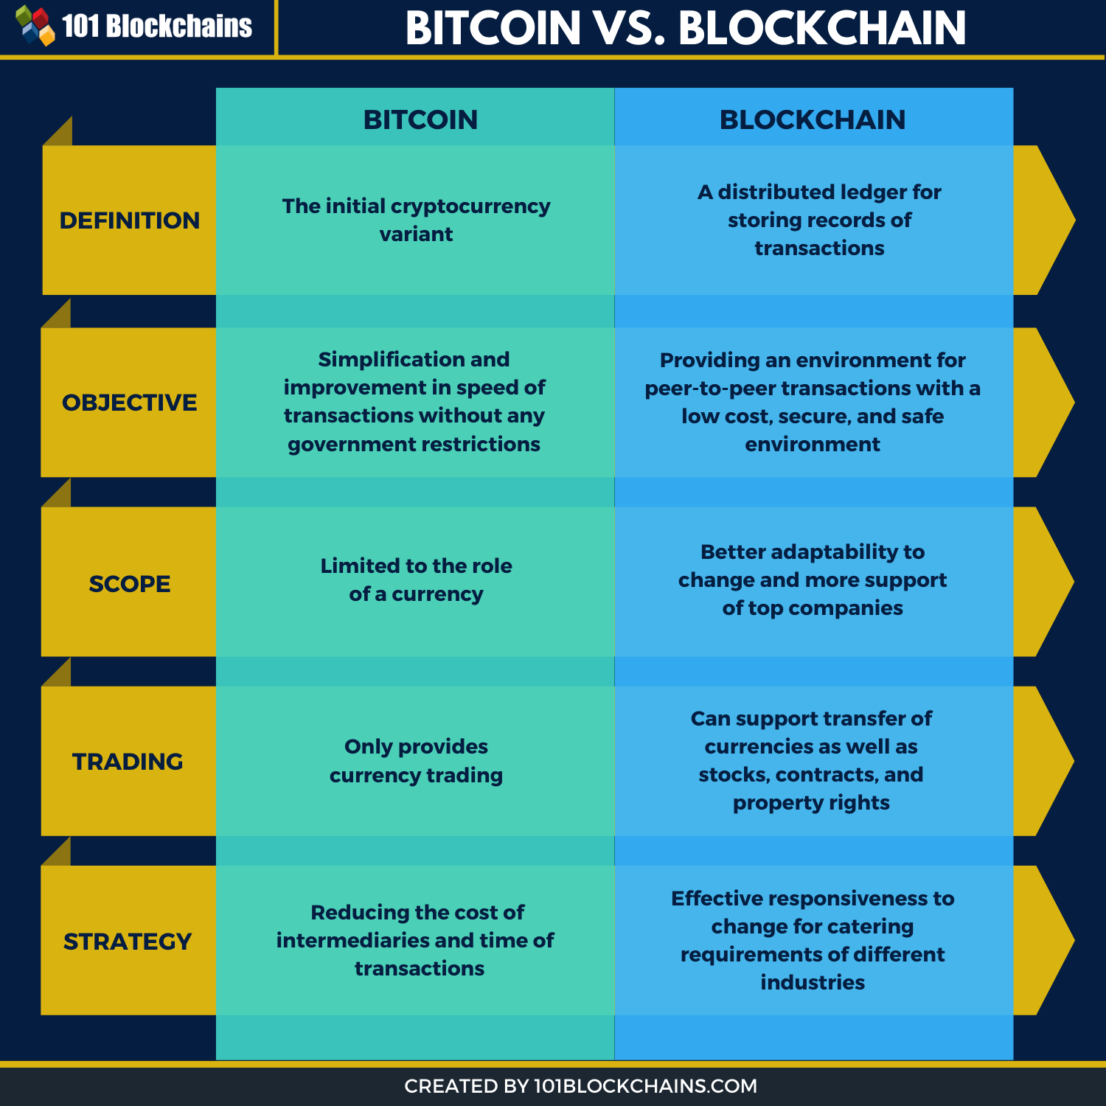

Conclusion:
In conclusion, cryptocurrency has emerged as a digital currency used for money transfers and investment. Its highly volatile and risky nature makes it an attractive yet speculative option for investors. Presently, only El Salvador and the Central African Republic have officially embraced cryptocurrencies, while other countries are showing increasing interest in its adoption. The potential advantage of reduced taxation through the use of cryptocurrencies lies in the lack of government regulation and control, leading to transactions being unrecorded in official government portals.
As of 2023, certain countries have experienced a surge in cryptocurrency usage, indicating a growing trend and potential transformation in the global financial landscape. The widespread acceptance and belief in cryptocurrency continue to evolve, with the potential for more countries to recognize its utility and adapt to its unique characteristics in the future.

References:
- Li, Q., & Wang, S. (2019). Decentralized finance: Overview and research directions. In 2019 IEEE International Conference on Blockchain (Blockchain) (pp. 113-117). IEEE.
- Akcora, C. G., Li, Y., Li, Y., & Song, C. (2020). Blockchain: A security and privacy survey. IEEE Transactions on Big Data, 6(4), 441-465.
- Tama, B. A., Muchtar, M. A., & Suprayogi, M. N. (2018). Implementation of smart contracts for investment management. In 2018 International Conference on Applied Computer and Communication Technologies (ComCom) (pp. 25-28). IEEE.
- Zhang, Y., & Liu, J. (2021). A survey of AI-driven smart contract. In 2021 IEEE 9th International Conference on Consumer Electronics-China (ICCE-China) (pp. 1-5). IEEE.
- Tsai, C. F., & Chen, C. W. (2019). Predicting bitcoin price direction using sentiment analysis. Applied Economics Letters, 26(15), 1227-1232.
- Kim, J. H., Kim, W. G., & Kim, T. T. (2020). The impact of investor sentiment on cryptocurrency returns. International Journal of Information Management, 50, 378-387.
- Wang, Y., Chen, X., & Xu, J. (2021). Visualization design for cryptocurrency trading based on virtual reality. In 2021 16th International Conference on Computer Science & Education (ICCSE) (pp. 484-488). IEEE.

