**Electrochemistry and Electrocatalytic Applications**

Vijay S. Sapnera,b and Bhaskar R. Satheb,c*

aDepartment of Chemistry, Shri Mathuradas Mohota College of Science, Nagpur-440024, Maharashtra, India

bDepartment of Chemistry, Dr. Babasaheb Ambedkar Marathwada University, Aurangabad 431004, Maharashtra, India

dDepartment of Nanotechnology, Dr. Babasaheb Ambedkar Marathwada University, Aurangabad 431004, Maharashtra, India

E-mail: [bsathe.chemistry@bamu.ac.in](mailto:bsathe.chemistry@bamu.ac.in) (Bhaskar R. Sathe)

**Introduction**

**1.1 Electrochemistry and Electrocatalysis**

The study of electrochemistry examines the connection between electricity, as quantifiable phenomenon that can be measured, and observable chemical changes, with electricity being viewed as the outcome of a certain chemical change or the opposite. In these reactions, an electrolyte (or ionic species in a solution) and electrodes exchange electric charges. The interplay between electrical energy and chemical change is thus the subject of electrochemistry. An electrochemical reaction occurs when a chemical reaction is sparked by an external current, as in electrolysis, or when a chemical reaction spontaneously generates an electric current, as in a battery. Redox reactions or oxidation reactions are terms used to describe chemical processes in which electrons are moved directly between molecules or atoms. The word "electrochemistry" refers to the overall processes that occur when discrete redox reactions are linked together by an intermediate electrolyte and an external electric circuit.

Voltammetry, a widely used electrochemical method, was created following the discovery of polarography. Polarography, cyclic voltammetry, linear sweep voltammetry (LSV), chronoamperometry (i-t), differential pulse voltammetry (DPV), square-wave voltammetry (SWV), and other forms of voltammetry are currently available for various analytical purposes. The potential is applied and the current is measured in all of these ways, but the operation with on yields different results. These discrepancies can also give chemical, electrochemical, and physical information in the form of highly quantitative analyses, chemical reaction constants, redox processes, and solution characteristics.

**1.1.1 Cyclic and Linear Sweep Voltammetry (CV and LSV)**

Cyclic voltammetry (CV) is a potentiodynamic electrochemical measuring technique. The working electrode potential is scaled linearly with time in a cyclic voltammetry experiment. In contrast to linear sweep voltammetry, when the set potential in a CV experiment is achieved, the potential of the working electrode ramps in the opposite direction to return to the beginning potential. As many times as necessary can be spent repeating these potential ramp cycles. Plotting the current through the working electrode against the applied voltage (or working electrode potential) yields the cyclic voltammogram trace. The electrochemical properties of an analyte in solution or a molecule adsorbed on an electrode are frequently investigated using cyclic voltammetry. The **Figure 1.1** schematic illustration of cyclic voltammetric redox peak (oxidation and reduction)



**Figure 1.1:** Schematic illustration of cyclic voltammetric redox peak (oxidation and reduction)

The modified and unmodified electrode surface features also affect the electrochemical parameters based on cyclic voltammetry. LSV is also a part of voltammetry, which relates to the linear potential sweep applied to the working electrode while observing concurrently the current. LSV having an adventitious during study of electrochemical reduction and oxidation relations. Above discussion using CV for sensing of biomolecules if there is oxidation using LSV at an applied potential of -1 to 1 V and if there is reduction applied potential at 1 to -1 V. In part of electrocatalytical oxygen evolution reaction, hydrazine oxidation reaction and oxygen reduction reaction using LSV can perform.

The LSV is very much similar to the CV The voltage is swept between two values a fixed point, but the scan is reversed and the voltage swept back toV1 now that the voltage exceeds V2 shown in **Figure 1.2**.



**Figure 1. 2:** Schematic illustration linear sweep voltammetry voltage sweep V1 and V2.

In LSV a fixed potential range is employed much like potential step measurements. However in LSV the voltage is scanned from a lower limit to an upper limit and as shown in **Figure 1.3.**

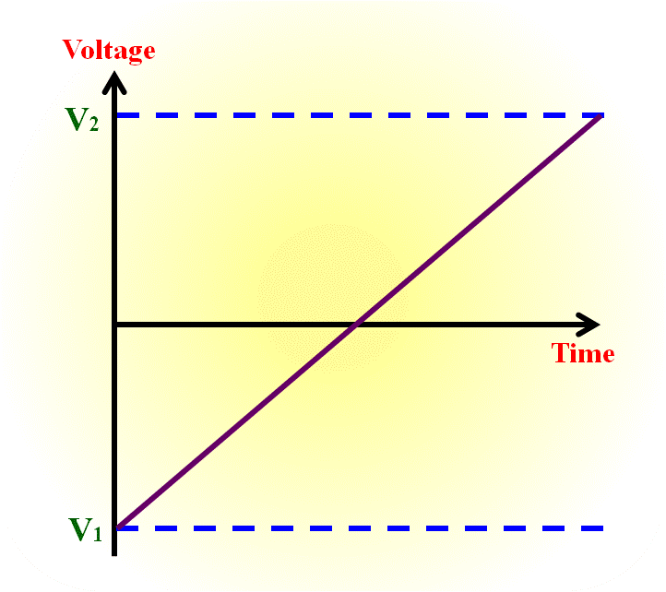

**Figure 1.3:** Schematic illustration of linear sweep voltammetry with fix potential.

**1.1.2. Chronoamperometry (i-t)**

Chronoamperometry is an electrochemical approach that includes stepping the voltage of the working electrode and measuring the current as a function of time that arises from the faradic processes that occur at the electrode. The working electrode of the electrochemical system is subjected to a single or double potential step, and the functional relationship between current responsiveness and time is then evaluated. The peak oxidation current against peak reduction current ratio can provide some information regarding the identification of the electrolyzed species. Chronoamperometry, like other pulsed approaches, creates high charging currents that decline exponentially with time, much like any RC circuit. The Cottrell equation describes how the Faradic current, which is typically the current component of interest and is, brought on by electron transfer events, decays. With significant exceptions, most electrochemical cells have a decay that is substantially slower than the charging decay. Three electrode setups are most commonly used. Because the current is integrated over longer time intervals, chronoamperometry has a higher signal-to-noise ratio than other amperometric methods.

The potential step, which is one of the simplest potential wave shapes, is shared by chronoamperometry (CA) and chronocoulometry (CC). As shown below **Figure 1.4**, the potential is changed instantaneously from the initial potential to the first step potential, and it is held at this value for the first step time. This experiment only has one possible outcome. In a double potential step experiment, the potential is transferred to the second step potential during the first step time and maintained there for the duration of the second step period. CC monitors the charge as a function of time, whereas CA monitors the current as a function of time. The fundamental potential step experiment of the epsilon is a CA, which implies that the current is recorded as a function of time throughout the experiment. By integrating the current, the data may also be shown as charge as a function of time after the experiment. Data from chronocoulometry can be acquired as a result. CA is a widely used method on the epsilon.

The time scale of CA is shorter (milliseconds and seconds) than that of CPE and DCA (seconds and minutes), distinguishing it from other constant potential techniques like constant potential electrolysis (CPE) and DC potential amperometry (DCA).

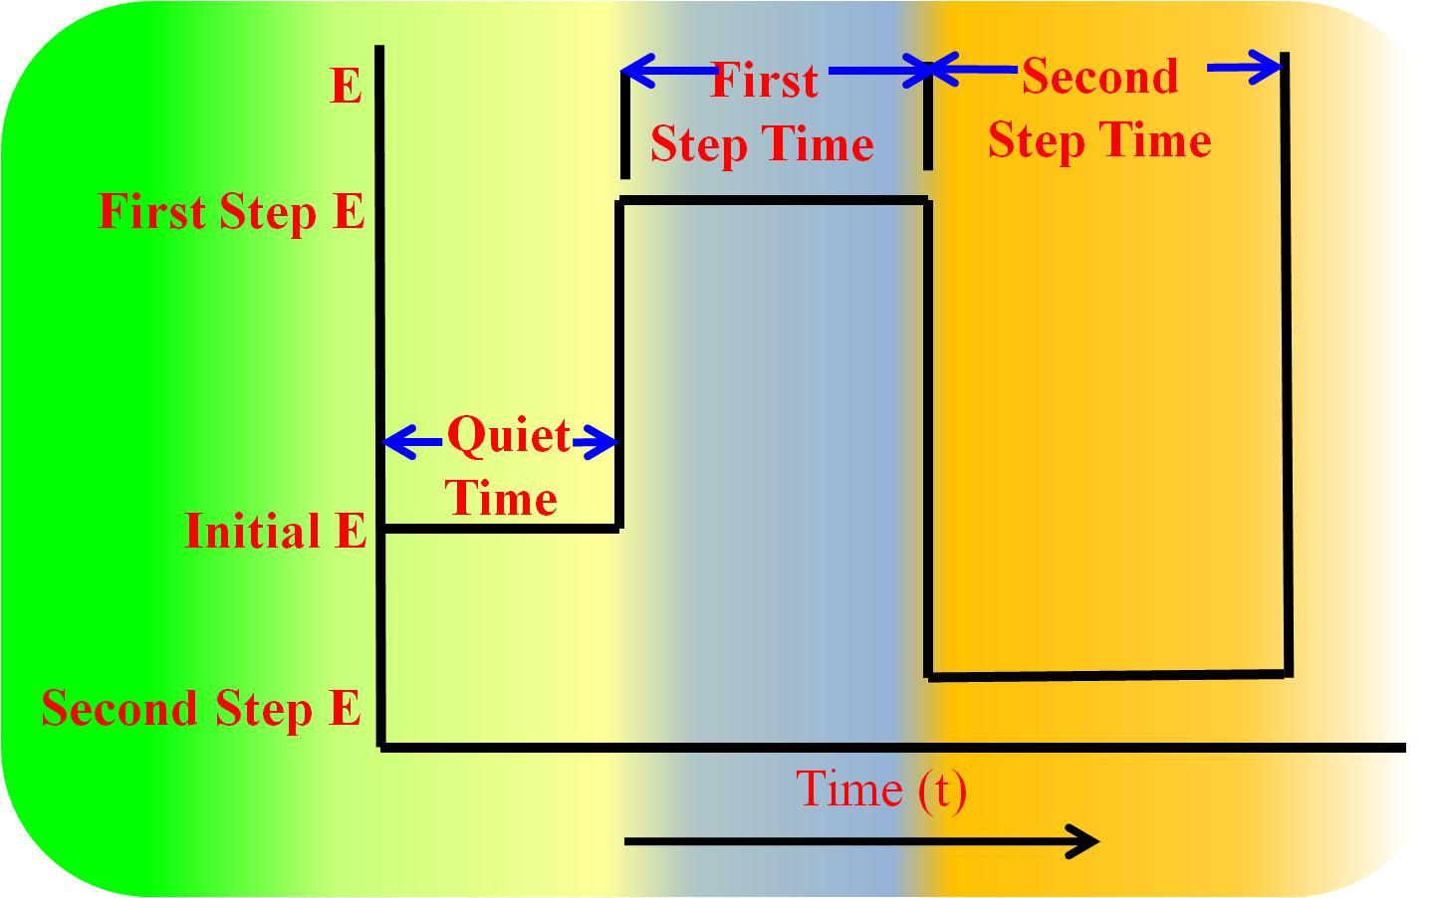

**Figure 1.4:** Potential wave form for chronoamperomtric and chronocoulometry.

1.1.3 Electrochemical Impedance Spectroscopy (EIS)

Electrochemical impedance spectroscopy (EIS) is an important technique to describe kinetics and changes at electrified interface of electrode/electrolyte. It is also use to determine the dielectric and transport properties, passive surfaces of material. EIS includes the application of a small or alternating current (AC) or voltage to the over range of frequencies with sample undergoing investigation in electrochemical cell. Basically, it is dependent on the Ohm’s law as the electrical resistance is inversely proportional to the passage of electrical current in the electrical cell or circuit.

By comparing the voltage's and current's amplitudes, one may determine a system's impedance. Consider the three forms of resistances in electrochemical reactions: electrode interface resistance, electrolyte resistance, and instrument resistance. Resistance increases with the size of the semicircle in the polarization plot, and vice versa for the low- and high-frequency regions. If there were two semicircles on the graph, the first one would represent the electrode interface and the second would represent the electrolyte resistance. Additionally, a smaller semicircle is seen at higher cathodic potentials than at lower potentials for the same frequency, indicating that the electron is more feasible at higher cathodic potentials.

**1.2. Electrocatalysis**

The process of oxidation and/or reduction by direct electron transfer processes at the electrode electrolyte interface is known as electrocatalysis. Electrochemical mechanical electrocatalytic processes are a major subject of research in several departments of chemistry and related science. For example, the second half reaction of the water oxidation process is the reduction of protons to hydrogen.

The tool used to carry out electrolysis is called an electrolytic cell. It consists of a jar that contains electrolytes in either a molten state or a liquid state. Two metal rods are inserted into it, connected to two terminals of a power supply, and filled with it. These rods are known as electrodes; in **Figure 1.5,** the cathode, which is linked to the negative pole of the battery, and the anode, which is connected to the positive pole, is shown.

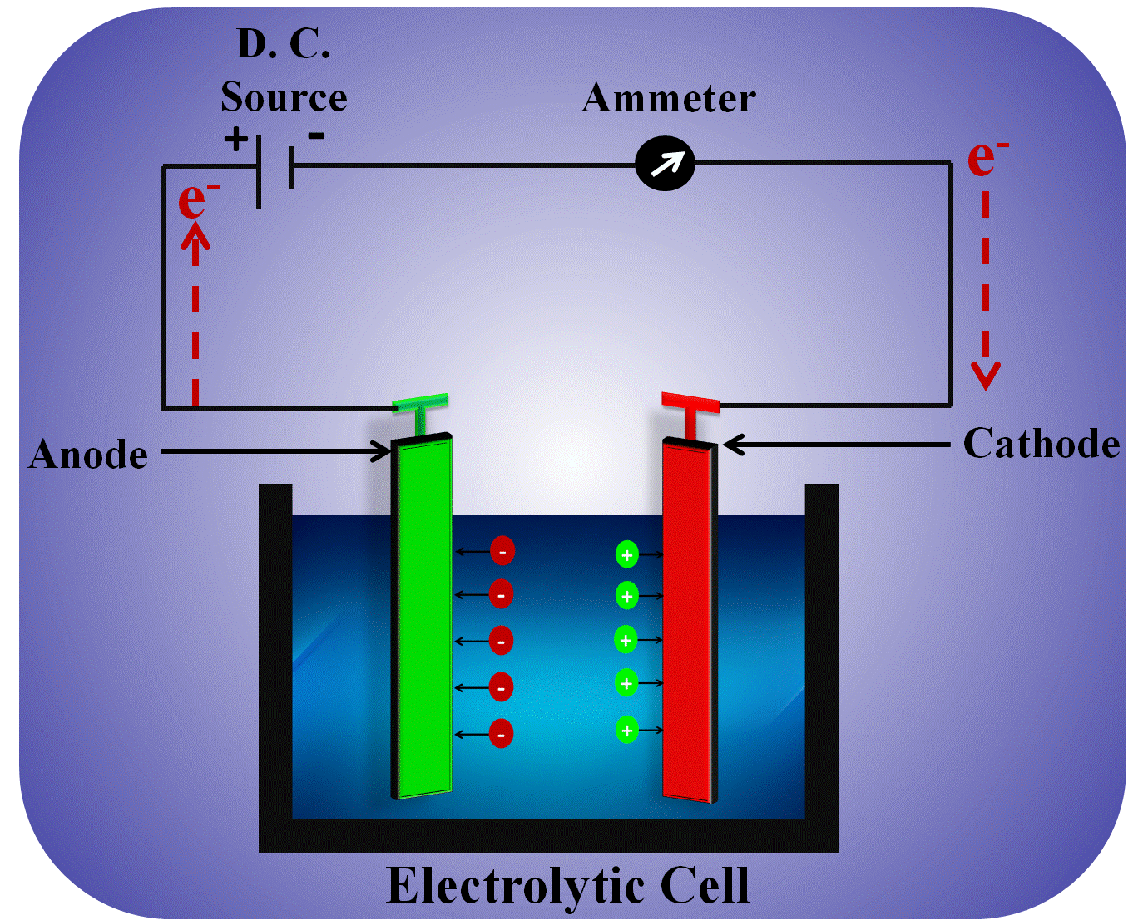

**Figure 1.5**: Schematic representation of electrochemical cell involving oxidation and reduction processes reactions at anode and cathode interface respectively.

**1.2.1. Mechanism and parameters**

Positive ions are drawn to the cathode (negative electrode) during electrolysis, where they take an electron and lose their charge. While migrating towards the anode (positive electrode), negative ions lose one electron and becoming neutral. The fundamental alteration is the transformation of ions into neutral species at each electrode. The product created by primary change may be preserved in its original form or it may go through secondary change to create the finished product.

**1.3. Electrochemical Biosensing**

In 1962 the biosensor era began with the invention of Clark and Lyon’s first glucose meter and progressed uncontrollable levels 1. At present, it covers fields such as genetics, biotelemedicine, ecology, drug discovery, food safety regulations, etc. ' biosensor ' refers to the electronic analytical system with a biological sensor and physiochemical transducer 2. Transforming advanced engineering equipment into small hand-held instruments became the biggest achievement of bio-sensors. In particular, the main interests are the electrochemical biosensors, with improved sensitivity and selectivity, LODs and quantification cap (LOQ's) have been accomplished through the implementation of biological factors in electronic devices. These are user-friendly as well as open to large audiences including non-specialists and patients with miniaturization, simplification and portability. A variety of electrochemical instruments, including amperometric sensors, electrical impedance sensors, electrical luminescence sensors and photo-electrochemical, provides wide-range of applications for the electrochemical modification of electrode interfaces in the identification of chemical and biological targets 3.

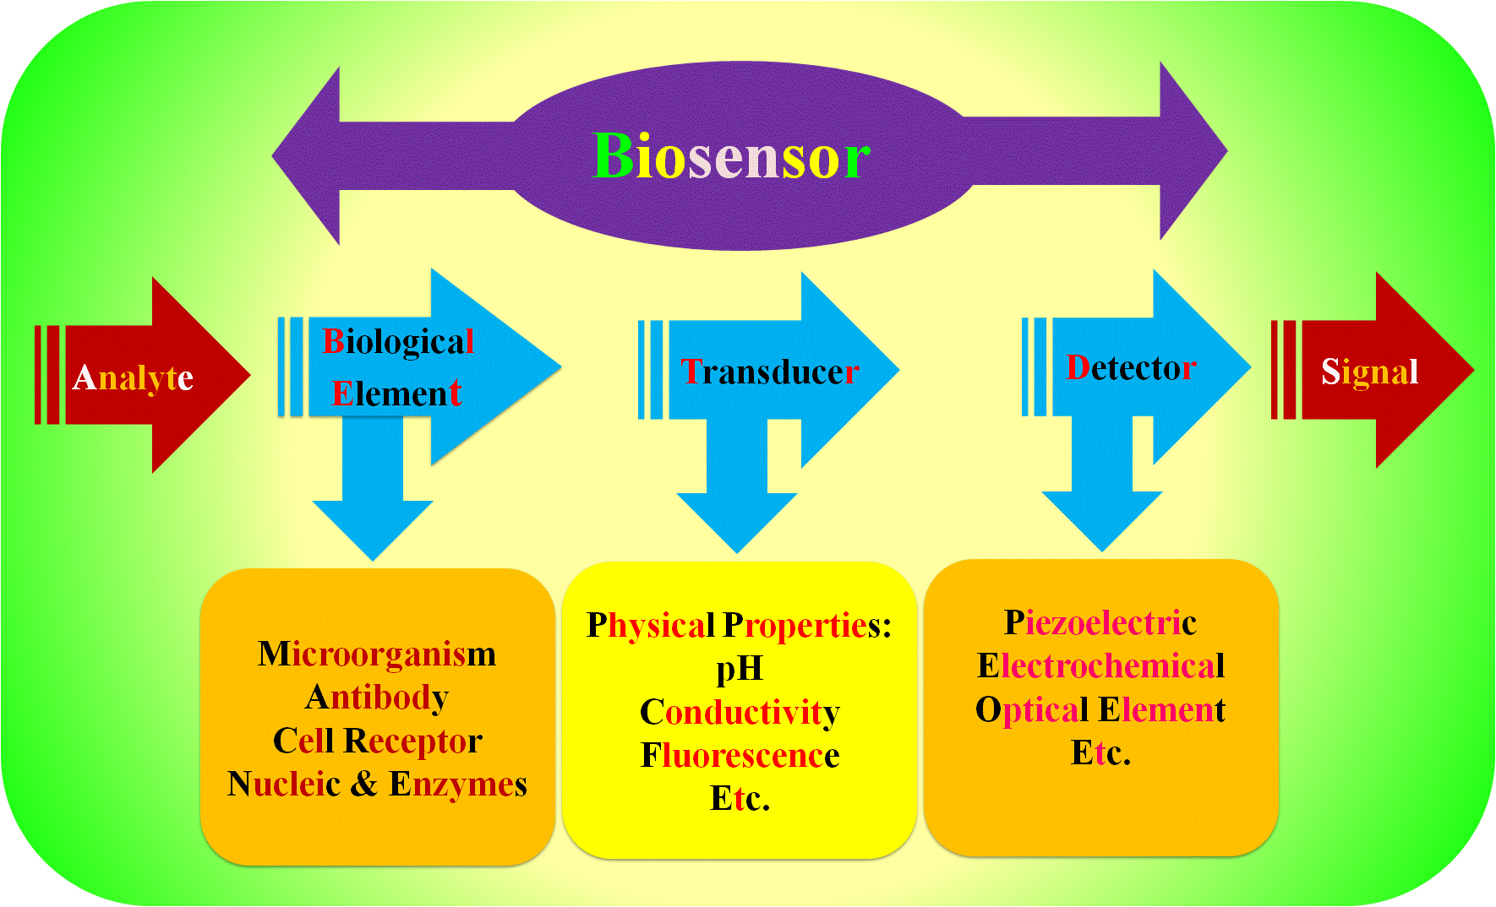

**Figure 1.6**: Schematic representation of electrochemical biosensors including different components.

Nanomaterials electrical signal amplifiers have a tremendous potential to increase the efficiency and selectivity in the area of electrochemical sensors and bio-sensors with their outstanding achievements in nanotechnology and nano-science 4. The development of several research concepts for high-level electrochemical sensing frameworks for the identification of target molecules is widely known to have been significantly aided by the electrode materials, which are also well recognised for this.5–8. Functional nanomaterials not only produce a synergistic effect between catalytic processes, conductivity, and biocompatibility to facilitate the transduction of a signal, but also to enhance bio recognition events by means of different signal tags leading to high-sensitivity biosensing 2. In addition to various electrochemical approaches extensive research is advancing the broad application of electrochemical tools in the design of the practical electrode materials. For instance, Walcarius et al. also referred to recent advances in the logical design of bifunctional electrodes as well as related biometric sensing systems with nano-engineered and/or nanostructure materials 9. The attraction of such nanomaterials is based on their ability to operate as efficient immobilisation matrices as well as their inherent and unique properties. Such properties together with biomolecular processing leading to improve the performance of bio electrodes with respect to sensitivity and specificity 10–18. **Figure 1.6** shows the schematic representation of electrochemical biosensors.

**1.3.1. General mechanisms of electrochemical biosensing**

An enzymatic catalytic process that uses or produces electrons often serves as the foundation of an electrochemical biosensor. Redox enzymes are the name given to these enzymes. The substrate of this biosensor normally includes three electrodes: a working electrode, a counter electrode, and a reference electrode.19.

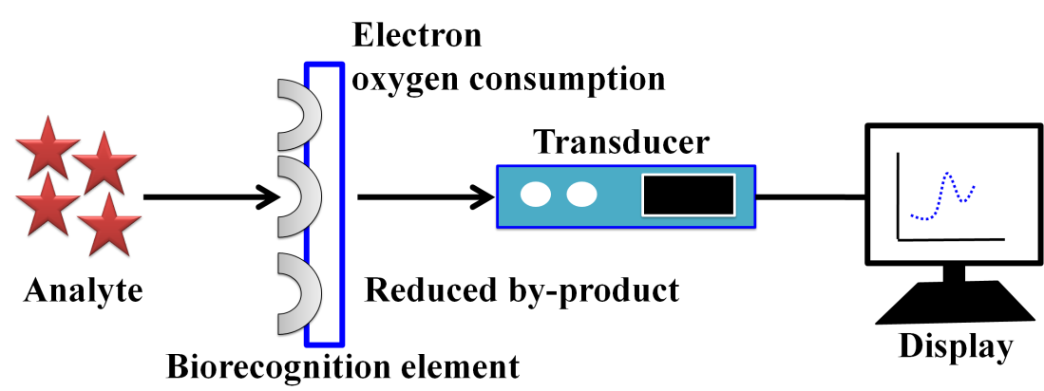

**Figure 1.7:** Schematic representation of mechanistic path for electrochemical biosensor

The analyte is involved in the reaction that occurs on the surface of an active electrode, and this reaction may result in electron transfer across the dual layer potential. It is possible to estimate the current at a given potential.

**1.4. Water Spitting Reactions**

The fields of science and engineering have been trying in the past couple of decades to develop new and improved types of energy technologies capable of improving life worldwide. Accordingly scientists and engineers have been developing nanotechnology based energy resources to make the next step forward from current technological generation. New fields in research, nanotechnology, are any development that contains components smaller than a hundred nanometer. A single part of the virus has a diameter of about 100 nanometers. Nanofabrication is a significant energy-related subfield of nanotechnology. Nano-manufacturing is the design and development phase on the nanoscale of products. Making devices smaller than 100 nanometers opens up several possibilities for developing new methods of energy capture, storage and transition. The level of control that nanoscience and engineers would obtain from nanofabrication would be crucial to the capacity to deal with many of the world's problems today related to energy technologies currently being developed. Scientists and engineers have already started developing strategies to use nanotechnology for producing consumer products. The advantages of the construction of these goods include improved lighting and heating performance, enhanced power storage capacity and decreased emissions as a consequence of energy consumption. Such benefits make capital spending a top priority in nanotechnology research and development. The constantly rising energy demand and through emissions require tremendous efforts to find sustainable and economically beneficial clean and renewable energy resources. In **Figure 1.8** show **s**chematic representation of water splitting reaction.

**2 H2O → O2+ 2H2**

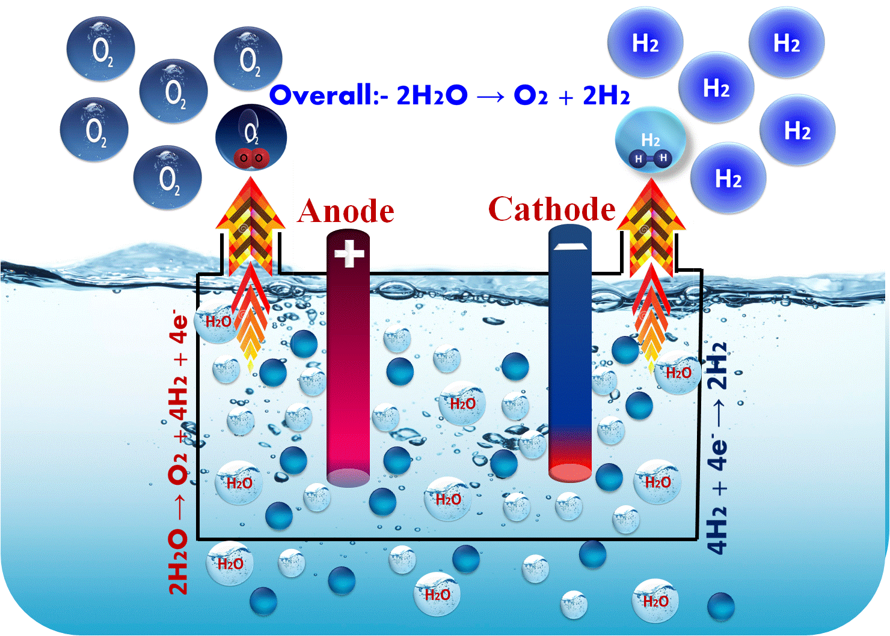

**Figure 1.8:** Schematic representation of water splitting reaction involving OER and HER at anode and cathodes respectively.

A hydrogen economy might be supported by the efficient and affordable splitting of photochemical water, which would represent a technical advance. Water splitting using pure water hasn't been shown in an industrially useful way, but the two component processes (H2 and O2 creation) are widely known. However, seawater and other salt water splitting is used industrially to manufacture chlorine, and the waste hydrogen recovered makes up approximately 5% of the world's supply. While photosynthesis involves a water splitting variation, hydrogen is not produced. The reversal of how water splits is the foundation of the hydrogen fuel cell. A potentially useful method for the large-scale, extremely pure hydrogen synthesis is water electrolysis. Extensive study has been conducted on the electrocatalytic splitting of water accomplished by graphene-based hybrids, in which graphene serves several functions as an electroactive component and/or functional support.

In this thesis, we summarizes the recent important progress in developing biomolecules based graphene hybrid electrocatalyst for water slitting, in particular highlighting amino acids functionalized graphene hybrids design strategies and graphene's function in electrocatalyst and/or support. Ultimately, we are addressing remaining problems and future prospects in the design of water splitting by using hybrid graphic electrocatalyst.

**1.4.1. General mechanisms of electrochemical water splitting (HER, OER)**

The most extensively researched catalytic technique of oxidising water prior, included the introduction of a chemical catalysis principle: electrolysis, the electrocatalysis of liquid water into hydrogen and oxygen using electricity.20–24 The following equation describes the entire process that is catalyzed at the three-phase anode and cathode interface of the electrified solid, liquid, and gas

**H2O (l) → H2 (g) + ½ O2 (g) (I)**

There are two half-cell redox processes involved in the electrochemical water splitting process. The HER, which is the mechanism by which the cathode is reduced, operates

**2H+ → 2e- + H2 (II)**

During the oxidation process OER at the electrolyze anode. Per mole of water transformed, two electrons are transmitted per formula, or a total charge of 192 928 C (=2 F) across the electrocatalytic contact.

**H2O→ ½ O2+ 2H++ 2e- (III)**

Electrochemical water splitting involves two concurrent catalytic half-cell reactions according to equation (II) (HER) and equation (III) (OER).

**1.5. Electrocatalytic Fuel Cell Reactions**

A fuel cell is an electrochemical device that converts the chemical energy of a fuel (often hydrogen) and an oxidising agent (typically oxygen) into electrical energy via two redox reactions. The chemical energy in a battery is typically derived from metals and their ions or oxides that are already present in the battery, whereas fuel cells, with the exception of flow batteries, differ from other batteries in that they require a constant supply of fuel and oxygen (typically from air) to support the chemical reaction.15,25 In **Figure 1.9** shown byschematic representation of fuel cell reactions.

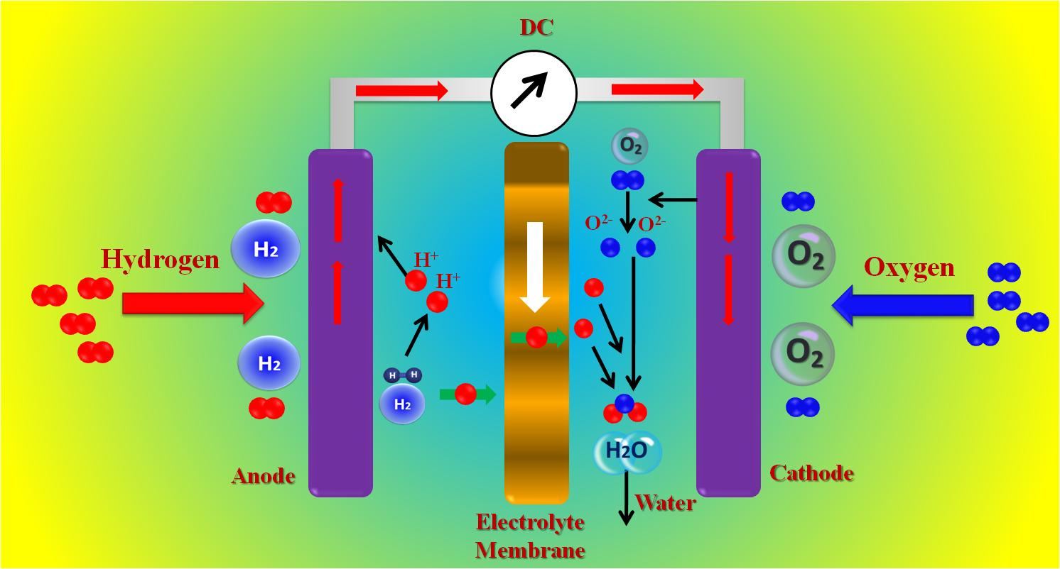

**Figure 1.9:** Schematic representation of fuel cell reactions.

1.5.1. ORR Reactions and Mechanistic path

The most prevalent element in the earth's crust is oxygen (O2). Perhaps the most important reaction in life activities like biological respiration and energy storage technologies like fuel cells is the oxygen reduction reaction (ORR).26. The direct 4-electron reduction channel from O2 to H2O and the 2-electron reduction pathway from O2 to hydrogen peroxide (H2O2) are the primary ORR mechanisms in aqueous solutions. The 1-electron reduction process from O2 to superoxide (O2) can also occur in non-aqueous aprotic solvents and/or alkaline solutions.27 Direct methanol fuel cells (DMFCs), which use proton exchange membrane (PEM) fuel cells, use ORR as the reaction taking place at the cathode. Typically, ORR kinetics is quite slow. To accelerate the ORR kinetics in fuel cells to a manageable level, a cathode ORR catalyst is required.28

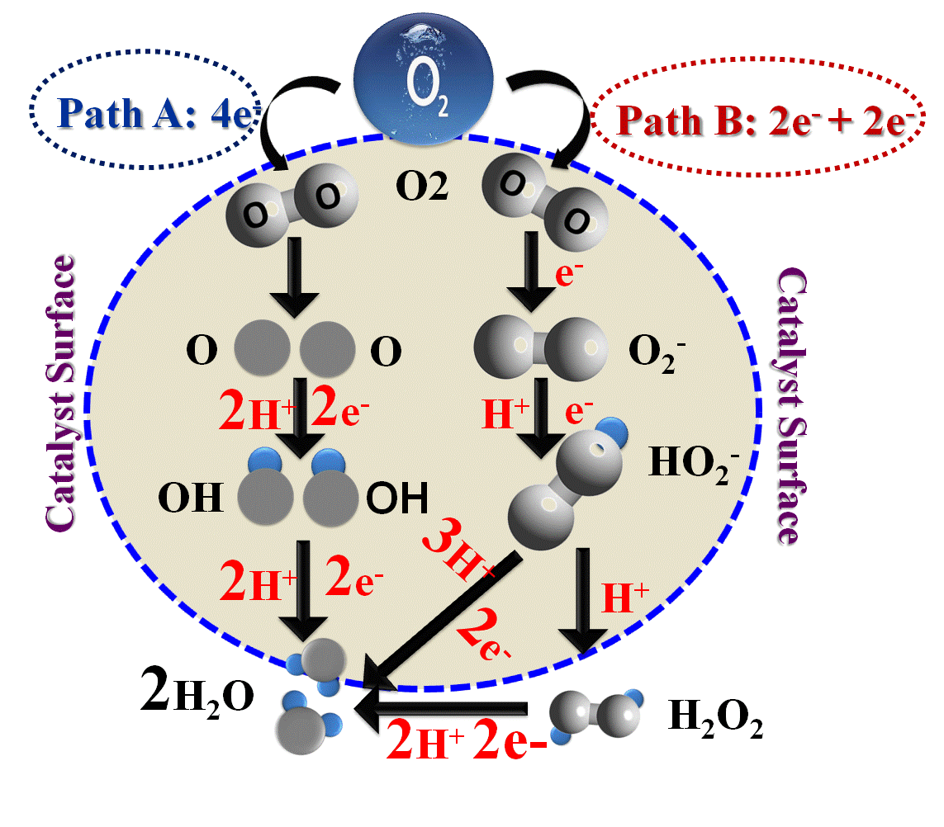

**Figure 1.10:** Schematic representation of mechanistic path for oxygen reduction reaction (ORR).

The ORR requires a various important steps. To date, the literature has suggested two possible mechanisms **Figure 1.10**. The direct reduction of O2 to H2O (route A) is the result of parallel O2 adsorption to the catalytic surface layer, according to Acre et al. This requires the presence of two active sites next to each other. Path B continues perpendicular to the electrode surface after an initial adsorption of O2 (by a single atom). However, the second phase (H2O2 reduction) has a large activation energy, which raises the overpotential.29.

1.5.2. HOR Reactions and Mechanistic path

Electro oxidation of hydrazine depends upon the electrode materials generally four electron transfer reaction.30 The electrocatalytical potential mechanistic route of the hydrazine oxidation reaction (HOR) is shown in **Figure 1.11;** the first step is the rate-determining slow step, in which one electron transfer is involved, and the second step is the fast phase, in which three electron transfer processes are involved. Thus, the blue circle represents the entire hydrazine oxidation process.



**Figure 1.11:** Schematic representation of hydrazine oxidation reaction mechanism.

1 L. C. Clark and C. Lyons, *Ann. N. Y. Acad. Sci.*, 2006, **102**, 29–45.

2 S. F. Oliveira, G. Bisker, N. A. Bakh, S. L. Gibbs, M. P. Landry and M. S. Strano, *Carbon* , 2015, **95**, 767–779.

3 E. Piccinini, C. Bliem, C. Reiner-rozman, F. Battaglini, O. Azzaroni and W. Knoll, *Biosens. Bioelectron.*, 2017, **92**, 661–667.

4 E. Katz and I. Willner, *ChemPhysChem*, 2004, **5**, 1084–1104.

5 J. Wang, *Anal. Chim. Acta*, 2002, **469**, 63–71.

6 Y. Hahn, R. Ahmad and N. Tripathy, *Chem. Commun.*, 2012, **48**, 10369–10385.

7 Y. Wang, Z. Li, J. Wang, J. Li and Y. Lin, *Trends Biotechnol.*, 2011, **29**, 205–212.

8 P. Sharma, S. K. Tuteja, V. Bhalla, G. Shekhawat, V. P. Dravid and C. R. Suri, *Biosens. Bioelectron.*, 2013, **39**, 99–105.

9 S. Zeng, D. Baillargeat, H. Ho and K. Yong, *Chem. Soc. Rev.*, 2014, **43**, 3426.

10 K. Schmidt-Rohr, *J. Chem. Educ.*, 2015, **92**, 2094–2099.

11 X. Li and A. Faghri, *J. Power Sources*, 2013, **226**, 223–240.

12 Y. Wei, S. Matar, L. Shen, X. Zhang, Z. Guo, H. Zhu and H. Liu, *Int. J. Hydrogen Energy*, 2012, **37**, 1857–1864.

13 S. Matar and H. Liu, *Electrochim. Acta*, 2010, **56**, 600–606.

14 S. Almheiri and H. Liu, *J. Power Sources*, 2014, **246**, 899–905.

15 S. P. S. Badwal, S. Giddey, A. Kulkarni, J. Goel and S. Basu, *Appl. Energy*, 2015, **145**, 80–103.

16 A. Liu, D. Chen, C. Lin, H. Chou and C. Chen, *Anal. Chem.*, 1999, **71**, 1549–1552.

17 J. Wang and Y. Lin, *TrAC Trends Anal. Chem.*, 2008, **27**, 619–626.

18 K. Schmidt-Rohr, *J. Chem. Educ.*, 2018, **95**, 1801–1810.

19 V. Dhull, A. Gahlaut, N. Dilbaghi and V. Hooda, *Biochem. Res. Int.*, 2013, **2013**, 1–18.

20 S. Kumar, P. K. Sahoo and A. K. Satpati, *ACS Omega*, 2017, **2**, 7532–7545.

21 H. M. A. A. Amin and H. Baltruschat, *Phys. Chem. Chem. Phys.*, 2017, **19**, 25527–25536.

22 J. Li, J. Kang, Q. Cai, W. Hong, C. Jian, W. Liu and K. Banerjee, *Adv. Mater. Interfaces*, 2017, **4**, 1700303.

23 S. Saha, K. Kishor, S. Sivakumar and R. G. S. Pala, *J. Indian Inst. Sci.*, 2016, **96**, 325–349.

24 J. Zhang, Z. Zhao, Z. Xia and L. Dai, *Nat. Nanotechnol.*, 2015, **10**, 444–452.

25 H. Erikson, A. Sarapuu, J. Kozlova, L. Matisen, V. Sammelselg and K. Tammeveski, *Electrocatalysis*, 2015, **6**, 77–85.

26 C. K. Chua and M. Pumera, *ACS Nano*, 2015, **9**, 4193–4199.

27 S. M. AlShehri, J. Ahmed, T. Ahamad, P. Arunachalam, T. Ahmad and A. Khan, *RSC Adv.*, 2017, **7**, 45615–45623.

28 C. Song and J. Zhang, *PEM Fuel Cell Electrocatal. Catal. Layers Fundam. Appl.*, 2008, 89–134.

29 J. Zhang, Z. Xia and L. Dai, *Sci. Adv.*, 2015, **1**, 1–19.

30 V. S. Sapner, P. P. Chavan, A. V. Munde, U. S. Sayyad and B. R. Sathe, *Energy & Fuels*, 2021, **35**, 6823–6834.