Liquid Crystal Nano-particle composites -Display applications
Mukesh Mishra
Shri Ramswaroop Memorial University, Lucknow- Deva Road, Uttar Pradesh, India-225003

Abstract: In the past several years a great deal of researches has been carried out to improve the important physical properties of LCs through various methods, other than chemical synthesis. One technique to achieve this goal is the dispersion of NPs in liquid crystalline materials. Doping, i.e. the intentional incorporation of small quantities of an additive into an LCs, is one of the most prominent processes to tune the properties of LCs. Liquid crystal–nanoparticles composites (LC-NPs) have emerged as a multidisciplinary field of research and attract great attention of scientists from the field of soft matter research as they can effectively be used to tune the properties of LCs. Different types of nanomaterial are used to optimize the liquid crystal as per requirement. The content of the present chapter focuses on the improvement of the electrical and electro-optical properties of nematic liquid crystals (NLCs) by doping with nanoparticles. These LC-NPs composites are mostly important for display applications.
Key Words: Liquid crystals, Nanoparticles, Liquid crystal naocomposites
Introduction: A liquid crystal display (LCD) is a flat-panel display, electronic visual display, or video display that uses the light modulating properties of LCs. LCDs are available to display arbitrary images (as in general-purpose computer display) or fixed images which can be displayed or hidden, such as preset words, digits, and 7- segment displays as in a digital clocks. LCDs are used in wide range of applications including computer monitors, televisions, instrument panels, aircraft cockpit displays, and signage. They are common in consumer devices such as video players, gaming devices, clocks, watches, calculators, and telephones and have replaced cathode ray tube (CRT) displays in most applications. Few researchers prepared a novel LCD device employing nematic materials instead of other liquid crystalline materials. NPs have shown an intriguing and viable way of manipulating the properties of LCs, which will likely prove to be of significant importance for LC-based uses in devices and display applications. In this chapter nanocomposites have been prepared by dispersion of Barium titanate nanoparticles (BTNPs) in 4-pentyl-4'-cyanobipheny (5CB) nematic liquid crystalline material. Because of permanent dipole moment ferroelectric NPs (BTNPs) induce realignment of neighboring LC molecules, (i.e. parallel correlation between NPs and LCs) enhanced electro optical properties of LCs. To study the various display parameters in only N phase I have dispersed BTNPs in 5CB. 5CB is a basic display material and its thermodynamic [1-5], dielectric [6-20], and electro-optical [21-30] properties are reported earlier by several workers.5CB possesses only nematic(N) phase in the temperature range 17-34.5ºC [31-33]. The molecular structure of 5CB is shown in the Figure 5.1. BTNPs with a diameter of 100 nm have been procured from Sigma-Aldrich. Nanocomposites are prepared by dispersion of BTNPs in 5CB.In order to obtain concentration dependence of the BTNPs on the physical parameters of 5CB three widely different concentrations (0.05, 0.5 and 5.0 wt %) of BTNPs have been dispersedand thermodynamic, dielectric, optical and electro-optical parameters have been studied.

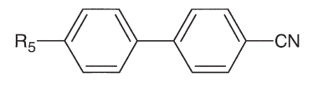
Figure 1.1.Molecular structure of 4-pentyl-4'-cyanobiphenyl (5CB) [7].

1.2 Results and Discussion
1.2.1 Thermodynamic Study
Dispersion of BTNPs in NLC matrix was examined under PLM. This technique provides the first clue if a particular nanomaterial tends to aggregates [34]. There is no any evidence of aggregation of NPs while observing the sample in the N phase under PLM. DSC was used to trace the effect of BTNPs on the nematic-isotropic transition temperature (T_{NI}) or isotopic-nematic transition temperature (T_{IN}) in the heating and cooling cycles. Accurate measurements of transition temperatures of liquid crystal-nanoparticles composites (LC-NPs) are needed to assess the effectiveness of blends for liquid crystal display (LCD) applications [35]. Samples have been given 5 thermal cycles before collecting fair data in order to stabilize the system. DSC thermograms of pure 5CB and its nanocompositesare shown in heating and cooling cycles (Figure 1.2a & b) at the scan rates of 5.0 °C min⁻¹. A heating and cooling rate dependent study of all transitions of 5CB and its nanocomposites has been performed. DSC was operated at various scanning rates between 2.5 °C min⁻¹ and 15 °C min⁻¹. As the scan rate decreases, all transitions shift toward lower temperature in the case of heating whereas shift toward higher temperature in the cooling [36].
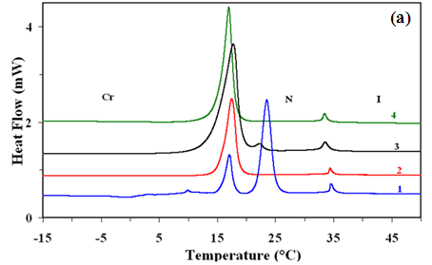
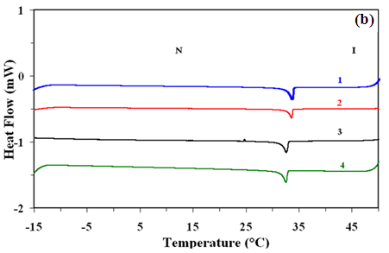
Figure 1.2: DSC thermograms for the (a) heating and (b) cooling cycles of pure 5CB and its nanocomposites . Curves 1, 2, 3 and 4 are for pure 5CB, 5CB + 0.05 wt % BTNPs, 5CB + 0.5 wt % BTNPs and 5CB + 5.0 wt % BTNPs, respectively.
.

Extrapolated transition temperatures at the scan rate of 0 °C min⁻¹ have been obtained through least square fit [37] which give following phase sequences in the heating and cooling cycles:
Heating cycles:
5CB: Cr-(17.0 ^{º}C)-N-(34.5 ^{º}C)-I
5CB + 0.05 wt% BT NPs: Cr-(16.9 ^{º}C)-N-(34.2 ^{º}C)-I
5CB + 0.5 wt% BT NPs: Cr-(16.6 ^{º}C)-N-(33.2 ^{º}C)-I
5CB + 5.0 wt% BT NPs: Cr-(16.5 ^{º}C)-N-(33.1 ^{º}C)-I
Cooling cycles:
5CB: I-(34.0 ^{º}C)-N
5CB + 0.05 wt% BT NPs: I-(33.8 ^{º}C)-N
5CB + 0.5 wt% BT NPs: I-(32.9 ^{º}C)-N
5CB + 5.0 wt% BT NPs: I-(32.8 ^{º}C)-N
When we performed the experiment on 5CB, 5 thermal cycles were not taken. So probably the sample was not stabilized. But in the case of composites 5 thermal cycles were taken before acquiring the final data. Yes previous thermodynamic studies [1-5] support this observation. From the above-mentioned results, it is concluded that the transition temperatures, i.e. T_{NI} (or T_{IN}) of the nanocomposite are lowered as compared to the pure 5 CB. Neither of the pure 5CB and its nanocomposite samples crystallizes up to lowest temperature i.e. up to -15 °C. From the above-mentioned DSC data we are able to conclude that increasing the amount of BTNPs, decreases the T_{NI} (also T_{IN}), which isalso confirmed by PLM. Most previous experiments showed that the addition of the ferroelectric NPs (BTNPsand Sn₂P₂S₆) leads to an increase in the T_{NI} of the nanocomposites [38-41], but a decrease of T_{NI} in some experiments was also observed [42-45]. In our case there is an apparent decrease in the T_{NI} as the concentration of BTNPs in 5CB increases. In the case of 5CB + 0.05 wt% BTNPs, T_{NI} decreases by ~0.3 °C, in 5CB + 0.5 wt% BTNPs, it decreases by 1.3 °C, while in 5CB +5.0 wt% BTNPs, it decreases by 1.4 °C. According to Gorkunov and Osipov [46] due to the presence of spherical NPs, the average separation between mesogenic molecules of the liquid crystal (LC) matrix is increased and then LC matrix is diluted. This also decreases the average strength of intermolecular interactions, reduces the N ordering and decreases the transition temperature in to the N phase. Lopatina et al. [47] have shown that the dipolar induction interaction between ferroelectric NPs and the surrounding NLC medium may result in a substantial decrease of the T_{IN.} According to Gupta et al. [48] another reason of decrement in T_{NI} (or T_{IN}) is that BTNPs increase the disorder in the system and destabilize the liquid crystalline phase. From the thermodynamic data, it is concluded that at low concentrations (<1wt %), T_{IN} decreases rapidly with increasing concentration. But at higher concentrations (>1wt %), T_{IN} decreases with slow pace as compared to low concentrations. Similar results are also reported by Gorkunovet al [49]. According to them, at low NP concentrations, there is no chance of phase separation and decrease in the T_{IN} is due to dilution effect, whereas at higher concentration phase separation may take place within a range of NPs concentrations. Vardanyanet al have been reported that only a small fraction of NPs are uniformly dispersed in LC matrix but higher concentration shows aggregation of NPs [50]. Our studies also suggest that for low concentrations, due to the good miscibility, T_{IN} decreases rapidly with the increasing concentration whereas while going in high concentration region, decrease of T_{IN} gets slow. The Latter seems due to the development of phase separation.
1.2.2 UV-Vis Study
The absorption spectra for 5CB, BTNPs and their nanocomposites are shown in Figure 1.3. The 5CB spectrum presents a maximum absorbance at wavelength ($λ_{max}$) of 302 nm and BTNPs show $λ_{max}$ at 285 nm (see inset of Figure 1.3). These results are in good agreement with respective $λ_{max}$ reported in literatures [51, 52]. The optical band gap of pure 5CB, BTNPs and its nano composites have been calculated using relation [53, 54]
$αhν={B(hν-E_{g})}^{m}$(1.1)
where$α$ is the absorption coefficient $(α= \frac{2.303×A}{l}$ , where $l$ and A are the path length of the cell and absorbance), $hν$ is the photon energy,${ E}_{g}$ is the optical band gap. Exponent $m$ is an index which assumes the values 1/2, 2, 3/2 and 3 corresponding to the direct allowed, indirect allowed, forbidden direct and forbidden indirect transitions, respectively depending on the nature of the electronic transition responsible for the absorptions.
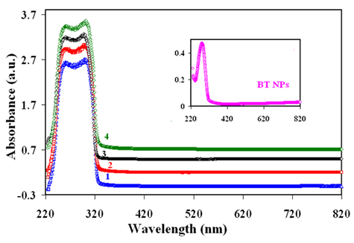
Figure 1.3:UV-Vis absorption spectra for the pure 5CB and its nanocomposites. Curves 1, 2, 3 and 4 are for pure 5CB, 5CB + 0.05 wt % BTNPs, 5CB + 0.5 wt % BTNPs and 5CB + 5.0 wt % BTNPs, respectively. Inset (a) shows absorbance of BTNPS.

The best linear relationship is obtained by plotting (αhν) ² vs.$hν$, indicating that the ${ E}_{g}$ of pure 5CB and its nanocomposites is due to the direct allowed transitions (for m= ½ the fitting parameters chi²=0.00012 and R²=0.99587)[55-57]. Therefore the values of ${ E}_{g}$ have been calculated by plotting (${αhν)}^{2}$ versus $hν$ and extrapolating the linear portion of the plot to (${αhν)}^{2}$=0 (see Equation1.1). ${ E}_{g}$ plots for pure BTNPs is shown in Figure1.4. The calculated ${ E}_{g}$ of BTNPs determined from the intercept of the straight line at $α$ = 0 has been found to be 4.03 eV. According to Wempleet al. [58] particles larger than 15 nm,${ E}_{g}$ is approximately equal to that of barium titanate in bulk. ${ E}_{g}$Plots for pure 5 CB, and its nanocomposites are shown in Figure 1.5. The${ E}_{g}$ of pure 5CB has been found to be 3.82 eV (seeFigure1.5a). $E_{g}$for5CB + 0.05 wt% BTNPs (Figure 1.5 b), 5CB + 0.5 wt% BT NPs (Figure 1.5 c) and 5CB +5.0 wt% BTNPs (Figure 1.5 d) have been determined to be 3.80 eV, 3.82 eV and 3.81 eV respectively. Reduction in $E_{g}$ for 0.05 wt% BTNPs is also responsible for the increase in the conductivity.
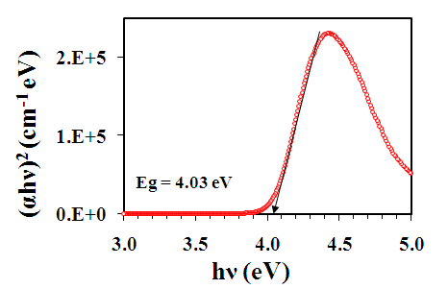
Figure 1.4.Determination of optical band gap (E_{g}) of pure BTNPs.

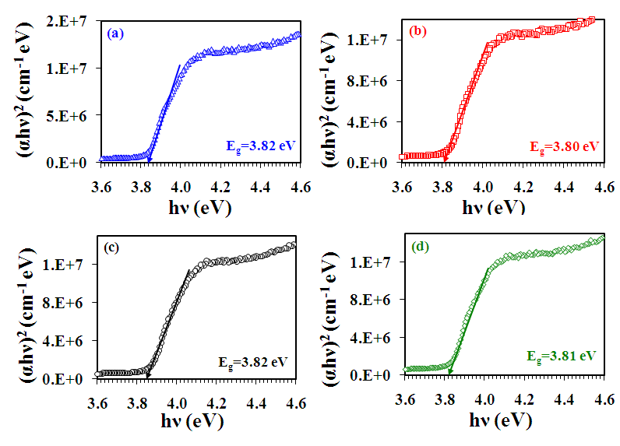Figure 1.5.Determination of the optical band gap (E_{g}) of pure 5CB and its nanocomposites.Figure a, b, c and d are for pure 5 CB, 5CB + 0.05 wt % BTNPs, 5CB + 0.5 wt % BTNPs and 5CB + 5.0 wt % BT NPs, respectively.

1.2.3 Electro-Optical Study
In Figure 1.6 transmission intensity with the applied voltage scale is plotted for pure 5CB and its nanocomposites in nematic phase at 23 °C, which gives important information regarding threshold $(V_{th})$, switching voltage ($∆V$) and the steepness (slope) of the transmission voltage curve (TVC). Bright and dark states are observed under the PLM at the lower and higher applied voltage respectively due to the reorientation of nematic molecules along the direction of external applied voltage. The reorientation of nematic directors with the application of electric field from bright state (Figure 1.6 Inset a) to dark state (Figure 1.6 Inset b) is also known as Freedericksz transition [59, 60]. The voltage required to achieve this transition is called threshold voltage ($V_{th}).$ At low voltages less than $V_{th}$ molecule lie in the planar alignment and consequently a bright state is observed. When the applied voltage is increased above $V_{th}$ the molecules gradually turn to the homeotropic orientation and a dark state is observed.
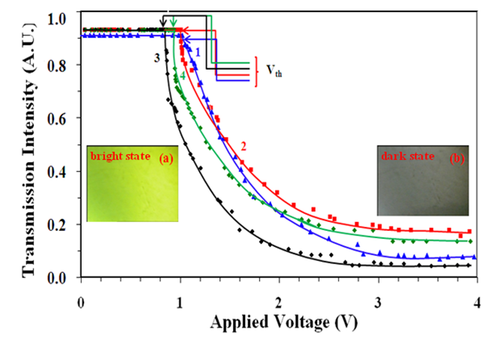
Figure 1.6: Transmission voltage (T-V) curves for pure 5CB and its nanocomposites to the applied voltage of frequency 1 kHz. Curves 1, 2, 3 and 4 correspond to the pure 5CB, 5CB + 0.05 wt % BTNPs, 5CB + 0.5 wt % BTNPs and 5CB + 5.0 wt % BTNPs, respectively. Insets (a and b) show bright and dark state of the cell filled with 0.5 wt% of BTNPs dispersed in 5CB respectively.

The $∆V$ is taken as$V_{90}-V_{10}$, where $V_{90}$and $V_{10}$are the voltages corresponding to the transmission intensity of 90% and 10% of the maximum value. The lower value of $∆V$ (~0.5-1.0) is beneficial for the applications. High steepness of the slope (($I_{90}-I_{10}$)/$V_{90}-V_{10}$)) of the TVC is also beneficial. I have analyzed the nature of dielectric anisotropy$(∆ε^{'})$, in order to observe the electro-optic parameters, where${ ∆ε^{'}=ε_{‖}^{'}-ε}_{⊥}^{'},{ ε}_{‖}^{'}$ and $ε_{⊥}^{'}$ are the longitudinal and transverse components of relative permittivity respectively. The variations of $ε_{‖}^{'}$ and $ε_{⊥}^{'}$ components of relative permittivity of the pure 5CB along with its nanocomposites on temperature scale are shown in Figure 1.7. The values of the${ ε}_{‖}^{'}$ and $ε_{⊥}^{'}$for pure 5CB are in good agreement with the literature data [6].
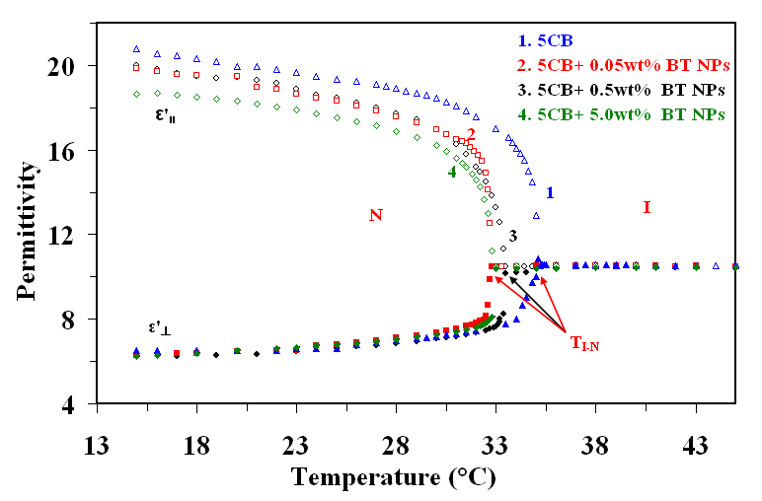Figure 1.7: Temperature dependence of the longitudinal ($ε_{‖}^{'}$)and transverse $(ε_{⊥}^{'})$ components of the relative permittivity for the pure 5CB and its nanocomposites. Curves 1, 2, 3 and 4 correspond to the pure 5CB, 5CB + 0.05 wt % BTNPs, 5CB + 0.5 wt % BTNPs and 5CB + 5.0 wt % BTNPs, respectively.

Figure1.7 shows that the $ε_{⊥}^{'}$is almost unchanged with the increasing concentration of BTNPs, whereas the $ε_{‖}^{'}$component drastically decreases in contrast to the results reported earlier [40, 61]. Therefore $∆ε^{'}$decreases with the increasing concentration of BTNPs. $∆ε^{'}$play an important role in the operation of twisted NLCs displays. The $V_{th}$is given by [60, 62-64]
$${ V}_{th}=π{\left(\frac{K_{11}}{ε_{0}∆ε^{'}}\right)}^{1/2}(5.2)$$
where${ k}_{11}$ is the splay elastic constant of the material and has been estimated by using the observed experimental values of $V_{th}$ and ∆$ε^{'}$. From the above equation, it can be seen that $V_{th}$ is directly proportional to the square root of $k_{11}$ and inversely proportional to the square root of $∆ε^{'}$of the material. $k_{11}$is also directly proportional to square of order parameter (S²) and ∆$ε^{'}∝$S; then we have $V_{th }∝ \sqrt{S }$[65]. $ε_{‖}^{'}$,$ε_{┴}^{'}$and average ($ε^{'}$= ($ε_{‖}^{'}$+ 2 $ε_{┴}^{'})$/3) components of the permittivity, $∆ε^{'},$ ratio of the${ ∆ε^{'}}/{ε_{⊥}^{'}}$,${ V}_{th}$,$∆V$, slope of the TVC ($=\left({∆I}/∆V\right)=({I_{90}-I_{10}}/{(V_{90}-V_{10}}$)), and $k_{11}$ are given in Table 1.1 for the N phase at 23.0 °C. ${ V}_{th}$ may decrease as the order parameter decreases (i.e. ∆$ε^{'}$) due to the existence of appropriate NPs. Note that the decrease in the $V_{th}$ observed in earlier studies [61] was accounted by assuming that $k_{11}$ remains unchanged with the addition of the NPs, whereas experimentally an increase in ∆$ε^{'}$ was observed. However in present investigation, we find that both $k_{11}$ and ∆$ε^{'}$ decreases with addition of NPs. Such reduction of the Freedericksz$V_{th}$and of the S induced by inorganic magnesium oxide (MgO) NPs in the N phase has also been reported earlier [66]. In the present study initially for 0.05 wt% of BTNPs dispersed sample, the decrease in the ∆$ε^{'}$ is 5% and the change in the value of K₁₁ is 32% (see Table 1.1) which is ultimately decreasing the $V_{th}$by only ~2% as compared to that of pure sample. However for 0.5 wt% of BTNPs composites, decrease in the ∆$ε^{'}$ is 7% and the change in the value of K₁₁ is 52%, hence decreasing the $V_{th}$by about 17% compared to pure sample. On the other hand $V_{th}$for higher concentration (>1 wt %) is not changed as much as expected. $V_{th}$ for 5.0 wt% of BTNPs has decreased by 8%, at the same time K₁₁ and ∆$ε^{'}$ decreases by 46% and 14 % respectively. Reznikov et al. [61] has reported that higher concentration (>2-3 wt %) of submicron particles create almost rigid liquid crystal suspension. Due to this, $V_{th}$ does not change significantly for 5.0 wt% of BTNPs dispersed systems. From Table 1.1, we can infer that $∆V$ decreases as concentration of BTNPs increases i.e. up to 0.5 wt %, at the same time steepness of the T-V curve increases. Decrease in the $∆V$ is mainly responsible for the improvement in the steepness of T-V curve. For 0.5 wt% of BTNPs, $∆V$ and steepness are unchanged compared to the pure sample.
Table 1.1: Longitudinal $\left({ ε}_{‖}^{'}\right),$transverse${(ε}_{⊥}^{'})$and average$($ε'$= (ε_{‖}^{'}+2 ε_{┴}^{'})/3)$components of the relative permittivity, dielectric anisotropy ($∆ε^{'}$), ratio of dielectric anisotropy to the transverse component of the relative dielectric permittivity ${(∆ε^{'}}/{ε_{⊥}^{'})},$ threshold voltage ($V_{th}$in Volts), switching voltage (∆V in volts), ratio of ${∆I}/{∆V}$(in V⁻¹) and splay elastic constant (K₁₁ in pN) in the N (at 23.0 °C) phase.
concentration ε'║ε'⊥ ε'= (ε'║ + 2 ε'⊥)/3 ∆ ε' ∆ ε'/ ε'⊥V_{th}∆V∆I/∆VK₁₁
5 CB 19.66.5 10.8 13.1 2.0 1.02 1.25 0.64 16.50
0.05wt% BT NPs18.9 6.5 10.6 12.4 1.9 1.00 1.06 0.75 11.13
0.5wt% BT NPs18.7 6.5 10.5 12.2 1.9 0.85 0.99 0.80 7.91
5.0wt% BT NPs17.9 6.7 10.4 11.2 1.7 0.94 1.20 0.66 8.88

1.2.4 Dielectric Study
Dielectric anisotropy of the N phase is governed by the Maier and Meier theory [67]
$$∆ε^{'}=\frac{NHF}{ε_{O}}\left[∆α-\frac{F}{2kT}P^{2}\left(1-3\cos^{2}β\right)\right]S (5.3)$$
where $M$ is the number density of molecules and S is the order parameter, ∆α is the anisotropy of the polarisability, $P$ is the resultant dipole moment of the molecule, β is the angle between the dipole moment and the long axis of the molecule and F is the feedback factor and$H=3ε'(0)/(2ε'\left(0\right)+1)$. According to Equation (1.3), $∆ε^{'}$ significantly depends upon both $N$ and S. $N$is expected to decrease with the increase in the doping concentration of BTNPs and due to the $∆ε^{'}$ decreases with the increasing concentration of BTNPs. Another reason is that order parameters of LC and ferroelectric NPs interact with each other and the dipole moments of ferroelectric NPs combine anti-parallell to dipole moments of NLC molecules. This corresponds to a lower value of $ε_{‖}^{'}$and hence $∆ε^{'}$ according to the Kirkwood et al. [68]. According to Vardanyan et al. [69], NPs increase the relative number of 5CB dimmers, which in turn decrease the $∆ε^{'}$ of the system.
Frequency dependence of $ε_{┴}^{'}$ for the pure 5CB and its nanocomposites shows that data are almost invariant up to 10MHz. This indicates that there is no relaxation mechanism for the planar orientation of molecules in the frequency window of our measurements. Therefore, I could not able to determine the relaxation frequency corresponding to the molecular rotation about the long axis. However, it could be possible to observe a relaxation mechanism in the homeotropic aligned molecules due to the rotation of about their short axes [70-72].
The variations of the experimental data of $ε_{‖}^{'}$and $ε_{‖}^{''}$with frequency in the N phase are shown in Figure 1.8 for pure 5CB and its nanocomposites. The data of permittivity ( $ε_{‖}^{'}$) and loss ($ε_{‖}^{''}$) for 5CB and its nanocomposites lie on the Cole-Cole semi circles as shown in Figure 1.9.From the value of the distribution parameter obtained from the fitting of the experimental data as well as from the Cole-Cole [73-75] plots shown in Figure1.9 (plots are complete semi circles), it is evident that the observed relaxations are a typical Debye process [76, 77].

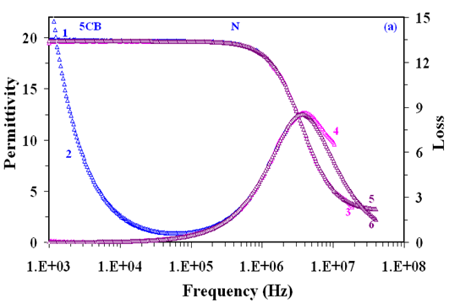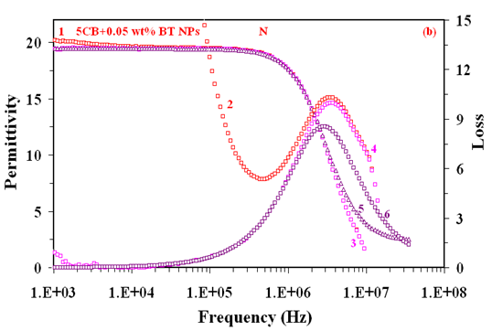
Figure1.8 is continued on next page also…..

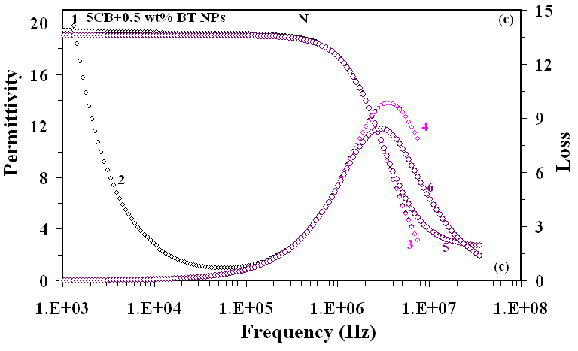
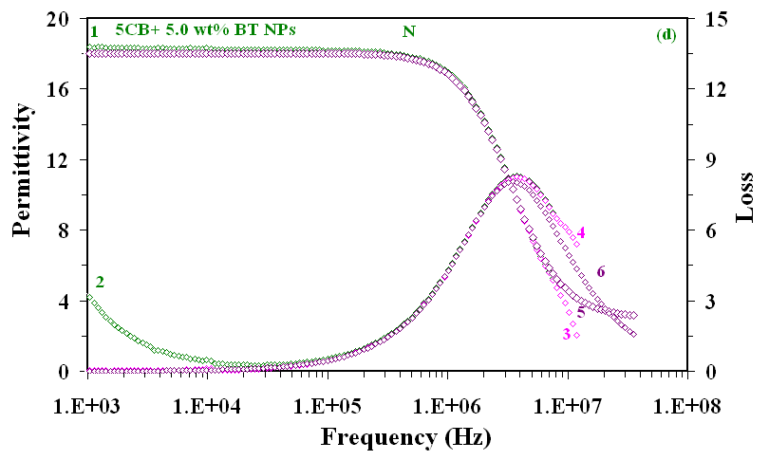
Figure 1.8: Frequency dependence of the longitudinal component of the relative permittivity ($ε_{‖}^{'}$)and the loss ($ε_{‖}^{''}$)in the N phase (23.0 °C). Curves1 and 2 show the measured value of$ε_{‖}^{'}$and$ε_{‖}^{''}$.Curves 3 and 4 represents the corrected data for$ε_{‖}^{'}$and$ε_{‖}^{''}$ obtained by subtracting the high and low frequency corrections from the measured data. Curves 5 and 6 are the generated data of $ε_{‖}^{'}$and$ε_{‖}^{''}$after low and high frequency corrections.Figure(a) 5CB, (b) 5CB + 0.05 wt % BTNPs, (c) 5CB + 0.5 wt % BTNPs and (d) 5CB + 5.0 wt % BTNPs dispersed samples.

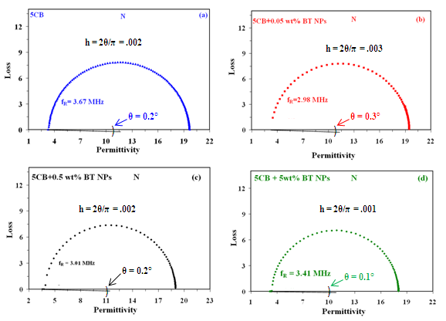
Figure 1.9:Cole-Cole plots showing the variation of loss ($ε_{‖}^{''}$) with permittivity ($ε_{‖}^{'}$)for the pure 5CB and its nanocomposites in the nematicphase (23.0 °C). Figure(a) Pure 5CB, (b) 5CB + 0.05 wt % BTNPs, (c) 5CB + 0.5 wt % BTNPs and (d) 5CB + 5.0 wt % BTNPs dispersed samples.

The variation of relaxation frequency ${(f}_{R})$with the inverse of the temperature is shown in Figure 1.10.$f_{R}$of the pure 5CB is 3.54 MHz in the N phase (at 23.0 °C) (see Figure 1.8 (a)). The observed values of the $f_{R}$ are in good agreement with the data [78] reported earlier. The observed values of $f_{R}$at 23 °C for 0.05 wt% BTNPs, 0.5 wt% BTNPs and 5.0 wt% BTNPs dispersed in 5CB are 2.98 MHz, 3.0 MHz and 3.37 MHz respectively. These data suggest that $f_{R}$ corresponding to flip flop motion of the molecules about the short axis is marginally decreased in the case of nanocomposites as compared to pure 5CB.

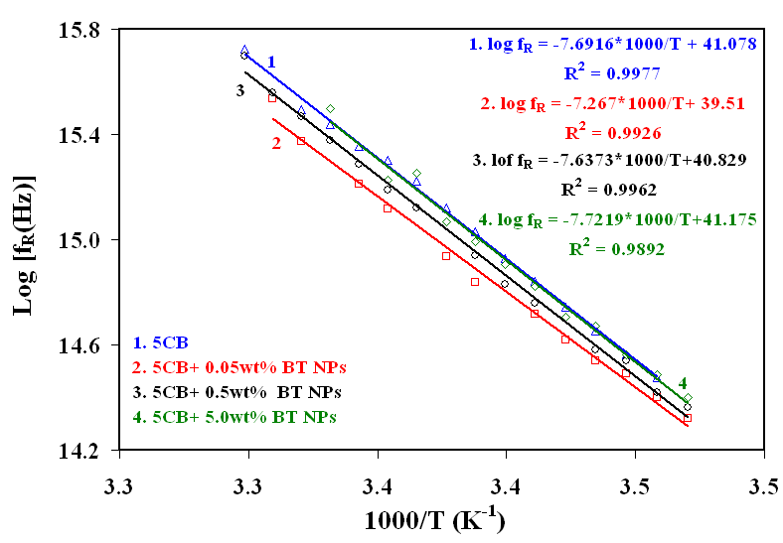
Figure 1.10: Variation of relaxation frequency ($f_{R}$) with inverse of absolute temperature (K⁻¹) showing Arrhenius behaviour of the observed relaxation mode. Curves 1, 2, 3 and 4 correspond to the pure 5CB, 5CB + 0.05 wt % BTNPs, 5CB + 0.5 wt % BTNPs and 5CB + 5.0 wt % BTNPs respectively.

The activation energy$(W_{A})$for the observed relaxation process was determined by the Arrhenius equation [79, 80]
$logf_{R}= logf_{0}-\frac{W_{A}}{}N_{A} kT$(1.4)
where, $W_{A}$is the activation energy, $N_{A}$ is the Avogadro number, $k$ is the Boltzmann constant and T is the absolute temperature. From Figure 1.10, slopes of log $f_{R}$vs inverse of temperature plots have been obtained by the method of least square fit. With the help of slopes of the straight lines, $W_{A}$ have been obtained for 5 CB and its nanocomposites.I have determined$W_{A}$of 63.9 kJ mol⁻¹ for the pure 5 CB sample in the N phase. The observed values of the $W_{A}$ are in good agreement with the data [78] reported earlier. The observed $W_{A}$are 60.3 kJ mol⁻¹, 63.5 kJ mol⁻¹, 64.2 kJ mol⁻¹ for 0.05 wt% BTNPs, 0.5 wt% BTNPs and 5.0 wt% BTNPs dispersed in 5CB respectively. From above mentioned results, it is concluded that${ W}_{A}$has decreased for 0.05 wt% BTNPs. However, for other concentrations, ${ W}_{A}$ increases.
The frequency dependence of the total conductivity parallel ($σ_{‖}$) to the director of 5CB and its nanocomposites are shown in Figure 1.11 (a) in N phase at 23.0 °C. From figure it is observed that at low frequencies conductivity is constant while at higher frequencies it frequency dependent [81, 82]. Temperature dependence of longitudinal ionic conductivity $(logσ_{i‖})$is shown in Figure 1.11 (b). It can be seen that for 0.05 wt% BTNPs composite system, $σ_{i‖}$ increases by two orders of magnitude and for 0.5 wt% BTNPs composites $σ_{i‖}$ is almost same with respect to that of pure 5CB. Singh et al have reported that due to dispersion of BTNPs in NLC conductivity anisotropy increases [39]. Whereas for 5.0 wt% BTNPs composite,$σ_{i‖}$ decreases as compared to pure 5 CB. At 23.0 °C, the $σ_{i‖}$ are 9.40 × 10⁻⁷ S m⁻¹ for pure 5CB and that of composites are 6.67 × 10⁻⁵ S m⁻¹ (0.05 wt %), 9.91 × 10⁻⁷ S m⁻¹ (0.5 wt %) and 1.78 × 10⁻⁷ S m⁻¹for 5.0 wt%. The solid lines in Figure 1.11 (a)show Arrhenius behaviour of the conductivity. The reason of conductivity enhancement is that, availability of additional space facilitates the motion of ions in the samples [31].One important result is that with increase of the doping concentration, $σ_{i‖}$decreases because higher concentration formsnanoscale ferroelectric NPs aggregates [83-86]. According to Shaydyuket al [87], higher concentrations (4.5 wt %) of montmorillonite (MMT) nanoplatelets in 5CB show strong tendency of aggregation. Due to this in the case of higher concentrations (5.0 wt% BTNs), $σ_{i‖}$ is decreases in our case as well. I have found enhancement in the only longitudinal component of the $σ_{i‖}$ due to the facile motion of BTNPs in the longitudinal direction of the nematic director. The unchanged value of the$σ_{i⊥}$signifies that there is no significant movement of BTNPs along the transverse direction of the nematic director.
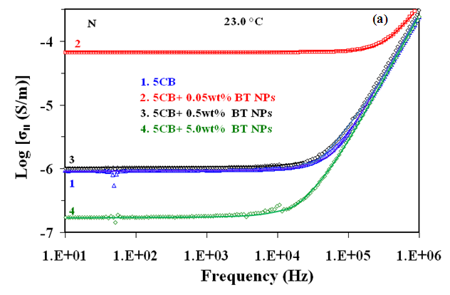
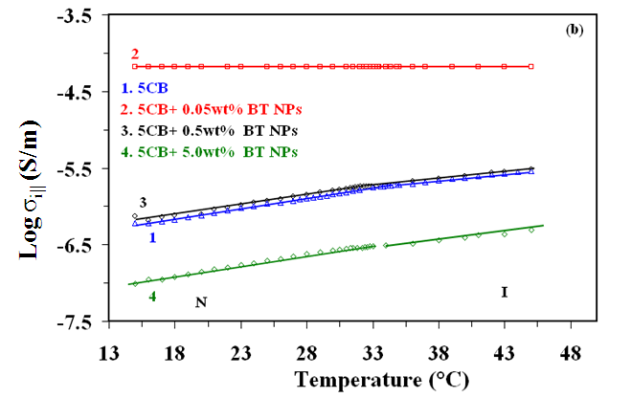
Figure 1.11: (a) Variation of conductivity along to the director (σ‖) with frequency and (b) variation of the logarthim of ionic conductivity along to the director (σ_{i‖}) with temperature for pure 5 CB and its nano composites. Curves 1, 2, 3 and 4 correspond to the pure 5CB, 5CB + 0.05 wt % BTNPs, 5CB + 0.5 wt % BTNPs and 5CB + 5.0 wt % BTNPs, respectively. The step like change seen in figure correspond to the T_{IN} and the lines are just guides to the eye.

1.3 Summary
From the above experimental results and discussion, the followings can be concluded:
- With increasing concentration of BTNPs in 5 CB it has been found that nematic-isotropic transition temperature decreases by 0.3 °C for 0.05 wt %, 1.3 °C for 0.5 wt % and 1.4 °C for 5.0 wt % of BTNPs.
- Longitudinal component of the dielectric permittivity decreases significantly however transverse component of the dielectric permittivity remains constant with increasing concentration of BTNPs.Hence dielectric anisotropy also decreases by about 5 % for 0.05 wt %, 7 % for 0.5 wt % and 14 % for 5.0 wt % of BTNPs.
- The relaxation frequencies of an observed relaxation mode corresponding to the flip-flop rotation of the molecules about their short axis initially decreases for 0.05 wt % but above this concentration they are increasing with the increasing concentration of BTNPs in 5CB.
- The activation energies of an observed relaxation mode corresponding to the flip-flop rotation of the molecules about their short axis initially decreases for 0.05 wt % but above this concentration they are increasing with the increasing concentration of BTNPs in 5CB.
- The longitudinal component of ionic conductivity has increased by about two orders of magnitude for 0.05 wt % BTNPs nanocomposites whereas on increasing concentration it decreases.
- Optical band gap of 5CB (3.82 eV) has decreased to 3.80eV for 0.05 wt %, 3.81eV for 0.5 wt % and 3.81eV for 5.0 wt % of BTNPs.

- Threshold voltage decreases by 2 % for 0.05 wt %, 17 % for 0.5 wt % and 8 % for 5.0 wt % due to dispersion of BTNPs in 5CB. Switching voltage, splay elastic constanthave decreased whereas steepness of TVC curve has increased.
References:
- P. P. Karat, N. V. Madhusudana. Mol. Cryst. Liq. Cryst. 36, 51, 1976.
- D. Porter, J. R. Savage, I. Cohen. Phys. Rev. E. 85, 041701, 2012.
- N. I. Lebovka , L. N. Lisetski , M. I. Nesterenko , V. D. Panikarskaya , N. A. Kasian , S. S. Minenko& M. S. Soskin. Liq. Cryst. 40, 968, 2013.
- M. Kuzma, M. M. Labes. Mol. Cryst. Liq. Cryst. 100, 103, 1983.
- U. Shivakumar, J. Mirzaei, X. Feng, A. Sharma, P. Moreira, T. Hegmann. Liq. Cryst. 38, 1495, 2011.
- R. Verma, R. Dhar, R. Dabrowski, M. Tykarska, V. K. Wadhawan, M. C. Rath, S. K. Sarkar. J. Phys. D: Appl. Phys. 42, 085503, 2009.
- R. Basu, G. S. Iannacchione. Appl. Phys. Lett. 93, 183105, 2008.
- A. Schonhals, H. L. Zubora, R. S. Fricke, L. Frunza, R. Moldovan. Cryst. Res. Technol. 34, 1309, 1999.
- S. Urban, B. Gestblom, R. Dabrowski. Phys. Chem. Chem. Phys. 1, 4843, 1999.
- M. Kole, T. K. Dey. J. Appl. Phys. 113, 084307, 2013.
- G. P. Sinha, F. M. Aliev. Phys. Rev. E. 58, 1998, 2001.
- R. Basu, G. S. Iannacchione. J. Appl. Phys. 106, 124312, 2009.
- J. Jadzyn, P. Kedziora. Mol. Cryst. Liq. Cryst. 145, 17, 1987.
- P. G. Cummins, D. A. Dunmur, D. A. Laidler. Mol. Cryst. Liq. Cryst. 30, 109, 1975.
- C. Dascalu, A.L. Alexe-Ionescu, G. Barbero. J. Electroanal. Chem. 767, 63, 2016.
- F. Al-Hazmi, A. A. Al-Ghamdi, N. Al-Senany, F. Alnowaiser, F. Yakuphanoglu. J. Mol. Liq. 190, 169, 2014.
- A. Bogi. S. Faetti. Liq. Cryst. 28, 729, 2001.
- A.V. Zakharova, A. Maliniak. Eur. Phys. J. E. 4, 435, 2001.
- S. Urban , H. G. Kreul, A. Wurflinger. Liq. Cryst. 12, 921, 1992.
- A. Dawid, W. Gwizdala. Rev. Adv. Mater. Sci. 23, 37, 2010.
- B. J. Frisken, P. P. Muhoray. Phy. Rev. A. 39, 1513, 1989.
- J. F. Blach, S. Saitzek, C. Legrand, L. Dupont, J. F. Henninot, M. Warenghem. J Appl. Phys. 107, 074102, 2010.
- S. P. Yadav, K. K. Pandey, A. K. Mishra, R. Manohar. Acta. Phys. Pol. A. 119, 824, 2011.
- S. Oka, M. Kimura, T. Akahane. Appl. Phys. Lett. 80, 1847, 2002.
- G. B. Hadjichristov, Y. G. Marinov, A. G. Petrov, L. Marino, N. Scaramuzz. J. Phys.: Conf. Ser. 682, 012015, 2016.
- G. B. Hadjichristov, Y. G. Marinov, A. G. Petrov, E. Bruno, L. Marino, N. Scaramuzza. Mol. Cryst. Liq. Cryst. 610, 135, 2015.
- D. Rajh, S. SHelestick, A. Mertelj, P. Umek, S. Irusta, A. Zak, I. Dolenik. Phys. Status. Solidi A. 210, 2328, 2013.
- F. Z. Elouali, D. A. Tabet, U. Maschke. Mol. Cryst. Liq. Cryst. 502, 77, 2009.
- I. Chashechnikova, L. Dolgov, T. Gavrilko, G. Puchkovska, Ye. Shaydyuk, N. Lebovka, V. Moraru, J. Baran, H. Ratajczak. J. Mol. Struct. 563, 744, 2005.
- J. Baran, L. Dolgov, T. Gavrilko, L. Osinkina, G. Puchkovska, H. Ratajczak, Y. Shaydyuk, A. Hauser. Phils. Mag. 87, 4273, 2007.
- A. S. Pandey, R. Dhar, S. Kumar, R. Dabrowski. Liq. Cryst. 38, 115, 2011.
- T. Bezrodna, I. Chashechnikova, T. Gavrilko, G. Puchkovska, Y. Shaydyuk, A. Tolochko, J. Baran, M. Drozd. Liq. Cryst. 35, 265, 2008.
- P. P. Korneychuk, O. G. Tereshchenko, Y. A. Reznikov, V. Yu. Reshetnyak, K. D. Singer. J. Opt. Soc. Am. B. 23, 1007, 2006.
- M. V. Rasna, L. Cmok, D. R. Evans, A. Mwrtelj, S. Dhara. Liq. Cryst. 42, 1059, 2015.
- V. G. Chigrinov. Liquid Crystal Devices: Physics and Applications. Bostan, MA: Artech House, 1999.
- R. Dhar. Liquid Crystals: Electrical, Optical and Thermodynamical Properties. D. Phil. Thesis submitted to the University of Allahabad, Allahabad, India, 1996.
- R. Dhar, R. S. Pandey, V. K. Agrawal. Indian. J. Pure Appl. Phys. 40, 901, 2002.
- M. Kaczmarek, O. Buchnev, I. Nandhkumar. Appl. Phys. Lett. 92, 103307, 2008.
- U. B. Singh, R. Dhar, R. Dabrowski, M. B. Pandey. Liq. Cryst. 41, 953, 2014.
- F. Li, O. Buchnev, C. Cheon, A. Gluushchenko, V. Resshetnyak, Y. Reznikov, T. J. Sluckin, J. L. West. Phys. Rev. Lett. 97, 147801, 2006.
- F. Li, J. West, A. Glushchenko, C. Cheon, Y. Reznikov. J. SID. 14, 523, 2006.
- Y. Lin, R. Douali, F. Dubois, A. Segovia-Mera, A. Daoudi.Eur. Phys. J. E. 38, 103, 2015.
- O. Kurochkin, H. Atkuri, O. Buchnev, A. Glushchenko, O. Grabar, R. Karapinar, V. Reshetnyak, J. West, Y. Reznikov. Condens. Matter. Phys. 13, 33701, 2010.
- O. Kurochkin, O. Buchnev, A. Iijin, S. K. Park, S. B. Kown, O. Grabar, Y. Reznikov, A colloid of ferroelectric nanoparticles in a cholestric liquid crystal, J. Opt. A: Pure Appl. Opt. 11, 024003, 2009.
- A. Lorenz, N. Zimmermann, S. Kumar, D. R. Evans, G. Cook, M. F. Martinez, H. S. Kitzerow. J. Phys. Chem. B. 117, 937, 2013.
- M. V. Gorkunov, M. A. Osipov. Soft matter. 7, 4348, 2011.
- L. M. Lopatina, J. V. Selinger. Phys. Rev. Lett. 102, 197802, 2009.
- M. Gupta, I. Satpathy, A. Roy. R. Pratibha. J. Colloid. Interface. Sci. 352, 292, 2010.
- M. V. Gorkunov, G. A. Shandryuk, A. M. Shatalova, I. Y. Kutergina, A. S. Merekalov, Y. Kudryavtsev, R. V. Talroze, M. A. Osipov. Soft Matter. 9, 3578, 2013.
- K. K. Vardanyan, R. D. Walton, D. M. Bubb. Liq. Cryst. 38, 1279, 2011.
- S. T. Wu. J. Appl. Phys. 69, 2080, 1991.
- M. R. A. Bhuiyan, M. M. Alam, M. A. Momin, M. J. Uddin, M. Islam. Int. J. Matter. Mech. Engg. 1, 21, 2012.
- J. Tauc. Amorphous and liquid semiconductor. Plenum. New York, 1974.
- J. Tauc. A. Menth. Non. Cryst. Solids. 8, 569, 1972.
- O. Harizanov, A. Harizanova, T. Ivanova. Mater. Sci. Eng. B. 106, 191, 2004.
- R. Ashiri, A. Nemati, M. S. Ghamsari, H. Aadelkhani. J. Non. Cryst. Solids. 355, 2480, 2009.
- H. X. Zhang, C. H. Kam, Y. Zhou, X. Q. Han, Y. L. Lam, Y. C. Chan, K. Pita. Mater. Chem. Phys. 63, 174, 2000.
- S. H. Wemple. Phys. Rev. B. 2, 2679, 1970.
- T. D. Ibragimov, A.R. Imamaliyev, G.M. Bayramov. Optik. 127, 2278, 2016.
- C. Cirtoaje, E. Petrescu, V. Stoian. Physica E. 67, 23, 2015.
- Y. Reznikov, O. Buchnev, O. Tereshchenkov, V. Reshetnyak, A. Glushchenko, J. West. Appl. Phys. Lett. 82, 1917, 2003.
- U. B. Singh, M. B. Pandey, R. Dhar, R. Verma, S. Kumar. Liq. Cryst. 2016 http://dx.doi.org/10.1080/02678292.2016.1159344
- R. Dhar, A. S. Pandey, M. B. Pandey, S. Kumar, R. Dabrowski. Appl. Phys. Express. 1, 12501, 2008.
- K. K. Vardanyan, D. M. Sita, R. D. Walton, W. M. Saideld, K. M. Jones. RSC Adv. 3, 259, 2013.
- P. G. de Gennes, J. Prost. The Physics of Liquid Crystals. 2nd ed., Clarendon Press, Oxford, 1993.
- F. Haraguchi, K. I. Inoue, N. Toshima, S. Kobayashi, K. Takatoh. Jpn. J. Appl. Phys. 46, L796, 2007.
- W. Maier, G. Meier. Z. Naturforsch. 16, 262, 1961.
- J. G. Kirkwood. J. Chem. Phys. 7, 911, 1939.
- K. K. Vardanyan, E. D. Palaazzo, R. D. Walton. Liq. Cryst. 38, 709, 2011.
- R. Nozaki, T. K. Bose, S. Yagihara, Phys. Rev. A. 46, 7733, 1992.
- H. Kresse, H. Stettin, F. Gouda, G. Anderson. Phys. Status Solidi A. 111, K265, 1989.
- S. Mohyeddine, M. B. Pandey, D. Revannasiddaiah. Phase Transitions. 82, 11, 2009.
- K. S. Cole, R. H. Cole, R. H. J. Chem. Phys. 9, 341, 1941.
- M. B. Pandey, R. Dhar, V. K. Agrawal, R. Dabrowski. Mol. Cryst. Liq. Cryst. 414, 63, 2004.
- M. B. Pandey, R. Dabrowski, R. Dhar. Ferroelectrics. 395, 99, 2010.
- O. Koysal, M. Okutan, M. Durmus¸ F. Yakuphanoglu, S.E. San, V. Ahse. Synt. Met.156, 58, 2006.
- C. J. F. Bottcher, P. Bordewijk. Theory of Electric Polarization, Vol II. Elsevier, Amsterdam, 1978.
- N. Yadav, R. Dabrowski, R. Dhar. Liq. Cryst. 41, 1803, 2014.
- N. E. Hill, W. E. Hill, A. H. Price, M. Davis. Dielectric properties and molecular behaviour. London: Van Nostrand Reinhold, 1991.
- M. B. Pandey, R. Dhar, V. K. Agrawal, R. P. Khare, R. Dabrowski. Phase Transitions. 76, 945, 2003.
- B. Kamaliya, M. V. Kumar, C. V. Yelamaggad, S. K. Prasad. Appl. Phys. Lett. 106, 083110, 2015.
- S. L. Srivastava, R. Dhar. Radiat. Phys. Chem. 47, 287, 1996.
- R. Basu, A. Garvey. Appl. Phys. Lett. 105, 151905, 2014.
- S. P. Meeker, M. C. K. Poon, J. Crain, E. M. Terentjev. Phys. Rev. E. 61, 6083, 2000.
- V. J. Anderson, E. M. Terentjev, S. P. Meeker, J. Crain, W. C. K. Poon, Eur. Phys. J. E. 4, 11, 2001.
- S. P. Yadav, R. Manohar, S. Singh. Liq. Cryst. 42, 1095, 2015.
- Y. Shaydyuk, G. Puchkovska, A. Goncharuk, N. Lebovka. Liq. Cryst. 38, 155, 2011.
- M. R. Herrington, O. Buchnev, M. Kaczmarek, I. Nandhkumar. Mol. Cryst. Liq. Cryst. 527, 72, 2010.
- A. Glushchenko, C. Cheon, J. West, F. Li, E. Buyuktanir, Y. Reznikov, A. Buchnev. Mol. Cryst. Liq. Cryst. 453, 227, 2006.
- S. N. Paul, R. Dhar, R. Verma, S. Sharma, R. Dabrowski. Mol. Cryst. Liq. Cryst. 545, 105, 2011.

