NANOEMULSIONS: FORMULATION, COMPOSITION, AND APPLICATIONS

Priyanka Keshri*, Alagusundaram M, Vijeta Bhattacharya, Mineeta Mahra, Gaurav Bhargava , Gineeta devi , Neha Chopra

School of Pharmacy, ITM University Gwalior (M.P.) Pincode – 4704001
Gurukul Institute of Pharmaceutical Science & Research, Gwalior (M.P) Pincode-474010

Email – priyankakeshri334@gmail.com

ABSTRACT:

Nanoemulsions are transparent or translucent dispersions of oil and water that are thermodynamically stable and are held together by an interfacial film of surfactant and co-surfactant molecules with droplet sizes smaller than 100 nm. Due to their small droplet size, which results in a high surface area per unit volume, higher stability, optical transparency, flexible fluidity, and increased bioavailability of lipophilic components, they have useful properties. Researchers have recently become interested in the interdisciplinary uses of nanoemulsions in consumer products, such as medicines, pesticides, cosmetics, food, paint, and environmental applications. The method of preparation, composition, analysis, and application of nanoemulsion as drug carriers for enhancing therapeutic agent delivery are briefly covered in this book chapter. For the creation of nanoemulsions using various techniques, including high- and low-energy ones, see the list below. Low energy methods include phase transition temperature, phase inversion composition, spontaneous emulsification, micro emulsion dilution, and recently developed approaches like D phase emulsification (DPE). High energy methods primarily include microfluidization, high pressure homogenization, and ultrasonication. The entrapment efficiency, particle size, polydispersity index, zeta potential, differential scanning calorimetry, Fourier-transform infrared spectroscopy, and transmission electron microscopy are just a few of the methods used to characterize nanoemulsions. Additionally, the stability and thermodynamic stability, shelf life, dispersibility, viscosity, surface tension, friccohesity, refractive index, percent transmittance, pH, and osmolarity of nanoemulsions are examined.

KEYWORDS:
Nanoemulsions, Novel drug delivery system, Bioavailability, Homogenization, Emulsification, Characterization, entrapment efficiency, droplet size

1. INTRODUCTION
A perfect formulation system achieves the goals of enhanced therapeutic response with least toxicity. By way of the progress and advancement in time, knowledge and tools, drug formulations have been enlarge from simple blend and tablets, to extremely complicated structure, which are famous as novel drug formulation systems (Fig..1). Drawbacks in intravenous administration such as extravasations of drug or blood, thrombosis and catheter infections can be prevented by administering the drug orally and thus making the oral drug delivery system the most accepted way of administration1. Though, oral drug deliverance is restricted by issues related to physicochemical properties of the drug i.e. poor solubility, low intestinal permeability, instability in the harsh acidic environment followed by rapid metabolism, all of which decreases oral bioavailability[2].With the advancement in the drug design, various molecules have been created to facilitate a potential medicinal effect. But the majority of the recently discovered molecules or chemical molecules is, anti-inflammatory, and antipyretic. It is used to treat osteoarthritis and rheumatoid arthritis. Despite being quickly absorbed when taken orally It undergoes significant 1st pass effect, very short half-life, gastric irritation etc. To increase drug action or delivery into systemic circulation. The present study was aimed to develop or evaluate fenoprofen ointment then in-vitro drug release was studies, stability studies at various temperature was carried for the best formulation [11].
Many dermatological products are available for the treatment of skin conditions [12]. Most ointments are made up of an ointment base, which acts as a container or carrier for the medication. [13] of high molecular weight (Phytochemicals) and belongs to biopharmaceutical classification system (BCS) –IV, with low water solubility and low intestinal permeation property. Hence these properties limit the bioavailability of orally administered drugs [3] Nanoformulations has brought a revolution in creating devices with novel concepts and in drug delivery systems. Recently, many “lipid based formulations (solid lipid nanoparticles, nanostructured lipid carriers”, nanoemulsion and liposomes) have been investigated to overcome the bioavailability issues associated with the oral administration of drugs [6]. Avoidance of first pass metabolism of drug, improve mucosal adhesion, improved permeation across the intestinal membrane barrier, protection against harsh GI environment and controlled release are major mechanisms which further enhance the bioavailability, effectiveness of phyto-medicines as well as their tunable release profile in blood circulation. NEs provide stability against sedimentation or creaming with Ostwald ripening being the pivotal pathway of NE degradation. The principal application of NEs in the formulation of nanoparticles by employing a polymerizable monomer serving as the disperse phase (the so-called miniemulsion polymerization method) where NE droplets function as nanoreactors. Another fascinating application is formulating NEs containing active pharmaceutical ingredients (APIs), namely, for controlled drug delivery as well as targeting [1]
1.1 WHAT ARE NANOEMULSIONS
Nanoemulsions are defined as isotropic, thermodynamically stable, transparent or translucent; dispersions of oil and water stabilized by surfactant molecules (forms an interfacial film) having the droplet size of 20-500nm [4]. The NEs are also called by other names such as mini emulsions, ultrafine emulsions as well as SMEs. NEs provide stability against sedimentation or creaming with Ostwald ripening being the pivotal pathway of NE degradation [5]. The principal application of NEs in the formulation of nanoparticles by employing a polymerizable monomer serving as the disperse phase (the so-called miniemulsion polymerization method) where NE droplets function as nanoreactors. Another fascinating application is formulating NEs containing active pharmaceutical ingredients (APIs), namely, for controlled drug delivery as well as targeting . The structural and functional tunability and versatility of NEs have contributed to the application of NEs for vaccine development and for new therapeutic platforms involving subcutaneous, intramuscular, intravenous, and mucosal routes (Fig. 4) . Subsequently, understanding NE composition and functional properties, along with the surrounding biological systems, is crucial for developing new, sophisticated NE drug delivery platforms[10].
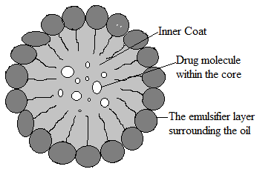
Fig. 1 Structure of nanoemulsion
1.2ADVANTAGESOF NANOEMULSION
Nanoemulsion is one of the best approaches to increase water solubility of the lipophilic drugs, which in turns increases the bioavailability of the drug in the systemic circulation. As the droplets are in nano size it is having increased interfacial areas it effects the transport properties of the drug, which is an very important factor in drug delivery Fig.2 (sustained and targeted) 13, 14.
• Plasma concentration profiles and bioavailability are more reproducible when the drugs are administered in nanoemulsion formulation 18, 14.
• It has been observed that as the oil droplets are fine, it empty quickly from the stomach and increase proper distribution of the API throughout the intestinal tract. By doing so it minimizes irritation frequently observed with long contact of the drug and gut wall 13, 19.
• Nanoemulsions based formulations are having higher capacity of solubilization than formulation based on simple micellar solutions. Nanoemulsions are also thermodynamically stable which offer advantage over emulsions and suspensions those are unstable dispersion system. Nanoemulsions can easily prepared by little energy input that is by less heat and mixing and it also has long shelf life [14].
• They also provide ultra low interfacial tension and large o/w interfacial areas 14, 20, 21.
• They also offer an advantage over existing self-emulsifying system in terms of rapid onset of action (no extra time for dispersion) and reduced inter subject variability in terms of GIT fluid volume.
• Nanoemulsions may possess high kinetic stability and optical transparency resembling to microemulsions 18, 22.
• The structures in the nanoemulsions are much smaller than the visible wavelength, so most nanoemulsions appear optically transparent, even at large loading 13, 18, 23.
• Nanoemulsions are also used to deliver peptides that easily undergo enzymatic hydrolysis (degradation) in GIT 14, 24, 25.
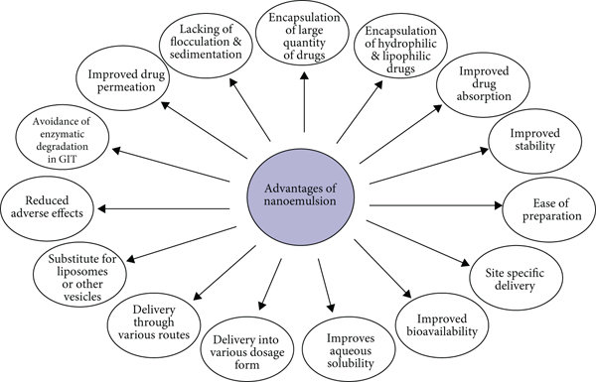
Fig. 2 Advantage of Nanoemulsion
1.3 MAJOR COMPONENTS OF NANOEMULSION
Three pivotal ingredients are necessary for NE preparation which are
1. Oil
2. Surfactant
3. Co-surfactant
Oils: Selection of an appropriate oily phase is very important as it influences the selection of other ingredients of nanoemulsions, mainly in case of O/W nanoemulsions. Usually, the oil which has maximum solubilising potential for selected drug candidate is selected as an oily phase for the formulation of nanoemulsions. This helps to achieve maximum drug loading in the nanoemulsions 17, 21. Triglycerides are highly lipophilic and their solvent capacity for drugs is commonly a function of the effective concentration of ester groups, thus on weight basis medium chain triglycerides (MCT) have higher solvent capacity and resistance to oxidation compare to long chain triglycerides 17. Modified vegetable oils, oils and fats (digestible or non-digestible) such as palm oil, olive oil, corn oil, sesame oil, oleic acid, hydrogenated soybean oil, peanut oil, soybean oil and beeswax are also used as oil phase in nanoemulsion formulation 16.
Surfactants: The surfactant should favour microemulsification of the oily phase and should also possess good solubilising potential for the hydrophobic drug compounds. The choice of the surfactant is critical for the nanoemulsion formulation. Surfactants with an HLB value 10) surfactants such as polysorbate 80 are hydrophilic and form o/w nanoemulsion. In many cases, mixture of lipophilic (low HLB) and hydrophilic surfactants (high HLB) may be required to obtain nanoemulsion 21. Below critical micellar concentration (CMC) of the
surfactant in solution it increases drug solubility by giving regions for lipophilic drug interactions in solution. Above CMC, surfactants aggregate to form micelles with the lipophilic core and a lipophobic surface. The lipophilic core of the micelles influence the entrapment of drug (mostly lipophilic in nature), thus increasing its solubility.
Co-surfactants: Most of the times, surfactant alone cannot lower theoil-water interfacial tension sufficiently to yield a nanoemulsion which necessitates the addition of an amphiphillic short chain molecule or cosurfactant to bring about the surface tension close to zero. Cosurfactants penetrate into the surfactant monolayer providing additional fluidity to interfacial film and thus disrupting the liquid crystalline phases which are formed when surfactant film is too rigid 21. Usually a very low HLB cosurfactant is used with a high HLB surfactant to modify the overall HLB of the system. Unlike surfactant, the cosurfactant may not be capable of forming self-associated structures like micelles on its own. Hydrophilic cosurfactants preferably alcohols of intermediate chain length such as hexanol, pentanol and octanol, which are known to reduce the oil/water interface and allow the spontaneous formation of nanoemulsion 16, 18.
Co-solvents: Production of an optimum nano-emulsion requires a high concentration of surfactants, that is generally more than 30% w/w. Various organic solvents like glycerol, polyethylene glycol(PEG), ethanol, propylene glycol (PG) are used for oral delivery of the drug, and this co-solvents are having efficacy to dissolve large amount of water soluble surfactant or the API in the lipid base. Mostly it makes the environment more lipophilic by decreasing the dielectric constant of aqueous phase 18. There are some co-solvents like alcohols and other volatile substances have disadvantage of evaporating into the soft gelatin or hard gelatin capsules shells of the in conventional SMEDDS which leading to precipitation of drug. Thus, formulation should be free from alcohol while designing 18, 21, 27
1.4 Following are the types of NEs formed depending on the composition
1. O/W NE: Here, the oil droplets are dispersed in the continuous aqueous phase
2. W/O NEs: Here, the water droplets are dispersed in the continuous oil phase
3. Bi-continuous NEs: Here, the microdomains of oil and water are inter-dispersed within the system
In all three categories of NEs, the interface is made stable by a required blend of surfactants and/or co-surfactants [31].
2. METHODS OF PREPARATION OF NANOEMULSIONS
Nanoemulsions are made from various excipients like surfactants those are approved for internal human use and some food materials 'Generally Recognized as Safe' by the Food and Drug Administartion. Nanoemulsions can be easily produced in large quantities by mixing aqueous phase with a water-immiscible oil phase using a process called high-stress, mechanical extrusion, which is easily available Fig 3. As nanoemulsions are having very small droplet size, it can be effectively prepared by high-pressure equipment.
Mostly equipments used for the formulation of the nanoemulsion are:
- High-pressure homogenization and
- Microfluidization
Both the equipments can be used for laboratory as well as industrial scale.
Other methods are also used in the formulation of nanoemulsion like, Ultrasonification and spontaneous emulsification which are also suitable for laboratory scale and not used for the commercial production show in Table 1 14, 21, 28.

Technique | Formulation | Conclusions | Ref
High pressure homogenization | Oral lipid nanoemulsion (primaquine) | Enhanced oral bioavailability, 10-200 nm particle size | 29
Pseudoternary phase diagram + spontaneous emulsification method | Ramipril nanoemulsion | Increased bioavailability, droplet size 80.9 nm | 30
High pressure homogenization | O/W nanoemulsions | Improved skin hydration and elasticity | 31
Spontaneous emulsification | O/W nanoemulsion (aceclofenac) | Nanoemulsion with potential for transdermal delivery of aceclofenac | 32
Spontaneous emulsification | Celecoxib nanoemulsion | Enhanced physical and chemical stability of celecoxib in nanoemulsion | 33
High pressure homogenization | Lecithin-based nanoemulsions (progesterone) | Improved permeation rates of progesterone with long-term stability | 34
High pressure homogenization | Prednicarbate nanoemulsion | Increased chemical stability of the drug in formulation | 35
Phase inversion temperature method | Acyclovir-loaded multiple W/O/W nanoemulsions | Excellent physicochemical stability for 6 mo at RT, mean droplet size of 100 nm | 36
Spontaneous nanoemulsification method | Clotrimazole nanoemulsion | Improved solubility of clotrimazole, mean globule size | 37
Ultrasonic emulsification method | Basil oil nanoemulsion | Nanoemulsions with droplet size of 29.6 nm, for food preservation | 38
High-pressure homogenizer | Dimethyl silicone dry nanoemulsion inhalation | Effective in acute lung injury, particle size of 19.8 nm | 39
Microfluidization method | Pitavastatin-containing nanoemulsions | Enhanced permeation | 40
High-pressure homogenization+ ultrasound | Nanoemulsion | Reduced energy demand for emulsification, low particle dimensions and higher stability | 41
Sonication method | Saponin-stabilized quercetin-loaded o/w nanoemulsion | Stable for 45 d at RT, mean particle size of 52±10 nm | 42
High-pressure homogenization | Paclitaxel-baicalein nanoemulsion | Strategy to overcome multidrug resistance | 43
Nanoemulsion templating | PLGA nanoparticles | Imaging agents for biomedical purposes | 44
Spontaneous emulsification method | Chitosan films with cinnamaldehyde nanoemulsions | Good UV barrier properties | 45
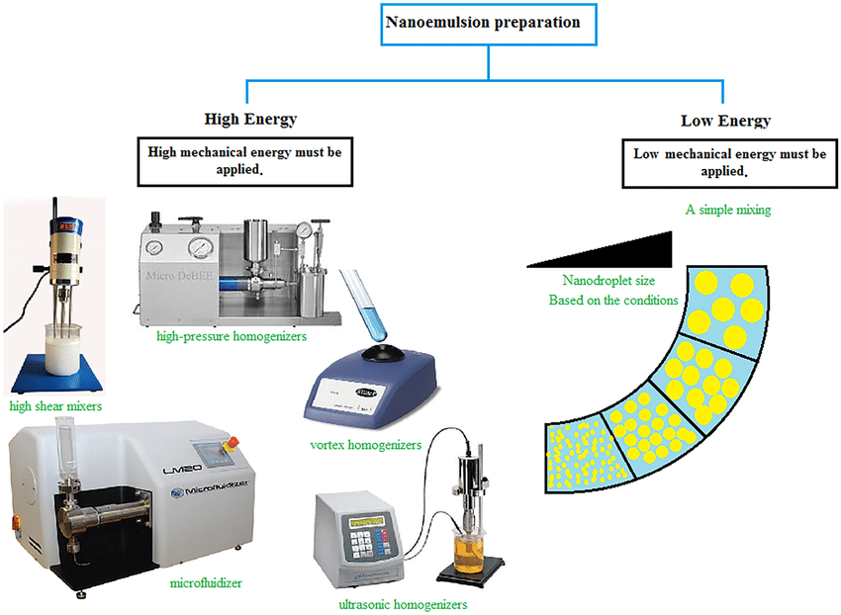
Fig.3 Preparation of Nanoemulsion

3. CHARACTERIZATION OF NANOEMULSIONS
The prepared nanoemulsions are evaluated for following parameters:
Dye Solubilization ⁴⁶
A water soluble dye is solubilized within the aqueous phase of the w/o globule but is dispersible in the o/w globule. An oil soluble dye is solubilized within the oil phase of the o/w globule but is dispersible in the w/o globule.
Measurment of Droplet Size and Polydispersity Index
The mean particle size and polydispersity index are measured at 250C by dynamic light scattering (DLS) using a Malvern Zetasizer. The size of the particles is measured by using disposable capillary cuvette equipped with electrodes. To avoid multiple scattering effects in the measurements, samples are diluted 100-fold with doubledistilled water immediately before measurement 47. The droplet size and poly dispersity index of the investigated samples is obtained (in triplicate) by calculating the average of 13 measurements at an angle of 1730 48, 49.
Interfacial Tension ⁵⁰: By measuring the interfacial tension the properties of nanoemulsion can be studied and Spinning-drop apparatus can be used to measure the ultra-low interfacial tension. Interfacial tensions are derived from the measurement of the shape of a drop of the lowdensity phase, rotating it in cylindrical capillary filled with high-density phase.
Particle Size Analysis: For the measurement of particle size and their distribution dynamic light scattering (DLS) method is generally used in case of nanoemulsion 51
Conductance Measurement ⁴⁶ Conductance measurements are usually carried out to determine the nature of the continuous phase and to detect phase inversion phenomena; the electrical conductivity measurements are highly useful. In o/w nanoemulsion where the external phase is water, are highly conducting whereas w/o are not, since water is the internal or dispersed phase. Dielectric measurements are a powerful means of probing both structural and dynamic features of nanoemulsion systems. Refractive Index: Refractive index of nanoemulsion is determined by using an Abbes type refractometer. The refractive index of each sample measured three times, and mean value and standard deviation (SD) are calculated Viscosity the viscosity of the nanoemulsions is measured by Brookfield viscometer and the spindle size of 62 and rpm 60 is used for the study and the viscosity is expressed in terms of centipoises.
Percent Drug Loading: To determine percent drug loading, pre-weighed nanoemulsion is extracted by dissolving in 25ml suitable solvent, then the extract is analyzed spectrophotometrically/ by using HPLC against the standard solution of drug. Drug content is determined by reverse phase HPLC method using different columns of appropriate porosity .
Determination of Entrapment Efficiency : Entrapment efficiency (EE %) is determined by measuring the concentration of free drug (un-entrapped) in aqueous medium. This is the prime importance, as it influences the release characteristics of drug molecule. The amount of drug encapsulated per unit weight of nanoformulation is determined after separation of the entrapped drug from the nanoemulsion formulation. The entrapment efficiency is determined by following formula:-
EE= Wt of total drug in formulation –Wt of drug in a.q. phase ×100
Wt of total drug in formulation
Stability studies For the evaluation of nanoemulsions, the stability study is an important criterion to be considered. Nanoemulsions are characterized by its high stability than the other dispersed systems. The various stability studies conducted for nanoemulsions include:
a) Thermodynamic stability studies, and b) Accelerated stability studies.
a. Thermodynamic stability studies In Thermodynamic stability studies the selected formulations are subjected to different thermodynamic stability studies tests to assess their physical stability 57. The process involved 3 cycles, initially heating and cooling cycles are carried out 6 times, followed by alternately heating and cooling at 40°C and 4°C respectively, this is followed by centrifugation at 3500 rpm for 30 min. Each cycle is observed for changes in the formulation due to phase separation.
b. Accelerated stability studies Accelerated stability studies are performed on optimized formulation. Three batches of the nanoemulsions are taken in glass vials and were kept at a temperature of 30°C, 40°C, and 60°C at ambient humidity condition 58. The samples are withdrawn for studying drug content as per standard procedure mentioned in International Conference on Harmonisation (ICH) Q1 guidelines. The amount of the drug degraded at each time interval is calculated nand order of the reaction is determined by graphical method. The degradation rate constant (K) is determined for each temperature.

4. APPLICATIONS OF NANOEMULSIONS IN VARIOUS FIELDS (Fig.4)
1. Nanoemulsions in drug delivery
II. Nanoemulsions in Biotechnology
III. Nanoemulsions in Cosmeticology
IV. Nanoemulsions in Food industry
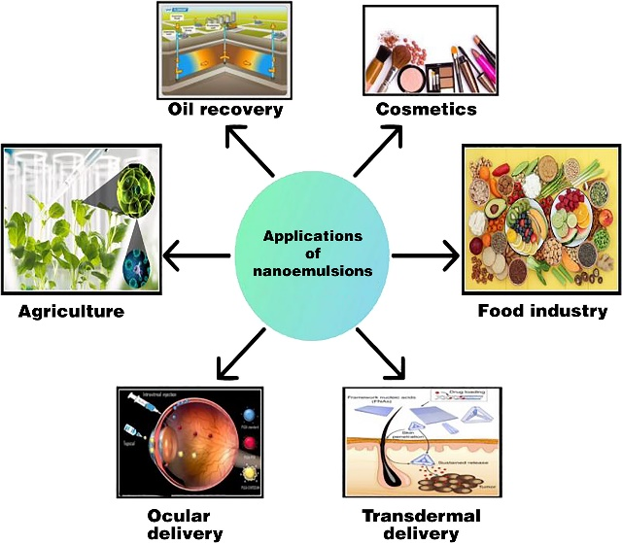
Fig.4 Application of nanoemulsion

I Nanoemulsions in drug delivery
Nanoemulsions have been used in most topical, ocular, intravenous, internasal and oral drug delivery Fig.5. These applications influence the lyphophilic nature of nanoemulsions to solvate water-insoluble drugs; and tunable charge and rheology of nanoemulsions to formulate aqueous solutions that can be easily delivered to patient. Though skin protects us from the external environment, it also acts as a transport barrier against administration of drugs through the skin. Topical medication formulated using nanoemulsions can provide unique advantages as the dispersed phase of O/W nanoemulsions enables enhanced solubility of lipophilic drugs in the oil phase and the continuous phase provides a mild, skin-friendly environment that can dissolve biopolymers such as alginate for adjusting the formulation rheology, appearance and texture. A considerable number of studies focused on using nanoemulsions for topical drug delivery. Few of the abovementioned studies included permeation tests to evaluate the effectiveness of topical delivery. Some studies claim that owing to the relatively small size and low z-potential of nanoemulsion formulations, hydrophobic drugs are delivered more efficiently than are suspensions of these drugs 59 Researchers have also explored the use of nanoemulsions in other modes of drug delivery such as ocular, intravenous, intranasal and oral delivery. Nanoemulsions have also been used as ultrasound imaging agents 61. Kaneda et al. prepared nanoemulsions containing perfluorocarbons for quantitative molecular imaging and targeted therapeutics. engineered a multifunctional nanoemulsion based platform to enable an imaging-guided therapy. Researchers evaluated the utility of the platform in a colon cancer mouse model. In this study, oil-in-water nanoemulsions carried iron oxide nanocrystals for MRI, the fluorescent dye Cy7 for NIRF imaging, and the hydrophobic glucocorticoid prednisolone acetate valerate for therapeutic purposes.
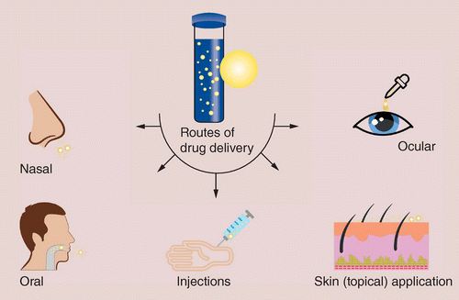
Fig.5 Route of Drug Delivery

II. Nanoemulsions in Biotechnology 64 Many enzymatic and biocatalytic reactions are conducted in pure organic or aqua-organic media. Biphasic media are also used for these types of reactions. The use of pure a polar media causes the denaturation of biocatalysts and the use of water-proof media is relatively advantageous. Enzymes in low water content display and have; ¬ Enhanced solubility in non-polar reactants. ¬ Possibility of shifting thermodynamic equilibria in favour of condensations. ¬ Improvement of thermal stability of the enzymes, thus enabling reactions to be carried out at higher temperatures. Many enzymes including lipases, esterases, dehydrogenases and oxidases often function in the cells in microenvironments that are hydrophobic in nature. In biological systems many enzymes operate at the interface between hydrophobic and hydrophilic domains and these usually interfaces are stabilized by polar lipids and other natural amphiles. Enzymatic catalysis in nanoemulsions has been used for a variety of rxns, such as peptides and sugar acetals transesterification, synthesis of esters and steroid transformation. Lipases are the most commonly used class of enzymes 65.
III. Nanoemulsions in Cosmeticology Nanoemulsion is used as vehicle for controlled delivery and as effective transport vehicle. The Kemira Nanogel nanoemulsion based carrier system is a patented system for cosmetic purpose which enhances skin production and penetration of API. Apart from that it also provide good skin feel 66. Topical administration itself has many advantages and by combining it with nanoemulsion, this formulatory may impart the better way of drug delivery system. It can bypass the hepatic first pass metabolism of the drug and related toxicity effects 67. IV. Nanoemulsions in Food industry Nanoemulsions offer a wide range of applications due to their compositional flexibility in various fields including food and beverage industries. As compared to microemulsions, nanoemulsions have found a lot of applications in food processing due to its very small size, thermodynamic stability, continuous self-assembly with hydrophilic and hydrophobic portion, transparency and weak light wave scattering capacity, which eventually lead to their incorporation into optically transparent products such as fortified soft drinks and waters. Disparate micro or other conventional emulsions, nanoemulsions can be prepared to be more viscous or gel-like with very low droplet concentrations, which can be easily used to make products with low fats and novel texture 68. Nanoemulsions can enhance the shelf-life of industrial products due to the stability of the droplet of the nanoemulsion, stability to particle aggregation and gravitational separation. Joe et al. used nanoemulsions prepared from sunflower oil for the processing of Indo-Pacific king mackerel steaks and observed no microbial growth up to 12 h and the shelf life of the product was increased up to 48 h 69

CONCLUSION
This review is concerned with nanoemulsions as a means of drug delivery. Drug delivery using nanoemulsion formulations has many benefits, including the ability to protect labile drugs, increase drug solubility, improve bioavailability, control drug release, and lower patient variability. Additionally, for more than 40 years, clinics have used nanoemulsions as total parenteral nutrition fluids. Because of their potential uses in the pharmaceutical, cosmetic, biotechnology, and food industries as a better delivery system due to their small droplet size, transparency, and high kinetic stability, nanoemulsions with droplet sizes of less than 100 nm have attracted a lot of attention in recent years. However, it is still important to focus on the toxicological assessment of the prepared nanoemulsions, which can be a large area of research in the future..

REFERENCES
- Gurpreet K, Singh SK. Review of nanoemulsion formulation and characterization techniques. Indian Journal of Pharmaceutical Sciences. 2018 Sep 1;80(5).
- Shafiq S, Shakeel F, Talegaonkar S, Ahmad FJ, Khar RK, Ali M. Development and bioavailability assessment of ramipril nanoemulsion formulation. European journal of pharmaceutics and biopharmaceutics. 2007 May 1;66(2):227-43.
- Shah P, Bhalodia D, Shelat P. Nanoemulsion: A pharmaceutical review. Systematic reviews in pharmacy. 2010 Jan 1;1(1).
- Kumar M, Bishnoi RS, Shukla AK, Jain CP. Techniques for formulation of nanoemulsion drug delivery system: a review. Preventive nutrition and food science. 2019 Sep;24(3):225.
- Ghosh V, Saranya S, Mukherjee A, Chandrasekaran N. Cinnamon oil nanoemulsion formulation by ultrasonic emulsification: investigation of its bactericidal activity. Journal of nanoscience and nanotechnology. 2013 Jan 1;13(1):114-22.
- Sharma N, Bansal M, Visht S, Sharma PK, Kulkarni GT. Nanoemulsion: A new concept of delivery system. Chronicles of Young Scientists. 2010 Apr 1;1(2):2-6.
- Gué E, Since M, Ropars S, Herbinet R, Le Pluart L, Malzert-Fréon A. Evaluation of the versatile character of a nanoemulsion formulation. International Journal of Pharmaceutics. 2016 Feb 10;498(1-2):49-65.
- Jafari SM, McClements DJ, editors. Nanoemulsions: formulation, applications, and characterization. Academic Press; 2018 Feb 24.
- Fofaria NM, Qhattal HS, Liu X, Srivastava SK. Nanoemulsion formulations for anti-cancer agent piplartine—Characterization, toxicological, pharmacokinetics and efficacy studies. International journal of pharmaceutics. 2016 Feb 10;498(1-2):12-22.
- Mustafa IF, Hussein MZ. Synthesis and technology of nanoemulsion-based pesticide formulation. Nanomaterials. 2020 Aug 17;10(8):1608.
- Gurpreet K, Singh SK. Review of nanoemulsion formulation and characterization techniques. Indian Journal of Pharmaceutical Sciences. 2018 Sep 1;80(5).
- Gurpreet K, Singh SK. Review of nanoemulsion formulation and characterization techniques. Indian Journal of Pharmaceutical Sciences. 2018 Sep 1;80(5).
- Attwood D, Mallon C, Ktistis G, Taylor CJ, A study on factors influencing the droplet size in nonionic oil-in-water microemulsions. Int J Pharm, 1992; 88:417
- Arun PK, Narayanan N, Rajalakshmi G. Int .J PharmaSci Rev and Res, 2010; 3(1):130.
- Mohammed NK, Muhialdin BJ, Meor Hussin AS. Characterization of nanoemulsion of Nigella sativa oil and its application in ice cream. Food science & nutrition. 2020 Jun;8(6):2608-18.
- Laxmi M, Bhardwaj A, Mehta S, Mehta A. Development and characterization of nanoemulsion as carrier for the enhancement of bioavailability of artemether. Artificial cells, nanomedicine, and biotechnology. 2015 Sep 3;43(5):334-44.
- Rodrigues FV, Diniz LS, Sousa RM, Honorato TD, Simão DO, Araújo CR, Gonçalves TM, Rolim LA, Goto PL, Tedesco AC, Siqueira-Moura MP. Preparation and characterization of nanoemulsion containing a natural naphthoquinone. Química Nova. 2018;41:756-61.
- Chakraborty S, Shukla D, Mishra B, Singh S. Lipid-an emerging platform for oral delivery of drugs with poor bioavailability. Eur J Pharm Biopharm, 2009; 73:1-15
- . Date AA, Nagarsenker S. Parenteral microemulsions: an overview. Int J Pharm, 2008; 355:19-30.
- Gershanik T, Benzeno S, Benita S. Interaction of a selfemulsifying lipid drug delivery system with the everted rat intestinal mucosa as a function of droplet size and surface charge. Pharm. Res, 1998; 15:863-869.
- Gursoy RN, Benita S, Self-emulsifying drug delivery systems (SEDDS) for improved oral delivery of lipophilic drugs. Biomed. Pharmacotherap, 2004; 58:173-182.
- Jumaa M, Mueller BW., Formulation and stability of benodazipines in a new lipid emulsion formulation. Pharmazie, 2002; 57:740-743.
- Kale NJ, Allen LV. Studies on microemulsions using Brij 96 as surfactant and glycerin. Int J Pharm, 1989; 57:87-93.
- Carey MC, Small DM, Bliss CM. Lipid digestion and absorption. Ann Rev Physio, 1983; 45:651-677.
- Craig DQM, Barker SA, Banning D, Booth SW. An investigation into the mechanisms of self-emulsification using particle size analysis and low frequency dielectric spectroscopy. Int J Pharm, 1995; 114:103-110.
- Schwarz JC, Klang V, Karall S, Mahrhauser D, Resch GP, Shakeel F, Baboota S, Ahuja A, Ali J, Aqil M, Shafiq S. Nanoemulsions as vehicles for transdermal delivery of aceclofenac. AAPS Pharm Sci Tech, 2007; 8(4):E104.
- Shakeel F, Baboota S, Ahuja A, Ali J, Aqil M, Shafiq S. Accelerated stability testing of celecoxib nanoemulsion containing Cremophor-EL. Afr J Pharm Pharmacol, 2008; 2:179-183.
- Klang V, Matsko N, Zimmermann AM, Vojnikovic E, Valenta C. Enhancement of stability and skin permeation by sucrose stearate and cyclodextrins in progesterone nanoemulsions. Int J Pharm, 2010; 393:153-161.
- Baspinar Y, Keck CM, Borchert HH. Development of a positively charged prednicarbate nanoemulsion. Int J Pharm, 2010; 383:201-208.
- Valenta C. Optimisation of multiple W/O/W nanoemulsions for dermal delivery of acyclovir. Int J Pharm, 2012; 435:69-75.
- Borhade V, Pathak S, Sharma S, Patravale V. Clotrimazole nanoemulsion for malaria chemotherapy. Part I: Preformulation studies, formulation design and physicochemical evaluation. Int J Pharm, 2012; 431:138-148.
- Ghosh V, Mukherjee A, Chandrasekaran N. Ultrasonic emulsification of food-grade nanoemulsion formulation and evaluation of its bactericidal activity. Ultrason Sonochem 2013; 20:338-344.
- Zhu L, Li M, Dong J, Jin Y. Dimethyl silicone dry nanoemulsion inhalations: Formulation study and anti-acute lung injury effect. Int J Pharm, 2015; 491:292-298.
- Başpınar Y, Gündoğdu E, Köksal C, Karasulu E. Pitavastatincontaining nanoemulsions: Preparation, characterization and in vitro cytotoxicity. J Drug Deliv Sci Technol, 2015; 29:117-24.
- Calligaris S, Plazzotta S, Bot F, Grasselli S, Malchiodi A, Anese M. Nanoemulsion preparation by combining high pressure homogenization and high power ultrasound at low energy densities. Food Res Int, 2016; 83:25-30.
- Kaur K, Kumar R, Mehta SK. Formulation of saponin stabilized nanoemulsion by ultrasonic method and its role to protect the degradation of quercetin from UV light. Ultrason Sonochem, 2016; 31:29-38.
- Meng L, Xia X, Yang Y, Ye J, Dong W, Ma P, et al. Co-encapsulation of paclitaxel and baicalein in nanoemulsions to overcome multidrug resistance via oxidative stress augmentation and Pglycoprotein inhibition. Int J Pharm, 2016; 513:8-16.
- Fornaguera C, Feiner-Gracia N, Calderó G, García-Celma MJ, Solans C. PLGA nanoparticles from nano-emulsion templating as imaging agents: Versatile technology to obtain nanoparticles loaded with fluorescent dyes. Colloids Surf B Biointerfaces, 2016; 147:201-209.
- Chen H, Hu X, Chen E, Wu S, McClements DJ, Liu S, et al. Preparation, characterization, and properties of chitosan films with cinnamaldehyde nanoemulsions. Food Hydrocoll, 2016; 61:662-671

- Fernandes AR, Sanchez-Lopez E, Santos TD, Garcia ML, Silva AM, Souto EB. Development and characterization of nanoemulsions for ophthalmic applications: Role of cationic surfactants. Materials. 2021 Dec 8;14(24):7541.
- Sanchez A, García MC, Martín‐Piñero MJ, Muñoz J, Alfaro‐Rodríguez MC. Elaboration and characterization of nanoemulsion with orange essential oil and pectin. Journal of the Science of Food and Agriculture. 2022 Jul;102(9):3543-50.
- Abu-Huwaij RT, Hamed R, Daoud E, Alkilani A. Development and in-vitro characterization of nanoemulsion-based buccal patches of valsartan. Acta Poloniae Pharmaceutica-Drug Research. 2019 Apr 30;76(2):313-21.
- Sheth T, Seshadri S, Prileszky T, Helgeson ME. Multiple nanoemulsions. Nature Reviews Materials. 2020 Mar;5(3):214-28.
- Ma D, Tu ZC, Wang H, Zhang Z, McClements DJ. Fabrication and characterization of nanoemulsion-coated microgels: Electrostatic deposition of lipid droplets on alginate beads. Food Hydrocolloids. 2017 Oct 1;71:149-57.
- Chen H, Hu X, Chen E, Wu S, McClements DJ, Liu S, et al. Preparation, characterization, and properties of chitosan films with cinnamaldehyde nanoemulsions. Food Hydrocoll, 2016; 61:662-671.
- Savardekar P, Bajaj A. Nanoemulsions- A Review. Inter J Res Pharm and Chem, 2016; 6:312-322
- Gupta PK, Pandit JK, Kumar A, Swaroop P, Gupta S. Pharmaceutical nanotechnology novel nanoemulsion high energy emulsification preparation, evaluation and application.The Pharma Research, 2010; 3:117-138.
- Sharma N, Mishra S, Sharma S, Deshpande RD, Sharma RK. Preparation and optimization of nanoemulsion for targeting drug delivery. International Journal of Drug Development and Research, 2013; 5:37-48
- Suyal J, Bhatt G and Singh N: Formulation and evaluation of nanoemulsion for enhanced bioavailability of Itraconazole. Int J Pharm Sci & Res, 2018; 9:2927-2931
- Calligaris S, Plazzotta S, Bot F, Grasselli S, Malchiodi A, Anese M. Nanoemulsion preparation by combining high pressure homogenization and high power ultrasound at low energy densities. Food Res Int, 2016; 83:25-30
- Sukanya G, Mantry S, Anjum S. Review on Nanoemulsions. Int J Innov Pharma Sci and Res, 2013; 1:192-205.

