“ISOLATION AND IDENTIFICATION OF MICROBES FROM NAIL SAMPLE AND ANTIDERMATOPHYTIC ACTIVITIES ON Lasowmnia intermis . Aloe barbadens
*Dr.R.KRISHNAVENI¹, S.KAVIYARASI¹, V.NITHYASRI¹, SUSITHRA¹
Dr.R.Krishnaveni, Assistant Professor and Head, PG and Research Department of Microbiology. Idhaya College for Women, Kumbakonam.

S.KAVIYARASI¹, V.NITHYASRI¹, SUSITHRA¹ Research student, Department of Microbiology

INTRODUCTION:

The present work carried out on isolation and characterization of microbes from nail samples and antidermatophytic activities with Lasowmnia intermis . Aloe barbadens .The Objectives of the present study include, isolaton of microbes from nail, samples of school student in different age groups Enumeration of microbes after washings hands with Dettol solution and Alloevera (Alloe barbadensis) soap and checking the microbial load. Comparative study of antimicrobial activity of Henna (Lawsonia inermis), Dettol solution and Alloevera (Alloe barbadensis) soap.Fungal infections is a significant health problem in our country. Invasive fungal infections cause of mortality. Death rates from invasive fungal infections remain unacceptably high

MATERIALS AND METHODS
Site of collection
For the present study of was carried out in school chidren in the age group 3-6 years age and 10-15 age groups. A total of 20 samples were collected from Banadurai Higher Secondary School students at Kumbakonam. Thanjavur district, Tanilnadu during the study period between Dec.2017 to march 2018. The nail clippings were collected for present work collected from nails white yellow discolouration. After giving therapy for after treatment with Herbal soap Aloevera, herbal lotion and Dettol. Isolation of fungi was carried out according to Standard Procedure for Medical Mycology (Parvez, 2010; Evans and Richardson,1989).
Isolation of fungi from nails
Samples of nail clippings was first dipped into sterile distilled water into a sterile petri dish for 10-15 minutes for softening of nail. Then small pieces were cut by using sterile and 5-10 pieces were put on the surface of potato dextrose agar medium plates. These plates were then incubated at 30⁰ celcius for further study.

Isolation of fungi from scraping
Scraping samples were directly placed over the Potato dextrose agar plates. These agar plates were then incubated at 30º celcius for further study.
Microscopic examination of samples
Microscopic examination was done by using KOH ( 20% KOH +15% glycerol) mount.
Culturing of dermatophytes. To a sterile petridish, 20ml of sterile Potato dextrose agar medium was poured.Nail clippings placed on medium. The plates were incubated at 37⁰ celcius for 3 weeks and growth was observed.
Lactophenol cotton blue mount
By lactophenol cotton blue staining the hyphae, spore structure and their arrangement was observed.

RESULT
The samples of nail clipping collected from school children Banadurai Higher Secondary School, Kumbakonam during the study period between 2017-2018. Total 20 student examine among them 10 belonh to age group of 3-6 and another 10 belong in age group of 10-15. The prevalence of microorganisms the fungus Aspergillussp, penicilliumsp, E.coli, staphylococcus aureus.Abundant in age group of 3-6.
In our investigation Table 1 shows the age group 3-6 containing following microbes E.coli, Staphylococcus aureus, Aspergillussp, Penicilliumsp, Mucorsp, Rhizopus sp.
Age group 10-15 the following microbes E.coli, Bacillus sp, Fusariumsp, Alternariasp, penicilliumsp
(Table 2)shows the following microbes containing biochemical characters of E.coli, it is appear gram negative rod. It apprears like agar slant culture morphology white, moist, glistening. Gelatin liquification is negative. Starch hydrolysis is negative. Lipid hydrolysis is lactose. Lactose produce acid and gas formation. Dextrose is produce acid and gas formation. Sucrose produce acid formation. Hydrogen sulphide is positive. Indole production is positive. Methyl red is positive. Vogesproskauer is negative. Citrate utilization is negative. Urease is negative. Catalase is positive. Oxidase is negative.
Table-1
Isolaton of microbes on Nail sample of age group of 3-6 and 10-15
s.no | Bacterial isolates | fungal isolates
 | 3-6 age
1. | E.coli | Aspergillussp,  Alternaria sp.
2. | Staphylococcus sp/  Lactobacillus sp . | Penicilliumsp,
 | 10-15 age
1. | E.coli | Mucorsp
2 | Bacillus sp | Rhizopussp
Table 2
s.no | Organism isolates | Total (50)
1. | Aspergillussp, | 12
2. | Penicilliumsp | 6
3. | Mucorsp | 8
4. | Rhizopussp | 7
5. | E.colisp | 6
6. | s.aureussp | 5
7. | Alternariasp | 3
8. | Fusariumsp | 2
9. | Bacillus sp | 1
Table 3
s.no | samples | Zone of inhibition (cm)
1 | Henna (lawsonaiinternis) | 1.2cm
2 | Dettol solution | 1.0cm
3 | Aloe vera (aloe barbadensis) | 0.5cm

Table 4
s.no | microorganisms | Cfu (ml)
1 | E.coli | 3X10-4
2 | Staphylococcus aureus | 5X10-4
3 | Bacillus sp | 4X10-4
4 | Lactobacillus sp, | 6X10-4

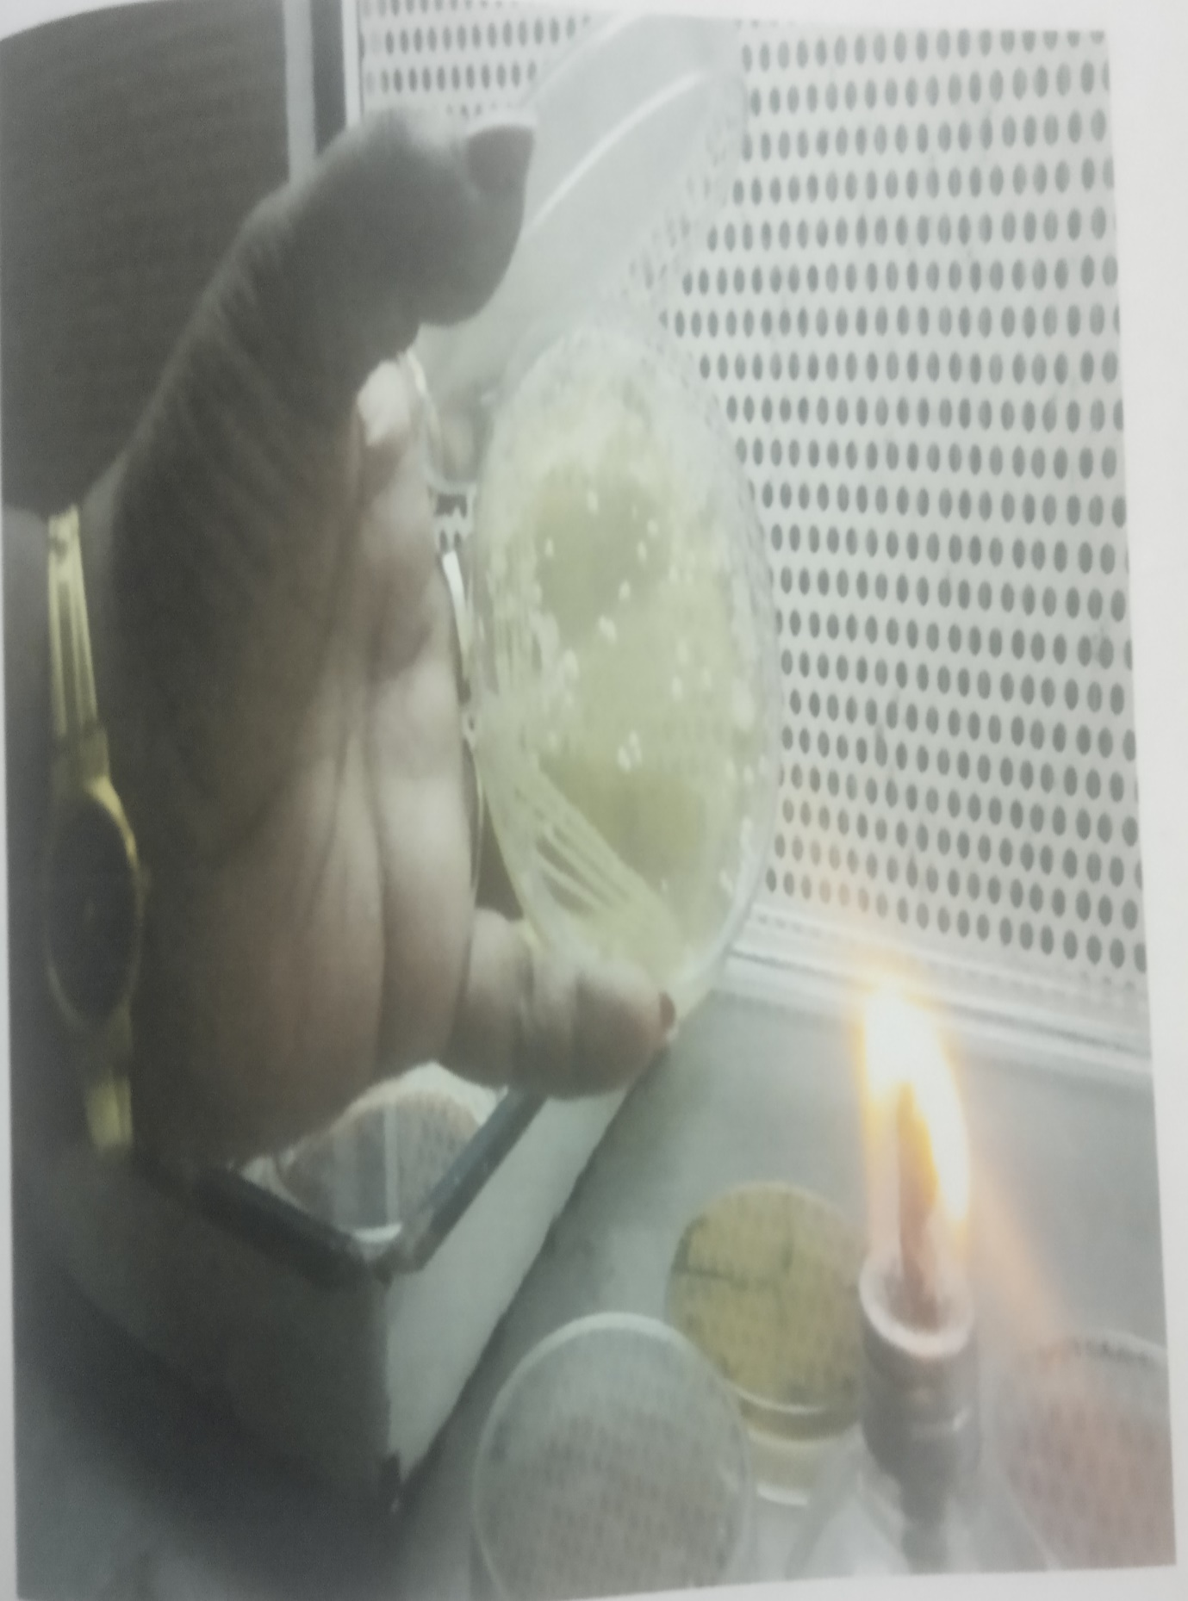
Isolation of sample from infected nail (staphylococcus aureus)
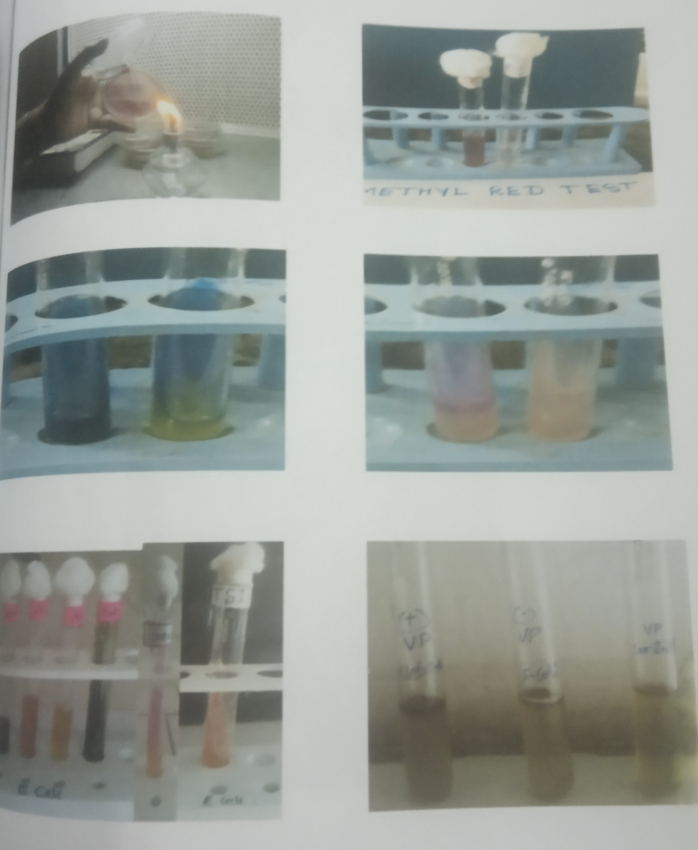
Isolation of microbes from nail sample (e. coli)
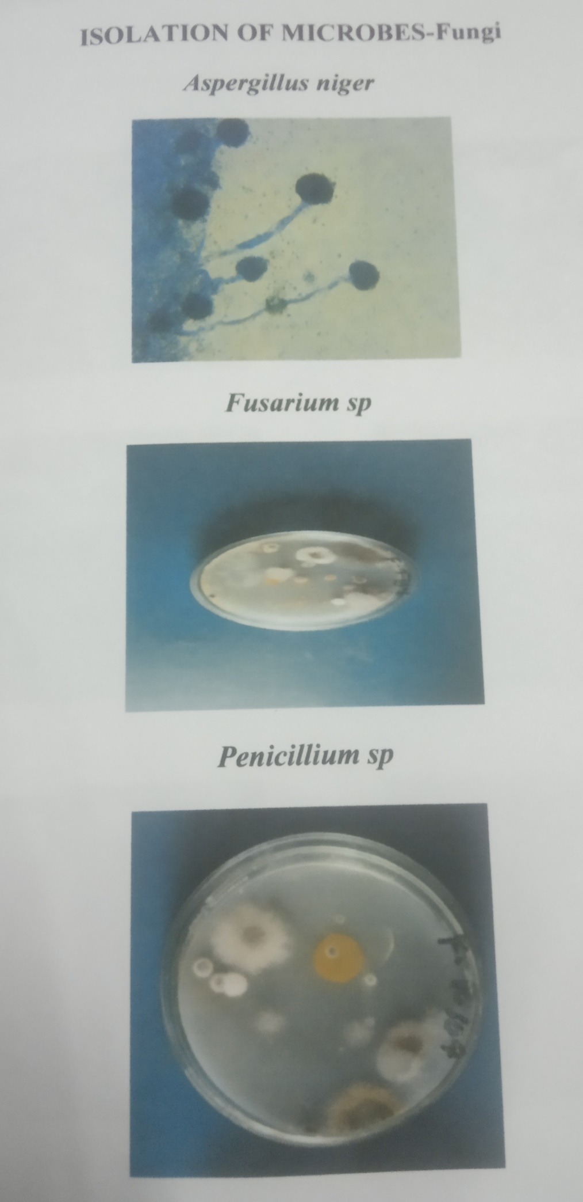

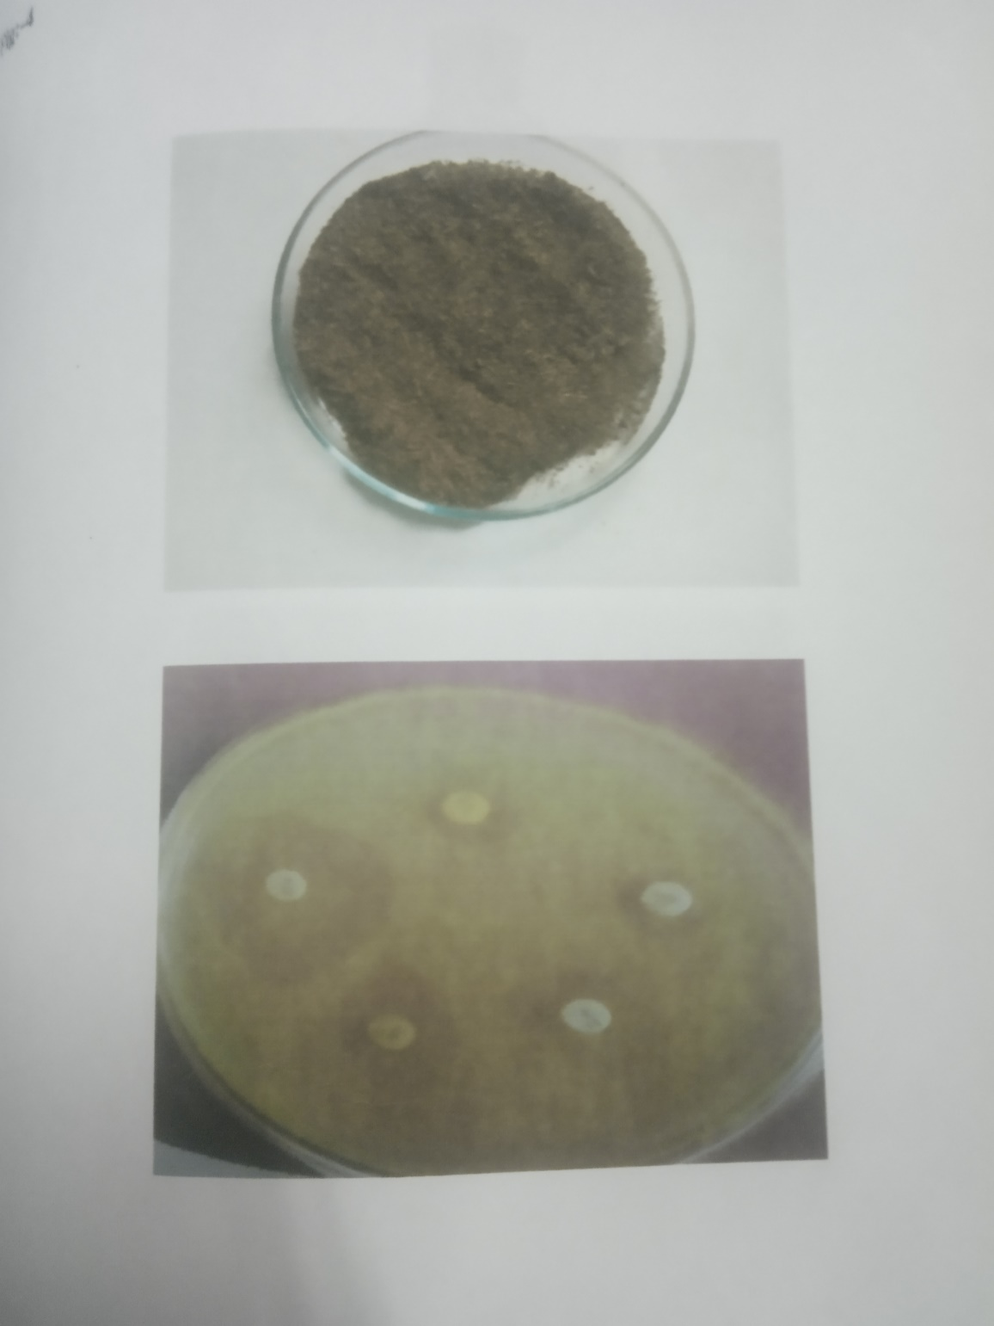
Antimicrobial activity of Dettol soap
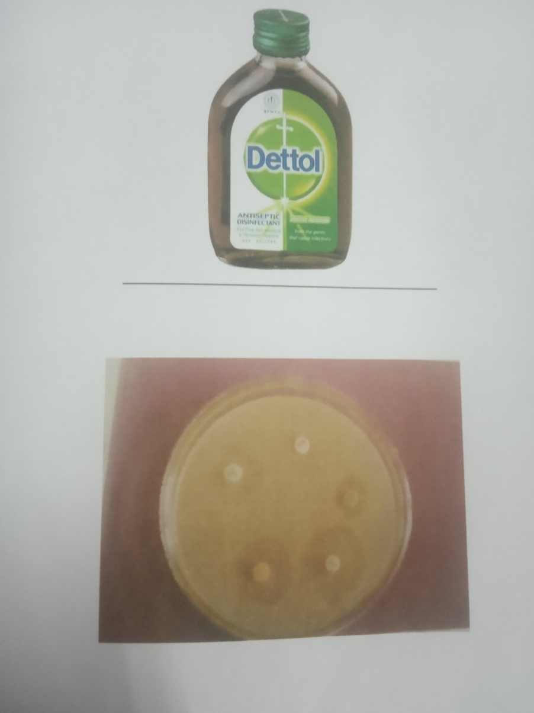
Antimicrobial activity of Dettol solution
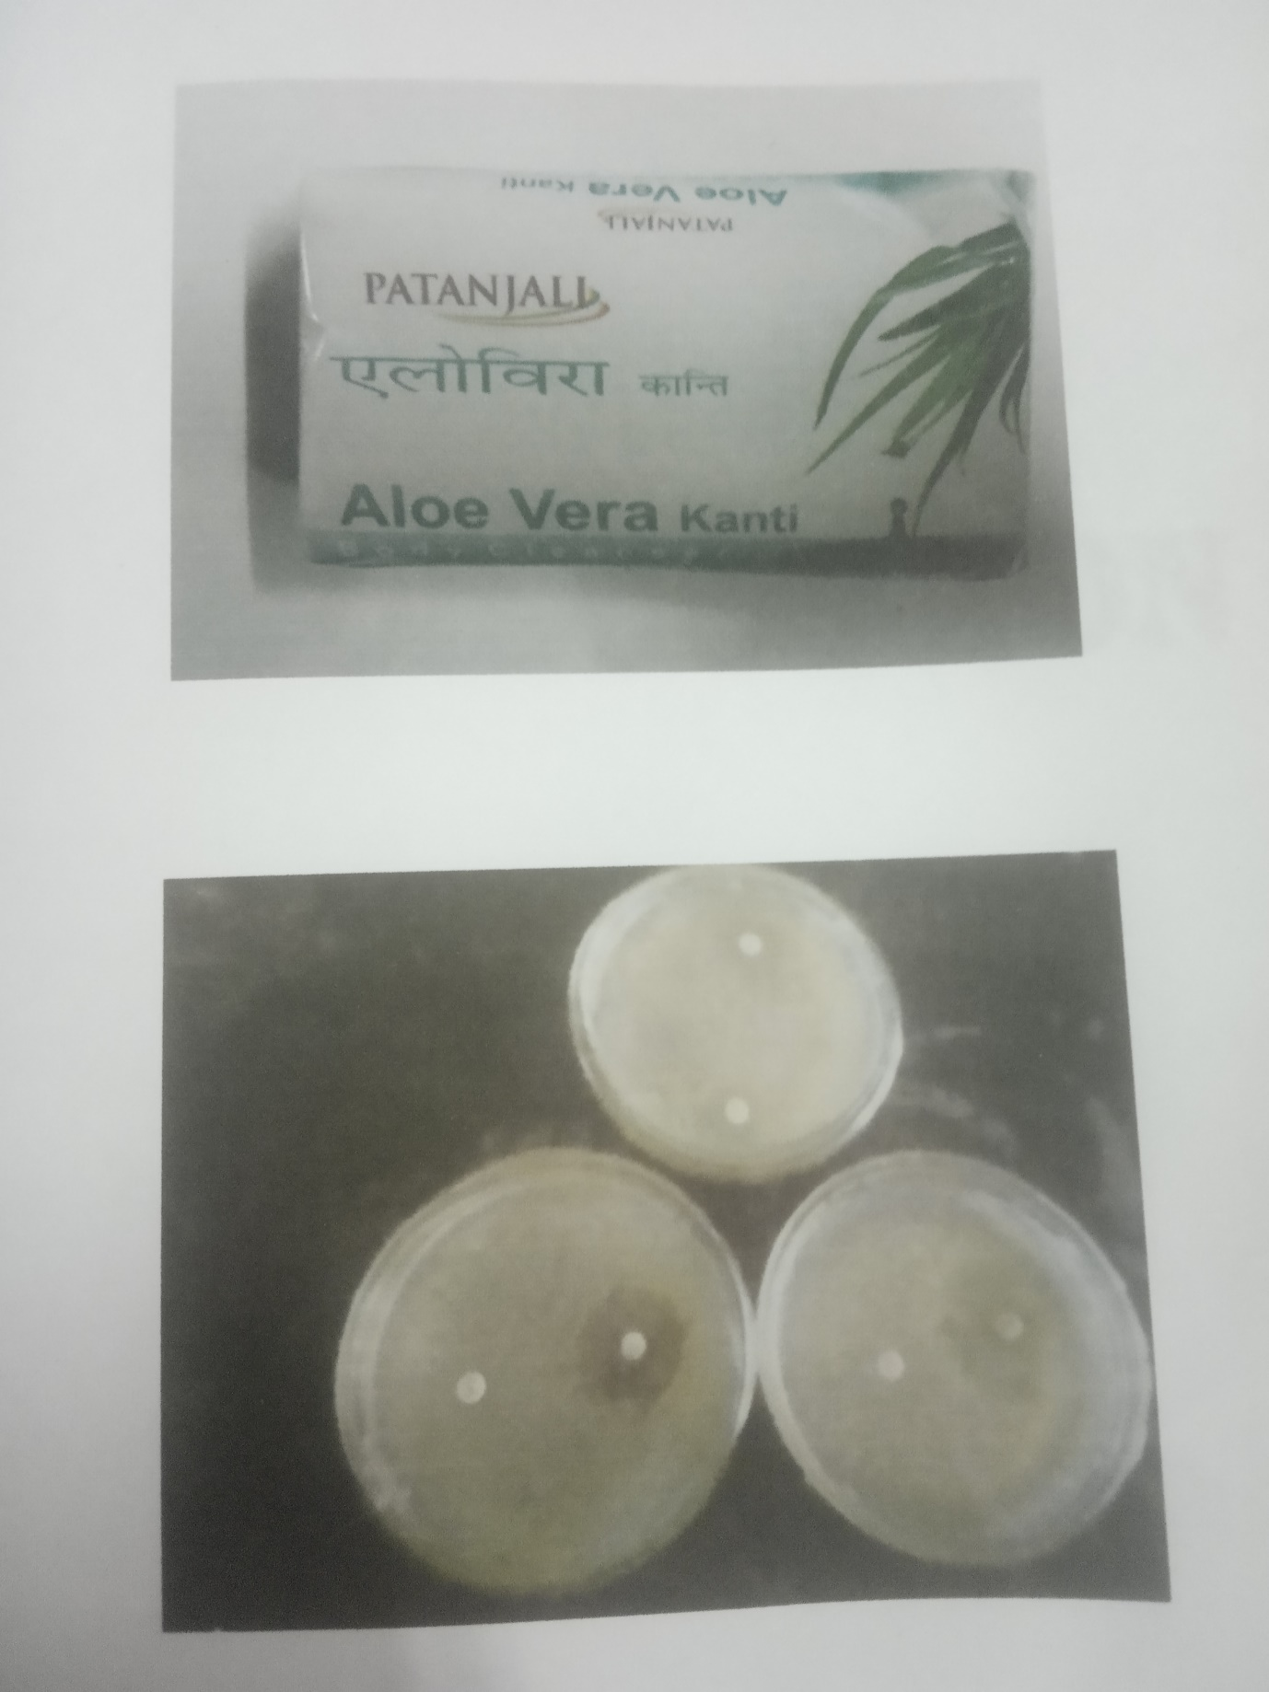

DISCUSSION
In this study, the medicinal plant Lawsonia inermis showed maximum zone of inhibition (1.2cm) against tested of microbes. Among three herbal lotion henna plant the Lawsonian inermis(henna) was given result.
Herbal soap Aloevera antimicrobial activity estimated (Alloe barbadensis) by (Williams et al.,1992).Antimicrobial and antifungal assays described by (cheesbrough 1984). Zone of inhibition diameters for soaps were determined against E.coli and Staphylococcus aureus.

SUMMARY AND CONCLUSION

The present study carried out the evaluate the antimicrobial activity of Henna plant (lawsoniainermis) against the chemical antibiotic Dettol solution and Aloe vera soap (Aloe barbadensis). Bacterium E.Coli, staphylococcus sp, lactobacillus sp, Bacillus sp, the fungal species were isolated from the nail samples.The henna plant (lawsoniainermis) extract was prepared and testing its antimicrobial activity the bacterial species against thr bacterial isolates as like the antimicrobial activity tested Dettol solution,Aleovera soap(aloe barbedens).In finding the Henna plant (lawsonia inermis) shows (1.2cm) zone of inhibition, Dettol solution shows (1.0cm) zone of inhibition, and Aloe vera soap (aloe barbedens)The henna plant (lawsonia inermis) (1.2cm) zone of inhibition at maximum observed.This study Concluded Henna plant (lawsomnia inermis) had maximum zone of inhibition and also more antimicrobial activity.

