DIGITAL INNOVATIONS
Introduction
The combination of era and dentistry has given thoughts-blowing outcomes. The generation and the armamentarium with the patient’s want has been interwoven to obtain the highest fulfillment costs. It brings many blessings on the table for the dentist, the assistant and the patient. technology has not most effective uplifted the accuracy and intricacy of dentistry however has decreased the weight at the clinician as properly. The astounding aspect approximately dental generation is how plenty it lends from different industries—CAD/CAM came from the manufacturing zone, and it simply took a few software program tweaks to enhance the accuracy.
In the past, the case history, physical examination, and two-dimensional X-ray statistics radiography (including periapical, panoramic, and cephalometric radiographs) have served as the cornerstone for the crucial stages leading up to the creation of a remedy plan and its implementation. Setting up an accurate prognosis and the best treatment plan may be difficult even with the most effective dimensions X-ray data available; treatment plans primarily depended on the operator's manual abilities and experience. 1 however now, Digitalisation comes with bounty of advantages. the speed and simplicity of processes, this means that the affected person can be inside and outside of the sanatorium with their teeth completely restored in manner much less time than with traditional techniques. Temporisation and never ending repeat appointments are a thing of beyond now, dentistry has revolutionised the patient revel in. unmarried appointment techniques with the capacity to diagnose, create and fit the restoration has made dentistry more match for the 21st century. you could enter and access large records just on the touch of our fingers¹.
In the subsequent years, virtual dentistry continued to evolve rapidly. Notably, companies such as 3Shape, DentsplySirona, and Align Technology, among others, made significant advancements in digital imaging and scanning technologies, 3D printing, and software systems for digital treatment planning and simulation. These technologies found applications across various dental specialties, including restorative and cosmetic dentistry, orthodontics, implant dentistry, and surgical procedures.²
The Role of Medicine and Technology in Shaping the Future of Oral Health
In the twenty-first century, oral health has evolved beyond the traditional "drill-and-fill" approach. While earlier dental efforts primarily focused on removing diseased tissue and restoring lost tooth structure, recent advances emphasize disease prediction and prevention. Despite living in a technologically, medically, and scientifically advanced society, there is still much work to be done to reach our full potential. In our nation, over 28 million citizens lack health care coverage, two-thirds of adults do not have dental insurance, there are 37,000 new cases of oral cancer each year, and an ongoing oral health crisis persists.³
The introduction of cutting-edge technology, whether it's robotics, artificial intelligence, tissue and organ transplants, the utilization of innovative antimicrobial agents, or the application of genomics for personalized oral care, is poised to have a lasting impact on patient care. Integrating dental practices into comprehensive healthcare teams, where dentists collaborate with physicians and pharmaceutical experts, including geneticists, represents a significant stride towards delivering comprehensive diagnosis and treatment to all patients.³
A promising advancement that involves the intersection of genomics with various dental disciplines is the application of salivary imaging and diagnostics. This approach utilizes novel salivary proteins, nucleic acids, metabolites, and other markers to enable the early detection of both oral and non-oral diseases.³
Due to the constantly changing characteristics of microorganisms and the need to prevent antibiotic misuse, new antimicrobial treatments are under development. These treatments rely on naturally occurring salivary antimicrobial proteins such as histatins, immunoglobulins, and defensins. Additionally, there is ongoing consideration of delivering antimicrobial proteins through targeted gene transfers in the salivary glands.³.
The Modern and Digital Transformation of Oral Health Care
Dentistry is a crucial part of the medical field that is actively embracing the digital revolution. The growing trend in digitization within dentistry has led to significant advancements in computer-based data processing and manufacturing. This progress has been significantly accelerated by the integration of technologies such as the Internet of Medical Things (IoMT), big data analytics, internet and communication technologies (ICT) including digital social media, augmented and virtual reality (AR and VR), and artificial intelligence (AI). The synergy between these advanced digital components has profoundly transformed the healthcare and biomedical sectors, particularly within the field of dentistry. These diverse technological applications not only have the potential to streamline oral healthcare processes, enhance workflow efficiency, improve oral health outcomes at a reduced cost compared to traditional approaches, and alleviate dentists and dental auxiliary staff from repetitive and labor-intensive tasks but also promote personalized participatory oral healthcare.⁴
Tele-Dentistry with Remote consultation :
The foundation of comprehensive oral healthcare revolves around patient-centered care. In this era, the primary challenge is the rapid escalation of dental treatment costs, the continuous aging of the population, the persistent prevalence of oral diseases affecting quality of life, and the necessity for dental care, especially for patients residing in remote and geographically challenging areas. The introduction of telemedicine in dentistry has been aimed at simplifying and creating a pathway for patients to reduce the frequency and timing of dental office visits, all while encouraging self-care for oral health at home. This technology can play a supportive role in various aspects, including aiding in the detection of dental caries, identifying impacted wisdom teeth, screening for oral diseases such as precancerous lesions, and more. Additionally, it offers several advantages, such as monitoring health conditions and providing oral health education, particularly for elderly patients in assisted living communities.⁵
Remote medical consultation is a platform that facilitates the exchange of a patient's information between primary and secondary care, enabling a fully integrated and comprehensive patient management system through a high-speed internet connection that incorporates visual and audio support streaming. This setup enables simultaneous discussions and decision-making involving the patient, dentist, and specialist, facilitating comprehensive oral healthcare. By eliminating the need for unnecessary travel, evaluations or consultations can be conducted at home, communal facilities, or primary care settings. This system effectively reduces and minimizes the risk of infection, particularly for vulnerable populations such as the elderly, individuals with chronic conditions like asthma, heart disease, renal failure, and children.

.⁵
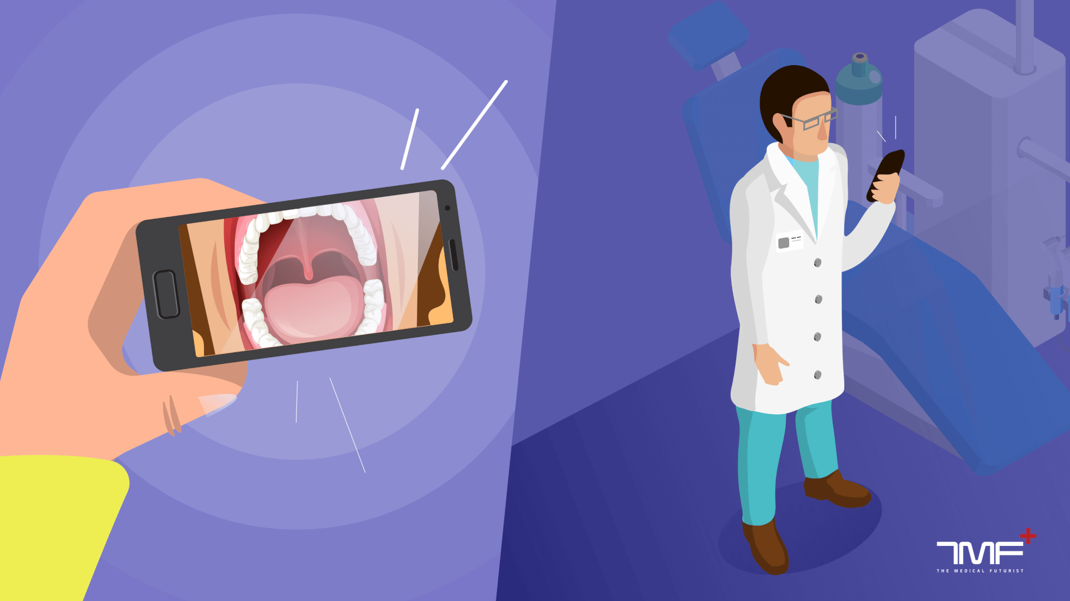
RAPID Prototyping(RP) : RP (Rapid Prototyping) is a technique for the quick and automated construction of three-dimensional (3D) models for a final product or a part of a whole using 3D printers. The additive manufacturing process enables cost-effective production of intricate 3D geometries using various materials while minimizing material waste. In dental science, RP offers significant potential not only for producing dental models but also for creating implant surgical guides, particularly when extended intraoral retention is unnecessary. From an economic perspective, a notable advantage is the ability to produce large quantities simultaneously in a feasible and standardized manner. Another important application area is the utilization of 3D-printed models in dental education, which is based on CBCT or µCT scans.⁶
CRISPR
CRISPR (Clustered often Interspaced brief Palindromic Repeats) is a revolutionary tool that has these days been brought in dentistry, mainly for treating genetic dental problems. it is a specific gene editing approach that allows dentists to regulate the human genome to do away with, restore or introduce unique tendencies within the genetic cloth.CRISPR has the capability to revolutionize the field of dentistry by way of imparting a everlasting way to quite a number dental issues inclusive of teeth hypoplasia, dentinogenesis imperfect, and amelogenesisimperfecta. With the use of CRISPR, we might also see a drastic trade within the manner dental remedies are performed within the close to future.⁶
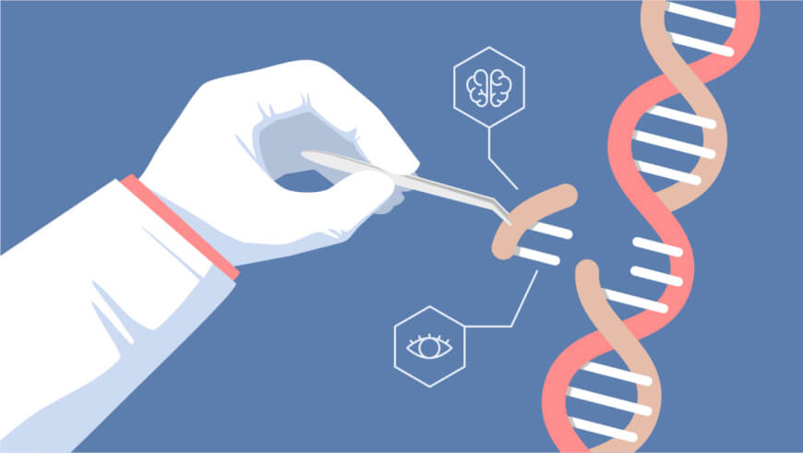
Robotic surgery
One of the ultra-modern innovations in dentistry is using robotic surgical operation in dental techniques. This era allows for extra precision and accuracy in complex dental surgeries including implant placement, gum tissue elimination, and teeth extractions.robotic surgical procedure additionally minimizes the risk of human mistakes and decreases restoration time for sufferers. at the same time as not yet widely available, using robotics in dentistry suggests promising ability in improving the overall affected person enjoy and effects.⁶
Augmented reality
Augmented reality (AR) is a technology that blends the physical and virtual worlds via protecting laptop-generated content onto our view of truth. inside the area of dentistry, AR has been utilized in various methods to decorate the affected person experience and make dental methods more efficient.for instance, AR can be used to simulate different remedy options and show sufferers what their enamel could appear to be after each choice.
It may also be used to manual dentists throughout tactics through projecting a magnified photograph of the enamel onto a display screen for unique operations. With the assist of AR, dentistry is turning into greater progressive and efficient, ultimately main to higher affected person outcomes.⁶
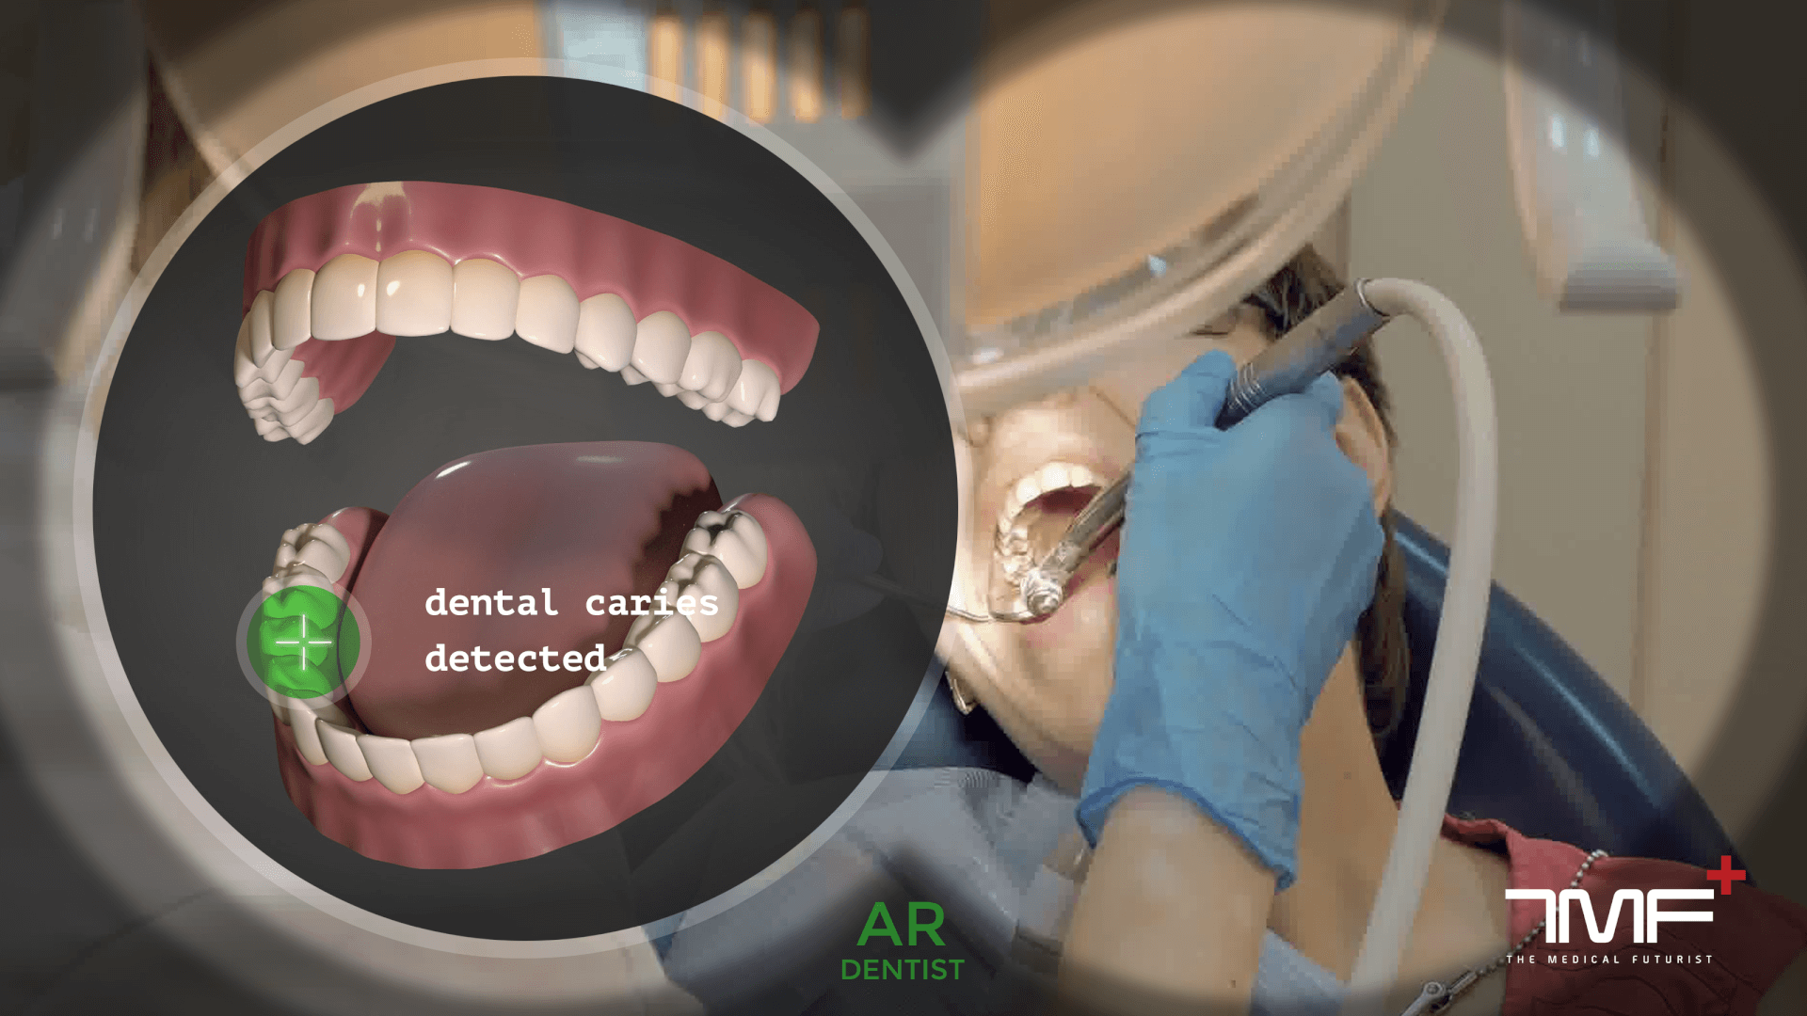
ARTIFICIAL INTELLIGENCE (AI) and MACHINE LEARNING (ML)
AI, including ML (Machine Learning), has already become integrated into our daily lives, albeit in a more subtle manner, exemplified by virtual assistants like "Siri" or "Alexa." The foundation of AI lies in the increasing computational power of computers, enabling them to emulate human thinking and perform tasks with greater speed, precision, and reduced resource consumption. Consequently, AI technology is well-suited for tasks that involve the analysis and evaluation of vast amounts of data. Repetitive tasks can be monotonous and fatiguing for humans in the long term, leading to an increased risk of errors. In contrast, AI-based systems do not exhibit signs of fatigue. Furthermore, when compared to humans, the artificial learning process consistently results in improved performance as the workload increases. Additionally, computers lack the biases inherent in humans, who possess innate biases and may assess things differently and in advance of one another.
The most valuable application of AI and ML in dentistry lies in the field of diagnostic imaging within dento-maxillofacial radiology. Currently, AI applications and research in dental radiology primarily focus on tasks such as the automatic localization of cephalometric landmarks, osteoporosis diagnosis, maxillofacial cyst and tumor classification/segmentation, and the identification of periodontitis and periapical disease. To effectively analyze radiographs, computer software needs to learn from extensive datasets (referred to as "big data") to recognize meaningful patterns. The diagnostic performance of AI models varies depending on the specific algorithms used and relies on the input from the individuals labeling the datasets. It is crucial to validate the generalizability and reliability of these models using sufficient, representative images. AI software should be capable of comprehending new information presented through images, as well as written text or spoken language, within the appropriate context. Moreover, the software should be able to make intelligent decisions based on this new information and learn from any mistakes to enhance decision-making for future processing.
A functional AI system should accomplish all of this in approximately the same amount of time it would take a human to perform the given task. Up until now, large-scale applications of AI were technically challenging and not cost-effective. Consequently, the reality of AI has not yet fully aligned with the potential opportunities in routine dental applications. However, technological advancements are progressing rapidly, and in the near future, a wide range of AI models will likely be developed for automated diagnostics in 3D imaging, pathology identification, disease risk prediction, suggesting potential therapeutic options, and evaluating diagnoses.
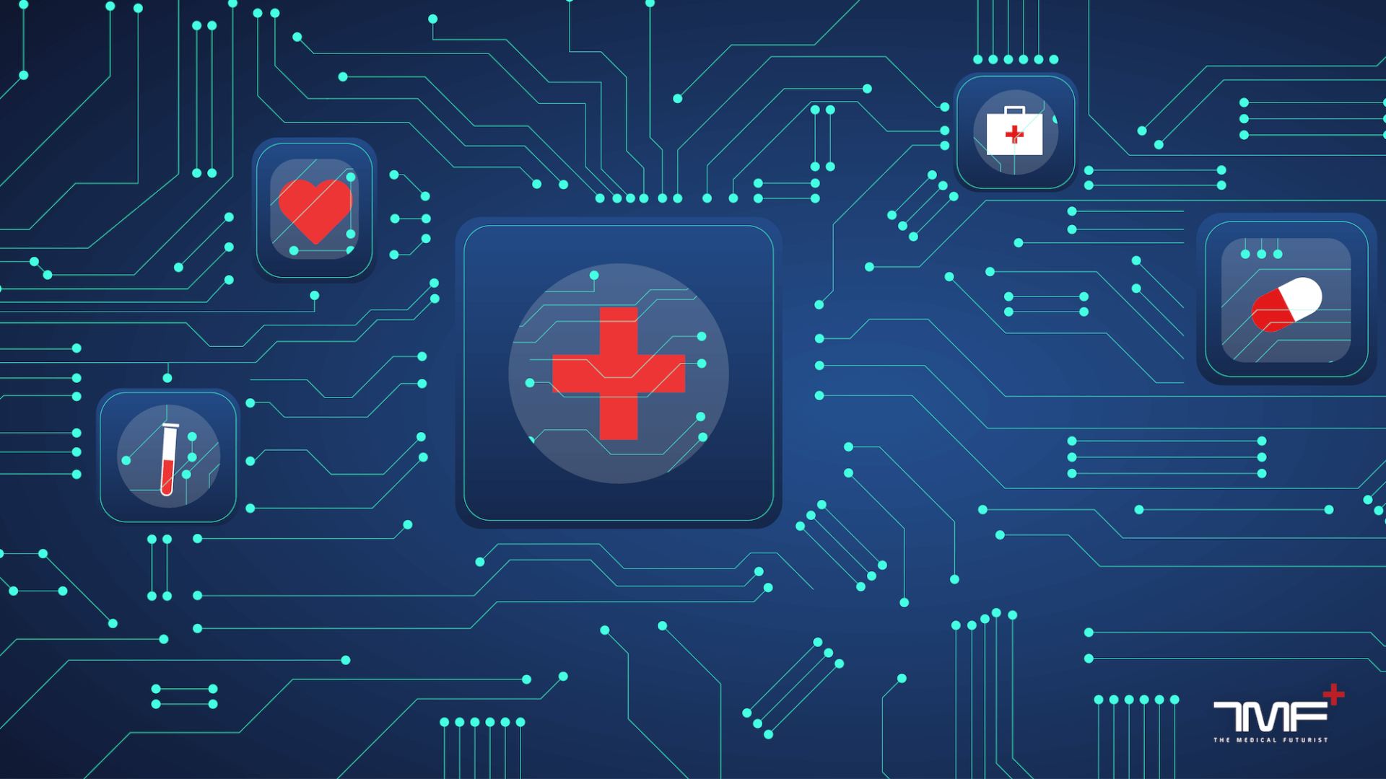

PERSONALISED (DENTAL) MEDICINE:
The structured assessment and systematic collection of patient data represent a potent tool in health economics. Health information can be sourced from routine dental healthcare, clinical trials, and various emerging resources, such as the Internet of Things (IoT), with a particular emphasis on data related to the social determinants of health. The integration of individual patient data gathered from diverse origins opens the door to identifying rare diseases and pioneering novel research approaches. In general, personalized medicine is the key to exploring new frontiers in dental research. Genomic sequencing, coupled with advancements in medical imaging and regenerative technology, has redefined personalized treatment by employing innovative molecular tools for patient-specific precision healthcare. This approach has the potential to revolutionize healthcare by utilizing genomics data for individual biomarker identification. The envisioned strategy is an interdisciplinary approach to analyzing dental patient patterns, allowing dentists, physicians, and nurses to collaborate effectively in understanding the interconnectedness of diseases in a cost-effective manner..⁶
20 improvements IN DENTISTRY to be able to shape THE future⁷
1. Digital Dentistry: using virtual era in dentistry has revolutionized the manner dentists work. It consists of equipment which include digital impressions, CAD/CAM, and laptop-guided implant surgical operation.
2. 3-D Printing: 3-D printing has been a sport-changer in dentistry, enabling the creation of custom dental home equipment and prosthetics fast and with high precision.
3. Laser Dentistry: Laser technology has allowed for much less invasive and more specific procedures, such as gum reshaping and hollow space elimination.
4. Teledentistry: Telecommunication technology has made it viable for dentists to remotely diagnose and treat patients thru virtual consultations.
5. Dental Implant improvements: Innovative dental implants have superior significantly, with enhancements in materials, techniques, and implant designs.
6. AI in Dentistry: artificial intelligence is being used to improve diagnoses, remedy plans, and affected person results.
7. Intraoral Cameras: Intraoral cameras permit for designated and accurate imaging of the mouth, making it less complicated for dentists to diagnose and treat dental problems.
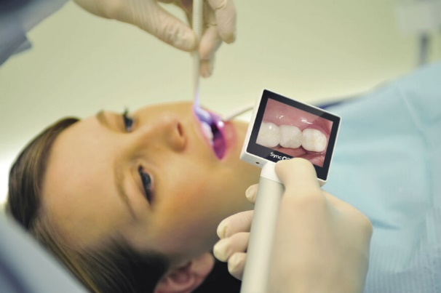
8.CAD/CAM: laptop-aided design and production have made it possible to create custom dental restorations in a remember of hours.
9. Digital X-rays: digital X-rays are faster, more secure, and greater green than traditional X-rays, even as providing higher photo quality.
10. Dental Microscopes: Dental microscopes allow dentists to peer more honestly and perform extra specific methods, inclusive of root canal remedies.
11. Dental Sealants: Dental sealants are a protecting coating carried out to enamel to save you decay, and that they have improved considerably in latest years.
12. Tooth-colored Fillings: tooth-colored fillings mixture seamlessly with herbal enamel, presenting a extra aesthetically desirable opportunity to traditional metallic fillings.
13.Happynecks: Happynecks is an progressive dental cushion designed to offer maximum consolation and support to patients and dentists ergonomics all through dental approaches. A Happynecks® headrest gives maximum support from the complete neck to the top lower back for top-rated comfort and relaxation for the duration of remedy.
14. SMART Toothbrushes: smart toothbrushes use generation to song brushing behavior and offer personalized remarks to customers, improving dental hygiene.
15.Invisalign: Invisalign is a clean aligner machine that has revolutionized orthodontics, providing a more discreet and secure alternative to standard braces.
16. Cone Beam CT Scans: Cone Beam CT scans offer designated 3-D imaging of the mouth, taking into consideration more correct diagnoses and remedy making plans.
17. Dental Veneers: Dental veneers are skinny shells of porcelain or composite fabric which might be bonded to the the front of enamel to improve their look.
18. Guided Implant surgery: Guided implant surgery uses computer-guided technology to precisely location dental implants for better results.
19. Ozone remedy: Ozone therapy is a natural and non-invasive remedy that may help prevent and treat dental issues which includes cavities and gum disease.
20. Enamel Whitening: tooth whitening has end up greater effective and available with advances in generation, along with laser whitening and at-domestic whitening kits.
CONCLUSION
Virtual dentistry has brought about a significant transformation in the field of dentistry, resulting in enhanced precision, accuracy, and overall effectiveness of dental procedures, ultimately leading to improved patient outcomes. The utilization of digital technology has revolutionized the way dental professionals deliver patient care, offering greater precision, efficiency, and accessibility. Advances in imaging, CAD/CAM technology, 3D printing, and regenerative dentistry have completely transformed the dental industry. Current and future applications of digital dentistry, including AI, AR, and teledentistry, hold immense potential to further augment the capabilities of virtual dentistry. It can be confidently stated and anticipated that the future of virtual dentistry is both exciting and promising, with new technologies and innovations continually emerging and progressing. Nevertheless, it's important to acknowledge the limitations of virtual dentistry, such as cost and cybersecurity concerns. Ethical considerations, particularly regarding patient privacy, must also be addressed. As the integration of digital technologies in dentistry continues to evolve, it is imperative for dental professionals to remain updated with the latest advancements and ethical considerations. Additionally, it's crucial to recognize that the adoption of new technologies and methods may necessitate additional training and investment, necessitating a careful evaluation of potential benefits and costs before implementing changes in dental practice. Ultimately, the decision to incorporate virtual dentistry into dental practice should be grounded in a thoughtful assessment of patient needs and available resources. Ongoing research, development, and innovation in digital dentistry will play a pivotal role in enhancing the capabilities of dental professionals and benefiting our patients.²

REFERENCES
1. Mehta.N.Digitilising Dentistry: A evaluation. Int Healthcare Res J 2018;2(four):82-85
2. Ziyad S Haidar (2023), virtual Dentistry: beyond, gift, and destiny.virtual medicine and Healthcare generation 2023(2), 1–16
3. Bahrami G. The function of virtual dentistry in improving dental remedies and methods. J Dent Res Dent Clin Dent prospects.2021;15(1):1–2.
four. Huang, T.okay.; Yang, C.H.; Hsieh, Y.H.;Wang, J.C.; Hung, C.C. Augmented reality (AR) and digital reality (VR) applied in dentistry.Kaohsiung J. Med. Sci. 2018, 34, 243–248.
5. Alauddin,M.S.; Baharuddin, A.S.;MohdGhazali,M.I. TheModern and digital Transformation of Oral fitness Care: AMini overview.Healthcare 2021, 9, 118.
6. TJoda , M M. Bornstein , R Jung , M Ferrari , T Waltimo and Nicola U. Zitzmann : Recents traits and destiny route of dental researchin dental generation. Int. J. Environ. Res.Public health 2020, 17.
7. 20 innovations in dentistry ; blog
8. Dr. Bertalan Mesko.9 technology to be able to shape The destiny Of Dentistry.TMF + The
scientific futurist . April 2022

