Monitoring of PV Based EV Converter System Using Internet of Things
R. Tharwin Kumar^{1,*}, Sharda Patwa², Siddheshwar Kar³, D.Madhivadhani⁴
Department of Electrical and Electronics Engineering, Puducherry Technological University, Puducherry, India, tharwin.eee@gmail.com
Department of Electrical Engineering, Medi-Caps University, M.P, India. sharda.patwa@medicaps.ac.in
Department of Electrical Engineering, Medi-Caps University, M.P, India. siddheshwar.kar@medicaps.ac.in
Faculty of Electronics & Communication Engineering, Kings Engineering College, Chennai-602117, India. vadhaniece@gmail.com
ABSTRACT
One of the most beneficial forms of renewable energy for electrification is solar energy for a number of motives which dominates other sources of energy in this battle for development. As a consequence, a PV system's characteristics and power must be continuously checked. In an electric car, a battery monitoring system is essential. It guarantees the lifespan of the battery, maintains the battery's functionality, and protects it from harm. To enhance battery performance and guarantee secure operation, battery operating systems are implemented. This study examines various digital information processing devices that are Internet of Things (IoT) based and are employed to track battery and solar PV system characteristics. It uses a modified SEPIC converter that can operate in either step-up mode or step-down mode. To find the optimal PI gains, a PI controller based on the dragonfly algorithm (DA) optimization approach is applied. In order to evaluate the effectiveness of the suggested work, MATLAB Simulink is employed.
Keywords- PV, EV, IoT, modified SEPIC Converter, Dragonfly Algorithm.
- INTRODUCTION
The popularity of EV has increased in recent years as a result of rising gasoline prices. Because of this, several automakers are looking for alternatives to gas-powered engines. Utilising electrical sources may benefit the environment since there is less pollutants. Furthermore, EV has tremendous advantages for saving energy and safeguarding the environment. The majority of EVs use rechargeable lithium ion batteries. It is less when compared to lead acid. It truly provides a continuous power supply and has a life cycle that is 6 to 10 times greater than a lead acid battery. There are a number of issues, such as overcharging and severe depletion, that can shorten the lifespan of lithium ion batteries. Yet, EVs frequently have a limited range of travel due to the size of the battery and the layout of the vehicle. One of the main factors currently limiting the usage of EVs is the safety of existing batteries [1]. For example, overcharging a battery has a chance to drastically shorten its shelf life and cause serious hazards like fire. An EV battery tracking system that can notify the user of the battery's state is necessary to prevent the abovementioned problems. When the battery was in poor condition, the older battery monitoring system was able to detect, recognise, and notify the user through a battery display within the automobile. Owing to advancements in warning system design, IoT technology may be used to alert producers and customers about the condition of the battery. One may consider this to be a service maintenance method that the manufacturer might do. IoT goes beyond typical uses to link a multitude of things and everyday goods, placing the entire globe at the user's disposal [2, 3].
Considering the preservation of fossil fuels is approaching its limit, sources of renewable energy have progressively increased as a major source of energy output. Therefore, the greatest way to meet energy needs and produce green energy for society is to use RES. For the purpose of to accomplish equitable growth in the production of electricity, it aids in the degradation of greenhouse gas emission and the ozone layer depletion. The generation of solar energy is advancing more quickly than other RES because it is less expensive, more readily available, requires less upkeep, and is easier to deploy. Therefore, for today's clients, the availability, dependability, and quality of the power supply from RES are crucial variables to address the aforementioned issues. [4,5]. Solar cells are often used in the PV system to absorb sunlight and convert it to electricity. The PV cell is made of silicon or other semiconductor components that use the PV effect to convert solar energy into DC power. The solar cell absorbs solar energy when sunlight interacts with it, which then results in the production of electricity [6]. Since it doesn't provide continuous adequate voltage. In this study, a modified SEPIC converter that provides a three times larger voltage gain is presented. Currently, power electronic circuits made of DC-DC Converters are a crucial component of any modern electric car. These converters get their power from low-voltage systems like fuel cells and solar PV. Though many innovative designs of DC-DC Converters have been developed as a consequence of the demand for high power unidirectional DC-DC Converters for possible electric cars [7]. A few hundred volts of DC are often produced by the batteries of a battery EV. Yet, the voltage needs of the electric parts within the car vary, with the majority using a significantly lower voltage. A type of power converter known as a DC-to-DC converter changes the voltage level of a DC source. Energy is able to be sent in a single direction if it is unidirectional. Additionally, a DC-DC converter plays a key role in the design of a battery-electric vehicle since it converts power from low voltage to high voltage so that electric gadgets can be charged. The SEPIC converter study is operating in both buck and boost modes. A SEPIC converter's operation is dependent on fluctuations in the voltage input and output, which are then used to derive the ideal values for the system's optimum performance. With respect to variables like the current voltage, several methods can be used to determine the PI controller parameters [8-12].
The PSO-based metaheuristic strategy to tracing the global peak in non-uniform weather conditions is provided in [13]. In constant state position, this approach did exhibit some fluctuations around the global MPP. In [14], a hybrid strategy is proposed that combines the traditional P&O method with ANN. This technique uses ANN to control the GMPP voltage restrictions such that the P&O algorithm can then easily follow the MPP. This method has demonstrated that it responds more quickly than the ANN method. By using incremental conductance and fractional open circuit voltage, alternative hybrid approach is proposed. These mixed approaches are more difficult and require both microcontrollers and a sizable amount of memory. As a result, each of these elements raises the price of the PV system as a whole [15]. This study implements the DFO algorithm to raise a PV system's performance. In this article, the application of a PID controller tuning strategy based on the Dragonfly optimizer to produce PI gains that achieve maximum efficiency is the main topic. The evaluation and discussion of the anticipated outcomes from the modified SEPIC converter are included in this paper's conclusion.
- RELATED WORKS
R. Pereira et al [2019][16] have presented a paper that outlines the conceptualization, creation, execution, and verification of an IoT network comprising sensors, signal processing circuits and PV plant management. PHP was used to create a website called Web Monitor that allows users to view charts of real-time data online. The primary goal of the concept is to monitor the temperature of the PV module, delivering information for evaluation of efficiency and identifying flaws in the event that the PV cells overheat. The monitoring of solar radiation, the surrounding temperature, comparative air humidity, and wind speed provides additional information for examining the impact of climatic factors on the operation of the PV module.
Chenxing Xu et al [2019][17] have conducted research on the off-grid power supply system composed up of PV, batteries, and RESOC and proposed it for the remote and unattended IoT monitoring system for oil and gas pipelines. This study explores the power framework and SOFC of each part, the working feature model of SOEC, and the system's operational dependability while also establishing a model of optimization for the functioning of off-grid power supply networks. The integrated energy conversion effectiveness of RESOC's "electric-hydrogen-electric" system is inferior to that of a battery, and its cost proved to be too high. In general, the research presented in this study helps the optimization of off-grid power system performance under various circumstances. Additionally, this will offer guidelines for future research on the system's capacity setup.
Koko Friansa et al [2017][18] They discussed about how a smart grid system's batteries can be monitored for efficiency and operations using an IoT based system. This smart microgrid is made up of an intelligent electronic device (IED) hybrid inverter, a solar power system, a pack of batteries, a grid link, and a source of power. The Human Machine Interface (HMI), data collecting algorithm, cloud system, and IoT created in this study comprise the IoT. In order to track the operation of each battery cell, a battery tracking system with cell tracking functionality is required. Additionally, different IoT communication protocols may be used to boost data transmission rates and enhance the dependability of cloud connections.
Kai huang et al [2020][19] have made a study on new agricultural IoT, or PAIoT, has been suggested with the fusion of both PA and IoT technology after briefly outlining the current uses for PA. It is better to understand how to implement PAIoT through an examination of important factors that affect its viability, such as photovoltaic panel disinfecting and broad water supply usage, installation of nodes and cost the optimization for sensor networks for multi-function and multi-monitoring requirements, transmission optimization of image data appropriation, and photovoltaic module fault identification.
Neeraj Priyadarshi et al [2020][20] have study about MPPT technique for solar PV systems using PSO and the IOT has been suggested. As an interface between PV and a DC load, a modified ZETA converter is employed. For obtaining the most electricity, the converter's duty cycle is constantly modified utilizing the PSO-IOT technique, which makes use of an Arduino and Bluetooth network. The PV system's MPPT controller receives tracking and compilation of PV reference voltage from an IOT-based management system. Under various operational circumstances, the IOT-based control system enables connection and tracking.
- PROPOSED SYSTEM
The PV system's general arrangement is shown in Figure 1. The system is composed of PV modules, a Modified SEPIC converter, a battery, and a grid. When it comes to effectiveness, stability, converging speed, and speed of response, the suggested DFO technique succeeds.
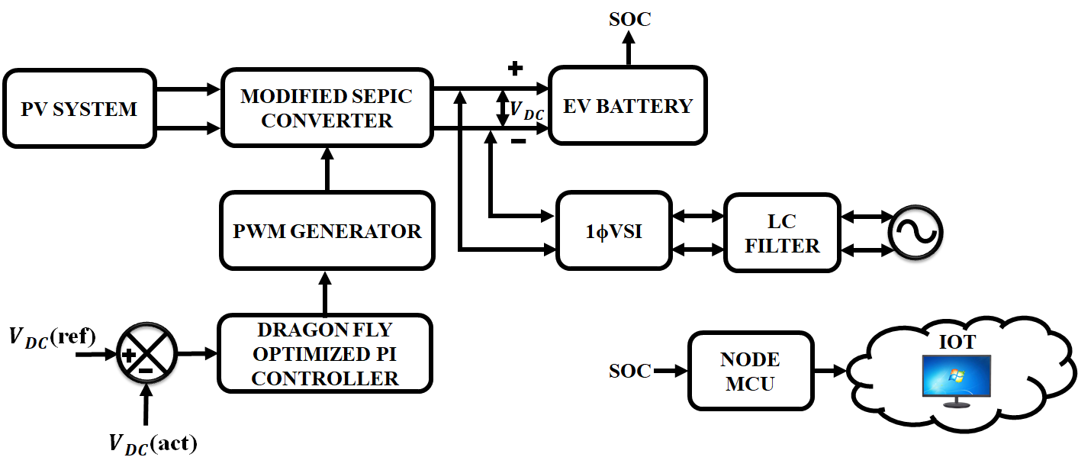
Figure 1: Proposed System Architecture
Figure 1 depicts the whole block structure that is going to be investigated in this research. In this study, a PV module which converts solar energy utilizing a Modified SEPIC converter is used to charge a battery. The output responsiveness is slower and the voltage ripple is undesirable when the PI control is used. Consequently, to give a quicker reaction from the output and maintain the converter's output voltage, the dragonfly optimized control technique is used. This converter keeps the output voltage in a constant state after the battery is completely charged. IoT is used to track the battery's SOC. The DC power generated by the converter must be converted into AC during grid integration using a single phase VSI, and resonance must be eliminated by attaching an LC filter device.
- PHOTOVOLTAIC SYSTEMS
A PV module, power converters, and storage devices are arranged in a PV system. Essentially, it is the power extractor that converts solar energy into electrical energy. Compared to the conventional method, which relies on fossil fuels for the production of electricity, this method is considerably different. While conventional techniques for distributing and transmitting electricity are still used, PV arrays are created by combining PV modules; when set up in series and parallel arrangements, these PV arrays are referred to as PV generators. After that, they are set up such that they are subjected to direct sunshine. With the aid of the inverters, the DC electricity produced by the PV generator is converted into AC. The transmission system can be utilized for delivering this power to the energy grid or for self-consumption. However, rather than being transported, the energy can be stored utilizing the batteries. The two types of PV models off-grid and on-grid PV models are categorized based on numerous types of functional elements. Figure 2 shows an illustration of how the PV system is set up to operate.
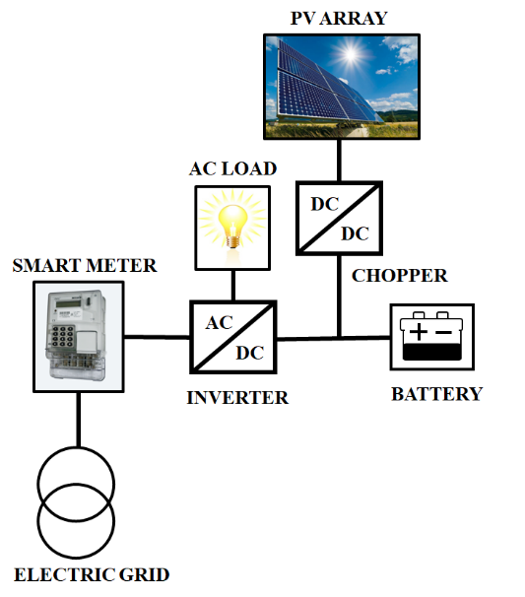
Figure 2: Layout of PV system
The DC-DC converter is provided to manage the stable output voltage under various solar cell operating conditions, and in this case, the modified SEPIC converter is employed to produce more voltage gain from the PV.
- MODIFIED SEPIC CONVERTER
A high performing dc-dc converter that has lower stress from voltage in all semiconductors and inherent high static gain, the improved SEPIC converter is employed in a variety of uses such as a renewable energy source. In this paper, a straightforward soft-switching structure appropriate for the various modified SEPIC converter designs is described. This structure lowers switching losses and diode reverse recovery current.
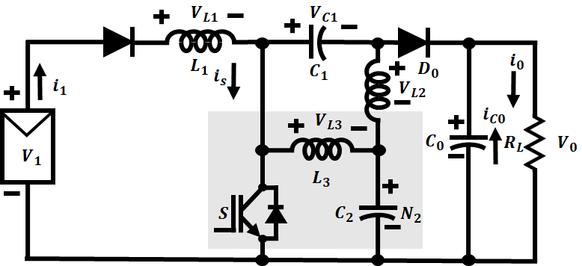
Figure 3: Modified SEPIC Converter

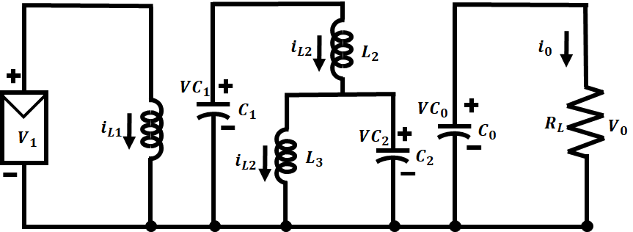
Figure 4: ON state of converter
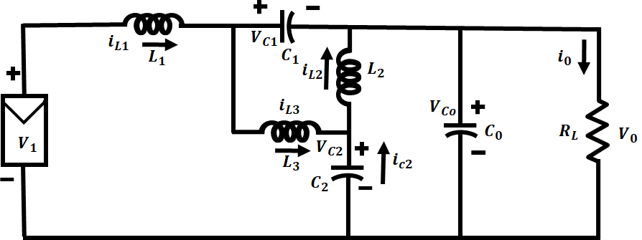
Figure 5: OFF state of converter
Figures 4 and 5 show how the improved SEPIC converter works in action. When the semiconductor switch (S) is turned ON, Figure 4 displays the circuit. Figure 5 depicts the circuit's comparable circuit with S off. When S is turned ON, the capacitor $C_{0}$ releases the stored energy, the inductors $L_{1},L_{2}$and $L_{3}$ retain the energy, and the diode$D_{0}$ is blocked. Energy is transmitted to the load across the capacitors and diode $D_{0}$ at the instant that S is turned OFF.
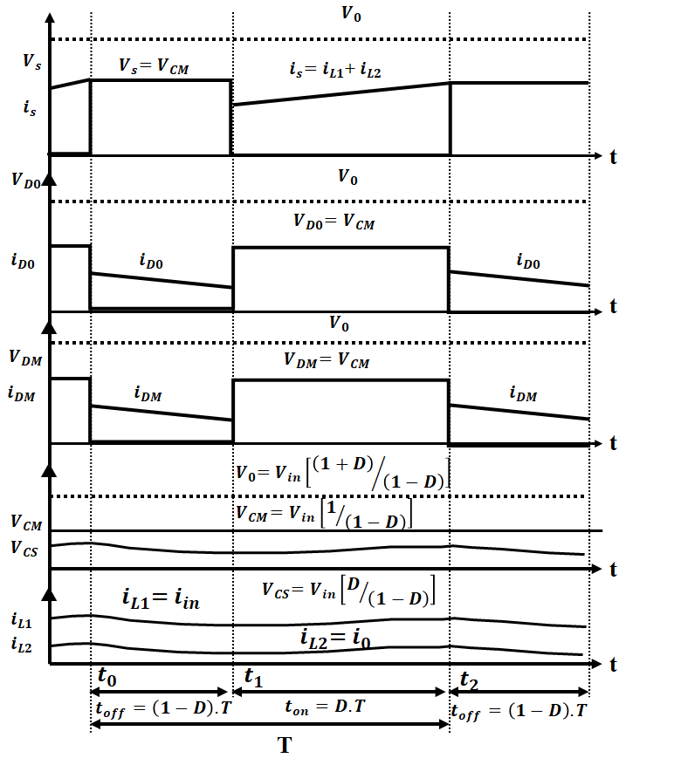
Figure 6: Waveform of the converter

The inductance and voltage calculations can be applied to the circuit for a single period in steady state if the switch S is switched on.
$V_{L1}=V_{1 ,}V_{L2}=V_{C1}+V_{C2}, V_{L3}=V_{C2}$ (1)
The inductance and voltage calculations are also valid throughout a single period in steady state if the switch S is switched OFF.
$V_{L1}=V_{0}+V_{C1}-V_{1}$ (2)
$V_{L2}=V_{0}+V_{C1}-V_{C2}$ (3)
$V_{L3}=V_{0}-V_{C2}$ (4)
At a constant level, the standard voltage between an inductor is zero. As a result, the converter's voltage turn ratio is able to calculated by using the formula below.
$δV_{L(ON)}=(1-δ)V_{L(OFF)}$ (5)
Equation 5 can be used to $L_{1}$ and yields the equation shown below. The term is the duty ratio of the switch.
$δV_{1}=(1-δ)(V_{O}+V_{C1}-V_{in})$ (6)
This is reduced to,
$V_{1}=(1-δ)V_{O}+(1-δ)V_{C1}$ (7)
Similar rules apply for $L_{2}$ by (7).
$δ\left(V_{C1}+V_{C2}\right)=\left(1-δ\right){(V}_{O}-V_{C2})$ (8)
This is reduced to,
$V_{C2}=\left(1-δ\right)V_{O}- δV_{C1}$ (9)
Similar rules apply for $L_{3}$ by (9).
${δV}_{C2}=\left(1-δ\right){(V}_{O}+V_{C1}-V_{C2})$ (10)
This is reduced to,
$V_{C2}=\left(1-δ\right)V_{O}+\left(1-δ\right)V_{C1}$ (11)
$V_{C1}$=0 is apparent from (9) and (11). The subsequent duty ratio formula can be easily determined if $V_{C1}$=0 is used (9).
$V_{1}=\left(1-δ\right)V_{O}$ (12)
$V_{O}=1/{\left(1-δ\right)V_{i}}$ (13)
The use of dragonfly optimized algorithm with PI controllers results in proper voltage regulation achieved in converters.
- DRAGON FLY OPTIMIZATION ALGORITHM
A method for smart search optimization is called dragonfly optimization (DFO). The dynamic and static behavior of dragonflies (DFs), which offer qualities of discovery and utilization that are important components for optimization, served as the inspiration for this method. The discovery stage is characterized by the swarm's dynamic behavior, while the extraction stage can be illustrated by the swarm's static behavior. Thus, these phases aid in creating the framework for DFO approach. The position, division, cohesiveness, enemy, and food are five key DF characteristics that can be used to predict how DFs are going to move as a group. The equation for mathematics that follows illustrates these characteristics (14-19).
With 'i' and 'n' neighbors, a cluster's total DFs is displayed. Equation (14), with the aid of the DFs in a cluster, demonstrates the separation $S_{pi}$ . Where x is DF's current position and$x_{k}$ is DF's position relative to its kth neighbor.
$S_{pi}=\sum_{k=1}^{n}{(x-x_{k})}$ (14)
The alignment term, which is denoted by (15), is employed to match the velocities of moving DFs. The velocity of the kth nearby DF is represented here by $V_{k}$.
$A_{gi}=-\frac{\sum_{k=1}^{n}{(V_{k})}}{n}$ (15)
Every DF has a tendency to move in the direction of the mass center of nearby DFs. The cohesiveness of DF is determined by equation (16),
${Ch}_{i}=-\frac{\sum_{k=1}^{n}{\left(x_{k}\right)}}{n}-x_{i}$ (16)
Equation (17) illustrates how food draws DFs to a location.
${At}_{i}=x_{food}-x$ (17)
The DFs have a propensity to retreat from the opposition. Then Equation (18) presents the enemy location $x_{e}$
${En}_{i}=x_{e}+x$ (18)
The sum of the five parameters yields the updated location of the individual DF. This is demonstrated by step $∆x_{i}$ and is indicated in Equation (19). Then the step size is determined.
$∆x_{i}=w∆x_{i}+(a.{Sp}_{i}+b.{Ag}_{i}+c.{Ch}_{i}+d.{At}_{i}+e.{En}_{i})$ (19)
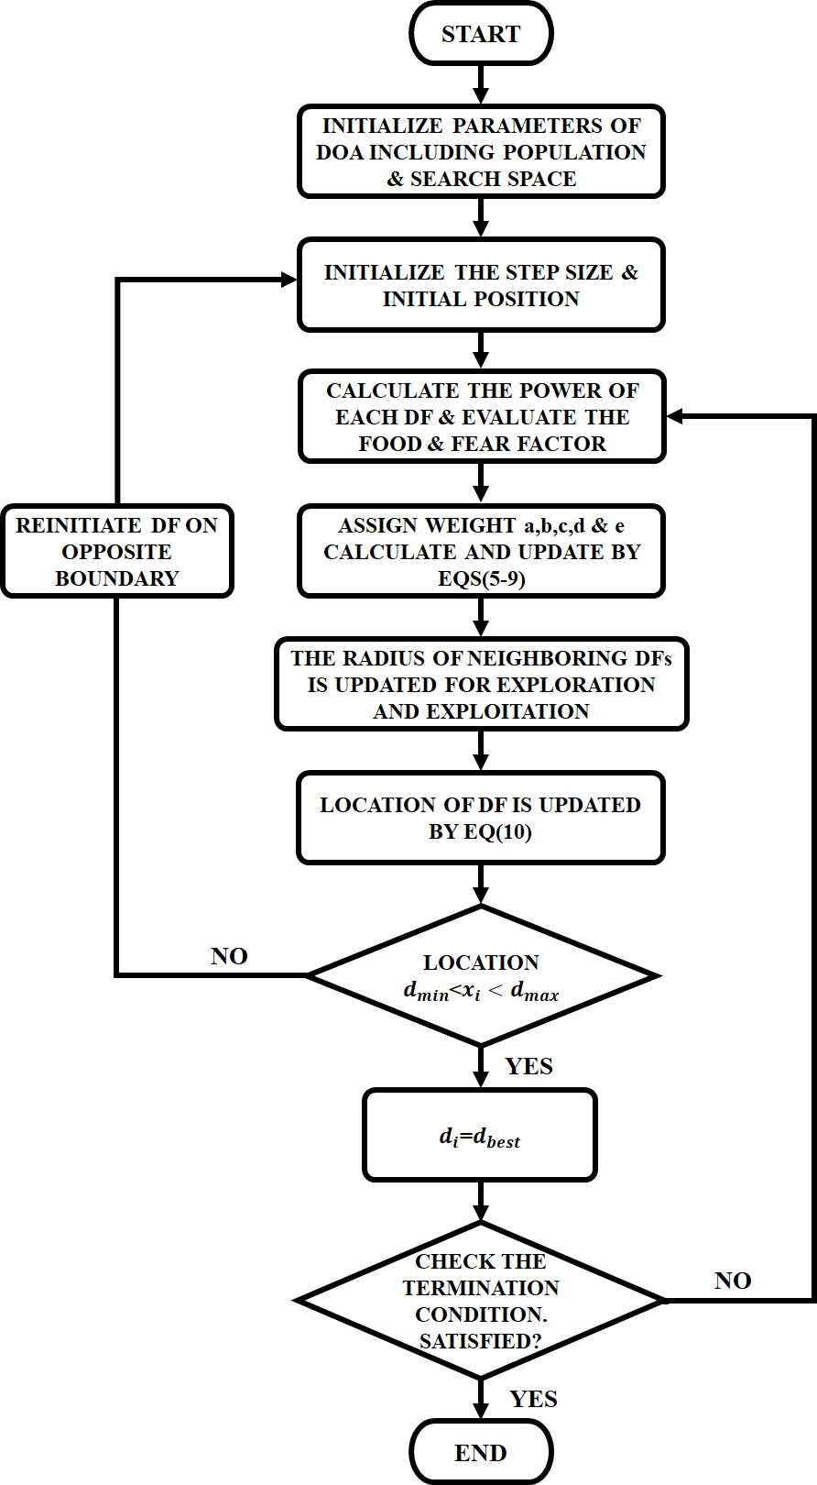
Figure 6: DFO algorithm Flow diagram
where w indicates the inertial weight. The corresponding weights for division, position, and cohesiveness are denoted by a, b, and c. Yet, the letters d and e are used to denote the components of food and enemies, correspondingly. This method can be used to track the MPP of a PV system in non-uniform weather conditions. The DOA flowchart is shown in Figure 6.
The following are the algorithmic stages for applying the DFO approach.
- The particles are started in the range of a min and a max in the search space. Step size is then started.
- Each DF's power is determined by the matching duty cycle in order to modify the position of the opponent and food.
- a,b,c,d, and e's values are provided. For the phases of exploration and exploitation, the adjacent radius is then modified.
- Then the position of DF is modified. If it lies outside of the search area, an algorithm is launched from a different point of entry.
- The algorithm will terminate if the terminating requirements are satisfied. Restart the search if necessary if not.
The management system can adapt to fluctuations and uncertainties effectively by using the optimization strategy, which improves performance and results in reliable regulation of the DC link voltage in usage. The suggested DOA technique has the advantage of precise estimation and precise loss calculation. Consequently, as exploitation potential rises, the rate of convergence gets better.
- BATTERY MONITORING USING IOT
An IoT-based battery tracking system is created in this project using Nodemcu, allowing you to monitor your battery's voltage, proportion, and rate of charging or discharging. The battery is, as we all know, the most important component of any gadget since it powers the whole system. Because incorrect or excessive charging or discharging could damage the battery or create a system failure, it is imperative to monitor the battery's voltage level. Most electrical devices include battery management systems (BMS), which are separate systems. The BMS monitors every aspect of the battery, such its voltage, current, temperature, and auto-off mechanism. This guarantees the handling of lithium-ion or lithium polymer batteries in an appropriate and secure way. Previous BMS only kept track of the battery's health and alerted the user via a battery display. But because to the Internet of Things, we can now instantly alert people from a distance. On their smartphone or computer dashboards, they are able to monitor the battery level from any location around the world. This IoT-based battery tracking system uses a chip called a Nodemcu to provide information about the battery's condition to the internet. The cloud shows the battery voltage in addition to the battery percentage in both charging and draining conditions.
- RESULTS AND DISCUSSIONS
MATLAB/Simulink is used to assess the potency and competence of the suggested converter and DFO-based method. Using the outcomes of the simulation, an analysis of the DOA's effectiveness and time to convergence is set up. MATLAB is used to implement controller algorithms, modified SEPIC converter modeling, and PV cell modeling. The setting specifications for the SEPIC-Cuk converter and the PV system are shown in Table 1.
Table 1: Parameter Specifications
Parameters | Rating
PV system
Peak power | 10 KW
Capacity | 5𝑊
Number of panels | 20
Modified SEPIC converter
$$L_{1},L_{2}$$ | 1 𝑚𝐻
$C_{1}$,$C_{2}$ | 4.7 𝜇𝐹
$$C_{0}$$ | 22,000 𝜇𝐹

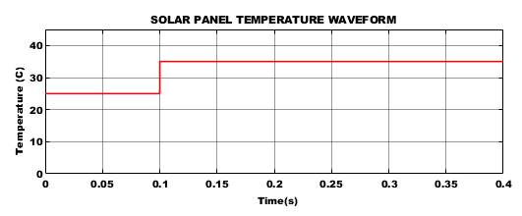
(a)
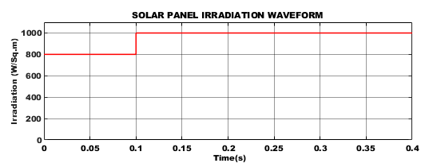
(b)

Figure 7: Solar Parameter Waveforms (a) Temperature and (b) Irradiation
The properties of the solar PV system as a function of temperature and radiation are depicted in Figure 7. After the surface temperature of the sun rises, it is observed that the temperature climbs from its initial starting point of 25°C to an average temperature of 35°C. Similar to this, the panel maintains its initial irradiation level of 800W/sq m, but after 0.1s because of a spike in temperature, it reaches an irradiation level of 1000W/sq m, providing sufficient power to the converter input.

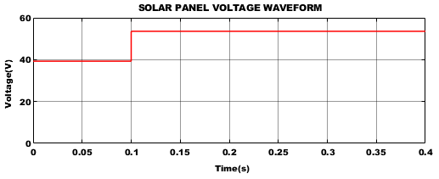
(a)

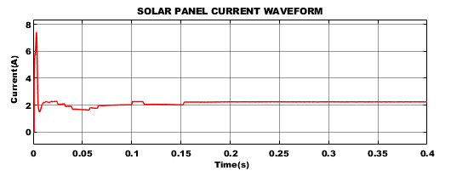
(b)

Figure 8: Solar Parameter Waveforms (a) Voltage and (b) Current
Figure 8 depicts the waveform of the electrical voltage and current from the solar panel to the modified SEPIC converter. After reaching and holding a starting input voltage of 40V for 0.1 seconds, a rise in the PV variable causes the voltage to rise to 55V and stay there for the rest of the time. In accordance with this, a constant current level of 2.2A is obtained within 0.01 seconds of the PV current's first phase's peak increase.

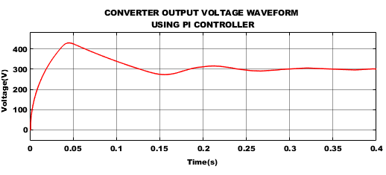
(a)

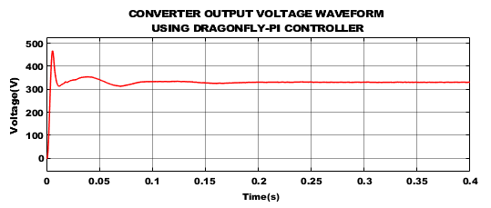
(b)

Figure 9: Output Voltage of Proposed Converter by adopting (a) PI, (b) DOA-PI.
Figure 9 demonstrates that the DC link supply was controlled utilizing DOA-PI and PI controllers to achieve the modified SEPIC converter output voltage. Figure 9(a) makes it evident that tuning is necessary because employing a PI controller does not result in a constant voltage. The DOA-tuned PI controller generates reliable output in Figure 9(b). In order to get stable DC voltage as soon as feasible, a DOA-PI controller is advised. This controller produces stabilized DC voltage of 320V, which is given in Table 2.
Table 2: Controller Performance Analysis
Performance Measures | PI | DOA-PI
Peak Time ($T_{p}$) in sec | 0.038 | 0.02
Rise Time ($T_{r}$) in sec | 0.017 | 0.01
Settling Time ($T_{s}$) in sec | 0.4 | 0.2

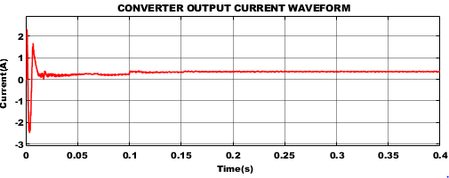

Figure 10: Output Current Waveform of Proposed Converter

The proper output current from the improved SEPIC converter is shown in Figure 10. Early on, the current appears to vary, but after 0.1s, it stabilizes and stays at a steady value of 0.3A.

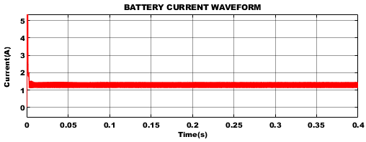
(a)
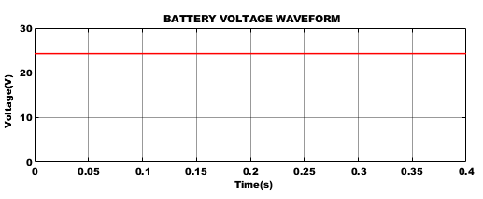
(b)

Figure 11: Battery (a) Current (b) Voltage
The battery cell was operating at 1.2A continuous current and 24V battery voltage. When the battery's SOC reaches 80%, it is tracked by Nodemcu via the Blynk app, as seen in figure 12.

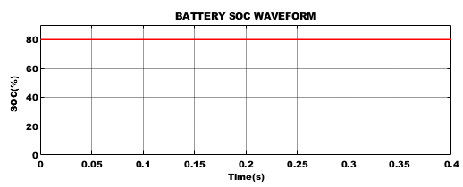
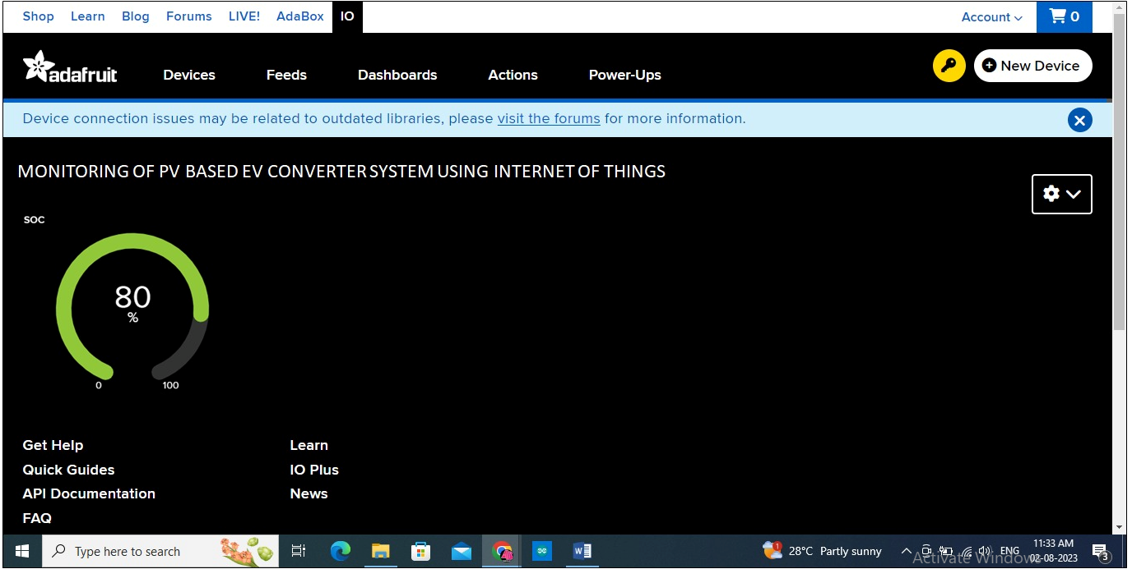

Figure 12: Battery SOC estimation using MATLAB and IoT

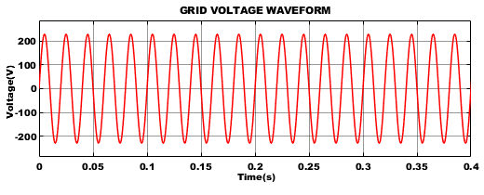
(a)
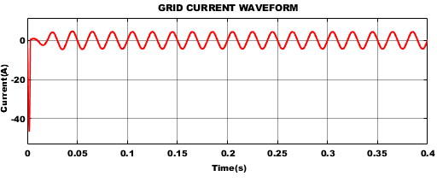(b)

Figure 13: 1Φ Grid (a) Voltage and (b) Current
The voltage and current waveform of a single-phase grid, which depicts different kinds of electrical energy, are shown in Figures 13(a) and (b). Due to their regulated voltage and current, these waveforms offer a consistent and steady flow of electricity with successful power transfer, efficient operation of electrical devices, and maintenance of a steady system.

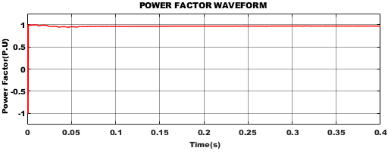
Figure 14: Power factor waveform

The waveforms illustrating power factor are shown in Figure 14. It is noted that the genuine power eventually maintains at roughly 0.9 P-U after initially suffering a few minor changes.
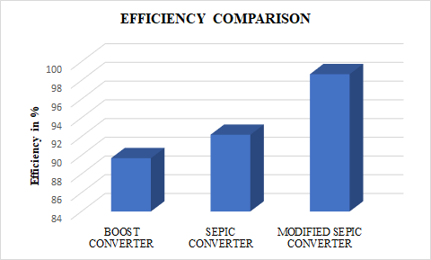
Figure 15: Converter efficiency comparison
Figure 15 illustrates an efficiency comparison between the proposed modified SEPIC converter design and standard converters. Research showed that the proposed converter had an efficiency of 98.67%.
- CONCLUSION
This study uses IoT to estimate SOC on an EV charging battery and the Blynk app to display the results. A modified SEPIC Converter that achieves the best efficiency of 98.67% is upgraded to increase the voltage generated by PV. Additionally, this study created the simulation environment using Matlab/Simulink software. The outcomes of the simulation show that the DFO algorithm is more efficient and has a higher rate of convergence. The DFO method may trace the global peak in a very short amount of time, with few fluctuations around a constant level, and regardless of changes in shading patterns. As a result, the DFO algorithm performs more effectively for a standalone PV system and has a settling time of less than 0.2 seconds.
REFERENCES
- Q. Yan, B. Zhang and M. Kezunovic, "Optimized Operational Cost Reduction for an EV Charging Station Integrated With Battery Energy Storage and PV Generation," in IEEE Transactions on Smart Grid, Vol. 10, no. 2, pp. 2096-2106, March 2019.
- S. Ali, T. Glass, B. Parr, J. Potgieter and F. Alam, "Low Cost Sensor With IoT LoRaWAN Connectivity and Machine Learning-Based Calibration for Air Pollution Monitoring," in IEEE Transactions on Instrumentation and Measurement, Vol. 70, pp. 1-11, no. 5500511,2021.
- Waluyo, A. Widura, F. Hadiatna and R. Maulana, "Implementation and Evaluation of a 3.3 kWp IoT-Based Photovoltaic Microgrid-Interactive Configuration," in IEEE Access, Vol. 9, pp. 106947-106963, 2021.
- S. Ganesan, U. Subramaniam, A. A. Ghodke, R. M. Elavarasan, K. Raju and M. S. Bhaskar, "Investigation on Sizing of Voltage Source for a Battery Energy Storage System in Microgrid With Renewable Energy Sources," in IEEE Access, Vol. 8, pp. 188861-188874, 2020.
- M. U. Jan, A. Xin, H. U. Rehman, M. A. Abdelbaky, S. Iqbal and M. Aurangzeb, "Frequency Regulation of an Isolated Microgrid With Electric Vehicles and Energy Storage System Integration Using Adaptive and Model Predictive Controllers," in IEEE Access, Vol. 9, pp. 14958-14970, 2021.
- B. Singh, A. Verma, A. Chandra and K. Al-Haddad, "Implementation of Solar PV-Battery and Diesel Generator Based Electric Vehicle Charging Station," in IEEE Transactions on Industry Applications, Vol. 56, no. 4, pp. 4007-4016, July-Aug. 2020.
- Y. Shen, H. Wang, Z. Shen, Y. Yang and F. Blaabjerg, "A 1-MHz Series Resonant DC–DC Converter With a Dual-Mode Rectifier for PV Microinverters," in IEEE Transactions on Power Electronics, Vol. 34, no. 7, pp. 6544-6564, July 2019.
- Karthikeyan, S. Kumaravel and G. Gurukumar, "High Step-Up Gain DC–DC Converter With Switched Capacitor and Regenerative Boost Configuration for Solar PV Applications," in IEEE Transactions on Circuits and Systems II: Express Briefs, Vol. 66, no. 12, pp. 2022-2026, Dec. 2019.
- V. Karthikeyan, S. Kumaravel and G. Gurukumar, "High Step-Up Gain DC–DC Converter With Switched Capacitor and Regenerative Boost Configuration for Solar PV Applications," in IEEE Transactions on Circuits and Systems ,vol. 66, no. 12, pp. 2022-2026, Dec. 2019.
- K. S. Tey, S. Mekhilef, M. Seyedmahmoudian, B. Horan, A. T. Oo and A. Stojcevski, "Improved Differential Evolution-Based MPPT Algorithm Using SEPIC for PV Systems Under Partial Shading Conditions and Load Variation," in IEEE Transactions on Industrial Informatics, Vol. 14, no. 10, pp. 4322-4333, Oct. 2018.
- Kumar, Vipin, Sandip Ghosh, NK Swami Naidu, Shyam Kamal, R. K. Saket, and S. K. Nagar. "A current sensor based adaptive step‐size MPPT with SEPIC converter for photovoltaic systems." IET Renewable Power Generation, Vol. 15, no. 5 ,pp: 1085-1099, 2021.
- Killi, Muralidhar, and Susovon Samanta. "An adaptive voltage-sensor-based MPPT for photovoltaic systems with SEPIC converter including steady-state and drift analysis." IEEE Transactions on Industrial Electronics, Vol. 62, no. 12, pp: 7609-7619, 2015.
- S. Obukhov, A. Ibrahim, A. A. Zaki Diab, A. S. Al-Sumaiti and R. Aboelsaud, "Optimal Performance of Dynamic Particle Swarm Optimization Based Maximum Power Trackers for Stand-Alone PV System Under Partial Shading Conditions," in IEEE Access, Vol. 8, pp. 20770-20785, 2020.
- Mitsuya, Max Tatsuhiko, and Anderson Alvarenga de Moura Meneses. "Efficiency of hybrid MPPT techniques based on ANN and PSO for photovoltaic systems under partially shading conditions." Am. J. Eng. Appl. Sci, Vol.12, no. 4, pp: 460-471, 2019.
- Sarika, P. E., Josephkutty Jacob, Sheik Mohammed, and Shiny Paul. "A novel hybrid maximum power point tracking technique with zero oscillation based on P&O algorithm." Int. J. Renew. Energy Res. IJRER 10, no. 4, 2020.
- R. I. S. Pereira, S. C. S. Jucá, P. C. M. Carvalho and C. P. Souza, "IoT Network and Sensor Signal Conditioning for Meteorological Data and Photovoltaic Module Temperature Monitoring," in IEEE Latin America Transactions, vol. 17, no. 06, pp. 937-944, June 2019.
- C. Xu et al., "Operation of off-grid power supply system using IoT monitoring platform for oil and gas pipeline based on RESOC," in CSEE Journal of Power and Energy Systems, vol. 6, no. 1, pp. 12-21, March 2020.
- Friansa, Koko, Irsyad Nashirul Haq, Bening Maria Santi, Deddy Kurniadi, Edi Leksono, and Brian Yuliarto. "Development of battery monitoring system in smart microgrid based on internet of things (IoT)." Procedia engineering, Vol. 170, pp: 482-487, 2017.
- Huang, Kai, Lei Shu, Kailiang Li, Fan Yang, Guangjie Han, Xiaochan Wang, and Simon Pearson. "Photovoltaic agricultural internet of things towards realizing the next generation of smart farming." IEEE Access 8, pp: 76300-76312, 2020.
- Priyadarshi, Neeraj, Sanjeevikumar Padmanaban, Jens Bo Holm‐Nielsen, Mahajan Sagar Bhaskar, and Farooque Azam. "Internet of things augmented a novel PSO‐employed modified zeta converter‐based photovoltaic maximum power tracking system: hardware realisation." IET Power Electronics, Vol.13, no. 13, pp: 2775-2781, 2020.

