RESISTANT STARCH-A PROMISING FUNCTIONAL INGREDIENT

Archana Y. Kalal¹, Udaykumar Nidoni², Sharanagouda Hiregoudar² and Pramod Katti³

¹Ph. D. (Agril. Engg.), Dept. of Processing and Food Engineering, College of Agricultural Engineering, University of Agricultural Sciences, Raichur-584102
²Professor, Dept. of Processing and Food Engineering, College of Agricultural Engineering, University of Agricultural Sciences, Raichur-584102
³Professor and Administrative Officer, University of Agricultural Sciences,
Raichur-584102, Karnataka
Abstract
Polysaccharides in food are composed of starch and plant cell wall components. Carbohydrates are the main source of energy for our body and their energy is used first in the body before proteins and fats. Starch is the main form of carbohydrate present in most foods. Starch consists of two main components, i.e., amylose and amylopectin. Starch is indigestible in its raw form, and its digestibility is significantly improved by cooking. Most of the starch becomes digestible after cooking; however, some parts remain resistant to digestion (Raigond et al., 2015). Based on their digestibility, starch is divided into three groups, namely easily digestible starch, partially resistant starch and resistant starch. The part of starch present in the diet that escapes digestion and absorption in the small intestine and is fermented in the human colon to form short-chain fatty acids (SCFA) is called "resistant starch" (RS). Based on their X-ray diffraction patterns, starch can be divided into four main categories as type A, type B, type C and type V. According to the definition and physical properties of RS that exist can be divided into four subtypes as RS1, RS2, RS3, RS4 and RS5 (Englyst et al., 1992; Nugent, 2005, Sajilata et al., 2006).
RS is the part of consumed starch that is digested incompletely and in an intact form or as products of its partial hydrolysis, escapes through the small intestine and enters the large intestine. It is measured from the difference between the amount of starch exposed to the activity of amylolytic enzymes and the amount of glucose (as starch equivalent) produced as a result of hydrolysis by these enzymes. The food materials are classified on the basis of RS content range from negligible (<1.0%) to very high (>15.0%) which includes various cereals, pulses, fruits, vegetables and its by-products (Goni et al., 1996).
Determination of RS in raw food materials and processed foods is necessary to provide nutritional information to consumers and others. Analytical procedures for the determination of RS need to be compared so that research results on RS can be effectively used for food processing and nutritional applications. A standard protocol was developed to estimate total and resistant starch from foods (Englyst et al., 1992). RS is becoming more important not only for its functional properties, but also for its nutritional value (Raigund et al., 2014). RS can be used in a variety of food products due to its very favourable properties such as swelling, viscosity increase, gel formation and water binding capacity (Fausto et al., 1997).
To meet the growing demand for functional foods, the food industry is researching ways to produce innovative functional foods with additional health benefits. With a range of health benefits, including a positive effect on gastrointestinal function, gut microbiota, blood cholesterol, GI and even diabetes management, and low-calorie content, RS is a high GI food. It can be used for fortification to convert into low GI foods. (Raigond et al., 2015). Several techniques are available to modify the GI and speed of starch digestion. These techniques include modifying key functional components with low or zero sugars, forming starch-lipid complexes, or processing with processing methods such as moisture heat treatment or extrusion. RS is incorporated into foods to improve physical properties of foods such as texture, water retention, processing stability, and nutritional performance. The stability of RS during processing is very important to maintain the nutritional performance of foods containing RS (Thompson, 2000). There are different methods to produce RS, including heat treatment, enzyme, enzyme heating and chemical.
Starch Australia Ltd introduces the first commercial RS, Hi-Maize. Other commercially available RSs include CrystalLean® (RS3), Novose® 240 (RS2), Novelose® 260 (RS2), Novelose® 330 (RS3), Eurylon® (RS2), Amyloomaize VII (RS2) and Neo-amylose (RS3) (Raigond et al., 2014).

Keywords: Resistant starch, Digestibility, Glycemic index (GI), Enzymes, Acidification,
Esterification, Hi-Maize, Novelose
- Introduction
Carbohydrates are the main source of energy and their energy is used by the body before proteins and fats. Starch is the main form of carbohydrate found in most foods. Starch consists of two main components, amylose and amylopectin. These substances exist in different proportions in different plants and foods. Starch quality depends on the ratio and organization of these two molecules in starch grains (Bello-Perez and Paredes-Lopez, 2009). Starch is not digestible in its raw state, but its digestibility increases greatly during cooking. Most of the starch becomes digestible after cooking. However, some parts remain indigestible. Among dietary starch, the part of starch that escapes digestion and absorption in the small intestine and is fermented in the human colon to produce short-chain fatty acids (SCFA) is called "resistant starch" (RS).

Starch
Starch (Greek amylon) is found in granular form in the endosperm of cereals and legumes, tubers (potatoes and sweet potatoes), unripe fruits (bananas and mangoes), and storage organs of many other plants. The most abundant storage polysaccharide available, depending on the plant source, starch exists in various forms such as round, oval, lenticular and angular, with grain size usually between 1 and 100 µm. Starch granules are composed of many monosaccharide or glucose molecules connected by α 1-4 and α 1-6 bonds. Starch consists of two components, amylose and amylopectin. Amylose is a linear chain of glucose with a degree of polymerization of 6000, while amylopectin is branched with a degree of polymerization of up to 2 million.
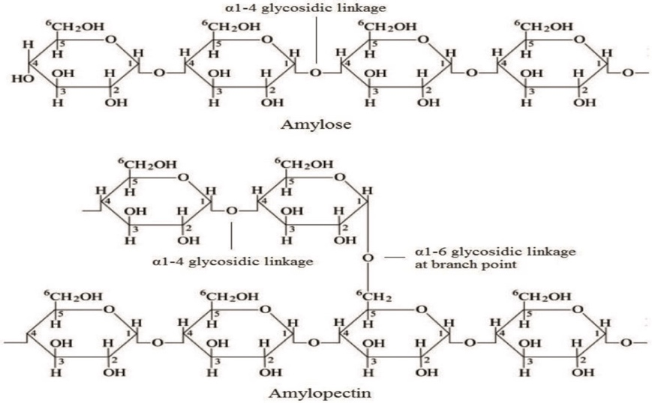
Fig. 1: Structure of amylose and amylopectin in starch

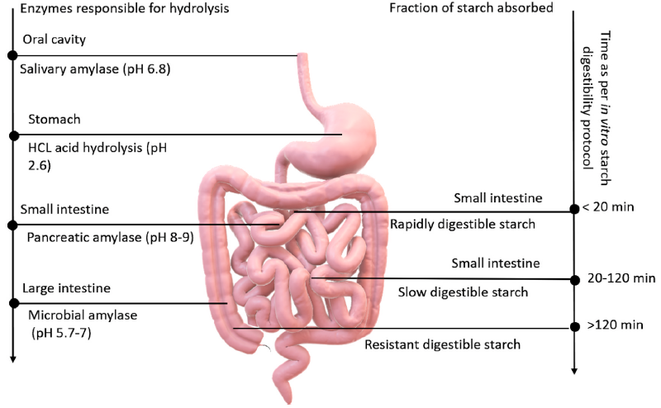
Fig. 2. Schematic representation of starch hydrolysis and absorption of different starch fractions (Kaimal et al., 2021)
Diagrammatic representation of in vitro starch hydrolyzation kinetics simulating the in vivo human digestive system. Starch fractions are divided into three categories: rapidly digestible starch (RDS), slow digestible starch (SDS) and resistant starch (RS). Starch digestion begins in the oral cavity, where salivary amylase breaks down the starch into maltose units and the bolus travels to the stomach, where the enzymes are inactivated (by the acidic environment). Carbohydrates are not broken down in the stomach and the bolus moves to the small intestine. The RDS portion is completely digested in the jejunum of the small intestine, while SDS is further digested up to the ileum. Pancreatic amylase breaks down the RDS and SDS portions in the small intestine. After RS ​​has escaped digestion from the mouth, stomach, and intestine, it travels to the large intestine (colon), where RS granules are dissolved, fermented, or biotransformed into short-chain fatty acids (SCFAs) by the gut microbiome SCFAs.

3. Classification of starch
I) Based on the action of enzymes
Starch undergoes hydrolysis due to the activity of amylolytic enzymes in the digestive system. Starches are classified based on the speed and amount of digestion and their physiological properties. There are three types of starch: rapidly digestible starch (RDS), slowly digestible starch (SDS) and resistant starch (RS) (Englyst et al., 1992).
Table 1: Classification of starch (Englyst et al., 1992)
Starch fraction | RDS | SDS | RS (Type 1-4)
Digestion timeline in vitro/place | Within 20 min, mouth and small intestine | 20-120 min, small intestine | >120 min, not in the small intestine, main action in colon
Examples | Freshly cooked food | Native waxy maize starch, millet, legumes | Raw potato, stale bread
Amount (g/100 g dry matter) | Boiled hot potato: 65 | Boiled millet: 28 | Raw potato starch: 75
Main Physiological property | Rapid source of energy | Slow and sustained source of energy and sustained blood glucose | Effects on gut health (i.e., prebiotic, fermentation to butyrate with hypothesized anticarcinogenic effects)
Structure | Mainly amorphous | Amorphous/crystalline | Depending on the type, mainly crystalline
II) Based on X-ray diffraction
Based on X-ray diffraction patterns, starches can be classified into four main categories. Type A: This type of structure has a chain length of 23-29 glucose units in amylopectin. This variant has a double helix packing and contains 4 water molecules per 12 glucose residues (Lebail et al., 2000). A-starch is mainly found in cereals. Type B: This type of structure has a chain length of 30-44 glucose units in amylopectin. Type B has a loosely packed double helix containing 36 water molecules per 12 glucose residues (Lebail et al., 2000). This is the natural pattern for tuber and banana starch. Type C: The type C structure consists of amylopectin with a chain length of 26-29 glucose molecules. This type is found in peas and beans. Type V: An additional type that is a single-helical structure initiated by amylose complexed with lipids or other agents (Zobel, 1988; Lebail et al., 2000). It is found in swollen granules.

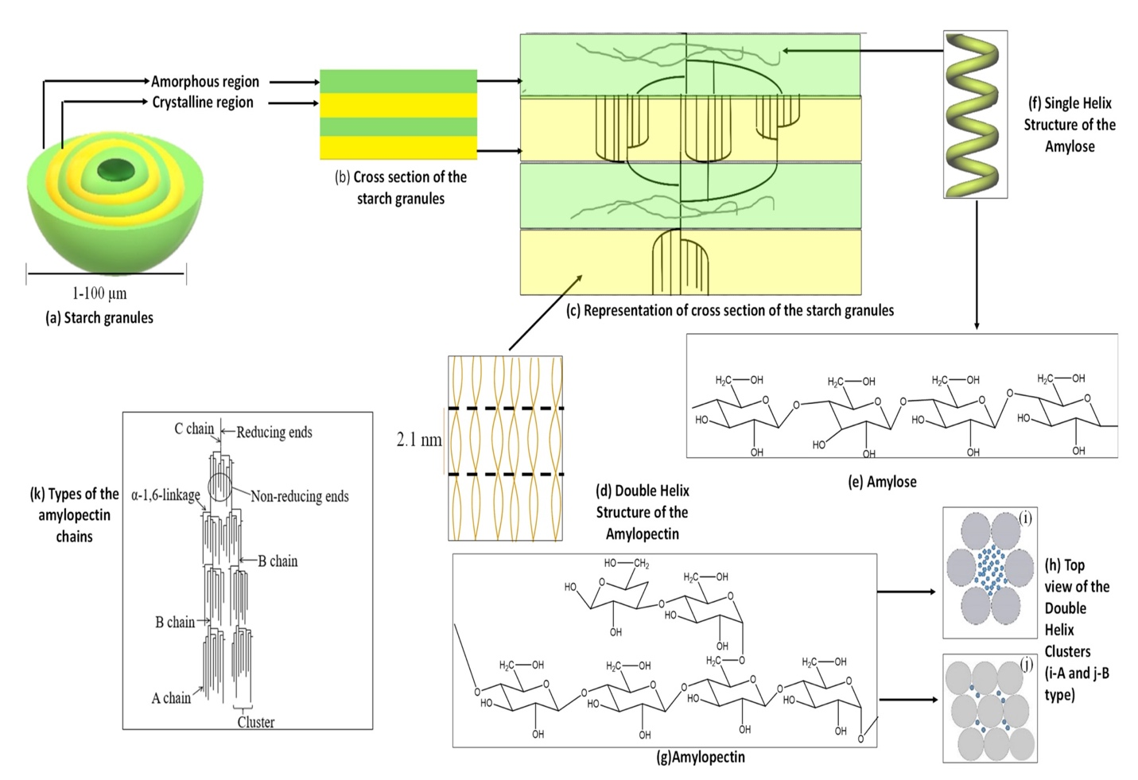
Fig. 3: Schematic representation of the (a) Starch granules; (b) Cross section of the starch granule; (c) Representation of the cross section of the starch granules; (d) Double helix structure of amylopectin; (e) Structure of amylose; (f) Single helix structure of amylose; (g) Structure of amylopectin; (h) Top view of the double helix clusters: (i) A type, (j) B type, and (k) Types of amylopectin chains.

Starch is mainly composed of amylose (80%), amylopectin (20%), lipids, proteins (0.6%) and minor amounts of minerals (<0.4%) (Alcazar-Alay et al., 2015). The amount of amylose and amylopectin depends on the starch source (Bertolini, 2009). Amylose is insoluble in water, while amylopectin is soluble in water (Bertolini, 2009). Starch also contains small amounts of compounds known as "intermediate compounds" that have intermediate properties between amylose and amylopectin (Vilaplana et al., 2012). Amylose has a molecular weight of about
10⁵-10⁷ Da, while amylopectin has a molecular weight of 10⁷-10⁹ Da. In addition, the molecular weight of the intermediate compound is smaller than amylopectin and larger than amylose (Vilaplana et al., 2012). Starch granules consist of alternating layers of amorphous and crystalline lamellae with a thickness of 100 to 400 nm (BeMiller and Whistler, 2009). The density of starch grains is about 1.5 grams per cubic centimetre. The granule diameter is generally between 1 and 100 μm (see Figure 3a) and the shapes can be regular such as spherical, ellipsoidal, angular or even highly irregular (Bertolini, 2009). In addition, the shape, size, structure and composition of starch grains depend on their botanical sources (Alcazar-Alay et al., 2015). However, due to strong hydrogen bonding between starch chains, starch granules are insoluble in cold water and room temperature (BeMiller and Whistler, 2009). As shown in Figure 3b, there are alternating layers of crystalline and amorphous lamellae. As seen in Figure 3c, d, the crystalline lamellae of starch granules are composed of clusters of double-helical amylopectin side chains, while the amorphous lamellae are composed of branching regions of amylopectin and amylose chains (Bertolini, 2009). Amylose is composed of D-glucose units linked by α-1,4-glycosidic linkages and composed of small branches, as shown in Figure 3e (Bertoft, 2017).
Normally, amylose forms single-helical complexes in the presence of complexing agents (see Figure 3f) (BeMiller and Whistler, 2009). Amylopectin is composed of α-D-glucose units linked by α-1,4 and α-1,6-glycosidic bonds (see Figure 3g) (Bertolini, 2009). The linear chains of amylopectin are relatively short compared to amylose chains. Furthermore, amylopectin is highly branched compared to amylose (Bertolini, 2009). Furthermore, as shown in Figure 3d, the degree of polymerization (DP) of these outer strands is about 10-20 because the two strands form a double helix with 6 glucose units per turn per strand and a pitch of 2.1 nm (Bertoft, 2017). These double helices are approximately 4–6 nm in length and crystallize in one of two polymorphs called the A-form or the B-form (Bertoft, 2017). As shown in Figures 3h, i and 3h, j, A type is characterized as a monoclinic unit cell containing 8 water molecules, while type B is a hexagonal unit containing 36 water molecules (Bertolini, 2009). As shown in Figure 3k, the structure of amylopectin consists of three types of chains known as A, B and C (Bertolini, 2009). Chain A is only attached to the α-d-glucose unit at the reducing end, not to another chain. The B chain is connected to the A chain or another A or B chain through one or more hydroxyl groups (-OH) in the amylopectin chain. The reducing end group is generally held by the C-type chain (Bertolini, 2009). The physicochemical properties of starch mainly depend on the ratio of amylose and amylopectin. Glass transition temperature (Tg) is one of the physical properties of polysaccharides and describes the temperature at which they change from an amorphous state to a viscous state (Alcazar-Alay et al., 2015). At Tg, the polymer material changes from a glassy and brittle state to a soft and flexible state. Since starch consists of both amorphous and crystalline regions, the Tg of starch cannot be easily determined (Alcazar-Alay et al., 2015).
- Why Resistant starch?
Most carbohydrate-rich foods cause blood sugar to rise. The glycemic index (GI) ranks foods based on their effect on blood sugar levels, and high GI foods lead to deadly health problems such as diabetes and obesity. Development of low GI carbohydrate based functional foods has become the need of the hour. Due to the inverse relationship between GI and RS, food nutritionists are investigating the use of RS as a fortifier to lower the GI of foods. In the development of functional foods, fortification is a cost-effective way to deliver desired ingredients such as RS to target populations. RS is naturally available from various plant sources and provides opportunities for its use as a functional element (Raigond et al., 2015).
Resistant Starch
The term "resistant starch" was coined by Englyst et al. A small fraction of starches resistant to hydrolysis by α-amylase and pullulanase treatments in vitro have been described (Englyst et al., 1992). RS resists digestion and absorption in the small intestine and is fermented in the large intestine. RS is a linear molecule of α 1,4 D-glucan mainly obtained from retrograde amylose in cooked starchy foods. A large number of factors influence the rate and extent of starch digestion, and all of these factors are interrelated, complicating our understanding of the tolerant nature of starch.
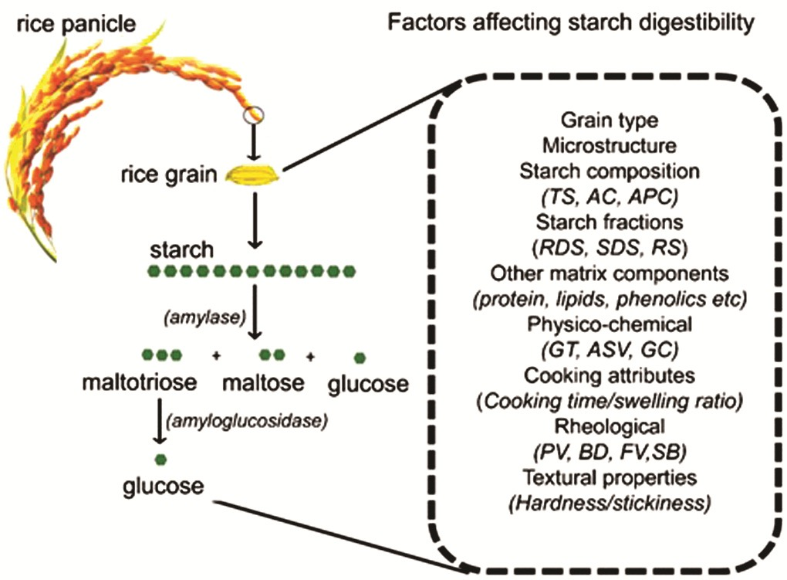
Fig. 4: Mechanism of in vivo starch hydrolysis and various factors affecting it (Rahaman
et al., 2020)
Mechanisms of starch hydrolysis inside the body and various factors affecting it. Rice contains about 78 to 89% of starch and its hydrolysis in the human body is done in two stages. The figure (left) shows the action of glycolytic enzymes such as amylase and amylglucosidase. Step 1 in starch digestion is catalyzed by salivary amylase and pancreatic amylase to produce maltotriose, maltose, and glucose. Step 2 is hydrolysis to glucose by a brush-like disaccharide enzyme or glucosidase. Individual factors that often interact to affect starch digestibility are shown on the right side of the chart.
- Global Resistant Starch market size
The resistant starch market has witnessed a compounded annual growth rate (CAGR) of $8.46 billion in the year 2018 which is expected to increase to $12.73 billion by 2025. The CAGR of 6.1% will be witnessed during the year 2019-2025. The APAC market is anticipated to witness rapid growth over the forecast time period. RS type 3 are largely used in bakery products and will observe a highest inclination of 6.4% CAGR by 2025.
Fig. 5: Global Resistant Starch market size (www.gminsights.com)
Types and structure of RS
RS is part of the consumed starch, incompletely digested, and passes from the small intestine to the large intestine either intact or as a product of its partial hydrolysis. It is measured from the difference between the amount of starch exposed to the activity of amylolytic enzymes and the amount of glucose (as starch equivalent) produced as a result of hydrolysis by enzymes (Sajilata et al., 2006).
- Types of Resistant Starch
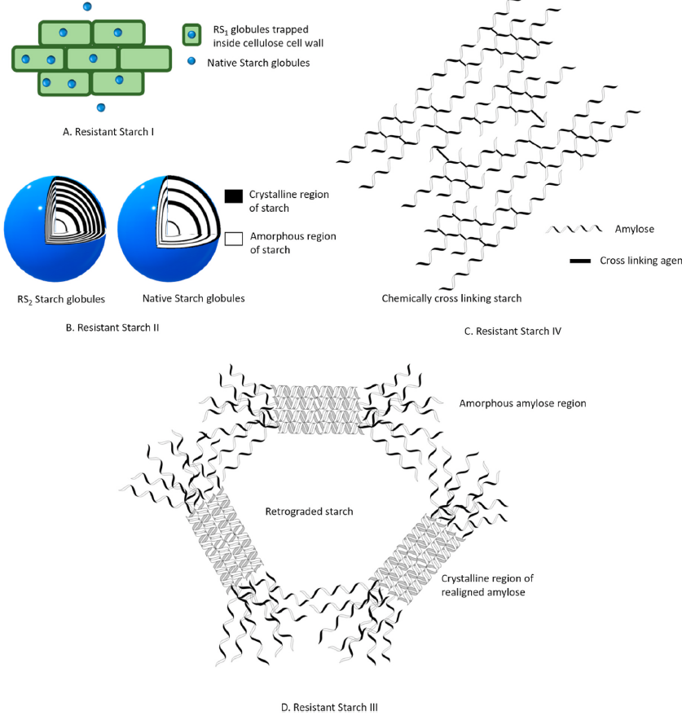
Fig. 5. Schematic representation of different resistant starch fractions (Kaimal et al., 2021)
A large body of literature indicates several factors in the resistance of RS to enzymatic hydrolysis. According to these factors, RS can be classified as RS1, RS2, RS3, RS4 and RS5. RS1 is the part of RS embedded in the food matrix. This submerged structural material limits the enzymatic hydrolysis of starch and makes it resistant (Figure 5). They are usually present in partially milled grains and are resistant to heat in most cooking operations (Sajilata et al., 2006). Therefore, the intensive milling operation may release the physically protected starch and reduce the RS1 content. RS2 starch fraction is natural non-pregelatinized starch granules found in raw foods such as green bananas and raw potatoes. The radially compact crystal structure of these starch segments limits enzymatic hydrolysis and confers resistance (Figure 5) (Sajilata et al., 2006). The RS3 makes up most of the RS segment. RS3 is also known as retrograde starch.
Starch retrogression is a helical amylose recrystallization phenomenon that occurs after cooling after gelatinization. These random helical amyloses ooze during gelatinization and rearrange to form a compact double-helical crystal structure (Figure 5) (Doppert and Staverman, 1966). These dense, impermeable structures prevent the entry of amylolytic enzymes and hinder digestion. (Sajirata et al., 2006). RS4 can be classified as a chemically modified starch. Chemical modifications are usually performed on native starches to give them immediate physical, thermal and functional properties (Dupuis et al., 2014). Chemical modifications such as substitution, crosslinking, and esterification create unusual chemical bonds (Figure 5). It changes the structure and solubility of starch and thus reduces the rate of hydrolysis (Sajilata et al., 2006). RS5 is a complex form of RS that results from amylose-lipid interactions. Interactions between lipid compounds such as long-chain fatty acids, glycerol monostearate (Eliason, 1994) and amylose render starch hydrophobic and resistant to enzymatic hydrolysis and gelatinization (Meenu and Xu, 2019).
Table 2: Classification of types of resistant starch (RS), food sources and factors affecting their resistance to digestion in the colon (Raigond et al., 2014)
RS type | Description | Food sources | Resistance minimized by | Digestion in small intestine
RS1 | Physically protected | Whole-or partially milled grains, seeds, legumes | Milling, Chewing | Slow rate, partial degree, totally digested if properly milled
RS2 | Ungelatinized resistant granules with type B crystallinity, slowly hydrolysed by α-amylase | Raw potatoes, green banana, some legumes, high amylose corn | Food processing and cooking | Very slow rate, little degree, totally digested when freshly cooked
RS3 | Retrograded starch | Cooked and cooled potatoes, bread, cornflakes, | Processing  conditions | Slow rate, partial degree, reversible digestion, digestibility improved by reheating
RS4 | Chemically modified starches due to cross-linking with chemical reagents | Foods in which modified starches have been used (e.g. breads,cakes) | Less susceptible to digestibility in vitro | A result of chemical modification, can resist hydrolysis
RS5 | Amylose-lipid complexes | Foods with high amylose content | Not susceptible to hydrolysis by α-amylase | Can resist digestion
Table 3: Classification of food materials according to the range of resistant starch content (% dry matter) (Goni et al., 1996)
Sl. No. | RS Range | Food materials
1 | Negligible (<1.0%) | Boiled potato (hot), boiled rice (hot), pasta, breakfast cereals containing a high proportion of bran, wheat flour
2 | Low (1.0–2.5%) | Breakfast cereals, biscuits, breads, pasta, boiled potato (cooled), boiled rice (cooled)
3 | Intermediate (2.5–5.0%) | Breakfast cereals (corn flakes, rice flakes), fried potatoes, extruded legumes
4 | High (5.0–15.0%) | Cooked legumes (lentils, chickpeas, beans), peas raw rice, autoclaved and cooled starches (wheat, potato, maize), cooked and frozen starchy foods
5 | Very high (> 15.0%) | Raw potatoes, raw legumes, amylo-maize, unripe banana, retrograded amylose

- Methods of RS determination
Determination of RS in raw food materials and processed foods is necessary to provide nutritional information to consumers and others. Analytical procedures for the determination of RS should be compared so that research results on RS can be effectively used for food processing and nutritional applications. Currently, there are significant differences between the methods related to sample preparation, enzymes used, and creating experimental conditions that mimic starch digestion through the digestive tract.
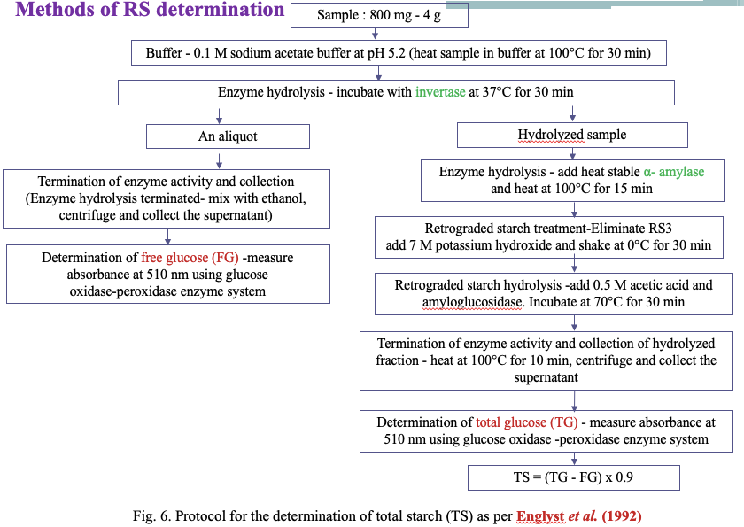
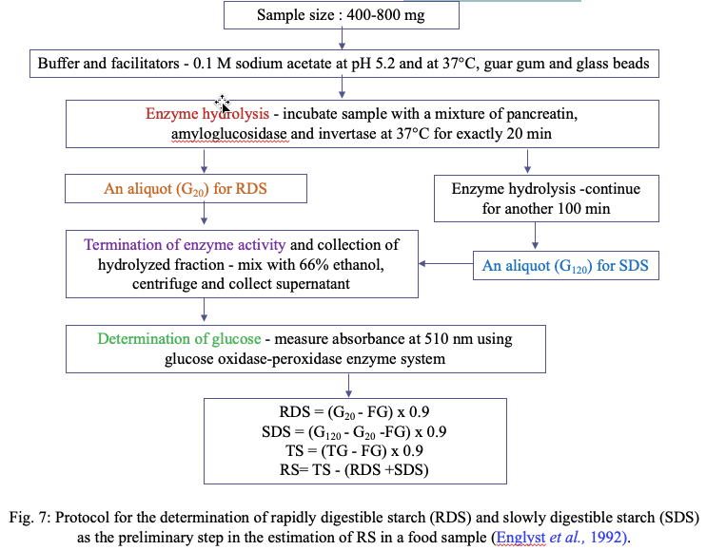
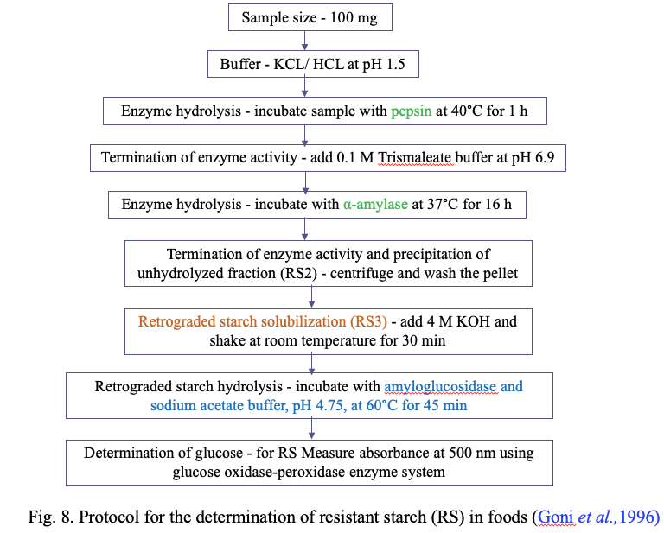
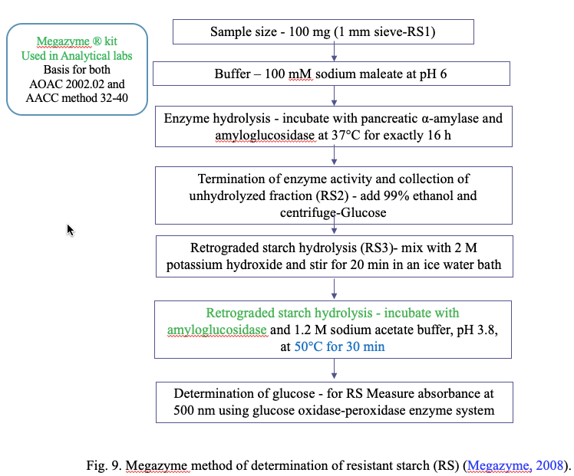
- Properties of RS
RS has gained importance because of its nutritional aspects as well as functional properties (Raigond et al., 2014). RS can be used in a variety of foods due to numerous desirable properties such as swelling, viscosity increase, gel formation, and water-binding capacity (Fausto et al., 1997).
- White in color
- High gelatinization temperature
- Fine particle size (which causes less interference with texture)
- Excellent extrusion and film forming quality
- Reduce the caloric value of food
- Increase coating crispness of products
- Enables the formation of low-volume, high-fibre products with improved texture, appearance, and mouthfeel (including better sensory properties) compared to conventional high-fibre products (Raigond et al., 2015).
- RS Production Technologies
To meet the growing demand for functional foods, the food industry is researching ways to produce innovative functional foods with additional health benefits. As consumers become more health and nutrition conscious, researchers and manufacturers are seeking to produce functional foods that complement health benefits (Aung et al., 2010). Researchers and nutritionists are working together to develop low GI functional foods. With a range of health benefits, including a positive effect on gastrointestinal function, gut microbiota, blood cholesterol, GI and even diabetes management, and low-calorie content, RS is a high GI food. It can be used for fortification to convert into low GI foods. (Raigond et al., 2015). The presence of natural sources of RS makes it a suitable functional element for nutritional fortification purposes (Belo-Perez and Pardez-Lopez, 2009). Consumers are willing to pay more for RS-enriched foods to increase their fibre intake. Several techniques are available to modify the GI and speed of starch digestion. These techniques include modifying key functional components with low or zero sugars, forming starch-lipid complexes, or processing with processing methods such as moisture heat treatment or extrusion. RS is incorporated into foods to improve physical properties of foods such as texture, water retention, processing stability, and nutritional performance. The stability of RS during processing is very important to maintain the nutritional performance of foods containing RS (Thompson, 2000). There are different methods to produce RS, including heat treatment, enzyme, enzyme heating and chemical.
1) Heat Treatment
1.1) Heating Cooling Cycles
Repeated heating and cooling cycles have long been used in RS manufacturing. Another method to produce RS involves gelatinization of starch, subsequent enzymatic cleavage of the gelatinized polymer, inactivation of the cleavage enzyme, and simultaneous drying/extrusion/crystallization of the resulting product. The RS is built using the RS3 heating and cooling cycle. Raigond et al. (2014) investigated the effect of cooking (boiling, microwave cooking, pressure cooking) followed by cold storage (4 and 12 hours) for different periods of time (12 hours and 48 hours) on the content of studied starch. For hot boiled potatoes, after the potatoes were boiled at 4°C for 48 hours and cooled, the RS content increased to 63%.
  - ) Hydrothermal Treatment
Hydrothermal treatment involves physical changes that change the physical and chemical properties of starch without changing the grain structure. Annealing (ANN) and wet heat treatment (HMT) are the main hydrothermal treatments and require control of heating temperature and time. These treatments are based on the ratio of starch to moisture. ANN processing uses a combination of excess water (more than 40%) and temperatures below the gelatinization temperature, while HMT uses a combination of controlled humidity (10-30%) and high temperature (90-120°C) (Zeng et al., 2015). Partial acid hydrolysis may increase the effectiveness of the hydrothermal treatment and produce thermally stable granular RS (Bromovsky and Thompson, 2001). HMT is a natural physical modification technology that is safer than chemical modification of starch. ANN processing requires keeping the temperature below the gelatinization temperature to preserve the initial granular structure of the starch. A combination of gelatinization and melting at moisture levels of 40-60% results in the loss of grain structure. Improved grain stability by hydrothermal treatment leads to higher RS ​​content (Thompson, 2000). ANN treatment is known to increase starch crystallinity, strengthen the crystalline morphology of granules, and order starch chains not only in the amorphous layer but also in the crystalline layer. All of this increase granule stability and decrease solubility and swelling capacity, thereby increasing the resistance of starch granules to amylolytic enzymes (Hoover and Vasanthan, 1994). Lee et al. (2012) obtained the highest RS yield, i.e., 66.8% with potato waxy starch (0% amylose), i.e., 20% moisture, 110°C temperature and 5 h treatment combination.
  - ) Extrusion
Extrusion technology is widely used in food processing industries to produce food in various shapes. It is a short time high temperature process (HTST) and can increase the RS content of foods to some extent. During extrusion, high shear forces cause polymerization and subsequent thermal splitting of starch molecules. The result is a linear chain that is more likely to return to RS3 (Agustiniano-Osornio et al., 2005). The RS content of conventional corn starch increased from 11% to 20% after acid hydrolysis followed by low- or high-shear extrusion (Hasjim and Jane, 2009). Extrusion conditions such as barrel temperature, screw speed and shear force have a greater effect on RS yield compared to starch moisture content (Dupuis et al., 2014). Corn starch extrusion at 12-18% moisture did not show a significant increase in RS content, while 20% moisture level led to a significant increase in RS content. Starch origin affects RS performance during extrusion. Due to its high gelatinization temperature and high amylose content, banana starch is the most efficient starch for the production of RS by extrusion compared to other starches (Bello-Perez and Paredes-Lopez, 2009).
  - ) Heat and Enzyme Treatment
RS production can be increased by using a combination of heat and enzymes or chemical and enzymatic modifications. Enzymes or chemicals can be used to remove the amorphous regions of retrograde starch. An example of simultaneous heat and enzyme treatment is the pullulanase treatment of gelatinized starch and product separation by drying/extrusion. Production of RS is also achieved by controlled heat treatment of starch followed by enzyme-assisted debranching, annealing and drying (Haralampo and Gross, 1998). Treatment of gelatinized starch with debranching enzymes such as isoamylase and pullulanase produces isolated amylopectin starch. Isolated amylopectin starch is used in the formulation of low-fat foods and can be made from any starch containing amylopectin, such as regular corn starch or waxy corn starch. In high-amylose corn starch, enzymatic cleavage followed by extrusion or drying increases the RS content, while the addition of mineral salts or isolated starch prior to isolation further increases the RS content (Sajilata et al., 2006). Debranching of potato amylopectin using pullulanase prior to repeated heating and cooling cycles increases the yield of RS3 similar to isolated corn starch (Zhang and Jin, 2011). However, to obtain a high yield of RS3 from corn starch, the starch must be autoclaved at 121°C for 1 h before debranching.
2) Enzymatic Treatment
Low molecular weight of starch and debranching of amylopectin are involved in increasing RS production and enzymes are used for both these purposes (Reddy et al., 2013). Separating enzymes such as pullulanase and isoamylase act only on α-1,6 glycosidic bonds at the branch points of amylopectin and cleave these bonds. As a result, the amylose content of starch increases and forms a strong crystalline structure that is responsible for starch resistance. Enzymes such as α-amylase and β-amylase can also be used to cleave α-1,4 glycosidic bonds. Both enzymes act on different regions of the starch molecule, α-amylase cleaves all α-1,4 glycosidic bonds and leaves bonds near the branch points to release glucose monomers.
β-amylase, on the other hand, cleaves any other α-1,4 glycosidic bonds from the non-reducing end of amylopectin or amylose, releasing maltose units. In practice, pullulanase and isoamylase are commonly used for RS production compared to α- and β-amylase. As α-amylase breaks almost all the α-1,4 glycosidic bonds of starch, it lowers the starch paste viscosity and as a result adversely affects crystal formation. In low viscosity starch pastes fast movement of linear chains causes difficulty in crystal formation (Gao et al., 2011). Optimization of α-amylase is required to obtain sufficient yield of RS. Determining the total dietary fibre content of RS samples with enzyme treatment showed that the concentration of α-amylase is more important compared to amylglucosidase (McCleary, 2000).
α-amylase activity showed an inverse correlation with RS content. Poly 1,4-α-D-glucan can also be used to produce a heat-stable, fermentable RS with optimal chain length. Pullulanase enzyme can also be used to produce RS with the same baking quality as rice starch or wheat flour. Starch from potato, barley, oats, sago, maize, wheat, tapioca and arrowroot can be used to produce RS through pullulanase treatment (Sajilata et al., 2006).

3) Chemical Treatment
Chemical reagents are used to prevent enzymatic access so that the modified starch cannot be digested after chemical treatment. Chemical treatment changes the molecular structure of starch and increases the production of RS. Acidification, esterification and cross-linking are the main forms of chemical modification of starch.

  - ) Acidification
The purpose of acidification is to hydrolyse first the amorphous part of the starch grains and then the crystalline parts. This process produces short chains of amylopectin, which are degraded by autoclaving and subsequent acidification. During retrogradation, these chains reorient to form a more ordered double helix structure that resists enzymatic hydrolysis (Hoover, 2000). Acid modification followed by autoclaving and aging has been reported by several researchers to increase the yield of RS (Shin et al., 2004). Acids such as hydrochloric acid, orthophosphoric acid and sulfuric acid can be used to modify starch (Wurzburg, 1995). Testers
et al. (2004) obtained 49.5% RS by treating lima bean (Phaseolus lunatus) with 1/60 part of natural starch in hydrochloric acid at 90°C for 1 h.
  - ) Cross-Linking
The food industry uses cross-linking to improve functional properties, freezing and thawing stability, and storage stability of starch paste in the refrigerator. Cross-linking stabilizes and strengthens starch by randomly adding intermolecular and intramolecular bonds (Acquarone and Rao, 2003). Woo and Seib (2002) describe the use of various cross-linking techniques to enhance RS performance in common starches from several plant sources. Starches are chemically modified using multifunctional reagents that form ether or ester bonds between the hydroxyl groups of starch molecules (Singh et al., 2007). Chemically modified starches, both raw and gelatinized, are resistant to enzymatic hydrolysis (Lehmann and Robin, 2007). Substitution of starch hydroxyl groups with citryl, acetyl, octenylsuccinyl, and hydroxypropyl during chemical modification improves starch tolerance (Xi and Liu, 2004). Starch phosphate cross-linking has been reported by some authors (Woo and Seib, 2002) to reduce starch digestibility and by some authors (Chung et al., 2008) to alter starch digestibility. Conflicting results have been shown, as they reported little or no change in starch. These differences may be due to differences in the origin and nature of starch and the conditions used for starch modification. Dual or multipurpose reagents such as sodium trimetaphosphate, phosphorus oxychloride, mixed anhydrides of dicarboxylic acids such as acetic acid and adipic acid are used to produce network starch. Kalaman et al. (2015) reported the use of reagents such as sodium triphosphate or its mixture with sodium tripolyphosphate to cross-link glucan to produce RS. Factors such as starch source, reaction conditions such as time, temperature, pH, and the type and concentration of cross-linking reagents affect the chemical and functional properties of cross-linked starch (Singh et al., 2007).
Chemically modified starches are used as food additives, thickeners or gelling agents, and fat substitutes. Hydrothermal treatment makes chemically modified starch more accessible to amylolytic enzymes. However, the level of digestion depends on the origin of the starch and the degree of substitution with chemical groups. Di-starch is a modified RS with high dietary fibre content (70% w/w) and resistance to amylase activity is directly related to the degree of chemical substitution (Woo and Seib, 2002). Retrograde acetylated starch is also classified as a chemically modified starch and its quality is affected by the degree of substitution and raw materials used for esterification (Ziba et al., 2013). Hydroxypropylation, roasting with glycine and cross-linking with epichlorohydrin also increase starch resistance to amylolytic enzymes (Juansang et al., 2012).
4) Hydrostatic Pressure Treatment
Hydrostatic pressure processing (HPT) is a non-thermal food processing method in which food is processed at a high hydrostatic pressure (HHP) of 200-600 MPa. This process uses water as a pressure transfer medium (Martin et al., 2002). During HPT, starch microstructure is affected by factors such as pressure level, method of pressure application, time, temperature, food composition and food phase state (Katopo et al., 2002). Li et al. (2012) carried out work where rice starch-water suspension (20%) was subjected to HPP treatment at 120 to 600 MPa (120, 240, 360, 480 and 600 MPa) for 30 min converted the A-type X pattern of starch to B-type at 600 MPa which led to complete gelatinization of starch granules.
- RS From Different Sources
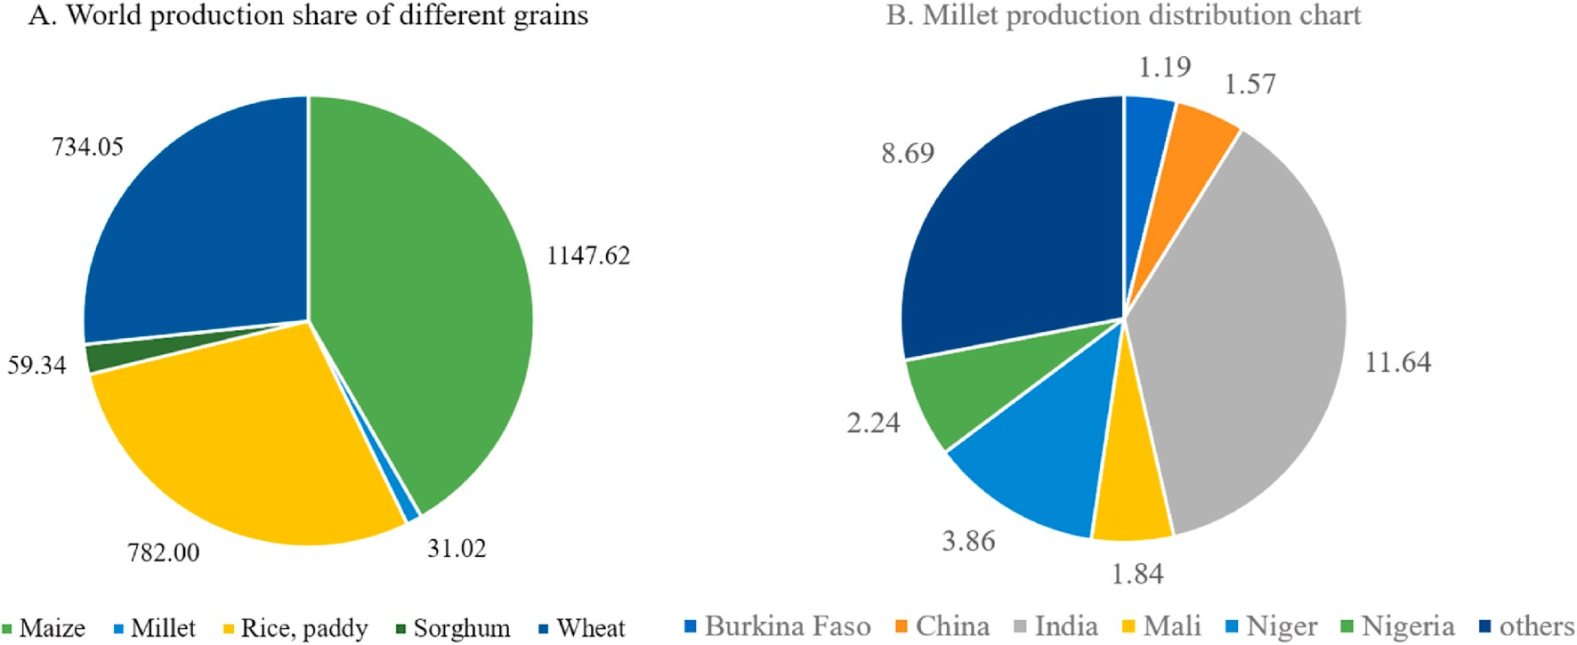
Fig. 10. Grain statistics. A. World production share of different grains for the year 2018 in million metric tonnes, B. Geographical distribution of millet production for the year 2018 in million tones (FAO, 2019).
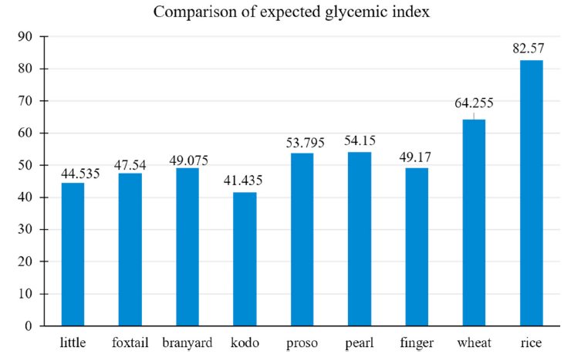
Fig. 11 Comparison of expected glycemic index from different raw grains (Bora et al., 2019; Sharma and Gujral, 2020)
Table 4: Comparison of starch fractions of different raw millets from different localities
(Kaimal et al., 2021)
Sl.  No | Grain | Country  of origin | Starch  (g/100g dry wt.) | Amylose  (g/100g starch) | Amylopectin (g/100g starch) | RDSª (g/100g starch) | SDSª  (g/100g starch) | RSª  (g/100g starch) | Reference
1 | Finger millet | India | 55.00–65.00 | 15.20–16.00 | 83.80–84.20 | 21.28–20.94 | 67.69–66.60 | 1.89–2.05 | Thippeswamy et al. (2016)
2 | Finger millet | Sri Lankan | 59.03–65.00 | 19.61–21.47 | 38.72–45.03 | 17.54–18.52 | 75.00–75.42 | 6.35–7.02 | Jayawardana et al. (2019)
3 | Pearl millet | India | 53.00–68.00 | 13.61–18.12 | 81.88–86.39 | 46.30–50.10 | 37.20–38.70 | 9.00–16.50 | Sandhu and Siroha (2017)
4 | Foxtail millet | Taiwan | 56.2–73.1 | 1.38–12.35 | 87.65–98.62 | 13.10–26.80 | 32.20–43.10 | 35.2–51.2 | Yin et al. (2019)
5 | Proso millet | China | 58.0–77.87 | 2.24–38.67 | 25.44–69.00 | 31.13–40.09 | 47.56–51.04 | 8.12–19.00 | Shen et al. (2018)
6 | Barnyard millet | India | 48.20–60.20 | 8.90–18.50 | 81.50–91.10 | 24.8–36.56 | 21.99–30.7 | 41.45–44.6 | Sharma and Gujral (2020)
7 | Little millet | India | 42.00–57.30 | 11.90–17.90 | 82.10–88.10 | 20.20–33.58 | 19.87–32.10 | 46.54-47.70 | Sharma and Gujral (2020)
8 | Kodo millet | India | 47.60–60.30 | 15.30–17.50 | 82.50–84.70 | 19.20–21.80 | 29.60–33.20 | 37.5–51.20 | Annor et al. (2013)
ª wt.: Weight, RDS: rapid digestible starch, SDS: slow digestible starch and RS: resistant starch.

Table 5: Comprehensive description of various literature available for millet RS preparation

Sl.  No. | Millet | Treatment | Parameters |  | Initial RS content  (g/100g) starch | Final RS  content  (g/100g) starch) | Inference |  | Reference
Thermal treatments
1 | Foxtail millet | Annealing | 50◦C for 24 h followed by cooling to 4◦C within 24 h |  | 18.2 | 42.33 | Annealing was found to be effective in increasing RS content of foxtail millet by 2.3-fold |  | Babu et al. (2019)
2 | Foxtail millet | Hydro-thermal  treatment | 110◦C for 16h |  | 13.1 | 32.93 | Hydrothermal treatment could  effectively increase the RS content of foxtail millet by 2.5-fold |  | Amadou et al. (2014)
3 | Proso millet | Autoclaving | 100°C and  121°C for 30 min. |  | 11.5 | 15.5 | They also conferred that RS formation can be promoted by increasein temperature |  | Ming-zhu et al. (2020)
Chemical treatments
4 | Pearl millet | Octenyl succinate  esterification | Esterified by 3% octenyl succinate anhydride for  2–5 h |  | 2.1 | 13.7 | The highest RS content was observed for samples with reaction time of 5 h |  | Sharma et al. (2016)
5 | Different varieties of pearl millet | Crosslinking by chlorohydrin | Crosslinking by epichlorohydrin (0.5%) for 5 h |  | 9.7 | 19.4 | The crosslinking could efficiently increase the RS content (15.3–19.4%) of all pearl millet varieties |  | Siroha and Sandhu (2018)
Novel technologies
6 | Barnyard millet | Microwave  drying | Drying at 110°C and  120°C for 10–20 min |  | 1.03 | 26.89 | Optimized parameters for RS enhancement was 180◦C for 20 min. |  | Kanagaraj et al. (2019)
7 | Foxtail millet | Ultrasound | 33khz for 30 min at  50°C |  | 18.2 | 20.14 | Ultrasound treated sample showed a marginal 10.6% increase in RS |  | Babu et al. (2019)
Combined treatments
8 | Finger millet | Thermo-  chemical  approach:  Sono-chemical  approach:  Acid pretreated  Chemical  approach: | Annealing:  110ºC for 6 h  Sonication: 33 khz for 1 h at 40ºC  Acidhydrolysis: citric acid(1m)for 6 h at 45ºC  Succination: succinic anhydride (4%) for 2 h | 7.04 |  | Thermo-  chemical:  10.49  Sono-chemical: 15.53  Acid pretreated  chemical:  18.19 |  | Samples pretreated with acid prior to succination was superior in RS content compared to other approaches |  | Babu et al. (2019)
9 | Foxtail millet | Thermo-  sonic  approach  Sono-thermal  approach | Annealing: 50ºC for 24 h followed by cooling to 4ºC within 24 h  Sonication: 33 khz for 30 min at 50ºC | 18.2 |  | Thermo-Sonic:  29.64  Sono-thermal:  45.59 |  | Synergistic correlation in RS content (150% increase) of ultrasound pre-treated annealed sample |  | Babu et al. (2019)

Influence of food constituents on millet RS

Starch can interact with various food components during processing and storages. The influence of food constitutes of millet in RS formation

Table 6: Influence of millet constitutes on starch digestibility and its mode of action (Annor et al., 2017; Bae et al., 2016)

Sl. No. | Millet constituent | Effect on starch digestibility | Mode of action
1 | Protein | Reduces | The protein-starch gel encapsulates  starch globules resulting in reduced gelatinization and enzyme permeability
2 | Lipid | Reduces | Lipophilic amylo-lipid inclusion complex refrains the entry of amylase
3 | Dietary fiber | Nominal effect | Reduces gelatinization by binding water
4 | Polyphenols | Reduces | Millet polyphenols act as amylase inhibitor
5 | Organic acid | Increases | Facilitates starch hydrolysis at higher  concentrations

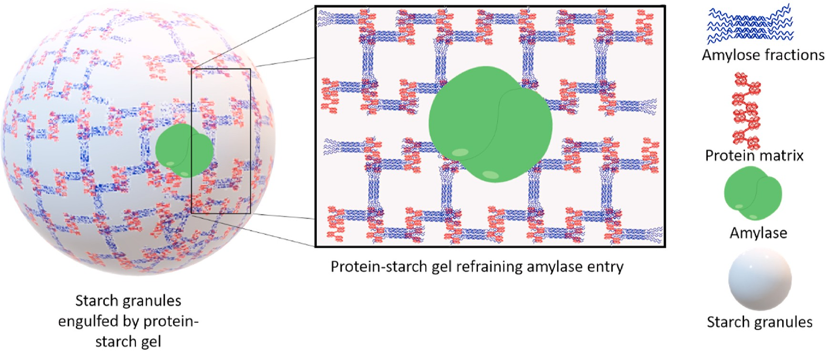

Fig. 12 Schematic representation of protein-starch gel restricting the entry of amylase into the starch granules

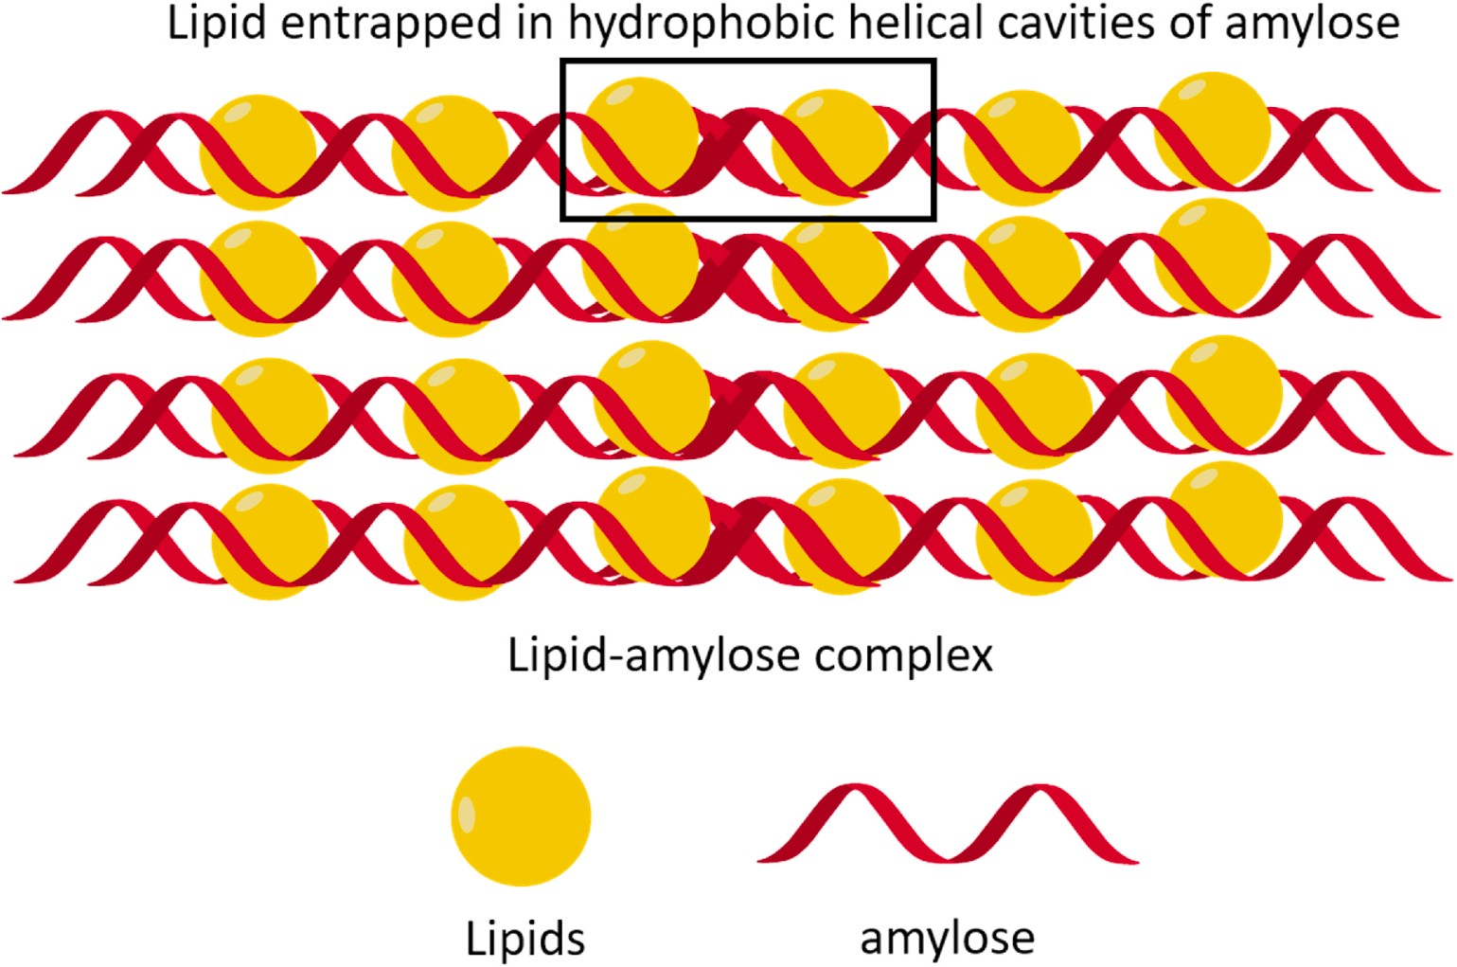
Fig. 13 Schematic representation of lipid-amylose inclusion complex
Table 7: Resistant starch concentrations in Pulses as influenced by genetics, processing method and RS analytical protocol (Perera et al., 2010)

Starch source | Treatment |  | RS | Method of RS analysis | Author
Pea | Raw, flour | Cultivar — 1674–13 | 13.3% | AACC method 32–40 (2000) with modifications | Chung et al. (2008)
 |  | Cultivar — 1215–33 | 14.7%
Pea | Raw | Cultivar — 1674–13 | 10% | Englyst et al. (1992) with modifications | Chung et al. (2009)
 | Annealed (15°C; 70% moisture; 24 h) |  | 10.9%
 | Heat-moisture treatment (100°C; 30% moisture; 2 h) |  | 13.3%
 | Heat-moisture treatment  (120°C; 30% moisture; 2 h) |  | 14.5%
Lentils | Raw flour | Cultivar — CDC Meteor | 14.9% | AACC method 32–40 (2000) with modifications | Chung et al. (2008)
 |  | Cultivar — CDC Robin | 14.4%
Lentils | Starch | Cultivar — CDC Meteor | 13% | AACC method 32–40 (2000) | Chung et al. (2008)
 |  | Cultivar — CDC Robin | 13.2%
Chickpea | Raw flour | Cultivar— Myles | 6.4% | AACC method 32–40 (2000) with modifications | Chung et al. (2008)
 |  | Cultivar — FLIP 97-101C | 4.7%
Chickpea | Starch | Cultivar — Myles | 8.4% | AACC method 32–40 (2000) | Chung et al. (2008)
 |  | Cultivar — FLIP 97-101C | 18.4%
Moth bean | Raw |  | 12.2% | Goni et al. (1996) | Bravo et al. (1998)
 | Freshly cooked |  | 3.9%
 | Cooked; stored at 4°C for 24 h |  | 4.8%
Horse gram | Raw |  | 26.4% | Goni et al. (1996) | Bravo et al. (1998)
 | Freshly cooked |  | 5.2%
 | Cooked; stored at 4°C for 24 h |  | 5.8%

Table 8. Resistant starch concentrations in Cereal starches as influenced by processing (Perera et al., 2010)
Starch source | Treatment | RS | Method of RS analysis | Author
Japonica brown rice | Pre-soaked in water at 25 or 50°C to reach 20% moisture + cooked | 29.2–32.4% | Englyst et al. (1992) | Han and Lim (2009)
 | Pre-soaked in water at 25 or 50°C to reach 30% moisture + cooked | 20.7–25.9% | Englyst et al. (1992) | Chung et al. (2006)
Corn | Acid modified with 1.64 M HCl at 40°C for 4 h + gelatinized+ autoclaved + lyophilized | 5% | AOAC 991.43 (1998) | Koksel et al. (2008)
 | Acid modified with 1.64 M HCl at 40°C for 4 h + gelatinized + autoclaved + Stored at 95°C for 48 h + lyophilized | 12%
Pastry wheat flour | Extruded at 20% moisture; 150/200/250 rpm; 40–120°C; stored at 4°C/0 days | 0.48–0.52% | Megazyme® assay | Kim et al. (2006)
 | Extruded at 20% moisture; 150/200/250 rpm; 40–120°C; stored at 4°C/7-14 days | 1.21–1.35%
 | Extruded at 40% moisture; 150/200/250 rpm; 40–120°C; stored at 4°C/0 days | 0.63–0.67%
 | Extruded at 40% moisture; 150/200/250 rpm; 40–120°C; stored at 4°C/7-14 days | 1.52–1.86%
 | Extruded at 60% moisture; 150/200/250 rpm; 40–120°C; stored at 4°C/0 days | 2.54–2.65%
 | Extruded at 60% moisture; 150/200/250 rpm; 40–120°C; stored at 4°C/7-14 days | 3.55–4.25%

- Commercially Available RS Products

Starch Australia Ltd. introduced the first commercial RS, i.e., Hi-maize. Later other companies introduced new commercial starches to market using different preparation technologies. The commercial RS prepared by different companies vary in percent RS content. Other commercial RS are CrystaLean® (RS3), Novelose®240 (RS2), Novelose®260 (RS2), Novelose®330 (RS3), Eurylon® (RS2), Amylomaize VII (RS2), and Neo-amylose (RS3) (Table 9). CrystaLean is RS3 produced by starch retrogradation of high amylose maize starch ae-VII hybrid. National Starch and Chemical Co. (USA) introduced Hylon-VII, a natural high amylose maize starch. Most of the above RS3 products are prepared by amylose retrogradation of high amylose corn starch using repeated heating and cooling cycles under controlled moisture and temperature conditions. These processes lead to manufacture of granular form of concentrated RS containing up to 47–60% RS content. A highly crystalline RS3 namely Actistar Act*-RS3 has also been prepared using maltodextrins as starting material. Due to the starting material and process used for the production, Act*-RS3 tastes very natural.
High amylose corn starch is also being used for the production of Fibersym HA, which is being used in a wide array of lower-net-carbohydrate food products. Fibersym HA provides more than 70% dietary fibre and is used in the preparation of food products such as pizza crust, breads, tortillas, cookies, muffins, breakfast cereals, snack products, and nutritional bars. Potato starch is used for the production of Fibersym 80ST. Fibersym 80ST has slightly higher water holding property which influences the properties of finished food products like cookie spread and muffin volume. Nutriose FB06 and Fibersol-2 also contain high RS content and provide 85% and 90% fibre content, respectively. Fibersym 80ST, Fibersym RW, Fibersym HA, and Fibersol-2 are all RS4 preparations and are available in the market. RS preparations without altering the organoleptic properties of food products reduce the availability of some saccharides. RS fortification does not alter the quality of product and organoleptic properties of extruded, baked products and confectionary remains unchanged (Raigond et al., 2014).

Table 9. Commercially manufactured resistant starch commonly used in various foods (Raigond et al., 2014)
Brand name  of commercial RS | Type | RS/TDF% content | Physiological and/or health  benefits | Manufacturer
Hi-maize | RS2 | 30-60%  TDF | Prebiotic properties. Lowers fecal pH. Increases the level of SCFA. (in particular butyrate which may reduce cancer risk). Increases bowel action with its mild laxative effect. Increases the bowels beneficial microflora | National Starch Chemicals co.,  USA
CrystaLean | RS3 | 19.2-41%  RS | Prebiotic effect. Increases proportion of butyrate. Increases cell proliferation in proximal colon (in rats). Provides soluble dietary fiber and prebiotic effects. Low glycemic index | Opta food  ingredients Inc., USA
Novelose 240 | RS2 | 47% RS | Lowers glycemic response when used as a substitute for flour and other rapidly digested carbohydrates | National Starch  and chemicals  co., USA
C*Actistar | RS3 | 53% RS | Health benefit potential. Prebiotic effect. Source of butyrate. Supports the immune system. Reduced glycemic response. Low calorific value. Easily fermentable RS. Very well tolerated. | Cerestar (Cargill company), US
Nutriose FB | - | 85% TDF | Low calorific value | Roquette, Freres, France
HylonR VII | RS2 | 23% TDF | Increases level of SCFA | National Starch and chemicals co., USA.

- Applications of RS
The potential physiological benefits and unique functional properties of RS have attracted the attention of nutritionists and food manufacturers. As consumers become more and more aware of healthy and nutritious foods, consumers look beyond the traditional nutritional aspects of foods to seek additional health benefits from regular RS consumption (Aparicio-Saguilan et al., 2007). RS is one of the ingredients used to fortify foods to increase their nutritional value and health benefits. Since RS occurs naturally in a wide range of starchy foods, it is convenient to use it as a functional ingredient for nutritional fortification purposes. RS-enriched foods are increasing in popularity among consumers, who are even willing to pay more for such foods to increase their fibre intake (Buttriss and Stokes, 2008). At the commercial level, RS is available with a starch component under the name "resistant starch". Most of these RS-enriched products are fully digestible and act as RS suppliers (Xie and Liu, 2004).
RS is used in the production of dry foods. Cross-linked RSs prepared from corn, tapioca, and potato starches have been used in formulations that require pasty texture, smoothness, flowability, low pH, and high temperature storage (Sajilata and Singhal, 2005). Baked goods, pasta products and beverages are fortified with RS to improve texture and nutritional value. We have succeeded in replacing most of the fat found in imitation cheeses with RS without adversely affecting the meltability or firmness of RS. In such cases, RS offers two advantages. One is the reduction of fat in food and the other is the health benefits provided by RS itself. Many products fortified with RS fibre are currently available on the market, including high-fiber breads, biscuits, and breakfast cereals. The availability of technology to prepare process-resistant RS has enabled the preparation of RS-rich foods. Dry pasta products containing up to 15% RS can be prepared without affecting the dough rheology during extrusion. Compared to unfortified pasta, RS-fortified pasta has a lighter colour and firmer texture similar to unfortified pasta (Sajilata et al., 2006). RS has added turbidity to the drink. It is used in thick and opaque health drinks where insoluble fibre is desirable. RS is superior to other fibres due to its mild flavour, less gritty feel and far less flavour masking. However, other fibres have a strong flavour, rough texture, and a poor and dry mouthfeel (Raigond et al., 2014).

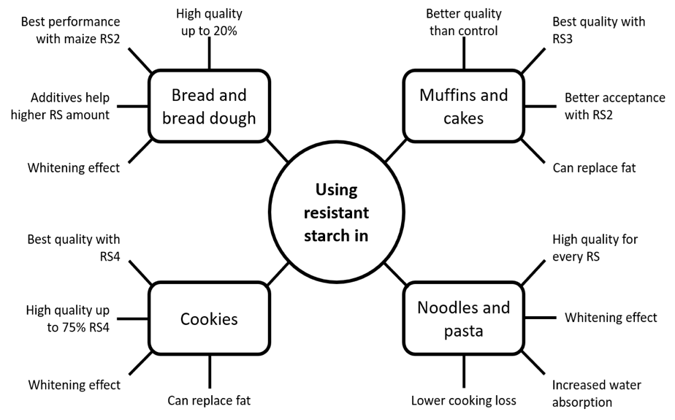
Fig. 14 Technological aspects of using resistant starch in wheat-based foods

Table 10: Summary of the main findings of testing RS in starchy, wheat-based foods (Arp et al., 2021)
Sl. No. | Product | Type and amount of RS | Results | Reference
1 | Bread dough | - Commercial maize RS2 up to 30% -  - Commercial maize RS3 up to 30%  - Lab-scale pea RS3 up to 30% | - ↑ water absorption, ↑ softening degree, ↑ resistance to extension  - ↓ development time, ↓ stability, ↓ extensibility Concentration effect  - Modified celluloses or enzymes can mitigate negative effects of RS2 | Arp et al., 2021
2 | Muffins | - Commercial tapioca RS3 15% | = volume and height and color  ↓ crumb hardness  ↑ RS (13.5%)  ↓ performance in sensory tests | Sanz et al., 2008
3 | Cakes | - Commercial maize RS2, RS3, and RS4  - Commercial potato RS3 | As fat replacers:  ↓ up to 50% of shortening addition  = or ↑ volume than full- or low-fat controls ↓hardening  = sensory scores than full-fat control | Serinyel and Ozturk, 2017
4 | Noodles and pasta | - Commercial maize RS4 up to 50%  - Commercial wheat RS4 up to 50% | ↑ water absorption  ↑ water absorption while cooking  ↓ extensibility and resistance to extension (raw and cooked samples)  = hardness (up to 40% RS)  ↓ cohesiveness (up to 20% RS)  ↓springiness (up to 30% RS)  ↓ GI estimated in vitro | Hsieh et al., 2020

Table 11: Summary of the main findings of testing RS in starchy, gluten-free foods
(Arp et al., 2021)
Sl. No. | Gluten-free product | Amount and type of RS (base or additional gluten-free ingredients) | Results | Reference
1 | Bread | Commercial maize RS2 up to 20%  Commercial tapioca RS3 up to 20%  (Base: maize and potato starch) | Good overall quality  ↓ volume at higher RS content  = (maize) or ↓ (tapioca or combination) hardness  = springiness and cohesiveness (20% RS)  ↑ dietary fiber up to 6.3% (maize), 4.3% (tapioca), 5.2% (combined) at 20% RS level | Korus et al., 2009
2 | Cakes | Commercial maize RS2 up to 20%  (Base: 20:80 tapioca starch and rice flour mix) | ↑volume  = or ↓ surface porosity and cell density  = or ↑ pore diameter  = cake color  = or ↓ elasticity  ↓ crumb firmness and firming rate  = overall acceptability scores | Tsatsaragkou et al., 2015
3 | Noodles and pasta | Commercial maize RS2 up to 20%  (Base: rice flour) | ↑ cooking time  ↓↓ cooking loss  ↑ firmness of cooked pasta  ↓ softness of overcooked pasta ↓ stickiness  ↑ RS loss after manufacturing | Foschia et al., 2017

- Potential Physiological effects

Table 12: Physiological properties of resistant starch (Brown, 2004; Champ, 2004)
Sl. No. | Potential Physiological effects | Conditions where there may be a protective effect
1 | Improve glycemic and insulinemic responses | Diabetes, impaired glucose and insulin responses, the metabolic syndrome
2 | Improved blood lipid profile | Cardiovascular disease, lipid metabolism, the metabolic syndrome
3 | Improved bowel health | Colorectal cancer, ulcerative colitis, inflammatory bowel disease, diverticulitis, constipation
4 | Prebiotic and culture protagonists | Colonic health
5 | Increased satiety and reduced energy intake | Obesity
6 | Increased micronutrient  absorption | Enhanced mineral absorption, osteoporosis
7 | Adjunct to oral rehydration  therapies | Treatment of cholera, chronic diarrhoea
8 | Synergistic interaction with other dietary component, e.g. dietary fibers, proteins, lipids | Improved metabolic control and enhanced bowel health

- Conclusion
RS is ideal for fortifying ready-to-eat cereals, snacks, pasta, noodles, baked goods and fried foods. These products can be simply labelled as "starches that provide additional nutritional supplementation." By changing the processing conditions, the content of foods can be increased. Products made with RS have excellent crispness, mouthfeel, colour and taste compared to products made with conventional fibres. RS is of great importance due to its physiological properties that reduce the risk of several diseases such as colon cancer and diabetes and also help control obesity and diabetes. Products fortified with RS are easily accepted by consumers due to their unique physical and chemical properties.

- References
Acquarone, V. M. and Rao, M. A., 2003, Influence of sucrose on the rheology and granule size of cross-linked waxy maize starch dispersions heated at two temperatures. Carbohydrate Polymers, 51:451–458.
Agustiniano-Osornio, J. C., Gonzalez-Soto, R. A., Flores-Huicochea, E., Manrique-Quevedo, N., Sanchez-Harnandez, L., Bello-Perez, L. A., 2005, Resistant starch production from mango starch using a single-screw extruder. Journal of Science Food Agriclture, 85:2105–2110.
Alcazar-Alay, S. C., Meireles, M. A. A., 2015, Physicochemical properties, modifications and applications of starches from different botanical sources. Food Science Technology, 35: 215–236.
Amadou, I., Gounga, M. E., Shi, Y.-H. and Le, G.-W., 2014, Fermentation and heat- moisture treatment induced changes on the physicochemical properties of foxtail millet (Setaria italica) flour. Food and Bioproducts Processing, 92(1): 38–45.
Annor, G. A., Marcone, M., Bertoft, E. and Seetharaman, K., 2013, In vitro starch digestibility and expected glycemic index of kodo millet (Paspalum scrobiculatum) as affected by starch–protein–lipid interactions. Cereal Chemistry, 90 (3): 211–217.
Annor, G. A., Tyl, C., Marcone, M., Ragaee, S. and Marti, A., 2017, Why do millets have slower starch and protein digestibility than other cereals? Trends in Food Science & Technology, 66: 73–83.
Aparicio-Saguilan, A., Sayagoayerdi, S., Vargastorres, A., Tovar, J., Ascencioatero, T. and Belloperez, L., 2007, Slowly digestible cookies prepared from resistant starch-rich lintnerized banana starch. Journal of Food Components Annuals, 20 (4):175–181.
Arp, C. G., Correa, M. J. and Ferrero, C., 2021, Resistant starches: a smart alternative for the development of functional breads and other starch-based foods, Food Hydrocolloids.
Aung, K. H., Surjani, U., Udayasika, P., Ingrid, A. M. A., Amparo, L.R. and Elliot, P. G., 2010, The effect of acid dextrinisation on enzyme-resistant starch content in extruded maize starch. Food Chemistry,120:140–149.
Babu, A. S., Mohan, R. J., & Parimalavalli, R., 2019, Effect of single and dual- modifications on stability and structural characteristics of foxtail millet starch. Food Chemistry, 271, 457–465. https://doi.org/10.1016/j.foodchem.2018.07.197
Bae, I. Y., Jun, Y., Lee, S. and Lee, H. G., 2016, Characterization of apple dietary fibres influencing the in vitro starch digestibility of wheat flour gel. Food Science and Technology, 65:158–163.
Bello-Perez, L. A. and Paredes-Lopez, O., 2009, Starches of some food crops, changes during processing and their nutraceutical potential. Food Engineering Reviews, 1:50–65.
BeMiller, J. N. and Whistler, R. L., 2009, Starch: Chemistry and Technology; Academic Press: Cambridge, MA, USA.
Bertoft, E., 2017, Understanding starch structure: Recent progress. Agronomy, 7: 56.
Bertolini, A., 2009, Starches: Characterization, Properties, and Applications; CRC Press: Boca Raton, FL, USA.
Bora, P., Ragaee, S. and Marcone, M., 2019, Characterisation of several types of millets as functional food ingredients. International Journal of Food Sciences & Nutrition, 70 (6): 714–724.
Brown, I. L., 2004, Applications and Uses of Resistant Starch. Journal of Association of Official Analytical Chemists, 87 (3): 727–732.
Brumovsky, J. O. and Thompson, D. B., 2001, Production of boiling-stable granular resistant starch by partial acid hydrolysis and hydrothermal treatments of high-amylose maize starch. Cereal Chemistry, 78(6):680–689.
Buttriss, J. L. and Stokes, C. S., 2008, Dietary fibre and health: an overview. British nutrition foundation. Food and Nutrition Bulletin, 33:186–200.
Champ, M. J., 2004, Physiological Aspects of Resistant Starch and in vivo Measurements. Journal of Association of Official Analytical Chemists, 87 (3): 749–755.
Chung, H. J., Shin, D. H. and Lim, S. T., 2008, In vitro starch digestibility and estimated glycemic index of chemically modified corn starches. Food Research International, 41:579–585.
Dupuis, J. H., Liu, Q. and Yada, R. Y., 2014, Methodologies for increasing the resistant starch content of food starches: A review. Comprehensive Reviews in Food Science and Food Safety, 13 (6): 1219–1234.
Eliasson, A. C., 1994, Interactions between starch and lipids studied by DSC. Thermochimica Acta, 246 (2): 343–356.
Englyst, H. N., Kingman, S. M. and Cummings, J. H., 1992, Classification and measurement of nutritionally important starch fractions. European Journal of Clinical Nutrition, 46:33–50.
Fausto, F.D, Kacchi, A.I. and Mehta, D., 1997, Starch products in confectionery. Beverage and Food World, 24(4):4–16.
Gao, Q., Suling, L., Jian, H. and Liang, S., 2011, Preparation and properties of resistant starch from corn starch with enzymes. African Journal of Biotechnology, 10 (7):1186–1193.
Goni, I., Garcia-Diz, L., Manas, E. and Saura-Calixto, F, 1996, Analysis of Resistant Starch: A Method for Foods and Food Products. Food Chemistry, 56 (4): 445–449.
Haralampu, S. G. and Gross, A., 1998, Granular RS and method of making. U.S. Patent 58.49.090.
Hasjim, J. and Jane, J., 2009, Production of resistant starch by extrusion cooking of acid-modified normal-maize starch. Journal of Food Science, 74 (7): 556–562.
Hoover, R., 2000, Acid-treated starches. Food Reviews International, 16 (3): 369–392.
Hoover, R. and Vasanthan, T., 1994, The effect of annealing on the physicochemical properties of wheat, oat, potato and lentil starches. Journal of Food Biochemistry, 17: 303–325.
Jayawardana, S. A. S., Samarasekera, J. K. R. R., Hettiarachchi, G. H. C. M., Gooneratne, J., Mazumdar, S. D. and Banerjee, R., 2019, Dietary fibres, starch fractions and nutritional composition of finger millet varieties cultivated in Sri Lanka. Journal of Food Composition and Analysis, 82 (363): 103249.
Juansang, J., Puttanlek, C., Rungsardthong, V., Puncha-arnon, S. and Uttapap, D., 2012, Effect of gelatinisation on slowly digestible starch and resistant starch of heat-moisture treated and chemically modified canna starches. Food Chemistry, 131:500–507.
Kahraman, K., Koksel, H. and Ng, P. K. W., 2015, Optimisation of the reaction conditions for the production of cross-linked starch with high resistant starch content. Food Chemistry, 174:173–179.
Kaimal, A. M., Mujumdar, A. S. and Thorat, B. N., 2021, Resistant starch from millets: Recent developments and applications in food industries. Trends in Food Science & Technology, 111: 563–580.
Kanagaraj, S. P., Ponnambalam, D. and Antony, U., 2019, Effect of dry heat treatment on the development of resistant starch in rice (Oryza sativa) and barnyard millet (Echinochloa furmantacea). Journal of Food Processing and Preservation, 43(7): 1–7.
Katopo, H., Song, Y. and Jane, J., 2002, Effect and mechanism of ultrahigh hydrostatic pressure on the structure and properties of starches. Carbohydrate Polymers, 47:233–244.
Lebail, P., Bule, A., Shiftan, D. and Marchessault, R. H., 2000, Mobility of lipid in complexes of amylose-fatty acids by deuterium and 13C solid state NMR. Carbohydrate Polymers, 43, 317–326.
Lee, C. J., Kim, Y., Choi, S. J. and Moon, T. W., 2012, Slowly digestible starch from heat moisture treated waxy potato starch: preparation, structural characteristics, and glucose response in mice. Food Chemistry, 133(4):1222–1229.
Lehmann, U. and Robin, F., 2007, Slowly digestible starch – its structure and health implications: a review. Trends Food Science and Technology, 18:346–355.
Martin, S. M., Barbosa-Canovas, G. and Swanson, B., 2002, Food processing by high hydrostatic pressure. Critical Reviews Food Science and Nutrition, 42: 627–645.
McCleary, B. V., 2000, Importance of enzyme purity and activity in the measurement of total dietary fibre and dietary fibre components. Journal of Association of Official Analytical Chemists, 83(4):997–1005.
Meenu, M. and Xu, B., 2019, A critical review on anti-diabetic and anti-obesity effects of dietary resistant starch. Critical Reviews in Food Science and Nutrition, 59 (18): 3019–3031.
Nugent, A.P., 2005, Health Properties of resistant starch. British Nutrition Foundation. Nutrition Bulletin, 30 (1): 27–54.
OECD/FAO., 2019, OECD-FAO agricultural outlook 2019-2028. OECD. https://doi.org/ 10.1787/agr_outlook-2019-en.
Perera, V., Meda, R. T. and Tyler, 2010, Resistant starch: A review of analytical protocols for determining resistant starch and of factors affecting the resistant starch content of foods. Food Research International, 43:1959–1974.
Rahaman, S., Singh, A., Praveen, S. and Krishnan, V., 2020, Low digestible starch and food industry: A changing paradigm. Indian Journal of Experimental Biology, 58: 830-841.
Raigond, P., Ezekiel, R. and Kaundal, B., 2014, Starch fractions of cooked potatoes at low temperature. Potato Journal, 41 (1):58–67.
Raigond, P., Ezekiel, R., Singh, B., Dutt, S. and Joshi, A., 2015, Resistant starch production technologies – a review. Potato Journal, 42 (2):81–94.
Reddy, C. K., Suriya, M. and Haripriya, S., 2013, Physico-chemical and functional properties of resistant starch prepared from red kidney beans (Phaseolus vulgaris. L) Starch by enzymatic method. Carbohydrate Polymers, 95: 220–226.
Sajilata, M. G. and Singhal, R. S., 2005, Specialty starches for snack foods. Carbohydrate Polymers, 59: 131–151
Sajilata, M. G., Singhal, R. S. and Kulkarni, P. R., 2006, Resistant starch - a review. Comprehensive Reviews Food Science, 5:1–17.
Sandhu, K. S. and Siroha, A. K., 2017, Relationships between physicochemical, thermal, rheological and in vitro digestibility properties of starches from pearl millet cultivars. Food Science and Technology, 83: 213–224.
Sharma, B. and Gujral, H. S., 2020, Modifying the dough mixing behavior, protein & starch digestibility and antinutritional profile of minor millets by sprouting. International Journal of Biological Macromolecules, 153: 962–970.
Sharma, M., Singh, A. K., Yadav, D. N., Arora, S. and Vishwakarma, R. K., 2016, Impact of octenyl succinylation on rheological, pasting, thermal and physicochemical properties of pearl millet (Pennisetum typhoides) starch. Lebensmittel-Wissenschaft & Technologie, 73: 52–59.
Shen, R., Ma, Y., Jiang, L., Dong, J., Zhu, Y. and Ren, G., 2018, Chemical composition, antioxidant, and antiproliferative activities of nine Chinese proso millet varieties. Food and Agricultural Immunology, 29(1): 625–637.
Shin, S., Byun, J., Park, K. H. and Moon, T. W., 2004, Effect of partial acid hydrolysis and heat-moisture treatment on formation of resistant tuber starch. Cereal Chemistry, 81 (2):194–198.
Singh, J., Kaur, L. and McCarthy, O. J., 2007, Factors influencing the physico-chemical, morphological, thermal and rheological properties of some chemically modified starches for food applications – a review. Food Hydrocolloids, 21:1–22.
Tester, R. F., Karkalas, J. and Qi, X., 2004, Starch structure and digestibility. Enzyme-substrate relationship. World Poultry Science Journal, 60 (2):186–195.
Thippeswamy, T. G., Junna, L. and Shinde, M., 2016, Proximate composition, resistant starch and other phytochemical constituents of native finger millet cultivar. International Journal of Food and Nutrition Science, 5(3), 67.
Thompson, D. B., 2000, On the non-random nature of amylopectin branching. Carbohydrate Polymers, 43: 223–239.
Vilaplana, F., Hasjim, J. and Gilbert, R. G., 2012, Amylose content in starches: Toward optimal definition and validating experimental methods. Carbohydrate Polymers, 88: 103–111.
Woo, K. and Seib, P. A., 2002, Cross-linked resistant starch: preparation and properties. Cereal Chemistry, 79 :819–825.
Wurzburg, O. B., 1995, Modified starches. In: Stephen AM (ed) Food polysaccharides and their applications. Marcel Dekker Inc, New York, pp 67–97.
www.gminsights.com
Xie, X. and Liu, Q., 2004, Development and physicochemical characterization of new resistant citrate starch from different corn starches. Starch 56 (8):364–370.
Yin, S. Y., Kuo, S. M., Chen, Y. R., Tsai, Y. C., Wu, Y. P. and Lin, Y. R., 2019, Genetic variation of physicochemical properties and digestibility of foxtail millet (Setaria italica) landraces of Taiwan. Molecules, 24 (23). https://doi.org/10.3390/ molecules24234323
Zeng, F., Ma, F., Kong, F., Gao, Q. and Yu, S, 2015, Physiochemical properties and digestibility of hydrothermally treated waxy rice starch. Food Chemistry, 72:92–98.
Zhang, H. and Jin, Z., 2011, Preparation of resistant starch by hydrolysis of maize starch with pullulanase. Carbohydrate Polymers, 83:865–867.
Zobel, H.F., 1988, Starch crystal transformations and their industrial importance. Starch, 40:
1–7.

