A NOVEL TWO ELEMENTS MIMO ANTENNA FOR 5G
COMMUNICATION
¹RAJU THOMMANDRU, ²Dr M. PURNA KISHORE, ³DESIMALA PRABHAKARA RAO, ⁴ARUMALLA RAJA, ⁵SHAIK MAHABOOB SUBHANI
^{1,3}Associate Professor, Department of ECE, Chalapathi Institute of Technology, Mothadaka, Guntur,

Andhra Pradesh, India

²Professor, Department of ECE, KKR & KSR Institute of Technology & Sciences, Vinjanampadu, Guntur, Andhra Pradesh, India
^{4,5}Assistant Professor, Department of ECE, Chalapathi Institute of Technology, Mothadaka, Guntur,

Andhra Pradesh, India
Corresponding Email ID : raazu.thommandru@gmail.com

ABSTRACT: High speed data transfer, higher receive reception, and an improved bit error rate are requirements in the present age of communication technology. Emerging as the next-generation technology that increases capacity, offers very low latency, extremely high data rates, and excellent service quality is fifth generation (5G). Antenna design and development are essential for the proper operation of any 5G devices. The antenna should cover the intended 5G bands with improved bandwidth, gain, and minimal radiation losses. It should also be compact in size and cost. The desire for high-quality, continuous broad band communications is common, particularly throughout developing countries like India, demanding high data rates and bandwidth. Wireless systems data rates, capacities, and connection dependability may all be significantly increased using MIMO (multiple input and multiple output) technology due to its ability to transmit and receive data over many paths. Currently used in 4G user equipment, the MIMO system is a promising technology for application in 5G mobile terminals. As a result, a novel two-element MIMO antenna for 5G communication is described in this work. High isolation between the antenna radiators is achieved by using two radiating components with slits in the radiators. When compared to previous 5G antennas, the MIMO antenna will keep its compact form and may be the smallest size.

KEYWORDS: multiple input and multiple output (MIMO), fifth generation (5G).
I. INTRODUCTION
Communication has become an essential component of life in the modern era, demanding the improvement of the communication system.

Over the past two years, wireless communication has developed into one of the most growing and quickly increasing technological sectors worldwide. It is frequently used in our homes and has a wide range of applications in the electrical devices we use every day, including computers, mobile phones, and televisions. They are now discussing "all connected" or the Internet of Things (IOT) with the introduction of the fifth generation (5G) [1].These are electrical wirelessly linked devices that can share information with a computer, tablet, or smartphone that can detect, examine, and respond to their environment [7].

An unambiguous technological representation of the way to address the growing need for high-speed connection and advanced wireless applications are the extensive research and development being done on fifth Generation (5G) technology. The next-generation technology known as 5G, is quickly gaining popularity because it increases capacity also offering excellent service quality, very low latency, and fast data rates. These domains of healthcare, education, business, and other social sectors are all benefit significantly from 5G [3]. With the quick development of current wireless technology, particularly with 5G, number of new features are now possible, including greater data rates and quickly high-quality transmission speeds.

Wireless systems have grown significantly over the years. The antenna, which uses ElectroMagnetic (EM) waves to send and receive data, is the most essential part of a wireless communication system. Transmitter, receiver, and medium make up the fundamental communication system. The medium is used in the communication system to transport radio frequencies from transmitter to receiver. An antenna is a device that transmits or receives signals in this context. As a result, the antenna is important to the wireless communication system. In order to function effectively, antennas need to be designed appropriately depending on their intended uses, and the parameters determine the extent to which the antenna performs [8].

An antenna is one of the most important elements of a wireless communication subsystem because it is used for signals with a certain intensity and direction to be transmitted and received. Microwave, radio, and satellite signals can all be sent, received, and transmitted using a conductor known as an antenna. There is a need for the construction of a small size antenna due to the regular advancements in technology, particularly in the field of communication devices like mobile phones, radio sets, laptops with wireless connections, etc. [4].

Technology developments in communication have increased the use of wireless devices. Additionally, the requirement for the miniaturization of these wireless devices is constantly increasing, greater data rates, and operating speeds. The antenna design faces a number of difficulties depending on the application. Utilizing diversity through the use of many antennas simultaneously for transmission and reception is one way to improve the transmission rate in this situation without increasing the sent signal's strength or bandwidth. This MIMO (Multiple Inputs Multiple Outputs) technology is used. This process is well known and one of the essential 5G communication technologies.

To develop a suitable MIMO antenna system for smartphones, it is necessary to consider a number of antenna design parameters, such as low-profile, simple fabrication, and high-isolation [5]. Among the various antenna structures in demand are those with a number of interesting qualities, including low-profile, small in size, and requiring wide operational bandwidth, which are current requirements. As a result, it is necessary to develop an antenna that combines the important qualities listed above. The antenna has to operate with specific standards approved by regulatory organisations such as the European Telecommunications Standards Institute (ETSI) and the Federal Communications Commission of the united states (FCC) in order to operate over a frequency bands. These specifications place restrictions on the antenna's minimum gain and maximum Effective Isotropic Radiated Power (EIRP), and etc [9].

Despite the possibility of using a typical microstrip patch antenna for 5G, the smaller antenna means that it has a narrower bandwidth. The antenna's bandwidth has to be expanded some techniques are implemented, such as the meta-surface, thick, stacking substrate, low permittivity substrate, shorting pins, folded patch, slots, slits and crossing stub structure [6]. There is a capacity restriction in standard SISO (Single Input Single Output) systems. Multiplexing, diversity, gain, multipath fading reduction, and channel capacity are all considered to be improved by Multiple-Input, Multiple-Output (MIMO) antenna models. The MIMO technology, which offers high data rates, large capacity, good spectrum efficiency, and significant diversity is essential to next generation wireless/mobile communication systems [2].

MIMO systems allow simultaneous communication of several independent data streams. The limited space within mobile phones is a significant design difficulty for MIMO systems. The recent analysis has examined a number of MIMO systems and has provided examples of various MIMO-based mobile equipment antenna designs [12]. The fifth Generation (5G) wireless system designers require a unique concept and design method to support faster data rates, better dependability, more connection, reduced latency, and increased security features. Over the years, different MIMO antenna designs are described.

The growing demand for high data rates is represents a lot of interest in MIMO antennas have now regarded as a important component of millimeter-wave communication. Because of the expected characteristics of faster data transfer, higher coverage, and resistance to numerous fading paths, MIMO technology is strongly advised. Mutual coupling caused by surface wave propagation and insufficient separation between system components decrease the channel capacity of some MIMO systems, which results in poor impedance and radiation performance. The simplest way to get high isolation is to simply increase the physical distance between the radiators, but this causes the antenna to increase an large size.

Researchers have made an effort to create methods that maximize packing density while improving isolation between radiators. Therefore, it would be important to maximize mutual coupling in wireless networks for communication. To achieve better results, this analysis presents a novel two elements MIMO antenna for 5G communication is presented. The analyses remaining sections are organized as follows: Section II provides a description of the literature review. In the Section III presents a novel two elements MIMO antenna for 5G communication. In the Section IV describes the results of the analysis. Finally, this analysis is completed in Section V.

II. LITERATURE SURVEY
R Rashmitha, Jugale Ajit Abhinandan, Niran N, Riyaz Mohammed Ahmed et. al., [13] proposes an architecture for a microstrip patch antenna for use in fixed, mobile, and satellite 5G communications. This technique was used by the scientists to build and a microstrip patch antenna for 5G communications should be created. The antenna operates at 43.7GHz in the Extremely high frequency (EHF) bands. The design was applied to a 4.4 relative permittivity Fire Resistant 4 (FR4) epoxy substrate. The antenna's gain, radiated patterns, VSWR (Voltage Standing Wave Ratio) return losses, and the current distributions have all been studied. The generated outcomes are checked against the specifications, and potential applications are described.

J. Colaco and R. Lohani et. al., [14] discusses that a microstrip patch antenna for 5G applications are implemented. This is described that a rectangular patch with a 2.2 dielectric constant might experience dielectric 0.0010loss. Modeling and analysis of the design is accomplished using the software named Feko. An acceptable return loss of −33.4 dB, an acceptable bandwidth of 3.56 GHz, a low VSWR of 2, and a high gain of 10 dB were obtained after modeling, and an antenna radiation efficiency of 99.5% were found by researchers. This proposed architecture is advantageous in the current world state of lockdown.

Maheswari T., S.Sai Reddy, V.Uma Sankar, B.Pradeep Kumar, Rushendrababu K. et. al., [15] explains a micro-strip patch antenna for 5G wireless applications is designed. The goal of this research is to create a rectangular Microstrip patch antenna for use in wireless computers and radios are one of the 5G frequency bands is 4.5 GHz, which is used by small mobile devices. The dimensions of the antenna were determined using analytical (mathematical) procedures, and rogers Ultralam1217, a dielectric substrate with a dielectric constant of 2.17, was used in the design. Transmission lines are used to achieve this models. In the High frequency structured simulator (HFSS), a microstrip patch antenna is developed and modeled.

Sudakshina Tiwari, Nitesh Kumar et. al., [16] an antenna for the 5G bands that uses MIMO. The problem of mutual coupling is one that has to be resolved with MIMO design, since MIMO antenna technology offers greater receive reception, a better bit error rate, and fast data transfer. In this analysis, authors have presented a 5G band MIMO antenna and a solution for problem of mutual coupling by using a decoupling element. The antenna's center frequency ranges from 38 to 39 GHz.

Z. Ren, A. Zhao and S. Wu et.al, [17] generates a small, decoupled antenna pair MIMO antenna for 5G mobile terminals. This research presents a self-decoupled compact antenna architecture for operating mobile terminals at fifth-Generation (5G) Multi-input and Multi-output (MIMO) speeds. Two adjacent antenna components that are placed very close to one another and on the same side of the system ground plane make up the antenna structure (1.2 mm, or 0.014 inches). The two adjacent antenna parts sharing a single common grounding branch can result in a small self-decoupled antenna pair. The 3.5GHz (3.4-3.6GHz) frequency band of the MIMO antenna system is its planned operational range with isolation better than -17dB. A working antenna prototype has been made, and measurements and simulations indicate good agreement.

Mahabub Atik, Al-Amin Md., Mostafizur Rahman Md., Sayedur Rahman Md., Masud Rana Md.et. al., [22] discusses the creation of a multiband patch antenna for 5G communication models. The suggested antenna arrays have provided directional radiation patterns, very small voltage standing wave ratios, high gain (VSWR), and directivity for each of the aforementioned systems working frequencies. This antenna is designed for multiband use, making it useful for 5G applications in addition to Wi-Fi and WiMAX (Worldwide Interoperability for Microwave Access).

Gaikwad Pooja Mohan, Prof. Dr. Suhas S. Patil et. al., [23] discusses fractal microstrip patch antenna design and development for 5G communications. This method uses fractal technology to create a rectangular-shaped microstrip patch antenna for 5G mobile communication. Compactness, multiband frequency, and impedance matching are utilizing fractal technology. 3.73GHz, 5.82GHz, and 8.85GHz are resonance frequencies for the antenna. For WLAN, WSN, Wi-Fi/Wi-Max, and Hiper LAN2, this antenna is helpful. To improve performance, researchers look at antenna features such radiation pattern, current distribution, VSWR, and S11. The HFSS programme is used to create the microstrip antenna.

Kumar Reddy N, Hazra Asish and Vinod Sukhadeve et. al., [24] explains a small elliptical microstrip patch antenna for usage in 5G wireless mobile communications. For the next fifth generation (5G) of mobile communications, they provide an elliptical inset fed microstrip patch antennas. With a relative permittivity of 4.4, the antenna is installed on a small Fr-4 substrate with dimensions of 5 x 5 x 1.6 mm 3. It is determined that the antenna operates at 28 GHz with a reflection coefficient (S11) of less than -10dB and rather steady emission patterns by simulating it using the HFSS software.
s
III. A NOVEL TWO ELEMENTS MIMO ANTENNA
A novel two element MIMO antenna for 5G communication is presented in this analysis. The configuration of the two-element MIMO antenna for 5G communication is shown in Fig. 1.There are several sending and receiving channels on the several Input Multiple Output antenna. This antenna utilizes the multipath propagation phenomenon, increasing the possibility of receiving reception. Compared to SISO (Single Input and Single Output) and SIMO (Single Input and Multiple Output) antenna, it additionally improves data speed and has a very low bit error rate. Because of this, next-generation communication systems most frequently utilize

In order to feed the radiating patch with a coaxial probe, a surface parallel to the y-axis can be utilized; this surface is shown in Figure 1(c) as a feed line. The perfect electric conductor (PEC), the antenna's main radiating component, is protected by the inner conductor of the coaxial feed, which is afterwards soldered. The bottom ground plane and top radiating element of the provided antenna are both connected to the outer conductor of the coaxial feed.
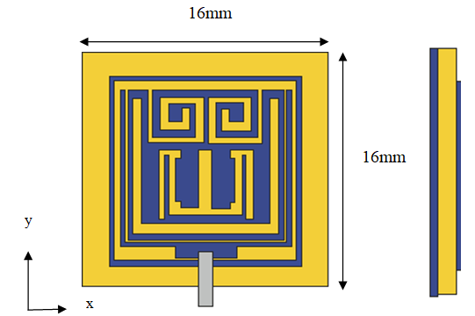
(a) (b)

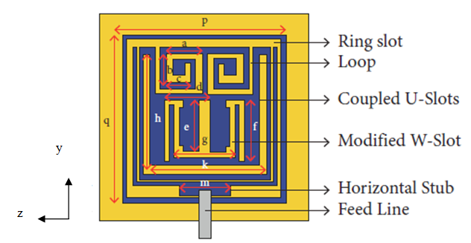
(c)

Dielectric
Perfect Electric Conductor

Fig. 1: Configuration of the presented two element MIMO antenna with material definitions. (a) Front view, (b) side view, and (c) geometrical details and labels of the presented antenna : a = 3.18 mm, b = 2.55 mm, c = 2.15 mm, d = 4.03 mm, e = 4.5 mm, f = 5.4 mm, g = 5.5 mm, h = 10.45 mm, k = 10.9 mm, and m= 4.4 mm.

Increasing the inductive effect or expanding the radiator's stubs electrically,

This is the key factor in achieving resonance at a lower frequency. Figure 1(c) shows the labels and physical dimensions to help with understanding of the constructed patch antenna. Therefore, a
number of methods are used to strengthen this inductive impact.

This paper describes a two-element-based MIMO antenna system that is inexpensive, low-profile, and small with a significantly decreased S21 < − 36 dB mutual coupling. Two slots are added to the radiating portion of the antenna elements and the antenna elements are rotated 45° in the clockwise direction, to improve the isolation in these densely packed elements. High isolation is achieved by extending the physical distance between the resonators through these slots. A 50-Ω feed line is used to excite the antenna's simple construction. This pattern is used on a Rogers 4350B laminate that is 0.8 mm thick. Given that the radiators in the provided structure have minimal mutual coupling, given the strong agreement between the simulated and measured results, 5G communication may be feasible due to its high diversity gain and low envelope correlation.

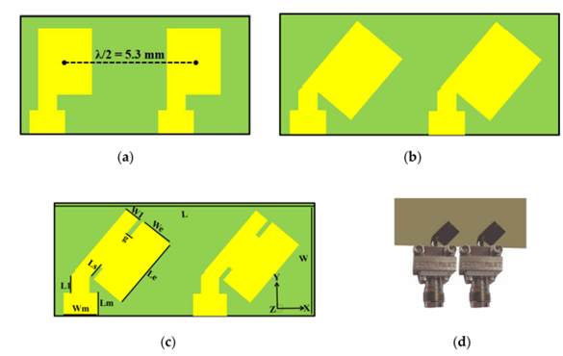
Figure 2: Design evolution of the presented MIMO Antenna (a) Straight elements (b) Bend elements (c) Presented (d) Prototype.

These antenna components that are currently being used are basic patch antennas with a rectangular form. Using the widely-accepted transmission line theories, the specific dimensions of the shown MIMO antenna are established.

Using the mentioned theory, the Width (W) and effective resonant Length (Lre) are determined for a given resonant frequency (fr).

$$L_{re}=\frac{c}{{2f}_{r}\sqrt{\left[\frac{ε_{r}+1}{2}+\frac{ε_{r}-1}{2}(1+12\frac{h}{W})^{-0.5}\right]}} -2∆L (1)$$

$$W=\frac{1}{{2f}_{r}\sqrt{μ_{o}ε_{o}}}\sqrt{\frac{2}{ε_{r}+1}} (2)$$

Similar to that, h stands for the substrate's thickness, c for light's speed, fr for resonance, and $∆$L for the fringing-induced length difference. Permeability, relative permittivity, and free space permittivity are all represented by the letters εo, εr, and μo, respectively. The provided antenna's dimensions for 29 GHz were determined using the calculations above.

The presented MIMO antenna is smaller than existing antennas, with total measurements of 11.2x5.3x0.8 mm³. On Roger 4350B substrate, a 45° rotating element has a relative permittivity of 3.66, a thickness of 0.8 mm, and two radiating patches with slits printed. The radiators had dimensions of 2.7 mm in width and 3.62 mm in length. A shared ground plane supports the substrate. At first, only straight antenna components with mutual coupling of S₂₁<− 16 dB working at 38 GHz are planned. By adding slots and rotating them 45 degrees clockwise, there was found to be little mutual contact between the patches. Slots lengthened the current route, the mutual coupling at the required frequency of 29 GHz decreased.

The surface current distribution was used to assess the mutual coupling performance of the provided two-element MIMO antenna. In order to improve isolation in these packed tightly components, two slots were first added to the radiating section of the radiators and turned by 45 degrees clockwise. High isolation is achieved as a result of these slots are extension of the physical distance between the resonators.

A 50-Ω feedline is used to excite the antenna's simple form. This pattern is used on a Rogers 4350B laminate that is 0.8 mm thick. Due to the recommended design's low envelope correlation, high diversity gain, and limited mutual coupling between the radiators, this may be an effective candidate for 5G communication, this highlights the good consistency between the simulated and measured outcomes.

IV. RESULT ANALYSIS
A novel two element MIMO antenna for 5G communication is presented in this paper. The recommended millimeter-wave MIMO antenna's compatibility, usability, and efficacy were examined using Envelope correlation coefficient (ECC) analysis. Considering the ECC, or incoming signals and their connection at the antenna port, is required to determine the uncorrelated channel's channel quality. Antenna performance decreases as a result of high correlation and low isolation caused by a high ECC setting.

Additionally, ECC represents that the total S-parameters of the planned MIMO antennas interact with one another. The received signal envelope, the S-parameter, or far field radiation can all be used to estimate complex cross correlation in order to find the ECC. The outcomes of the far field radiation patterns and S-parameter approaches used to calculate ECC in this section are listed below:

$$ECC=\frac{|S_{ii}*S_{ij}+S_{ji}*S_{jj}|^{2}}{\left(1-|S_{ii}|^{2}-|S_{ji}|^{2}\right)\left(1-|S_{jj}|^{2}-|S_{ji}|^{2}\right)} (3)$$

$$ρ_{ij}=\frac{|\int{\int_{0}^{4π}{\left[\vec{F_{i}} \left(θ,ϕ\right)×\vec{F_{j}} \left(θ,ϕ\right)dΩ\right]|^{2}}}}{\int{\int_{0}^{4π}{\left[\vec{F_{i}} \left(θ,ϕ\right)|^{2}dΩ\int{\int_{0}^{4π}{|}}\vec{F_{j}} (θ,ϕ|^{2} \right]dΩ}}} (4)$$

Where, the i-th and j-th MIMO antenna components, respectively, indicate the ECC $\vec{F_{i}} \left(θ,ϕ\right)$ and $\vec{F_{j}} \left(θ,ϕ\right)$ radiation patterns, In the recommended design, I, j = 1, 2, which are represented.

When analyzing the effectiveness of MIMO antennas, another important factor that must be taken into consideration is Diversity Gain (DG). This metric presents as an estimate for the MIMO system's dependability. For high DG antenna systems, the radiators are isolated to a greater extent. For computing the DG of the MIMO antenna, apply the relation follows.

$$DG=10\sqrt{1-(ECC)^{2}} (5)$$

Multiplexing efficiency (ηMux) is measured as follows:
$$η_{Mux}=\sqrt{1-|ρ_{c}|^{2}}η_{1}η_{2} (6)$$

where $ρ_{c}$ is the antenna patch complex correlation coefficient. The radiator for the i-th antenna has a total efficiency of ECC$≈|ρ_{c}|^{2}$ and | $η_{i}|$. Since they had a MIMO array with two elements, they used i = 1, 2.

The Fig. 3 shows the simulated radiation efficiency comparison.

Fig. 3: Simulated Radiation Efficiency Comparative Graph

Figure 3 represents the SISO and presented MIMO antenna's radiation efficiency. The described MIMO antenna achieves a radiation efficiency of over 87% over the working band. In the ideal scenario, the ECC value would be 0. Therefore, uncorrelated MIMO is restricted to an ECC limit of 0.5. The diversity gain and ECC of the presented antenna are shown in Figure 4 using simulation and measurement.
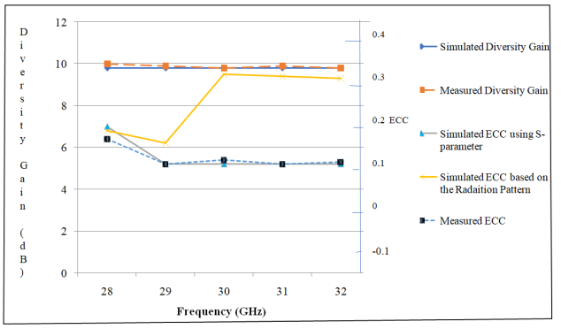
Fig. 4: Simulated and measured ECC and diversity gain of the presented antenna

At the target band of 29 GHz, the ECC value for the specified MIMO antenna is 0.0001, which is very near to zero, as shown in Figure 4. The provided MIMO antenna's Diversity Gain (DG) for a number of frequencies is shown in Figure 3. A DG > 10 dB is found in the provided antenna across the operational band. With different frequencies, Figure 5 represents multiplexing effectiveness and peak gain.
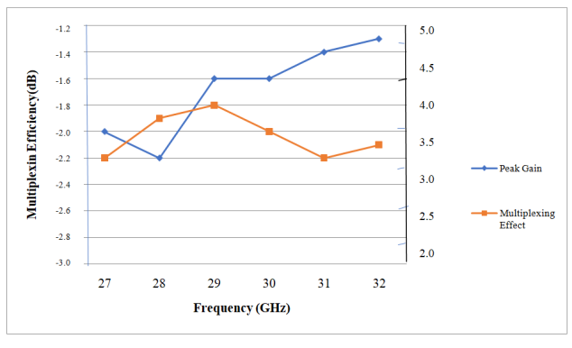
Fig. 5: Simulated peak gain and multiplexing efficiency of the reported MIMO antenna

Through utilizing slotted and inclined antenna radiators, this MIMO antenna was able to retain a small (11.2x5.3mm2) size. A lower ECC value of 0.00009, improved isolation of 38 dB, and obtaining a high diversity gain of >9.9 dB was successful. An effective option for 5G communications and applications, the described architecture shows good consistency between measured and simulated outcomes.
V. CONCLUSION
A novel two elements MIMO antenna for 5G communication is presented in this analysis. The 5G communication method discussed a novel 2x2 MIMO antenna. Despite the simple shape, slits in the radiators are added to extend the current route and result in a significant reduction in antenna area (11.2x5.3 mm²). The patches are slotted and rotated 45 degrees in the clockwise direction, high isolation between the resonators is achieved. The given MIMO antenna is a strong candidates for 5G applications, according to the simulation outcomes for ECC (ECC 0.00009), DG (DG > 9.9 dB), and isolation between the radiators (> 38 dB). The modeling and testing results revealed good S-parameter, radiation pattern, diversity gain, and ECC performance even though the antenna is smaller than previous 29 GHz millimeter-wave antennas.

VI. REFERENCES
[1] P. Singla, K. Kaur, M. Srivastava and R. Mittal, "Design and Implementation of Printed Antennas for 5G Applications," 2023 3rd International Conference on Advance Computing and Innovative Technologies in Engineering (ICACITE), Greater Noida, India, 2023, pp. 131-134, doi: 10.1109/ICACITE57410.2023.10182522.
[2] Neeta P. Kulkarni, Nilesh Bhaskarrao Bahadure, P. D. Patil, Jayshri S.Kulkarni, “Flexible MIMO Antennas for 5G Applications”, Research square, 2022, doi: 10.21203/rs.3.rs-1358314/v1
[3] Malathi Kanagasabai, Shanmathi Shanmuganathan , M. Gulam Nabi Alsath , and Sandeep Kumar Palaniswamy, “A Novel Low-Profile 5G MIMO Antenna for Vehicular Communication”, International Journal of Antennas and Propagation, Volume 2022, Article ID 9431221, 12 pages, doi:10.1155/2022/9431221
[4] Mohammad Monirujjaman Khan , H. M. Arifur Rahman, Md. Nakib Alam Shovon, Alhakami , Myriam Hadjouni , Hela Elmannai , and Sami Bourouis, “Design and Analysis of a 5G Wideband Antenna for Wireless Body-Centric Network”, Hindawi Wireless Communications and Mobile Computing Volume 2022, Article ID 1558791, 16 pages, doi:10.1155/2022/1558791
[5] Lijaddis GetnetAyalew, Fanuel MelakAsmare, “Design and optimization of pi-slotted dual-band rectangular microstrip patch antenna using surface response methodology for 5G applications”, Heliyon 8 (2022) e12030,
Doi:10.1016/j.heliyon.2022.e12030
[6] Dolores García, Jesus O. Lacruz, Damiano Badini, Danilo De Donno, Joerg Widmer, “Model-free machine learning of wireless SISO/MIMO communications, Computer Communications, Volume 181, 1 January 2022, Pages 192-202, doi: 10.1016/j.comcom.2021.09.033
[7] Marwa Daghari, Chaker Essid ,and Hedi Sakli, “Muli-UWB Antenna System Design for 5G Wireless Applications with Diversity”, Hindawi Wireless Communications and Mobile Computing
Volume 2021, Article ID 9966581, 18 pages, doi:10.1155/2021/9966581
[8] Narukurthi Vivek, Sandeep Kumar B, Dr K. Shambavi, “Design Of Wearable Antennas for 5G Applications”, International Journal of Electrical Engineering and Technology (IJEET), Volume 12, Issue 5, May 2021, pp. 148-156, ISSN Online: 0976-6553, DOI: 10.34218/IJEET.12.5.2021.014
[9] Mustafa Shakir, Sohaib Aslam, M. Usman Sarwar, Muhammad Adnan and Muhammad Rafay Khan, “Performance evaluation and design of 5G communication‑based millimeter wave antenna”, EURASIP Journal on Wireless Communication and Networking, 2021:179, https://doi.org/10.1186/s13638-021-02052-9
[10] R.Shantha Selvakumari And R.Banu Sangari, “Design and Simulation of an Array Antenna For 5G Base Station”, International Research Journal Of Engineering And Technology (IRJET) E-ISSN: 2395-0056 Volume: 08 Issue: 04, Apr 2021
[11] T. Prabhu and S. Chenthur Pandian, “Design and Implementation of T-Shaped Planar Antenna for MIMO Applications”, Computers, Materials & Continua
DOI:10.32604/cmc.2021.018793
[12] D.S.Bhargava, T.V.Padmavathy, Yadhamuri Vinitha Reddy, Neelapareddy Kavitha, Vuppalapati Hema, “Design and Simulation of MIMO Antennas for Mobile Communication”, IOP Conf. Series: Materials Science and Engineering 994 (2020) 012033, IOP Publishing , doi:10.1088/1757-899X/994/1/01203
[13] Rashmitha R, Niran N, Abhinandan Ajit Jugale, Mohammed Riyaz Ahmed, “Microstrip Patch Antenna Design for Fixed Mobile and Satellite 5G Communications”, Third International Conference on Computing and Network Communications (CoCoNet’19), Procedia Computer Science 171 (2020) 2073–2079, Elsevier, Doi: 10.1016/j.procs.2020.04.223
[14] J. Colaco and R. Lohani, "Design and Implementation of Microstrip Patch Antenna for 5G applications," 2020 5th International Conference on Communication and Electronics Systems (ICCES), Coimbatore, India, 2020, pp. 682-685, doi: 10.1109/ICCES48766.2020.9137921.
[15] T.Maheswari,V.Uma Sankar,S.Sai ReddyB.Pradeep Kumar, K.Rushendrababu, “Design of a Microstrip patch Antenna for 5G Wireless Applications”, 2019 IJRAR International Journal of Research and Analytical Reviews March 2019, Volume 6, Issue 1,
E-ISSN 2348-1269,
[16] Sudakshina Tiwari, Nitesh Kumar, “A MIMO antenna for 5G band”, International Journal of Scientific Development and Research (IJSDR), October 2019, Volume 4, Issue 10, IJSDR1910009, ISSN: 2455-2631
[17] Z. Ren, A. Zhao and S. Wu, "MIMO Antenna With Compact Decoupled Antenna Pairs for 5G Mobile Terminals," in IEEE Antennas and Wireless Propagation Letters, vol. 18, no. 7, pp. 1367-1371, July 2019, doi: 10.1109/LAWP.2019.2916738.
[18] E Sandi, A Diamah, M W Iqbal and D N Fajriah, “Design of substrate integrated waveguide to improve antenna performances for 5G mobile communication application”, 4th Annual Applied Science and Engineering Conference, Journal of Physics: Conference Series 1402 , (2019) 044032
IOP Publishing, doi:10.1088/1742-6596/1402/4/044032
[19] Abdulrahman al Ayidh, J. B. Nadas, R. Ghannam, G. Zhao and M. A. Imran, "Communication and Control Co-Design Using MIMO Wireless Network," 2019 UK/ China Emerging Technologies (UCET), Glasgow, UK, 2019, pp. 1-5, doi: 10.1109/UCET.2019.8881847.
[20] T.Kiran, N.Mounish, Ch.Mythily, D.Akhil, T.V.B.Phani Kumar, “Design of Microstrip Patch Antenna for 5g Applications”, IOSR Journal of Electronics and Communication Engineering (IOSR-JECE) e-ISSN: 2278-2834,p- ISSN: 2278-8735.Volume 13, Issue 1, Ver. I (Jan.- Feb. 2018), PP 14-17
[21] Wanwei Tang, Shaoli Kang, Jinlong Zhao, Yinpu Zhang, Xiurong Zhang2, Zhenyu Zhang, “Design of MIMO-PDMA in 5G mobilecommunication system”, IET Commun., 2020, Vol. 14 Iss. 1, pp. 76-83, doi: 10.1049/iet-com.2018.5837
[22] Atik Mahabub, Md. Mostafizur Rahman, Md. Al-Amin, Md. Sayedur Rahman, Md. Masud Rana, “Design of a Multiband Patch Antenna for 5G Communication Systems”, Open Journal of Antennas and Propagation, 2018, 6, 1-14, ISSN Online: 2329-8413, doi: /10.4236/ojapr.2018.61001
[23] Gaikwad Pooja Mohan, Prof. Dr. Suhas S. Patil, “Design and Development of Fractal Microstrip Patch Antenna for 5g Communication”, Advances in Wireless and Mobile Communications. ISSN 0973-6972 Volume 10, Number 1 (2017), pp. 13-25, doi:10.24113/ijoscience.v6i5.287
[24] N Kumar Reddy, Asish Hazra and Vinod Sukhadeve, “A Compact Elliptical Microstrip Patch Antenna for Future 5G Mobile Wireless Communication”, Transactions on Engineering & Applied Sciences, Vol. 1. No. 1, pp. 1-4, 2017, DOI: 10.24999/IJOAEM/02070036, ISSN 2456-8066
[25] W. Cheng, X. Zhang and H. Zhang, "Statistical-QoS Driven Energy-Efficiency Optimization Over Green 5G Mobile Wireless Networks," in IEEE Journal on Selected Areas in Communications, vol. 34, no. 12, pp. 3092-3107, Dec. 2016, doi: 10.1109/JSAC.2016.2599980.

