NOSOCOMIAL INFECTION AND CONTROL MEASURES
*Dr.R.Krishnaveni¹, S. Lavanya¹, N.Najma Begam¹, R.Raja Rajeshwari¹
*Dr.R.Krishnaveni¹,Assistant professor and Head,Department of Microbiology,Idhaya college for women.Kumbakonam.
S. Lavanya¹, N.Najma Begam¹, R.Raja Rajeshwari¹,Research students ,Department of Microbniology.Idhaya college for women.Kumbakonam.
Corresponding Author ;R.Krishnaveni ,Mail.id;.krishnavenimicro@gmail.com

INTRODUCTION
The hospital acquired infections otherwise called Nosocomial infection. It occurs in hospital or other healthcare or other healthcare facilities. It occurs in hospital, nursing home, outpatient clinic or other. The contaminant equipment, bed lines or air droplet spread infection.
Indwelling catheters, procedure using intravascular, antimicrobial lock therapy. Unexpected blood borne pathogens introducing antibiotics, catheter. Main route of transmission contact by direct contact method. Droplet transmission by droplet containing microbes from infected person. Droplet are generated from coughing, sneezing and taking bronchoseopy. Particle less then 5Mm or small size suspend air for long time so the dust particle contain infectious agents. Air borne transmission by environmental factors. Ventilation microbes transmitted by air borne transmission include Micobacterium tuberculosis, Varicella viruses, Legionella sp.,. Common vehicle transmission microbes transmitted to host by contaminately items, such as food, water medications, divices equipment. Vector borne transmission by mosquito, flies, rats. Root of contact transmission direct transmission. It involve direct body surface to body surface contact it transmit others when turns a patients.
Transient flora Staphylococcus aureus, Klepsiella pnemoniae, Acinetebacter, Enterobacter, Candida spp. This goal of hand hygine by washing normal antiseptic soap hand washing, alcohol based hand rubs. Gloves use of reduce risk. Fomite can transmit microbes. Surface sanitation by non-flammable alcohol vapour in co₂ system.
The importance of the estimation of the quality and types of airborne microorganisms are that these values can be used as an index or the cleanliness of the environment as well as an index of risk in relation to human health and as source of hospital-acquired infections (Jaffal AA, Benat IM, et al., 1997).
The aim of this study was to evaluate the bacterial and fungal pathogens contaminating the air and protective wears in the theatre and surgical wards of two teritiary-care hospital in Kumbakonam.
Microorganisms are the primary sources of indoor air contamination. The indoor air environment can potentially place patients at greater risk than the outside environment, because enclosed spaces can confine aerosols and allow than to build up to infectious levels (Lewis, F.A., 1994).Indoor biological population has only recently begun to receive the afforded attention. The apparent lack of interest is tied to the difficulties in sampling biological aerosol as well as the evaluation of their variable health effect (Glick,T.H, 1978).
For this study, we used settle plates technique to estimate bacterial load in the indoor air of wards.
The present study carried out on the Government hospital, Kumbakonam, Thanjavur(D.t) health care facility in the city of kumbakonam provides high level Medicare to a large population of people in a highly populated state, and render mostly free medical services.
RESULT
Pseudomonas aeruginosa is a very significant contaminant of pharmaceutical and cosmetics its presence in such as products causes inactivation of medicaments, it creates thread to patient care. Therefore, continuous careful monitoring of the object and sights is necessary to control infection in hospitalised patients. Regular practice is environmental survive and suitable control measure help to reduce hospital acquired infection considerably.
The antibiotic susceptibility pattern of environmental isolates of Pseudomonas aeruginosa is mostly over looked and rarely reported a few reports available on susceptibility pattern on Pseudomonas aeruginosa such as significant resistant to a variety of antibacterial agents (Nagovabs, beshmukh SR et al.,1997; Gadgf, Eidomany et al., 2007; Lemmen SW, Hafner H et al., 2004; pal RB , Rodrigues M,, data S, 2010).
Bacteriologic identification ratio of hospital patients was very high but the prevention method was probably antibiotic treatment before admission on the way to low bacteriologic identification (Celaayaz et al.,2004). The mixed bacterial infection revealed that Pseudomonas sp.,E.coli,S.aureus and Proteus sp.,Pseudomonas auroginosa stains isolated from patients invoved in an outbreak of catheter associated urinary tract infection that occurred in a neurosurgery ward of a hospital in sandai,Japan( Se kiguchi,2005). The present observation also present in Pseudomonas sp.,. This organism resistance to some kinds of disinfectants. The several study showed that Proteus sp., occurred more frequently in infectious among the older group (Silberg SI et al., 1976). In the present study Proteus sp., present in male ward.
Most of the study indicated that Escherichia coli with core criteria of Indole positive, oxidase negative, non spreading organisms on sheep blood agar plates, having typical gram-negative rod plate morphology. Defined as gram positive growth on gram-negative rod-selective media(York MK et al., 2000). Recently urinary tract infections have become more complicated and difficult to treat affected from Enterococcs faecials followed by Pseudomonas,(Shegemura K et al., 2005). Pseudomonas auroginosa, that is found mainly in environmental flora, have low virulence and is frequently pathogenic in immune suppressive patients with invivo foreign materials.
SUMMARY
Nosocominal infection make up an important problem in public health care nosocominal infections are influenced by the microbes intrinsic virulence as well as its ability to colonize and survive with in institution in the present study the microbes are collected from Kumbakonam Government hospital.
The microorganisms are identified biochemical and culture technique the microbes like Environmental Klebsiella sp., Pseudomonas sp., Aeromonas, Proteus sp., E.coli, Staphylococcus sp., Outpatient ward E.coli, Klebsilla sp., Pseudomonas sp., Enterobacteria, Citrobacteria ICU E.coli, Staphylococcus sp., Male surgery ward Pseudomonas sp., Enterobacteria, Proteus sp., Klebsilla sp., Materity ward E.coli, citrobacter, Pseudomonas sp., Shiella sp., Salmonella sp., the microbes was isolated.
In this report, the microbial load obtain from the different section of the hospital varies. The total viable count(TVC) obtain in female surgical wards (FSW) was higher and significantly different (p<0.05) from the other sections. The bacteria isolated from the hospital section sampled are Escherchia coli, Klebsiella pnemoniae, Staphylococcus aureus, Bacillus subtilis and Proteus mirabilis. Previous reports had implicated most of the bacteria isolates listed above as common pathogens isolated from hospital environment (Amadi and Amadife,2006; Madigan et al., 2000; Ogunbi and Anyiwo,1998; Fuest, 1983).
In this study the higher microbial load in environment and all wards due to hygienic and poor waste management system. Attention must be given control those environment factors which favours the growth and multiplication of microbes in indoor environment.
A hospital environment may not be a place the where people get well and but also be a place where sick people get sicker(Madigan et al., 2000). Infections in hospital environment are

as a result of the following factors: microorganisms in the hospital, the compromised immune status of the patient and the chain of hospital (Tortora et al., 2004). The alarming frequently with which microorganisms in hospital environment resistant to antibiotics, particularly by the mechanisms of transmissible drug resistant and the fact that the antibiotics to which they remain sensitive often highly toxic has made nosocominal infection in a serious problem (Thomas, 1987).
In our present investigation the hospital surroundings and different ward like maternity ward ICU and male surgery ward. Outpatient ward, consist of more antibiotic resistance bacteria, care should taken for maintain environment and wards, cleanliness and make reduce transient microbes and its diseases.
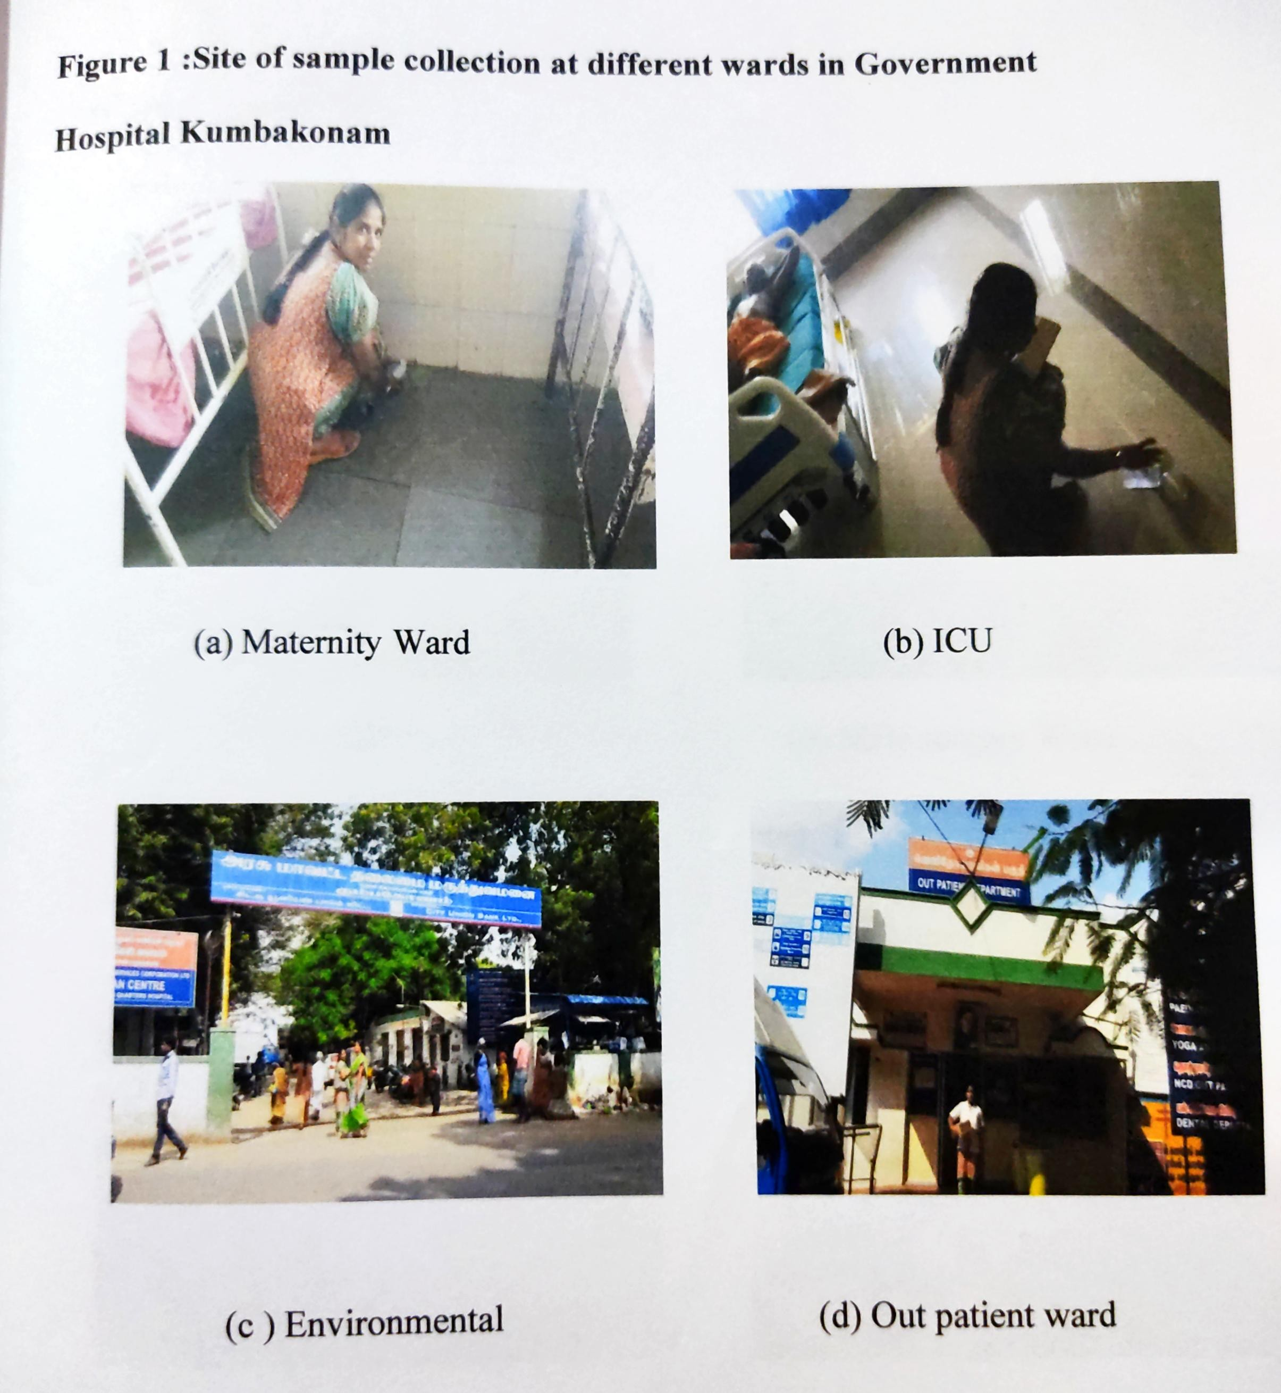

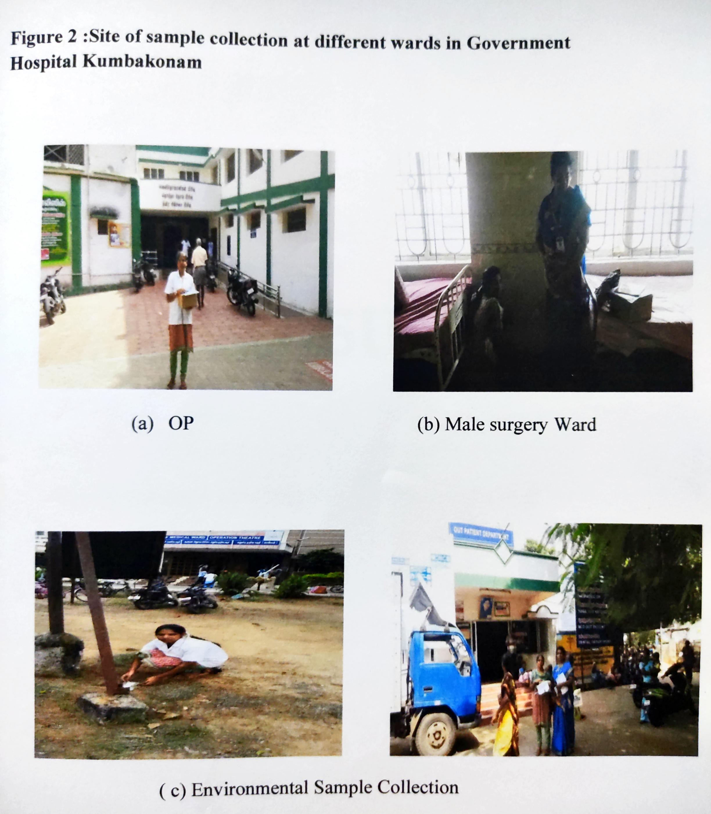

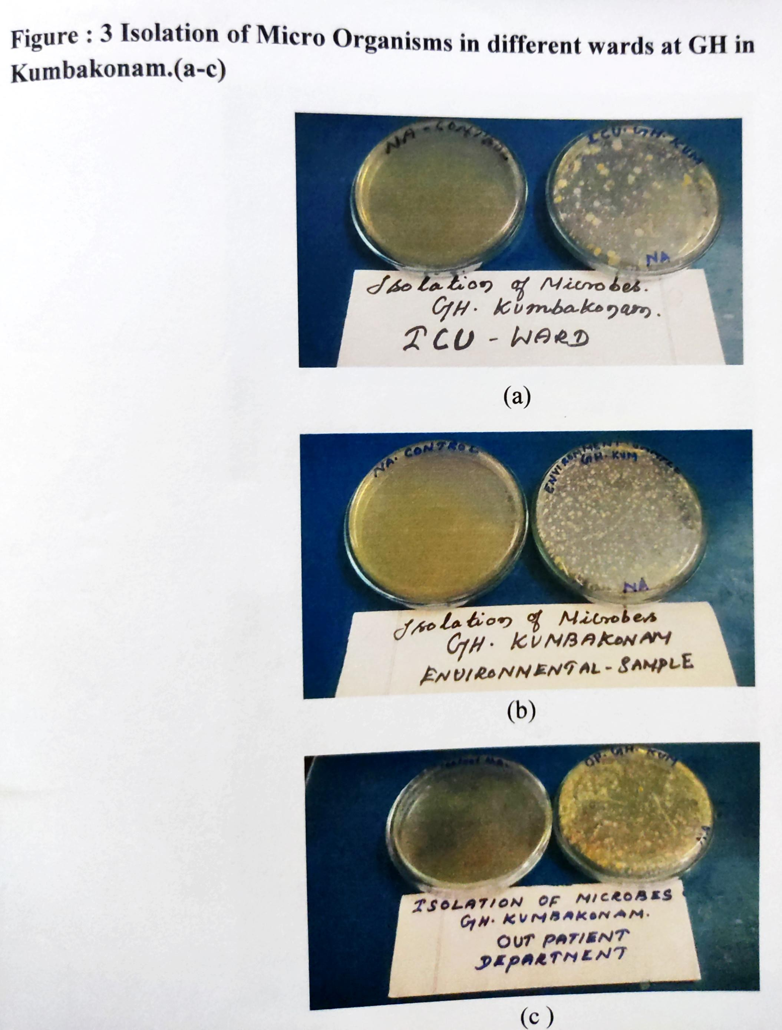

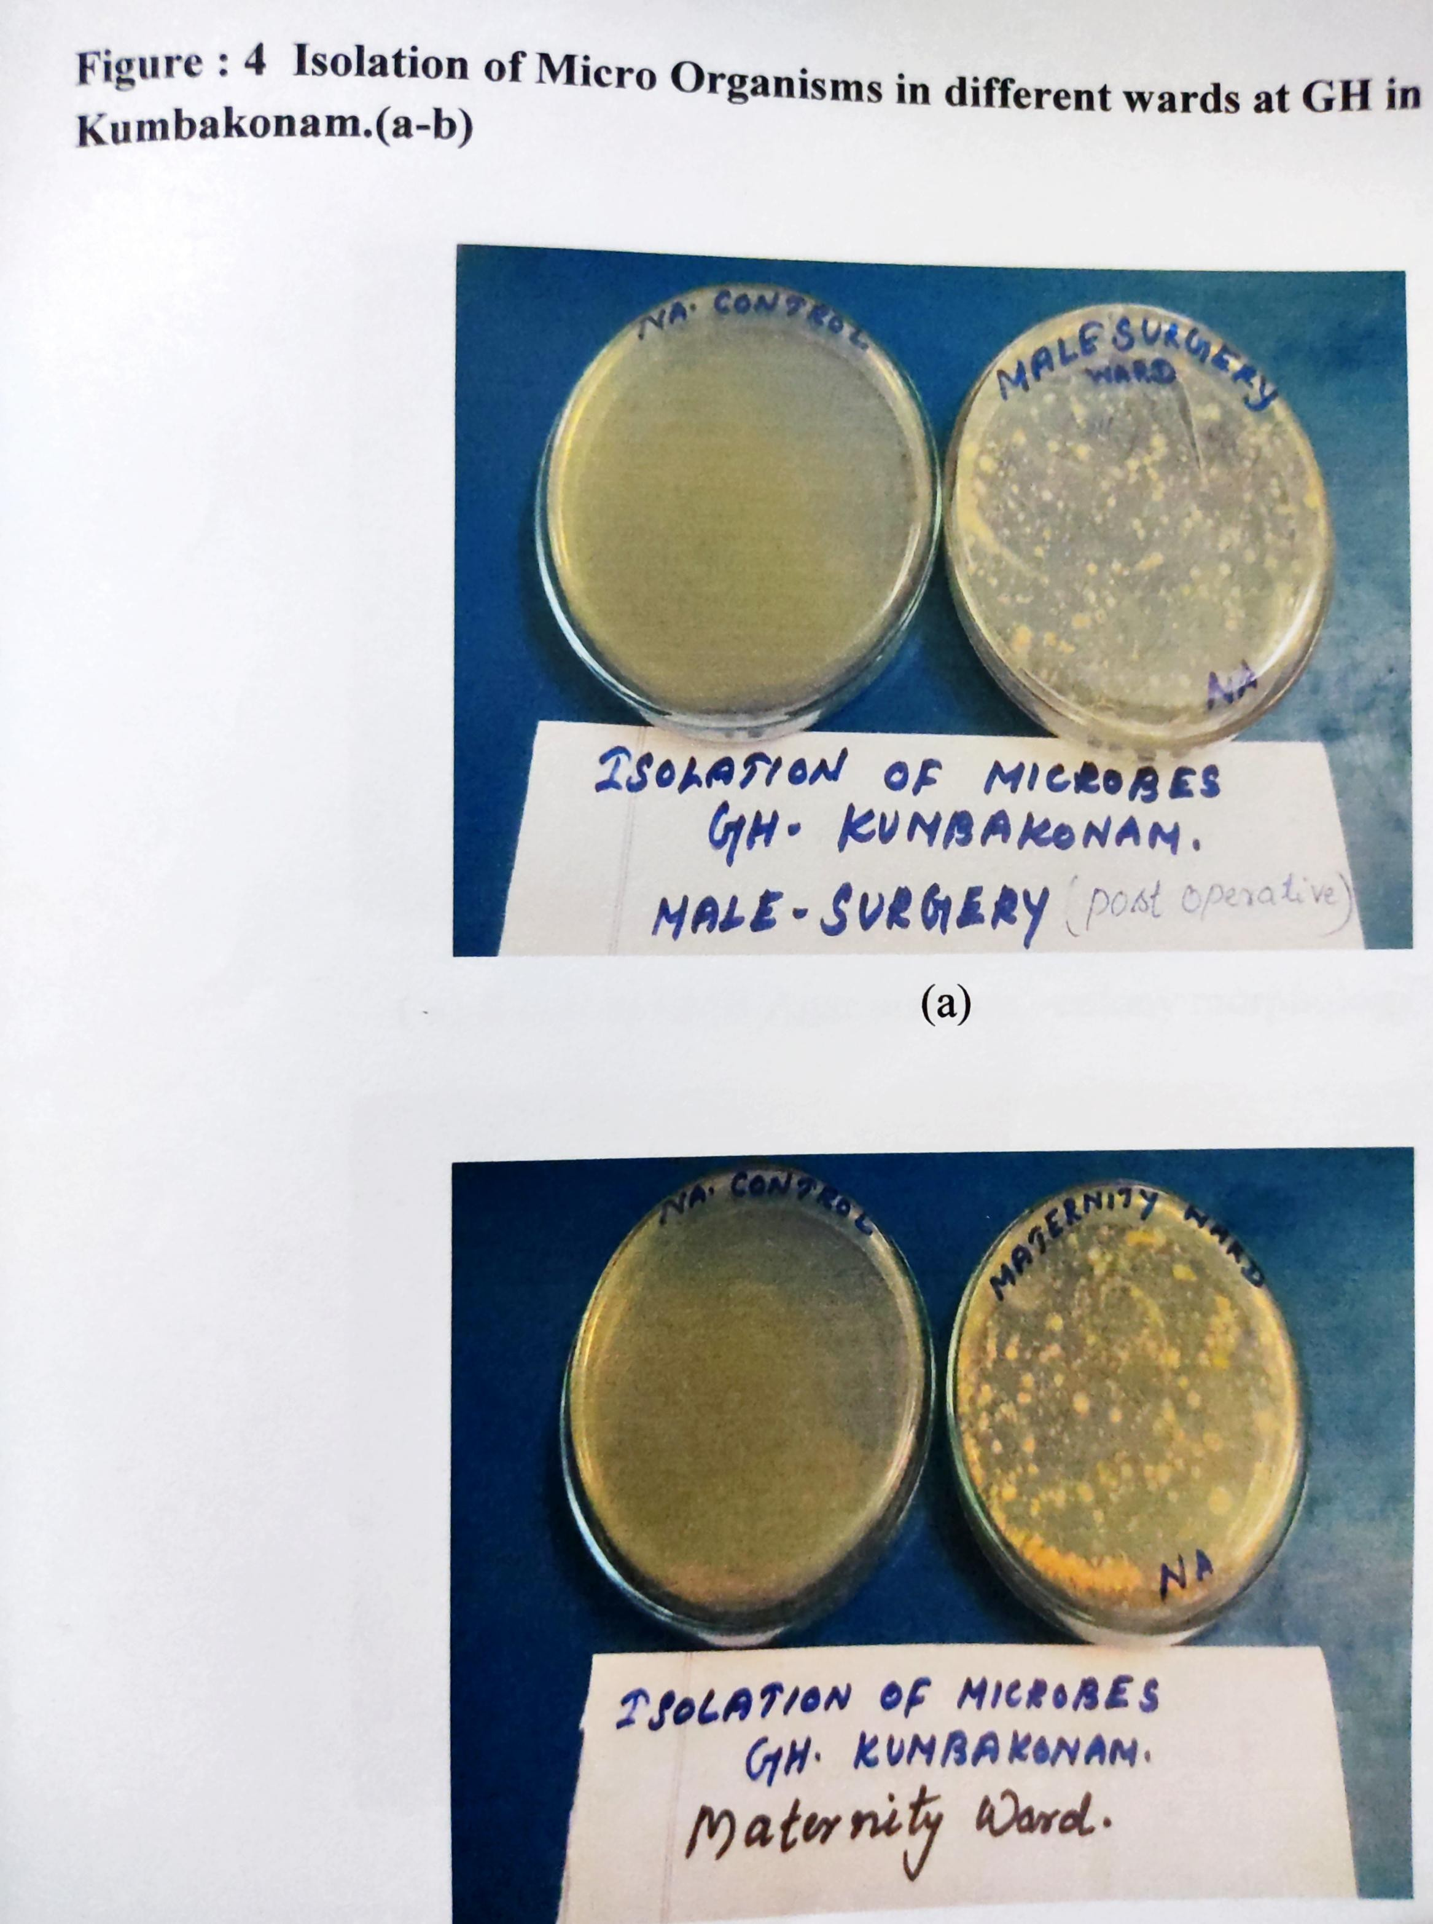

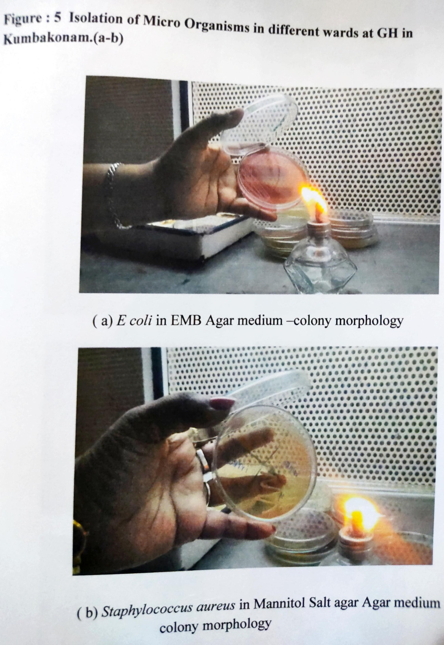

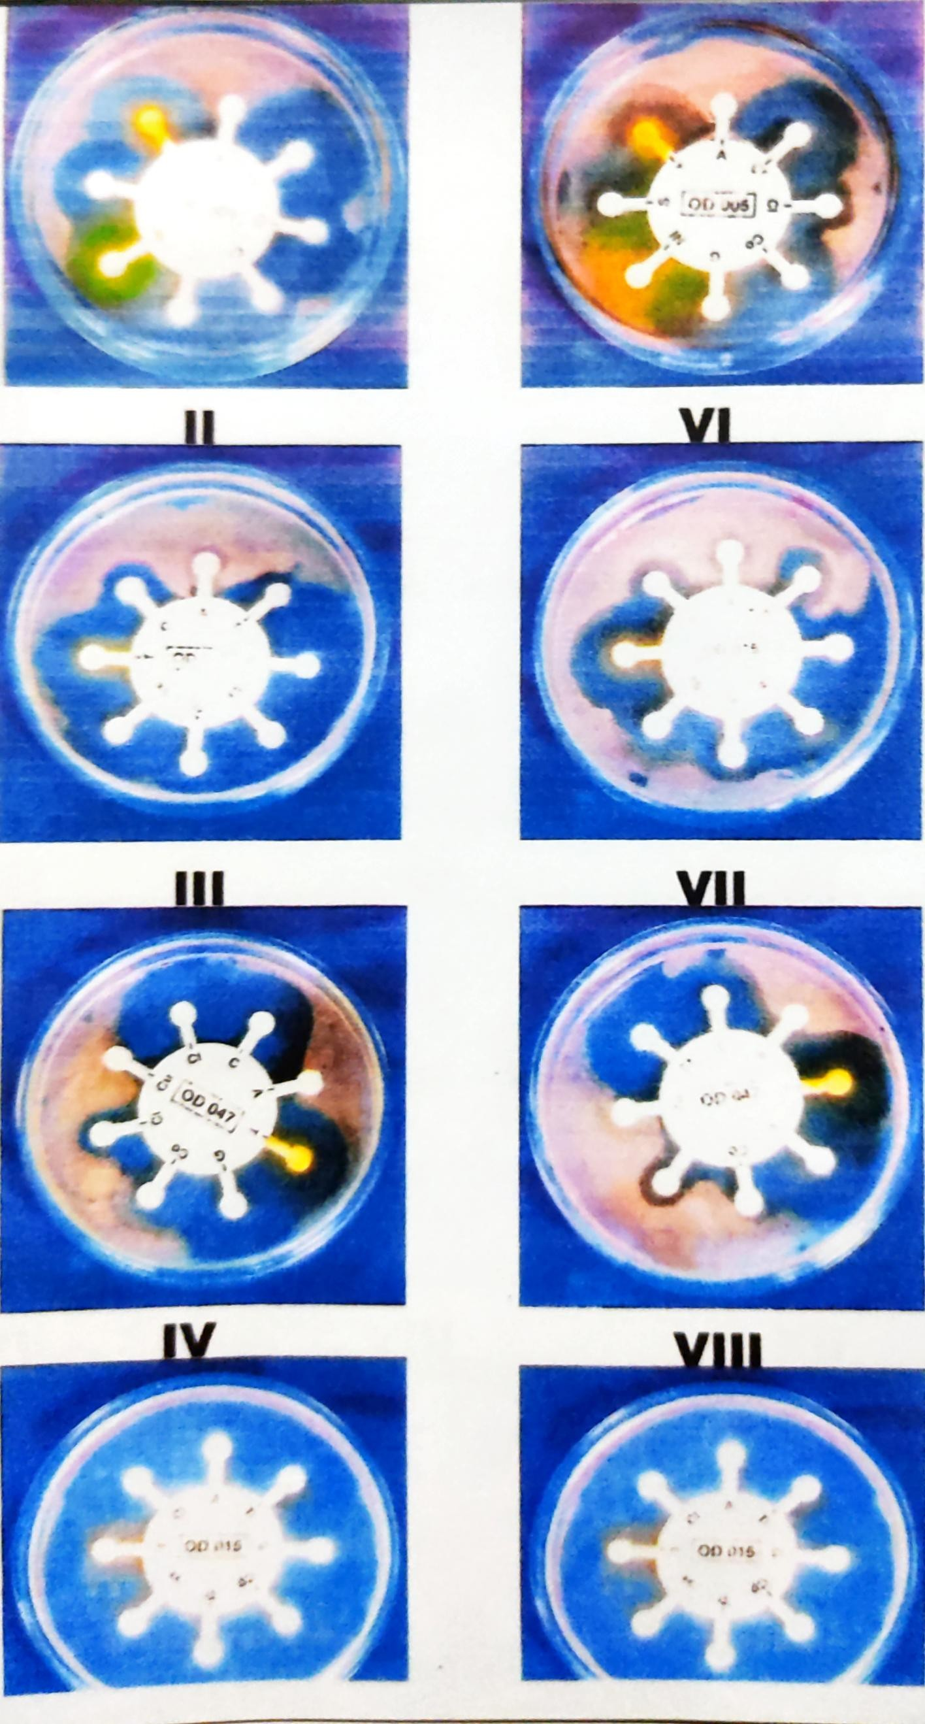

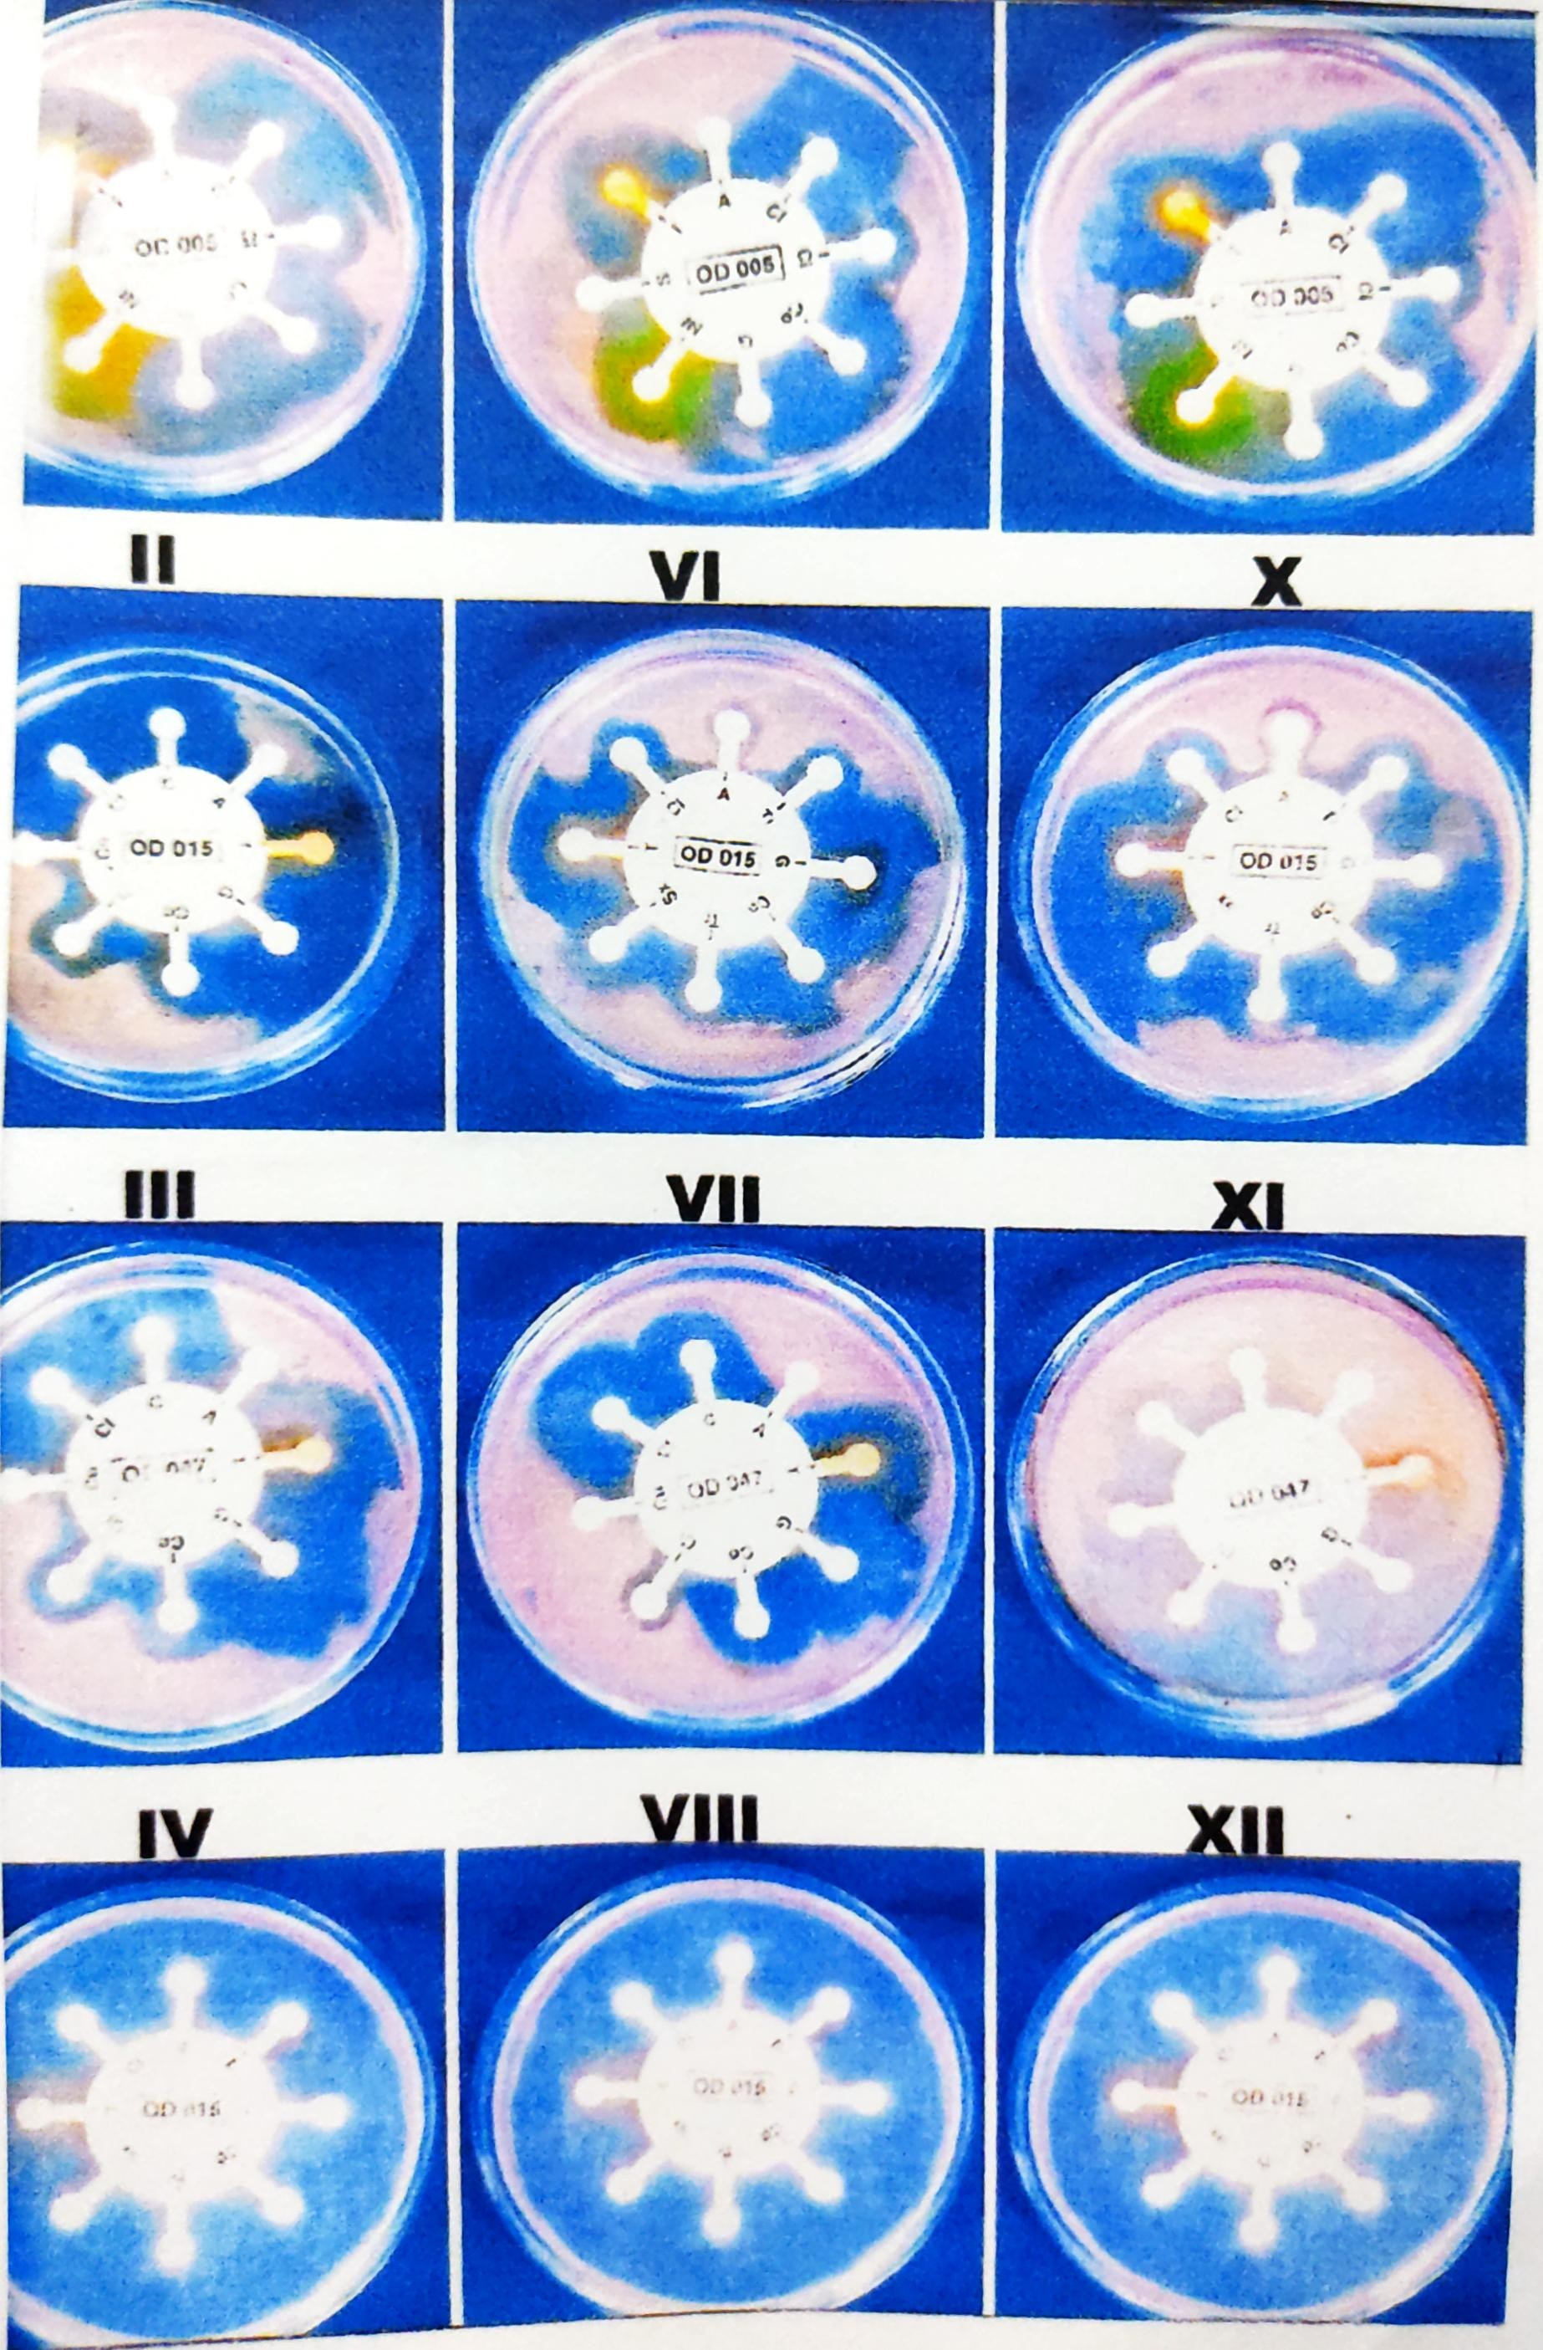

REFERENCE:
- Jaffal AA, Bannat IM, EI Mogtheth AA, Nsanze H, Benar A, Ameen AS. Residential indoor airbone microbial populations in the United Arab Emirates. Environment International.
- Amadi, E.C.and A.M.Amadifi, 2006. Bacteria air micorflora of medical in the surgical wards of a Teaching Hospital in Nigeria . Proceedings, workshop Foundation for Africal Development Through International Biotechnology(FADIB).
- Madigan, M.T.,J.M.Martinko and J.parker , 2000. Brock Biology of Microorganisms 8th Edition. Prentice Hall, Upper saddle River, NJ.
- Ogunbi O. and C.E.Anywo, 1998. Lagos University Teaching Hospital (LUTH) infection control programme. Proceedings Third Edition National symposium on Nsoscominal infections, lagos.pp
- Thomas, C.G.A. 1988 medical microbiology 6th Edn., Bailler Tindall, London,pp.
- Shigemura K. Tanaka k, Okada H, Nakano Y, kinoshita S, Gotoh A, Arakakwa S, fujisawa M, (2005). Pathogen occurrence and antimicrobial susceptibility of urinary tract infections during a 20 year period JPN.
- Silberg SL, Adess ML, Parker DE, Corrie RN,(1976). Epidemiologic aspects of nosocominal infections . South Med J. Wells WF.(1995). Airborne contagion and air hygine. Chapter 1, Harvard University Press, Cambridge, Massachusetts.
- York MK, Baron EJ, Clarridge JE, Thomoson RB, Weinstein MP, (2000). Multi laboratory validation of rapid spot tests for identification of Escherichia coli.J clin Microbiol.

