Artificial Intelligence – Its Evolution, Future, and growing importance in different fields
Mr. Ashwini Saini Mr.Abhishek Gupta Akanksha Joshi Ankit Mahajan
Assistant Professor Assistant Professor B.Tech CSE(AI & ML) B.Tech CSE
CSED, G.B.P.I.E.T CSED, G.B.P.I.E.T G.B.P.I.E.T G.B.P.I.E.T

ABSTRACT
Artificial Intelligence is an umbrella term consisting of Machine Learning, Deep Learning, Computer Vision, Robotics, etc under it. It is being used in various sectors such as Healthcare, Agriculture, and Industries. From being just a concept regarding emulation of the Human Brain, Now Artificial Intelligence has become the present and upcoming future of the world. Faster Diagnosis, Automation of Vehicles, Industries, and Development of Robots are some of its applications. This paper gives a detailed review of the evolution of the concept of Artificial Intelligence, its various domains, applications, and advancements in different fields, and its boom in the future. The future of Artificial Intelligence is hopeful as applying it to all aspects of life can improve its overall quality.
Keywords: Artificial Intelligence, Machine Learning, Deep Learning, Healthcare, E-commerce

INTRODUCTION

As time grows, everything gets evolved. Human Intelligence is one of its examples. Humans evolved in many phases from ancient times to modern times. Human Intelligence is of utmost importance. It is an extremely powerful tool to learn, apply and reinforce the information learned.
To replicate Human Intelligence and make it more faster and efficient, the term “Artificial Intelligence” was introduced. In 1950, Alan Turing published “Computer Machinery and Intelligence” which proposed a test of machine intelligence called the Imitation Game. In 1955, John McCarthy coined the term “Artificial Intelligence”. After that, the era of Artificial Intelligence flourished. Artificial intelligence imitated human intelligence and replicated their learning, and problem-solving processes.
It consists of Machine Learning, Deep Learning, Data Science, Neural Networks, etc which are trying to replicate human intelligence more precisely with a higher accuracy rate while solving any problem. Initially, Machine Learning was used to implement Artificial Intelligence in Machines. When the data increased, due to nonlinearity and relationships among various data, the concept of solving the problems using Artificial Neural Networks came into popularity which we know as Deep Learning. It provides more accurate results as being capable of solving very complex and non-linear problems.
The most important aspect of Artificial Intelligence is that it can Automate the processes and reduce the labor needed which improves efficiency as well as cost-saving.
During the emergency of COVID-19 which exploded as a pandemic for the whole world and everyone was unaware of its nature, Robots became a support for humankind. They worked with frontline workers, and doctors and contribute to spreading awareness. A squad of robots was used in a Medical Centre in Rwanda to defeat the person-to-person transmission of Corona Virus. They were used to provide medicines and other necessities to the patients in the hospitals.
In the medical sector, For the faster diagnosis of various diseases, smart systems have developed. Automation of the process has increased rapidly. In many developed countries, automated markets and stores are available which requires less or negligible Man Power.
Artificial Intelligence has spread in various fields improving its efficiency and reducing the difference between Human Brain and Artificial Brain. The only thing which Artificial Intelligence cannot do is Rational Thinking like the Human Brain.

EVOLUTION OF ARTIFICIAL INTELLIGENCE

Artificial Intelligence has now become a source that has the potential to increase efficiency and change the traditional methods of working in different fields. It is completely based on the imitation of the Human Brain and Intelligence by learning the patterns of the human brain and its cognitive process.
The history of Artificial Intelligence began with the test known as "Turing Test", proposed by the Mathematician, Alan Turing. The main focus of this test was on the Machine's ability to imitate human actions up toss a level that they are considered indifferent to real Human Behavior. This test leads to the exploration of a new field which is currently the present and upcoming future of the world.
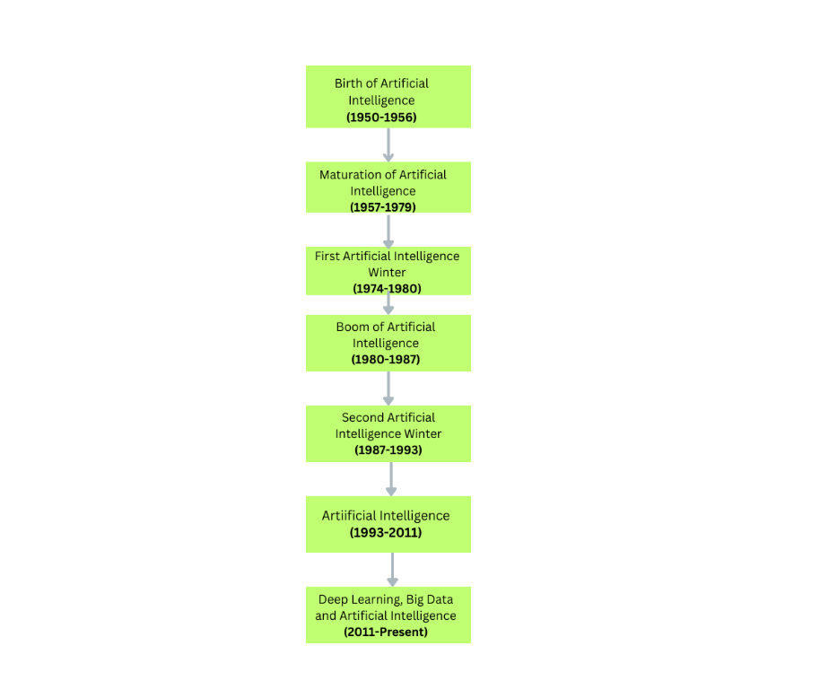
1. Birth of Artificial Intelligence (1950-1956): During this period, researchers from different fields came together to explore the possibility of emulating the human brain. they were inclined towards the formation of the artificial brain. The Turing test conducted by Alan Turing is considered to be the landmark proposal in the history of Artificial Intelligence. In 1956, Dartmouth Workshop organized by Marvin Minsky, John Mccarthy, Claude Shannon, and Nathan Rochester played an immensely important role in the birth of Artificial Intelligence In this workshop, the term Artificial Intelligence was coined. Various predictions regarding the future of Artificial Intelligence were made during this period.
2. Maturation of Artificial Intelligence(1957-1979): As the research started in the field of Artificial Intelligence, various algorithms were developed to solve mathematical/numerical problems.
1n 1964, a Natural Language Processing program was designed by Daniel Bobrow which was able to solve Algebra Word Problems.
ELIZA named chatbot was developed by Joseph Weizenbaum in 1966.
WABOT-1 was the first human-robot built in 1972 by Japan.
3. First Artificial Intelligence Winter(1974-1980): This was one of the difficult times for Artificial Intelligence. During this period, Governments stopped funding the research related to it and everyone started losing interest in this field which made it less popular. Research stopped due to the shortage of funds and no advancement was done.
4. Boom of Artificial Intelligence(1980-1987): During this period, Expert systems were introduced. These are the systems that imitate the ability of humans to reach any decision. Stanford University organized the first National Conference of the American Association of Artificial Intelligence in 1980.
In 1985, Bayesian Networks Analysis was introduced by Judea Pearl which was based on providing statistical techniques to represent uncertainty in computers.
5. Second Artificial Intelligence Winter (1987-1993): This was another period where the government and researchers stopped funding AI research due to the inefficiency of research. The systems were not yielding much productivity as compared to the amount of funds used on them.
6. Artificial Intelligence( 1993-2011): During this period, intelligent agents were used. These agents are the programs that can make decisions by perceiving information from their environment, inputs from users, and learning from their experience.
IBM's Deep Blue beat the world chess champion, Gary Kasparov in 1997.
Facebook, Twitter, and Microsoft started using AI.
7. Deep Learning, Big Data, and Artificial Intelligence (2011- Present): This period showed the advancements of Artificial Intelligence which is being developed today and will continue in the future. The concept of using Neural Networks to train the model to enhance accuracy came into existence. Data Mining, Deep Learning concepts are becoming more popular. It is used in various fields such as Healthcare, Entertainment, Self Driving cars, market analysis and predicting the behavior of customers, etc.

VARIOUS DOMAINS IN ARTIFICIAL INTELLIGENCE
Artificial intelligence is a broad term that can be understood as trying to emulate the work of the human brain and its intelligence. It includes training the machine to learn from its experience and predict the results for the unknown problem, Mining useful information from the data, and analyzing the obtained patterns which can be further used. Machine learning, Deep learning, Computer vision, Natural language processing, Fuzzy logic, Expert system, etc. are the domains of Artificial Intelligence.
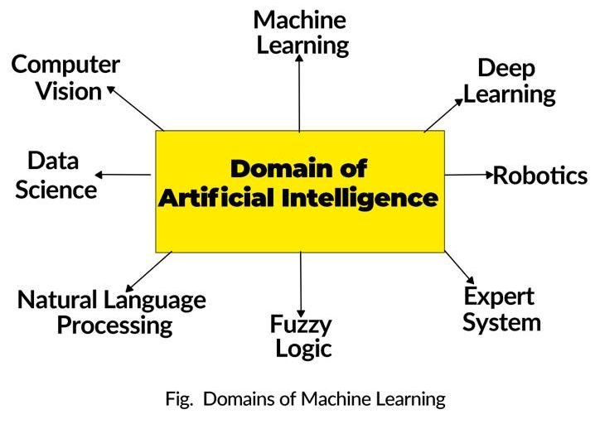

1. Machine Learning: Machine learning is a subset of Artificial intelligence. It means training the machine with data so that it can learn from the given data and identify the patterns or the relationship between the data.
For Example, We want the machine to classify the emails as spam. For that purpose, the program is written and then it is trained with various spam and non-spam mails. The data we used to train the model is called the Training data. The model learns from its experience and classifies the new emails as spam or non-spam based on its experience. The unseen data which is used to test the accuracy of the model is known as Testing data.
Machine learning is divided into 3 categories.
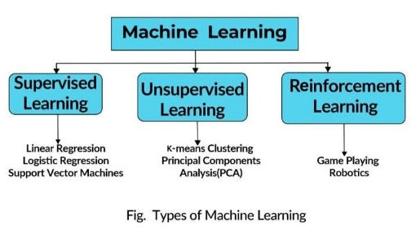
Supervised Learning: It is a type of machine learning technique in which the training data is labeled, that is we know the input and the output variables. It creates a mapping function that predicts the result for new unseen inputs.
Examples: Linear regression, Logistic regression, etc.
Unsupervised learning: In this, the output to the input in the training dataset is not provided. The model has to find the underlying patterns and predict the output on its basis.
Example-:Clustering, Principal Component Analysis, etc.
Reinforcement learning: In this model, it learns from its environment, reacts accordingly and it works on reward and punishment.
Examples: Game playing and Robotics.
2. Deep Learning: Deep Learning is derived from Machine Learning. When the number of layers increases. Interrelation of data increases. The concept of nonlinearity gets introduced. when we have a large number of inputs and outputs. Deep Learning is used. It is more accurate and has higher efficiency as it can deal with many layers of input and output which can be considered as input for another layer based on Artificial neural networks.
Examples: Artificial Neural Networks, Convolutional Neural Networks, Recurrent Neural Networks, etc.
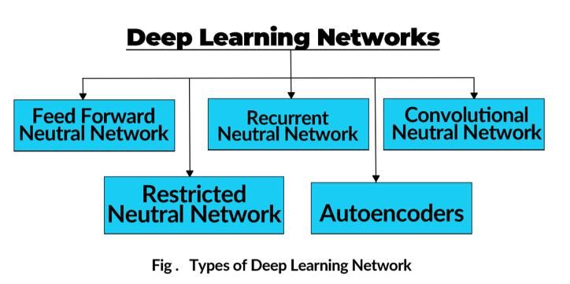
3. Robotics: Robotics is a subset of machine learning which is focused on creating a machine that looks like a human and performs different tasks by replicating human intelligence in the real physical world. They take input in the form of speech, waveforms, or images. Robots are equipped with sensors and effectors through which they can collect information from the real world.
Robots are being used in the healthcare sector, restaurants, etc. to minimize Human Labour.
4. Expert Systems: We have seen some systems where we feed our problems and related information and get suggestions like an actual expert would give. A system that solves complex problems and makes decisions like a human expert is known as an Expert system. They extract the knowledge from the knowledge-based storage, apply reasoning and inference rules and provide the decision to the user Queries.
MYCIN and DENDRAL are some of the expert systems.
5. Fuzzy Logic: Sometimes a situation arises when it's difficult to predict the states as true or false. In this case, fuzzy logic is used. It provides the truth values of the variables in the range of real numbers between 0 and 1.
It represents the uncertainty in making decisions. It is used in Image processing, medical diagnosis, etc.

6. Natural Language Processing: Natural Language Processing refers to an artificial intelligence technique that takes audio as input and breaks it for better understanding. It provides interactivity between the machine and the user. Alexa and Siri are like Voice Assistant language-based chatbots and are working on the principle of Natural Language Processing. It can process text and speech classify text and provides language interactions.
The phases of NLP are as follows: -
- Lexical Analysis: Scans the code as a stream of characters and converts it into lexemes.
- Syntax Analysis: Checks grammar, arrangement of words, and relationship among words.
- Semantic Analysis: Focuses on the real meaning of words and sentences.
- Discourse Integration: Connection between the meaning of one sentence and its following one.
- Pragmatic Analysis: It helps in discovering the real effect of the sentence.

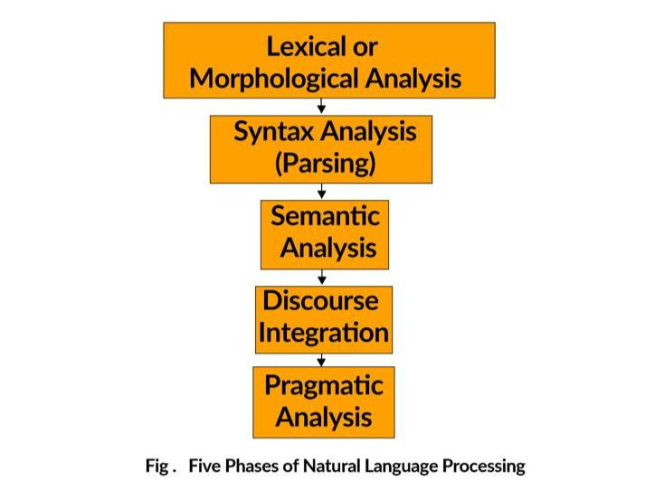
7. Data Science: Artificial Intelligence has immense importance in Business and Industries. It finds the patterns and insights from the large amount of data collected by the business by analyzing it. It can be combined with Associative Mining and Market Analysis to make the business more profitable.
8. Computer Vision: Computer vision refers to the collection of data from real-world images and extracting useful information from it. It is focused on understanding the human vision system and its processing mechanism. It is used for the classification of objects, segmentation of objects, etc. It combines Digital Image processing, Machine learning, and Deep learning to provide more accurate results.

IV. APPLICATION OF ARTIFICIAL INTELLIGENCE IN VARIOUS FIELDS
The main idea behind the creation of Artificial Intelligence was to maximize the efficiency level and minimize labor. It replicated human intelligence so effectively that it can train the models to solve complex problems in a little amount of time. Artificial Intelligence and its subsets are being used in different sectors to improve accuracy and minimize the amount of time taken to perform a particular task. It is leading toward the automation of various processes. Nowadays, Artificial Intelligence is being used in Healthcare, Agriculture, E-Commerce, and Automobiles.
[A] ARTIFICIAL INTELLIGENCE IN HEALTHCARE
Because of its indispensable role in the formation of a healthy society, Healthcare is one of the most important sectors which is progressing with the use of Artificial Intelligence. Artificial Intelligence is playing a very important role in disease diagnosis, preventive care, and tracking of the spread of contagious diseases. Artificial Intelligence is being used in Oncological, Cardiovascular, and Dermatological Diagnosis and is widely appreciated due to its higher efficiency.
Various research and progress have been made in the field of Healthcare and Telemedicine. To allow blind people to get some experience of normal people as an intelligent system named RUDO was developed which supported the blind people in living with people with sight. They can work in electronics, informatics, etc. with the help of this system. The system was based on DSR (Design Science Research) which focuses on solving the problem by design, construction, and evaluation of an artifact.
Many pregnant women are going through the difficult phase of maternity. Smart, Intelligent systems can help her with diet requirements and other suggestions needed. AI can act as an E-Doctor to diagnose a disease and supports the immediate case needed. Machine learning can be used to process high-complexity clinical information, apply reasoning to the data, and use the knowledge received for different purposes.
It covers a wider range of healthcare applications and can be used for the prediction of Urinary Bladder Control, Epileptic seizures, prediction of strokes, etc.
Artificial intelligence combined with Robotics played a crucial role during the time of Covid. Robots were used for disinfection purposes, delivery of medicine, and other necessities. Systems were designed for tracking COVID-19 symptoms, assisting the Nasopharyngeal swap sample collection, Check the proximity with COVID-19 patients.
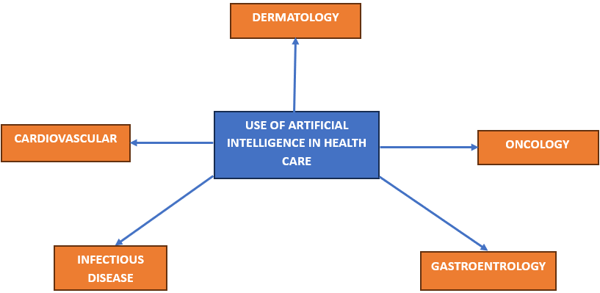
Dermatology: Skin cancer named 'Melanoma' is one of the deadliest cancers which can be evaluated early through the AI with CNN. It has provided an advancement to the research based on skin cancer. It can also differentiate between Benign and Malignant Lesions and has given birth to Tele dermatology in which you upload a picture of your skin, and it gives a detailed analysis of your skin. Apps such as Cure Skin and Skin Craft are providing this feature.
Cardiovascular Diseases: It is the leading cause of death. Artificial intelligence can predict the disease early and can ask patients about the warning. New smartwatches in the market can take your heart reading from ECG and provide you with warning signs in case of an emergency.AI can also predict the abnormal condition that can lead to death with the help of the previous dataset.
It can be used in predicting cancerous cells. Alzheimer's detection using MRI scans, which can make healthcare more efficient and effective.
[B] ARTIFICIAL INTELLIGENCE IN ROBOTICS
When Artificial intelligence and Robotics get combined, it creates a driving force for the creation of new industries which increase the efficiency of labor. Training robots to perform different types of tasks using machine learning data to save costs and labor. Prosthetic arms, Humanoid Robots are the example of machine learning combined with robotics. They are well equipped with sensors, processing units, and speech recognition systems to announce the efficiency of the systems.
[C] ARTIFICIAL INTELLIGENCE IN ENTERTAINMENT
This is the era of technology and the Internet. Without the Internet, our world seems to be lonelier. Whenever you are scrolling through the Internet on Facebook, Netflix, or Instagram. It starts showing preferences according to your searches. Are you aware that this is the result of Artificial Intelligence? To enhance your interest in a particular platform, It collects the data searched by you. By using Machine learning, it finds interesting patterns in your searches and gives you recommendations according to them. These kinds of recommendation systems are the results of the progression of Artificial Intelligence in the field of Entertainment.
[D] ARTIFICIAL INTELLIGENCE IN VEHICLES
The automobile is one of the robust industries which has a large scope. Self-driving cars are the most advanced feature of Artificial Intelligence. These cars can drive on road without the human intervention. This auto-driving mode is one of the craziest achievements of Neural networks and machine learning. These self-driving cars have a well-established connection between sensors and cameras which helps in identifying the object in front of the car. It is also connected with Google Maps to provide accurate driving routes, but these projects are not readily available in the whole world. This field is being monitored to avoid any kind of casualties. Google has its self-driving car project. Automobile companies such as Tesla and Audi already have their self-driving cars in the testing phase. The USA is implementing this concept of self-driving cars and has six levels of driving from level 0 being human driving to level 6 being fully automated driving.
[E] ARTIFICIAL INTELLIGENCE IN E-COMMERCE
E-commerce implies running a business online that is selling products or services over the Internet. Amazon, Flipkart, Myntra, Nykaa, and Snapdeal are some of the largest e-commerce companies which have a huge turnover. To remain part of the race in the first paged world, one needs to get involved. Periodically analyzing the preferences of the customer through their search history and identifying the unseen patterns from it is of utmost importance. These patterns can give us the advantage of the likelihood of the customer's necessities and interests. All the leading companies are using artificial intelligence in the form of data mining, data science, big data, and machine learning. The recommendation list we see is an elegant example of AI in e-commerce.
[F] ARTIFICIAL INTELLIGENCE IN AGRICULTURE
Agriculture is the backbone of any country to overcome the problem of inadequate food. It is of the utmost importance. All of the citizens of any country are dependent on agriculture to get food to survive. Due to increasing population and climatic changes, the agriculture sectors have been badly impacted to improve the overall production agriculture now combined with artificial intelligence, robotics, and sensing systems has decreased labor, saved time, and increased the yield of crops. Agriculture robots have been developed to deal with the diverse aspects of the agriculture sector.
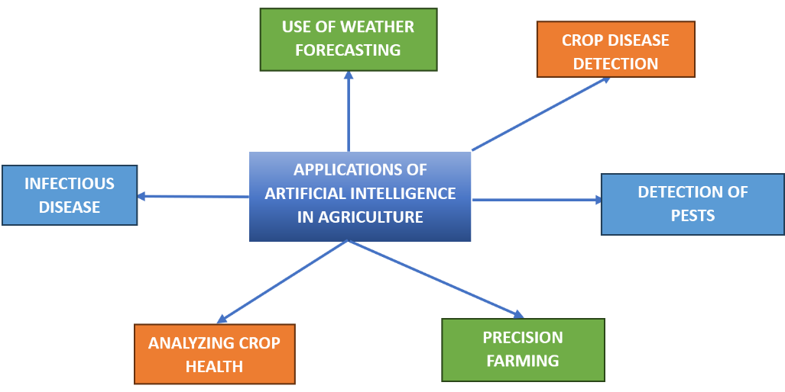
Soil management: Soil is the most valuable step for agriculture. There should be an adequate amount of nutrients in the soil. AI maps the soil-land relationship and helps in identifying the suitability of soil for the crops.
Weed management: Weed is one of the major concerns that hamper the crop yield to kill the weeds. AI systems that provide an adequate number of insecticides or pesticides have been developed with the help of artificial intelligence.
Crop and disease dissection.: Crops growth is greatly hampered by diseases. By different types of diseases, artificial intelligence. With machine learning, deep learning, and neural networks, we have developed models to classify crop diseases with the help of a camera for capturing the input and the model classifies the diseases.

V. FUTURE OF ARTIFICIAL INTELLIGENCE
Artificial Intelligence is progressing at a very fast rate in today’s time which is relatively tough to keep up. It is focusing on improving the overall quality of life of human beings. The main aim of the advancement of artificial intelligence is to increase the speed and accuracy of processes and save precious time. It has spread into different fields like Healthcare, Self Driving vehicles, E-commerce, etc. Many of the processes are being automated with the help of Artificial Intelligence, Machine Learning, and Deep Learning. In the USA, Self Driving Cars have been put to testing and are also allowed on roads with some guidelines. The future of Artificial Intelligence will be a boom for the whole world. It will automate the processes, and improve accuracy and efficiency. By 2050, Most of the processes will get automated. CHATGPT is one of the most prominent examples of the advancement of AI. The Reliance Retail Brand Azorte stores will be fully automated which will be one of the examples of the futuristic Artificial Intelligence. More advanced research on complex diseases and their early diagnosis and prognosis will be the future of Artificial Intelligence.
VI. CONCLUSION
Artificial Intelligence is a broad term that was developed on the idea of mimicking the human brain, its network of neurons, and cognitive processes. It has become the trend of the future. The evolution of Artificial Intelligence from being just a concept to becoming a reality is a journey itself that took the hard work of many researchers and scientists. The various subdomains of Artificial Intelligence have their characteristics and specialty when it comes to solving different kinds of problems. To solve the problems, getting early diagnosis and preventive care are the most important applications of Artificial Intelligence. Smart watches with Heart Rate Monitoring Systems, Crop disease detection systems using drones and cameras, Early diagnosis of deadly diseases, and some of the boon outcomes for us. AI is spreading in all the fields such as Industries, TeleMedicine, and Gaming, and improving its importance. But it cannot think rationally like the human brain, so it can become a topic of concern if not handled correctly. We should control Artificial Intelligence not let AI control us. This is an advantage that should be utilized in a regulated and organized manner. Its controlled use will have good effects on the overall quality of life
REFERENCES

[1] Basu K, Sinha R, Ong A, Basu T. Artificial Intelligence: How is It Changing Medical Sciences and Its Future? Indian J Dermatol. 2020 Sep-Oct;65(5):365-370. doi: 10.4103/ijd.IJD_421_20. PMID: 33165420; PMCID: PMC7640807. https://www.ncbi.nlm.nih.gov/pmc/articles/PMC7640807/
[2] J. Liu et al., "Artificial Intelligence in the 21st Century," in IEEE Access, vol. 6, pp. 34403-34421, 2018, doi: 10.1109/ACCESS.2018.2819688.
[3] H. Zhao, G. Li and W. Feng, "Research on Application of Artificial Intelligence in Medical Education," 2018 International Conference on Engineering Simulation and Intelligent Control (ESAIC), Hunan, China, 2018, pp. 340-342, doi: 10.1109/ESAIC.2018.00085.
[4] K. Hussain, X. Wang, Z. Omar, M. Elnour and Y. Ming, "Robotics and Artificial Intelligence Applications in Manage and Control of COVID-19 Pandemic," 2021 International Conference on Computer, Control and Robotics (ICCCR), Shanghai, China, 2021, pp. 66-69, doi: 10.1109/ICCCR49711.2021.9349386.
[5] Zawacki-Richter, O., Marín, V.I., Bond, M. et al. Systematic review of research on artificial intelligence applications in higher education – where are the educators?. Int J Educ Technol High Educ 16, 39 (2019). https://doi.org/10.1186/s41239-019-0171-0.
[6] Jiang, F., Jiang, Y., Zhi, H., Dong, Y., Li, H., Ma, S., ... & Wang, Y. (2017). Artificial intelligence in healthcare: past, present and future. Stroke and vascular neurology, 2(4).
[7] Secinaro, S., Calandra, D., Secinaro, A., Muthurangu, V., & Biancone, P. (2021). The role of artificial intelligence in healthcare: a structured literature review. BMC medical informatics and decision making, 21, 1-23.
[8] Rong, G., Mendez, A., Assi, E. B., Zhao, B., & Sawan, M. (2020). Artificial intelligence in healthcare: review and prediction case studies. Engineering, 6(3), 291-301.
[9] R. Sharma, "Artificial Intelligence in Agriculture: A Review," 2021 5th International Conference on Intelligent Computing and Control Systems (ICICCS), Madurai, India, 2021, pp. 937-942, doi: 10.1109/ICICCS51141.2021.9432187.
[10] Jha, K., Doshi, A., Patel, P., & Shah, M. (2019). A comprehensive review on automation in agriculture using artificial intelligence. Artificial Intelligence in Agriculture, 2, 1-12.
[11] Talaviya, T., Shah, D., Patel, N., Yagnik, H., & Shah, M. (2020). Implementation of artificial intelligence in agriculture for optimisation of irrigation and application of pesticides and herbicides. Artificial Intelligence in Agriculture, 4, 58-73.
[12] L. Li, S. Zhang and B. Wang, "Plant Disease Detection and Classification by Deep Learning—A Review," in IEEE Access, vol. 9, pp. 56683-56698, 2021, doi: 10.1109/ACCESS.2021.3069646.
[13] L. Ale, A. Sheta, L. Li, Y. Wang and N. Zhang, "Deep Learning Based Plant Disease Detection for Smart Agriculture," 2019 IEEE Globecom Workshops (GC Wkshps), Waikoloa, HI, USA, 2019, pp. 1-6, doi: 10.1109/GCWkshps45667.2019.9024439.
[14] Zha, J. (2020, December). Artificial intelligence in agriculture. In Journal of Physics: Conference Series (Vol. 1693, No. 1, p. 012058). IOP Publishing.
[15] Mateas, M. (2003, November). Expressive AI: Games and Artificial Intelligence. In DiGRA Conference (Vol. 15).
[16] https://www.analyticsvidhya.com/blog/2020/11/artificial-intelligence-in-agriculture-using-modern-day-ai-to-solve-traditional-farming-problems/
https://en.wikipedia.org/wiki/Artificial_intelligence_in_healthcare
https://www.ncbi.nlm.nih.gov/pmc/articles/PMC6748906/
[17] Hudec M, Smutny Z. RUDO: a home ambient intelligence system for blind people. Sensors 2017;17(8):1926
[18] Liopyris, K., Gregoriou, S., Dias, J. et al. Artificial Intelligence in Dermatology: Challenges and Perspectives. Dermatol Ther (Heidelb) 12, 2637–2651 (2022). https://doi.org/10.1007/s13555-022-00833-8
[19] Abraham A, Sobhanakumari K, Mohan A. Artificial intelligence in dermatology. J Skin Sex Transm Dis 2021;3(1):99-102.
[20] Bawack, R. E., Wamba, S. F., Carillo, K. D. A., & Akter, S. (2022). Artificial intelligence in E-Commerce: a bibliometric study and literature review. Electronic markets, 32(1), 297-338.

