Detection of Bacterial Blight on Cotton by Using Hyperspectral Reflectance.

Priyanka U. Randive
Department of Computer Science & IT,
Dr. B. A. M. University,
Aurangabad.
priyankarandive7@gmail.comd

Ratnadeep R. Deshmukh
Department of Computer Science & IT,
Dr. B. A. M. University,
Aurangabad.
rrdeshmukh.csit@bamu.ac.in

ABSTRACT
Remote sensing is crucial in agriculture for identifying pests and disease infestations in crops, reducing production and quality. Hyperspectral remote sensing sensors record reflectance in narrow bands of electromagnetic spectrum, including visible, near-infrared, and short wave infrared regions. Early detection of disease on cotton crops is crucial for timely control. This research uses an ASD FieldSpec4 spectroradiometer to capture spectral data from leaf samples, analyzing physical and biochemical changes in crops in a nondestructive way. Spectral vegetation indices (VI) are used to derive reflectance properties of vegetation, highlighting specific vegetation properties. Bacterial Blight infection on cotton crop is categorized in different grades. Vegetation indices, MCARI, TCARI, NPCI, OSAWI used to find the infection effects. SVM and Decision Tree classifier is used to find the results. SVM and Decision tree classifier gives training accuracy R² as 91.66 and 92.85 and Mean Square Error 0.08 and 0.07 respectively. At Validation stage SVM and Decision Tree gives result R² as 95.55 and 95.83 and Mean Squared Error 0.06 and 0.01 respectively.
Keywords—Remote Sensing, Bacterial Blight, Cotton, Spectroscopy, ASD Fieldspec, Vegetation Indices

INTRODUCTION

Hyperspectral Remote Sensing
Hyperspectral Remote Sensing (HRS) is a new technology used for analyzing various objects and their biological and chemical compositions. It covers a wide range of electromagnetic spectrum, including visible, near infrared, and SWIR regions. Spectroscopy detects specific absorption features due to bonding in solid, liquid, and gaseous objects [1]. Remote sensing can be useful in detecting disease within crops in a short period.
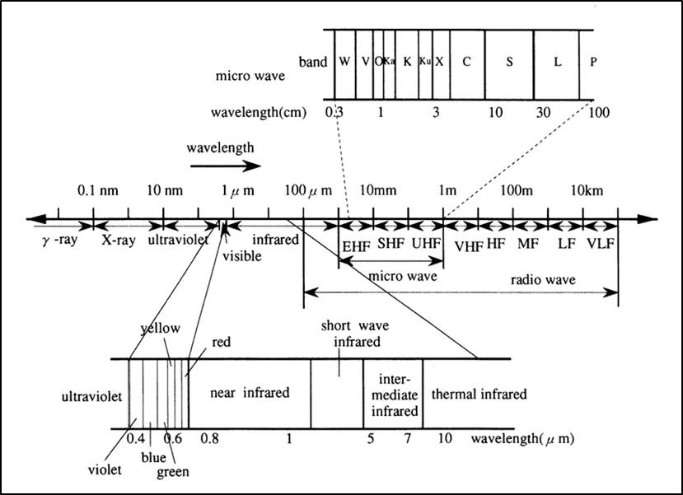
Figure 1. Spectral Bands used in Remote sensing [2]

Remote Sensing Applications in Agriculture
Remote sensing technology offers numerous applications in agriculture, including crop production forecasting, assessment of crop damage and progress, horticulture, crop identification, crop acreage estimation, crop condition assessment and stress detection, planting and harvesting dates, crop yield modeling and estimation, pest and disease identification, soil moisture estimation, soil mapping, problematic soils, and crop nutrient deficiency detection [3]. Remote sensing technology helps farmers predict crop yields, assess crop damage and progress, and analyze flower growth patterns and crop systems. It also helps in identifying pests and disease infestations, estimating soil moisture, and determining the type of crop to plant in specific soils. Remote sensing technology also helps farmers identify problematic soils, ensuring the soil is suitable for the crop they can grow. By detecting nutrient deficiencies in crops, remote sensing technology helps farmers plan remedies to increase yields and improve overall agricultural practices.

Bacterial Blight
Bacterial blight of cotton, caused by the bacterium Xanthomonas malvacearum occurs in all the aerial parts of the plant and encompasses descriptive names such as seedling blight, angular leaf spot, leaf vein blight, black arm and bacterial boll rot [4]. Monitoring cotton disease by traditional way is very hectic and time-consuming. Bacterial blight is a rapidly growing disease affecting cotton crops worldwide, causing decreased crop yield and quality loss. Controlling disease using biological and chemical measures like pesticides and herbicides is challenging. Traditional methods require expert identification, but remote sensing plays a crucial role in precision farming by identifying disease effects, nutrient and water stress, and pest-affected plants. This cost-effective and economical method helps identify disease and pest-affected plants, ensuring better crop conditions and economic growth.
- Bacterial Blight Symptoms:
The bacterium attacks all stages from seed to harvest usually five common phases of symptoms are noticed. At the time of the seedling stage, seedling blight occurs. When it occurs on leaf it called leaf blight or angular leaf spot. Bacterial attack when happen on veins of the plant it called Vein blight. Infection of the bacteria’s occurred on stem them it causes black arm. When bacteria attack in the bolling stage of the cotton plant then it is called boll rot or square rot.

Disease Detection Techniques
Molecular techniques for plant disease detection involve extracting the genetic material of the disease-causing microorganism, but they require detailed sampling and processing procedures. Imaging techniques allow pre-symptomatic monitoring of changes in plant physiological state and disease-related changes in light emission patterns. These techniques can be applied on microscopic observation to airborne remote sensing, allowing for early crop monitoring and reducing yield losses. Spectroscopic techniques, such as fluorescence, visible, and near-infrared spectroscopy, provide information on disease detection at early stages, controlling disease spread, identifying stress levels, and monitoring fruit and vegetable quality.

VEGETATION INDICES USED FOR EVALUATE CROP CONDITION

VI are mathematical combinations of spectral bands used for qualitative analysis of vegetation dynamics, including plant growth, health, and attributes. These algorithms are widely used in remote sensing applications and can identify specific features by detecting changes in the electromagnetic spectrum sensitivity[5]. VI helps identify plant type, water content, and inherent plant contents[6]. Researchers have developed vegetation indices to determine vegetation cover and biochemical properties quantitatively and qualitatively.Maintaining the Integrity of the Specifications.

- Spectral Vegetation Indices for finding disease effect.

There are a number of VI are available for a number of purposes. There is some VI that is used to identify disease effects on the plant. MCARI (Modified Chlorophyll Absorption in Reflectance Index),TCARI (Transformed Chlorophyll Absorption in Reflectance Index),NPCI (Normalized Pigment Chlorophyll Index), and OSAWI (Optimized Soil-Adjusted Vegetation Index)[7].
- MCARI (Modified Chlorophyll Absorption in Reflectance Index)
Kim in 1994 developed CARI index i.e. chlorophyll absorption ratio index [8].Which measures the depth of the chlorophyll absorption at 670 nm and peak at 550 nm and 700 nm. These indices were developed to reduce the visibility of the photosynthetically active radiation due to the presence of varied photosynthetic materials. These indices are used to identify the absorption due to the chlorophyll a.
MCARI = [(R₇₀₀ - R₆₇₀) – 0.2*(R₇₀₀ – R₅₅₀)]*(R₇₀₀/R₆₇₀)

- TCARI (Transformed Chlorophyll Absorption in Reflectance Index)
TCARI is also used to find out chlorophyll absorption. MCARI is affected by various parameters like leaf area, background reflectance chlorophyll, etc [9]. This effect is reduced in TCARI. To increase the sensitivity at low chlorophyll values TCARI is defined.
TCARI = 3*[(R₇₀₀ - R₆₇₀) – 0.2*(R₇₀₀ – R₅₅₀)(R₇₀₀/R₆₇₀)]
- OSAVI (Optimized Soil Vegetation Index)
OSAVI optimized soil vegetation index which belongs to the SAVI i.e. Soil-adjusted vegetation index. OSAVI is defined with the following equation. Daughtry et al. (2000) proved that MCARI combined with an OSAVI, the sensitivity to the fundamental soil reflectance properties can be reduced.
OSAVI = (1 + 0.16)(R₈₀₀ - R₆₇₀)/(R₈₀₀ + R₆₇₀ + 0.16)
- NPCI (Normalized Pigment Chlorophyll Index)
NPCI is Normalized Pigment Chlorophyll Index. This index is used in the improvement of Nitrogen management of the plant-based on the chlorophyll contents of the leaves. NPCI shows significant change in leaf when the color of the leaf began change [10].
NPCI= (R₆₈₀ – R₄₃₀)/(R₆₈₀ + R₄₃₀)

DESIGN AND DEVELOPMENT OF SYSTEM
- Conceptual Model
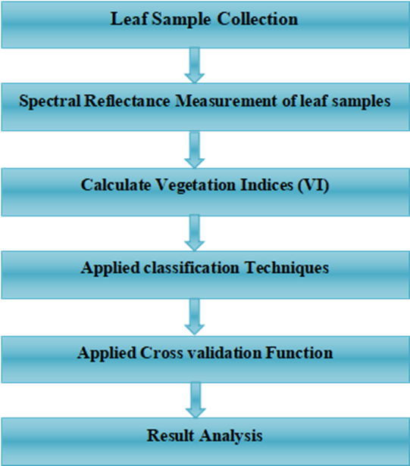
Figure2. Conceptual model
- Data Collection And Analysis
Cotton leaf samples from the study area were collected such as healthy leaves and diseased leaves with dark black spots on the leaf. These leaves were placed in airtight bags to maintain freshness of leaves fresh. Spectral reflectance of leaf samples were measured within 2 hours from plucking from the plant. Spectral reflectance of leaves was collected using device Fieldspec4 Spectroradiometer in controlled condition inside the lab at the Department of Computer Science and Information Technology, Dr. Babasaheb Ambedkar Marathwada University Aurangabad. Fielspec4 Spectroradiometer provides a wide range of reflectance from 350 to 2500 nm. With a sample range of 3 to 10 nm (350 to 1000 nm to 1000 to 2500 nm). Device comes with a 50W quartz halogen lamp as the light source.The Distance of the sample from the light source kept 40cm. Height of light source kept 42 cm. The distance between the sample and spectral gun was 11 cm. Before taking a spectral signature of the leaf optimization and calibration of the device were done using white reflectance panel. Ten spectral signature of each leaf sample was collected. The mean spectra of ten spectral signatures is considered for further analysis. For data visualization and analysis, ViewSpecPro Software was used.

For training data samples of cotton, leaves are considered. That leaves were divided inside four groups namely Grade 0th, Grade 1st, Grade 2nd, Grade 3rd. Grade 0 leaves belonged to healthy class and from grade 1 to grade 3 leaves were belongs to diseased class. For classification of leaves in the diseased group was decided from the number of black spots and the size of the black spot visible on the leaf.

For testing data set hundred leaf samples of cotton leaves are considered plucking from ten plants. From each plant, ten leaves were collected(4 from top, 3 from middle and 3 from bottom). This is to identify the disease effect in plant[11].
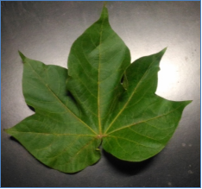 | 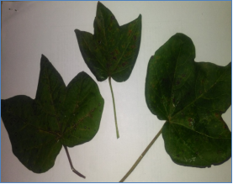
a) | b)
Figure 3. Cotton Leaf Samples a) Healthy leaf b) Diseased leaves
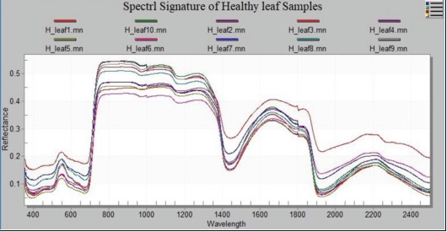
Figure 4. Spectral signature of healthy leaf samples
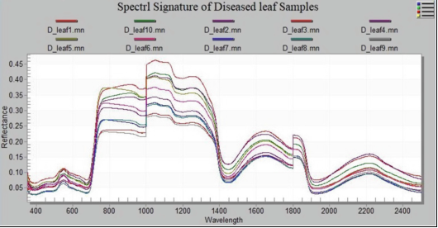
Figure 5. Spectral signature of diseased leaf samples.

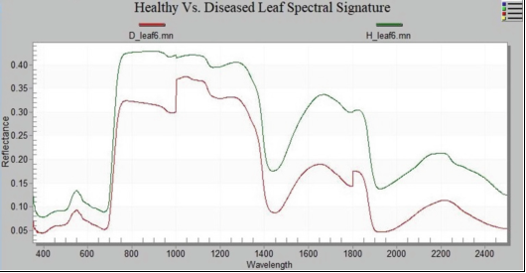
Figure 6. Healthy Vs. Diseased leaf.
From the figures, we see that higher reflectance found in a healthy group of cotton leaves than the reflectance found in the diseased group of cotton. NIR region is mostly affected in diseased leaves shows less reflectance. That due to disease effect on the cell structure of leaf. We can say that cell structure is damaged in diseased leaves due to the disease. Whereas healthy leaves show higher reflectance in all regions of the electromagnetic spectrum. This information is helpful for studying disease effects on the plant's body.

RESULTS
In this study, the samples of cotton leaves collected from the study area. Cotton leaf samples are collected for two purposes. To identify healthy and diseased leaf of cotton and identify average percentage effect of disease on plant.
For the first purpose, healthy and diseased leaves are collected separately and for identifying the average effect of disease on plant 10 leaf samples of plant were collected(4 top, 3 middle, 3 bottom).
Spectral signature of the samples were taken using FieldSpec4 Spectroradiometer. This spectral signature covers electromagnetic range from 350 nm to 2500 nm. Ten spectral signature of each sample is collected using FieldSpec4 Spectroradiometer with the help of RS3 software. These spectral signatures then processed using ViewSpecPro software for calculating the mean of each sample and for visualization purpose. After calculating the mean spectra CSV file is generated for further analysis.
- Grading of diseases and percent damage of cotton plant:
Table 1: Grading of cotton by bacterial blight infection
Grade | Symptoms shows of disease
Grade 0 | Healthy leaf
Grade 1 | Three to four Small size black spots
Grade 2 | More than four black spot
Grade 3 | Larger Size dark black spot
Cotton leaf samples included Grade 0, Grade 1, Grade 2, Grade 3 leaves. Diseased leaves are divided into three groups on the basis of the number of black spots and the size of black spots visible on the leaves. Grade 0 indicates healthy cotton leaves. Grade 1 to Grade 3 is the disease leaves. Grade 1 shows minimum infection and Grade 3 shows maximum infection on leaves.
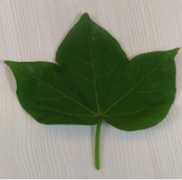 | 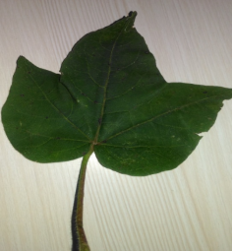
(a) | (b)
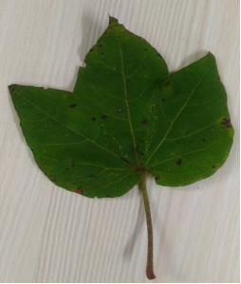 | 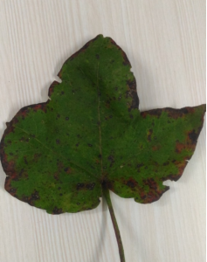
(c) | (d)
Figure7. Diseased grades of cotton leaf
(a) Grade 0 (b) Grade 1 (c) Grade 2 (d) Grade 3
The mean of each sample is considered for the analysis. Vegetation Indices MCARI (Modified Chlorophyll Absorption in Reflectance Index), TCARI(Transformed Chlorophyll Absorption in Reflectance Index), NPCI(Normalized Pigment Chlorophyll Index) are applied over these samples. After calculating indices the file data is used for further analysis.

The following table shows the calculated Vegetation Indices value of sample data.
Table 2: Calculation of Vegetation indices.
Sr. No. | NPCI | MCARI | TCARI | Grade
1 | 0.040359 | 0.107026 | 0.207443 | 0
2 | 0.079755 | 0.12731 | 0.217759 | 0
3 | -0.02222 | 0.052095 | 0.098945 | 1
4 | -0.02857 | 0.060612 | 0.102424 | 1
5 | -0.02941 | 0.03437 | 0.066745 | 2
6 | -0.01449 | 0.043329 | 0.079165 | 2
7 | -0.06349 | 0.076271 | 0.143339 | 3
8 | -0.06349 | 0.075932 | 0.142322 | 3
9 | 0.041667 | 0.052138 | 0.126 | 0
10 | 0.09375 | 0.085341 | 0.150097 | 0

For multilevel disease identification SVM and Decision Tree classifier were applied over calculated vegetation indices data file of the cotton leaves sample spectral data. For validation purpose K- fold cross-validation function is applied to check the correctness of the result.
Figure 8. Spectral signature of different grades.
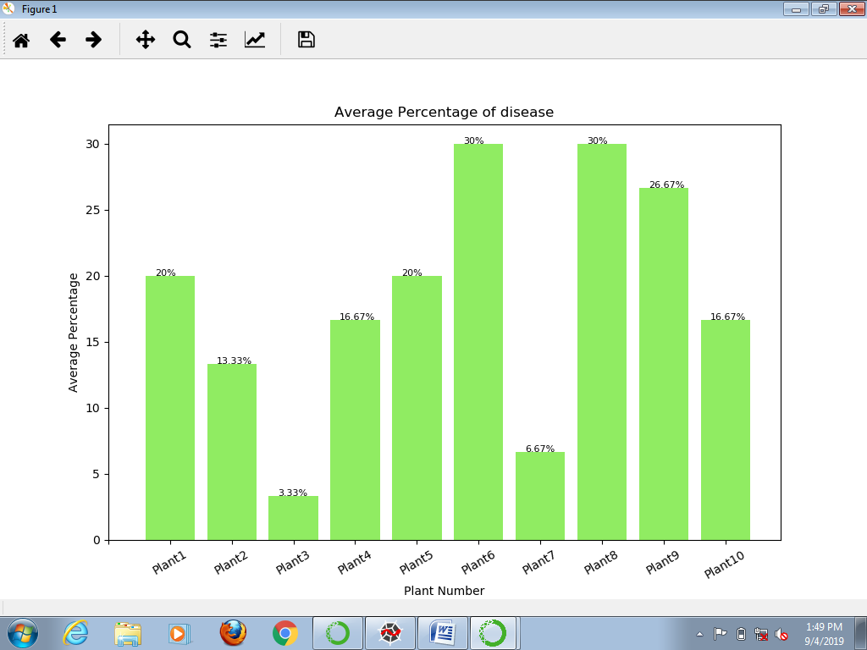
Figure 9. Average percentage of disease on plant
NPCI vegetation index gives a clear indication that leaf is a diseased leaf or normal leaf. NPCI value found less in diseased leaves and an increase in healthy leaves . MCARI and TCARI values are found higher in adult leaves as compare to small leaves [12]. The values of MCARI and TCARI not found uniform for the clear classification of healthy and diseased leaves of cotton. Reflectance of healthy leaves found higher than the diseased leaves [13].
Table 3: Result Table
Classifier  Steps | SVM |  | Decision Tree
 | R² | MSE | R² | MSE
Training | 91.66 | 0.08 | 92.85 | 0.07
Validation | 95.55 | 0.06 | 95.83 | 0.01

SVM and Decision tree classifier gives training accuracy R² as 91.66 and 92.85 and Mean Square Error 0.08 and 0.07 respectively. At Validation stage SVM and Decision Tree gives result R² as 95.55 and 95.83 and Mean Squared Error 0.06 and 0.01 respectively. In this result, the Decision Tree algorithm shows better accuracy than the SVM classifier.

CONCLUSION
Found that the spectroscopic technique is useful for plant disease detection than the traditional approach to detect plant disease. The proposed work is presented to detect Bacterial Blight disease on cotton using hyperspectral reflectance to find out Bacterial Blight on cotton using ASD Fieldspec4. It is possible to detect a disease effect on the cotton plant. Decision tree classifier found more significant than SVM for the prediction of disease effect along with the vegetation indices. Hyperspectral data used to analyze disease on the crop that can improve the speed of detection. It gives the opportunity to identify disease in a non-destructive way.

REFERENCES

- Pooja Vinod Janse and Ratnadeep R. Deshmukh, Hyperspectral Remote Sensing for Agriculture: A Review, International Journal of Computer Applications Vol. 172(7), August 2017.
- Campbell J. B., Introduction to Remote Sensing, Taylor and Francis, London, 1996.
- Remote Sensing Applications in Agriculture, https://grindgis.com. [Online] 02 11, 2018. [Cited: 7 13, 2019.] https://grindgis.com/remote-sensing/remote-sensing-applications-in-agriculture.
- COTTON :: MAJOR DISEASE :: BACTERIAL BLIGHT, http://eagri.org/. [Online] 6 8, 2017. http://eagri.org/eagri50/PATH272/lecture13/008.html.
- Xue, J.; Su, B. Significant Remote Sensing Vegetation Indices: A Review of Developments and Applications, Journal of Sensors, Vol. 2017(1), pp. 1-17, 2017.
- L. Chang, S. Peng-Sen,Liu Shi-Rong, A review of plant spectral reflectance response to water physiological changes, Chinese Journal of Plant Ecology, vol. 40(1), pp. 80–91, 2016.
- Gröll K., Graeff S., and Claupein W.,Use of Vegetation indices to detect plant diseases, in: Proceedings of the 27th GIL Annual Conference, 340, Stuttgart, Germany, 5–7 March 2007, pp: 91–94,2007.
- Kim, M.S., Daughtry, C.S.T., Chappelle, E.W., et al. ,Theuse of high spectral resolution bands for estimating absorbed photosynthetically active radiation (Apar), In: Proceedings of the Sixth Symposium on Physical Measurements and Signatures in Remote Sensing, Val D’Isere, France, pp. 299–306, January 17–21,1994,
- Daughtry C. S. T., Walthall C. L., Kim M. S., de Colstoun E. B. and McMurtrey J. E., Estimating corn leaf chlorophyll concentration from leaf and canopy reflectance, Remote Sensing of Environment, Vol. 74, pp. 229-239, 2000.
- Hatfield J.L.,Prueger J.H., Value of using different vegetation indices to quantify agricultural crop characteristics at different growth stages under varying management practices, Remote Sensing, Vol. 2, pp. 562–578, 2010.
- Ranjitha G.,Srinivasan M.R ,Abburi Rajesh ,Detection and estimation of damage caused by aphid, aphis gossypii (glover) in cotton using hyperspectral radiometry, International Journal of Recent Scientific Research, Vol.5( 4) ,PP.750-753, 2014.
- Pramod N. Kamble, Sanjay P. Giri , Ranjeet S. Mane and, Anupreet Tiwana, Estimation of Chlorophyll Content in Young and Adult Leaves of Some Selected Plants, Universal Journal of Environmental Research and Technology, Vol. 5(6), pp.306-310, 2015.
- Tingting Chen , Ruier Zeng , Wenxuan Guo , Xueying Hou , Yubin Lan, Lei Zhang , Detection of Stress in Cotton (Gossypium hirsutum L.)Caused by Aphids Using Leaf Level Hyperspectral Measurements, Sensors,Vol. 18, 2018.

