**Growth Characteristics and Microbial population of *Azadirachta indica* A. Juss and *Eucalyptus camaldulensis* Dehnh Shelterbelts at Kiyawa, Jigawa State**

1, 2 Salami K. D., and 1Lawal, A. A.

1, 2 Department of Forestry and Wildlife Management, Federal University Dutse, Nigeria

2Forest Ecology and Conservation Unit, Center for Arid Zone Ecology, Federal University Dutse, Jigawa State, Nigeria

**Corresponding author’s email:** [foristsalam@yahoo.com](mailto:foristsalam@yahoo.com); 07034294371

### ABSTRACT

This study was carried out at Kiyawa community and aimed at determining tree growth attributes, identifying fungi, bacteria and determining the microbial load in the Neem and Eucalyptus shelterbelt. Data were collected from four temporary sample plots of 30 x 30m each laid at interval of 100 m along a line transect of 500m in length. Also, 1 × 1m subplot was laid within the 30 x 30 m plot and used for soil sample collection. Dbh and total height of all trees were measured using a measuring tape and spigeal relascope while volume and Basal area were calculated using appropriate formula. Potato Dextrose Agar and Nutrient Agar media were used for the isolation of fungi and bacteria. The collected data was analysed using descriptive statistics and t-test. The Neem shelterbelts had the highest Dbh, Basal area, Height, and volume of 82.25cm±1.23, 0.90m2±0.15, 15.90m±0.2, 97.08m3±4.27m3followed by Eucalyptus shelterbeltwhich had the lowest value of 62.50±0.93cm, 0.463±3.43m, 3.75±0.03 and3.48±2.43m.The findings revealed the presence of three (3) bacteria species in each study site. *Staphylococcus aureus* and *Bacillus cereus* were found in the Eucalyptus shelterbelt, while *Bacillus subtilis* and *E. coli* were found in the neem shelterbelt.  However, *Aspergillus flaming* occurred in eucalyptus shelterbelt while *Fusarium oxysporum* was found in Neem shelterbelt. Result showed that mean microbial load of fungi (Eucalyptus = 1.45x 106; Neem = 1.50 x106) was higher than that of bacteria (Eucalyptus = 1.24 x 106; Neem = 1.3 x106). There was significant difference (p≤ 0.05) between the bacterial microbial loads between the two study sites. Thus, the shelterbelt support growth of neem tree and fungal growth. Therefore, interplanting of tree with arable crops is recommended for improved economic production and

enhancement of shelterbelt.

**Keywords:** Growth characteristics, Neem, Eucalyptus, Kiyawa, Microbial population, Shelterbelts

**INTRODUCTION**

Forest inventory is the collection of data and forest information for assessment of its resources. An estimate of the value and possible uses of timber is an important part of the broader information required to sustain ecosystems (Dau and Chukwu, 2018). It provides information on the account of the forested area which includes ownership and accessibility, estimates of timber quality and quantities, estimates of growth and drains. Non-timber information may also be included, such as wildlife resources, areas of recreational and touristic interest, soil and land use capabilities on watershed values and among others (Saka *et al.,* 2020; Salami and Akinyele, 2017). Forest biodiversity protection depend on the ability to assess sites, quantify and predict spatial and temporal trends of key species which maintain a natural disturbance regime and limit harmful human activities (Thompson *et al*., 2009). According to the International Union for Conservation of Nature (IUCN), protected area is an area of land and/or sea dedicated to the protection, maintenance of biological diversity, and of natural and associated cultural resources, and managed through legal or other effective means (IUCN, 1994).

Forest protected areas help to conserve ecosystems which provide cover, food, raw materials, germplasm, a barrier against disasters, a stable source of resources, goods and services which could have an vital role in assisting species, human being and nations to adapt with climate change (<https://www.fao.org/3/i0670e/i0670e13.htm>). In addition, they assist in conserving indigenous species that are resistant to pests, diseases and pathogens, environmental stresses and nutrient loss, especially in natural forests. They can thus continue to serve as a natural storehouse of genetic material into the future. Soil is a multifaceted and dynamic ecosystem where substantial physical, chemical, and biological processes take place (Jelena *et al*., 2018). According to Nannipieri *et al.* (2003), the most important biological processes in soil (80-90%) occur due to the reactions of microbial enzyme systems.

Rousk *et al*. (2008), stated that soil chemical and physical characteristics are key factors of soil microbial community structure. The physicochemical properties of soil are mostly related to soil fertility which affects the floristic composition of forests. There is a common connection between the soil microflora and the vegetation of an ecosystem. Microorganism helps in mineralization and decomposition of plant materials to a form that can be absorbable by plants (Pietikainen, 1999). Also, Sigstad *et al*. (2002) recognized bacteria as the most occurring microflora and it is through their metabolic activity that minerals and soil organic matter are transformed in a way that vital nutrients such as N, P, and S are concurrently changed into usable forms for plant and micro-organisms.

*Eucalyptus camadulensis* tree has extractives that are known to have antitermic repellent activities (Jibo *et al.,* 2021; Geoff, 2007) and discharges compounds which inhibit the germination and growth of plant competitors. Outside their natural ranges, the species is applauded for their valuable economic impacts on poor populations (Luzar, 2007). According to "Merriam Webster" Shelterbelt are barrier of trees and shrubs that provide protection from wind, storm and erosion. A shelterbelt is commonly made up of one or more rows of trees or shrubs planted in such a way to offer shelter from wind and to protect soil against erosion. Shelterbelts are also windbreaks because they are commonly planted in hedge rows around the edges of fields on farms. Shelterbelts play roles in the daily lives of people, specially farmers. Some of the uses are: providing habitat for wildlife, provide woods when the trees are harvested, windbreaks reduce the cost of heating and cooling and thus save energy (Karen, 2023). The aim of the study is to access the growth variables and microbial population of Katika Shelterbelt, Jigawa State, Nigeria with the view of providing better management and conservation strategies for the shelterbelts.

**MATERIALS AND METHOD**

**The study area**

The Shelterbelts, which are situated in Kiyawa Local Government Area of Jigawa state, Nigeria (Figure 1), were established in 1989 by the former Department of Forestry, Ministry of Environment Kano State. Jigawa and Kano were ruled under the same government. Kiyawa Local Government Area later fall under Dutse Emirate (Salami *et al.,* 2022) and covers an area of about 3 hectares. They are positioned at Latitude 11°45'49"N, 09°36'48"E. The elevation of the site is about 500-600m above the sea level (Maryam *et al.,* 2019). The tree species used in the Shelterbelts are *Azadirachta indica* and *Eucalyptus camaldulensis* (Plate 1 and 2), which are planted in rows (Jigawa Agricultural Rural Development Agency, 2016). The annual mean temperature is about 25oC but the mean monthly value ranges between 21oC (coolest month) # and 31oC (hottest month) (Azare *et al.,* 2019) and also soil form is sandy (Salami and Lawal, 2018; Jibo *et al.,* 2021) while the mean temperature and rainfall are 37.78°C and 552mm respectively (Salami *et al.,* 2022).

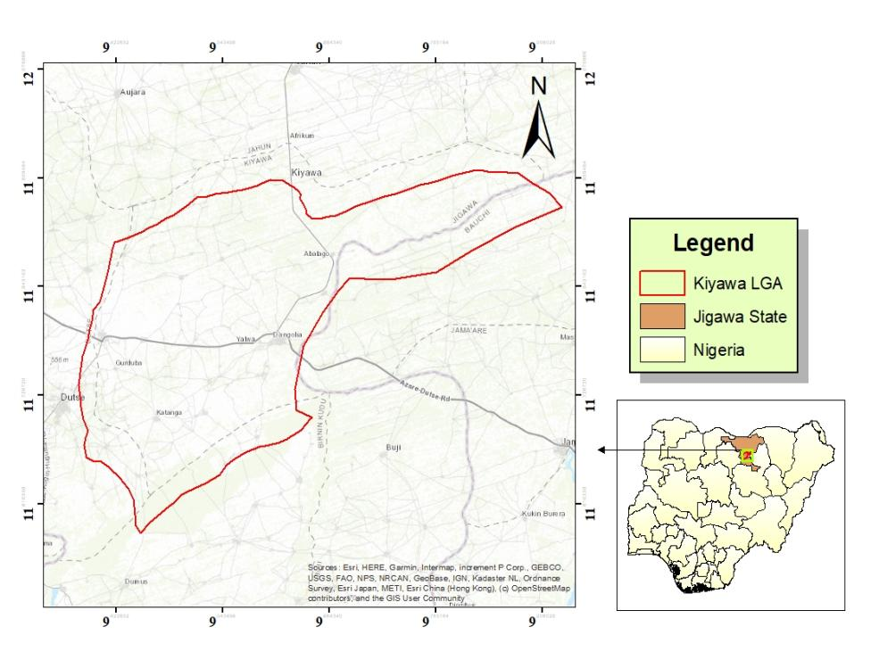

**Figure 1:** Map of Kiyawa Local Government Area of Jigawa state (insert Map of Nigeria showing the location of Jigawa State.

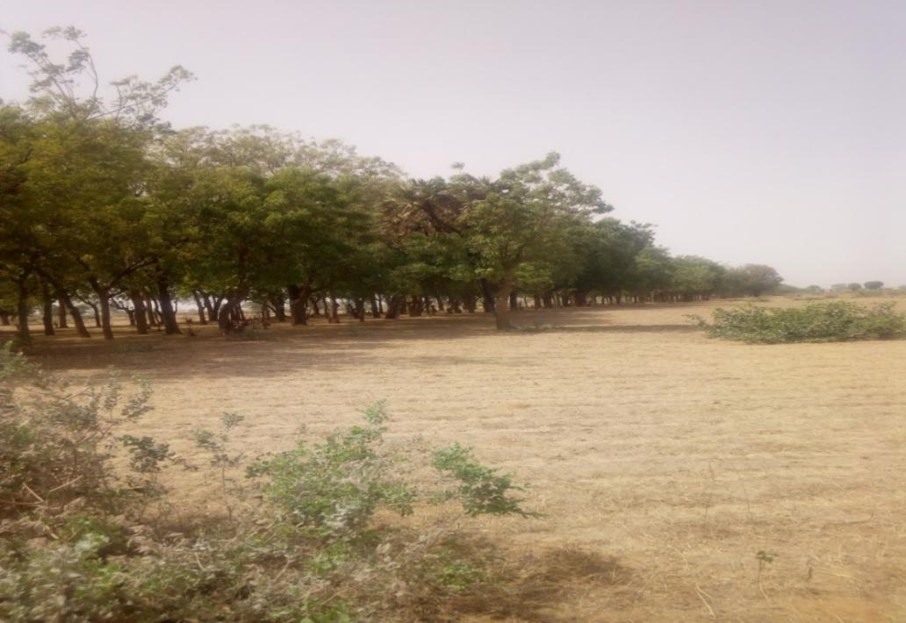

**Plate 1:** Shelter belt of *Azadirachta indica* (Neem) (Field survey, 2021)

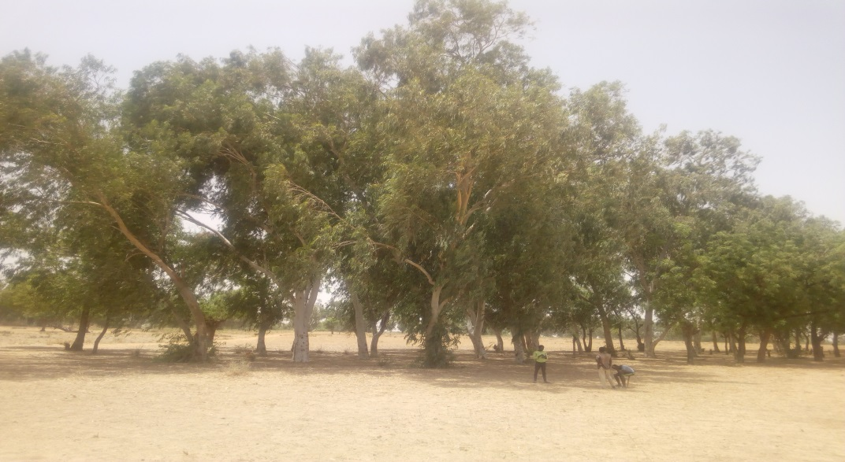

**Plate 2**: shelter belt of *Eucalyptus camaldulensis* (Field survey, 2021)

**Data collectionSampling Layout and procedure**

Systematic sampling design (systematic line transects) was used in laying out of the plot. A line transects of 500m with four samples of size 30m × 30m was laid in each shelterbelt at 100m interval. Eight sample plots were assessed during experiment for both studies. All woody plants within the sample plots were enumerated while 1m x 1m sample plot was laid within each of the sample plot for soil collection (Aminu, 2021; Salami, 2017)

**Tree enumeration**All Woody tree and shrubs with diameter at breast height (Dbh) of 10 cm and above were counted and measured. Growth variables such as the diameter at the base (Db) and diameter at the breast height (Dbh) were measured using measuring tape in centimetre (cm) while the diameter at the top and the height were assessed using Spiegel Relaskop in centimetres (cm). Basal area and volume were determined using equations 1 and 2.

**Soil collection**

Soil samples were collected at 0 - 15cm depth along the diagonal from one point for each of the sample plot with the aid of a soil auger. Soil sample collected was bulked. The soil sample was collected at soil depth of 0-15cm only, because the number of count of bacteria and fungi always decrease with the depth of soil sample (Lawal *et al.,* 2018)

**Identification of Micro-Organisms**

Fungi structure was studied with the use of microscope by noticing colony structures (Colour and texture) and by staining with lacto phenol cotton blue and observed under compound microscope for the conidia, conidiophores and arrangements of spores (Ameba, 2001). Gram staining was carried out on the growth culture plate to differentiate gram negative organism from gram positive organism. Biochemical test was carried out base on Gram's result in the laboratory of the Department of Microbiology, Federal University Dutse in February, 2021.

**Isolation of Micro-organisms**

Potato Dextrose Agar (P.D.A) media was used for the isolation of fungi, the plate was kept at room temperature for 7 days. Dilution was prepared and used for the isolation of Bacteria. One (1g) of soil sample was taken and serial dilution was carried out in distilled water. Nutrient Agar (N.A) medium was used to isolate bacteria sterilized in autoclave for 15 minutes at 121°C. After 2 hours of incubation at 37°C. Streaking plate method was used to get single colonies of the culture (Shanmugam *et al.,* 2013).

**Data analysis**

The data collected was analyzed using descriptive statistics such as tables while inferential such as independent T- test was employed to compare fungi, bacterial and microbial population in the study sites.

**Basal area calculation**

The basal area of all trees in the sample plots was calculated using this formula:

 ……………………………………....................................................(*eqn 1*).

Where **BA** = Basal area (m2), **D** = Diameter at breast height (cm) and Pie (3.142).

**Volume over bark estimation**

Using smailian’s formular

**V =** h(Db + Dt)/2…………………………………………………….………………..(eqn 2)

Where V = Volume over bark (m3), H = stem height (m), Db = Diameter at the base and Dt = Diameter at the top

**Results**

Presented in Table 1 is the growth variables of Neem and Eucalyptus species in the shelterbelts. The diameter at breast height (DBH) measurements for Neem and Eucalyptus trees in the study site ranged from 0.20 to 1.45 m and 0.18 to 1.07 m, respectively. The mean DBH for Neem was 0.82 meters, while for Eucalyptus, it was 0.63 meters. The standard error for both species was relatively low, 1.23 and 0.93 meters for Neem and Eucalyptus species respectively. Neem trees exhibited a basal area ranging from 0.15 to 1.65 square meters, while Eucalyptus trees ranged from 0.025 to 0.90 square meters. The mean basal area for Neem was 0.90 square meters, whereas for Eucalyptus, it was 0.46 square meters. Eucalyptus trees showed a wider range of basal area values. The standard error for the basal area for Neem was 0.15 and 3.43 meters for Eucalyptus. The heights range from 2.90 to 13.00 meters for the Neem trees, while Eucalyptus trees ranged from 1.20 to 6.30 meters. The mean height for Neem was 15.90 meters, and for Eucalyptus, it was 3.75 meters. The standard error for height measurements were 0.24 and 0.03 meters for Neem and Eucalyptus species respectively. Neem trees showed a volume range of 56.55 to 1885 cubic meters, while Eucalyptus trees ranged from 21.60 to 674.1 cubic meters. The mean volume for Neem was 999.90 cubic meters, whereas for Eucalyptus, it was 365.24 cubic meters. The standard error for volume measurements was relatively low for both species.

**Table 1:** Growth Variables of Neem and Eucalyptus Species in the Shelterbelts

|  |  |  |  |  |  |  |
| --- | --- | --- | --- | --- | --- | --- |
| **Parameters** | **Study site** | **Min** | **Max** | **Total** | **Mean** | **Stand Error** |
| **DBH(m)** | Neem  Eucalyptus | 0.20  0.18 | 1.45  1.07 | 84.42  65.62 | 0.82  0.63 | 1.23  0.93 |
| **Basal area (m2)** | Neem  Eucalyptus | 0.15  0.025 | 1.65  0.90 | 92.70  48.56 | 0.90  0.46 | 0.15  3.43 |
| **Height (m)** | Neem  Eucalyptus | 2.90  1.20 | 13.00  6.30 | 818.85  393.75 | 15.90  3.75 | 0.24  0.03 |
| **Volume (m3)** | Neem  Eucalyptus | 56.55  21.60 | 1885  674.1 | 999.90  365.24 | 970.78  347.85 | 1.27  2.43 |

**Source:** Field survey, (2021)

Table 2 showed the comparative analysis of soil bacterial occurrence in Eucalyptus and Neem Shelterbelts. The table lists several bacterial species, including *Staphylococcus aureus, Bacillus cereus, Pseudomonas spp, Bacillus subtilis,* and *E. coli.* Each bacterial species was either marked "V" (present) or left empty (absent) in both Eucalyptus and Neem shelterbelts.It was shown that there is a presence of soil bacteria in both Eucalyptus and Neem shelterbelts.The data indicate a similar number of bacterial species (3) occurring in both types of shelterbelts. *Staphylococcus aureus* was found in Eucalyptus shelterbelts but was absent in Neem shelterbelts. *Bacillus cereus* was present in both Eucalyptus and Neem shelterbelts. *Pseudomonas spp* was found in both shelterbelt types. *Bacillus subtilis* was observed in Eucalyptus shelterbelts. *E. coli* was present in both shelterbelt types.

**Table 2: Occurrence of Soil bacteria in Eucalyptus and Neem Shelterbelts**

|  |  |  |  |
| --- | --- | --- | --- |
| **SN** | **Species** | **Eucalyptus shelterbelt** | **Neem shelterbelt** |
| 1 | *Staphylococcus aureus* | V |  |
| 2 | *Bacillus cereus* | V |  |
| 3 | *Pseudomonas spp* | V | V |
| 4 | *Bacillus subtilis* |  | V |
| 5 | *E.coli* |  | V |
| **Total** |  | **3** | **3** |

**Note**: V= *present*

**Source:** Field survey, (2021)

Table 3 highlighted the occurrence of soil fungi in Eucalyptus and Neem shelterbelts. It also lists several fungal species, including *Aspergillus niger, Aspergillus flavus, Penicillium spp,* and *Fusarium oxysporum.* Each fungal species was either marked "V" (present) or left empty (absent) in both Eucalyptus and Neem shelterbelts.The data indicate that there is a presence of soil fungi in both Eucalyptus and Neem shelterbelts.Similar to the bacterial data (Table 2), the table shows that both types of shelterbelts have an equal number of fungal species (3) occurring. *Aspergillus niger* and *Penicillium spp* were found in both Eucalyptus and Neem shelterbelts. *Aspergillus flavus* was present in Eucalyptus shelterbelts but absent in Neem shelterbelts. *Fusarium oxysporum* was observed in Eucalyptus shelterbelts.

**Table 3: Occurrence of Soil Fungi in Eucalyptus and Neem Shelterbelt**

|  |  |  |  |
| --- | --- | --- | --- |
| **S/N** | **Species** | **Eucalyptus shelterbelt** | **Neem shelterbelt** |
| 1 | *Aspergillus niger* | V | V |
| 2 | *Aspergillus flavus* | V |  |
| 3 | *Penicillum spp* | V | V |
| 4 | *Fusarium oxysporun* |  | V |
| **Total** |  | **3** | **3** |

**Note**: V= *present*

**Source:** Field survey, (2021)

Table 4 provided data on the mean microbial population of soil bacteria in Eucalyptus and Neem shelterbelts based on the field survey conducted. It listed out the bacterial species involved which are *Staphylococcus aureus, Bacillus cereus, Pseudomonas spp, Bacillus subtilis,* and *E. coli.* The bacterial populations are measured in colony forming units per gram (CFU/g) of soil for both Eucalyptus and Neem shelterbelts. The data show the population of soil bacteria in both Eucalyptus and Neem shelterbelts. Overall, the mean bacterial population in Neem shelterbelts (1.3 x 106 CFU/g) is slightly higher than in Eucalyptus shelterbelts (1.24 x 106 CFU/g). *Staphylococcus aureus* has a population of 1.32 x 106 CFU/g in Eucalyptus shelterbelts, while it is not observed for Neem shelterbelts. *Bacillus cereus* has a population of 9.2 x 105 CFU/g in Eucalyptus shelterbelts but is not observed for Neem shelterbelts. *Pseudomonas spp* populations are 1.48 x 106 CFU/g in Eucalyptus and 2.18 x 106 CFU/g in Neem shelterbelts. *Bacillus subtilis* is observed only in Eucalyptus shelterbelts*. E. coli* populations are present in both shelterbelt types.

**Table 4 :** Mean microbial population of soil bacteria in Eucalyptus and Neem shelterbelt

|  |  |  |  |
| --- | --- | --- | --- |
| **SN** | **Species** | **Eucalyptus shelterbelt** (CFU/g) | **Neem shelterbelt** (CFU/g) |
| 1 | *Staphylococcus aureus* | 1.32x106 |  |
| 2 | *Bacillus cereus* | 9.2 x105 |  |
| 3 | *Pseudomonas spp* | 1.48 x106 | 2.18 x106 |
| 4 | *Bacillus subtilis* |  | 1.46 x106 |
| 5 | *E.coli* |  | 1.56 x106 |

**mean 1.24 x 106 1.3 X106**

**Note**: CFU/g is colony forming unit

**Source:** Field survey, (2021)

The Comparative Analysis of Soil Fungal Populations in Eucalyptus and Neem Shelterbelts is shown in Table 5 below. *Aspergillus niger, Aspergillus flavus, Penicillium spp,* and *Fusarium oxysporum* were the fungal populations present in the soil. This funga populations are measured in colony forming units per gram (CFU/g) of soil for both Eucalyptus and lNeem shelterbelts.The mean fungal population in Neem shelterbelts (1.50 x 106 CFU/g) is slightly higher than in Eucalyptus shelterbelts (1.45 x 106 CFU/g).

*Aspergillus niger* has a population of 1.30 x 106 CFU/g in Eucalyptus shelterbelts and 1.88 x 10^6 CFU/g in Neem shelterbelts*. Aspergillus flavus* has a population of 1.01 x 106 CFU/g in Eucalyptus shelterbelts but is absent in Neem shelterbelts. *Penicillium spp* populations are 2.04 x 106 CFU/g in Eucalyptus and 1.38 x 106 CFU/g in Neem shelterbelts. *Fusarium oxysporum* is reported only in Neem shelterbelts.

**Table 5:** Mean microbial population of soil fungi in Eucalyptus and Neem shelterbelt

|  |  |  |  |
| --- | --- | --- | --- |
| SN | **Species** | **Eucalyptus shelterbelt** (CFU/g) | **Neem shelterbelt** (CFU/g) |
| 1. | *Aspergillus niger* | 1.30x106 | 1.88 x106 |
| 2 | *Aspergillus flavus* | 1.01 x106 | Nil |
| 3 | *Penicillum spp* | 2.04 x106 | 1.38 x106 |
| 4 | *Fusarium oxysporun* | Nil | 1.23 x106 |

**mean 1.45 x106 1.50 x106**

**Note**: CFU/g is colony forming unit

**Source:** Field survey, (2021)

**Table 6:** Bio- chemical test for shelterbelt A (Eucalyptus)

|  |  |  |  |  |  |  |  |  |  |
| --- | --- | --- | --- | --- | --- | --- | --- | --- | --- |
| **Samples** | **Catalase** | **Oxidase** | **Indole** | **Methyl red** | **Vogesprokau** | **Nitrile reduction** | **Coagulase** | **Citrate** | **Urease** |
| **S1** | + | _ | _ | + | + | + | + | + | + |
| **S2** | + | _ | _ | + | + | + | + | + | + |
| **S3** | + | _ | _ | _ | + | _ | _ | + | _ |
| **S4** | + | + | _ | _ | _ | + | _ | + | _ |

**Table 7:** Biochemical test for shelterbelt B (Neem)

|  |  |  |  |  |  |  |  |  |  |
| --- | --- | --- | --- | --- | --- | --- | --- | --- | --- |
| **Samples** | **Catalase** | **Oxidase** | **Indole** | **Methyl red** | **Vogesprokau** | **Nitrile reduction** | **Coagulase** | **Citrate** | **Urease** |
| **S1** | **+** | **+** | **_** | **_** | **_** | **+** | **_** | **+** | **_** |
| **S2** | **+** | **_** | **_** | **_** | **+** | **_** | **_** | **+** | **_** |
| **S3** | **+** | **_** | **_** | **_** | **+** | **_** | **_** | **+** | **_** |
| **S4** | **+** | **_** | **+** | **+** | **_** | **+** | **_** | **+** | **_** |

**Discussion**

**Growth parameter indices**

The results showed that *A. indica* plots had the highest Dbh, Basal area, total height, and volume of 82.25±1.23 cm, 0.90±0.15 m2, 15.90±0.24 m and 97.78±4.27 m3, respectivelywhile the *E. camaldulensis* shelterbelt hotspot which had the lower value of 62.50±0.93 cm, 0.463±3.43 m2, 3.75±0.03 m and 3.48±2.43 m3,respectively. However, the results were obtained from two different studies sites. It showed that *A. indica* had higher productivity (volume and basal area) and growth (height, dbh) compared to *E. camaldulensis*.Themean basal area of 0.90±0.15m2 that was obtained from Neem shelterbelt, implies that Neem shelterbelt had high tree density that can be useful for such purposes as wood for furniture, electric poles, fuelwood, charcoal production, etc when properly managed. The *E. camaldulensis* shelterbelt, with basal area of 0.463±3.43m2, will also be useful for the inhabitants of the study area. Thus, in addition to their environmental protection goal (e.g. windbreak) tree species used in shelterbelt can serve other purposes. The result disagrees with the finding of Salami *et al*. (2021), who reported higher mean volume and Basal area (14.13m3; 339.998m2) at Warwade plantation than the results of study.

**Presence of fungi and bacterial**

Tables 2 and 3 revealed the presence of soil bacteria and fungi in the study sites. The findings showed the presence of three (3) species of bacteria in the study site. Eucalyptus shelterbelt had *Staphylococcus aureus* and *Bacillus cereus* while *Bacillus subtilis* and *E. coli* were presence in Neem shelterbelt. *Pseudomonas spp* were encountered in the shelterbelt with both tree species. This implies that this species can thrive and found the two habitats. Four different species of fungi were found to be present in both sites. Two (2) of the fungi were common to the two shelterbelt while one species found to be only present in each of the sites. The fungi: *Aspergillus niger* and *Penicillum species* were present in both study sites. However, *Aspergillus flavus* only occurred in Eucalyptus shelterbelt while *Fusarium oxysporum* was only present in Neem shelterbelt.

**Relationship between Microbial populations of the study sites**

The microbial load of fungi and bacteria were influenced by physical features of the soil of the study sites. This agrees with finding of Ateh *et al.* (2020) who reported that the texture of the soil determine the nature of microbes present. Microbial organism plays importance roles in the decomposition of organic matter, nitrogen fixation and nutrient cycling (Lawal *et al*., 2018; Ateh *et al.,* 2019). The effects of the soil microbes are influenced by their population classes (Archana *et al.,* 2015). Microbial population in forest soils are determined by both chemical and physical properties of the soil (Seeley, 1981). The results from Tables 4 and 5 showed the relationship between loads of bacteria and fungi found in the study site. The study revealed that five (5) species of bacterial were found which are *Staphylococcus aureus, Bacillus cereus, Pseudomonas spp, Bacillus subtilis and E.coli.* A higher load of *Pseudomonas spp* was recorded in the Neem shelterbelt (2.18 x106)compared with that of Eucalyptus shelterbelt (1.48 x106). The mean of Neem hotspot was recorded to be 1.3 X 106 which is higher than Eucalyptus hotspot with value of 1.24 X106. This implies that bacterial microbial load is more prominent and active in the neem than Eucalyptus shelterbelt. However, there was no significant difference between the bacterial microbial loads the shelterbelt of the two species (p≤ 0.05).

Furthermore, there is similarity in the microbial load of fungi recorded in the two study sites, with overall mean values of 1.45 x106 and 1.50 x 106 For Eucalyptus and Neem shelterbelt, respectively. *Aspergillus niger* was higher in Neem shelterbelt than in Eucalyptus shelterbelt with respective microbial loads of 1.88 x 106 and 1.3 x 106 while for *Penicillum spp*, the microbial load was higher in Eucalyptus (2.06 x 106) than Neem shelterbelt (1.38 x106). The weight of the fungi was lower in Eucalyptus shelterbelt due probably to the effect of allele-chemicals which was higher in Eucalyptus than Neem shelterbelt. The results on Tables 4 and 5 revealed that fungi load was higher than bacteria load at both study sites. Some research workers (e.g. Barbour *et al.,* 1987; Zhou *et al.,*2018) had revealed that the nature of physical properties of the forest soil determines the type of microbes in the soils and their populations. The dominant and structural organization of the sand textural class in the study sites provided a spatially heterogeneous habitat for fungal community because the of smaller size fractions (silt and clay) host higher bacterial community than larger size particle (size). Ateh *et al.* (2019) reported that microbial load of fungi was higher than bacteria with the value of 4.49 x105 and 3.43 x105 respectively at the same soil profile level (0-15cm) in Girea soil of Adamawa, which is supported by the results of this study. Our results also agree with that of Nkereuwem *et al*. (2020), who reported that fungi did better than bacteria in adapting to drying rewetting stress across the

different soil locations during the drying rewetting cycle. However, Adekunle *et al.* (2005),  
disagreed with the finding and reported that the amount of bacterial load is higher than that of fungi load in Akure Forest Reserve in southwestern , Nigeria with the range of (26.106 to 360 x106 MPNG-1 and 2.50 x106 to 23.34 x106 MPNg-1) respectively.

**Biochemical elements**

The biochemical elements of the study area show that some elements are present in both study areas and some are absence. The rest are either moderately present or absent. Catalase and Citrate are present in both study areas. Coagulase and Urease are moderately present in eucalyptus site and not present at all in Neem site. Oxidase is present in both but in minute quantity (Table 6 and 7).

**Conclusion**

The neem hotspot supports the growth bacteria and fungi microbial load. Bacteria microbial load is not prominent unlike fungi. Therefore, this study gives a basis for further research especially on degree of allelo-chemicals characteristics on the growth of arable crops/plants between neem and eucalyptus shelterbelt since there is no documentation at Kiyawa Shelter belt.

**REFERENCES**

Adekunle, V. A. J., Dafiewhare, H. B. and Ajibode, O.F (2005): Microbia population and Diversity as influenced by soil ph and organic matter in different forest ecosystem. *Pakistan Journal of Biological Science* 8(10): 1478-1484

Aminu, M. (2021). Evaluation of Stem Volume, Litterfall, and Soil Fertility of *Azadirachta indica* (A. Juss) and *Eucalyptus camaldulensis* (Dehnh) at Shelterbelts in Kiyawa, Jigawa State, Nigeria. An unpublished project submitted to the Department of Forestry and Wildlife Management, Federal University Dutse, Jigawa State.

Archana B., Bishwoyog B and Sunil, P. (2015). Variation of soil microbial population in different soil horizons *Journal of Microbiology and Experimentation* V2:(2)

Ateh, G. O. Saka, M. G., Dishan, E. E. and Meer, B. B. (2020) Evaluation of Physicochemical Properties and Microbial Populations of Soil of Bagale Forest Reserve, Girei Local Government Area, Adamawa State, Nigeria. *Asian Journal of Research in Agriculture and Forestry,* 5(1): 13-21.

Azare, I. M, Adebayo, A. and Saddiq, A. M. (2019). Effect of Selected Soils Properties On The Performance Of Pearl Millet Varieties In Parts of Jigawa State, Nigeria. *Ife Research Publications in Geography,* 17 (1): 76-85

Barbour, M.G, Lugard, J.H, and Pitt, W.D. (1987) Terrestrial plant ecology 2nd edition. Benjamin Cummings, New York. pp1-3.

Dau, J. H and Chukwu, O. (2018) Forest Inventory: A Basic Conservation Tool for Sustainable Forest Management of Nigerian Ecozones Proceedings of 6th NSCB Biodiversity Conference; Uniuyo 2018 (212 – 218 pp)

Geoff, N. P. (2007). Eucalyputus oil and market Technical report.

Husch B., Beers T.W. and Kershaw J.A.Jr. (2003). Forest mensuration, 4th, 443 Hoboken, NJ: John Wiley and Sons, Inc

International Union for Conservation of Nature (1994). Guidelines for Protected Area Management Categories. Gland and Cambridge: IUCN.

Jigawa Agricultural Rural Development Agency (2016). Climatic Data. pp112

Janger, P. and J. Pender. 2003. The role of trees for sustainable Management of less favored lands: the case of Eucalyptus inEthiopia. Forest Policy economics. 5: 83-95.

Janger, P. and. Pender. J.(2000). The role of trees for sustainable management of less-favored lands: the case of Eucalyptus

Jelena M., Dragana , B., Jordana B., Jovica B., Branislava B. and Milorad Z. (2018) Effect of different soil usage on the microbial properties in the soil of Cental Serbia *Ratar Potvt* 55(2): 58-64

Jibo, A. U., Salami, K. D., Kareem Akeem, A. Muhammad, Y. K. and Musa, F. Y. (2021) Impact of provenances on seed germination, early growth performance and survival rate of *Tamarindus indica*(L) in north western Nigeria. *Nigerian Journal of Horticultural Science*, 26(1&2): 87-104

Karen, S. (2023) Windbreak Agriculture. Science and Technology, Britanica

Lawal, A.A, Usman, A. Karage, M. Y. Ilu K. J. and Khalid, S. I. (2017) Assessment of soil microbial diversity Under canopies of neem tree in University of Marduguri, Borno state, Nigeria.  *Journal of Forest science and environment* 4(2): 269-275

Luzar, J. (2007) The political –ecology of a Forest –transition. Eucalyptus forestry in the Southern Peruvian Andes. Ethnobotany Research and application, 5: 85-93

Maryam, A.D., Dawud, I. I., Angarawai, P.B. Tongonako., K. O., John, S.Y. and Eleblo, B.E (2019). Farmer’s production constraints, Knowledge Striga and preferred trait of pearl millet in Jigawa state. *Global Journal of Science of Frontier* V 12(3):54-67

Mansourian, S., Belokurov, A. and Stephenson, P. J The role of forest protected areas in adaptation to climate change. World Wide Fund for Nature (WWF) International, Gland, Switzerland. Retrieved on 2nd September, 2023 from <https://www.fao.org/3/i0670e/i0670e13.htm>

Nannipieri P., Ascher J., Ceccherini M.T., Landi L., Pietramellara G. and Renella G. (2003). Microbial diversity and soil functions. *European Journal of Soil Science,* 54: 655-670.

Nkereuwem, M. E., Adeleye, A. O., Edem, I. D., Abubakar, M. Z., Onokebhagbe, V. O. and Abubakar, A. (2020) Response of Indigenous Microbial Community To Drying-Rewettin Stress: Evidences From Warwade Dam Irrigation Scheme Soil In Dutse*. Dutse Journal*

Pietikainen J. (1999). Soil microbes in boreal forest humus after five. Finish forest Research Institute, pp. 78.

Rousk J., Demoling L., Bahr A. & Baath E. (2008). Examining the fungal and bacterial niche overlap using selective inhibitors in soil. FEMS Microbiology Ecology, 63: 350-358.

Saka, M. G., Aujara, Y.I., Ilu K. J., Salami, K. D. and Yakubu Mustapha (2020) Composition and Diversity of Non-Timber Forest Products (NTFPS) in Baturiya Wetland Game Reserve, Jigawa State, Nigeria *Fudma Journal of Sciences* (FJS) Vol. 4 No. 3, March, 2020, Pp 416-425

Salami. K.D. (2017) Tree species Diversity and Soil status of Omo Biosphere and Gambari Forest Reserves in South western Nigeria. Ph.D Thesis, Department of Forest Resources Management, University of Ibadan, Nigeria

Salami, K. D and Lawal, A.A (2018) Tree species Diversity and Composition in the Orchard of Federal University Dutse, Jigawa State. *Journal of Forestry Research and Managemen*t. 15(2):112-122

Salami, K.D., Kareem Akeem A., Ahmed B., Gidado A. H., Harisu, S and Umaru A. (2021). Growth Assessment and Regression Models for the Tree Volume Prediction of *Azardirachta indica*(A. Juss) at Warwade Forest Reserve, Dutse, Jigawa State, Nigeria. *Journal of Research in Forestry, Wildlife and Environment.*13(1):239-250

Salami K.D. Aminu M Ilu K. J. Lawal AA and Folohunsho WO (2022) Evaluation of stem volume, litter fall, Soil fertility of *Azardirachta indica A. JUSS and Eucalyptus camadulensis* Dehnh at Shelterbelt in Kiyawa, Jigawa state, Nigeria*.* *International Journal of Agricultural Research, Sustainability and food Sufficient*. V9(01): 560 -569

Salami, K.D and Akinyele, A.O. (2017). Tree species Diversity Abundance in Degraded Gambari forest reserve, Southwest Nigeria. Translating Research findings into policy in developing countries. Contributions from Humbolt Kolleg Osogbo-2017. Lambert Academic Publishing. Pp 276-287 GERMANY

Seeley, W.H. and Van Demark, P.J. (1981) Microbes in action. A laboratory manual of microbiology 3rd edition. WH Freeman & company USA, 350 pp.

Sigstad E., Bajas A., Amoroso M. and Garcia I. (2002). Effect of deforestation on soil microbial activity a worm-composite can improve quality? Thermo Chimicaacta, 394: 171-178.

Thompson, I., Mackey, B., McNulty, S. and Mosseler, A. (2009). Forest Resilience, Biodiversity, and Climate Change. A synthesis of the biodiversity/resilience/stability relationship in forest ecosystems. Secretariat of the Convention on Biological Diversity, Montreal. Technical Series no. 43, 67 pp.

Zhou, M. and Chen, J.L. (2018) Comparison of soil physicochemical properties and mineralogical compositions between non collapsible soils and collapsed gullies. Geoderma, 2018;317:56-66