THREE DIMENSIONAL MINI PLATES IN ORAL AND MAXILLOFACIAL SURGERY: A PROSPECTIVE CLINICAL STUDY
Chandrashekhar S. Pingal
MDS, PGDEMS
Reader
c_pingal@yahoo.com
+91 9850551821
Yogita Dental College And Hospital, khed
Maharashtra, India 415709.

ABSTRACT
The purpose of all therapy of fractures is the restoration of the original form and function. An important requirement to this end is immobilization. Failure to achieve these conditions of healing results in infection, malocclusion, nonunion or malunion. Internal fixation was born of necessity due to limitations imposed by closed reduction techniques. Osteosynthesis implies functionally stable internal fixation of bone fractures, which allows the early recovery of function1.
Rigid internal fixation was initially used in the oral and maxillofacial region in the late 1970s.Since the work of Michelet et al. and later Champy et al., miniplate osteosynthesis has become an important fixation method in maxillofacial and craniofacial surgery. Later several systems have been developed. The rigid systems were replaced by more functionally oriented systems, and the term “semi-rigid” has gained more importance1.
Miniplate fixation of mandibular fracture has become the standard treatment of providing stable internal fixation and eliminating the need of IMF. It is usually accepted that symphyseal and parasymphyseal fractures can be treated with 2 miniplates. Treatment of mandibular angle fracture consists of one plate at superior border, although a second plate at a lower level may provide additional stability, while high complication rates are reported with 2 plates by others2. A geometrically closed quadrangular plate (3D plate) secured with bone screws creates stability in 3 dimensions. Its biomechanical results have shown good stability in fixation of mandibular angle fracture3. It also has better bending stability and more resistance to out of plane movement4,5.
Rigid fixation can produce three-dimentional stability of the fracture site, promoting primary fracture healing. The healing is extremely susceptible to mechanical influences. Mobility at the fracture site is one of the main causes of healing disturbances and stability is considered the best protection against infection1.
For years, many surgeons felt the necessity to change the traditional long period of maxilla-mandibular fixation thought to be essential for successful treatment of mandibular fractures. Dispensing the intermaxillary fixation allows the patient to protect their airway more effectively and facilitates postoperative function and nutrition with an early return to work. When absolute stability of the fragments is achieved, immediate postoperative jaw function is possible1.
Most recently, three dimensional plates and screws have been developed by Farmand. Their shape is based on the principle of the quadrangle as a geometrically stable configuration for support. The biomechanical and technical constraints of the conventional rigid internal fixation devices have prompted the current study to evaluate the efficacy of the three dimentional titanium miniplates as a viable treatment modality1.

INTRODUCTION

Increasing urbanization and rapid influx of high speed automobiles with poor road conditions are causing the road traffic accidents to scale new heights and the incidence of traumatic injuries to the maxillofacial skeleton are increasing alarmingly. The aim of all forms of the therapy is restoration of the form and function of the face and jaws to near normal.
The history of treatment of facial bone fractures parallels the development in modern oral and maxillofacial surgery. Maxilla and mandible are the keystones to the bony architecture of the face, and the presence of teeth in maxillofacial region makes the management of maxillofacial trauma unique compared to long bones. If put on the time line the management of trauma has evolved greatly over the years from supportive bandages, splints , circummandibular wiring , extraoral pins to rigid fixation and more lately semirigid.^{1,2,3,4,5,6} It was only after the second world war that the treatment modality has changed from closed reduction to open reduction and direct fixation using bone plates and screws.⁷ Rather internal fixation was born of necessity , due to limitations imposed by closed reduction techniques.

Miniplate fixation of mandibular fracture has become the standard treatment of providing stable internal fixation and eliminating the need of IMF. It is usually accepted that symphyseal and parasymphyseal fractures can be treated with 2 miniplates. Treatment of mandibular angle fracture consists of one plate at superior border, although a second plate at a lower level may provide additional stability, while high complication rates are reported with 2 plates by others. A geometrically closed quadrangular plate (3D plate) secured with bone screws creates stability in 3 dimensions. Its biomechanical results have shown good stability in fixation of mandibular angle fracture. It also has better bending stability and more resistance to out of plane movement.

Rigid fixation can produce three-dimentional stability of the fracture site, promoting primary fracture healing. The healing is extremely susceptible to mechanical influences. Mobility at the fracture site is one of the main causes of healing disturbances and stability is considered the best protection against infection.

For years, many surgeons felt the necessity to change the traditional long period of maxilla-mandibular fixation thought to be essential for successful treatment of mandibular fractures. Dispensing the intermaxillary fixation allows the patient to protect their airway more effectively and facilitates postoperative function and nutrition with an early return to work. When absolute stability of the fragments is achieved, immediate postoperative jaw function is possible.

Most recently, three dimensional plates and screws have been developed by Farmand. Their shape is based on the principle of the quadrangle as a geometrically stable configuration for support. The biomechanical and technical constraints of the conventional rigid internal fixation devices have prompted the current study to evaluate the efficacy of the three dimentional titanium miniplates as a viable treatment modality.

AIM
Three dimensional mini plates as treatment modality for the stabilization of the fractured or osteotomized bone fragments in maxillofacial region.
OBJECTIVES
To evaluate the three dimensional plating system, taking certain parameters of success into consideration such as post-surgical occlusion, postoperative complications.
The inclusion criteria:
- Patients of either trauma, orthognathic, reconstructive, craniofacial surgery in which 3D plates is indicated.
- Gender: Both Males and females.
- Race: All races and ethnicities are eligible for study.
- Health status: Healthy patients are eligible for study.
The exclusion criteria:
- Pre-existing Systemic Illness: patients that are immunocompromised, , patients with systemic diseases like uncontrolled diabetes.
- Medically compromised patients
MATERIAL & METHOD OF DATA COLLECTION
This study includes 15 patients of either trauma, orthognathic, reconstructive, craniofacial surgery, in which three dimensional plates are indicated. A through clinical history taken and meticulous clinical examination performed on all the patients. All subject who has sustained maxillofacial fractures advised a panoramic radiograph. A definitive diagnosis of maxillofacial fracture established with the aid of clinical and radiographic findings. Patient are evaluated for post-surgical occlusion, postoperative complications.
All patients are followed for 3 months postoperatively. The evaluation done at 1st postoperative day, 7th postoperative day,1st month and 3 month.
CASE PHOTOGRAPHS
PRE-OPERATIVE
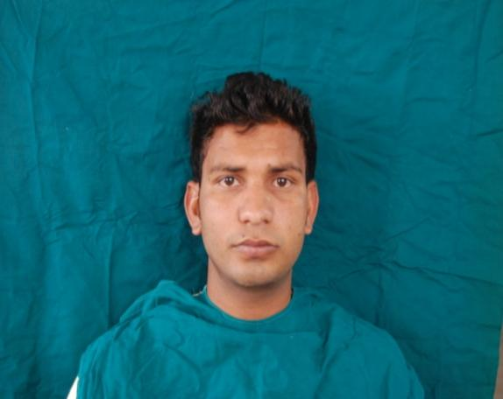
FRONT PROFILE
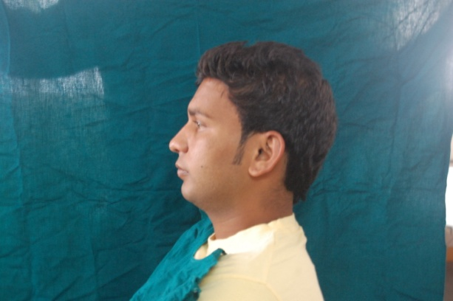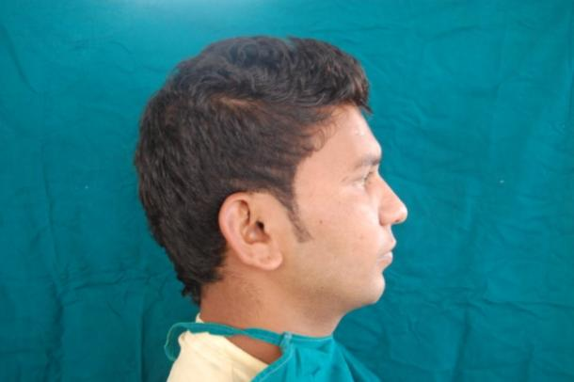
LATERAL PROFILE (LEFT) LATERAL PROFILE (RIGHT)
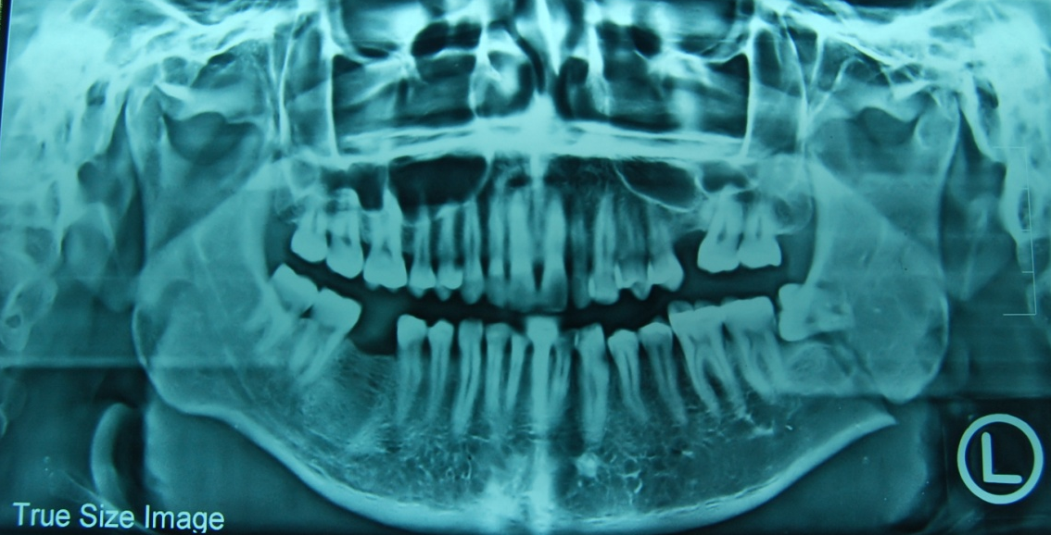
PRE-OPERATIVE OPG

PRE-OPERATIVE OPG

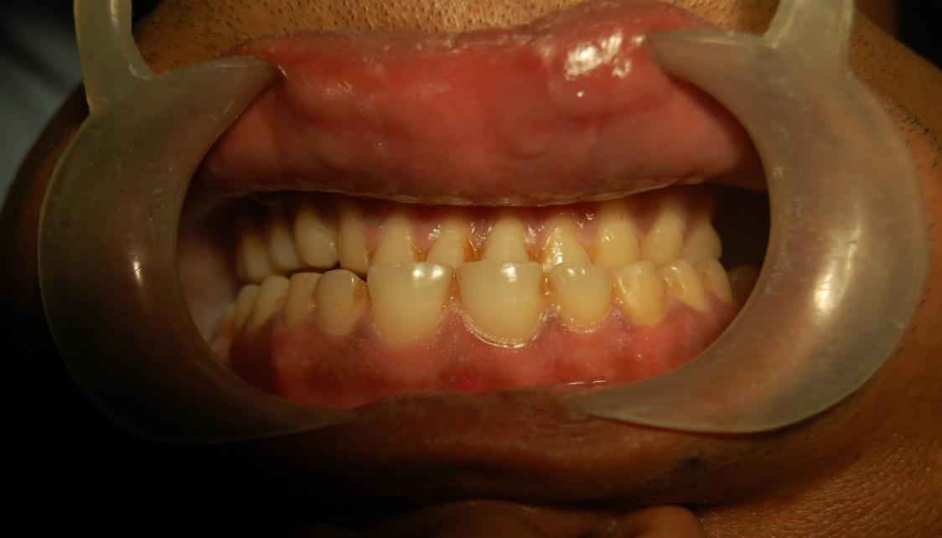

PRE-OPERATIVE OCCLUSION

PRE-OPERATIVE

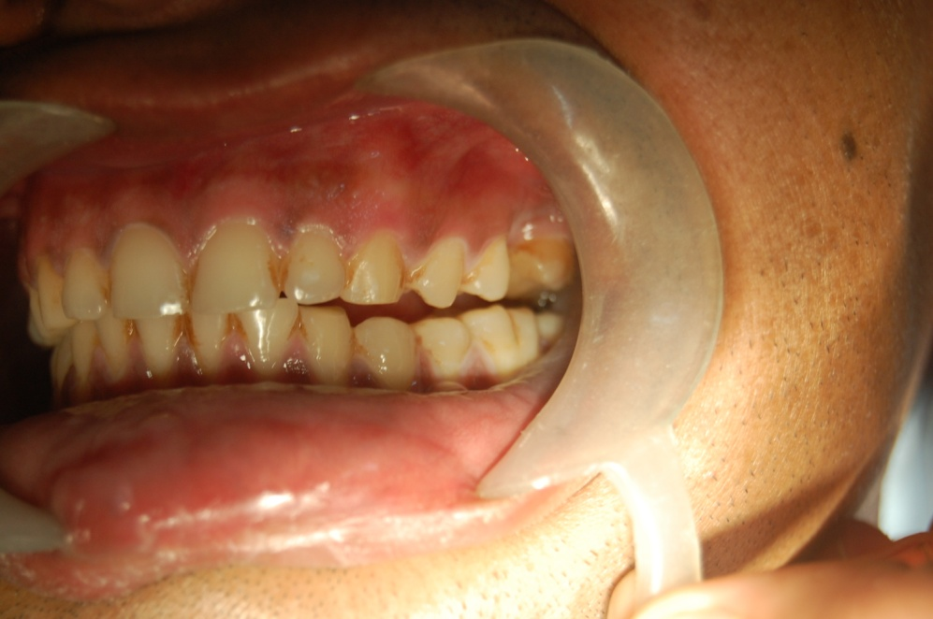
PRE-OPERATIVE OCCLUSION (LEFT)

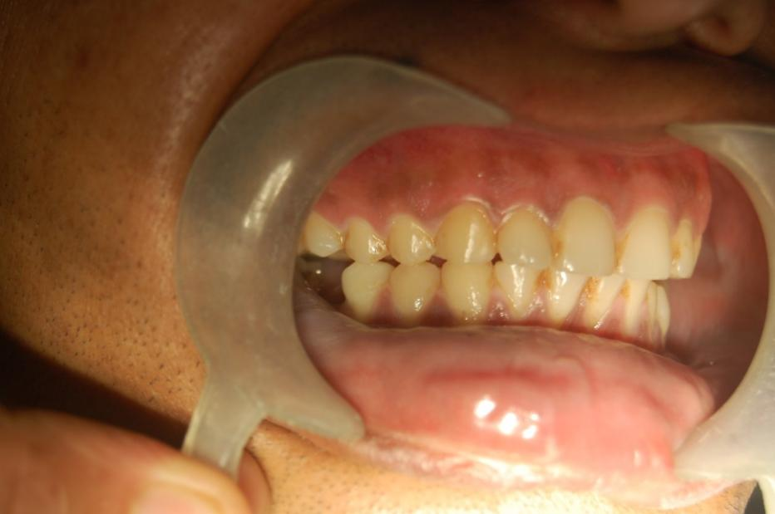
PRE-OPERATIVE OCCLUSION (RIGHT)

OPERATIVE

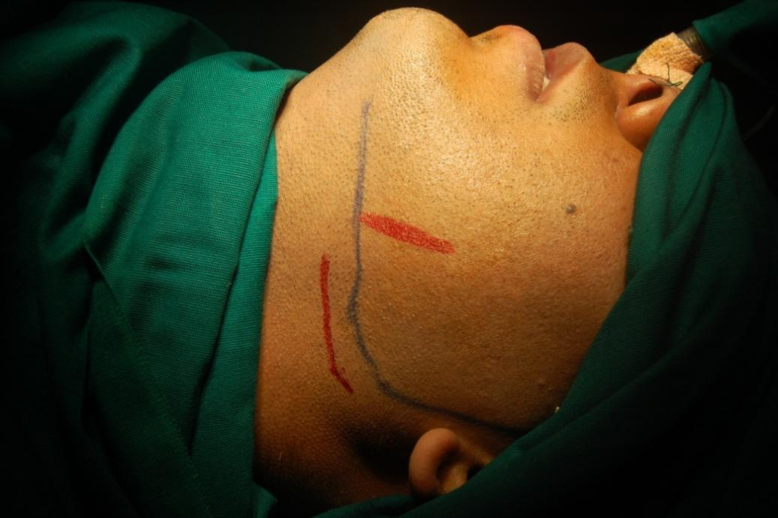
SURFACE MARKING

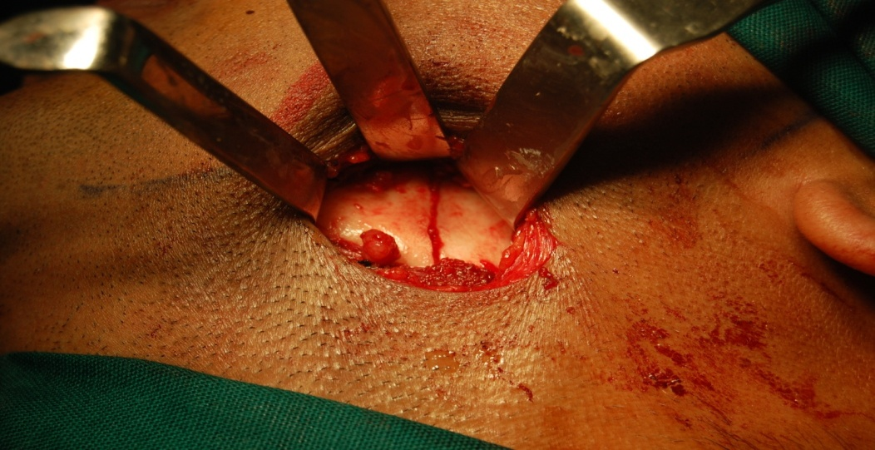
FRACTURE LINE
OPERATIVE

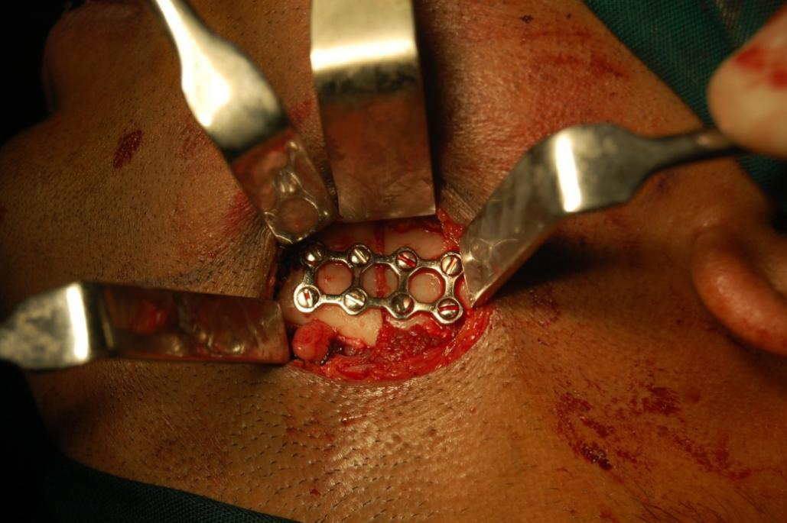
REDUCTION WITH THREE DIMENSIONAL MINI PLATE

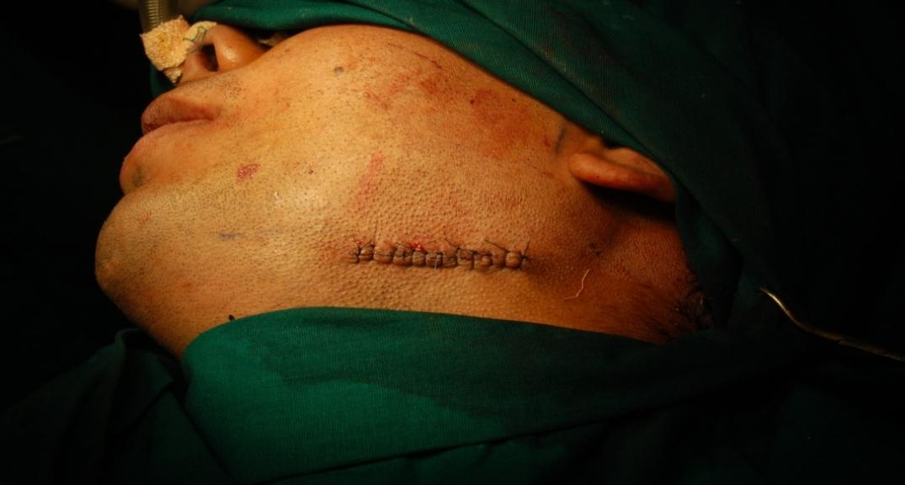
SKIN SUTURE

POST-OPERATIVE

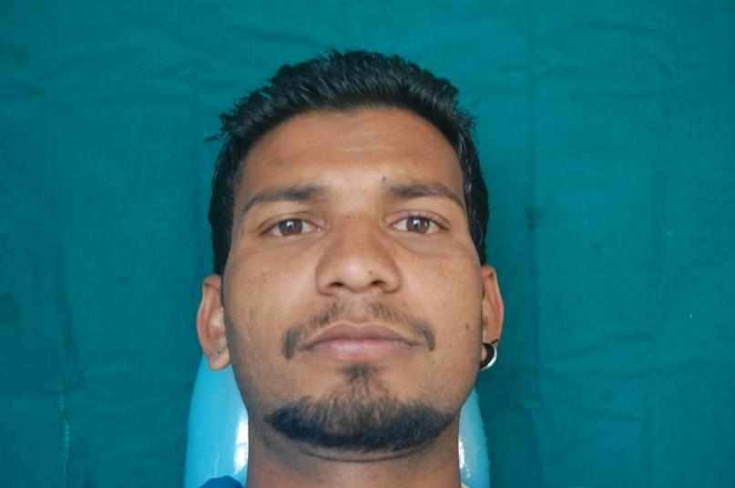
FRONT PROFILE

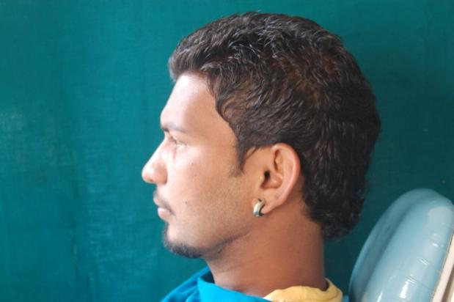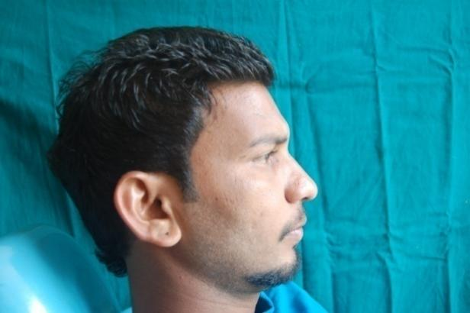
LATERAL PROFIFE (LEFT) LATERAL PROFIFE (RIGHT)

POST-OPERATIVE

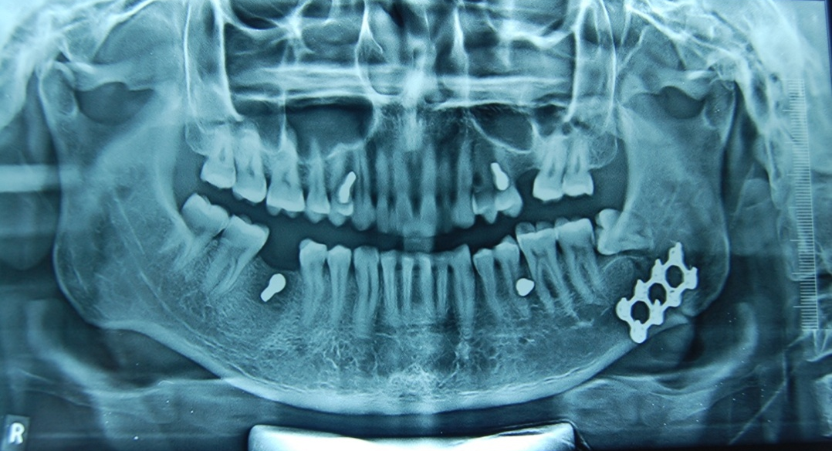
POST-OPERATIVE OPG

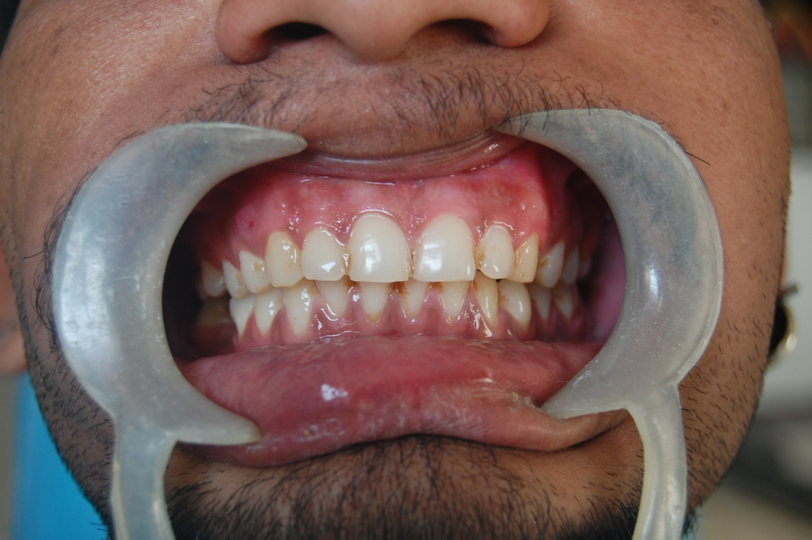
POST-OPERATIVE OCCLUSION

POST-OPERATIVE

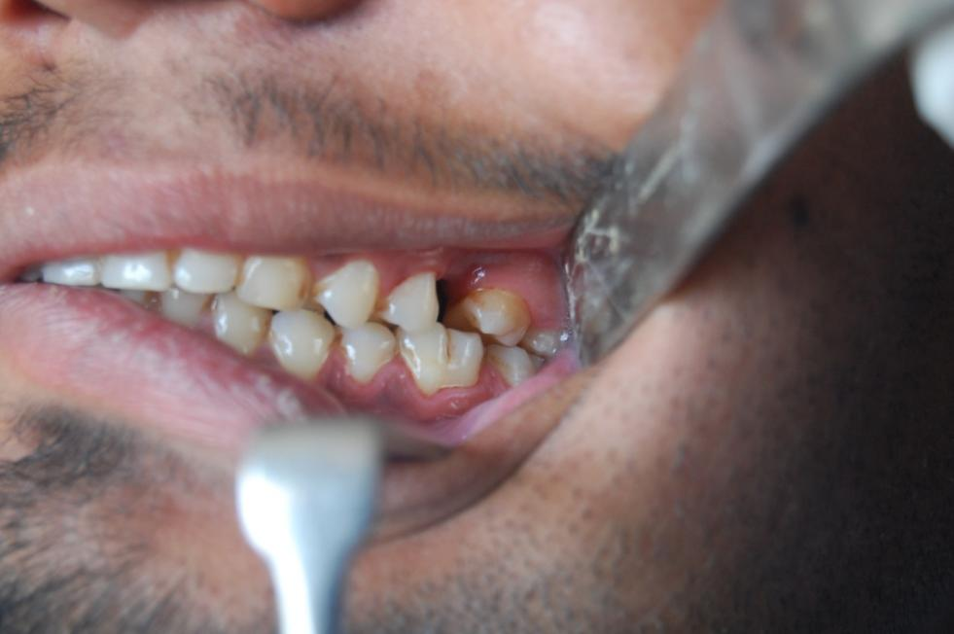
POST-OPERATIVE OCCLUSION (LEFT)

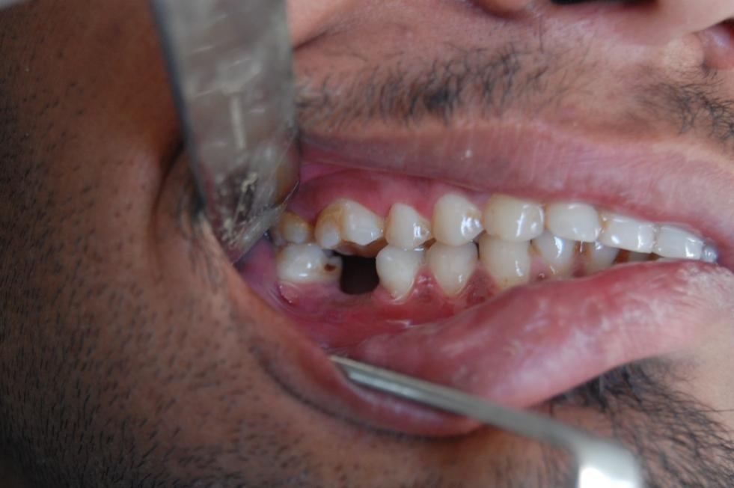
POST-OPERATIVE OCCLUSION (RIGHT)

Table No.1: Post- surgical occlusion (Follow-up):
 | Satisfactory | Unsatisfactory
 | No. (%) | No. (%)
1st day | 10(66.66%) | 5(33.34%)
7th day | 14(93.33%) | 1(6.67%)
1st month | 15(100%) | 0
3rd month | 15(100%) | 0

Table No.2: Postoperative complications
 | No. (%)
Yes | 2(13.33%)
No | 13(86.67%)
Total | 15

RESULT
Post-surgical occlusion
Table No. 1 shows the comparison of post-surgical occlusion
Table No.3: By applying Z test of difference between two proportions there is a significant difference between proportion of post-surgical occlusion at 1st day, 7th day, 1st month and 3rd month (p< 0.05).
From the table, total 5 (33.34%) patients had occlusal discrepancy in 1st day postop,which was corrected by giving elastics & it showed no discrepancy in 1st month follow-up.Only 1 (6.67%) patient had occlusal discrepancy in 7th day postop. which also showed no discrepancy 1st month follow-up & after 1st month postop no single patient had any occlusal discrepancy in the follow-up period. Hence post-surgical occlusion was satisfactory in all cases after the 1st month follow-up.
The same is illustrated in Graph No. 1
Post operative complications
Table No. 2 shows the post operative complications
Table No.2: By applying Z test of difference between two proportions there is a no significant of post operative complications in study population (p< 0.05).
From the table, we can see that, out of 15 patients, only 2 patients had postoperative complication (paresthesia),from which 1 patient showed normal sensation in the follow-up.but 1 patient still showing symptoms & follow up is going on for the same.
The same is illustrated in Graph No. 2

DISCUSSION
3D titanium plates have been used sporadically by few surgeons predominantly for fixation of the mandibular angle region. ^{18, 20} .Only recently Hughes extended its use to the anterior mandible. ⁶⁶ Its use in the maxilla has remained skeptical, with Farmand being the only surgeon to have used them for the maxillary fracture osteosynthesis.¹⁸ Thereby we also intended to use 3D plates for fixation in the mandible mostly. The use of 3D plates in mandibular fractures has not yet become established. In a recently published survey of 104 North American and European AO/ASIF surgeons, only 6 % stated that they use this type of plate.These plates have been quoted by many names in the English literature i.e. 3D plates , matrix plates and strut plates.

Guimond & Jeurgen found the fixation with 3D plates predictable, the plate strong yet malleable facilitating stabilization both at superior and inferior borders. They concluded that 3D titanium plates are an easy to use alternative to conventional mini plates but contraindicated its use in fractures with less inter fragmentary bone contact. However, these reports of successful mandibular fracture fixation using 3D plates have used titanium as the osteosynthesis material. Stainless steel is a more popular and cost effective osteosynthesis material in the developing countries.

The clinical effectiveness of 3D plate needs to be verified or substantiated by biomechanical studies. Wittenberg in his biomechanical experiment found that entire 3D titanium plate was formed by joining two miniplates with interconnecting vertical cross bars which reinforced each other, thereby the plate acting as a single unit.¹⁹ Interconnections of the plate reduced the vertical displacement and shearing of bone to minimal.¹⁹
In the present study, the total 5 (33.34%) patients had unsatisfactory occlusion in 1st day postop.which was corrected by giving elastics & it showed no discrepancy in 1st month follow-up. Only 1 (6.67%) patient had unsatisfactory occlusion in 7th day postop. which also showed no discrepancy 1st month follow-up & after 1st month postop no single patient had any occlusal discrepancy in the follow-up period. Hence post-surgical occlusion was satisfactory in all cases.
Generally measurement of neurosensory function in trauma patients is complicated. In immediate post operative period marked pain and edema in the surgical site affect the sensation. There can be transient neurosensory deficit in the immediate post-operative period which gradually recovers back to normal. From the present study,we can see that, out of 15 patients only 2 patients had postoperative complication (paresthesia), from which 1 patient showed normal sensation in the follow-up.but 1 patient still showing symptoms & follow up is going on for the same.
Hence, from the results of the study suggest that fixation of mandibular fracture with 3D miniplate provides 3D stability because of its design, ease of technique during fixation of fracture fragments and carries low morbidity and infection rates that may prove to be comparable to the standard plating systems. The only probable limitation of these plates may be excessive implant material due to the extravertical bars incorporated for countering the torque forces.

SUMMARY & CONCLUSION

In conclusion the results from the study suggest that three dimensional plates provide good stability of bone fragments due to closed quadrangular geometric shape,and the of contouring and adapting. It uses lesser material, reduces the operation time and overall cost of the treatment. A few post-operative complications was seen which was negligible
The three dimensional mini plate screw system was found to be more suitable in terms of stability of fractured segments. The system is reliable and effective treatment modality for mandibular fractures.
Hence, in conclusion three dimensional mini plates are the best treatment modality for the stabilization of the fractured segments in maxillofacial region.

REFERENCES

1) Raymond F.J., Walter R.V. Oral and Maxillofacial Trauma, Pennsylvania 1997, W.B. Saunders Company, 2nd Edition, Vol 1 : 474-478.

2) Clark H.B., Hayes P.A. “A study of comparative effects of rigid and semirigid fixation on the healing of fractures of mandible in dogs ”. J Bone Joint Surg 1963; 45 : 731-741.

3) Becker R. “ Stable compression plate fixation of mandibular fractures”. Br J Oral Surg 1974; 12 : 13.

4) Kruger E., Schilli W. - Oral and Maxillofacial Traumatology, Chicago 1982, Quitesence Pub. Co. : 308-370.
5) Champy M., Lodde J.P., Schmitt R., Jaeger J.H., Muster D. “ Mandibular osteosynthesis by miniature screwed plate via a buccal approach”. J Max-Fac Surg 1963; 6 : 14-21.

6) Ikemura K. “ Biomechanical study on monocortical osteosynthesis for fracture of mandible”. Int J Oral Surg 1984 ; 13 : 307-312.

7) Shera R.B. “Open reduction of mandibular fractures”. J Oral Surg 1954 ; 12 : 52.

8) Lindqvist C. “ Rigid internal fixation of mandibular fractures – an analysis of 45 patients treated according to the AO/ASIF method”. J Oral Maxillofac Surg 1986; 15 : 657-664.

9) Pogrel M.A. “Compression osteosynthesis in mandibular fractures ”. Int J Oral Maxillofac Surg 1986 ; 15 : 521-524.

10) Lizuka T. “Infection after rigid internal fixation of mandibular fractures: A clinical and radiological study”. J Oral Maxillofac Surg 1991; 49(6): 585-593.

11) Michelet F.X., Deymes J., Dersus B. “ Osteosynthesis with miniatures screwed plates in maxillofacial surgery ”. J Oral Maxillofac Surg 1973; 1 : 79-84.

12) Reitzik M.B., Schrool W. “ Bone repair in the mandible”. J Oral Maxillofac Surg 1983; 41 : 215.

13) Rhinelander F.W., Baragry R.A. “Microangiography in bone healing in undisplaced closed fractures ”. J Bone Joint Surg 1962; 44A : 1273.

14) Roaf R. – Non union and delayed union. In: Modern Trends in Orthopaedics – Science of Fractures – IV, London 1964, Buttersworth.

15) Karasz I., Laszlo K., Gyorgy S. “Photoelastic stress analysis on mandibular osteosynthesis ” . Int J Oral Maxillofac Surg 1986 ; 15 : 259-262.

16) Ellis E., Walker L.R. “Treatment of mandibular angle fractures using one non compression miniplate”. J Oral Maxillofac Surg 1996; 54 : 864-871.

17) Juergen Zix,Olivier Lieger and Tateyuki Lizuka. Use of Straight and Curved 3-Dimensional Titanium Miniplates for Fracture Fixation at the Mandibular Angle. J. of Oral and Maxillofacial Surgery 2007;65(9):1758-1763.
18) Farmand M. The 3-D plating system in maxillofacial surgery. J Oral Maxillofac Surg. 1993; 51(suppl 3):166.
19) J. M. Wittenberg, D. P. Mukherjee, B. R. Smith, R. N. Kruse. Biomechanical evaluation of new fixation devices for mandibular angle fractures. Int. J. Oral Maxillofac. Surg. 1997; 26:68-73.
20) Joerg M. Wittenberg. Treatment of mandibular angle fractures with 3-D
titanium miniplates. J Oral Maxillofac Surg. 1994; 52(suppl 2):106.

