SUSTAINABLE FOOD SYSTEMS

Chapter Outline (Index)-----
Introduction
Food and Nutrition Security: An Overview
What are Food Systems
Conclusion
References and Suggested Readings

INTRODUCTION
Concept of Sustainable Development
The term ‘Sustainable Development’ was first coined in 1980 with a very basic notion of ‘conserving earth’s natural resources’ which was an outcome of the World Conservation Strategy. A decade later, in 1987, the World Commission on Environment and Development (WCED) used a multi-disciplinary approach to conceptualize sustainable development as a form of development that meets the needs of the present without compromising the ability of future generations to meet their own needs (Brundtland Commission Report). In 1992, at the United Nations Conference on Environment and Development at Rio de Janeiro, the blueprint for sustainability in the 21st century was laid. The ‘Rio Declaration’ identifies 27 principles of sustainable development, emphasizing the critical links between healthy and productive lives for people and protection and sustainable use of nature and natural resources.
Sustainable development has four key dimensions – society, environment, culture and economy. These four dimensions are closely connected and lack of development in any one of them may affect the sustainability of the others. For instance, for a society to be called as a developed society, it relies on healthy people with adequate access to food and resources, safe drinking water, access to education, access to decent jobs, gender equality, developed infrastructure, and safe environment. If people have adequate food but no access to safe drinking water, or access to education but not decent jobs, then the development is not sustainable. Thus, for development to be sustainable, it must take account of all four dimensions.

Sustainable Development Goals-

The Sustainable Development Goals (SDGs) were adopted by the United Nations in 2015 as a universal call to action to end poverty, protect the planet, and ensure that by 2030 all people enjoy peace and prosperity. There are 17 Sustainable Development Goals, which are as follows:
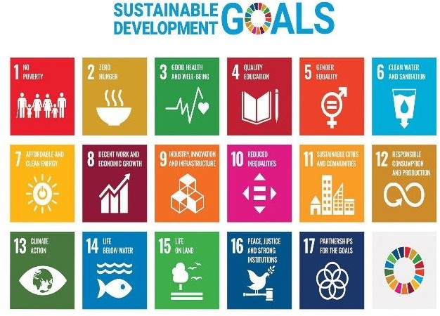
- No Poverty
- Zero Hunger
- Good Health and Well-being
- Quality Education
- Gender Equality
- Clean Water and Sanitation
- Affordable and Clean Energy
- Decent Work and Economic Growth
- Industry,
Innovation and Infrastructure
- Reduced
Inequalities
Figure 5.1 Sustainable Development Goals

- Sustainable Cities and Communities

- Responsible Consumption and Production
- Climate Action
- Life Below Water
- Life On Land
- Peace, Justice and Strong Institutions
- Partnerships for the Goals

The present chapter will focus on the Sustainable Development Goal of ‘Zero Hunger’ (SDG 2). This goal seeks sustainable solutions to end hunger in all its forms by 2030 and to achieve food security. The aim is to ensure that everyone everywhere has enough good-quality and nutritious food to lead a healthy life. Achieving this goal will require better access to food and the widespread

promotion of sustainable agriculture, that is, production practices which don’t over- use or over-exploit our natural resources, especially soils and water (Refer Figure 5.1 for other SDGs).

In a world where we produce enough food to feed everyone, up to 811 million people still go to bed on an empty stomach each night. Acute food insecurity affected 135 million people in 55 countries in 2019. Even more – one in three
suffer from some form of malnutrition. Hunger is the leading cause of death in the world. Our planet has provided us with tremendous resources, but unequal access and inefficient handling leaves millions of people malnourished. If we promote sustainable agriculture with modern technologies and fair distribution systems, we can sustain the whole world’s population and make sure that nobody will ever suffer from hunger again (SDG Goal 2: Zero Hunger). The Zero Hunger Challenge posed by SDG 2 also calls for the following:
  - Zero stunted children under the age of two
  - 100% access to adequate food all year round
  - All food systems are sustainable
  - 100% increase in smallholder productivity and income
  - Zero loss or waste of food

FOOD AND NUTRITION SECURITY: AN OVERVIEW

Food security historically referred to the overall regional, national, or even global food supply and shortfalls in supply compared to requirements. However, despite overall adequacy of food supply, there was an increased observation of insufficient food intake by certain groups. Therefore, the term has later been applied mostly at a community, local, household or individual level (Foster, 1992). According to the accepted definition, adopted at the World Food Summit in 1996, Food Security is achieved when it is ensured that “all people, at all times, have physical, social and economic access to sufficient, safe and nutritious food which meets their dietary needs and food preferences for an active and healthy life”. Food here is defined as any substance that people eat and drink to maintain life and growth, hence includes safe and clean water.

The High-Level Panel of Experts to the Committee on World Food Security (HLPE-CFS), at the global level, is the foremost inclusive and evidence-based international and intergovernmental platform for food security and nutrition (FSN). It has emphasized that the ‘Right to Food’ is central to the definition of food security. In addition to the four dimensions of food security, namely, availability, access, utilization and stability. implied in the above definition, it has added two more dimensions of agency and sustainability .

The period of mid-1990s, started increasingly to emphasize ‘nutrition security’ as an integral part of ‘food security’, given the persistence of a range of micronutrient deficiencies. Nutrition security focuses on both the quantity and quality of food consumption by the household or the individual and on how that food is utilized by the body. The focus on nutrition adds the aspects of caring practices, and health services and healthy environments to the concept, in addition to the quality and diversity of food (Quisumbing, 1995).

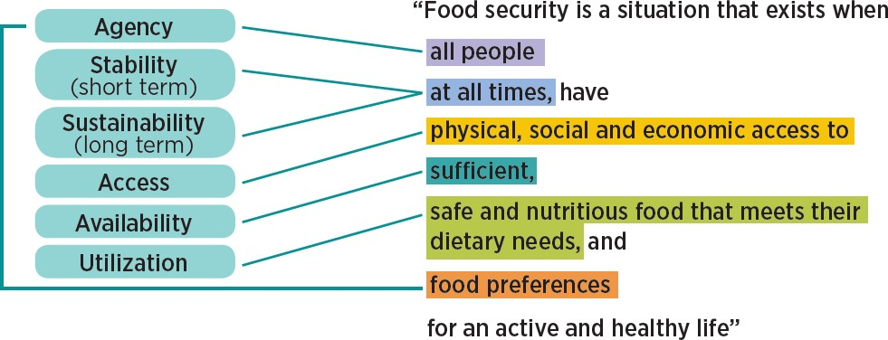
Figure 5.2 Dimensions of Food Security

FOOD SYSTEMS

A food system gathers all the elements (environment, people, inputs, processes, infrastructures, institutions, etc.) and activities that relate to the production, processing, distribution, preparation and consumption of food, originating from agriculture, forestry or fisheries, and the outputs of these activities, including broader socio-economic and environmental outcomes (HLPE, 2017). The food system is composed of sub-systems (e.g. farming system, waste management system, input supply system) and interacts with other key systems (e.g. energy system, trade system, health system). Therefore, a structural change in the food system might originate from a change in another system; for example, a policy promoting more bio fuels in the energy system will have a significant impact on the food system.

Food systems are diverse, ranging from traditional to mixed and modern food systems. While modern food systems are characterized by more diverse food options all year long, and by processing and packaging to extend food’s shelf life, they are not necessarily the healthiest. Policymakers should focus on encouraging the availability and accessibility of diverse and healthy diets, particularly for the marginalized and the most vulnerable. They should aim to limit the consumption of highly processed and nutrient-poor foods by targeting the industries that produce them (e.g. through marketing restrictions, content restrictions and labeling requirements for trans fats and added sugars) as well as the consumers (e.g. through subsidies and taxes, and nutrition education).

Sustainable Food Systems
A sustainable food system (SFS) lies at the heart of the United Nations’ Sustainable Development Goals (SDGs). Adopted in 2015, the SDGs call for major transformations in agriculture and food systems in order to end hunger, achieve food security and improve nutrition by 2030. To realize the SDGs, the global food system needs to be reshaped to be more productive, more inclusive of poor and marginalized populations, environmentally sustainable and resilient, and able to deliver healthy and nutritious diets to all. These are complex and

systemic challenges that require the combination of interconnected actions at the local, regional, national, and global levels. “A food system that delivers food security and nutrition for all in such a way that the economic, social and environmental bases to generate food security and nutrition for future generations are not compromised” means that:
    - It is profitable (economic sustainability);
    - It has broad-based benefits for society (social sustainability); and
    - It has a positive or neutral impact on the natural environment (environmental sustainability).

Drivers of a Sustainable Food System
Food systems can be sustainable only if the interconnectivity and interrelatedness between different parts of the system is ensured. For instance, the progress on SDG 2 – ‘Zero hunger’ has a direct bearing on progress of SDG 3 – ‘Good health and well-being’, and vice versa; similarly, SDG 6 – ‘Clean water and sanitation’, is necessary for food production as well as good nutrition; SDG 12 – ‘Responsible production and consumption’ is necessary to achieve food security and nutrition in a sustainable manner.

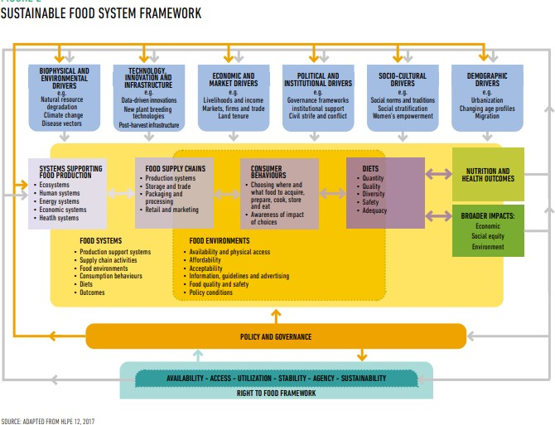
A sustainable food system recognizes the complexity of relationships among the systems that support food production, food supply chains, food environments, the behaviors of individual consumers, diets, and nutritional and wider outcomes that feed back into the system. In the past, a narrow focus on agricultural production and agricultural policies, with little attention to the diversity of food system drivers as discussed below, has meant that despite sufficient food production at the global level, many millions remained hungry. Simultaneous focus in a coordinated manner to create the right policies and incentives/disincentives across sectors and levels of the food value chains, from production to consumption, can only ensure the right to food for all.

Figure 5.3 Framework of Sustainable Food System

Figure 5.3 illustrates the framework of sustainable food systems. It highlights six main categories of food system drivers including the biophysical and environmental; technology and innovation; economic and market; political and institutional; socio-cultural; and demographic. These are discussed below.

i.) Biophysical and environmental - Food production is heavily dependent on natural resources such as water, land and soil, and ecosystem services like biodiversity, the number of plant and animal species, as well as intra-species variety. All these are critical for food security, diets and nutrition, and serve as the foundation for a sustainable and well managed agriculture system. Climatic conditions such as floods and droughts, impact not only agricultural productivity but also human health. As Devereux notes “Hunger seasons” are most severe when there is also unpredictable rainfall or extreme weather events (2015).

ii.) Technology, innovation and infrastructure - To address the issue of depleting natural resources and build a sustainable food system that protects communities in the events of climatic change, the role of innovation and technology becomes critical. For instance, digital farming is being used by farmers of industrialized countries to improve the efficiency of farm inputs such as energy and agrochemicals. Farmers in less industrialized countries, including small-scale farmers, are also beginning to adopt digital technologies, although there is a knowledge gap in this area and more research is needed to gain a full picture of usage trends (HLPE, 2020).

Infrastructure plays a vital role in today’s context where the produced food moves a longer distance. Developing countries with weak storage infrastructure face restricted ability to translate harvests into food items especially in case of fruits and vegetables. Limited transport infrastructure results in high levels of food losses. Robust infrastructure for storage and transportation can help address food shortages, thereby contributing to food security and safety.

iii.) Economic and market - Global food trade has significant impacts on diets and nutrition of people where food systems and agricultural supply chains are globalized. An expansion of agric-food markets like supermarkets has changed dietary demands, but also relations between countries. For instance, in recent years, food trade has been disrupted owing to growing trade tensions between the world’s two largest economies - China and the United States of America (HLPE, 2020). The global agric-food markets and trade have also faced critiques due to their exclusionary nature, which marginalize small-scale producers and remote areas from the supply chains, by denying them access to such markets.

Another factor which has impacted the food system is the growing financial investments by private entities, which have received both positive and negative responses. On the negative side, it is believed that such financial investment in agricultural commodities has been a key factor driving food price volatility as occurred during the 2008 food price crisis. The impacts of large-scale land acquisitions in developing countries are ambiguous, providing capital for the development of agricultural sector, while also dispossessing local populations.

iv.) Political and institutional - There is a critical role of leadership and governance at regional, national, and global levels for framing a pro-people, and sustainable food security and nutrition policy. However, recent years have seen a decline in public sector investment in agriculture and much of the increased investment in food and agriculture, since the 2007 global food crisis, has been from the private sector (Giller et al., 2017). Much more research is needed on the potential implications of declining public investment for FSN outcomes.

Other political factors impacting food systems are civil strife and conflicts. These lead to chronic food insecurity and malnourishment as food systems are repeatedly put under stress due to unstable food supply chains. Moreover, violent and armed conflict can lead to the destruction of crops, livestock, land and water systems, as well as disruptions in infrastructure and human resources required for food production, processing, distribution and safe consumption.

v.) Socio-cultural - Inequalities based on factors such as geographical location, class, race, gender and caste make certain groups of people more vulnerable and therefore, they become a critical group in food security and nutrition framework. HLPE (2017) identified inequality as an important barrier to agency, access and sustainability in food systems. For instance, rural women face disproportionately high rates of poverty and barriers against accessing productive assets for agriculture, such as land, credit and inputs (FAO, 2017b) which affect their resilience to withstand shocks such as climate-related disasters or increased food prices. Women-headed households are particularly vulnerable and their situation worsens if they belong to already marginalized communities like Dalits and Tribal’s in India.

vi.) Demographic - Population growth and changing demographics put pressure not only on the planet, but also on the sustainability of livelihoods and development. Although population growth rates are declining globally, as countries go through their demographic transition, world population continues to increase. According to FAO (2018f) the food demand is projected to increase, though the extent of increase will depend on consumer food choices and the ability to reduce food losses and waste. Urbanization puts further stress on food systems as people’s demand and dietary needs change. Increased consumption of pre-packaged and processed food and demand for a greater diversity of food in urban areas has not only dictated the kind of foods to be grown by rural producers but also how these foods are traded, processed, distributed and marketed. While urbanization affects diets and nutrition in complex ways, rural to urban migration weakens the capacity of rural communities to produce food, because of the loss of labour in rural areas.

These six broad drivers have social, economic and environmental impacts, reinforcing the interconnected and interrelated nature of our food systems:

Food supply chains are often referred to as food production and distribution networks. These are an important component of food systems, and include all the stages and actors, including private sector businesses, from production to trade, processing, retail marketing, consumption and waste disposal (HLPE 12, 2017). Food supply chains draw on supporting ecological, human, energy and economic systems to produce and distribute food, while also providing livelihoods for those who work at various points in the production-to- distribution continuum.

Food environments consist of ‘food entry points’, namely, personal spaces of acquiring food, personal determinants of food choice and underlying socio- cultural and political factors that shape access, affordability, safety and food preferences. Food environments typically overlap with food supply chains, consumer behaviors and diets. In fact, people are experiencing food and diet transitions due to multiple factors including improved food supply chains, better infrastructure, more accessibility, affordability, and advertising and promotion. People aspire to foods seen as ‘modern’ and often include processed foods such as corn flakes, bread, noodles, pasta, chips etc. which are not necessarily healthy. Unlike these foods, tribal communities in India source food from agriculture, from forests and ponds, local markets and the government’s public distribution system. Though the traditional food of tribal and rural communities presents a diverse plate and is often a ‘balanced’ diet, these foods are seen as ‘backward’, wild (in case of tribal areas) and are discouraged. Therefore, there is a need to recognize the close link between traditional foods, farming practices and cultures and how they modify themselves when in contact with modern food cultures.

Consumer behaviors are the responses of people to food environments and comprise of individual awareness and decisions on where and what foods to acquire, prepare and eat. These are ultimately individuals’ decisions that shape their diets in terms of quantity, quality, diversity, safety and adequacy of food (Downs et al., 2020).

Diets shape outcomes that affect other systems, such as nutritional impacts within populations affecting health, or the climate impacts of diets affecting ecosystems. These linkages create feedback loops that shape the drivers of food system change and the policies that address it (Burlingame, 2019). Well- nourished individuals and communities are key to sustaining food systems, ensuring positive life outcomes and feeding those outcomes back by influencing people’s ability to work and exercise agency within the food system.

Policy and governance systems encompass both formal and informal rules, norms and processes that shape policies and decisions affecting food systems. These could include taxation, import-export policies, land use policies, or perceptions about what constitutes agricultural development or healthy food. The key actors engaged in food governance include public actors, such as governments and intergovernmental organizations, civil society, including non- governmental agencies and social movements, and private sector actors, such as businesses. Food policy and governance seeks to shape food system outcomes, and in the process shape the ways in which drivers of food system change, affect consumer behaviors, and the rules by which supply chain actors operate, amongst others. Food system policy and governance, guided by the principle of the right to food, are most likely to support the six dimensions of food security.

CONCLUSION

We are not on track to meet the SDGs, especially those related to food and nutrition security. To be sustainable, food systems need to address the different dimensions of food security. We need to strengthen our conceptual understanding of the different drivers and processes involved in the food system, and their implications on wellbeing outcomes. Research and documentation, using participatory, people-oriented methods, to understand and support diverse food systems, are needed. This can be accomplished through land reforms, access to institutionalized credit, promoting usage of good quality seeds, fertilizer and pesticides, new and effective methods of irrigation like sprinkle irrigation and drip irrigation, tax reforms, and so on Further, access to food implies having sufficient resources to obtain appropriate foods for a nutritious diet at country, household and individual levels. Measures should be taken to strengthen social protection and governance mechanisms, and ensuring accountability, participation and transparency to assure access to food for marginalized and vulnerable communities.

REFERENCES AND SUGGESTED READINS

Freedman D.A., Vaudrin N., Schneider C. et al. (2016). Systematic Review of Factors Influencing Farmers’ Market Use Overall and among Low-Income Populations. J Acad Nutr Diet,116(7), 1136–1155.

HLPE (2017). Nutrition and food systems. A report by the High-Level Panel of Experts on Food Security and Nutrition of the Committee on World Food Security, Report 12. Rome.

HLPE (2020a). Food security and nutrition: building a global narrative towards 2030. Committee on World Food Security. Report 15. Rome. http://www. fao.org/3/ca9731en/ca9731en.pdf.

HLPE (2020b). Interim Issues Paper on the Impact of COVID-19 on Food Security andNutrition (FSN). Committee on World Food Security. Rome. http://www.fao.org/fileadmin/templates/cfs/Docs1920/Chair/HLPE_En glish.pdf.

Kumar, Dharma (2005). The Cambridge Economic History of India, Volume II:
c. 1757–2003. New Delhi: Orient Longman.

Dr.Suman Singh, (Assistant Professor,) Indira Gandhi National Open University Maidan Garhi New Delhi, Pin -110068. Office Context Number.- 011-29573096, Mobile NO. 9170979915, Email Id – sumansingh@ignou.ac.in.

REFERENCES AND SUGGESTED READINS

Freedman D.A., Vaudrin N., Schneider C. et al. (2016). Systematic Review of Factors Influencing Farmers’ Market Use Overall and among Low-Income Populations. J Acad Nutr Diet,116(7), 1136–1155.

HLPE (2017). Nutrition and food systems. A report by the High-Level Panel of Experts on Food Security and Nutrition of the Committee on World Food Security, Report 12. Rome.

HLPE (2020a). Food security and nutrition: building a global narrative towards 2030. Committee on World Food Security. Report 15. Rome. http://www. fao.org/3/ca9731en/ca9731en.pdf.

HLPE (2020b). Interim Issues Paper on the Impact of COVID-19 on Food Security andNutrition (FSN). Committee on World Food Security. Rome. http://www.fao.org/fileadmin/templates/cfs/Docs1920/Chair/HLPE_En glish.pdf.

Kumar, Dharma (2005). The Cambridge Economic History of India, Volume II:
c. 1757–2003. New Delhi: Orient Longman.

Dr. Suman Singh, Assistant Professor, Indira Gandhi National Open University Maidan Garhi New Delhi, Pin -110068. Office Context NO.- 011-29573096, Mobile NO. 9170979915, Email Id is here– sumansingh@ignou.ac.in.

