AN EVALUATION OF THE BIOACTIVITIES OF SILVER NANOPARTICLES SYNTHESIZED FROM RED MARINE MACROALGAE
Govindan Pothiaraj¹, Murugan Manoranjani¹, Sasikumar Pitchaikani¹, Premavathi Venkatachalam¹, Konda Mani Saravanan^{2*}, HarshavardhanShakila^{1*}

¹Department of Molecular Microbiology, School of Biotechnology, Madurai Kamaraj University, Madurai - 620021, Tamil Nadu, India.
²Department of Biotechnology, Bharath Institute of Higher Education and Research, Chennai – 600073, Tamil Nadu, India.

*Corresponding author: saravananbioinform@bharathuniv.ac.in & mohanshakila@yahoo.com

ABSTRACT
Nanobiotechnology is emerging as a swiftly expanding field, encompassing a range of scientific and technological applications to generate innovative materials at the nanoscale, typically ranging from 1 to 100 nanometers. In recent times, the utilization of seaweed extracts for producing silver nanoparticles has gained prominence. Additionally, these extracts possess a significant abundance of bioactive compounds. In this study, we present a comprehensive account of the synthesis of silver nanoparticles (AgNPs) using an aqueous extract of Chondrococcus hornemannii seaweed. The resulting nanoparticles were subjected to characterization using standard procedures. Additionally, the antibacterial properties of the synthesized nanoparticles were evaluated. The antimicrobial activity of an aqueous extract derived from C. hornemannii seaweed was investigated. The AgNPs synthesized through biosynthesis demonstrated a significant antioxidant activity of 94% at a concentration of 100μg/mL. The antimicrobial efficacy of the AgNPs was evaluated against various bacterial pathogens, demonstrating significant activity. The AgNPs demonstrated noteworthy antibacterial and antioxidant activities.

Keywords
Herbal medicine; Nanobiotechnology; Silver nanoparticles; Antimicrobial efficacy; Antioxidant.

1. BACKGROUND
Seaweeds are a taxonomically distinct assemblage of macroalgae that inhabit various marine and brackish ecosystems. These organisms exhibit photosynthetic capabilities, cannot produce flowers, and typically adhere to a stable substrate characterized by low light availability of approximately 0.01% (Behera et al., 2022). Additionally, they demonstrate adaptability to challenging conditions such as the periphery of reefs, areas with turbulent waves, and intertidal zones. Seaweeds are categorized into three distinct groups, namely red (Rhodophyta), brown (Phaeophyta), and green (Chlorophyta), based on their biochemical and cellular characteristics (Watt and Scrosati, 2014). The larger seaweeds exhibit a sophisticated anatomical organization featuring specialized tissues that facilitate the transport of nutrients and photosynthetic products. In contrast, some seaweed possesses a nearly indistinguishable structure (Baweja et al., 2016). The dimensions of seaweeds exhibit a range of sizes, spanning from smaller forms consisting of a single cell to larger forms composed of multiple cells. The smaller seaweeds exhibit a size range of a few millimeters, while the larger seaweed species can exceed lengths of 30 to 50 meters. Additionally, there is a discernible variation in cell size between these two categories. Certain cells exhibit more nuclei and organelles responsible for protein synthesis (Lomartire and Gonçalves, 2023). According to Rayapu et al., the presence of proteins is expected to facilitate the accelerated growth of seaweeds (Rayapu et al., 2017). The substances found in them include lipids, vitamins, minerals, polysaccharides, polyphenols, and proteins. There is a total of approximately 1,800 species of green seaweeds that inhabit marine environments. Red seaweeds exhibit comparatively lower levels of diversity when compared to the other two groups. The seaweed is drying in a shaded environment to enhance its storage capabilities, thereby extending its shelf life (Friedlander, 2008). In contemporary times, the utilization of seaweeds is widely acknowledged as an environmentally sustainable approach within the field of nanotechnology (Vidyasagar et al., 2023).
Many individuals have turned to biological approaches to address toxicity due to their inherent safety and environmentally friendly nature (APB et al., 2022; Walling et al., 2023). These methods also serve as functionalizing ligands, enabling nanoparticle utilization in biomedical therapies and enhancing their capacity for metal binding. Numerous techniques are currently accessible for the environmentally friendly production of nanoparticles, utilizing diverse biological resources such as marine organisms, plant extracts, microorganisms, and microfluidics (Jiménez-González et al., 2012). Among these, plant extracts and bio-reductants have emerged as particularly significant for the green synthesis of nanoparticles due to their advantageous characteristics, including ease of handling, cost-effectiveness, and widespread availability. Silver nanoparticles have garnered significant attention in nanotechnology due to their unique properties (Joicy et al., 2023; Yan and Chen, 2019). Silver has been widely recognized as an antimicrobial agent within the medical domain for an extended period (Lesjak et al., 2014). According to Martínez-Gutierrez et al., antimicrobial properties in AgNPs can facilitate the development of a broader range of nanosilver products (Martínez-Gutierrez et al., 2012). These may include contraceptive devices, wound dressings coated with nanosilver, and surgical implements. In addition to these attributes. Recently, there have been reports of using silver nanoparticles in various applications, such as detergents, paint formulations, and the textile industry.
The utilization of silver nanoparticles (AgNPs) has garnered significant attention in various fields. This is primarily due to the remarkable physicochemical properties of AgNPs (Khamhaengpol and Siri, 2017) and their subsequent potential for application (Jamil et al., 2015). The material demonstrates catalytic activity, notable chemical stability, and antibacterial properties, rendering it highly promising for various biological applications (Andersson et al., 2016; Muñoz-Escobar et al., 2019). Nevertheless, silver nanoparticles (AgNPs) have a crucial function in exhibiting a high level of reactivity, which effectively hinders the processes of oxidation and aggregation among particles. The demand for environmentally friendly methods of metal-nanoparticle synthesis, which do not involve toxic chemicals, has been steadily increasing. This has led to a subsequent rise in the development of green nanoparticle preparation techniques (Chen et al., 2008).
Nevertheless, numerous conventional methodologies for synthesizing nanoparticles with precise size and composition exist. Nanoparticles composed of high metal content have been synthesized using environmentally friendly methods, employing compounds such as CdO, ZnO, Sm2O3, and other metals. These synthesis techniques avoid the use of toxic chemicals and aim to achieve the smallest possible particle size (Thakkar et al., 2010; Thema et al., 2015; Thovhogi et al., 2015). The synthesis of novel nanoparticles exhibiting diverse sizes and shapes significantly influences their inherently dynamic properties. Nanoparticles (NPs) exhibit significant influence due to their morphology, size, and structure, with the characteristic feature of having smaller diameters ranging from 1 to 100 nanometers. However, it possesses a substantial surface area and finds numerous applications in medicine and industry, including but not limited to biological engineering, electron devices, and catalysts. Various techniques for synthesizing nanoparticles exist, including extractions and gum-based approaches. The control of nanoparticle (NP) size stabilization and monitoring was achieved through the use of polysaccharides, as demonstrated by Andersson et al. (Andersson et al., 2016). The primary aim of this investigation is to propose an efficient and effective method for the green synthesis of AgNP's, which have demonstrated notable biological characteristics.

2. METHODS
2.1. Seaweed Collection
Chondrococcus hornemannii (Lyngbye), a species of red seaweed, was obtained from the coastal region of Villoondi Theertham. This particular location was situated in the region between Rameswaram and Pamban, which are both located in the state of Tamil Nadu, India. The identification of the seaweed was conducted through the utilization of morphological characterization. The seaweed was thoroughly washed using running tap water and two subsequent washes with a 10% SDS solution. The washed seaweeds were subjected to a drying process for one week at a temperature of 37ºC. The concentrated aqueous liquid extracts were prepared using hot extraction with water as the solvent. The powder was combined with a volume of water twice as large and subsequently subjected to boiling. Subsequently, the samples that had undergone boiling were filtrated. The filtered samples were then further filtered. The resulting filtrate was stored at 4ºC for subsequent experimental procedures.
2.2 Synthesis of nanoparticles
A 1 millimolar (mM) silver nitrate (AgNO3) solution from Sigma-Aldrich served as a source of silver ions. Subsequently, the aqueous liquid extract of Chondrococcus hornemannii, measuring 1 mL, was solubilized in a solution containing 50 mL of silver nitrate with a concentration of 1 millimolar. The colorless solution (AgNO3 solution) was transformed into a dark brown color through direct visual observation, and the samples were subsequently verified using Ultraviolet-visible spectroscopy. The utilization of an aqueous extract derived from seaweeds as a negative control was implemented in the study. All experimental procedures were replicated twice and conducted in triplicate. Following centrifugation, the liquid portion above the sediment, known as the supernatant, was meticulously extracted. The concluding residue was retained for future utilization.
2.3. Screening of AgNPs
The investigation focused on examining the composition of phytochemicals in the aqueous extract. The research methodology followed the protocol established by Farnsworth in 1966 (Farnsworth et al., 1985).
2.4. Characterization of AgNPs
A volume of 1 mL of the prepared sample was analyzed using UV spectroscopy at various wavelengths, employing a spectrophotometer. The absorbance spectra were recorded using a UV spectrophotometer (UV-1800m, Shimadzu) within the 300-700 nm wavelength range. Following a 48-hour reaction, the mixture containing synthetic silver nanoparticles (AgNPs) underwent centrifugation at 13,000 revolutions per minute (rpm) for 15 minutes at a temperature of 4ºC. Subsequently, the supernatant was meticulously extracted. The pellets were dissolved in sterile MilliQ water and filtered through a Millipore filter (0.45µm) to remove impurities. The FTIR spectrum of the dried reaction mixture was obtained using Bruker Optik GmbH, Germany (Model: TENSOR 27).
2.5. Zeta potential
Silver nanoparticles (AgNPs) exhibit a +^{ve} charge and have been observed to possess a -^{ve} charge on their surfaces. In this study, the synthesized AgNPs, weighing 1mg, were dissolved in sterile deionized water measuring 1 mL.
2.6. Antimicrobial activity
The antimicrobial efficacy of various concentrations (1, 3, 5 mM) of fabricated AgNPs was assessed against Gram positive and negative bacterial strains. Notably, the lowest concentration (5 mM) of AgNPs exhibited superior inhibitory activity against the bacterial pathogen. Subsequently, the LB Agar medium plate, which consisted of 1% of the suitable bacterial culture at a concentration of 1×104 Colony Forming Units per milliliter, was evenly distributed onto the surface of the Petri plate. The solution should be allowed to cool for approximately 5 to 10 minutes. Following this, three distinct concentrations (1, 3, and 5 mM) of AgNPs were introduced into each well. Subsequently, the Petri plates were subjected to incubation at a temperature of 37ºC for one night. The diffusion of AgNPs into the agar plate is employed to inhibit bacterial growth.
2.7. Antioxidant efficacy
A solution containing 100 microliters of 0.2 millimolar DPPH was prepared by dissolving it in methanol suitable for high-performance liquid chromatography (HPLC). Subsequently, this solution was combined with different concentrations of silver nanoparticles (25, 50, 75, and 100 micrograms per milliliter). Subsequently, the reaction mixtures were meticulously blended and subjected to a 30-minute incubation period under conditions of darkness. Methanol was utilized as a blank, while ascorbic acid served as the standard (Chang et al., 2001). The quantification of the scavenging activity of free radicals was determined.

3. RESULTS
3.1. Synthesis of AgNPs
The process of synthesizing AgNPs involved the combination of a 5 mL extract obtained from seaweed with a solution of AgNO3 (50 mL). This mixture was then incubated at a temperature of 28ºC for 24 hours. The bioremediation process involving the conversion of AgNO3 into AgNPs was confirmed through visual observation of color changes. Figure 1 shows that the color solution undergoes a transition from its initial state, characterized by coloration, to a colorless state (AgNO3). Eventually, the solution progresses further to attain a reddish-brown hue (AgNPs).
3.2. UV-Vis Spectroscopy
UV-Vis spectroscopy, specifically utilizing the UV-1800m instrument manufactured by Shimadzu, was employed to confirm the formation of AgNPs. The spectroscopic analysis was conducted within the 200 to 800nm wavelength range. The presence of AgNPs was confirmed by the presence of surface plasmon resonance band, with peaks at 300 and 400nm. The spectra obtained from the newly prepared AgNPs were utilized to assess the photostability of the samples and were subsequently compared to the spectra obtained from silver samples. The sample's ampule consisted of a quartz cell, while a blank was prepared using Molecular grade water (Figure 2).
3.3. FTIR spectroscopy
The utilization of this instrument has proven to be highly advantageous in identifying functional groups close to the interaction between metal particles and biomolecules. These functional groups play a crucial role in the bioreduction of Ag+ and also serve as primary agents for capping and stabilizing (Dada et al., 2016). The seaweed extract has been found to contain carbohydrates, flavonoids, and glycosides, which have demonstrated a significant capacity for reducing Ag+ ions. The technique was employed to characterize and identify the chemical constituents on the surfaces of the AgNPs, as depicted in Figure 3.
3.4. XRD
The XRD patterns of the AgNPs exhibited distinct and well-defined peaks, indicating their crystalline structure. This observation was further supported by XRD analysis, and the corresponding image is presented in Figure 4.
3.5. Zeta Potential Measurement
Zeta potential measurement is a method used to indirectly assess the net positive and negative charges present on the surface of nanoparticles when they are in a liquid state. The electrophoretic mobility of nanoparticles in the U-type tube at a temperature of 25°C was determined by using a zeta sizer instrument manufactured by Beckman Coulter. The impact of the Zeta potential on the AgNPs nanoparticles, which were produced using an aqueous liquid extract of Chondrococcus hornemannii, is depicted in Figure 5.
3.6. Antimicrobial efficacy
The antibacterial efficacy was initially verified through the determination of the minimal inhibitory concentration (MIC), although the specific data is not presented in this context. The present study investigated silver nanoparticles' antimicrobial properties using aqueous extracts derived from Chondrococcus hornemannii. The disc diffusion method was employed to assess the antimicrobial activity of these nanoparticles at varying concentrations of 3 and 5 mM. The gram-positive bacterium Streptococcus aureus (Figure 6A) and the gram-negative bacteria Escherichia coli and Pseudomonas aeruginosa (Figures 6B and C) were utilized. At the same time, the antibiotic streptomycin can be employed as a positive control, as recommended for evaluating the antibacterial efficacy of the synthesized silver nanoparticles. The antibiotic disc results are presented in Table 1.
Three filter paper discs with a diameter of 2.5 mm were impregnated with a solution of AgNPs at different concentrations, namely 1, 3, and 5 mM, with each disc soaked in 2.5 mL of the respective solution. Subsequently, the aseptic discs were positioned onto the agar plate harboring Escherichia coli, and the Petri dishes were incubated at 37º C for 16 hours. Following the incubation period, the zone of inhibition was measured.
3.7. Antioxidant efficacy
The DPPH free radical scavenging activity and corresponding outcomes are illustrated in Figure 7. In this study, a range of concentrations of synthesis AgNPs and ascorbic acid (standard) were utilized, specifically 25, 50, 75, and 100 µg/mL. The graph presented herein demonstrates the robust antioxidant property of AgNPs. Notably, it is observed that as the concentration of AgNPs is elevated, there is a corresponding increase in the scavenging activity. The AgNPs exhibit a significantly higher antioxidant activity of 96% at a concentration of 100μg/mL. The standard ascorbic acid demonstrates a 92% inhibition rate when comparing equal concentrations.

4. CONCLUSION
The present study describes the green synthesis of AgNPs from Chondrococcus hornemannii. This research represents the first report on the synthesis of silver nanoparticles using this particular organism. The synthesized silver nanoparticles were subjected to characterization using various techniques. The observed antibacterial efficacy of the AgNPs against both gram-positive and gram-negative bacteria has been confirmed. The AgNPs synthesized through biological means have demonstrated significant therapeutic potential. In the future, nanotechnology holds potential for advancements in medicine, particularly in the development of nanomedicine and the manufacturing of various pharmaceutical products.

REFERENCES
Andersson, D.I., Hughes, D., Kubicek-Sutherland, J.Z., 2016. Mechanisms and consequences of bacterial resistance to antimicrobial peptides. Drug Resist. Updat. 26, 43–57. https://doi.org/https://doi.org/10.1016/j.drup.2016.04.002
APB, B., Bhuvaneswari, S., Raj, L., Bupesh, G., Meenakshisundaram, K., KM, S., 2022. A Review on the Potential Species of the Zingiberaceae Family with Anti-viral Efficacy Towards Enveloped Viruses. J. Pure Appl. Microbiol. 16, 796–813. https://doi.org/10.22207/JPAM.16.2.35
Baweja, P., Kumar, S., Sahoo, D., Levine, I., 2016. Chapter 3 - Biology of Seaweeds, in: Fleurence, J., Levine, I.B.T.-S. in H. and D.P. (Eds.), . Academic Press, San Diego, pp. 41–106. https://doi.org/https://doi.org/10.1016/B978-0-12-802772-1.00003-8
Behera, D.P., Ingle, K.N., Mathew, D.E., Dhimmar, A., Sahastrabudhe, H., Sahu, S.K., Krishnan, M.G., Shinde, P.B., Ganesan, M., Mantri, V.A., 2022. Epiphytism, diseases and grazing in seaweed aquaculture: A comprehensive review. Rev. Aquac. 14, 1345–1370. https://doi.org/https://doi.org/10.1111/raq.12653
Chang, S.-T., Wu, J.-H., Wang, S.-Y., Kang, P.-L., Yang, N.-S., Shyur, L.-F., 2001. Antioxidant Activity of Extracts from Acacia confusa Bark and Heartwood. J. Agric. Food Chem. 49, 3420–3424. https://doi.org/10.1021/jf0100907
Chen, J., Wang, J., Zhang, X., Jin, Y., 2008. Microwave-assisted green synthesis of silver nanoparticles by carboxymethyl cellulose sodium and silver nitrate. Mater. Chem. Phys. 108, 421–424. https://doi.org/https://doi.org/10.1016/j.matchemphys.2007.10.019
Dada, A.O., Latona, D., Ojediran, O., Nath, O., 2016. Adsorption of Cu (II) onto bamboo supported manganese (BS-Mn) nanocomposite: effect of operational parameters, kinetic, isotherms, and thermodynamic studies. J. Appl. Sci. Environ. Manag. 20, 409–422. https://doi.org/10.4314/jasem.v20i2.24
Farnsworth, N.R., Akerele, O., Bingel, A.S., Soejarto, D.D., Guo, Z., 1985. Medicinal plants in therapy. Bull. World Health Organ. 63, 965–981.
Friedlander, M., 2008. Israeli R & D activities in seaweed cultivation. Isr. J. Plant Sci. 56, 15–28. https://doi.org/10.1560/IJPS.56.1-2.15
Jamil, N., Che Hussin, N., Nordin, S., Awang, K., 2015. Automatic Plant Identification: Is Shape the Key Feature? Procedia Comput. Sci. 76, 436–442. https://doi.org/10.1016/j.procs.2015.12.287
Jiménez-González, C., Constable, D.J.C., Ponder, C.S., 2012. Evaluating the “Greenness” of chemical processes and products in the pharmaceutical industry—a green metrics primer. Chem. Soc. Rev. 41, 1485–1498. https://doi.org/10.1039/C1CS15215G
Joicy, A., Selvamani, R., Janani, C., Balasubramanian, C., Prabhu, K., Marimuthu, K., Giridharan, B., Vijayakumar, T., Saravanan, K.M., 2023. Photocatalytic Degradation of Textile Dye Using Green Synthesized Nanoparticles. Lett. Appl. NanoBioScience 12, 102. https://doi.org/10.33263/LIANBS124.102
Khamhaengpol, A., Siri, S., 2017. Green synthesis of silver nanoparticles using tissue extract of weaver ant larvae. Mater. Lett. 192, 72–75. https://doi.org/https://doi.org/10.1016/j.matlet.2017.01.076
Lesjak, M.M., Beara, I.N., Orčić, D.Z., Petar, K.N., Simin, N.Đ., Emilija, S.Đ., Mimica-Dukić, N.M., 2014. Phytochemical composition and antioxidant, anti-inflammatory and antimicrobial activities of Juniperus macrocarpa Sibth. et Sm. J. Funct. Foods 7, 257–268. https://doi.org/https://doi.org/10.1016/j.jff.2014.02.003
Lomartire, S., Gonçalves, A.M.M., 2023. Algal Phycocolloids: Bioactivities and Pharmaceutical Applications. Mar. Drugs. https://doi.org/10.3390/md21070384
Martínez-Gutierrez, F., Thi, E.P., Silverman, J.M., de Oliveira, C.C., Svensson, S.L., Vanden Hoek, A., Sánchez, E.M., Reiner, N.E., Gaynor, E.C., Pryzdial, E.L.G., Conway, E.M., Orrantia, E., Ruiz, F., Av-Gay, Y., Bach, H., 2012. Antibacterial activity, inflammatory response, coagulation and cytotoxicity effects of silver nanoparticles. Nanomedicine 8, 328–336. https://doi.org/10.1016/j.nano.2011.06.014
Muñoz-Escobar, A., Ruíz-Baltazar, Á. de J., Reyes-López, S.Y., 2019. Novel Route of Synthesis of PCL-CuONPs Composites With Antimicrobial Properties. Dose-Response 17, 1559325819869502. https://doi.org/10.1177/1559325819869502
Rayapu, L., Makkar, F., Chakraborty, K., Valluru, L., 2017. PHYTOCHEMICAL EVALUATION AND ANTIMICROBIAL ACTIVITY OF GRACILARIA OPUNTIA: AN IMPORTANT ANTI-DIABETIC RED MARINE MACROALGAE. Int. J. Curr. Pharm. Res. 9, 37. https://doi.org/10.22159/ijcpr.2017v9i6.23426
Thakkar, K.N., Mhatre, S.S., Parikh, R.Y., 2010. Biological synthesis of metallic nanoparticles. Nanomedicine Nanotechnology, Biol. Med. 6, 257–262. https://doi.org/https://doi.org/10.1016/j.nano.2009.07.002
Thema, F.T., Manikandan, E., Dhlamini, M.S., Maaza, M., 2015. Green synthesis of ZnO nanoparticles via Agathosma betulina natural extract. Mater. Lett. 161, 124–127. https://doi.org/https://doi.org/10.1016/j.matlet.2015.08.052
Thovhogi, N., Diallo, A., Gurib-Fakim, A., Maaza, M., 2015. Nanoparticles green synthesis by Hibiscus Sabdariffa flower extract: Main physical properties. J. Alloys Compd. 647. https://doi.org/10.1016/j.jallcom.2015.06.076
Vidyasagar, Patel, R.R., Singh, S.K., Singh, M., 2023. Green synthesis of silver nanoparticles: methods, biological applications, delivery and toxicity. Mater. Adv. 4, 1831–1849. https://doi.org/10.1039/D2MA01105K
Walling, B., Bharali, P., Giridharan, B., Gogoi, B., Sorhie, V., Alemtoshi, Mani, S.K., 2023. Bacterial nanocellulose: A novel nanostructured bio-adsorbent for green remediation technology. Acta Ecol. Sin. https://doi.org/https://doi.org/10.1016/j.chnaes.2023.02.002
Watt, C.A., Scrosati, R.A., 2014. SEAWEEDS AS ECOSYSTEM ENGINEERS. Bull. Ecol. Soc. Am. 95, 250–251. https://doi.org/https://doi.org/10.1890/0012-9623-95.3.250
Yan, A., Chen, Z., 2019. Impacts of Silver Nanoparticles on Plants: A Focus on the Phytotoxicity and Underlying Mechanism. Int. J. Mol. Sci. https://doi.org/10.3390/ijms20051003

Table: 1 Antibacterial activity of synthesis of AgNPs by Zone of inhibition:
Zone of inhibition mM
Test pathogen | Seaweed  Extract | AgNPs  3 mM | AgNPs  5 mM | Streptomycin
S. aureus | 7.3 | 7.3 | 8.2 | 6.3
E. coli | 6.2 | 7.0 | 9.0 | 6.2
P. aeruginosa | 7.0 | 7.2 | 9.2 | 7.0

Figure1. Investigating the effect of silver nitrate salt on the synthesis of silver nanoparticles (A) Aqueous seaweed extract (B) Ag⁺solution (C) Chondrococcus hornemannii AgNPs.
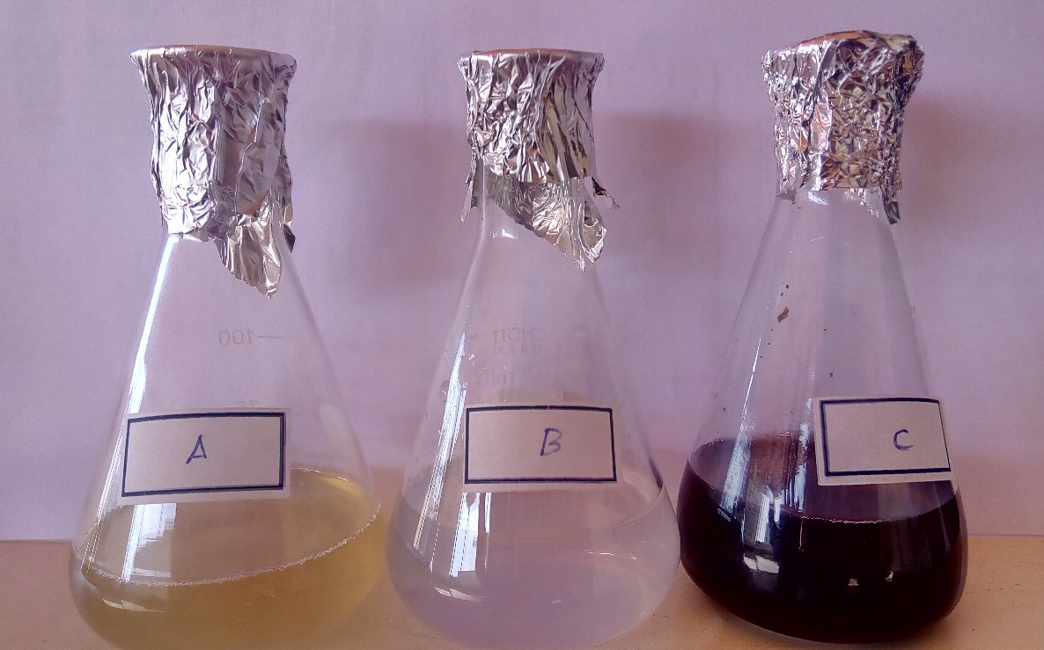

Figure 2. UV-Visible absorbance spectrum of AgNPs as a function of silver nitrate concentration in aqueous extracts of Chondrococcus hornemannii.
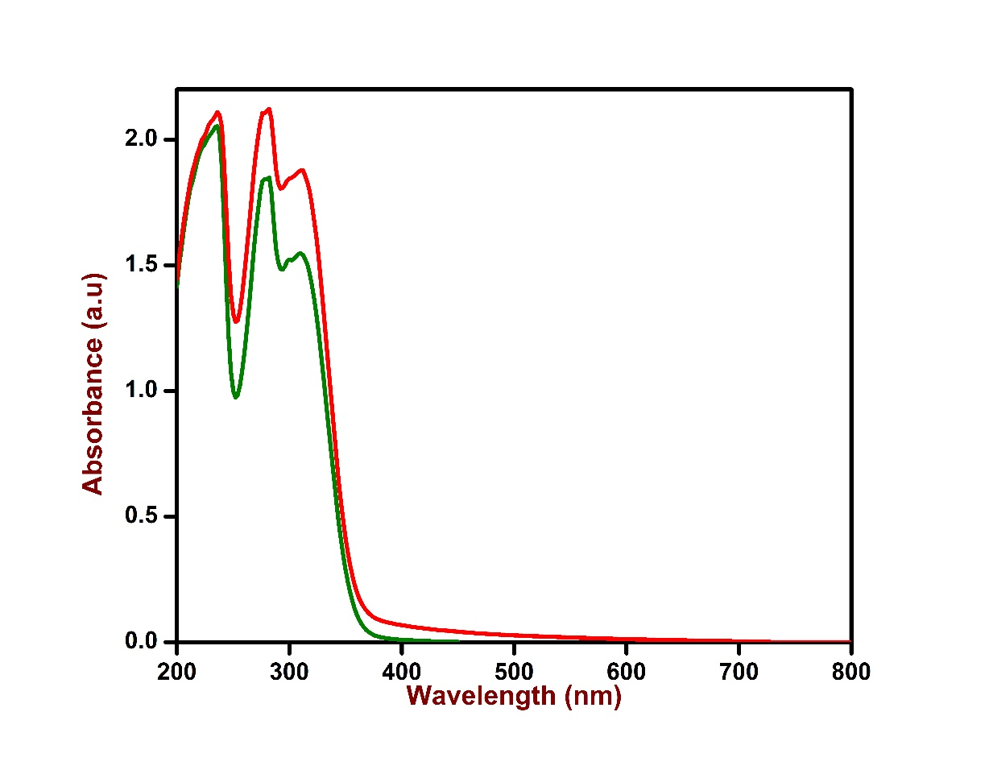

Figure 3. FTIR studies of the silver nanoparticles synthesized using an aqueous liquid extract of Chondrococcus hornemannii.
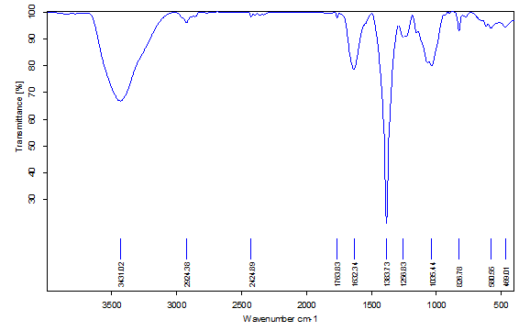

Figure 4. XRD studies of the silver nanoparticles synthesized using an aqueous extract of Chondrococcus hornemannii. 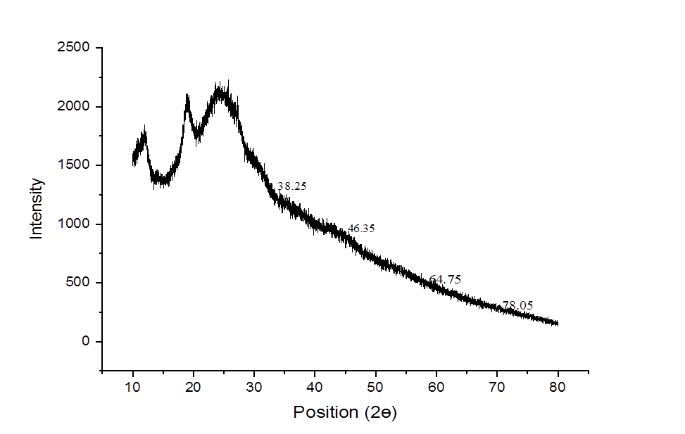

Figure 5. Zeta potential effect of the AgNPs synthesized using an aqueous liquid extract of Chondrococcus hornemannii.

Figure 6. Plates indicating the antimicrobial activities of synthesized AgNPs from Chondrococcus hornemannii in the following method (A) Well diffusion (B) Filter paper discs (C) Antibiotic discs.
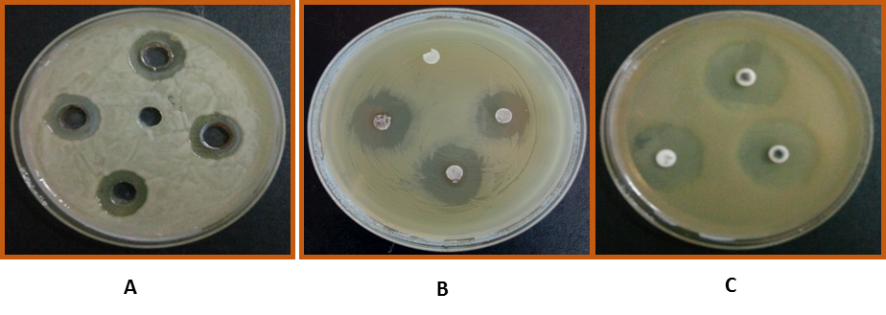

Figure 7. The antioxidant activity of biosynthesized Chondrococcus hornemannii AgNPs.

