Green Fuel - A Sustainable Fuel For The Future
Lakshman Thangaraj
B. Prasanna Kumar
Fermentation and Bioprocess Associate, Valagro Biosciences Private Limited, Hyderabad

CONTENTS
Abstract
Abbreviation
- Introduction
- Advanced Resources for Progressive Bioethanol Production
  - Energy crop
  - Forest biomass
  - Agriculture residues
2.4 Industrial waste
2.5 Municipal solid waste
2.6 Plant cell wall engineering
2.7 Algae
3.0 Manufacturing of green fuel
3.1 Grinding
3.2 Cooking and liquefaction
3.3 Fermentation
3.4 Distillaiton and increase of ethanol concentration
3.5 Biodiesel from microalgae through photobioreactor.
4.0 Developments- Application and upgradation of biofuels
4.1 various application of biofuel in different industries
5.0 Future potential and challenges
6.0 Conclusion.
7.0 References

Abstract
The higher rate of depletion in petroleum products call for an alternative fuel thus biofuels are becoming hugely popular. Biofuels have many attributes like they are helping mitigating climate change and are very reliable they can also be used as additives and can be used in many engines type and on top of that it is carbon neutral.
The discussion covers various aspects of green fuel usage and its sources. Then the first, second and third generation of biofuel and different innovative sources of raw organic materials like energy crops, forest biomass, Agriculture residues, Industrial waste, municipal solid waste, plant cell wall engineering, algae. from which we can extract the green fuel. Further, a clear picture of manufacturing of bioethanol is mentioned with various illustrations are mentioned. The processes involved are grinding in hammer then cooking and liquefaction followed by fermentation, distillation as last stage to increase of ethanol concentration, and additionally the production of biodiesel through photobioreactor. Then, the current trends in the application and upgradation of biofuels are explained with its numerous applications in different industries. Finally, the future potentials and challenges are discussed with conclusion
Keyword: Algae; Biofuel ; Feedstock ; Plant cell wall engineering ; Photobioreactor

Abbreviation
OFMSWs- Organic Fraction of Municipal Solid Waste
CDS- condensed solubles
SSF-Simultaneous Saccharification and Fermentation
HWE-Hot water extraction
FAO-Food and Agriculture Organization
UN- United Nations

GREEN FUEL
1.0 Introduction
Henry Ford had commented that ethanol is going to be the future of the fuel. He said – In the future the fuels are going to be extracted from apple, weeds and sawdust. We can ferment every piece of vegetable staple into fuel. Now, the prediction has come true (Geyer et al., 2007).
The number of inhabitants and number of automobiles are going to be almost equal in the near future. The emissions emitted by automobiles contribute a major percentage to the greenhouse effect. There was always a call for alternative and sustainable fuels. Thus, green fuel is the future because it creates a carbon dioxide neutral situation. (Demirbas, 2008)
The major environmental test now is over usage of fossil fuel in transportation as 24% of Carbon dioxide emissions is accounted at the global level (8.2 Gt in 2019)(Duque et al., 2021). The road transportation taking major portion in this with 75%. The degree of harm caused are worsening in recent years. Therefore, the need of biofuel is vital and plays an important role in mitigating this challenge. Thus various research institute in collaboration with government and industries are working together to make the process more viable as this has potential to improve many aspects like safety, mitigation of climate change, and can help local development of the nation (Tye et al., 2011).

Fuel, power, and other fuel sources, among others, are very important to the world economy. Someone else's garbage might be someone else's treasure, as the old saying goes. Numerous recyclable wastes and raw materials can be used as bioethanol production substrates. Examples include organic and oil-based residues, specified agricultural products, and lignocellulosic material.(Millati et al., 2019)
The United States and Brazil are giant fuel producers in the world. Then some countries in Europe also produces in huge qualities. Currently, the major raw material are food crops like sugar cane, barley, wheat and corn and they are used widely in producing the fuel. ((Duque et al., 2021)
All the regions have their own feed stock through forest, urban sources and agriculture produce. There are many varieties of biomass feed stocks existing and the extraction of biomass can be done from plants and animals. Moreover, major portion of them can be made liquid fuel and another energy source to generate electricity and another byproduct which make it a reliable source. (Johnson, 1996)

First generation biofuel
Traditional biofuels are first generation biofuels. Biodiesel and ethanol are two primary biofuel which are produced by fermentation of sugarcane and starch. Majorly they are blended with diesel to be utilized by trucks or another logistic vehicle. Few resources are vegetable oil and palm oil. With current technology in the market, we can extract oil and sugar. Huge requirements or high demand for supply chain for this product make this a apprehension with resources and food competitiveness. (Nanda et al..2018)
Second generation biofuel
These are advanced biofuels produced by using various biomass which include woody plants, agriculture waste, lignocellulosic biomass, and animal fats. To extract the fuel we need to use necessary physical and chemical process. This are highly technical process. The first-generation fuel uses food by product as resource and the second generation biofuel utilizes numerous agriculture resources.

Third generation biofuel
This is advanced biofuel which is made out of algae, currently the production of biofuel out of algae is done at small scale. The expectation of third generation biofuel is higher as this produces biofuel without taking resources from food and agriculture products or produce and also requires small land to produce it.
2.0 Advanced resources for progressive bioethanol
There are many promising resources of biofuels. Many byproducts or resources which have less or no commercial value can be used for the production of biofuel.
The sources of biofuel are as follows:
- Agriculture produces like rice and wheat straw, sugarcane and few starch crops.
- Agriculture residue and food waste as a organic matter
- Forest biomass and animal byproducts
- Deposits of sludge from waste water and energy crops
- Industrial and municipal waste
2.1 Energy crop
Energy crops are the crops which are majorly or partially used as raw material for the production of biofuel. They have high biomass per square feet. Short growing season in low fertile land makes them a more favorable choice.
There are two types of energy crops
- Herbaceous – which are perennial grasses like switchgrass, giant reed and miscanthus.
- Woody crop – which are like from wood biomass
2.2Agriculttural waste
According to FAO the agriculture waste refers to the wastage happened on farm or household level which could have occurred during the handling and transporting. Agriculture waste can be utilized as resources many countries are not doing it only developed nations are doing so. The huge amount of waste is a promising resource for biofuel as it is already producing millions of liters through agricultural waste. (Abbas &Ansumali,2010). The energy output may differ from the different feedstock used .
  - Industrial leftover
Major bioproduct we are getting is form industrial waste from food, textile and paper industries from which we extract our first- and second-generation biofuel. These are used in profitable way as these waste in the industries could be of no use. The waste contains good amount of organic matter which can be converted into fuel. Fiber material from textile industry is also used as feedstock. Form waste wood the hot water extraction

  - Municipal waste
The house hold trash produced are higher and in developed nations it is above four hundred kg and the percentage of wastage produced in developing nations are also constantly raising. Then the wastes coming from offices and restaurants are even higher. Through many lignocellulosic approaches we can break down this substance and ferment. There is lot of potential in this area which needs to be further explored.
  - Algae
Algae supersedes all other resources as it a unique potential raw material and possess less disadvantage compared with others and considered as potential form of resource to produce raw material. And thus it is third generation biofuel, and its global market is heavily growing.
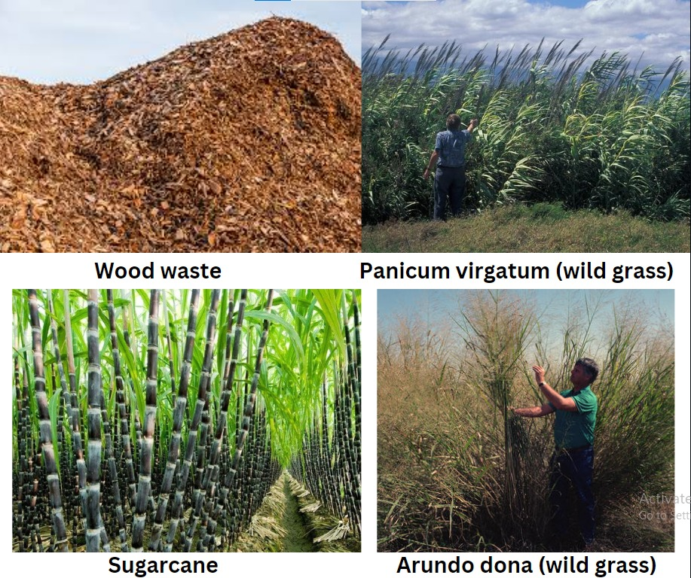

3.0 Manufacturing of green fuel
As now we have understood that there are many raw material or organic matter to produce biofuel. We will look into the way it is produced, taking corn as one example, which can be converted into fuel by processing. The processes used are milling both wet and dry. Further grinding for fermentation process. New developments are seen in this area like in last few decades the drastic increase is seen in dry mill facility.
Dry milling is a process where we can crush into flour which can further be fermented to produce fuel. The process involve many step like cleaning, cooking, distillation and storage.
In this process the starch is converted to glucose. This is done in fermentation through yeast. Afterward the ethanol is separate from water by applying downstream steps like evaporation and drying.
In dry grind method of production, we yield fuel and other products which can be used for another activities. The byproducts are distillery grains and carbon dioxide. According to environmental condition and equipment used the production and concentration rate may differ. (Overview of Corn-Based Fuel Ethanol Coproducts: Production and Use | IntechOpen, n.d.)

3.1 Grinding
Roller or grinding mill is used for grinding. The diagram below shows that how the corn is put through and crushed. The hammer is linked to rods that turns the rotor against the wall. The particles are collected at the bottom and the larger particles are hammered continuously till it comes to correct size. Here grinding helps breaking kernel and further they are mashed.
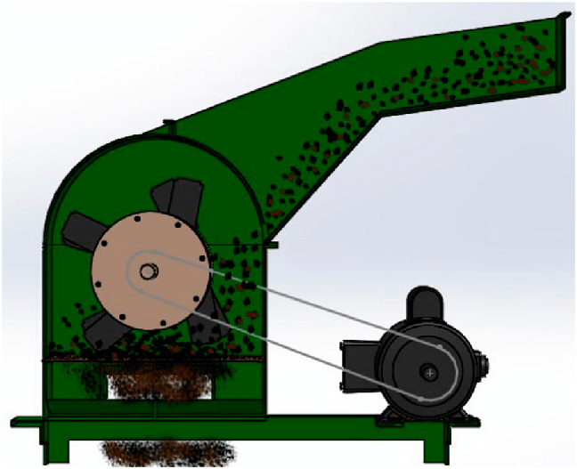
Figure -2 Hammer mill machine - adopted from research gate
3.2 Cooking and liquification

Once the corn is mashed into slurry in the hammer mill the further process is cooking and liquification. This process is widely known as gelatinization where water interacts with starch when temperature is above 76 degrees Celsius.
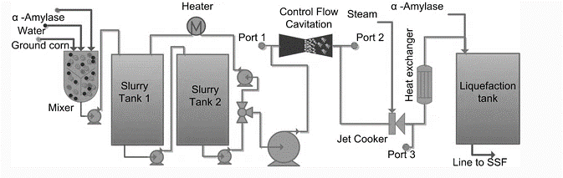
Figure 3: Biofuel production flow (Fig. adopted from Conventional Biodiesel Production, n.d.)

After this point the required media with carbon and nitrogen sources where autoclaved in specific percentage and they were few enzymes were added to extract maltose. The next step is saccharification for the hydrolysis of glucose monomers.
3.3 Fermentation
Is final process in the upstream level for the production of biofuel or ethanol. The chemical reaction produces 2 moles of ethanol and 2 moles of carbon dioxide.
C₆H₁₂O₆→2C₂H₆OH + 2 CO₂C₆H₁₂O₆→2C₂H₆OH + 2 CO₂
The fermentation is taken place by adding saccharomyces cerevisiae which is yeast. If we consider taking formation in batch process it takes 2-3 days at 30-32°C. By additional yeast nutrients proteins are converted into amino acid. Antibiotics are added to prevent contamination. Above 90% of glucose is converted into fuel.
The process where we can do both saccharification and fermentation together is know as SSF. Is done by adding required enzyme and saccharomyces cerevisiae. The fermentation parameters are followed which are optimized. As both fermentation and saccharification is done together this can reduce the production charge.
3..4 Distillation and Increase of Ethanol Concentration
The final stage of biofuel production is the processing of biofuel’s concentration where our products is found to be only 15% and rest is all water. The distillation is carried out at 78°c as
It is the boiling temperature of ethanol. Above are the four steps in extracting biofuel form corn. In next topic we will discuss about the microalgae which comes under third generation biofuel.
3.5 Biodiesel from Microalgae through photobioreactor.
A photobioreactor means that it employs light. Do we need light? - yes, when an organism needs. The organism that requires light is called a photosynthetic organism. Photosynthetic organisms, when you use them and develop them, you need to use a photobioreactor.
It is a third-generation biofuel and as discussed before this is it covers less capital and land area. Moreover, it can be used as efficient fuel and have potential to be used in lager applications. The key is they convert the carbon dioxide in the air to bio-fuel and that is why, it is also considered a carbon neutral kind of a situation. That is, it does not take any carbon from the earth. It just takes the carbon from the air, converts it into bio-fuel and even if it gets back into air, it is still a neutral kind of a situation, there is no addition of carbon dioxide from the earth into the atmosphere. Thus, the process is rather simple. Everything is known about the process. This is the vessel here that contains the broth, and this vessel is provided enough light for the growth of microalgae.

Figure 4 : Biofuel production by algae(Adopted form feednavigator.com, 2018)

4.0 Developments- application and upgradation of biofuel

Social sustainability
- Government support
- Community involvement
- Employment generation
- Rural power support
- Reduce human health impact

Economic Sustainability
- Feedstock
Collection
- Logistic support
- Stakeholder
Need
- Effective Land use
- Competitive cost energy

Utilization of un-used waste biomass, stop uncontrolled combustion of biomass burning, Reduction of GHG emission from unauthorized dumping of biomass

Renewable energy
Ethanol and Biodiesel
Reduce carbon & water Footprints

Tabel 4.1 sustainable approach to biofuel
Currently, there are many cutting edge technologies developed in biofuel industries to make the process more sustainable and viable. The call form government to support to a lager extent is required as it has many benefits to support local community with employment and reduce environmental impact by reducing green gas effect, reducing combustion in road transport. The process where all the organic matter can be easily processed where these biomasses can be more designed with the view of emitting less green house effect in its base level. The conclusions should be draw by keeping environmental perspective in center. In G20 carbon and water footprint are great challenges to be mitigated thus by making biofuel more accessible to the public we can reap good amount of reimbursements from environmental pollution and scarcity of water.

4.2 Various applications of biofuels in different industries.
The bio fuels are used are alternative fuel to regular gasoline or petrol to both commercial and own vehicle in the form of bioethanol and biodiesel their advantages are numerous to say a few greater fuel efficiencies and less emission, and concentrated chemicals like Sulphur and chlorine are less which are key considerations to make it as alternative fuel. One of the major contributors to climate change is aviation industry the high gradient petrol is used in aviation thus there are many research institutions and research center working on this aspect to make it more viable. Further more they can be used as alternative lubricants also. In oil cleaning – oil spillage is one of the major concerns when are inadvertently spilled thus biofuels can play vital role there by not contamination the oceans and other water bodies. (Chen et al., 2020).The advantage derived needs more validation by making it cost effective and implement more creative process to viable the process. (Hendriks & Zeeman, 2009)

5.0 Future Potential
Biofuel serves as best replacement. Every region in the globe needs biofuel by knowing its advantages. The heavy research is going on to make is more accessible and also looking at different feedstock to produce it. There are biorefinery coming up and soon there will be many in the future. Through this biorefinery we will get biogas and electricity also. (Menon & Rao, 2012). Many technological aspects to improve biofuel production are developed, for example, selection of pretreatment technology in rice to increase its saccharification activity and making the process more economical. (Abbas & Ansumali, 2010). Few other bio products come from this process which are also having high economic value. Which are useful biobased products such as fertilizers and perfume. The major work is going on algae which comes under third generation biofuel and has proven its potential.
6.0 conclusion
We have discussed about green fuel as an alternative fuel which is essential for sustainable future. The different types of feedstocks and another potential resources. Basically, every organic matter can be converted in fuel. Some of them may require little processing before using. There are three type of biofuel which are knows as first generation, second generation and third generation biofuel. Furthermore, we looked at wide research in this area, and production of biofuel that involves process like grinding, fermentation and distillation. Then we saw the manufacturing of biofuel by taking corn and algae as feedstocks. Finally, we saw the advancement and potential of biofuel.

7.0 References
Abbas, A., & Ansumali, S. (2010). Global Potential of Rice Husk as a Renewable Feedstock for Ethanol Biofuel Production. BioEnergy Research, 3(4), 328–334. https://doi.org/10.1007/s12155-010-9088-0
Alam, F., Mobin, S., & Chowdhury, H. (2015). Third generation biofuel from algae. Procedia Engineering, 105, 763–768.
Asif, M., & Muneer, T. (2007). Energy supply, its demand and security issues for developed and emerging economies. Renewable and Sustainable Energy Reviews, 11(7), 1388–1413.
Balat, M., Balat, H., & Öz, C. (2008). Progress in bioethanol processing. Progress in Energy and Combustion Science, 34(5), 551–573.
Bhushan, S., Jayakrishnan, U., Shree, B., Bhatt, P., Eshkabilov, S., & Simsek, H. (2023). Biological pretreatment for algal biomass feedstock for biofuel production. Journal of Environmental Chemical Engineering, 11(3), 109870.
Bušić, A., Marđetko, N., Kundas, S., Morzak, G., Belskaya, H., Ivančić Šantek, M., Komes, D., Novak, S., & Šantek, B. (2018). Bioethanol Production from Renewable Raw Materials and Its Separation and Purification: A Review. Food Technology and Biotechnology, 56(3), 289–311. https://doi.org/10.17113/ftb.56.03.18.5546
Chen, Z., An, C., Boufadel, M., Owens, E., Chen, Z., Lee, K., Cao, Y., & Cai, M. (2020). Use of surface-washing agents for the treatment of oiled shorelines: Research advancements, technical applications and future challenges. Chemical Engineering Journal, 391, 123565.
Chopade, S. G., Kulkarni, K. S., Kulkarni, A. D., & Topare, N. S. (2012). Solid heterogeneous catalysts for production of biodiesel from trans-esterification of triglycerides with methanol: A review. Acta Chimica & Pharmaceutica Indica, 2(1), 8–14.
Demirbas, A. (2008). Biofuels sources, biofuel policy, biofuel economy and global biofuel projections. Energy Conversion and Management, 49(8), 2106–2116.
Duque, A., Álvarez, C., Doménech, P., Manzanares, P., & Moreno, A. D. (2021). Advanced Bioethanol Production: From Novel Raw Materials to Integrated Biorefineries. Processes, 9(2), Article 2. https://doi.org/10.3390/pr9020206
feednavigator.com. (2018, August 27). US: Microalgae co-product may have role in cutting fishmeal use. Feednavigator.Com. https://www.feednavigator.com/Article/2018/08/27/US-Microalgae-co-product-may-have-role-in-cutting-fishmeal-use
Fig. 13.6 Flow sheet for conventional biodiesel production. (n.d.). ResearchGate. Retrieved July 31, 2023, from https://www.researchgate.net/figure/Flow-sheet-for-conventional-biodiesel-production_fig3_278655010
Figure 3: Proposed hammermill with flat screen. (n.d.). ResearchGate. Retrieved August 2, 2023, from https://www.researchgate.net/figure/Proposed-hammermill-with-flat-screen_fig3_326490185
Geyer, L. L., Chong, P., & Hxue, B. (2007). Ethanol, biomass, biofuels and energy: A profile and overview. Drake J. Agric. L., 12, 61.
Gold, S., & Seuring, S. (2011). Supply chain and logistics issues of bio-energy production. Journal of Cleaner Production, 19(1), 32–42. https://doi.org/10.1016/j.jclepro.2010.08.009
Gupta, A., & Verma, J. P. (2015). Sustainable bio-ethanol production from agro-residues: A review. Renewable and Sustainable Energy Reviews, 41, 550–567.
Hendriks, A. T. W. M., & Zeeman, G. (2009). Pretreatments to enhance the digestibility of lignocellulosic biomass. Bioresource Technology, 100(1), 10–18. https://doi.org/10.1016/j.biortech.2008.05.027
Johnson, A. W., Shaine Tyson, David. (1996). Biomass Feedstock Resources and Composition. In Handbook on Bioethanol. Routledge.
Maki-Arvela, P., Salmi, T., Holmbom, B., Willfor, S., & Murzin, D. Y. (2011). Synthesis of sugars by hydrolysis of hemicelluloses-a review. Chemical Reviews, 111(9), 5638–5666.
Menon, V., & Rao, M. (2012). Trends in bioconversion of lignocellulose: Biofuels, platform chemicals & biorefinery concept. Progress in Energy and Combustion Science, 38(4), 522–550.
Millati, R., Cahyono, R. B., Ariyanto, T., Azzahrani, I. N., Putri, R. U., & Taherzadeh, M. J. (2019). Agricultural, industrial, municipal, and forest wastes: An overview. Sustainable Resource Recovery and Zero Waste Approaches, 1–22.
Muktham, R., Bhargava, S. K., Bankupalli, S., & Ball, A. S. (2016). A Review on 1st and 2nd Generation Bioethanol Production-Recent Progress. Journal of Sustainable Bioenergy Systems, 6(3), Article 3. https://doi.org/10.4236/jsbs.2016.63008
Nanda, S., Rana, R., Sarangi, P. K., Dalai, A. K., & Kozinski, J. A. (2018). A broad introduction to first-, second-, and third-generation biofuels. Recent Advancements in Biofuels and Bioenergy Utilization, 1–25.
Okolie, J. A., Mukherjee, A., Nanda, S., Dalai, A. K., & Kozinski, J. A. (2021). Next-generation biofuels and platform biochemicals from lignocellulosic biomass. International Journal of Energy Research, 45(10), 14145–14169.
Overview of Corn-Based Fuel Ethanol Coproducts: Production and Use | IntechOpen. (n.d.). Retrieved July 28, 2023, from https://www.intechopen.com/chapters/17480
Ramesh, P., Selvan, V. A. M., & Babu, D. (2022). Selection of sustainable lignocellulose biomass for second-generation bioethanol production for automobile vehicles using lifecycle indicators through fuzzy hybrid PyMCDM approach. Fuel, 322, 124240.
Ramirez-Cadavid, D. A., Kozyuk, O., & Michel, F. C. (2014). Improvement in commercial scale dry mill corn ethanol production using controlled flow cavitation and cellulose hydrolysis. Biomass Conversion and Biorefinery, 4(3), 211–224. https://doi.org/10.1007/s13399-013-0103-5
Reshmy, R., Philip, E., Unni, R., Paul, S. A., Sindhu, R., Madhavan, A., Sirohi, R., Pandey, A., & Binod, P. (2023). Bioethanol—A promising alternative fuel for sustainable future. In Valorization of Biomass to Bioproducts (pp. 179–196). Elsevier.
Singh, P., Rajkhowa, S., Hussain, C. M., & Oraon, R. (2022). Environmental Sustainability and Industries: Technologies for Solid Waste, Wastewater, and Air Treatment. Elsevier.
Timilsina, G. R., & Mevel, S. (2013). Biofuels and climate change mitigation: A CGE analysis incorporating land-use change. Environmental and Resource Economics, 55, 1–19.
Tye, Y. Y., Lee, K. T., Abdullah, W. N. W., & Leh, C. P. (2011). Second-generation bioethanol as a sustainable energy source in Malaysia transportation sector: Status, potential and future prospects. Renewable and Sustainable Energy Reviews, 15(9), 4521–4536.
Varnero, C. S., Urrutia, M. V., & Ibaceta, S. V. (2018). Bioenergy from perennial grasses. Advances in Biofuels and Bioenergy, 1.
Velvizhi, G., Goswami, C., Shetti, N. P., Ahmad, E., Pant, K. K., & Aminabhavi, T. M. (2022). Valorisation of lignocellulosic biomass to value-added products: Paving the pathway towards low-carbon footprint. Fuel, 313, 122678.
Vohra, M., Manwar, J., Manmode, R., Padgilwar, S., & Patil, S. (2014). Bioethanol production: Feedstock and current technologies. Journal of Environmental Chemical Engineering, 2(1), 573–584.
Wietschel, L., Messmann, L., Thorenz, A., & Tuma, A. (2021). Environmental benefits of large-scale second-generation bioethanol production in the EU: An integrated supply chain network optimization and life cycle assessment approach. Journal of Industrial Ecology, 25(3), 677–692.
Duque, A., Álvarez, C., Doménech, P., Manzanares, P. and Moreno, A.D., 2021. Advanced bioethanol production: From novel raw materials to integrated biorefineries. Processes, 9(2), p.206.

