Synbiotics: A Novel Approach in Managing Oral Diseases
Dr. Subhashree Mohapatra, Dr. Rahul Mohandas
Department of Public Health Dentistry, Department of Oral and Maxillofacial Pathology and Oral Microbiology
Dr. D.Y. Patil Dental College and Hospital, Dr. D.Y. Patil Vidyapeeth
Pune, India

ABSTRACT
The desire for natural alternatives has increased as a result of the usage of antibiotics, which has caused pathogenic organisms to exhibit skyrocketing levels of multidrug resistance. Clinical evidence demonstrating the usefulness and effectiveness of several prebiotics and probiotic strains in enhancing oral health has increased over the last few years. It has recently been suggested that combining prebiotics and probiotics may result in the development of novel synbiotics that may function well in the fight against oral bacteria. According to the FAO/WHO (2001), probiotics are described as live microbes that boost the host’s health when given in sufficient quantity. According to Gibson and Roberfroid (1995), prebiotics are described as non-digestible food ingredient that beneficially affects the host by selectively stimulating the growth and/or activity of one or a limited number of bacteria in the colon, and thereby improves host health Mixtures of probiotics and prebiotics that beneficially affect the host by enhancing the survival and implantation of live microbial dietary supplements are referred to as "synbiotics." The creation of synbiotics may have a positive synergistic impact on oral health and make up for the shortcomings of the individual components. This article has reviewed the most recent information on the function of synbiotics in preserving oral health, recommendations, and potential future applications.
Key words: probiotics, prebiotics, synbiotics, oral health, dental caries, periodontitis, oral cancer
I. INTRODUCTION
Antibiotic therapy was introduced in the mid-20th century and since then it has been used extensively to inhibit the growth of several micro-organisms. (1) In dental practice, antibiotics are routinely used to treat odontogenic and non-odontogenic infections, focal infections, and to prevent the spread of infection to neighbouring tissues and organs. (2)
However, the overuse of antibiotics has resulted in pathogenic organisms developing alarmingly high levels of multidrug resistance, driving up the demand for natural alternatives. (3) Clinical evidence demonstrating the usefulness and effectiveness of several prebiotics and probiotic strains in enhancing oral health has increased over the last few years. (3) It has recently been suggested that combining prebiotics and probiotics may result in the development of novel synbiotics that may function well in the fight against oral bacteria. (4)
A. Probiotics and Prebiotics: Shaping the Future of Dentistry
According to the FAO/WHO (2001), probiotics are described as live microbes that boost the host’s health when given in sufficient quantity. (5) Probiotics like L. acidophilus, L. reuteri, L. paracasei, L. salivarius strains WB21 and T1271, L. paracasei SD1, Streptococcus thermophiles and L. bulgaricus, Lactobacillus rhamnosus, L. salivarius strains WB21 and T12711, Lactococcus lactis, L. plantarum strain 299v, L. helveticus, L. salivarius WB21 and L. fermentum, Bacillus subtilis and L. salivarius, E. faecium WB2000, S. thermophiles, S. salivarius K12 have proved to be a potential substitute for antibiotics in several oral conditions like halitosis, dental caries, and periodontitis. (6) However, the exact mechanism of action of probiotics is unknown. A proposed mechanism of action suggests that the probiotic organisms either damage the pathogenic organism directly or modulate the host response towards the pathogens (Figure 1). (6)
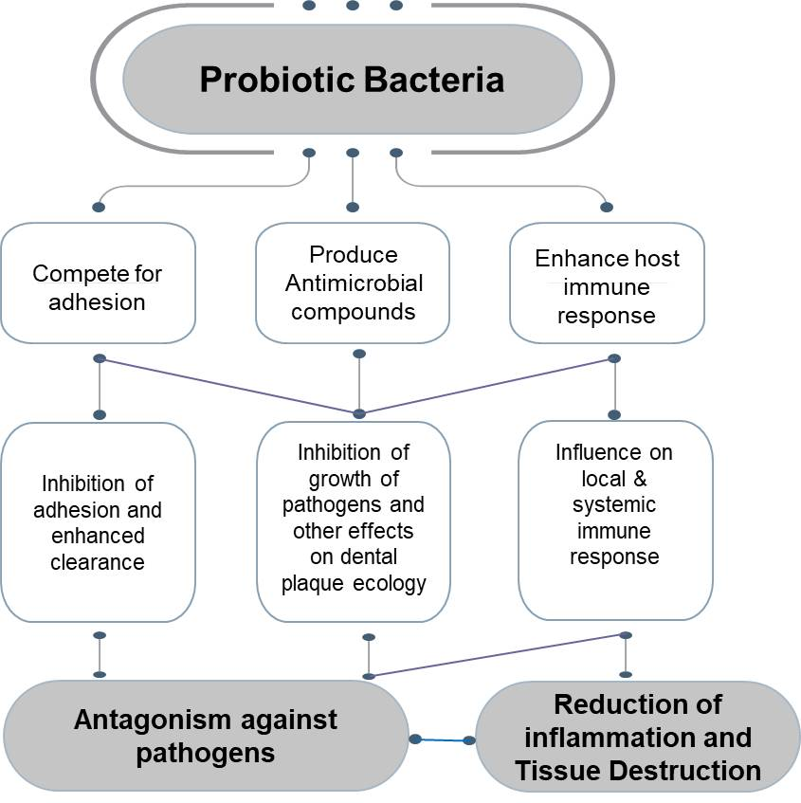
Figure 1: Proposed mechanism of action of probiotics
The ‘prebiotic approach’ has been introduced more recently. According to Gibson and Roberfroid (1995), prebiotics are described as non-digestible food ingredient that beneficially affects the host by selectively stimulating the growth and/or activity of one or a limited number of bacteria in the colon, and thereby improves host health. (7) Certain probiotics are grown more rapidly by prebiotics than others. Prebiotics should be able to change intestine microbial flora and its activity as well as systemic components of the host defence system as they are neither digested nor absorbed by mammalian enzymes.. (8)
Prebiotics have shown potential scope in various aspects of health such as improving calcium absorption, (9) immune system, (10) and reducing colorectal cancer. (11) However, limited research has been done to evaluate prebiotics’ impact on oral health. Prebiotics operate as a nutrition supply to aid in the colonisation of oral-beneficial bacteria in the oral cavity, promoting the growth of these organisms. (12) In a study, biofilms were created using 14 different types of oral bacteria, which were then treated with prebiotic solutions. Succinic acid, N-acetyl-D-mannosamine, and Met-Pro all showed promise as prebiotic substrates since they produced a biofilm made up of >95% of species of healthy oral bacteria. N-acetyl-D-mannosamine was identified as the most promising oral prebiotic substrate as it showed significant changes in bacterial composition. (13) Similar findings were seen in another study, where a comparison was done between the effects of structural analogues N-acetyl-d-mannosamine (NADM) and N-acetyl-d-glucosamine (NADG) on multispecies oral biofilms. NADM showed a beneficial microbial compositional shift, reduced virulence of microorganisms, altered metabolism, and decreased inflammatory potential. (14) Recently, arginine-containing prebiotics have shown superior effect in caries prevention as compared to the controls. It has been shown that administering L-arginine to supragingival biofilms prevents the development of the biofilm matrix and the microbial interactions that promote the development of cariogenic biofilms. (15) However, prolonged arginine consumption may raise the risk of oral anaerobe overgrowth, including Porphyromonas gingivalis, and plaque alkalization. (16)
B. Relationship between probiotics and prebiotics
The ability of a microbe to colonise the surfaces of the oral cavity is a crucial prerequisite for its classification as an oral probiotic. Probiotic bacteria, however, may not be able to adhere to oral surfaces, which calls into question if they can actually benefit oral health. (17) Prebiotics specifically promote the development of probiotic bacteria while preventing the emergence of harmful microorganisms. Therefore, combining probiotics and prebiotics may improve oral health issues in a synergistic manner. (17)

II. SYNBIOTICS: THE BEST OF BOTH THE WORLDS
By enhancing the survival and implantation of live microbial dietary supplements, synbiotics are characterised as "mixtures of probiotics and prebiotics that beneficially affect the host" (Figure 2). (18) Prebiotics function by promoting good bacteria like Lactobacilli and Bifidobacteria over pathogenic strains' potential attachment sites. As a result, the microbes become less virulent due to their anti-adhesive qualities. (19) Different studies have reported on the evidence for prebiotics and probiotics in enhancing dental health. However, the creation of synbiotics may have a synergistic effect in enhancing oral health and make up for the shortcomings of the individual components (20,21,22). (23) Below is a summary of the most recent information on the contribution of synbiotics to sustaining oral health. (Figure 3).
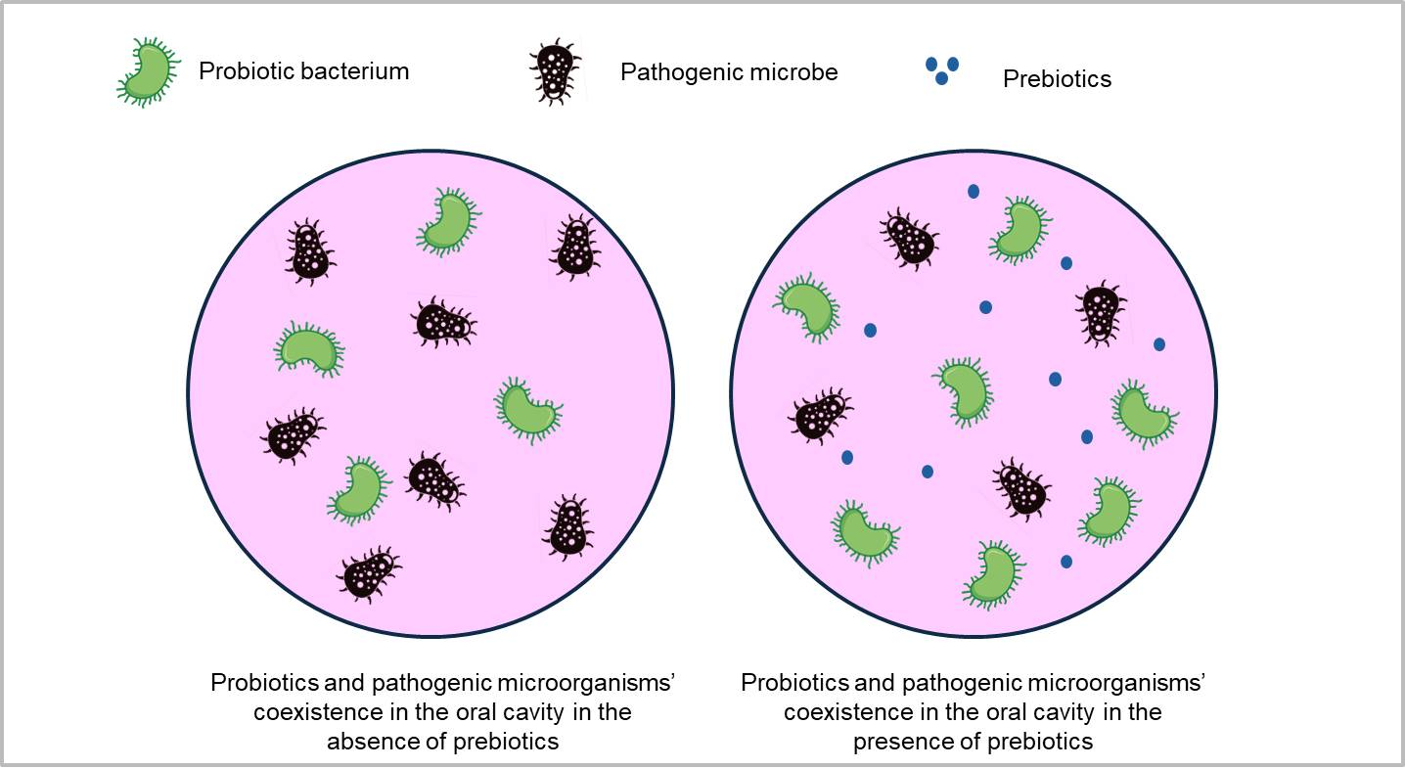
Figure 2: Synbiotics-products containing both probiotics and prebiotics

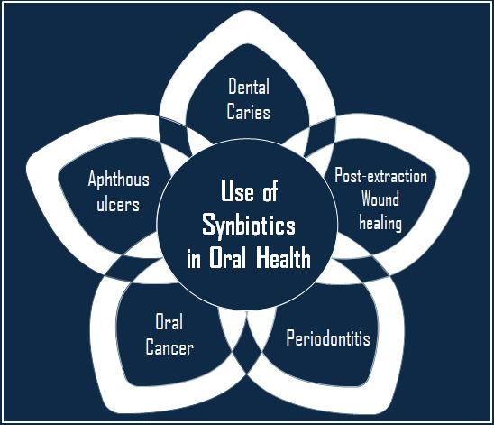
Figure 3: Role of synbiotics in oral health
A. Dental caries
3.09 billion incident instances of caries in permanent teeth were reported in the 2019 Global Burden of Disease Study. (24). Dental caries has a detrimental effect on psychosocial well-being and the quality of life associated to oral health (25). Dental cavity treatment and continuing care have significant financial costs in addition to having a detrimental effect on quality of life. To minimise the worldwide burden of caries and its negative effects, broad caries prevention is therefore required.
Dental caries is a multifactorial disease caused by the presence of excessive cariogenic microorganisms as compared to healthy oral commensals. The cariogenic pathogens metabolize fermentable carbohydrates and cause a prolonged acidic microenvironment in the oral cavity, thus leading to demineralization of the tooth. (26) Although topical fluoride application inhibits enamel demineralization and promotes remineralization (27), a limited biofilm control is offered by them. (28) Therefore, to preserve ecological symbiosis, topical fluoride treatment must be combined with biofilm-focused techniques.
Biofilm inhibition and biofilm modulation are the two types of biofilm targeted strategies. Biofilm inhibition using antimicrobial agents for a long term may cause antimicrobial resistance and disrupt the oral microbial ecology. By reducing the prevalence of infections and promoting the establishment of healthy commensals, biofilm modulation preserves the oral ecosystem. Therefore, biofilm modulation is a desirable approach to restore homeostasis in the oral cavity. (23) External supplementation of beneficial synbiotics may act synergistically and can be a good option to trigger biofilm modulation.
Synbiotics have been shown in numerous trials to be beneficial in reducing the growth of Streptococcus mutans. According to a study, the combination of 2% L-arginine (a prebiotic) and L. rhamnosus GG (LrG), a probiotic, inhibits the growth of Streptococcus mutans in a synergistic manner. (29) The combination of Lactobacillus acidophilus and glucomannan hydrolysate, (30) 3% galacto-oligosaccharides and 1% fructo-oligosaccharides along with Lactobacillus acidophilus, (31) have been found to suppress the growth of S.mutans. Prebiotic arginine and arginolytic probiotics have also shown promising results in preventing dental caries. (32) In contrast, a study has reported that the combination of galacto-oligosaccharides and Lactobacillus acidophilus does not inhibit the growth of S. mutans. (33) Synbiotics were found to reduce salivary viscosity and enhance the saliva's ability to act as a buffer in a quasi-experimental clinical trial on people with active tooth decay. (34) However, a randomised controlled trial indicated that children who take probiotic curd as opposed to those who receive symbiotic curd have better growth inhibition of S. mutans. (35) Since most of the studies done on this aspect have been in-vitro in nature, the scientific proof of the involvement of synbiotics in inhibiting Streptococcus mutans growth and reducing dental caries is still only preliminary.
B. Periodontitis
Periodontitis, one of the most common disorders that affect teeth, destroys the tooth's supporting and encircling tissue. (36) The word "periodontitis" is made up of the two terms "periodont-" and "itis," where "periodont-" stands for "structure surrounding the teeth" and "itis" stands for "inflammation." Periodontitis is a disorder that first affects the gingival tissue before spreading to deeper tissues, disrupting the natural homeostasis of the bone and resulting in tooth loss if left untreated. (37) Periodontal disease has a complex aetiology. (37) Periodontitis' primary cause has been identified as the bacterial biofilm that is growing on the surfaces of the teeth. (38) Genetics, environmental variables, the patient's systemic health, lifestyle decisions, and other socioeconomic determinants all play a role in the progression of the disease, even though the host response, along with local variables like plaque and calculus, affects the disease's course. (39) Patients' general health suffers as a result of periodontopathogens' detrimental effects, which go beyond the periodontium. (40)
The conventional treatment for periodontal disease is mechanical sub-gingival debridement, followed by antibiotic therapy because it changes the sub-gingival flora to one that is less harmful. However, re-colonisation of more aggressive microorganisms occurs within one-two weeks. The long-term effect of periodontal therapy may not be really improved by antibiotics or antiseptics. Hence, an alternative strategy needs to be developed for plaque-induced periodontitis. (41)
To determine the effectiveness of synbiotics in the treatment of smokers and non-smokers with gingivitis, a randomised controlled trial (RCT) was done. It was found that patients in the treatment group (who used symbiotic tablets) had lower levels of IL-8, IL-6, and IL-10 in their gingival crevicular fluid than those in the control group (who took placebo tablets). However, there was no significant difference between the groups in terms of gingival and plaque index. (42)
The levels of pocket depth (PD), clinical attachment loss (CAL), plaque index, malondialdehyde (MDA), and interleukin-1 (IL-1) were found to be significantly reduced by symbiotic supplementation with a combination of multispecies probiotics and 100 mg fructo-oligosaccharide in another RCT among diabetes mellitus patients receiving non-surgical periodontal therapy (NSPT). Total antioxidant capacity (TAC), superoxide dismutase (SOD), and glutathione peroxidase (GPx) serum levels increased significantly. (43) Similar to the previous RCT, which involved patients with aggressive periodontitis (AP), this study found that co-administration of a synbiotic lozenge and a standard treatment regimen (doxycycline) significantly improved periodontal health. (44) In a study, individuals with chronic periodontitis underwent guided periodontal pocket recolonization (GPR) utilising synbiotics as a supplement to scaling and root planing. In patients with chronic periodontitis, synbiotic therapy was observed to enhance clinical, microbiological, and biochemical markers. (45)
C. Aphthous ulcers
Since ancient times, medical and dental practitioners have frequently recognised painful oral aphthous ulcers in otherwise healthy patients as aphthae or canker sores. They affect the oral mucosa the most frequently in the general population. (46) The Greek verb "aphthi," which means "to set on fire" or "to inflame," is where the word "aphthae" comes from and it is believed that Hippocrates originally used it to describe the discomfort brought on by a common oral condition that was prevalent in his time (possibly, aphthous stomatitis). (47) The aetiology of repeated mouth ulcerations has been linked to local trauma, hereditary factors, nutritional inadequacies, viral and bacterial infections, as well as immunological or endocrine disorders. Recurrent aphthous stomatitis (RAS) is a term used to describe situations in which no cause can be determined and a diagnosis of exclusion must be made. There are three types of RAS: herpetiform (10%), major (10%), and minor (>70% of cases). (48) The form, location, severity, and prognosis of these subgroups vary.
The standard treatment for treating recurrent aphthous ulcers is long term administration of steroids. However, it is associated with several adverse effects such as immunity deficiency, and oral mucosa atrophy. Therefore, alternative therapies with lower side effects and higher efficiency need to be developed. (49) In a study, it has been found that symbiotic lozenges along with mucopain gel and Cap. Becasules are more effective in resolving aphthous stomatitis with no adverse effects, as compared to the standard therapy alone. (50)
D. Post-extraction wound healing
To evaluate the efficiency of synbiotics, antibiotics, and analgesics in post-extraction wound healing in tooth sockets, an RCT was carried out. The effectiveness of synbiotics was found to be equal to that of standard analgesic-antibiotic regimen. (51)
E. Oral cancer
Oral cancer is a highly relevant global public health issue, especially for dental surgeons. In 2020, there were 377,713 OSCC cases annually, with Asia recording the most cases (248,360), followed by Europe (65,279) and North America (27,469), according to statistics from the Global Cancer Observatory (GCO). (52) The majority of oral cancers are linked to tobacco use, alcohol consumption, or both. Oral cancers that are HPV-positive have become more common recently. (53)
No research has examined the effectiveness of synbiotics in preventing oral cancer as of yet. However, they have been found to be effective in preventing colorectal cancer. (54) The exact mechanism of synbiotics in inhibiting colorectal cancer has not been established yet. However, there are two proposed mechanisms of action: (i) formation of complementary synbiotics, in which probiotics and prebiotics work together to produce an additive antioxidant effect at the host, and (ii) synergistic synbiotics, in which prebiotics, whether or not they are antioxidants, support and enhance probiotics antioxidant function to produce higher characteristics than either component alone (Figure 4). (55) They have also shown prophylactic effects post gastrointestinal cancer surgery. (56) These findings are preliminary and carefully designed human trials need to be planned. Also, the findings cannot be generalized to all cases, as each individual has a unique microflora composition.
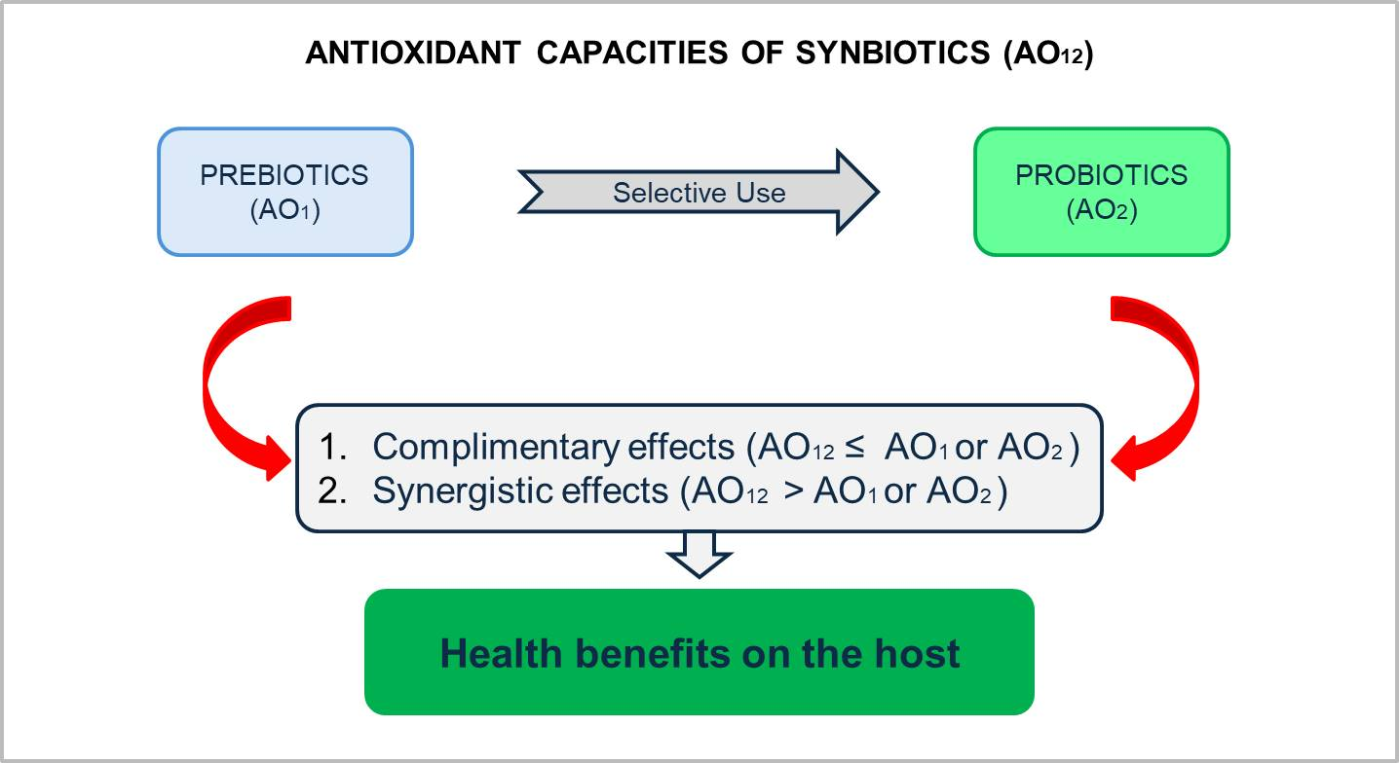
Figure 4: Antioxidant activities (AO) of synbiotics
III. RECOMMENDATIONS AND FUTURE SCOPE
- The exact mechanism of action of synbiotics against cariogenic pathogens needs to be identified.
- Several synbiotics have been proposed for the prevention of dental caries, however it is important to determine whether or not they truly qualify as synbiotics.
- Although a number of in-vitro investigations have produced encouraging findings, human trials are still required to determine the therapeutic efficacy of synbiotics in preventing dental caries.
- In several RCTs, synbiotic supplementations have shown promising results in improving periodontal health. In future research, they can be included in mouthwashes and checked for clinical effectiveness.
- The effectiveness of particular probiotic strains, the optimal dosage of probiotics and prebiotics, and the length of treatment must all be evaluated for future synbiotic research.
- Synbiotics based on arginine have showed promising benefits in the prevention of dental cavities. However, to evaluate their long-term effectiveness, prospective, longitudinal studies must be carried out.
- Future research can be done to assess the role of synbiotics in oral cancer as they have shown promising results in colorectal and gastrointestinal cancer.

IV. CONCLUSION
Based on the available evidence, it is apparent that synbiotics have a lot of potential for enhancing oral health. However, future research is necessary to maximise and determine the size of this advantage. It is also necessary to look into how prebiotics can improve oral health. Additionally, the choice of synbiotics—or probiotics and prebiotics separately—depends on the extensive ecological changes in the mouth brought on by their consumption and how they will affect oral health in the long run.
REFERENCES
[1] Morcillo E, Cortijo J, Villagrasa V. Bases farmacológicas de la antibioticoterapia en infecciones odontogénicas. Med Oral. 1996; 1:15-23.
[2] Roda RP, Bagán JV, Bielsa JMS, Pastor EC. Antibiotic use in dental practice. A review. Med Oral Patol Oral Cir Bucal. 2007;12:E186-92.
[3] Mehta K, Mehta H. Synbiotics in oral immunity: a review. International Journal of Otorhinolaryngology and Head and Neck Surgery Mehta K. Int J Otorhinolaryngol Head Neck Surg. 2021;7(5):915-91.
[4] Kojima Y, Ohshima T, Seneviratne C. J, Maeda N. Combining prebiotics and probiotics to develop novel synbiotics that suppress oral pathogens. J. Oral Biosci.2015; 58, 27–32.
[5] FAO/WHO (2001). Evaluation of Health and Nutritional Properties of Probiotics in Food Including Powder Milk with Live Lactic Acid Bacteria. Report of a Joint FAO/WHO Expert Consultation.
[6] Nanavati G, Prasanth T, Kosala M, Bhandari SK, Banotra P. Effect of Probiotics and Prebiotics on Oral Health. Dental Journal of Advance Studies. 2021;9(1):1-6.
[7] Gibson G. R, and Roberfroid M. B. Dietary modulation of the human colonic microbiota: introducing the concept of prebiotics. J. Nutr. 1995;125: 1401–1412.
[8] Pandey KR, Naik SR, Vakil BV. Probiotics, prebiotics and synbiotics- a review. J Food Sci Technol 2015;52(12):7577–7587.
[9] Scholz-Ahrens KE, Schrezenmeir J. Inulin and oligofructose and mineral metabolism: the evidence from animal trials. J. Nutr. 2007;137 (11 Suppl): 2513S–23S.
[10] Lomax AR, Calder PC. Prebiotics, immune function, infection and inflammation: a review of the evidence. Br J Nutr. 2009; 101 (5): 633–58.
[11] Geier MS, Butler RN, Howarth GS. Probiotics, prebiotics and synbiotics: a role in chemoprevention for colorectal cancer? Cancer Biol. Ther. 2006;5(10):1265-1269.
[12] Mohd Fuad A.S, Amran N.A, Nasruddin N.S.The Mechanisms of Probiotics, Prebiotics, Synbiotics, and Postbiotics in Oral Cancer Management. Probiotics & Antimicro. Prot. 2022.
[13] Slomka V, Herrero ER, Boon N, Bernaets K, Trivedi H, Daep C. Oral prebiotics and the influence of environmental conditions in vitro. J Periodontol. 2018;89(6):708-717.
[14] He J, Hwang G, Liu Y, Gao L, Kilpatrick-Liverman L, Santarpia P, Zhou X, Koo H. L-arginine modifies the exopolysaccharides matrix and thwarts Streptococcus mutans outgrowth within mixed-species oral biofilms. J Bacteriol. 2016;198(19):2651–2661.
[15] Verspecht T, Holm WV, Boon N, Baernaets K, Daep C, Zayed N. Comparison of the modulatory effects of three structurally similar potential prebiotic substrates on an in vitro multi-species oral biofilm. Sci. Rep.2021:11(1);15033.
[16] Zheng X, Cheng X, Wang L, Qiu W, Wang S, Zhou Y. Combinatorial effects of arginine and fluoride on oral bacteria. J Dent Res. 2015;94: 344–53.
[17] Manigandan T, Mangaiyarkarasi SP, Hemalatha R, Hemalatha VT, Murali NP. Probiotics, Prebiotics and synbiotics-A Review. Biomed Pharmacol J. 2012;5(2).
[18] Andersson H, Asp NG, Bruce Å, Roos S, Wadström T, Wold AE. Health effects of probiotics and prebiotics a literature review on human studies. Scand J Nutr. 2001;45: 58–75.
[19] Gibson, G.R, McCartney A.L, Rastall R.A. Prebiotics and resistance to gastrointestinal infections. Br. J. Nutr. 2005, 93, S31–S34.
[20] Astvaldsdottir A, Naimi-Akbar A, Davidson T, Brolund A, Lintamo L, Attergren Granath A. Arginine and Caries Prevention: A Systematic Review. Caries Res. 2016;50: 383–393.
[21] Li J, Huang Z, Mei L, Li G, Li H. Anti-caries effect of arginine-containing formulations in vivo: A systematic review and meta-analysis. Caries Res. 2015;49: 606–617.
[22] Cagetti MG, Mastroberardino S, Milia E, Cocco F, Lingström P, Campus G. The use of probiotic strains in caries prevention: A systematic review. Nutrients. 2013;5: 2530–2550.
[23] Bijle MN, Ekambaram M, CO Lo E, Yiu C. Synbiotics in caries prevention: A scoping review. PLoS One. 2020;15(8):e0237547.
[24] Qin X, Zi H, Zeng X. Changes in the global burden of untreated dental caries from 1990 to 2019: A systematic analysis for the Global Burden of Disease study. Heliyon. 2022;8(9):e10714.
[25] Mota-Veloso I, Soares MEC, Alencar BM, Marques LS, Ramos-Jorge ML, Ramos-Jorge J. Impact of untreated dental caries and its clinical consequences on the oral health-related quality of life of schoolchildren aged 8–10 years. Qual Life Res. 2016;25: 193–199.
[26] Bowen WH. The Stephan Curve revisited. Odontology. 2013;101: 2–8.
[27] Ten Cate JM, Buzalaf MAR. Fluoride mode of action: Once there was an observant Dentist. J Dent Res. 2019;98: 725–730.
[28] Dang MH, Jung JE, Lee DW, Song KY, Jeon JG. Recovery of acid production in Streptococcus mutans biofilms after short-term fluoride treatment. Caries Res. 2016;50: 363–371.
[29] Bijle MN, Neelakantan P, Ekambaram M, CO Lo E, Yiu C. Effect of novel symbiotic on Streptococcus mutans. Scientific Reports.2020;14(10): 7951.
[30] Tester RF, Al-Ghazzewi FH. A preliminary study of the synbiotic effects of konjac glucomannan hydrolysates (GMH) and lactobacilli on the growth of the oral bacterium Streptococcus mutans. Nutr Food Sci. 2011;41: 234–237.
[31] Nunpan S, Suwannachart C, Wayakanon K. Effect of prebiotics-enhanced probiotics on the growth of Streptococcus mutans. Int J Microbiol. 2019;2019: 4623807
[32] Zaura E, Twetman S. Critical appraisal of oral pre- and probiotics for caries prevention and care. Caries Res. 2019;53: 514–526.
[33] Nunpan S, Suwannachart C, Wayakanon K. The inhibition of dental caries pathogen by using prebiotic and probiotic combination. JDAT. 2017;67: 31–38.
[34] Hernández Y, Medina B, Mendoza E, Sánchez-Vargas LO, Alvarado D, Aranda-Romo S. Short-term effect of a synbiotic in salivary viscosity and buffering capacity; a quasi-experimental study. J Oral Res. 2020;9: 96–101.
[35] Duraisamy V, Geethapriya P R, Bharath C, Niveditha R S, John J B. Role of probiotics and synbiotics on inhibiting Streptococcus mutans level in saliva of children: A randomized controlled trial. J Indian Soc Pedod Prev Dent. 2021;39:275-278.
[36] Hajishengallis G, Darveau RP, Curtis MA. The keystone-pathogen hypothesis. Nat Rev Microbiol. 2012 Oct;10(10):717-25.
[37] Petersen PE, Baehni PC. Periodontal health and global public health. Periodontol 2000. 2012 Oct;60(1):7-14.
[38] Bartold PM, Van Dyke TE. Periodontitis: a host-mediated disruption of microbial homeostasis. Unlearning learned concepts. Periodontol 2000. 2013 Jun;62(1):203-17.
[39] Socransky SS, Haffajee AD, Cugini MA, Smith C, Kent RL. Microbial complexes in subgingival plaque. J Clin Periodontol. 1998 Feb;25(2):134-44.
[40] Darveau RP. Periodontitis: a polymicrobial disruption of host homeostasis. Nat Rev Microbiol. 2010 Jul;8(7):481-90
[41] Parihar AS, Vatoch V. Probiotics in oral health: A Review. Journal of Advanced Medical and Dental Sciences Research. 2015;3(1):57-65.
[42] N Ercan, E Olgun, U Kisa, M Yalim. Effect of synbiotics in the treatment of smokers and non-smokers with gingivitis: randomized controlled trial. Aust. Dent.J.2020;65(3):210-219.
[43] H Bazyar, LM Norouzabad, M Yarahmadi, H Gholinezhad, L Moradhi, P Salehi. The Impacts of Synbiotic Supplementation on Periodontal Indices and Biomarkers of Oxidative Stress in Type 2 Diabetes Mellitus Patients with Chronic Periodontitis Under Non-Surgical Periodontal Therapy. A Double-Blind, Placebo-Controlled Trial. Diabetes Metab Syndr Obes. 2020;13:19-29.
[44] G Murugesan, KM Sudha, MK Subaramoniam, T Dutta, KR Dhanasekar. A comparative study of synbiotic as an add-on therapy to standard treatment in patients with aggressive periodontitis. J Indian Soc Periodontol. 2018;22(5):438-441.
[45] S. Shetty, SK Srigiri, KH Sheikh. A Comparative Clinical, Microbiological and Biochemical Evaluation of Guided Periodontal Pocket Recolonisation (GPR) using Synbiotics as an Adjunct to Scaling and Root Planing in Patients with Chronic Periodontitis: A Pilot Project. Int J Med Res Health Sci. 2020; 9(5): 20-32.
[46] Femanio F, Lanz A, Buonaiuto A. Guidelines for diagnosis and management of aphthous stomatitis. Pediatr Infect Dis J. 2007;26(8):728–732.
[47] Compilato D1, Carroccio A, Calvino F. Hematological deficiencies in patients with recurrent aphthosis. J Eur Acad Dermatol Venereol. 2010;24(6):667–673.
[48] Belenguer-Guallar I, Jiménez-Soriano Y, Claramunt-Lozano A. Treatment of recurrent aphthous stomatitis. A literature review. J Clin Exp Dent. 2014;6(2):e168–e174.
[49] Jinbu, Y., Demitsu, T. Oral ulcerations due to drug medications. Jpn. Dent. Sci. Rev. 2014; 50(2):40-46.
[50] Aswath N, Praveen Kumar ST, Raghavendra JS, Manigandan T, Sarumathi T. A randomized, open label, clinical study of synbiotics in patients with recurrent minor aphthous ulcers. Research Journal of Pharmaceutical, Biological, and Chemical Sciences. 2014;5(2):1900-1905.
[51] Singh S, Sahana S, Kumar S, Gupta NK, Comparative evaluation of the synbiotics, antibiotics, analgesics in post extraction healing of tooth sockets-A randomized controlled trial. Int J Oral Health Dent. 2020;6(4):279-282.
[52] SiegelR, MillerKD, WagleNS, JemalA. Cancerstatistics 2023. CACancerJClin. 2023;73(1):17‐48.
[53] Johnson, D.E., Burtness, B., Leemans, C.R. Head and neck squamous cell carcinoma. Nat Rev Dis Primers.2020; 6(92).
[54] Fotiadis CI, Stoidis CN, Spyropoulos BG, Zografos ED. Role of probiotics, prebiotics and synbiotics in chemoprevention for colorectal cancer. World J Gastroenterol. 2008;14(42):6453-6457.
[55] Chan, M.Z.A.; Liu, S.-Q. Fortifying Foods with Synbiotic and Postbiotic Preparations of the Probiotic Yeast, Saccharomyces Boulardii. Curr. Opin. Food Sci. 2022, 43, 216–224.
[56] Tang G, Huang W, Tao J, Wei Z. Prophylactic effects of probiotics or synbiotics on postoperative ileus after gastrointestinal cancer surgery: A meta-analysis of randomized controlled trials. PLoS ONE. 2022; 17(3): e0264759.

