Prognosticative model for mapping ionospeheric disturbance in NavIC data

Manaswini R
Research scholar, Dept of ECE Jain Deemed-to-be University kanakapura road, Jakkasandra, post Bengaluru, Karnataka 562112, India. And Assistant Professor Dept of ECE, School of Engineering Technology Presidency university Itigalpura Rajanakunte yelahanka Bangalore 560064 manaswikrishna20@gmail.com
Raju G Professor, Dept of ECE Jain Deemed-to-be University kanakapura road, Jakkasandra, post-Bengaluru, Karnataka 562112, India

ABSTRACT
One of ISRO's key projects is the Indian regional navigation satellite system, which will principally focus on offering accurate, precise position and time data. The Earth's ionosphere is a significant layer that influences the electromagnetic signals sent and received between a satellite and a user, introducing inaccuracy into location determination. The amount of total electron content will increase as the ionosphere-induced delay increases, and vice versa. More mistake in position determination will be indicated by an increase in Iono delay and total electron concentration. These variables will be estimated by an IRNSS receiver prediction model that is currently being used. Using IRNSS real-time data, the fluctuation of the ionosphere over the Bangalore region is studied using data from several days. The research takes into account the accuracy-determining characteristic known as DOP, which has declined when the satellite numbers incremented the accuracy also increases of IRNSS.

Keywords—Indian regional navigation system, ionosphere delay Dilution of Precision

INTRODUCTION

Real-time timing and accurate location are made possible via the Global Navigation Satellite System (GNSS), a constellation of satellites. Indian Space Research Organization (ISRO) launched a cluster of satellites together called NavIC. When assessing a GNSS system's performance, a number of factors are taken into account, including.

The speed at which the location is determined by an individual receiver is important during dynamic conditions in real time. The speed of location determination at a specific receiver location, the precision of the position that is estimated and its availability in real-time, the integrity, which refers to the system's capacity to function without interruption and under challenging circumstances, and its ability to provide services IRNSS satellite signals tend to shift when they pass through a dynamic ionosphere because the signal's refractive index varies and influences how it propagates. The system that receives the data records a propagation delay. Due to the signal's properties changing as it travels through the ionospheric layer, the signal delay affects range and phase. The total delay of the satellite signal depends on the frequency of the electron density. Group delay, phase delay, refraction, and dispersion are examples of propagation effects that are caused by fluctuations in the ionospheric TEC. To establish the ionospheric delay in the reception of GNSS signals, TEC must be correctly tracked. The resultant ratios for GPS are L1/L2 = 1.28 and L1/L5 = 1.34, both much less than the sum of the L5 and S1 signals for GPS (S1/L5 = 2.19 for IRNSS, which consists of signals with the L1, L2, and L5 frequencies). When S1 and L5 signal frequencies are employed, the accuracy of TEC measurements is increased since it is possible to compute the TEC exactly when the frequency ratios are higher than average. Since TEC values may be properly estimated when frequency ratios are bigger than normal, the precision of TEC assessments is increased when S1 and L5 signal frequencies are employed.

METHODOLOGY

An MOU has been established between Jain University and the Indian Space Research Organization's SAC in Ahmedabad, which has given the receiver capable of receiving data from GPS and IRNSS satellites. It is intended to accept data transmitted from IRNSS signals within the L5 & S1 bands of frequencies in along with data from GPS signals that operate in the L1 C/A frequency band. An Ethernet connection to link the computer and the receiving device, a portable computer for storage and display, a power source, and a receiver unit are all included in the apparatus. To minimize the impacts of multipath, the antenna is mounted on the roof without any obstructions. The data that was received by the receiver in raw data format is displayed and stored on the laptop Both RINEX types of data may be received by the receiver. Comma-separated value (CSV) files matching to the obtained raw data are also given. The CSV data files include information about the satellite, the user's location, numerous aspects of satellite data, and pertinent computations. This research explores features that are affected by ionospheric fluctuations and develops an automated methodology to quickly estimate VTEC and TEC. The TEC content of a given region may be determined using a number of different methods. The ionosphere's delay is computed for the observed TEC values in the study area using both L5 and S1 frequency signals. For a thorough examination, all available satellite data is taken into account, and the relevant TEC values are computed. Dual frequency receivers like IRNSS receivers, which offer both L5 and S1 frequency, may determine the total electron content using a technique is code TEC value estimation. When determining the total electron energy, the pseudo-range values established by both frequencies at a certain moment are taken into consideration. Since it is impossible to determine the satellite's precise location, pseudo-range is employed to calculate its distance from the user. To determine a position properly, four satellite signals must be acquired. The pseudo ranges is calculated using time taken by signals to travel from the satellite.

RESULT AND ANALYSIS

In the studies and study findings, data from those that receive at the city of Bangalore at Jain University is included. The data sample have been taken into account and that have a greater influence on the ionosphere under intense solar flare circumstances. The dates were chosen because they were readily available in the information system, and they were refined even more by additional investigation and processing. The ionospheric impact detection module produces about 120 charts, each of which is a plot of the values of a number of different satellite parameter combinations. The identification of the ionospheric turbulence is supported by a few significant pieces of evidence that are supplied.

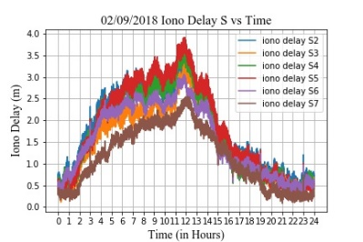

Figure 1: The graph indicates the iono delay experienced by all satellites on 2/09/2018 for S band frequency.

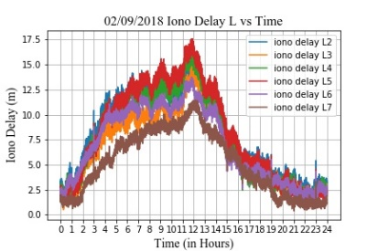

Figure 2: The graph indicates the iono delay experienced by all satellites on 2/09/2018 for L band frequency.

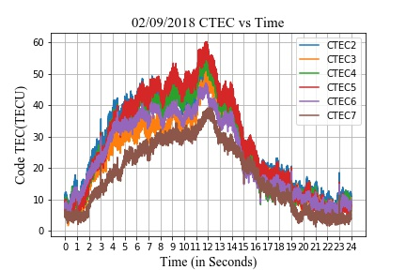
Figure 3: The graph indicates the CTEC experienced by all satellites on 2/09/2018 for L band frequency.

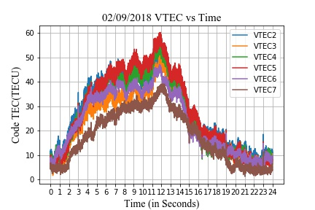
Figure 4: The graph indicates the VTEC experienced by all satellites on 2/09/2018 for L band frequency.

ACKNOWLEDGEMENT

The IGS receiver hardware that the ISRO Space Application Centre Ahmedabad (SAC) installed at Jain University Bangalore provided the data for the investigation's purposes. The authors would like to take this opportunity to express their gratitude to ISRO SAC Ahmedabad for its assistance with the space weather investigations and the IRNSS performance evaluation.

REFERENCES

- Aa, E., Zhang, S.-R., Erickson, P. J., Coster, A. J., Goncharenko, L. P., Varney, R. H., & Eastes, R. (2021). Salient Midlatitude Ionosphere-Thermosphere Disturbances Associated With SAPS During a Minor but Geo-Effective Storm at Deep Solar Minimum. Journal of Geophysical Research: Space Physics, 126(7), e29509. https://doi.org/10.1029/2021JA029509
- Real-time (Quicklook) Dst index, World Data Center for Geomagnetism, Kyoto. https://wdc.kugi.kyotou.ac.jp/dst_realtime/index.html. Accessed on 20th April 2022.

- Space Weather Prediction Center, National Oceanic and Atmospheric Administration. https://www.swpc.noaa.gov/phenomena/f107-cm-radio emissions. Accessed on 15th April, 2022.
- Aa, E., Zhang, S.-R., Wang, W., Erickson, P. J., Qian, L., Eastes, R., et al. (2022). Pronounced Suppression and X-Pattern Merging of Equatorial Ionization Anomalies After the 2022 Tonga Volcano Eruption. Journal of Geophysical Research: Space Physics, 127(6), e2022JA030527. https://doi.org/10.1029/2022JA030527
- Aa, E., Zou, S., Eastes, R., Karan, D. K., Zhang, S.-R., Erickson, P. J., & Coster, A. J. (2020). Coordinated
- Desai MV, Shah SN (2020) An observational review on influence of intense geomagnetic storm on positional accuracy of NavIC/IRNSS system. IETE Tech Rev 37(3):281–295. https://doi.org/10.1080/02564602.2019.1599739
- Ratnam, D. V., T. R. Vishnu, and P. B. S. Harsha, “Ionospheric gradients estimation and analysis of S-band navigation signals for NAVIC system,” IEEE Access, Vol. 6, 2018 pp66954–66962.
- M. Ravi Kumar, M. Sridhar, D. Venkata Ratnam, P. Babu Sree Harsha, S. Navya Sri, “Estimation of ionospheric gradients and vertical total electron content using dual-frequency NAVIC measurements,” Astrophys Space Science, 2019 pp. 1-9. https://doi.org/10.1007/s10509-019-3535-y
- Abe, O. E., X. Otero Villamide, C. Paparini, S. M. Radicella, and B. Nava, “Analysis of a grid ionospheric vertical delay and its bounding errors over West African sub-Saharan region,” J. Atmos. Solar-Terrestrial Phys., Vol. 154, 67–74, Feb. 2017, doi: 10.1016/j.jastp.2016.12.015.
- Jiang, H., Z. Wang, J. An, J. Liu, N. Wang, and H. Li, “Influence of spatial gradients on ionospheric mapping using thin layer models,” GPS Solut., Vol. 22, No. 1, Jan. 2018, doi: 10.1007/s10291-017- 0671-0.
- T. Biswas, P. Banerjee, “Testing the conformity of GPS and IRNSS in terms of ionospheric delay and position errors,” 5th International Conference on Signal Processing and Integrated Networks, 2018, pp. 159-163.
- M. Ravi Kumar, M. Sridhar, D. Venkata Ratnam, P. Babu Sree Harsha, S. Navya Sri, “Estimation of ionospheric gradients and vertical total electron content using dual-frequency NAVIC measurements,” Astrophys Space Science, 2019 pp. 1-9.
- Abe, O. E., X. Otero Villamide, C. Paparini, S. M. Radicella, and B. Nava, “Analysis of a grid ionospheric vertical delay and its bounding errors over West African sub-Saharan region,” J. Atmos. Solar-Terrestrial Phys., Vol. 154, 2017, pp67–74
- Interface control document (icd) of distress alert transmitter - second generation (dat-sg) 2nd ed., Indian Space Research Organization., ISRO, India, 2019, pp. 1-30.
- K.Ramulamma, K.C.T.Swamy “Estimation and Analysis of IRNSS Satellites Differential Code Biases using Real Data,” International Journal of Recent Technology and Engineering Vol-8 Issue-3, 2019, pp.740-743
- Shivani Sinha, Ritika Mathur, Sharat Chand Bharadwaj, Anurag Vidyarthi, B S Jassal, A K Shukla, “Estimation and Smoothing of TEC from NavIC Dual Frequency Data,” 4th International Conference on Computing Communication and Automation, 2018, pp. 1-5.
- D. Venkata Ratnam, J. R. K. Kumar Dabbakuti, N. V. V. N. J. Sri Lakshmi “Improvement of Indian-Regional Klobuchar Ionospheric Model Parameters for Single-Frequency GNSS Users,” IEEE Geoscience and Remote Sensing Letters, Vol. 15, pp.971-975, 2018.

