Agricultural Waste management
Nibha Singh*
Department of Biochemistry, Jamia Hamdard University, New Delhi, India
*Corresponding author: singhnibha821@gmail.com
Abstract
Waste management in agriculture is a critical component of sustainable farming practices. These review highlights the importance of managing agricultural waste to maintain soil health, minimize environmental pollution, and ensure long-term productivity. Agricultural waste encompasses diverse materials such as crop residues, animal manure, and agrochemical containers. Effective waste management practices, including composting, recycling, and responsible pesticide use, can transform waste into valuable resources while reducing the environmental impact. Furthermore, integrated pest management and biogas generation from organic waste contribute to sustainable agricultural systems. However, managing agricultural waste presents challenges due to its volume, variety, nutrient loss, potential pollution, storage requirements, regulatory compliance, and economic viability. These challenges require education, infrastructure development, policy support, and collaboration among stakeholders. By prioritizing waste management in agriculture, farmers can contribute to a sustainable food system that supports food security, preserves resources, and safeguards the environment for future generations.
Keywords Agriculture waste, Agro-waste, Biogas, Environment, Pollutants

1. INTRODUCTION
Waste management is a critical aspect of agriculture that is often overlooked. As we strive for sustainable food production and environmental stewardship, it is essential to implement effective waste management practices in agricultural systems (Kumawat et al., 2022). In this chapter, we will explore the significance of waste management in agriculture, discuss the challenges it presents, and provide practical strategies for farmers and stakeholders to adopt sustainable waste management practices Agricultural waste can come from several sources, including crop residues, animal manure, agrochemical containers, packaging materials, and food processing by-products. These waste materials can have significant environmental impacts if not managed properly, including water and soil pollution, greenhouse gas emissions, and health risks. Agricultural waste refers to the leftover materials generated during the cultivation and processing of various agricultural products like fruits, vegetables, meat, poultry, dairy, and crops (Duodu et al., 2022). These waste materials are the byproducts of agricultural production and processing, which may contain substances that can be useful to humans but have a lower economic value compared to the costs associated with collecting, transporting, and processing them for beneficial purposes.
Agricultural waste, also known as agro-waste, is a diverse mixture of waste materials resulting from various agricultural activities. These wastes can exist in the form of liquids, slurries, or solids, depending on the agricultural system and practices. They encompass different types of waste, including animal waste such as manure and animal carcasses, waste generated during food processing (where only 20% of maize, for example, is canned and 80% becomes waste), crop waste such as corn stalks and sugarcane bagasse, as well as drops, culls from fruits and vegetables, and pruning waste. There is hazardous and toxic agricultural waste, which includes substances like pesticides, insecticides, and herbicides (Hassan et al., 2022).

The goal of agriculture waste management is to minimize waste generation, optimize resource utilization, and prevent negative environmental impacts. It involves a systematic approach that includes waste reduction, reuse, recycling, and safe disposal. Additionally, sustainable agricultural practices such as organic farming and precision agriculture can contribute to minimizing waste generation at the source. In recent years, there has been increasing awareness of the importance of agriculture waste management. Governments, environmental organizations, and agricultural communities have recognized the need to address this issue and have implemented various policies, regulations, and best management practices (Wadleigh et al., 1968). These include the development of bioenergy production systems that convert organic agricultural waste into renewable energy sources such as biogas or biofuels. Waste-to-value approaches, such as composting and vermicomposting, can transform organic waste into nutrient-rich soil amendments, reducing the need for synthetic fertilizers.
In this chapter, we will delve into the various aspects of agriculture waste management. We will explore the types of agricultural waste generated, their environmental impacts, current practices and regulations, as well as innovative solutions and emerging trends in the field. By understanding these key elements, we can develop a comprehensive understanding of agriculture waste management and identify effective strategies for sustainable agricultural production (Anon et al., 1968).
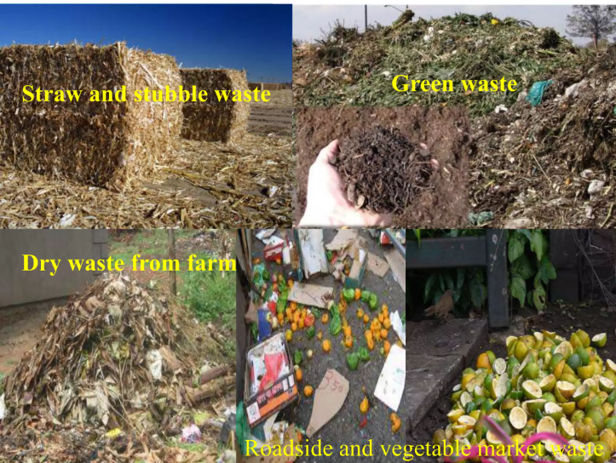
Figure.1 Different types of waste in agriculture

2.The Importance of Waste Management in Agriculture
Agricultural activities generate various types of waste, including crop residues, animal manure, packaging materials, and agrochemical containers. Improper handling and disposal of these wastes can lead to detrimental environmental impacts, such as soil degradation, water pollution, and greenhouse gas emissions. Implementing sound waste management practices is crucial to minimize these adverse effects and promote sustainable agricultural systems. Waste management plays a crucial role in the sustainable development of agriculture (Freeman et al., 1969s). Effective waste management practices are vital for maintaining soil health, minimizing environmental pollution, and ensuring the long-term productivity of agricultural systems. Agriculture generates various types of waste, including crop residues, animal manure, and agrochemical containers. These waste materials, if not managed properly, can have detrimental effects on the environment and human health. Through proper waste management techniques such as composting, recycling, and proper disposal, agricultural waste can be transformed into valuable resources. Composting organic waste can produce nutrient-rich compost that enhances soil fertility, reduces the need for synthetic fertilizers, and promotes healthier crop growth. Recycling agrochemical containers and adopting responsible pesticide use helps prevent pollution of water sources and safeguards ecosystems (Brightbill et al. 1974). By prioritizing waste management in agriculture, we can create a sustainable and environmentally-friendly farming system that supports food security, preserves natural resources, and protects our planet for future generations.
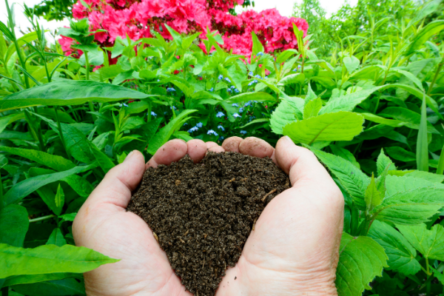
Figure.2 Benefits of organic waste Composting

3.Challenges in Agriculture
Many farmers and agricultural communities lack awareness and understanding of proper waste management practices. Limited knowledge about the environmental impacts of agricultural waste and the benefits of sustainable management hinders the adoption of appropriate measures. Inadequate waste management infrastructure, such as collection systems, recycling facilities, and composting sites, poses a challenge (Loehr et al., 2012). Limited access to these essential facilities makes it difficult for farmers to dispose of their waste properly. Implementing advanced waste management practices can be costly for farmers, especially for small-scale and resource-limited operations. Lack of financial resources and incentives may discourage the adoption of technologies and practices that promote efficient waste management. It is subject to a variety of regulations and guidelines at local, national, and international levels. Navigating through complex and evolving regulatory frameworks can be challenging for farmers, leading to confusion and compliance issues. Improper handling and disposal of agricultural waste can lead to contamination of soil, water sources, and air, posing risks to human and animal health (Walker et al., 1970). The presence of harmful pathogens, agrochemical residues, and pollutants in waste requires careful management to mitigate these risks. Public perception and acceptance of certain waste management practices, such as composting or the use of bioenergy systems, may vary. Overcoming social barriers and promoting acceptance of innovative waste management approaches is essential for their successful implementation. Addressing these challenges requires a multi-faceted approach that involves raising awareness, providing technical assistance, improving infrastructure, offering financial incentives, and streamlining regulatory frameworks (Levi et al., 1972). Collaboration among farmers, policymakers, researchers, and waste management experts is crucial to finding practical solutions that promote sustainable agriculture waste management practices.
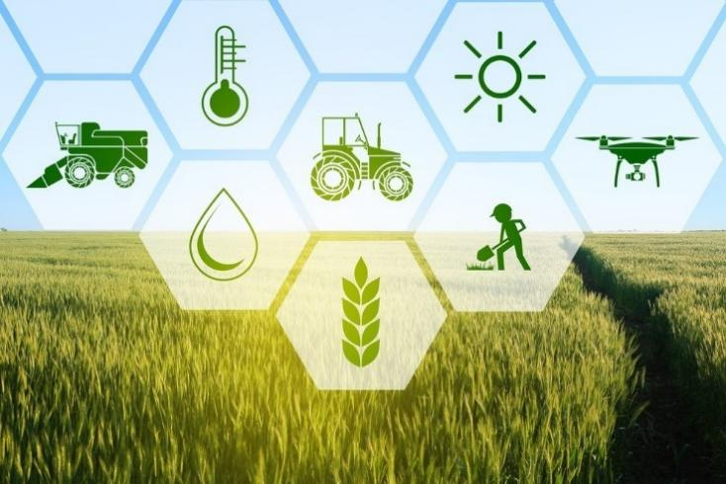
Figure.3 Major challenges in Agriculture
Managing agricultural waste presents unique challenges due to its diverse nature and scale. Some of the key challenges include:
1. Volume and Diversity of Waste
Agricultural waste comprises a wide range of materials, each requiring specific handling and disposal methods. Dealing with the sheer volume and diversity of waste can be overwhelming for farmers and agricultural enterprises.

2. Nutrient Management
Certain agricultural wastes, such as animal manure and crop residues, contain valuable nutrients that can be recycled and used as organic fertilizers. However, proper nutrient management is crucial to avoid nutrient imbalances, water contamination, and the proliferation of harmful pathogens.
3. Nutrient Loss and Soil Degradation: Improper management of agricultural waste can lead to nutrient loss from the soil. For example, if crop residues are not adequately recycled or composted, valuable nutrients are not returned to the soil, depleting its fertility and reducing crop productivity. This requires careful planning to ensure the proper recycling and reuse of waste materials to maintain soil health.
4. Environmental Impacts
Inadequate waste management practices in agriculture can result in significant environmental impacts. For example, the release of excess nutrients and agrochemicals into water bodies can lead to eutrophication and harm aquatic ecosystems. Similarly, the open burning of agricultural residues can contribute to air pollution and exacerbate respiratory issues.
5.Environmental Pollution: Agricultural waste, if not managed properly, can contribute to environmental pollution. Animal manure, for instance, can release harmful pathogens and excess nutrients into water bodies, leading to water pollution and eutrophication (Willrich et al., 1971). Similarly, the inappropriate disposal of agrochemical containers or the excessive use of chemical inputs can contaminate soil, water, and air, posing risks to ecosystems and human health.
6. Storage and Handling: Storing and handling large volumes of agricultural waste can be challenging, particularly for livestock operations. Proper storage infrastructure is necessary to prevent odor issues, leaching, and the attraction of pests. Additionally, safe handling practices are crucial to protect farmers and workers from potential hazards associated with waste materials.
7. Regulatory Compliance: Agricultural waste management is subject to various regulations and policies, which can vary across regions and countries. Compliance with these regulations, such as proper disposal of waste, recycling requirements, and handling of hazardous materials, can pose challenges for farmers who need to stay updated and implement the necessary measures to meet legal obligations.

8. Economic Viability: Implementing effective waste management practices can require investment in infrastructure, equipment, and training. For some farmers, especially those with limited resources, the costs associated with waste management can be a significant barrier. Balancing the economic viability of waste management practices with their environmental benefits can be a challenge, and supportive policies or financial incentives may be necessary to encourage adoption.

These challenges require a multi-faceted approach that includes education and awareness, infrastructure development, policy support, and collaboration among farmers, researchers, government agencies, and waste management experts. By adopting sustainable waste management practices, the agricultural sector can mitigate environmental impacts, conserve resources, and contribute to a more resilient and sustainable food system.

4.Best Practices for Agricultural Waste Management
The challenges mentioned above and foster sustainable agricultural practices, the following best practices can be implemented:

1. Composting
Composting is a natural process that transforms organic waste into nutrient-rich compost. By composting agricultural residues and other organic materials, farmers can create a valuable soil amendment that enriches soil fertility, improves water-holding capacity, and reduces the need for synthetic fertilizers (Lyon et al., 1967). Implementing on-site composting systems or collaborating with local composting facilities can effectively manage organic waste.
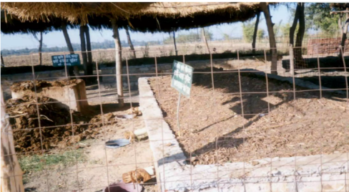
Figure.4 Vermi compost unit
2. Anaerobic Digestion
Anaerobic digestion is a process that converts organic waste, such as animal manure, into biogas and nutrient-rich digestate. Biogas can be used for energy generation, while the digestate can serve as an organic fertilizer (Wisdom et al., 1966). Adopting anaerobic digestion systems on farms can help generate renewable energy, reduce greenhouse gas emissions, and effectively manage livestock waste.
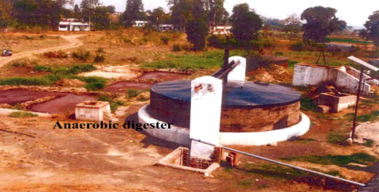
Figure.5 Anaerobic Digest

3. Crop Residue Management
Proper management of crop residues is essential to prevent soil erosion, nutrient loss, and weed infestation. Farmers can implement practices such as mulching, incorporation, or direct seeding to maintain soil health and promote nutrient cycling. Utilizing crop residues as livestock feed or bedding can also minimize waste and enhance resource efficiency.
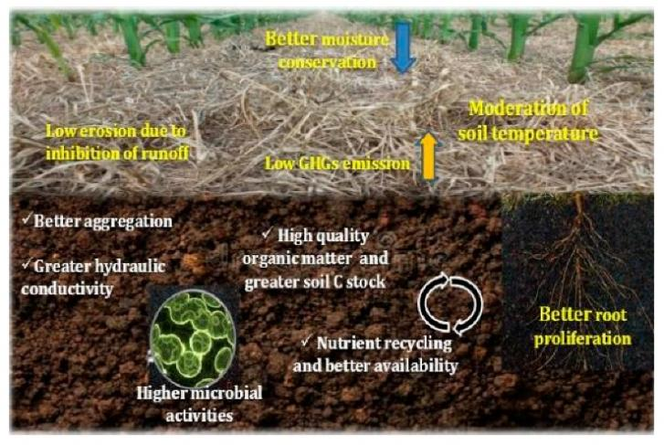
Figure.6 Crop Residue
4. Recycling and Reuse
Promoting recycling and reuse of agricultural waste materials is a sustainable approach. Packaging materials, agrochemical containers, and other non-organic waste should be segregated and sent for recycling. Additionally, farmers can explore innovative ways to repurpose waste materials, such as using empty feed bags for storage or transforming them into eco-friendly products.
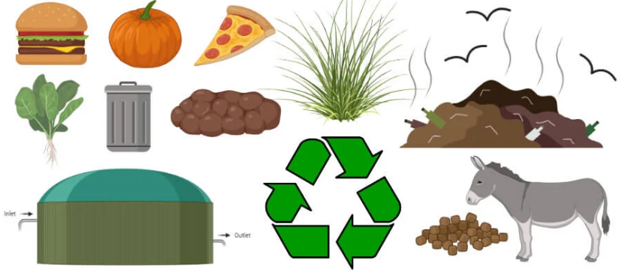
Figure.7 Organic waste recycling (Created with BioRender.com)

5. Education and Awareness
Enhancing education and awareness among farmers, agricultural workers, and stakeholders is crucial for effective waste management in agriculture. Training programs, workshops, and informational campaigns can disseminate knowledge about sustainable waste management practices and encourage their adoption at all levels of the agricultural sector.
6. Responsible Pesticide Use: Proper handling and disposal of agrochemicals are essential for minimizing their negative impacts on the environment. Farmers should strictly follow instructions for pesticide application, store chemicals safely, and dispose of empty containers in an environmentally responsible manner. This prevents contamination of soil, water sources, and ecosystems.
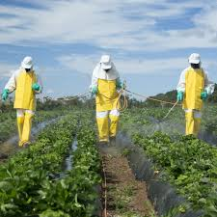
Figure.9 Safe Use of pesticide

7. Integrated Pest Management (IPM): Implementing IPM practices can reduce the reliance on chemical pesticides, thereby minimizing waste generation. IPM involves using a combination of techniques such as crop rotation, biological control methods, and cultural practices to manage pests effectively while minimizing the use of synthetic pesticides.

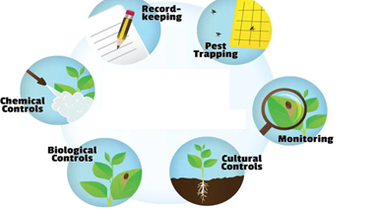
Figure.10 Integrated Pest Management

Conclusion
Effective waste management in agriculture is a fundamental aspect of sustainable farming practices. By implementing the best practices outlined in this article, farmers and stakeholders can minimize environmental impacts, promote resource efficiency, and contribute to a greener future. Remember, every effort made towards sustainable waste management in agriculture brings us one step closer to achieving a resilient and environmentally conscious food production system.

Reference
- Kumawat, T.K., Sharma, V., Kumawat, V., Pandit, A. and Biyani, M., 2022. Agricultural and agro-wastes as sorbents for remediation of noxious pollutants from water and wastewater. In Sustainable Materials for Sensing and Remediation of Noxious Pollutants (pp. 161-176). Elsevier.
- Duodu, M.G., Singh, B. and Christina, E., 2022. Waste management through bioremediation technology: An eco-friendly and sustainable solution. In Relationship Between Microbes and the Environment for Sustainable Ecosystem Services, Volume 2 (pp. 205-234). Elsevier.
- El-Ramady, Hassan, Eric C. Brevik, Yousry Bayoumi, Tarek A. Shalaby, Mohammed E. El-Mahrouk, Naglaa Taha, Heba Elbasiouny, Fathy Elbehiry, Megahed Amer, Neama Abdalla, and et al. 2022. "An Overview of Agro-Waste Management in Light of the Water-Energy-Waste Nexus" Sustainability 14, no. 23: 15717. https://doi.org/10.3390/su142315717
- Wadleigh, C.H., Waste in relation to agriculture and forestry. U.S., Dep. Agr., Misc.Publ.1065(1968).
- Anon., ‘’A National Program of Research for Environmental Quality- Pollution in Relation to Agriculture and Forestry.’’ Joint Task Force of the U.S. Dept. Of Agriculture and the state Universities and Land Grant Colleges, Washington, D.C.,1968.
- Freeman, O.F., and Bennett, I.L., ‘’A Report to the President – Control of Agriculture – Related Pollution. ‘’ U.S. Department of Agriculture and the Office of Science and Technology, Washington, D.C., 1969
- Brightbill, G. D., & Maxson, W. C. (1974). Citation Manual for United States Government Publications. Study Guides and Teaching Aides, Paper No. 10.
- Loehr, R. (2012). Agricultural waste management: problems, processes, and approaches. Elsevier.
- Walker, W. R. (1970). Legal restraints on agricultural pollution. IN: RELATIONSHIP OF AGRICULTURE TO SOIL AND WATER POLLUTION.
- Levi, D. R. (1972). A Review of Public and Private Livestock Waste Regulations.
- Willrich, T. L., & Miner, J. R. (1971). Litigation experiences of five livestock and poultry producers. Livestock Waste Management and Pollution Abatement Proc.
- Lyon, W.A., European practice in water in water quality control. J. Sanit. Eng. Div., Amer. Soc. Civil Eng. 93, SA3,37(1967).
- Wisdom, A.S., “The Law on the Pollution of waters, “2nd ed. Shaw, London, 1966.

