**ARDUINO BASED SMART PARKING SYSTEM**

**[1]Mr.N.Nagarjuna,[2] Mrs.P.Lavanya Kumari,[3]Ms.V.Bhulakshmi, [1],[3]Assistant Professor,[2]Associate Professor**

**[1],[2],[3] Department of Computer Science and Engineering(Data Science)** [**Email:[1]nagarjuna.nagaram@gmail.com**](mailto:Email:[1]nagarjuna.nagaram@gmail.com), **[2]lavanya.madina@gmail.com [3]**[**varipalli.bhulakshmi19@gmail.com**](mailto:varipalli.bhulakshmi19@gmail.com)

**ABSTRACT:**

The growth in the traffic congestion nowadays had open doors for the smart car parking system. We have developed an Arduino based car parking system. The smart parking technology will help optimize parking space usage and help in smoother traffic flow. It helps the driver in finding the vacant spot to park the vehicle. The empty spot is detected with the use of IR sensors that detects the presence or absence of a vehicle. The parking software automates tasks related to enforcing, issuing, and facilitating parking for private garages, public parking, municipal authorities and educational organizations that provide space or premises for Parking.

By measuring the distance using IR sensor, drivers are able to find the slot easily and reduce the searching time. The input is read by the Arduino and process the output and shows on the 20*4 LCD screen. We achieved this by programming the IR sensors and Arduino.

***Keywords— Arduino, IR Sensors, LCD Screen, Servo motor.***

**1. INTRODUCTION:**

Drivers searching for parking are estimated to be responsible for about 30% of traffic congestion in cities. [1] Historically, cities, businesses, and property developers have tried to match parking supply to growing demand for parking spaces. It has become clear, though, that simply creating more parking spaces is not sufficient to address the problem of congestion. [2] New approaches using smart parking systems look to provide a more balanced view of parking that better manages the relationship between supply and demand. [3] Smart parking can be defined as the use of advanced technologies for the efficient operation, monitoring, and management of parking within an urban mobility strategy.

The global market for smart parking systems reached $93.5 million, with the United States representing 46% market share, and offering a strong growth opportunity for companies offering services in the United States and overseas. [4] A number of technologies provide the basis for smart parking solutions, including vehicle sensors, wireless communications, and data analytics. [5] Smart parking is also made viable by innovation in areas such as smart phone apps for customer services, mobile payments, and in-car navigation systems. [6] At the heart of the smart parking concept is the ability to access, collect, analyze, disseminate, and act on information on parking usage. Increasingly, [7] this information is provided in real-time from intelligent devices that enable both parking managers and drivers to optimize the use of parking capacity.

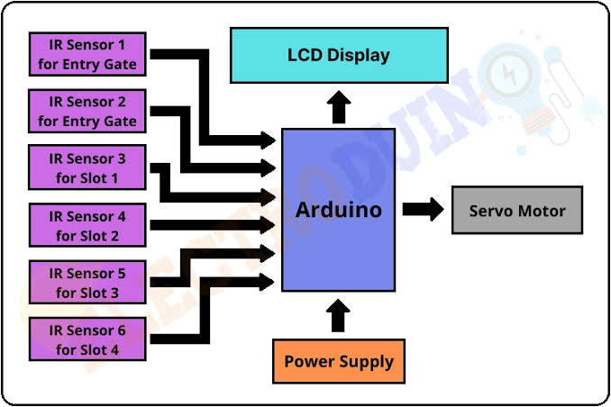**2. BLOCK DIAGRAM OF SMART PARKING SYSTEM:**

Figure: BLOCK DIAGRAM OF SMART PARKING SYSTEM

**2.1 DESCRIPTON OF BLOCK DIAGRAM:**

The above figure shows the block diagram of “**SMART PARKING SYSTEM”**

It mainly consists of three blocks

1. Input block
2. Data processing system block
3. Output block

* In Input block we attach the sensors to identify the vehicle at the entrance of the parking place
* Next that input will be stored in our second block i.e. Data processing system
* Data processing system consists of Arduino and Servo Motor
* Here the data given by the user is processed according to the input given by user
* Then after processing the output signal will be displayed on the LCD.
* Output block consists of servo motor barrier and the LCD Display
* Whenever the output block gets a signal from data processing system it shows the availability of parking slot on LCD and opens and closes the Barrier according to the user instructions

**3. IMPLEMENTATION:**

The Arduino web editor allows you to write code and upload sketches to any official Arduino board from your web browser.

This IDE (Integrated Development Environment) is a part of Arduino creates an online platform that enables developers to write code, access tutorials, configure boards, and share projects. Designed to provide users with a continuous workflow.

**Step 1** − First you must have your Arduino board (you can choose your favourite board) and a USB cable. In case you use Arduino UNO, Arduino Duemilanove, Nano, Arduino Mega 2560, or Diecimila, you will need a standard USB cable (A plug to B plug), the kind you would connect to a USB printer as shown in the following image.

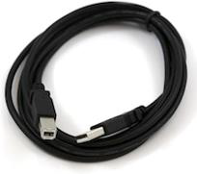

Figure: USB Cable (A plug to B plug)

In case you use Arduino Nano, you will need an A to Mini-B cable instead as shown in the following image.

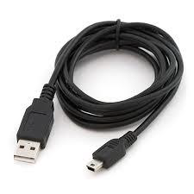

Figure: Cable of Arduino Nano

**Step 2 − Download Arduino IDE Software**

You can get different versions of Arduino IDE from the Download pageon the Arduino Official website. You must select your software, which is compatible with your operating system (Windows, IOS, or Linux). After your file download is complete, unzip the file.

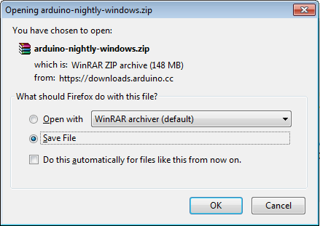

Figure: Download Arduino Ide Software

**Step 3 − Power up your board**

The Arduino Uno, Mega, Duemilanove and Arduino Nano automatically draw power from either, the USB connection to the computer or an external power supply. If you are using an Arduino Diecimila, you have to make sure that the board is configured to draw power from the USB connection. The power source is selected with a jumper, a small piece of plastic that fits onto two of the three pins between the USB and power jacks. Check that it is on the two pins closest to the USB port.

Connect the Arduino board to your computer using the USB cable. The green power LED (labelled PWR) should glow.

**Step 4 − Launch Arduino IDE**

After your Arduino IDE software is downloaded, you need to unzip the folder. Inside the folder, you can find the application icon with an infinity label (application.exe). Double-click the icon to start the IDE.

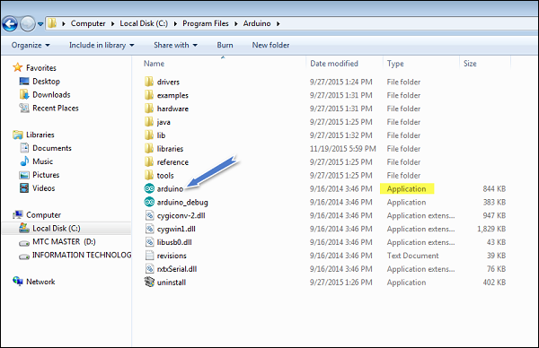

Figure: Launch Arduino IDE

**Step 5 − Open your first project**

Once the software starts, you have two options −

* Create a new project.
* Open an existing project example.

To create a new project, select File → **New**.

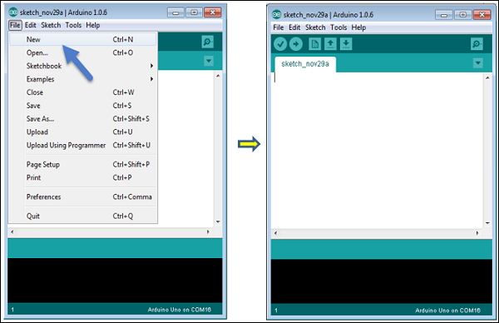

Figure: Create Project in Arduino

To open an existing project example, select File → Example → Basics → Blink.Open Project

Figure: Create an Example

Here, we are selecting just one of the examples with the name **Blink**. It turns the LED on and off with some time delay. You can select any other example from the list.

**Step 6 − Select your Arduino board**

To avoid any error while uploading your program to the board, you must select the correct Arduino board name, which matches with the board connected to your computer.

Go to Tools → Board and select your board.

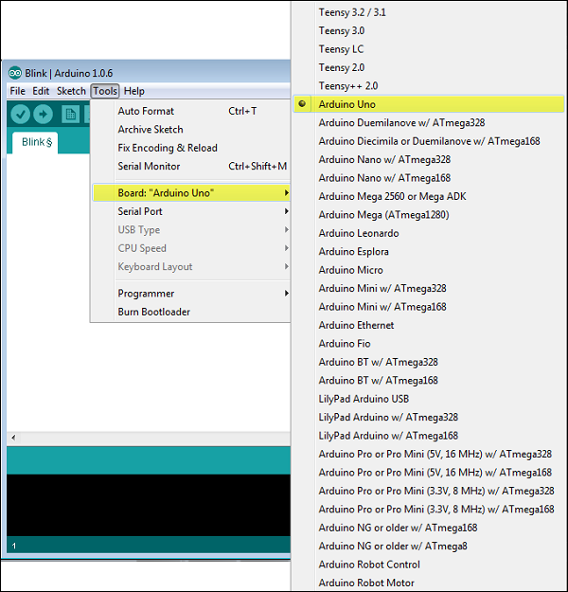

Figure: Selecting Arduino Board

Here, we have selected Arduino Uno board according to our project, but you must select the name matching the board that you are using.

**Step 7 − Select your serial port**

Select the serial device of the Arduino board. Go to **Tools → Serial Port** menu. This is likely to be COM3 or higher (COM1 and COM2 are usually reserved for hardware serial ports). To find out, you can disconnect your Arduino board and re-open the menu, the entry that disappears should be of the Arduino board. Reconnect the board and select that serial port.

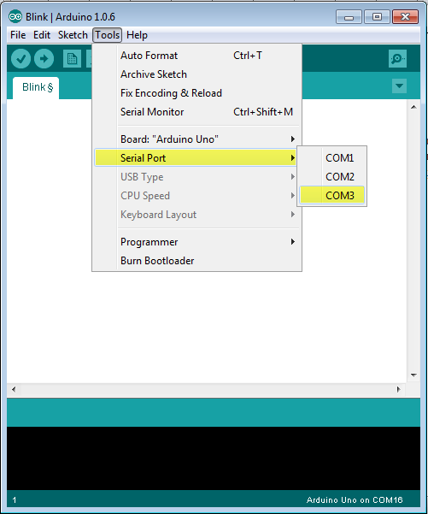

Figure: Selecting Serial Port

**Step 8 − Upload the program to your board**

Before explaining how we can upload our program to the board, we must demonstrate the function of each symbol appearing in the Arduino IDE toolbar.

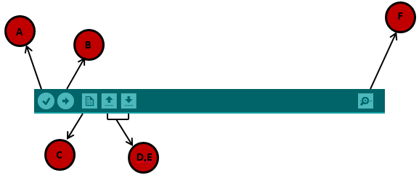

Figure: Uploading the Program

**A** − Used to check if there is any compilation error.

**B** − Used to upload a program to the Arduino board.

**C** − Shortcut used to create a new sketch.

**D** − Used to directly open one of the example sketches.

**E** − Used to save your sketch.

**F** − Serial monitor used to receive serial data from the board and send the serial data to the board.

Now, simply click the "Upload" button in the environment. Wait a few seconds; you will see the RX and TX LEDs on the board, flashing. If the upload is successful, the message "Done uploading" will appear in the status bar.

**Note** − If you have an Arduino Mini, NG, or other board, you need to press the reset button physically on the board, immediately before clicking the upload button on the Arduino Software.

**4. FUTURE EXPANSION:**

It is possible to enhance the system by including different applications, such as internet booking by utilizing GSM, where the driver can book for the parking area at home or while in transit to the shopping center. Also, it is possible to include image processing to the system to recognize the cars by their number plates, by using this type of technology users can directly pay the car parking using a mobile phone.

**5. CONCLUSION:**

Here we conclude that in Arduino based car parking project that when a vehicle comes near servo barrier ,the sensor detects the object and servo barrier gets open and when other vehicle come it automatically open the barrier .when the parking slot is full the LCD displays shows , “slots are full “. When any vehicle from inside goes out the second IR sensors detects and first IR sensor opens the barrier and shows slot left in the parking lot. In this way the Arduino based car parking

**6. REFERENCES:**

[1] *Agarwal, P., Sharma, S., Gupta, L., & Manideep, B. (2017). Smart electronic garbage management system-based IoT. International Journal of Soft Computing and Engineering (IJSCE), 7(1), 93-96.*

[2] Ali, Z. H., Ali, H. A., & Badawy, M. M. (2015). Internet of Things (IoT): definitions, challenges and recent research directions. *International Journal of Computer Applications*, *128*(1), 37-47.

[3] Chowdary, U. V., Rohith, K., Sandeep, P., &Ramu, M. (2015). Home Automation System Using IR Sensors. International Journal of Electrical and Electronic Engineering (IJEEE), 4(6), 11–16.

[4] Deekshitha, D. D., Malavika, & Soumya.(2017). Traffic Monitoring System Using IR Sensors. *International Journal of Advance Research, Ideas and Innovations in Technology*, *3*(3), 1045-1057.

[5] Kousalya, S., Priya, G. R., Vasanthi, R., & Venkatesh, B. (2018). IOT based smart security and smart home automation. *International Journal of Engineering Research & Technology (IJERT)*, *7*(04), 43-46.

[6] Larisis, N., Perlepes, L., Stamoulis, G., &Kikiras, P. (2013). Intelligent Parking Management System Based on Wireless Sensor Network Technology. Sensors and Transducers Journal, 18(Special Issues), 100–112.

[7] Mitra, S., Mishra, P., Daniel, J. A., & Balaji, S. (2019). Smart light for home with automatic direction and intensity adjustment using arduino. *International Journal of Recent Technology and Engineering (IJRTE)*, *8*, 479-484.

[8] Bhor, V., Morajkar, P., Gurav, M., Pandya, D., & Deshpande, A. (2015). Smart garbage management system. *International journal of engineering research & technology (IJERT)*, *4*(03).

[9] Rani, L. P. J., Kumar, M. K., Naresh, K. S., & Vignesh, S. (2017, March). Dynamic traffic management system using infrared (IR) and Internet of Things (IoT). In *2017 Third International Conference on Science Technology Engineering & Management (ICONSTEM)* (pp. 353-357). IEEE.