PHYTOREMEDIATION
Abhijeeta Nandha
Department of Biotechnology, Kalinga University, Raipur-492001
INTRODUCTION:
Industrialization has given so many things to improve human lifestyle. They have spread their root not only in one area but in different areas like Agriculture, education, production of goods, etc. However, this industrialization not only leads to good life but they are also sabotaging the future of our earth’s environment. Increasing industry also increase the pollution in every area like air, soil, water etc. And with current survey, these industries has became major source of such pollution. Frequently spilled oil in water or land, inorganic and organic residual compounds leakage from mining, agricultural practices, manufacturing products etcetra. Some of these products or residues are harmless, but others can be toxic and cause great harm to the environment. Out of those compounds, some can be highly toxic and that residual compounds are especially harmful to groundwater and soil. The planet has existing environmental remediation systems, however all those natural process to remediate soil and groundwater takes time.
There are certain environmental cleanup technologies has started to develop to protect earth from crumbling down further. Out of which ‘Bioremidiation’ is also one of those technologies which can help to purify the air, water, soil with different strategies. There are certain technologies in which some instruments or remediation equipment are used for filtering the pollutants before sending them back into natural resources. However, bioremidiation use different living organisms to remove or neutralize the pollutants from contaminated areas (Verma and Jaiswal, 2016).
Microorganisms are omnipresent. Some of those microbes have natural ability to decompose, recycle and rectify contaminated soil as well as water. In nature, these bacteria naturally perform their role and try to control the damage nonstop. However, sometime those contaminants in area are so high, like sudden leakage of oil tanker in sea, leakage of some hazardous materials on soil, that it started to affect other flora and fauna of that area. In addition to that these damage are really hard to control by natural process.
In such condition, environment is in hand of researchers and scientist, they need to look for some resolution. Bioremidiation is one of those technique which can help to eradicate the pollutant by using biological means like microorganism, plants or enzymes produces by microbes and plants.

What is Bioremidiation?
Bioremidiation can be define in many ways, however, most precise can be as “ the intentional usage of living organism to degrade and eliminate the pollutants from the site which were releases intentionally or unintentionally” (Madsen, 1997). To balance the process, application of those components may need to control, manipulate and monitor at soil or surface (i.e., in situ technologies), or in surface reactors (i.e., ex situ technologies).
TYPES OF BIOREMIDIATION
Even after come into focus in recent years, the bioremidiation has history of usage since past few decades.
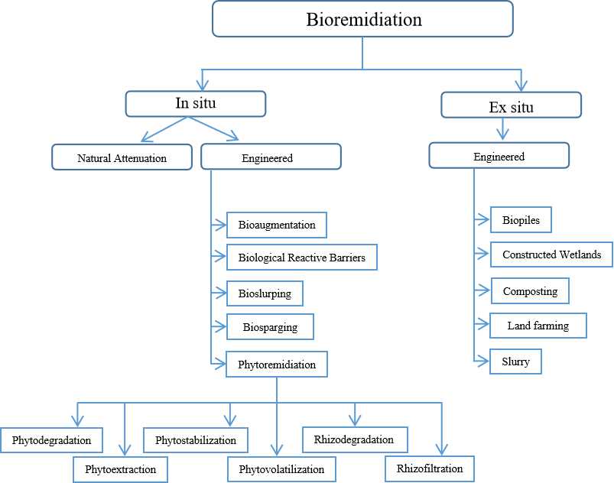
Fig. 1: Types of Bioremidiation

- Microbial Bioremediation:
- Biostimulation: This involves adding nutrients, such as nitrogen and phosphorus, to the contaminated area to enhance the growth and activity of naturally occurring microorganisms that can degrade pollutants.
- Bioaugmentation: In this method, specific strains of microorganisms that are proficient at degrading the target pollutants are introduced into the contaminated site to accelerate the cleanup process.
- Bioventing:
This process involves enhancing the activity of naturally occurring soil microorganisms by providing them with oxygen through the injection of air or other oxygen sources. This stimulates the breakdown of pollutants.
- Biofiltration:
Contaminated air or water is passed through a medium (such as soil or compost) that contains microbial communities capable of degrading the pollutants. The microorganisms in the medium break down the contaminants into harmless byproducts.
- Bioleaching:
This technique involves the use of bacteria to extract valuable metals from ores. The bacteria facilitate the oxidation of the metals, making them easier to separate from the ore.

- Phytoremediation:
- Phytostabilization: Certain plants are used to immobilize or stabilize contaminants in the soil, preventing their movement into the surrounding environment.
- Phytoextraction: Plants with the ability to accumulate pollutants in their tissues are cultivated in contaminated soil. After the plants have absorbed the contaminants, they are harvested and properly disposed of.
- Phytodegradation: Plants can release enzymes into the soil that help break down pollutants or stimulate microbial activity for degradation.

- Mycoremediation:
Fungi, such as mushrooms, are employed to break down or absorb pollutants. Fungi can degrade a wide range of contaminants, including hydrocarbons, heavy metals, and organic pollutants.
- Constructed Wetlands:
Wetland ecosystems are designed and constructed to treat contaminated water. The plants, soil, and microorganisms in the wetland work together to remove pollutants through various physical, chemical, and biological processes.
- Biosorption:
Certain microbial or plant materials are used to bind and remove heavy metals or other pollutants from water or soil by adsorption onto their surfaces.
Each of these bioremidiation techniques has its advantages and limitations, and the choice of method depends on factors such as the type of pollutant, the site conditions, and the desired remediation goals.

PHYTOREMIDIATION
In this chapter, our main focus is on phytoremidiation. Phytoremidiation word comes from two different word “phyto”, in Greek, means plants while “remedium”, which is Latin word, means restoring the balance. Thus the mean of phytoremidiation is plants use for restoring the balance. There are various technologies which helps to remediate different contamination, such as heavy metal from soil, by solidification, soil washing as well as permeable barriers. However, the major drawback of these technologies are that they are having high cost and they a majority of these technologies are costly to implement and cause further disturbance to the already damaged environment. Phytoremidiation is evolving as a cost-effective alternative to high-energy, high-cost conventional methods. It is considered to be a “Green Revolution” in the field of innovative cleanup technologies. (Suresh and Ravishankar, 2004)
Types of phytoremidiation
This approach takes advantage of the natural abilities of certain plants to accumulate or transform various contaminants in their tissues. Phytoremediation can be a sustainable and cost-effective method for cleaning up contaminated soil, water, and air. There are several sub types of phytoremediation techniques:

- Phytoextraction: Plants with the ability to hyper-accumulate pollutants, such as heavy metals, are grown in contaminated soil. These plants take up the pollutants through their roots and accumulate them in their above-ground biomass. Once the plants have absorbed a significant amount of contaminants, they can be harvested and removed, effectively removing the pollutants from the site.

ii. Phytostabilization: This method involves using plants to immobilize or stabilize contaminants in the soil, preventing their movement and dispersion. The plants' root systems create a physical barrier that helps bind the pollutants in place and reduces their mobility.

iii. Phytodegradation or Rhizodegradation: Certain plants release enzymes and other biochemical substances from their roots that can break down organic contaminants in the soil. These substances promote the growth of microorganisms that assist in the degradation process.

iv. Phytovolatilization: Plants can take up contaminants from the soil and release them into the atmosphere through a process called volatilization. This is particularly effective for volatile organic compounds (VOCs) and some heavy metals.

v. Phytoreduction or Phytoimmobilization: Some plants can facilitate the reduction of metal ions in the soil to less toxic and less mobile forms. This helps in reducing the bioavailability and mobility of certain metals.

vi. Rhizofiltration: In this method, plants are used to remove contaminants from water, often in constructed wetland systems. The plant roots filter out pollutants as water passes through them.

vii. Hydroponic Phytoremediation: Plants are grown in a hydroponic system (without soil) where contaminated water is circulated through the roots. The plants take up and accumulate pollutants from the water.

viii. Agroforestry: Trees and other vegetation are used in conjunction with agricultural practices to remediate contaminated sites. The plants can help stabilize the soil and reduce erosion while also assisting in pollutant removal.

Phytoremediation is a versatile approach that can be tailored to different contaminants and site conditions. However, it's important to note that the effectiveness of phytoremediation can be influenced by factors such as the types of plants used, their growth rates, the concentration and type of pollutants, soil conditions, and climate. It's often used in combination with other remediation methods to achieve comprehensive cleanup of contaminated sites.
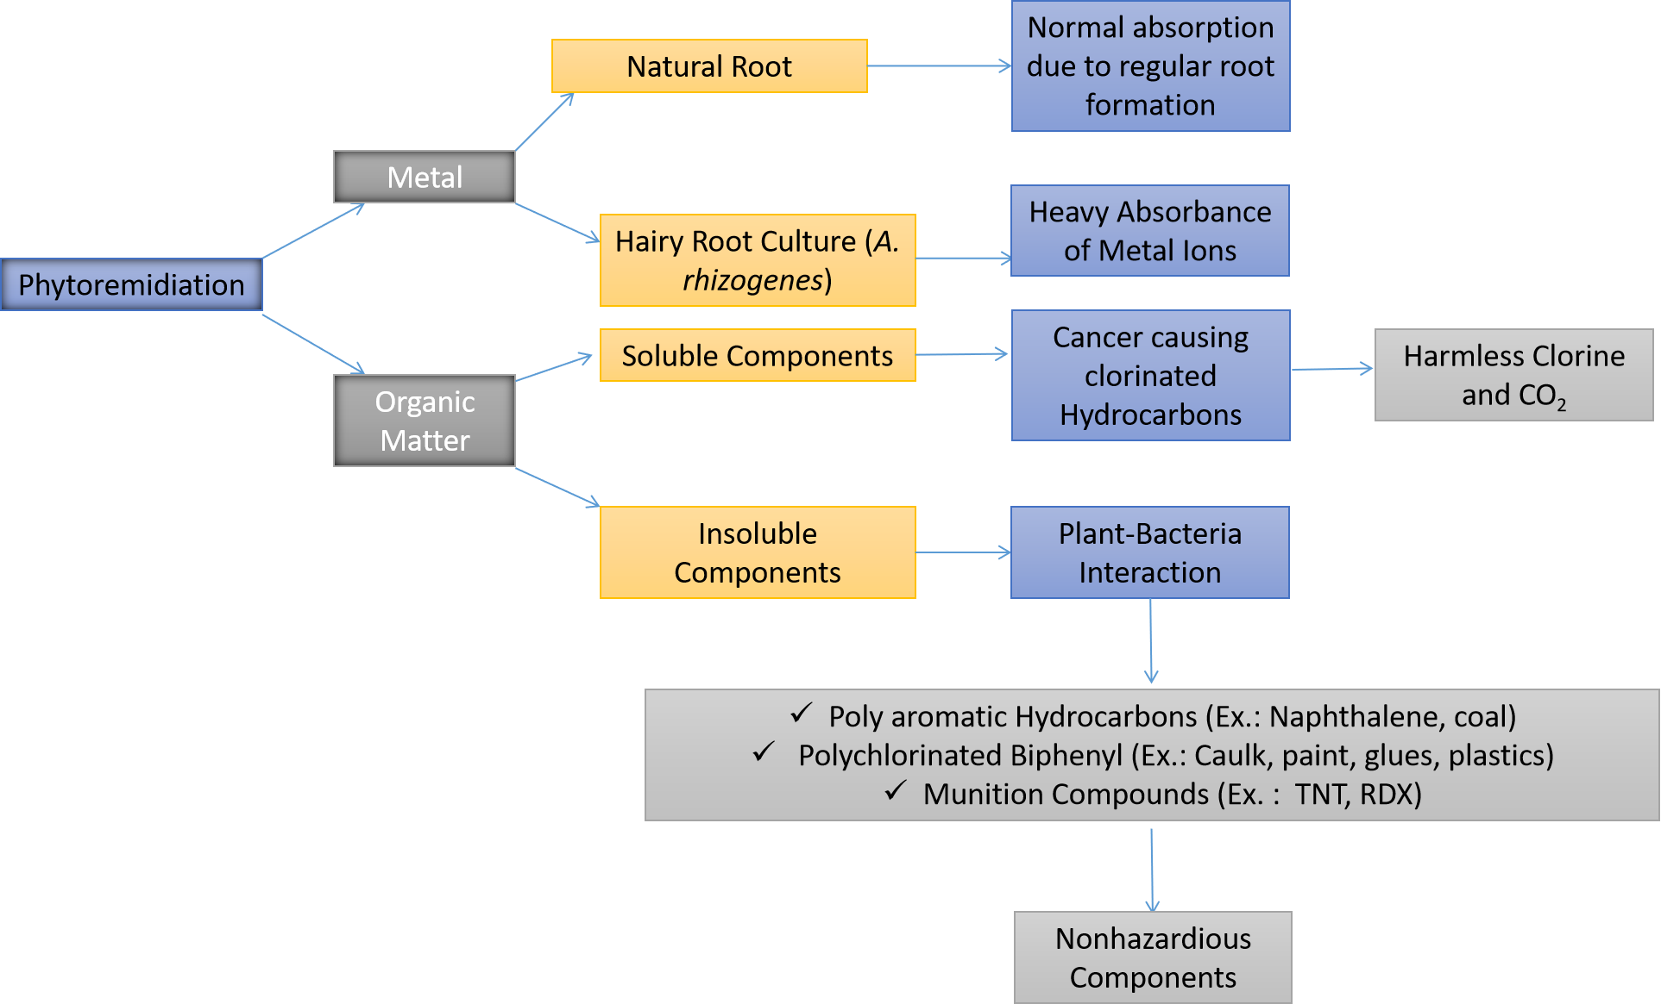
Fig. 2: Mechanisms of phytoremidiation

FACTORS AFFECTING PHYTOREMIDIATION
Phytoremediation is influenced by variety of factors which can impact their effectiveness in cleaning up contaminants from the environment. These factors can vary depending on the specific phytoremediation technique being used and the characteristics of the pollutants and the site. Some key factors that affect Phytoremediation are given as below:
Plant Species Selection: The choice of plant species is crucial because different plants have varying abilities to tolerate, accumulate, and transform specific pollutants. Some plants are better suited for certain contaminants than others. The selected plants should also be well-adapted to the local climate and soil conditions.
Pollutant Type and Concentration: The type of pollutant and its concentration in the soil or water can significantly impact phytoremediation. Some plants are more effective at removing specific contaminants, while high concentrations of pollutants might be toxic to plants or inhibit their growth.
Plant Growth Rate and Biomass: Plants with fast growth rates and high biomass production are generally more effective in phytoremediation. Rapidly growing plants can take up more contaminants and cover larger areas, accelerating the cleanup process.
Development of the Root System: Well-developed root systems enhance the uptake of contaminants by plants. Plants with extensive and deep root systems can access pollutants present in different soil layers and depths.
Soil Characteristics: Soil properties such as pH, texture, organic matter content, and nutrient levels can influence phytoremediation. Some pollutants are more readily taken up under specific soil conditions, while adverse soil conditions might hinder plant growth.
Climate and Environmental Conditions: Climate factors like temperature, precipitation, humidity, and sunlight availability affect plant growth and the efficiency of phytoremediation. Some plants might be more suitable for specific climates.
Site Conditions: Site-specific factors like topography, drainage, and hydrology play a role in phytoremediation. Proper site preparation and design are important to ensure effective pollutant uptake and plant growth.
Contaminant Mobility and Bioavailability: The mobility and bioavailability of contaminants in the soil or water influence how readily plants can take them up. Some contaminants might be tightly bound to soil particles, making them less accessible to plants.
Interactions with Microorganisms: The presence of beneficial soil microorganisms can enhance phytoremediation by promoting the degradation or immobilization of contaminants in the rhizosphere (the area around plant roots).
Management and Maintenance: Proper management practices, including irrigation, fertilization, and pest control, are essential to support plant health and growth during the phytoremediation process.
Duration of Remediation: Phytoremediation is often a time-consuming process. The duration required to achieve significant reductions in contaminant concentrations depends on factors like plant growth rates, pollutant concentrations, and site conditions.
Regulatory and Safety Considerations: Depending on the nature of the contaminants and the site, regulatory approvals and safety precautions may need to be taken into account.
Due to the complexity of these factors, successful phytoremediation projects require careful site assessment, appropriate plant selection, and ongoing monitoring to ensure the effectiveness of the remediation process. In many cases, phytoremediation may be used in combination with other remediation methods for comprehensive cleanup.

DIFFERENT MECHANISMS OF PHYTOREMIDIATION
The mechanisms underlying phytoremediation involve a series of processes at the cellular and molecular levels within plants and the rhizosphere (the soil region surrounding plant roots). These mechanisms enable plants to take up, accumulate, sequester, transform, or degrade contaminants (Fig. 2). The specific mechanisms can vary based on the type of contaminant and the phytoremediation technique being employed. Some general overview of some key mechanisms involved in different phytoremediation processes are given as bellow:

- Uptake and Accumulation:
Plants take up contaminants through their roots using various transport mechanisms. These mechanisms can involve passive diffusion, facilitated transport, or active transport proteins. Plants can regulate the uptake of ions, including contaminants, through ion channels embedded in the cell membranes.

- Sequestration and Storage:
Vacuole Sequestration: Vacuoles play a vital role in storing various compounds, including nutrients, waste products, and toxic substances like heavy metals. In response to heavy metal contamination in the environment, plants have developed mechanisms to sequester these toxic metals into vacuoles, thereby reducing their toxicity within the rest of the cell. This sequestration prevents heavy metals from interfering with crucial cellular processes in other parts of the cell.
When heavy metals enter plant cells, they can be transported across the cell membrane through various transporters. These transporters are often selective, facilitating the entry of essential nutrients while also allowing toxic metals to enter. Once inside the cell, the metal ions can be directed to the vacuoles through specific transport proteins located in the vacuolar membrane. This process helps isolate heavy metals from the rest of the cellular components, minimizing their harmful effects.

Binding to Ligands: Some plants produce metal-binding peptides (phytochelatins) that help sequester heavy metals in a less toxic form. Some plants have evolved a fascinating strategy to cope with heavy metal toxicity by producing metal-binding peptides known as phytochelatins. Phytochelatins are small peptides rich in sulfur-containing amino acids, particularly cysteine. These peptides have a high affinity for heavy metals and can form strong complexes with metal ions. When heavy metal ions enter the plant cells, phytochelatins are synthesized and bind to the metals, forming metal-phytochelatin complexes.
The formation of these complexes serves several purposes:
- Reduced Toxicity: By binding to phytochelatins, heavy metals are rendered less toxic to the plant cells. This detoxification mechanism prevents heavy metals from interfering with essential cellular processes and reduces the risk of damage.
- Sequestration: The metal-phytochelatin complexes are often transported into vacuoles for storage. This further contributes to the overall sequestration of heavy metals away from sensitive cellular components.
- Regulation of Homeostasis: The production of phytochelatins and subsequent formation of complexes is often triggered by the presence of heavy metals. This mechanism helps the plant maintain metal ion homeostasis and avoid excessive accumulation.

- Metabolic Transformation and Degradation:

Enzymatic Degradation: Enzymatic degradation is a natural process in which plants and their associated microorganisms produce specific enzymes to break down complex organic contaminants into simpler, less harmful compounds. These enzymes play a crucial role in the detoxification of contaminated environments and the transformation of pollutants.
Different contaminants may require different enzymes for degradation, as these enzymes are often specific to particular classes of pollutants. For example, some organic pollutants such as polycyclic aromatic hydrocarbons (PAHs) and chlorinated compounds can be difficult to break down due to their complex structures. Plants and microorganisms have evolved enzymes that target these compounds and facilitate their breakdown into smaller, more manageable molecules.
One of the key advantages of enzymatic degradation is that it can lead to complete mineralization, where the organic contaminants are broken down into carbon dioxide, water, and other innocuous compounds that can re-enter the natural nutrient cycles.
Rhizodegradation: Rhizodegradation is a process in which plant roots release a variety of organic compounds into the rhizosphere—the soil zone immediately surrounding the roots. These compounds can include sugars, amino acids, organic acids, and other exudates. The presence of these compounds creates a unique environment in the rhizosphere that fosters the growth and activity of microorganisms.
The interaction between plant roots, exudates, and microorganisms in the rhizosphere can lead to enhanced degradation of organic contaminants. There are different ways on how the process works like;
- Microbial Growth: The organic compounds released by plant roots serve as a food source for various microorganisms present in the soil. These microorganisms can include bacteria, fungi, and other soil-dwelling organisms.
- Enhanced Activity: The increased microbial population in the rhizosphere leads to higher metabolic activity. This increased activity can result in the production of enzymes capable of breaking down organic contaminants.
- Contaminant Degradation: The enzymes produced by microorganisms can degrade organic contaminants, converting them into simpler and less harmful compounds. This process can effectively reduce the concentration of pollutants in the soil.
- Synergistic Effects: The presence of plants in the rhizosphere provides a stable environment for microorganisms and can enhance their ability to degrade contaminants. Additionally, some plants can even exude specific enzymes that contribute to contaminant degradation directly.

- Enhancing Microbial Activity:
Root Exudates: Root exudates are organic compounds that plants release into the soil through their roots. These exudates serve various purposes, including nutrient acquisition, defense against pathogens, and establishing beneficial interactions with microorganisms. Root exudates can consist of sugars, amino acids, organic acids, vitamins, and other compounds.
One important aspect of root exudates is that they serve as a carbon source for soil microorganisms. When plants exude these organic compounds, they create a food source for a diverse community of microorganisms in the rhizosphere. This increased microbial activity can lead to the breakdown of organic contaminants through metabolic processes. As microorganisms utilize the exudates for energy and growth, they can also produce enzymes that facilitate the degradation of complex contaminants.

Plant-Microbe Interaction: Certain plants form symbiotic relationships with mycorrhizal fungi, which can improve nutrient uptake and enhance microbial activity in the rhizosphere. Mycorrhizal fungi are beneficial fungi that form symbiotic associations with plant roots. There are two main types of mycorrhizal associations: arbuscular mycorrhizae (AM) and ectomycorrhizae (ECM). These associations involve a mutual exchange of resources like Nutrient Exchange. Mycorrhizal fungi extend their hyphal networks into the soil, greatly expanding the root's reach for nutrient acquisition. In return for providing the fungus with sugars produced through photosynthesis, the plant gains access to nutrients such as phosphorus, nitrogen, and trace minerals. It also helps to enhance other microbial activities. Mycorrhizal associations can indirectly enhance microbial activity in the rhizosphere, contributing to contaminant degradation by using different actions. Out of which few are given as bellow;
- Hyphal Networks: The extensive mycorrhizal hyphal networks help create physical pathways for the movement of nutrients and water. This structure also allows for the distribution of microbial communities, leading to more widespread microbial activity.
- Induced Resistance: Mycorrhizal associations can induce systemic resistance in plants, making them more resilient to stresses, including contamination. This enhanced plant health can lead to increased root exudation, further supporting microbial communities involved in contaminant degradation.
- Enzyme Production: Some mycorrhizal fungi have been shown to produce enzymes that aid in the breakdown of organic contaminants. These enzymes can directly contribute to the degradation of pollutants in the soil.

- Phytoextraction and Phytoaccumulation:
Metal Transporters: Plants that are hyperaccumulators of heavy metals possess specialized metal transporters that play a crucial role in the movement of metals from the soil, through the roots, and into above-ground plant parts. These transporters are a key component of the plant's mechanism to tolerate and accumulate high levels of heavy metals. They ensure that metals are efficiently taken up from the soil and transported to where they can be stored or detoxified.
Hyperaccumulator plants have evolved various strategies to enhance metal transport, including overexpression or mutation of transporters that are responsible for metal uptake and translocation. These transporters are often highly selective and efficient, allowing the plants to accumulate high concentrations of metals in their tissues without suffering from toxicity.

Metal Sequestration in Above-Ground Biomass: Once heavy metals are taken up by the roots and transported to above-ground plant tissues such as leaves and stems, they can be sequestered and stored there. This process serves several purposes a) Detoxification: In which heavy metals were moved from the roots to above-ground parts, the plant can reduce the potential damage caused by the metals to essential root functions and overall plant health. b) Storage: Some plants store heavy metals in their above-ground tissues as a means of defense against herbivores and pathogens. The accumulated metals can deter or poison herbivores that consume these plants and c) Removal and Disposal: The ability of hyperaccumulator plants to accumulate high concentrations of heavy metals in their above-ground biomass presents an opportunity for phytoremediation. Phytoremediation is an approach to environmental cleanup in which plants are used to extract, stabilize, or sequester contaminants from the soil. Once the above-ground biomass has accumulated a significant amount of metals, it can be harvested and then safely removed and disposed of, effectively reducing the concentration of contaminants in the soil.

- Phytostabilization:
Root Exudates and Precipitation: Plants can release compounds that promote the formation of insoluble mineral complexes, reducing the mobility and bioavailability of contaminants in the soil. Many root exudates contain organic acids and other compounds that can chelate or bind to metal ions in the soil. When these exudates are released into the rhizosphere—the soil zone around plant roots—they can interact with metal ions present in the soil solution. This interaction often leads to the formation of insoluble complexes or precipitates.

PHYTOREMEDIATION IN SOIL
Phytoremediation in soil is a process that uses plants to clean up and mitigate the effects of soil contamination. Different phytoremediation techniques can be employed based on the types of contaminants present and the specific goals of the remediation effort. Here are some key phytoremediation techniques used in soil:

Phytoextraction:
In phytoextraction, plants are grown in contaminated soil to take up and accumulate heavy metals or other pollutants from the soil into their above-ground biomass. Plants take up contaminants through their root systems, which are equipped with specialized transporters that facilitate the uptake of metal ions. Once taken up, metals can be transported via the xylem vessels to the shoots and leaves. This movement relies on metal transporters like Heavy Metal ATPases (HMAs).
In hyperaccumulator plants, metals are accumulated in high concentrations within above-ground tissues. The metal ions can be stored in vacuoles or bound to metal-binding peptides like phytochelatins. Once the plants have accumulated sufficient metal concentrations, they can be harvested and removed from the site. This process effectively reduces the metal content in the soil. There are various crops which are used for this process. Some of those plants are Indian mustard (Brassica juncea) for cadmium and lead, sunflowers (Helianthus annuus) for lead and cesium.

Phytostabilization:
Phytostabilization aims to immobilize contaminants in the soil, reducing their mobility and bioavailability, thereby preventing their movement into the food chain or groundwater. Certain plants, like various grasses and sedge, are chosen for their ability to modify the rhizosphere environment by releasing root exudates, such as containing organic acids, phenolic compounds, and other substances, that promote the precipitation of contaminants or stabilize them in less mobile forms. These compounds have ability to alter the chemistry of the rhizosphere, leading to metal precipitation or formation of less soluble compounds. Root exudates also foster the growth of microorganisms that can contribute to stabilizing contaminants. For example, some bacteria can produce extracellular polymeric substances that bind metals. Through root exudates and microbial interactions, contaminants are immobilized in the soil, reducing their bioavailability and potential for leaching into groundwater or being taken up by plants.

Phytodegradation:
Plants like Hybrid poplar (Populus spp.) have ability to degrade organic pollutants like chlorinated solvents, willows for petroleum hydrocarbons. Phytodegradation involves using plants to break down organic contaminants in the soil through root exudates and interactions with microbial communities. Plant roots release exudates that stimulate the growth of pollutant-degrading microorganisms in the rhizosphere. These microbes produce enzymes that break down organic contaminants. Unlike phytostabilization, Root exudates produces by these crops contain organic compounds like sugars, amino acids, and organic acids. These compounds serve as an energy source for soil microorganisms. Microorganisms in the rhizosphere use root exudates to fuel metabolic processes by producing enzymes like dehydrogenases, oxidases, and hydrolases that break down organic pollutants into simpler, less toxic compounds. This enhanced microbial activity leads to the degradation of organic contaminants.

Rhizofiltration:
Rhizofiltration employs plants to remove contaminants from groundwater or contaminated water bodies by passing the water through the root systems of the plants. Plant roots adsorb or absorb contaminants, effectively filtering the water as it flows through the root zone. Contaminants in the water are adsorbed onto the surfaces of root cell walls and root hairs through ion exchange processes. Cations on the root surface can exchange with positively charged contaminants in the water. Plants with dense root systems and large root surface areas are more effective at adsorbing contaminants from water. Depending on the plant species, contaminants can be translocated to shoots or stored in roots. Water hyacinth (Eichhornia crassipes) can be used for removing heavy metals and nutrients from water.
In contrast to phytoextraction, where metals are translocated to above-ground tissues, phytoaccumulation involves storing contaminants in root tissues without significant translocation throughout the lifespan of crop. Phytoaccumulators are often plants that can tolerate high concentrations of contaminants without showing significant toxic effects even after long time for accumulation. Thus, this also reduces the need for harvesting.
Phytoaccumulation:
Various hyperaccumulator plants for accumulating heavy metals, such as nickel, zinc, and cadmium can be removed by this method. Phytoaccumulation involves cultivating plants specifically to accumulate high concentrations of contaminants in their tissues, which can then be harvested and removed. Plants are selected based on their ability to tolerate and accumulate contaminants. The contaminants are stored in the plant's tissues without much translocation to above-ground parts.

Phytohydraulics:
Phytohydraulics is a technique that uses plants to control groundwater levels and aid in the remediation of contaminated sites with groundwater pollution. Plants are chosen for their high water consumption rates. They take up excess groundwater, which helps prevent the migration of contaminants and promotes natural attenuation processes. Phytohydraulics involves selecting plants that have high water uptake rates. These plants help lower the water table by using excess groundwater for transpiration.
Lowering the water table can promote the movement of contaminants towards plant roots, enhancing natural attenuation processes by facilitating microbial degradation or immobilization.

PHYTOREMEDIATION IN WATER
Phytoremediation in water refers to the use of plants to clean up and improve the quality of water bodies contaminated with various pollutants. Water phytoremediation techniques leverage the natural abilities of plants and their associated microbial communities to remove, stabilize, or degrade contaminants from aquatic environments. Here are some key phytoremediation techniques used in water:

Constructed Wetlands:
Constructed wetlands are carefully engineered systems that consist of a substrate layer for plant growth and a water flow system that directs contaminated water through the wetland which mimic natural wetland ecosystems. Contaminated water is directed through these systems as contaminated water passes through the substrate, plants and their root systems help physically filter particles, while microbial communities in the rhizosphere contribute to the degradation and transformation of pollutants. Plants in constructed wetlands provide surface area for biofilms to develop, which consist of microbial communities that can break down contaminants through biological processes. Emergent plants like cattails and bulrushes are commonly used in constructed wetlands to remove pollutants like nutrients, heavy metals, and organic compounds. Constructed wetlands are particularly effective at removing nutrients like nitrogen and phosphorus through plant uptake and microbial processes, which helps mitigate eutrophication.

Floating Treatment Wetlands
In this treatment, wetlands involve plants growing on floating platforms or mats on the water's surface which provide buoyancy and support for plant growth. The roots of the floating plants extend into the water, where they absorb nutrients and contaminants, aiding in nutrient and pollutant removal.
Root systems and associated microbial communities contribute to the degradation of nutrients, metals, and organic compounds in the water. Water hyacinth, duckweed, and floating grasses are often used in floating treatment wetlands.

Algal Remediation
Algal phytoremediation uses algae, including microalgae and macroalgae, to remove contaminants from water through processes like nutrient uptake, bioaccumulation, and photosynthetic transformation. Algae can absorb nutrients like nitrogen and phosphorus, reducing eutrophication. Some algae can also bioaccumulate heavy metals. Certain species of microalgae and macroalgae like seaweed are employed for nutrient and metal removal in aquatic environments.

Submerged Aquatic Vegetation
Submerged aquatic vegetation (SAV) refers to aquatic plants that grow entirely underwater. They can contribute to water quality improvement by taking up nutrients and providing habitat for beneficial organisms. SAVs absorb nutrients like nitrogen and phosphorus, reducing their availability in the water column and combating eutrophication. The root systems of SAVs stabilize sediment and prevent erosion, which in turn can reduce the release of sediment-bound contaminants. Submerged plants like seagrasses and pondweeds help improve water quality in estuaries, lakes, and coastal areas.

Each of these phytoremediation techniques in water capitalizes on the unique traits of plants and their interactions with water and microbial communities. By harnessing these mechanisms, phytoremediation offers a sustainable approach to improving water quality and restoring aquatic ecosystems. Proper site assessment, plant selection, and design are essential to maximize the effectiveness of these techniques in specific water bodies.

Conclusion
In conclusion, phytoremediation stands as a promising and environmentally friendly technique for addressing contaminated soils and waters. Harnessing the natural abilities of plants and their interactions with soil microorganisms, this technique offers several advantages that make it an increasingly attractive option for environmental cleanup. Phytoremediation exploits a range of plant-based mechanisms, including root exudation, metal transporters, symbiotic relationships, and enzymatic degradation, to effectively remove, stabilize, or detoxify contaminants. This multifaceted approach offers a sustainable and cost-effective alternative to traditional remediation methods, which often involve invasive and disruptive processes.
The diversity of plant species and their unique adaptations to various contaminants provide a flexible toolkit for tackling different types of pollution. Hyperaccumulator plants, for instance, have the ability to accumulate high concentrations of specific contaminants, while various plant-microbe interactions enhance the breakdown and sequestration of pollutants. However, successful phytoremediation requires careful consideration of factors such as plant selection, site conditions, contaminant types, and long-term monitoring. Additionally, while phytoremediation can substantially reduce contaminant levels, it might not completely eliminate pollutants in all scenarios.
Incorporating phytoremediation into broader remediation strategies or combining it with other techniques can enhance its efficiency and effectiveness. Ultimately, phytoremediation offers a sustainable and nature-based solution that not only addresses contamination but also contributes to the restoration and revitalization of ecosystems, creating a healthier environment for current and future generations.

Referances:
Verma JP and Jaiswal DK. Book review: Advances in biodegradation and bioremediation of industrial waste. Frontiers in Microbiology. 2016;6:1-2. DOI: 10.3389/fmicb.2015.01555
Medsen, E. L. (1997). C.J. Hurst, G.R. Knudsen, M.J., Mcinerney, L.D., Stetzenbach, M.V. Walter (eds.), Methods for determining biodegradability. Manual of environmental microbiology, ASM Press, Washington DC.
Suresh, B. and Ravishankar, G. A. (2004). Phytoremediation—A Novel and Promising Approach for Environmental Clean-up, Critical Reviews in Biotechnology, Vol. 24, No. 2-3 : Pages 97-124

