Non-Conventional Energy Resources
We are all aware that the world we live in faces many difficult problems; only a few of these include poverty, hunger, inequality, and climate change.
Strong action is needed to overcome significant challenges, which is where the Global Goals come in. We all have a part to play in making the goals of the 2030 Agenda for Sustainable Development, which were agreed upon by all world leaders.¹
SDGs (Sustainable Development Goals) are listed in fig.1 as having a total of 17 by the UN. In this chapter, Goal No. 7—Affordable and Clean Energy—is discussed, with a special emphasis on non-conventional energy sources.
The Sustainable Development Goals (SDGs) are an international plan to eradicate extreme poverty, lessen inequality, and preserve the environment by 2030.
The SDGs, which 193 nations ratified in 2015, were the result of the most extensive and inclusive UN deliberations in history and have motivated people from all sectors, regions, and cultural backgrounds. The 2030 goals will demand heroic and creative effort, as well as resolve to learn about what works and agility to adapt to new knowledge and changing trends.
The UN Foundation gives priority to concepts and initiatives that have a broader reach, advance the SDG's "leave no one behind" objective, and are backed by facts, concrete commitments, and action.²
The SDGs' promise and potential are being realized on the planet thanks to people, inventions, and activities.
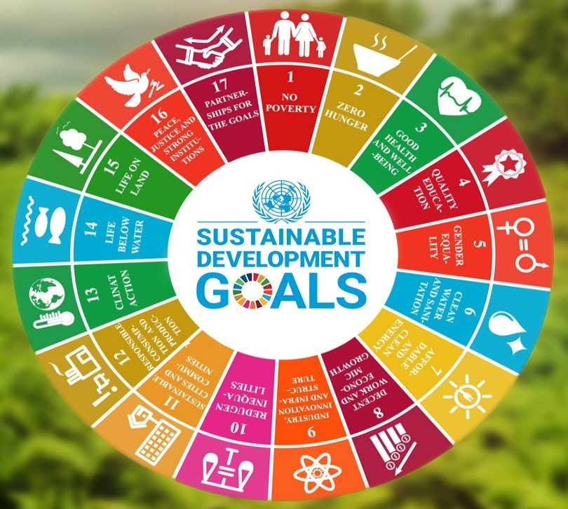

Fig1. https://naturalfarming.niti.gov.in/sustainable-development-goals/

What are non-conventional sources of energy?
Abstract:
Energy has been essential to human growth and development ever since the beginning of civilization. As technology has developed, so too has the demand for and exploitation of energy. However, as the population of the world has grown, more pressure is placed on the fossil fuels that currently provide our energy. As a result, we are in danger of running out of these resources, and the rate at which global warming is causing climate change is threatening human life. This article focuses on various renewable resources, emphasizing primarily on the Indian context, how it is beneficial for generating alternative sources of energy that can be highly beneficial for the environment.
Keywords: biomass-powered vehicles, grid-connected vehicles, solar, wind, hydro, geothermal, etc.
Introduction
The issue of sustainability emerges in relation to energy supplies. For us to heat our homes, power our cities, and operate our cars, resources must deliver adequate energy. However, it's equally crucial to think about how these resources might be used in the long run. Some resources will essentially never be depleted. These are referred to as non-traditional or renewable energy sources. Additionally, clean energy—which has lower pollution and greenhouse gas emissions that don't add to climate change—is produced from renewable resources.
India's energy sources have changed through time, from relying on wood before the nineteenth century to subsequently adopting non-renewable resources including fossil fuels, petroleum, and coal, which are still the country's main energy sources now. These resources, however, are scarce on Earth. Recent years have seen a rise in the utilization of renewable resources, and more and more study is being done on how to produce and use this kind of energy.
One of the nations with the highest renewable energy generation is India. 35% of India's installed energy generation capacity, which accounts for 17% of the nation's total electricity production as of 2019, is derived from renewable sources.
The use of renewable resources is not without its difficulties. For instance, with seasonal or even daily swings in the amount produced, renewable energy may not be as consistent as conventional energy. But scientists are constantly addressing these issues and trying to increase the viability and dependability of renewable resources. Energy from biomass sources (such ethanol), hydropower, geothermal power, wind power, and solar power are examples of renewable resources.

According to information presented to Parliament on Tuesday, India's installed renewable energy capacity would total 168.96 GW by the end of February 2023. The capacity of solar power accounts for 64.38 GW of the total 168.96 GW, along with hydropower (51.79), windpower (42.02), and biopower (10.77 GW), according to R K Singh, Union Minister for Power, New and Renewable Energy.
He noted in a written reply to the upper House that 82.62 GW more green energy capacity is being built and 40.89 GW is in various stages of tendering.
Renewable energy sources produced a total of 3,16,754.86 MU of power for the current fiscal year 2022–23 (until January 2023), according to Singh.
India's overall capacity for power production, according to the minister, is 412.21 GW.³
Utilizing renewable resources has a number of disadvantages. For instance, the output of renewable energy may fluctuate seasonally or even daily, making it less dependable than unconventional energy. While working to make renewable energy more reliable and practical, scientists are constantly addressing these issues. Examples of renewable resources include hydropower, geothermal power, wind power, solar power, and biomass energy (such as ethanol).
- Renewable Energy Explained
Renewable energy sources including solar, wind, hydropower, biomass, and geothermal energy may all generate electricity without adding to global warming. Renewable energy is typically at the top of the list of improvements that the world can undertake to lessen the worst consequences of global warming in any discussion about it. This is because renewable energy sources, like solar and wind, don't produce carbon dioxide or other greenhouse gases, which are responsible for contributing to global warming.
There are a lot more benefits to clean energy than just being "green." The growing industry boosts employment, improves electric infrastructure, expands access to energy in developing nations, and brings down energy costs. With wind and solar establishing new electricity records, all of these factors have played a role in the recent revolution in renewable energy.
For the past 150 years or so, fossil fuels such as coal, oil, and other have been heavily relied upon by humans to run everything from lightbulbs to automobiles to factories. The greenhouse gases produced by the combustion of fossil fuels have risen to previously unheard-of heights as a result of their pervasive use in almost everything we do.
Because greenhouse gases prevent heat from escaping into space and instead retain it in the atmosphere, average surface temperatures are rising. Scientists currently refer to the complex changes affecting our planet's weather and climate systems as climate change, and global warming is one of its symptoms. Increased extreme weather, shifting animal populations and habitats, increasing sea levels, and a number of other effects are all results of climate change in addition to rising average temperatures. The causes of air pollution are shown in the following diagram.

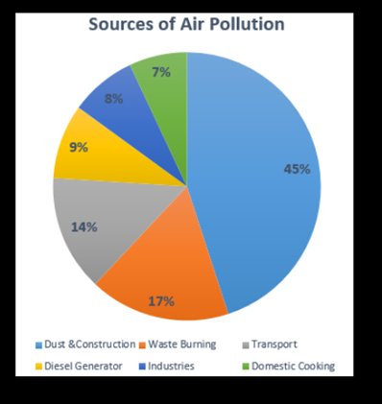
Fig:2 Laira Aggarwal - http://indpaedia.com/ind/index.php/Air_pollution:_India (Accessed March 12, 2020)

The second largest source of air pollution in India is rubbish burning, followed by dust and construction. Dust and building work are typically concentrated in urban areas, whereas rubbish burning is more common in rural (agricultural) areas.
Renewable energy sources undoubtedly come with their own set of compromises and debates, just like any other source of energy. Determining renewable energy is a topic of one of them. In a literal sense, renewable energy is exactly what you might expect: it is always available or, in the words of the US Energy Information Administration, "virtually inexhaustible." But "renewable" does not automatically imply "sustainable," as critics of ethanol made from corn or huge hydropower dams have been known to argue. In addition, it leaves out other low- or zero-emission options with their own advocates, like nuclear power and energy efficiency.
2.Types of Renewable Energy Sources
2.1Hydropower:
People have been using dams to control water flow for ages to harness the power of river currents. The largest renewable energy source in the world by far is hydropower, which is mostly produced in China, Brazil, Canada, the United States, and Russia. Theoretically, hydropower is a clean energy source that is supplied by snow and rain, but it also has a number of disadvantages.

WHAT IS HYDRO POWER?
The term "hydropower" or "hydroelectricity" refers to the process of turning the energy of moving water into electricity. The sun continuously regenerates the water cycle, hence it is regarded as a renewable energy source.
Mechanical milling, such as grain grinding, was one of the early uses of hydro power in the past. electricity is produced by modern hydro plants using turbines and generators, which
When water is moving, a turbine's rotors spin and produce mechanical energy. A connection between the turbine and an electromagnetic generator produces energy as it rotates.
Large (>30 MW), small (100 kW - 30 MW), and micro (100 kW) hydro plant facilities are the three categories.
There are three main types of hydro plants.
1. The most popular method of creating huge water reservoirs using a dam is called impoundment facilities. Water flowing through the dam's turbines generates electricity.
2. Pumped storage structures are comparable, except they contain a second reservoir under the dam. Pumping water can store energy for use later on by moving water from the lower reservoir to the upper reservoir.
3. Run-of-river facilities, which occasionally operate without the aid of a dam or reservoir, rely more on the natural flow rates of rivers, diverting only a small percentage of the river's water through turbines. Run-of-river hydro is more sporadic than hydro from dams since it is dependent on the fluctuation of the water supply.

CONTEXT
With a contribution of 6.7% to the world's electricity production, hydropower leads all other renewable energy sources in importance. This established technology has the potential to grow even though some nations have already built cost-effective sites.
Where applicable, hydropower provides a plentiful, inexpensive source of energy despite high initial construction costs. Because it can be stored for use later, it is also a more versatile and dependable source of electricity than other renewable sources. Additionally, dammed reservoirs can be utilized for recreation, to regulate flooding, and to ensure a consistent water supply.
Hydropower does provide a number of challenges, especially with regard to large dam projects. Since it floods upstream landscapes, displaces local communities frequently, alters wildlife habitats, and clogs fish pathways, damming a river has a significant impact on the regional environment. The destruction of landscapes and the deaths of persons who live downstream can result from dam breaches, which are also dangerous.
Finally, greenhouse gas emissions from hydroelectric plants are not entirely eliminated. As with other energy sources, building produces carbon dioxide emissions, particularly due to the extensive use of cement, and methane, another greenhouse gas, is produced as plant matter decomposes underwater in flooded areas.⁴

Hydropower potential in India
India has an estimated 1,45,000 MW of hydroelectric capacity, and at a 60% load factor, it can provide all of the country's estimated 85,000 MW of demand. Small hydropower projects have an estimated 20,000 MW of potential power capacity.⁵

By 2022, India will have 51,785 MW of hydropower installed. In 2022, hydropower provided the nation with 174.5 TWh of electricity. 10% of all electricity produced in India comes from this source.⁶
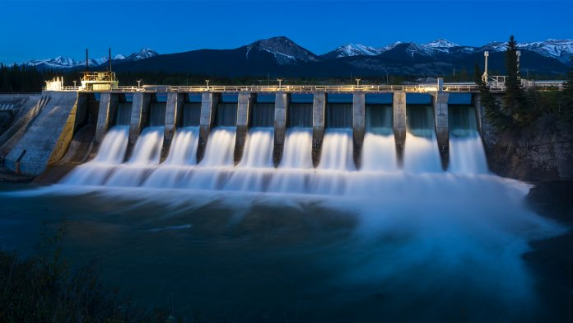
Fig 3: © iStock/James_Gabbert

List of Hydro Power Plants in India 2022: India ranks sixth in the world for hydroelectric energy production, having a total installed capacity of 47,057 MW. At the end of the 19th century, electricity supply in Darjeeling was put into operation. In 1902, a hydroelectric station in Sivasamundram, Karnataka, was put into operation.
Prime Minister Modi recently laid the cornerstone for and inaugurated hydropower projects worth Rs 11,000 crore in Mandi, Himachal Pradesh, since electricity is a crucial component of economic development and contributes to improving quality of life. ⁷

Table1:Top 10 List of Hydro Power Plants in India 2022
S.No. | Name | State and river | Year of establishment | Highlights
1. | Tehri | State- Uttarakhand  River- Bhagirathi | 1978 | It is the highest dam in India. It was built in collaboration with the USSR.
2. | Srisailam | State- Andhra Pradesh  River- Krishna | 1960 | It is the second-largest hydropower project in India.
3. | Bhakra Nangal Dam | State- Himachal Pradesh  River- Satluj | 1948 | It is used by both Punjab and Haryana.
4. | Nagarjuna Sagar Dam | State- Andhra Pradesh and Telangana  River- Krishna | 1967 | It is the world’s largest masonry dam and is protected by 26 gates.
5. | Idukki | State- Kerala  River- Periyar | 1976 | The state of Kerala is heavily dependent on it.
6. | Sardar Sarovar Dam | State- Gujarat  River- Narmada | 1987 | It is the largest dam of the Narmada Valley Project.
7. | Shivanasamudra | State- Karnataka  River- Kaveri | 1902 | It is the first hydropower plant in India.
8. | Teesta Dam | State- Sikkim  River- Teesta | 2003 | This dam comprises 3 turbines for hydropower generation.
9. | Koyna | State- Maharashtra  River- Koyna | 1956 | It is the largest hydel power project in India.
10. | Salal | UT-  Jammu and Kashmir  River- Chenab | 1970 | It is constructed in two stages– I and II.

- 2.2 Wind Energy:
Wind energy is a renewable energy source that generates power from the wind. Wind turbines are tall towers with rotating blades that transform wind kinetic energy into mechanical energy. This mechanical energy is subsequently converted into electricity.

It produces no greenhouse gases or other pollutants, making wind energy a clean and sustainable energy source. Furthermore, it can be produced even when the sun is not shining, making it a reliable energy source.
In India, there is a lot of room for growth in the wind energy sector. It is ideal for the production of wind energy because the average wind speed in the nation is 6 to 8 meters per second. As of 2023, India will rank fourth in the world in terms of installed wind power capacity (42.6 GW).
The Indian government is dedicated to constructing more wind energy projects to meet the nation's rising energy needs. A goal of installing 100 GW of wind power capacity by 2022 has been set by the Ministry of New and Renewable Energy.
Some advantages of wind energy include:
• Because it comes from a renewable source, no greenhouse emissions or other pollutants are produced.
• It is a reliable source of energy because it can be produced even when the sun isn't shining; • It is a clean and sustainable form of energy because wind power costs have been falling recently; and • It is a cost-effective source of energy because it can be produced even when the sun isn't shining.
Several obstacles to wind energy are listed below:
• Because the amount of electricity produced by wind is intermittent, it can change with the wind's velocity.

• People who live close may find wind turbines to be a nuisance due of their noise.

• Because bats and birds are susceptible to being killed by wind turbines, it's critical to locate them away from these animals.

Wind energy has the potential to be a significant component of India's energy mix because it is a clean and sustainable source of electricity. The cost of wind power has been falling recently, and the government of India is dedicated to creating additional wind energy projects. Because of this, using wind energy to satisfy India's expanding energy needs is a more appealing alternative.

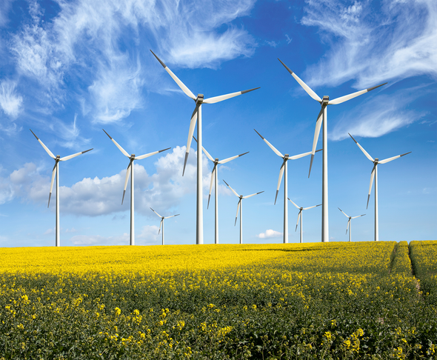
Fig 4: Credit: Maria Wachala Getty Images
In the fiscal year 2022–23, wind power generated 71.814 TWh, or roughly 4.43% of all electricity produced, accounting for nearly 10% of India's total installed utility power production capacity.⁸
In order to reach its larger objective of installing 500 GW of renewable energy sources by the end of the decade, India plans to install 140 gigawatts (GW) of wind capacity by 2030, which could power about 100 million homes.
According to Martand Shardul, the Global Wind Energy Council's policy director for India, wind energy is essential for India's energy transformation because supplying 24 hours a day with green power will require a quicker deployment of wind and solar energy to maintain grid resilience and the balancing of multiple sources.
Without fully utilizing wind energy, Shardul warned that "India and other parts of the world may not be able to achieve net-zero (emission) ambitions."
India, which has the fourth-highest wind power capacity in the world, intends to put about 8 GW of wind power projects up for auction each year through 2030.
FIRST OFFSHORE WIND FARM
India expects solar energy to make up the majority of the remaining amount of its 2030 renewable energy objective, with wind power expansion contributing to close to a third.

According to the government, a tender will shortly be released for the nation's first offshore wind farm, which will be located in the southern state of Tamil Nadu and coming into operation in roughly four years. According to Dinesh Jagdale, offshore developments will help India's wind installation and supply chain sectors.⁹
Installed wind capacity by state as of 30 April 2023^{[33]}
State | Total Capacity (MW)
Gujarat^{[34]} | 10,144.02
Tamil Nadu | 10,073.52
Maharashtra | 5,026.33
Karnataka | 5,294.95
Rajasthan | 5,193.42
Andhra Pradesh | 4,096.65
Madhya Pradesh | 2,844.29
Telangana | 128.10
Kerala | 62.50
Others | 4.30
Total | 42,868.08
Table 2: https://en.wikipedia.org/wiki/Wind_power_in_India

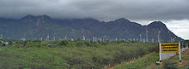
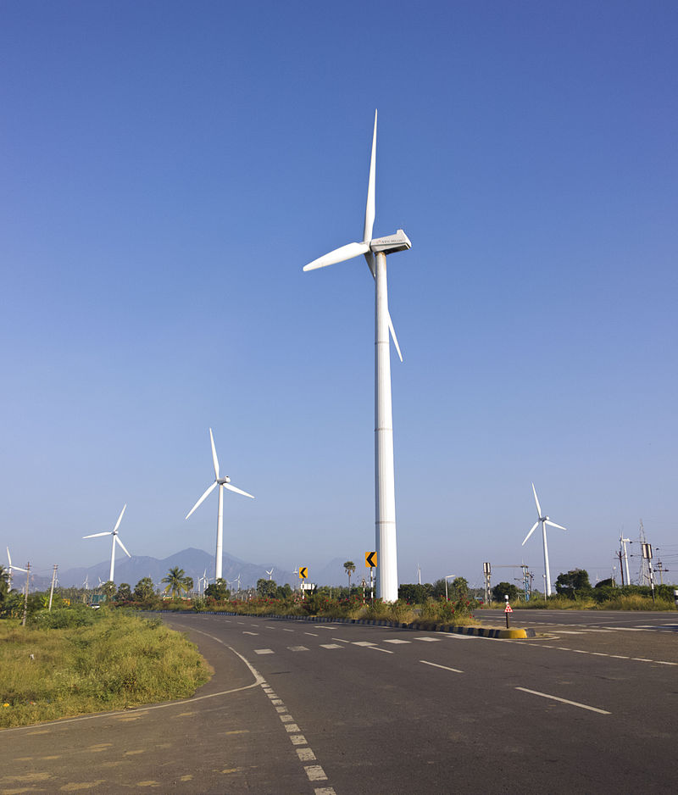

Fig 4:Muppandal Wind farm near NH44 Muppandal wind farm in Tamil Nadu

In the fiscal year 2022–2023, wind energy produced 71.814 TWh, or roughly 4.43% of all electricity produced, in India, where it makes up almost 10% of the country's installed utility power generating capacity.¹⁰
2.3 Solar energy
As the origin of all life on Earth, the Sun has long been revered by humans. We learned about sunlight as a source of energy during the industrial era. The solar energy potential in India is considerable. An estimated 5,000 trillion kWh of energy are incident over India's land surface each year, with the majority of places receiving 4–7 kWh per square metre per day. Effectively harnessing solar photovoltaic energy would enable India to scale it up significantly. Additionally, solar energy enables distributed power generation and quick capacity expansion with short lead times. Rural applications will benefit from off-grid, decentralized, and low-temperature applications, which will also meet other energy requirements for power, heating, and cooling in both rural and urban areas. Since it is so readily available, solar energy is the most reliable energy source. Theoretically, the nation's entire electrical needs could be met by a small portion of the incident solar energy, provided it were efficiently caught.
The landscape of Indian energy has recently been significantly impacted by solar energy. Decentralised and distributed applications based on solar energy have benefited millions of people in Indian villages by providing their energy needs for lighting, cooking, and other uses in a safe and sustainable way. The social and economic advantages include decreased drudgery among rural women and girls engaged in long-distance fuel wood collection and cooking in smoke-filled kitchens, decreased risks of developing lung and eye diseases, the creation of jobs in the village, and ultimately an improvement in the standard of living and the creation of opportunities for economic activities at the village level. In addition, India's solar energy industry has grown into a significant player in grid-
generator capacity that is linked. In addition to playing a crucial role in supplying the country with energy and guaranteeing energy security, it contributes to the government's objective of sustainable growth.
According to the National Institute of Solar Energy, assuming solar PV modules occupy 3% of the country's waste land area, the country's solar potential is approximately 748 GW. With the National Solar Mission as one of the main missions, solar energy has been given priority in India's National Action Plan on Climate Change. The National Solar Mission (NSM), which was launched on January 11, 2010, got underway. The National Sustainable Development Mission (NSM) is a significant initiative of the Indian government that aims to encourage environmentally sound growth while addressing the country's energy security concerns. The project has considerable support from the states. India's contribution to the international effort to address climate change concerns would also be substantial. The Mission's objective is to provide fast-evolving legislative frameworks for the spread of solar technology across India in order to position India as a global leader in solar energy. By 2022, the Mission aims to construct 100 GW of solar power facilities that are connected to the grid. This is in line with India's Intended Nationally Determined Contributions (INDCs), which seek to reduce the emission intensity of its GDP by 33 to 35% compared to 2005 levels and achieve roughly 40% of the nation's installed electric power capacity from non-fossil fuel sources by 2030. Government of India has introduced a number of programs to promote the production of solar energy in the nation in order to meet the aforementioned goal, including the Solar Park Program, VGF Programs, CPSU Program, Defense Program, Canal Bank & Canal Top Program, Bundling Program, Grid Connected Solar Rooftop Program, etc. The announcement of a trajectory for Renewable Purchase Obligation (RPO) incorporating Solar was one of the policy measures put into place. for projects that will be finished by March 2022, the interstate sale of solar and wind energy will not be subject to the costs and losses of the interstate transmission system (ISTS). status, must-run Guidelines for the purchase of solar energy using a tariff-based competitive bidding process, Standards for the Installation of Solar Photovoltaic Devices, Guidelines for developing smart cities and the availability of rooftop solar Amendments to the Building Code that would mandate roof-top solar for new construction or higher floor area ratios, Solar project infrastructure status getting long-term financing from multilateral institutions, issuing tax-exempt solar bonds, and other similar strategies. As of the end of 2021, India now ranks fourth globally for solar PV deployment. As of the 30th of November 2022, installed solar power capacity was approximately 61.97 GW. Achieving grid parity, solar tariffs in India are currently highly competitive. ¹¹
a) GENERAL
The best and most plentiful energy source on the planet is solar energy. A year's worth of human activity is roughly equal to the amount of solar energy that strikes the earth's surface in an hour. Three main methods of using solar energy exist: concentrating solar power (CSP) and solar thermal collectors for heating and cooling (SHC). Direct conversion of sunlight into electricity using photovoltaic (PV) cells is one of the methods. 5,000 trillion kilowatts of clean energy can be produced by the copious solar energy that India has access to. Around 300 days of sunshine and 4–7 kWh of solar insolation per square meter per day are showered upon the nation. If this power is effectively captured, it can easily reduce our energy deficit scenario and that to with
no carbon dioxide emissions. Many Indian states have already found the potential for solar energy, and more are planning to do so in order to satisfy their expanding energy needs with sustainable and endless solar energy. Solar energy will soon play a significant part in supplying India's energy needs.
b) SOLAR PV TECHNOLOGY
Direct conversion of solar light to energy is accomplished by solar photovoltaic (PV) cells. Literally, photovoltaic means "light-electricity." Silicium Crystalline
Crystalline silicon (c-Si) was the first material used in solar PV modules. Single-crystalline (SC-Si) and multi-crystalline (mc-Si) C-Si modules are the two categories into which they fall. Length of the Film
Thin film is a more recent technology than crystalline silicon. They are divided into three groups: amorphous (a-Si) and micro morph silicon (a-Si/c-Si), cadmium telluride (CdTe), copper indium diselenide (CIS), and copper indium gallium diselenide (CIGS). Emerging technologies include things like advanced thin films and organic cells. The latter are getting ready to join the market using specialized applications.
CPV (concentrator technology)
Solar energy is directed to a tiny, high-efficiency cell using concentrator technologies (CPV), which employ an optical concentrator system. Now, CPV technology is being evaluated in pilot applications. Novel PV concepts aim to produce solar cells with an ultra-high efficiency level by using improved materials and creative conversion concepts and methodologies. Presently, basic research is concentrated on them.
c) Solar thermal Technology
Solar energy is employed as a direct heat source for heating needs as well as a steam generator for generating electricity through turbines.
Various concentrating solar energy technologies for solar thermal power plants include:
i) Parabolic troughs
A parabola has the ability to concentrate incoming radiation onto its focus. Based on this, linear concentrators with parabolic shapes are covered in highly reflective material and can be angled in the direction of the sun to focus incoming solar energy onto a long-line receiving absorber tube. A working fluid is used to transport the solar energy, and it is subsequently sent to an exchanger or a conventional conversion system. Parabolic trough systems work best in locations with a lot of direct solar radiation since they only use direct-beam sunlight and need tracking systems to keep them facing the sun. The majority of systems use single-axis tracking during the day and are typically oriented east-west or north-south.

ii) Solar Tower (Central Receiving System)
Using double axes mechanisms that follow azimuth and elevation angles, central receiver systems use heliostats to track the sun in order to reflect sunlight from numerous heliostats placed around a tower and concentrate it on a central receiver at the top of the tower. This approach has the advantage of effectively transferring solar energy by optical means and delivering intense sunshine to a single central receiver unit, which acts as the energy input to the power conversion system. Despite the appealing design concept and the possibility for high concentration and efficiency in the future, more advancements in central receiver technology are needed to scale plant performance even higher.
The main draw of it is the potential for high process temperatures produced by intensely focused solar radiation to provide energy for any power conversion system's topping cycle and to feed efficient energy storage systems that can meet the demand of contemporary power conversion systems.
Successful receiver heat transfer techniques have been used with water/steam, liquid sodium, molten salt, outside air, and oil.
Solar tower plants offer a very good long-term outlook for high conversion efficiencies and the use of very efficient energy storage systems through the utilization of high temperatures to improve solar capacity or solar share.
iii) Linear Fresnel
With the use of long, flat or slightly curved mirrors, the Linear Fresnel technique concentrates sunlight onto a linear receiver placed at the common focal point of the reflectors. The receiver, which is positioned above and parallel to the reflectors, collects heat to boil water in the tubes, generating high-pressure steam that drives the steam turbine without the need for heat exchangers. The Fresnel lens effect used by the reflectors allows for a concentrating mirror with a large aperture and a small focal length. This lowers the cost of the plant because sagged-glass parabolic reflectors are typically significantly more expensive. Saturated steam conditions must be taken into account because the operating temperatures and optical efficiency are much lower than in other CSP systems. Pilot projects are gradually giving way to bigger, more commercialized projects in the development phase. Fluid connections, like those seen in troughs and dishes, are not necessary because the receiver is stationary. Mirrors have a simpler structural design because they do not need to support the receiver. It is possible to pack more mirrors onto the available land space when the proper aiming methods are used (mirrors pointed at various receivers at various times of day).
D) Floating Solar:
Particularly in nations with dense populations and competing uses for available land, floating solar photovoltaic (PV) installations provide significant possibility for increasing solar producing capacity. They have some advantages over land-based systems, including as the utilization of existing electricity transmission infrastructure at hydropower sites, closeness to demand centers (in the case of water supply reservoirs), and improved energy production because of the cooling effects of water and the absence of dust. Yet to be demonstrated by larger installations, across multiple
geographical areas, as well as in the long run, albeit in many cases they may even out any rise in capital costs.
The overall design of a floating PV system is the same as a land-based PV system, with the exception that the PV arrays and, in certain circumstances, the inverters are situated on a floating platform (figure 1). Electricity produced by PV modules in the form of direct current (DC) is gathered by combiner boxes and transformed into alternating current (AC) by inverters. The inverters can be situated on land, close to the array, for small-scale floating plants close to the beach. The most common type of inverter used on specially constructed floats is a central or string inverter. An crucial part of any floating PV installation is the platform, which also includes the anchoring and mooring system.¹²
Additionally, the government has indicated that it aims to have 500 GW of built non-fossil fuel capacity (hydro, nuclear, solar PV, wind, biomass, etc.) by 2030. In order to accomplish its goal, India has set its sights on capturing solar energy. The nation has embarked on a remarkable journey to advance solar power generation and create a brighter, more environmentally friendly future thanks to its abundant sunlight resources. In recent years, India has achieved significant advancements in the widespread use of solar energy. The nation's dedication to solar energy was strengthened by the introduction of the ambitious Jawaharlal Nehru National Solar Mission in 2010.¹³
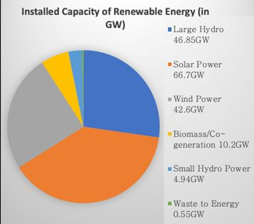

Fig5: source: National Investment Promotion and Facilitation Agency (India), February 2023

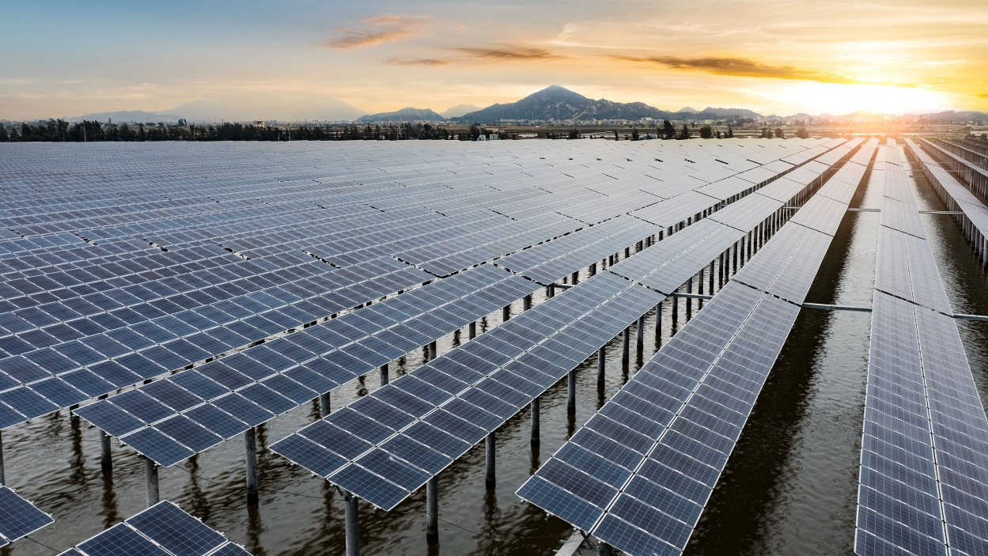
Fig 6: Image: Getty Images
  - Biomass
Municipal solid waste, wood waste, biogas from landfills, and biofuels like ethanol and biodiesel are all examples of biomass energy. Similar to solar energy, biomass is a versatile energy source that may be used to power electric motors, heat buildings, and fuel transportation.
Biomass energy, or energy derived from living things, has been used by humans ever since the earliest hominids started using fires made of wood to cook food or stay warm.

As it is made up of material from living things like plants and animals, biomass is organic. The most frequently used biomass materials for energy production are plants, wood, and trash. Feedstocks for biomass production are what they are called. A nonrenewable source of energy is also possible with biomass.
Through photosynthesis, plants convert water and carbon dioxide into nutrients (carbohydrates), which are then transformed into biomass. This process allows plants to absorb solar energy.
Both directly and indirectly are methods that the energy of these organisms can be transformed into useful energy. Direct combustion of biomass can be used to generate heat or power, while direct conversion to biofuel is also possible.
Thermal Conversion
Thermal conversion is one way to turn biomass into energy. Heating biomass feedstock for burning, dehydration, or stabilization is known as thermal conversion. The most typical biomass feedstocks for thermal conversion are raw materials like municipal solid waste (MSW) and leftovers from paper or lumber mills.
A variety of energy sources include anaerobic decomposition, pyrolysis, gasification, co-firing, direct firing, and pyrolysis.
But biomass first needs to be dried before it can be burned. The term for this chemical process is torrefaction. Temperatures between 200° and 320° Celsius (390° and 610° Fahrenheit) are needed to torrefy biomass. Biomass loses its ability to absorb moisture or decompose when it totally dries out. 20% of its initial bulk is lost, but 90% of its energy is retained. Torrefaction can be accelerated by using the lost mass and energy.
Biomass is converted into a dry, charred substance through torrefaction. Briquettes are then made by crushing the material. Highly hydrophobic, or water-rejecting, biomass briquettes are produced. They may now be kept in wet conditions for storage thanks to this. In direct or co-firing applications, the briquettes burn easily and have a high energy density.
Co-Firing and Direct Firing
Most briquettes are consumed right away. A generator produces energy by being driven by a turbine that is driven by the steam created during the firing process. Equipment can be powered by this electricity, and buildings can be heated with it.
Co-firing, or burning biomass alongside a fossil fuel, is another option. In coal plants, biomass is frequently co-fired. A new biomass processing facility is not necessary with co-firing. The use of coal is decreased through co-firing. It reduces the amount of CO2 and other greenhouse gases released during the burning of fossil fuels.
Pyrolysis
A heating method for biomass known as pyrolysis is comparable to combustion. Biomass is heated to temperatures between 390 and 570 degrees Fahrenheit (200 to 300 degrees C) during pyrolysis. This alters the biomass's chemical makeup and stops it from burning.
Syngas, a synthetic gas produced during pyrolysis, pyrolysis oil, and charcoal are the three end products. To produce energy, any of these components can be used.
Pyrolysis oil, commonly known as bio-oil or biocrude, is a kind of tar. In addition to being a part of other fuels and polymers, it can be burned to create energy. Pyrolysis oil is being studied by scientists and engineers as a possible petroleum substitute.
Synthetic natural gas, for instance, can be converted from syngas into fuel. Additionally, it can be converted into methane and utilized in place of natural gas.
Biochar is one kind of charcoal. A carbon-rich material called biochar is used in a variety of ways in agriculture. Pesticides and other nutrients are kept from leaking into runoff thanks to biochar, which also feeds the soil. An excellent carbon sink is biochar. Carbon sinks are chemical repositories that contain carbon and greenhouse gases.

Gasification
The direct conversion of biomass to energy can also be accomplished through gasification. In the process of gasification, a biomass feedstock (typically MSW) is heated to temperatures more than 700° C (1,300° F) with a controlled proportion of oxygen. The molecules break down, generating syngas and slag.
Hydrogen and CO are the main components of syngas. During gasification, pollutants including mercury, sulfate, and other impurities are removed from syngas. Clean syngas can be transformed into chemicals, fertilizers, biofuels for transportation, or it can be utilized to produce heat or electricity.
The liquid form of slag is molten glass. Cement, asphalt, and shingles are all made with its help.
All across the world, industrial gasification facilities are being created. However, one of the largest gasification plants in the world is currently being built in Stockton-on-Tees, England. Asia and Australia are home to the majority of facilities that are being built and operated. Over 350,000 tonnes of MSW will eventually be able to be turned into 50,000 homes' worth of electricity at this plant.
Decomposition Under Anaerobic Conditions
In the absence of oxygen, microbes, primarily bacteria, break down material in a process known as anaerobic decomposition. When biomass is crushed and compacted, creating an anaerobic (or oxygen-deficient) environment, decomposition takes place anaerobically. This happens in landfills.
Methane, a useful energy source, is produced as biomass decomposes in an anaerobic environment. Possible replacements for fossil fuels include this methane.
Along with landfills, farms with livestock and ranches can also use anaerobic decomposition. In order to meet the farm's energy needs sustainably, manure and other animal waste might be treated.
Biofuel
In order to produce liquid biofuels like ethanol and biodiesel, only biomass is a sustainable energy source. In countries like Sweden, Austria, and the United States, biofuel is produced by gasification and used to power automobiles.
Sugarcane, wheat, or corn biomass, which is high in carbs, is fermented to make ethanol. Blending ethanol with used cooking fat, vegetable oil, or animal fat produces biodiesel.
As compared to gasoline, biofuels are less efficient. However, by combining them with gasoline, they may effectively power automobiles and machinery without producing any of the pollution associated with fossil fuels. Acres of farms are required to grow biocrops for ethanol, typically maize. 400 gallons of ethanol may be produced from one acre of maize. This land, however, is therefore unavailable for
cultivation of crops for consumption or other uses. Due to the lack of planting diversity and the extensive use of pesticides, producing enough maize for ethanol places a burden on the environment.
Ethanol is a common alternative to wood in house fireplaces. It produces heat when burned, but not smoke, but rather flames and water vapor.
Biochar
Agricultural and environmental uses can be made of biochar, which is produced during pyrolysis.
Large volumes of methane and carbon dioxide are released into the atmosphere when biomass rots or burns, whether naturally occurring or as a result of human activity. However, burning biomass sequesters, or stores, its carbon content. Reintroducing biochar into the soil will allow it to continue absorbing carbon and create significant subsurface carbon sinks, which will reduce carbon emissions and improve soil quality.
Soil augmentation is another benefit of biochar. It can be penetrated. When added to the soil, biochar holds and absorbs nutrients and water.
The technique known as "slash-and-char" uses biochar in Brazil's Amazon rainforest. Agriculture that uses slash-and-burn techniques loses 97 percent of its carbon while temporarily boosting soil nutrients. Slash-and-char agriculture takes its place. During slash-and-char, the burned plants (biochar) are reintroduced to the soil, preserving 50% of the soil's carbon. As a result, the soil quality is enhanced and plant growth is significantly raised.
Black Liquor
Black liquor, a highly energetic, toxic liquid, is created when wood is converted into paper. Prior to being released into local water systems in the 1930s, black spirits from paper mills was seen as a waste product.
Black liquor, on the other hand, manages to hold onto more than 50% of the wood's biomass energy. In the 1930s, the recovery boiler was developed, enabling the mill to be powered by reclaimed black liquor. The United States' paper sector is among the most energy-efficient in the nation because paper mills use almost all of the black liquor produced there to run their mills.
Black liquor has recently been gasified in Sweden in an effort to create syngas, which can then be used to produce electricity.
Hydrogen Fuel Cells
Hydrogen may be chemically extracted from biomass and used to power turbines and power vehicles. Remote locations, including wilderness areas and spacecraft, are powered by stationary fuel cells. California's Yosemite National Park, for instance, uses hydrogen fuel cells to heat and power its administration building.

As a source of energy for cars, hydrogen fuel cells may have considerably more promise. The US Department of Energy estimates that annual hydrogen production from biomass is 40 million tonnes. This will supply 150 million vehicles with energy.
Buses, forklifts, boats, submarines, and other vehicles are all powered by hydrogen fuel cells; airplanes and other types of vehicles are also being tested using them.
The viability of this technique for commercial use and sustainability, however, are some of the topics of debate. There is not much energy left over for useful applications after the energy needed to separate, compress, package, and transport hydrogen.
Biomass and the Environment
The carbon cycle on Earth depends critically on biomass. Every layer of the Earth's atmosphere, hydrosphere, biosphere, and lithosphere exchanges carbon as part of the carbon cycle.

Different ways in which the carbon cycle is manifested. The amount of sunlight that reaches the Earth's atmosphere can be controlled in part because to carbon. All human activity, respiration, photosynthesis, and breakdown exchange it. When a plant releases carbon-based nutrients into the biosphere through photosynthesis, for instance, carbon that the soil has absorbed from the decomposition of an animal may be recycled. The decomposing organism can change into peat, coal, or petroleum under the right circumstances, and these materials can subsequently be collected using either natural processes or human activity.
In between exchange cycles, carbon is sequestered or stored. In fossil fuels for millions of years, carbon has been kept in storage. The carbon that has been stored in fossil fuels is released into the atmosphere after their extraction and usage as energy sources. Fuels made of fossils do not reabsorb carbon.

In contrast to fossil fuels, biomass comes from living things that have recently existed. Biomass contains carbon, which can be continuously transferred throughout the carbon cycle.
Sustainable management of biomass resources, such as plants and forests, is necessary for the Earth to effectively maintain the carbon cycle process. Reabsorbing and storing carbon in plants and trees, like switchgrass, takes decades. The process can be significantly impacted by uprooting or disrupting the soil. To sustain a healthy environment, there must be a consistent and diverse supply of trees, crops, and other plants.
Algal Fuel
Unique in its ability to serve as a source of biomass energy, algae are a unique organism. The most popular name for algae is seaweed, and it can produce energy through photosynthesis up to 30 times more quickly than any other biofuel source.
It does not deplete freshwater supplies because algae may flourish in seawater. Additionally, because it doesn't need soil, it doesn't eat up available space on the ground that could be utilized to grow food crops.
Algae may be grown and regenerated like a living organism even if it produces CO2 when burned. In the process of replenishment, it releases oxygen while also absorbing impurities and carbon emissions.
In comparison to other biofuel crops, algae requires a lot less space. The US Department of Energy estimates that the amount of algae needed to provide all of the country's energy needs could be grown on about 38,850 square kilometers (15,000 square miles, or less than half the area of the US state of Maine).

It is possible to create biofuel from the oils contained in algae. The Aquaflow Bionomic Corporation in New Zealand, for instance, uses pressure and heat to process algae. This results in "green crude," which is comparable to crude oil in characteristics and can be used as a biofuel.
Algal growth, photosynthesis, and energy production all rise when carbon dioxide is bubbled through it. An effective filter for sequestering carbon is algae. A device created by the Scottish business Bioenergy Ventures transfers carbon emissions from a whisky distillery to an algae pool. Algae thrives with the additional carbon dioxide. When the algae die (after a week or so), their lipids (oils) are collected and used to make fish food or biofuel.

Algae has tremendous potential as a renewable energy source. However, transforming it into usable forms is expensive. The cost per tonne was $5,000 in 2010, despite the crop producing 10 to 100 times more fuel than other biofuel crops. Most likely, the cost will go down. Although the price will probably drop, the majority of people cannot afford it right now.
Biomass and People
Advantages
A clean and regenerative energy source is biomass. Plants or algae biomass can recover in a rather short amount of time after receiving the first energy from the sun. Trees, crops, and municipal solid waste are constantly available and may be managed sustainably.
When trees and crops are raised sustainably, they can reduce carbon emissions by respiring carbon dioxide. In some bioenergy processes, more carbon is reabsorbed than is released during fuel processing or usage.
Many biomass feedstocks, such as switchgrass, can be gathered on marginal lands or pastures where food crops are not grown. Unlike other renewable energy sources, such as wind or solar, biomass energy is stored within the organism, and can be harvested when it is needed.
Disadvantages
If biomass feedstocks aren't replenished as quickly as they're used up, they can stop being renewable. For instance, a forest's regeneration may take hundreds of years. Compared to a fossil fuel like peat, this time period is still much shorter. Peat may regenerate in three feet (one metre) chunks in 900 years.

It takes arable land to develop biomass most often. This indicates that land used for biofuel crops like corn and soybeans is not now suitable for growing food or supporting natural habitats.
"Old-growth forests" are forested areas that have been established for many years and are able to absorb more carbon than newly planted trees. As a result, if forested areas are not properly cleared, replanted, and given time to develop and absorb carbon, the advantages of using wood for fuel are not offset by tree regeneration.

Most biomass facilities require fossil fuels in order to be economically viable. For instance, a sizable facility currently under construction close to Port Talbot, Wales, will need to import fossil fuels from North America, which will somewhat negate the enterprise's sustainability.

Biomass does not have the same "energy density" as fossil fuels. During the energy conversion process, water, which makes up up to 50% of biomass, is lost. The movement of biomass further than 160 kilometers (100 miles) from the location where it is processed is not thought to be economically feasible. The energy density of the fuel can be increased and exporting made simpler by reducing biomass into pellets as opposed to wood chips or bigger briquettes.

Burning biomass results in the release of pollutants such as carbon monoxide, carbon dioxide, nitrogen oxides, and other toxins. Burning biomass can discharge more pollutants than burning fossil fuels if these pollutants are not captured and recycled, which can result in smog.

FAST FACT
Balancing Biomass
A Balanced Definition of Renewable Biomass is a set of useful and effective sustainability guidelines that can assist ensure that woody biomass harvests are done sustainably. The Union of Concerned Scientists contributed to its development.¹⁴
Indian Biomass Energy
• About 450–500 million tonnes of biomass are produced annually in India. 32% of the nation's total primary energy consumption is currently derived from biomass.
• Depending on how broadly the term "biomass" is used, EAI estimates that India's short-term potential for power from biomass can range from about 18,000 MW to roughly 50,000 MW. 5% ethanol blends in gasoline, which the government has mandated in 10 states, are the only biofuels that currently make up a significant portion of the total fuel used. Although it is not currently available on the Indian fuel market, biodiesel will be used by the government to meet 20% of the nation's diesel needs by 2020.
• In India, potential biodiesel sources include Jatropha curcas, Neem, Mahua, and other untamed plants.
Over 63 million ha of the nation's waste land can be converted into jatropha plants, which can be grown on about 40 million ha of the remaining waste land. Jatropha planting is used in India as part of a number of incentive programs to persuade people to clean up wastelands.
• Jatropha will be grown on 11.2 million acres by the Indian government by 2012.¹⁵
2.5. Geothermal
The heat created deep within the Earth's core is known as geothermal energy. It is possible to use geothermal energy to generate heat and electricity. It is a clean, sustainable resource.16 17.The heat produced by the Earth is known as geothermal energy. In Greek, "thermal" means "heat," and "geo" means "earth." It may be harvested and used by people because it is a renewable resource.
2,900 kilometers (1,800 miles) or so beneath the Earth's crust, or surface, is where our planet's core is situated. The friction and gravitational pull that existed when Earth was forming roughly 4 billion years ago are responsible for a small portion of the core's heat. On the other hand, radioactive isotopes like potassium-40 and thorium-232 continuously produce the largest majority of the Earth's heat through their radioactive decay.
Elements that differ from the element's regular atoms in terms of neutron count are called isotopes.
20 neutrons are found in the nucleus of potassium, for instance. As opposed to this, potassium-40 has 21 neutrons in it. Massive amounts of energy (radiation) are produced as the nucleus of potassium-40 changes during decay. Calcium (calcium-40) and argon (argon-40) are the two most prevalent potassium-40 isotopes.
Radioactive decay takes place constantly in the core. Over 5,000° Celsius (or 9,000° F) is the highest temperature that can be experienced. Rocks, water, gas, and other geological components are constantly being heated as heat radiates from the core.
Deeper within the Earth's interior than its surface, the temperature rises. Temperature decline that occurs gradually is known as the geothermal gradient. Most of the world's locations have a geothermal gradient of about 25 °C (1 °F) per 77 feet of depth.
700-1,300° C (1,300-2,400° F) of heat can cause underground rock formations to erupt as magma. Rock that is partially melted and molten that is also filled with gas and gas bubbles is known as magma. In the mantle and lower crust, magma can be found. Lava can occasionally bubble to the surface from the magma.
The rocks in the immediate area and the aquifers below get heated by magma. Hot water can also be released from mud pots, steam vents, submarine hydrothermal vents, geysers, and hot springs.
Geothermal energy is used by all of them. Either their steam or their heat can be used to directly produce heat or electricity. Geothermal energy is a viable option for heating structures, parking lots, and sidewalks. Not all of the geothermal energy that escapes from the Earth is released as steam, water, or magma. It continues to radiate outward from the mantle over time, accumulating as hot spots.
Drilling can access this geothermal heat, which can then be supplemented with water injection to create steam.
Techniques for capturing geothermal energy have been developed in numerous nations. Geothermal energy comes in a variety of forms and is accessible in various parts of the world. Most people in Iceland can rely on geothermal energy as a reliable, affordable source of electricity because there is a lot of hot, easily accessible subsurface water there. Drilling for geothermal energy costs more in other nations, such as the United States.
Harvesting Geothermal Energy: Heating and Cooling
Geothermal Energy at Low Temperatures
Almost wherever on the earth, geothermal heat is available and usable as a source of heating. Low-temperature geothermal energy is the term for this kind of heat energy. Heat pockets at 150° C (302° F) are the source of low-temperature geothermal energy. The vast majority of low-temperature geothermal energy pockets are barely a few meters below the surface of the planet.
At low temperatures, geothermal energy can be used to heat buildings, residences, fisheries, and commercial operations. Although creating electricity can occasionally be done using low-temperature energy, heating is where it is most effective.
Engineering, comfort, medicine, and cooking have all long made use of this type of geothermal energy. Indigenous American tribes gathered 10,000 years ago near naturally occurring hot springs to rest up or seek refuge from conflict, according to archeological data. On a mountain in central China called Lishan, around the third century BCE, scholars and statesmen warmed themselves in a hot spring fed by a stone pool. One of the most popular hot spring resorts is located in Bath, England. Beginning in 60 CE, Roman conquistadors built a sophisticated network of steam rooms and baths that drew heat from the area's sparse pockets of geothermal energy that are only accessible at low temperatures.
The French town of Chaudes Aigues has benefited from its hot springs since the 1300s as a source of prosperity and vigor. In order to attend the town's upscale spas, tourists travel there. For heating homes and buildings, low-temperature geothermal energy is also utilised.
In Boise, Idaho, the first geothermal district heating system in the United States was set up in 1892. Around 450 houses are still heated by this technology.
Co-Produced Geothermal Energy
Geothermal energy technology that is co-produced needs other energy sources. Byproducts from oil and gas wells are used in this type of geothermal energy, such as warm water.

In the US, a byproduct that is produced annually is roughly 25 billion barrels of hot water. This heated water was formerly simply thrown away. It's been recently

acknowledged as a potential source of additional energy: Its steam can be utilized to produce power that can either be used right away or sold to the grid.

The Rocky Mountain Oilfield Testing Center in the U.S. state of Wyoming launched one of the earliest co-produced geothermal energy projects.
Co-produced geothermal energy facilities are now moveable thanks to newer technology. Mobile power plants have a lot of potential for isolated or underdeveloped areas, even though they are still in the experimental stages.

Geothermal Heat Pumps: Geothermal heat pumps (GHPs) use Earth's heat to generate energy and can be used almost anywhere on the earth. In comparison to typical oil and gas wells, GHPs are drilled between 3 and 90 meters (10 and 300 ft) deep. The energy source for GHPs can be reached without bedrock breaking.
A pipe attached to a GHP is organized into a continuous loop known as a "slinky loop" that rotates both underneath and above ground, generally throughout a building. In order to heat a parking lot or well-kept area, the loop might alternatively be totally buried.
In this system, the pipe is used to convey water or other liquids, such as glycerol, which is a lot like antifreeze for cars. Throughout the winter season, the liquid stores geothermal heat beneath the surface. It moves heat upward through the structure and releases heat through a duct system. Additionally, hot water tanks can be used to route these heated pipelines, lowering the cost of water heating.
The GHP system works in reverse during the summer, absorbing heat from the structure or parking lot and dispersing it underground to be cooled by the liquid in the pipes.
According to the United States Environmental Protection Agency, geothermal heating is the most economical and environmentally friendly method of heating and cooling.
Harvesting Geothermal Energy: Electricity
Electricity is produced by geothermal power plants by harnessing heat that is located a few kilometers beneath the surface of the Earth. There are some places where pockets of steam or hot water spontaneously occur underground. Steam can be produced almost anywhere, but it usually needs to be "enhanced" by water injection.
Dry-Steam Power Plants
Using underground natural steam sources, dry-steam power plants generate electricity. A power plant's steam is pumped directly there, where it powers turbines and produces energy. The oldest kind of geothermal energy power plant is one that uses dry steam. In 1911, Larderello, Italy saw the construction of the first dry-steam power plant. Over a million residents in the neighborhood still have access to electricity thanks to the Larderello dry-steam power plants.
Only Yellowstone National Park in Wyoming and The Geysers in California are recognized as sources of subsurface steam in the United States. The Geysers is the only location with a dry-steam power plant due to Yellowstone's status as a protected area. One-fifth of California's renewable energy is produced by this complex, one of the largest geothermal energy facilities in the world.
Flash-Steam Power Plant
Utilizing naturally occurring steam and hot water sources beneath the ground, flash-steam power plants produce steam. Water heated above 182° C (360° F) is introduced into a low-pressure area. Some of the water "flashes," or quickly evaporates, into steam, which is then channeled out to power a turbine and produce electricity. Any water that is still present can be flashed in a different tank to gain more energy.
The most common kind of geothermal power plant is a flash-steam plant. An extensive network of flash-steam geothermal power plants supplies almost all of Iceland's electricity. Iceland is an island country with active volcanoes. The steam and extra warm water produced by the flash-steam method are used to heat ice parking lots and sidewalks in the bitter Arctic winter.
Additionally, the islands of the Philippines are situated above the "Ring of Fire" of the Pacific Ocean, a tectonically active region. The Philippines today ranks second only to the United States in terms of geothermal energy utilization thanks to investments made by the government and business in flash-steam power plants. In actuality, Malitbog, Philippines' flash-steam facility is the largest single geothermal power plant in the world.
Binary Cycle Power Plants
Binary cycle power plants utilize a unique technology to conserve water and produce heat. Temperatures of 107°-182° C (225°-360° F) are reached by heating water underground. A conduit that travels above ground is where the hot water is kept. A substance in an organic liquid that has a lower boiling point than water is warmed by the hot water. Steam is produced by the organic liquid, which then powers a generator by passing through a turbine and creating steam. This process solely generates steam as a byproduct. The organic component is heated again using the recycled water from the pipe, which is returned to the earth and re-heated there by the planet. The Beowawe Geothermal Facility in the American state of Nevada uses the binary cycle to produce electricity. The organic material used at the production is tetrafluoroethane, a greenhouse gas. It turns into gas at low temperatures because this refrigerant has a lower boiling point than water. The turbines are powered by the gas and are connected to generators.¹⁶
Enhanced Geothermal Systems
Nearly unlimited heat and energy exist below the surface of the Earth. It can't, though, be converted into energy unless the subsurface regions are "hydrothermal." The subterranean areas are therefore porous, liquid-filled, and heated in addition to being heated. The three elements are lacking in many places. To provide fluid and increase permeability in areas with hot but dry subterranean rock, enhanced geothermal systems (EGS) use drilling, fracturing, and injection. A vertical "injection well" is drilled into the earth to construct an EGS. This can vary from 1 km (0.6 mi) to 4.5 km (2.8 mi), depending on the type of rock.
High-pressure cold water is injected into the drilled cavity, forcing the rock to fracture in new ways, enlarge existing fissures, or simply crumble. Thus, a fluid reservoir below ground is created.
When water is injected into the well, it passes through the reservoir and picks up heat from the rocks. A "production well" is then used to pump the brine, or boiling water, back up to the Earth's surface. The brine is heated and is in a pipe. It warms a second fluid with a low boiling point, causing it to evaporate and turn into steam, which powers a turbine. Again absorbing heat from below the surface, the brine cools and cycles back down the injection well. No gaseous emissions are produced, other than the water vapor released by the evaporating liquid.
Seismic activity, or minor earthquakes, may result from the pumping of water into the ground for EGSs. When water was injected into Basel, Switzerland, the operation resulted in hundreds of minor earthquakes that continued to grow until there was major seismic activity. As a result, in 2009, the geothermal project was abandoned.
Geothermal Energy and the Environment
Geothermal energy is a renewable source of power. The Earth has been emitting heat for around 4.5 billion years and will continue to do so for many more because of the ongoing radioactive decay in its core.
However, most heat-collecting wells will ultimately cool, particularly if heat is removed more quickly than it can be replaced. The steam pressure in Larderello, Italy, the location of the first geothermal power plant in the world, has decreased by more than 25% since the 1950s.
Re-injecting water sometimes can extend the life of a cooling geothermal facility. But this procedure may cause "micro-earthquakes." Even if the majority of them are too small to be felt by humans or measured on a scale of magnitude, the ground can tremble at more dangerous levels and compel the geothermal project to stop, as it did in Basel, Switzerland.
A small amount of freshwater is not required for geothermal systems. Binary systems never expose or evaporate water; it is only used as a heating agent. It is reusable, recyclable, and can even be used to vent non-toxic steam into the air. Arsenic, boron, and fluoride are a few of the hazardous materials that geothermal fluid may accumulate if it is not contained and recycled in a pipe. These dangerous substances may rise to the top and discharge themselves when water evaporates. Furthermore, if the fluid leaks into other underground water systems, it might damage sources of clean drinking water and aquatic habitats.
Advantages
There are many advantages to using geothermal energy either directly or indirectly:
• Geothermal energy is a sustainable source of energy; it is not a finite resource like fossil fuels. For billions of years to come, the Earth will keep emitting heat from its interior.
• Using geothermal energy is comparatively clean; it is accessible and usable wherever in the world. The majority of systems merely release water vapor, but a few also release very trace amounts of sulfur dioxide, nitrous oxide, and particulates.
• The lifespan of geothermal power facilities can reach the hundreds of years. The amount of energy extracted and the rock's rate of regenerating its heat can be kept in balance with the right reservoir management.Geothermal systems are "baseload," unlike other renewable energy sources. They are therefore not reliant on varying conditions like the presence of wind or sun and may operate in both the summer and the winter. All seven days of the week, geothermal power plants produce heat or electricity.
• When compared to other types of power plants, geothermal facilities require substantially less space to construct. A geothermal plant requires the equivalent of 1,046 square kilometers (404 square miles) of land to generate a GWh (a gigawatt hour, or one million kilowatts of energy for one hour, a vast amount of energy). 3,458 square kilometers (1,335 square miles) are needed for wind energy, 8,384 square kilometers (3,237 square miles) are needed for solar photovoltaic facilities, and 9,433 square kilometers (3,642 square miles) are needed for coal power plants to create the same amount of GWh.
• Geothermal energy systems can be configured to operate in a variety of environments.
They can be used to heat, cool, or power individual homes, whole districts, or industrial processes.
Disadvantages
Harvesting geothermal energy still poses many challenges:
• Minor seismic activity, or small earthquakes, can be caused by the process of injecting high-pressure water streams into the Earth.
Subsidence, or the steady sinking of land, has been associated with geothermal plants. The fissures in the earth fall in on themselves to do this. • Geothermal plants may leak trace amounts of greenhouse gases including carbon dioxide and hydrogen sulfide, which can result in harm to natural drainage systems, pipelines, roads, and buildings.
• Toxic substances including arsenic, mercury, and selenium can be detected in minute quantities in water that passes through subsurface reservoirs. • Even though geothermal technology uses almost no fuel to operate, the initial cost of installing it is high. If the system is not adequately insulated, these hazardous materials could leak into water sources. A geothermal power plant may not be feasible for developing nations to build given their lack of capital or advanced infrastructure. Investments from American business and government organizations, for instance, made it feasible for several facilities to be built in the Philippines. Today, Philippine nationals own and run the plants.
Geothermal Energy and People
Geothermal energy can be extracted and used in a variety of ways because it can be found on the Earth's surface in various forms (such as dry heat, steam vents, lava, and geysers).
Natural geysers and steam vents in New Zealand heat swimming pools, houses, greenhouses, and prawn farms. Additionally, New Zealanders employ dry geothermal heat to dry grain and lumber.
Many other nations, including Iceland, use the molten rock and lava resources produced by volcanic activity to heat their houses and structures. In Iceland, geothermal energy is used for heating by roughly 90% of the population. To melt snow, warm fisheries, and heat greenhouses, Iceland also depends on its natural geysers.
In comparison to other nations, the United States produces the most geothermal energy. At least 15 billion kilowatt-hours are produced annually in the United States, which is equal to 25 million barrels of oil. Western U.S. regions have seen a concentration of industrial geothermal technologies. In 2012, there were 59 geothermal projects in Nevada that were either operating or in development. California had 31 projects, and Oregon had 16 projects.

Geothermal energy technology is now more affordable for both consumers and businesses because to a decline in price over the past ten years.¹⁷
despite the fact that the first geothermal plant was started in India. India does not have any plants that are running at the moment.
References:
1.https://www.globalgoals.org/goals/
2. https://unfoundation.org/what-we-do/issues/sustainable-development-goals/?gclid=Cj0KCQjw_O2lBhCFARIsAB0E8B-bzsfY3orNIeJdq2igGOOat1tHwHoXrywSClSkZ-yKBOn-cyIEmS4aAvYHEALw_wcB
3. https://economictimes.indiatimes.com/industry/renewables/indias-renewable-energy-capacity-reaches-168-96-gw-till-feb-2023-minister-r-k-singh/articleshow/98862427.cms?utm_source=contentofinterest&utm_medium=text&utm_campaign=cppst
4.https://studentenergy.org/source/hydropower/?_gl=1*enbltv*_up*MQ..&gclid=Cj0KCQjw_O2lBhCFARIsAB0E8B8NGSDt1LLfFbRsb9gD2uT4nEhniDvDeTGcRhdRt4TAsX45_fvt2SkaAlcrEALw_wcB
5. Source: Ministry of Power
6. https://powermin.gov.in/en/content/power-sector-glance-all-india
7. https://www.jagranjosh.com/general-knowledge/list-of-hydro-power-plants-in-india-1501159366-1
8. https://www.google.com/search?q=Wind%20energy%20in%20india&authuser=1
9.Read more at:https://economictimes.indiatimes.com/industry/renewables/will-indias-new-wind-energy-push-make-green-jobs-fly/articleshow/100993990.cms?utm_source=contentofinterest&utm_medium=text&utm_campaign=cppst
10. https://en.wikipedia.org/wiki/Wind_power_in_India
11. https://mnre.gov.in/solar/current-status/
12. https://www.ireda.in/solar-energy
13. mondaq.com/india/renewables/1330754/growth-of-solar-power-in-india
14. https://education.nationalgeographic.org/resource/biomass-energy/
15. https://www.eai.in/ref/ae/bio/bio.html
16. https://education.nationalgeographic.org/resource/geothermal-energy/
17. https://education.nationalgeographic.org/resource/geothermal-energy/

