**Breaking the outer layer of the “virus (Covid-19)” with the help of electrical stimulation and protect the Human body against virus (Covid-19) infection.**

**Dr. Mamataben Soni, Dr. Bhavinkumar Soni**

**GRAPHICAL ABSTRACT**

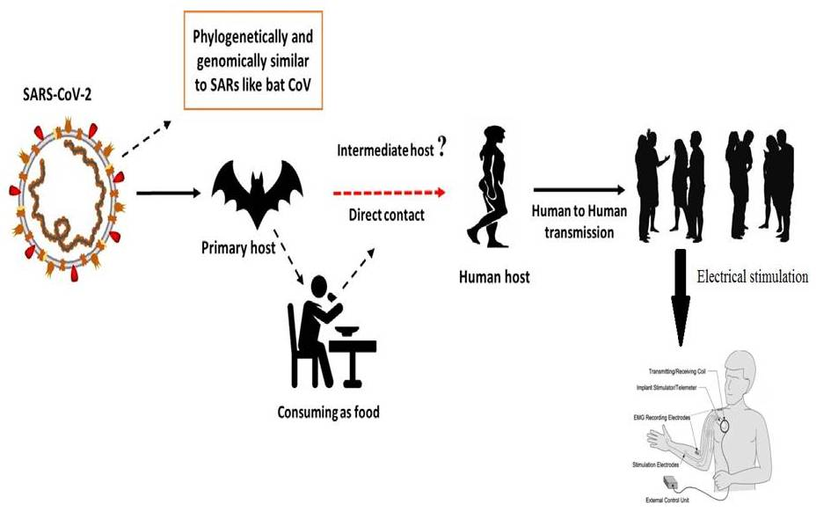

**KEY WORDS**

Electrical stimulation, Covid-19, Current, Voltage, SARS-CoV, MERS-CoV,

**INTRODUCTION**

Corona viruses are members of the Nidovirales order's Corona viridae family. Corona refers to the crown-like spikes on the virus's outer surface; consequently, it was dubbed a corona virus. Corona viruses are minute in size (65–125 nm in diameter) and include a single-stranded RNA as a nucleic material, size ranging from 26 to 32kbs in length (Fig. 1). Corona virus subgroups include alpha (a), beta (b), gamma (c), and delta (d) corona viruses. SARS-CoV, H5N1 influenza A, H1N1 2009, and Middle East respiratory syndrome corona virus (MERS-CoV) cause Acute Lung Injury (ALI) and Acute Respiratory Distress Syndrome (ARDS), which lead to pulmonary failure and death. Until 2002, when the world experienced a Severe Acute Respiratory Syndrome (SARS) outbreak caused by SARS-CoV in Guangdong, China, these viruses were thought to primarily infect animals [Zhong et al., 2003]. Only a decade later, another dangerous corona virus, Middle East Respiratory Syndrome corona virus (MERS-CoV), produced a Middle Eastern endemic [Wang et al., 2013].

At the end of 2019, Wuhan, China's emerging commercial hub, saw an outbreak of a novel corona virus that killed over eighteen hundred people and infected over seventy thousand more within the first fifty days of the epidemic. This virus was identified as a member of the corona virus b group. The Chinese researchers termed the novel virus Wuhan corona virus or 2019 novel corona virus (2019-nCov). The virus was identified as SARS-CoV-2 and the disease as COVID-19 by the International Committee on Virus Taxonomy (ICTV) [Cui et al, 2019; Lai et al., 2019;WHO 2020]. SRAS-CoV (2003) infected 8098 people with a 9% fatality rate across 26 nations in the world, whereas new corona virus (2019) infected 120,000 people with a 2.9% mortality rate across 109 countries as of this writing. It demonstrates that SARS-CoV-2 has a higher transmission rate than SRAS-CoV, which could be due to a genetic recombination event at the S protein in the RBD region of SARS-CoV-2, which may have boosted its transmission potential.



**Figure: 1**Structure of respiratory syndrome causing human corona virus

**History of the electrical stimulation therapy use in various diseases**

One of the problems in this case is the use of electrical equipment (Black Boxes, Magnetic Pulse Generators) for blood electrification, with the claim that such devices can be used to treat infections like viruses, bacteria, and yeast, as well as diseases like cancer. These statements have a historical grounding in the scientific literature. Lyman and colleagues reported in 1990 that passing 50 to 100 microamperes of direct current through Aids-infected blood would inactivate the Aids virus and halt viral replication (Lyman et al., 1990). On March 14th, 1991, this research was presented at the First International Symposium on Combination Therapies (an AIDS conference) in Washington DC.

Over the last few decades, the development of more effective antibiotics against bacterial infections has revolutionized medical treatment, resulting in a drastic reduction in mortality caused by microbial diseases; however, the widespread use of antibiotics has unfortunately led bacteria to develop defences against antibacterial agents, resulting in increased resistance, imposing serious limitations on the options for treating bacterial infections, which is a major threat (Castro et al., 2002; Silveira et al.,2006). Bacteria of the genera *Enterobacter* and Staphylococcus stand out in the world picture of bacterial resistance, and the medicines used to control them are typically ineffective, making treatment difficult (Martins et al.,2012).*Enterobacter* is a genus of facultative anaerobic gram-negative bacilli of the *Enterobacteriaceae* family. *Enterobacter aerogenes* and *Enterobacter* cloacae are opportunistic bacteria that have emerged as pathogens of critical care unit patients capable of establishing resistance mechanisms to β -lactams. (Regli et al., 2015).

The more the Amp-C gene expression by *Enterobacter*, the greater the mechanism of resistance to particular antibiotics such as cephalosporin, and there have been cases of *carbapenemase*-producing bacteria (Tuon et al., 2015). Staphylococcus *aureus*, on the other hand, is a gram-positive *cocci* bacteria prevalent in healthy people's skin and nasal passages; it is the primary etiological agent of skin infections due to its ability to disrupt the integrity of the skin barrier. S. *aureus* can cause life-threatening infections such as pneumonia, meningitis, *endocarditis*, septicemia, and even systemic infections. In addition, infections induced by this agent have a significant morbidity and death rate in both hospital and home-based cases (Martins et al.,2012).

Because of this bacterium's great potential to develop antibiotic resistance, it has become a key aetiology of hospital infections, prompting it to become a worldwide concern (Almeida et al.,2007; Zavadinack et al., 2001). Several outbreaks of hospital and community illnesses have been linked to resistant bacteria, viruses, and parasites since the discovery of treatment-resistant S. *aureus* in the 1950s (Barradas et al., 1997). In reality, a significant incidence of S. *aureus*-caused purulent skin infections is typical in general practise and the emergency room (Sukumaran et al.,2016). Furthermore, antimicrobial drug resistance is one of the most important factors influencing disease epidemiology, leading to an increase in the prevalence and lethality of various diseases that were previously thought to be under control (Barradas et al., 1997). Because of the critical importance of microbial resistance evolution and the necessity to prevent hospital and non-hospital infections, novel bacteriostatic and bactericidal medicines that improve infected patients' therapy are required. High Frequency Equipment (HFE) is one of the viable solutions. HFE generates alternating currents (high voltage and low intensity), and its vacuum or gas glass electrodes conduct current and ionize air molecules, resulting in fluorescence. The physiological effects seen are caused by the generation of ozone (O3) by the current-generated spark as it crosses the electrode, as well as the heating action of the equipment caused by the electric field formation. Local peripheral vasodilatation, for example, promotes blood flow and oxygenation (Martins et al.,2012;Korelo et al., 2013). The equipment is widely used by physiotherapists and aesthetics professionals to treat skin conditions, as an analgesic, anti-inflammatory and mainly to accelerate cicatricial processes (Martins et al.,2012;Korelo et al., 2013; Sa HP et al., 2010).

Because of its oxidative capacity, O3 is transformed into molecular oxygen (O2) and atomic oxygen (O) when it comes into contact with the skin. The efficiency of O3 action on bacteria is ensured because it operates on the bacterial membrane by interfering with its enzymatic activity, affecting cell permeability, and inducing oxidation of amino acids and nucleic acids, which results in bacterium death (Martins et al.,2012;Korelo et al., 2013; Oliveira et al., 2011). In this respect, this study evaluated the bactericidal action of HFE in standard S. *aureus* and E. *aerogenes* strains numerous times and at various intensities, and determined the sensitivity of this electrotherapeutic resource on these bacteria.

Figure 2 a depicts the bacterial growth of E. *aerogenes* after 30, 60, 90, 120, and 180 seconds following irradiation with 6, 8, or 10 mA HFE. The spark at 6 mA had no bactericidal effect when compared to the control group; however, a significant bacterial growth reduction occurred at 8 mA at 120 and 180 seconds, and at 10 mA, reduction could already be verified at 30 seconds; however, total bacterial growth inhibition occurred only at 10 mA at 180 seconds.

S. *aureus* growth was strongly inhibited at all intensities tested; however, at 6 mA, no bacterial growth was seen after 120 and 180 seconds. The bacterium growth was suppressed after just 30 seconds of irradiation when the flashing intensity was increased to 8 and 10 mA, suggesting that the higher the intensity, the shorter the time required for the equipment to generate a bactericidal effect (Figure 2 b.).

|  |  |
| --- | --- |
|  |  |
| **Figure: 2a.** The antimicrobial effect of high frequency equipment on the growth of a standard culture of *Enterobacter aerogenes* at different times (seconds).  **Notes:** Results are expressed as mean ± standard error of the mean. Data were analyzed by one-way analysis of variance, followed by Tukey post hoc*.* \**p*<0.01, compared with the control group. | **Figure: 2b.** Antimicrobial effect of the high frequency equipment on the growth of *Staphylococcus aureus* standard culture at different times (seconds).  **Notes:** Results are expressed as mean ± standard error of the mean. Data were analyzed by one-way analysis of variance, followed by Tukey post hoc*.* \**p*<0.01, compared with the control group. #*p*<0.05 compared with 6 mA in 30 seconds. |

**DISCUSSION**

Electrical stimulation devices, in our opinion, have a solid basis for usage in the treatment of numerous disorders. Like cancer, AIDS, Herpes and many more. So here, we discuss that current Global epidemic covid-19 were spread on the earth. For this epidemic covid-19 we also use this method and break the outer surface of the corona virus and burst its cell. Use of this method to stop the replication of cell. In some case electrical stimulation can suppress the activity of cell.

**ACKNOWLEDGEMENT**

We will gratitude **Evellyn Claudia Wietzikoski Lovato and his team** who published research article on **“High frequency equipment promotes antibacterial effects dependent on intensity and exposure time”** its published in journal **Clinical, Cosmetic and Investigational Dermatology** in **2018**. This article helps the analysis of result in my review article.

**REFERENCES**

* Almeida MC, Simoes MJS, Raddi MSG. [Ocorrencia de infeccao urinaria em pacientes de um hospital universitario]. *Revista de Ciências Farmacêuticas Básica e Aplicada*. 2007;28(2):215–217. Portuguese.
* Barradas RC. [O desafio das doencas emergentes e a revalorizacao da epidemiologia descritiva]. *Revista Saúde Pública*. 1997;31(5):531–537. Portuguese.
* Castro MS, Pilger D, Ferreira MBC, Kopittke L. [Tendencias na utilizacao de antimicrobianos em um hospital universitario, 1990–1996.] *Revista Saúde Pública*. 2002;36(5):553–558. Portuguese.
* Cui J, Li F, Shi Z-L. Origin and evolution of pathogenic corona viruses. Nat Rev Microbiol 2019;17(3):181–92.
* Korelo RIG, Oliveira JJJ, Souza RSA, Hullek RF, Fernandes LC. Gerador de alta frequencia como recurso para tratamento de ulceras por pressao: estudo piloto. *Fisioter Mov*. 2013;26(4):715–724.
* Lai C-C, Shih T-P, Ko W-C, Tang H-J, Hsueh P-R. Severe acute respiratory syndrome coronavirus 2 (SARS-CoV-2) and corona virus disease-2019 (COVID- 19): the epidemic and the challenges. Int J Antimicrob Agents 2020;105924.
* Lyman WD, et al. Lab Test Results of HIV inactivation by electric current: Reporting Inactivation of AIDS Virus by Electric Current. First International Symposium on Combination Therapies in Washington DC on March 14th, 1991.
* Martins A, Silva JT, Graciola L, et al. [Efeito bactericida do gerador de alta frequencia na cultura de *Staphylococcus aureus*]. *Fisioterapia e Pesquisa*. 2012;19(2):153–157. Portuguese.
* Oliveira LMN. [Utilizacao do ozonio atraves do aparelho de alta frequencia no tratamento da ulcera por pressao]. *Revista Brasileira de Ciências da Saúde.* 2011;9(30):41–46. Portuguese.
* Organization WH. Laboratory testing for coronavirus disease 2019 (COVID-19) in suspected human cases: interim guidance, 2 March 2020. World Health Organization, 2020.
* Regli AD, Pages JM. *Enterobacter aerogenes* and *Enterobacter cloacae*: versatile bacterial pathogens confronting antibiotic treatment. *Front Microbiol*. 2015;6:392.

1. Sa HP, Nunes HM, Santo LAE, et al. [Estudo comparativo da acao do laser GaAIInP e do gerador de alta frequencia no tratamento de feridas cutaneas em ratos: estudo experimental]. *ConScientiae Saúde*. 2010;9(3):360–366. Latin.
2. Silveira GP, Nome F, Gesser JC, et al. [Estrategias utilizadas no combate a resistencia bacteriana]. *Revista Química Nova*. 2006;29(4):844–855. Portuguese.
3. Sukumaran V. Bacterial skin and soft tissue infections. *Aust Prescr*. 2016;39(5):159–163.
4. Tuon FF, Scharf C, Rocha JL, Cieslinsk J, Becker GN, Arend LN. KPC-producing *Enterobacter aerogenes* infection. *Braz J Infect Dis*. 2015;19(3):324–327.
5. Wang N, Shi X, Jiang L, Zhang S, Wang D, Tong P, et al. Structure of MERS-CoV spike receptor-binding domain complexed with human receptor DPP4. Cell Res 2013;23(8):986.
6. Zavadinack MN, Herreiro F, Bandeira COP, et al. *Staphylococcus aureus*: incidencia e resistencia antimicrobiana em abcessos cutaneos de origem comunitaria. *Acta Scientiarum*. 2001;23(3):709–712.
7. Zhong N, Zheng B, Li Y, Poon L, Xie Z, Chan K, et al. Epidemiology and cause of severe acute respiratory syndrome (SARS) in Guangdong, People’s Republic of China, in February, 2003. The Lancet 2003;362(9393):1353–8.